**WEEK6** REACT

**Exercise 1 :**

Create a new React Application with the name “myfirstreact”, Run the application to print “welcome to the first session of React” as heading of that page.

**App.js**

import React from 'react';

function App() {

  return (

    <div>

      <h1>Welcome to the first session of React</h1>

    </div>

  );

}

export default App;

**O/P**

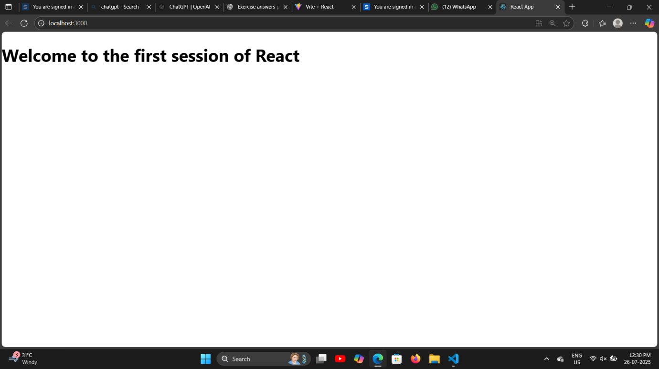

**Exercise 2:**

Create a react app for Student Management Portal named StudentApp and create a component named Home which will display the Message “Welcome to the Home page of Student Management Portal”. Create another component named About and display the Message “Welcome to the About page of the Student Management Portal”. Create a third component named Contact and display the Message “Welcome to the Contact page of the Student Management Portal”. Call all the three components.

**App.js**

import React from 'react';

import Home from './Components/Home';

import About from './Components/About';

import Contact from './Components/Contact';

function App() {

  return (

    <div>

      <Home />

      <About />

      <Contact />

    </div>

  );

}

export default App;

**Home.js**

import React from 'react';

class Home extends React.Component {

  render() {

    return <h2>Welcome to the Home page of Student Management Portal</h2>;

  }

}

export default Home;

**About.js**

import React from 'react';

class About extends React.Component {

  render() {

    return <h2>Welcome to the About page of Student Management Portal</h2>;

  }

}

export default About;

**Contact.js**

import React from 'react';

class Contact extends React.Component {

  render() {

    return <h2>Welcome to the Contact page of Student Management Portal</h2>;

  }

}

export default Contact;

**O/P**

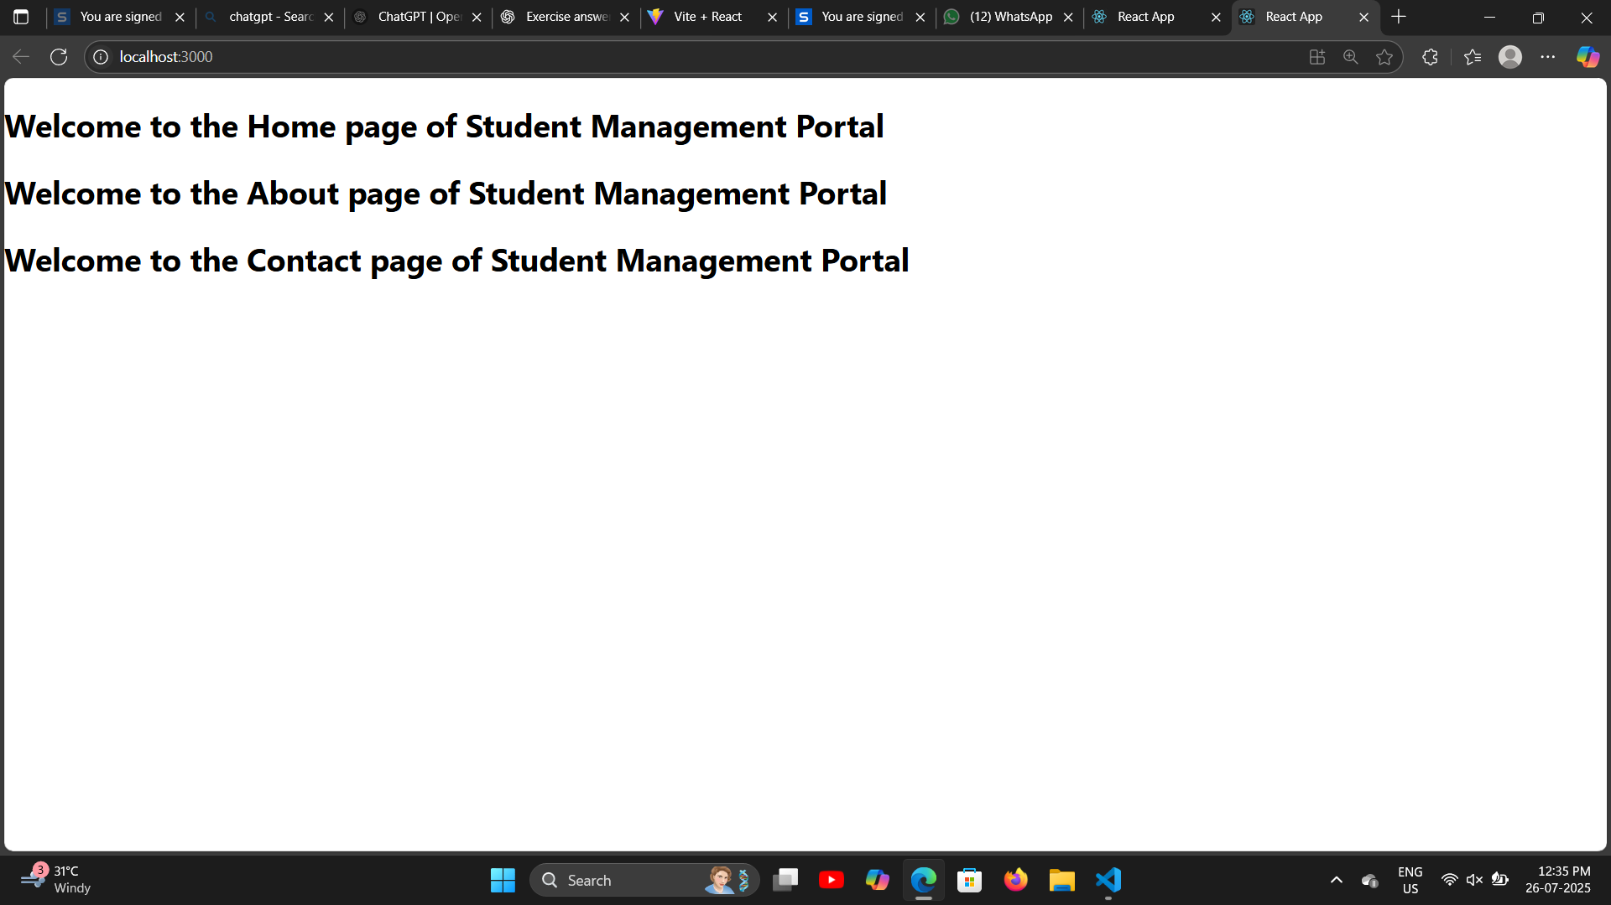

**Exercise 3:**

Create a react app for Student Management Portal named scorecalculatorapp and create a function component named “CalculateScore” which will accept Name, School, Total and goal in order to calculate the average score of a student and display the same.

**App.js**

import React from 'react';

import CalculateScore from './Components/CalculateScore';

function App() {

  return (

    <div>

      <CalculateScore name="Alice" school="XYZ High School" total={480} goal={6} />

    </div>

  );

}

export default App;

**CalculateScore.js**

import React from 'react';

function CalculateScore({ name, school, total, goal }) {

  const avg = total / goal;

  const containerStyle = {

    border: '1px solid black',

    padding: '20px',

    margin: '20px',

    backgroundColor: 'skyblue',

    fontFamily: 'Arial, sans-serif',

    textAlign: 'center',

    fontSize: '18px',

    borderRadius: '10px',

    boxShadow: '2px 2px 10px rgba(0,0,0,0.2)'

  };

  return (

    <div style={containerStyle}>

      <h2 style={{ color: 'darkred' }}>{name}</h2>

      <p style={{ color: 'green' }}>School: {school}</p>

      <p style={{ color: 'navy' }}>Total Marks: {total}</p>

      <p style={{ color: 'purple' }}>Goal: {goal}</p>

      <p style={{ color: 'maroon' }}>Average: {avg}</p>

    </div>

  );

}

export default CalculateScore;

**O/P**

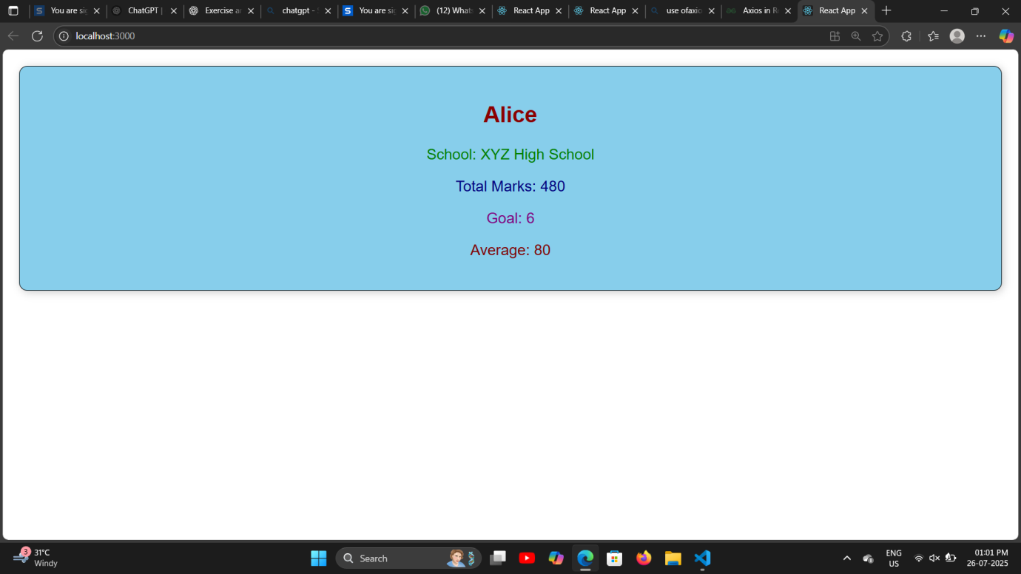

**Exercise 4:**

Create a new react application using create-react-app tool with the name as “blogapp” by following the below steps.

**App.js**

import React from 'react';

import Posts from './Posts';

function App() {

  return (

    <div>

      <Posts />

    </div>

  );

}

export default App;

**Posts.js**

import React, { Component } from 'react';

class Posts extends Component {

  constructor() {

    super();

    this.state = { posts: [], hasError: false };

  }

  loadPosts = async () => {

    try {

      const res = await fetch('https://jsonplaceholder.typicode.com/posts');

      const data = await res.json();

      this.setState({ posts: data });

    } catch (error) {

      this.setState({ hasError: true });

    }

  };

  componentDidMount() {

    this.loadPosts();

  }

  componentDidCatch(error, info) {

    alert("An error occurred: " + error);

  }

  render() {

    return (

      <div>

        <h2>Blog Posts</h2>

        {this.state.posts.map(post => (

          <div key={post.id}>

            <h3>{post.title}</h3>

            <p>{post.body}</p>

          </div>

        ))}

      </div>

    );

  }

}

export default Posts;

**O/P**

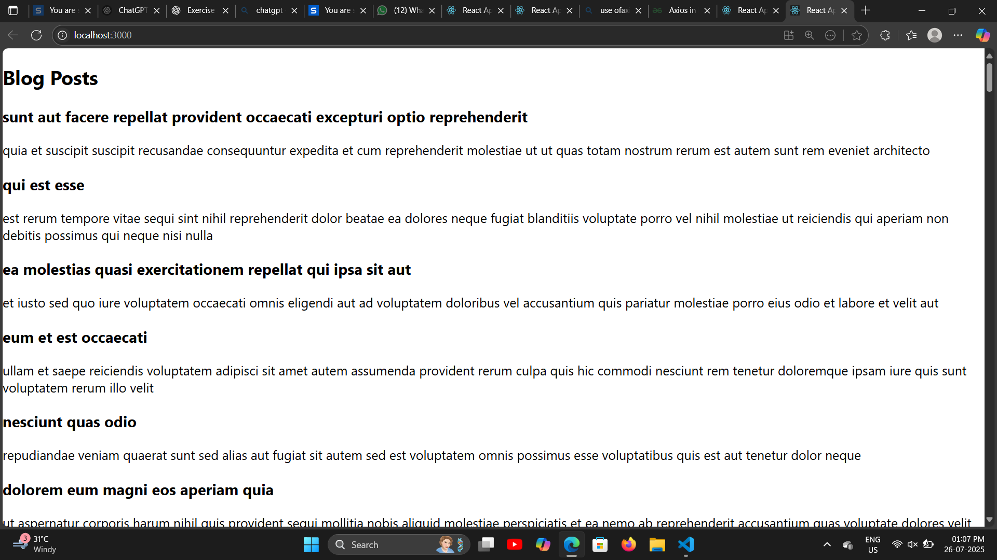

**Exercise 5:**

My Academy team at Cognizant want to create a dashboard containing the details of ongoing and completed cohorts. A react application is created which displays the detail of the cohorts using react component. You are assigned the task of styling these react components.

**App.js**

import React from 'react';

import CohortDetails from './CohortDetails';

function App() {

  return (

    <div>

      <CohortDetails name="React Basics" status="ongoing" instructor="John Doe" />

      <CohortDetails name="Node Advanced" status="completed" instructor="Jane Smith" />

    </div>

  );

}

export default App;

**CohortDetails.js**

import React from 'react';

import styles from './CohortDetails.module.css';

function CohortDetails({ name, status, instructor }) {

  const titleStyle = {

    color: status === 'ongoing' ? 'green' : 'blue'

  };

  return (

    <div className={styles.box}>

      <h3 style={titleStyle}>{name}</h3>

      <dl>

        <dt>Status:</dt>

        <dd>{status}</dd>

        <dt>Instructor:</dt>

        <dd>{instructor}</dd>

      </dl>

    </div>

  );

}

export default CohortDetails;

**CohortDetails.module.css**

.box {

    width: 300px;

    display: inline-block;

    margin: 10px;

    padding: 10px 20px;

    border: 1px solid black;

    border-radius: 10px;

  }

  dt {

    font-weight: 500;

  }

**O/P**

