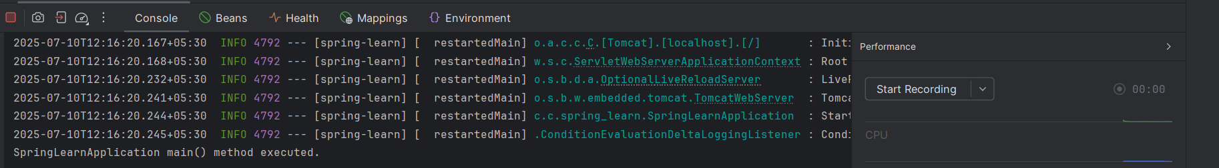
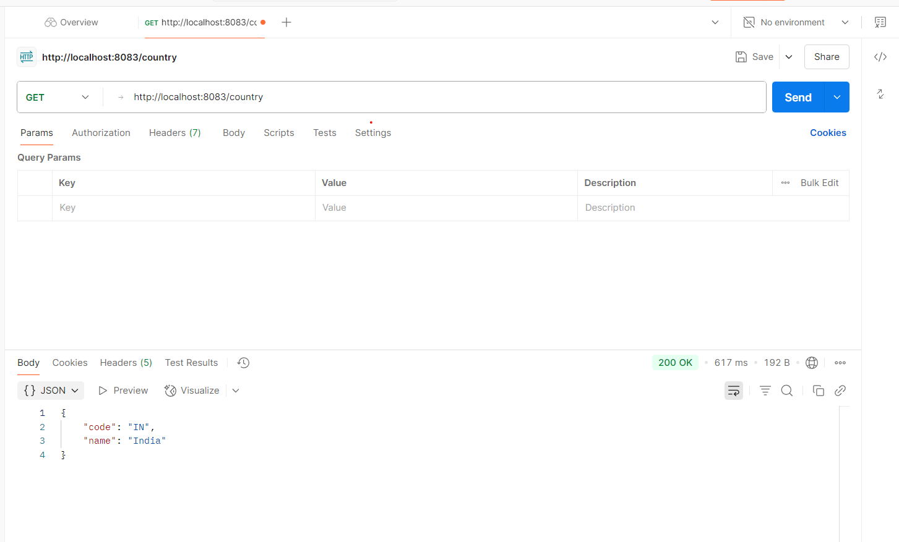
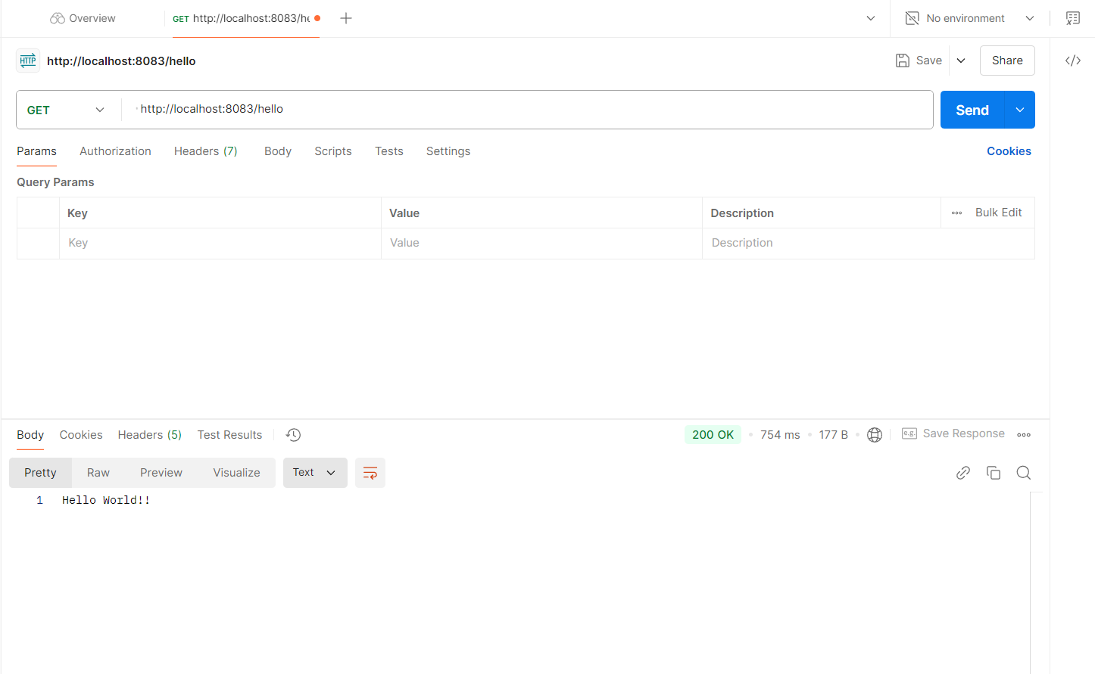
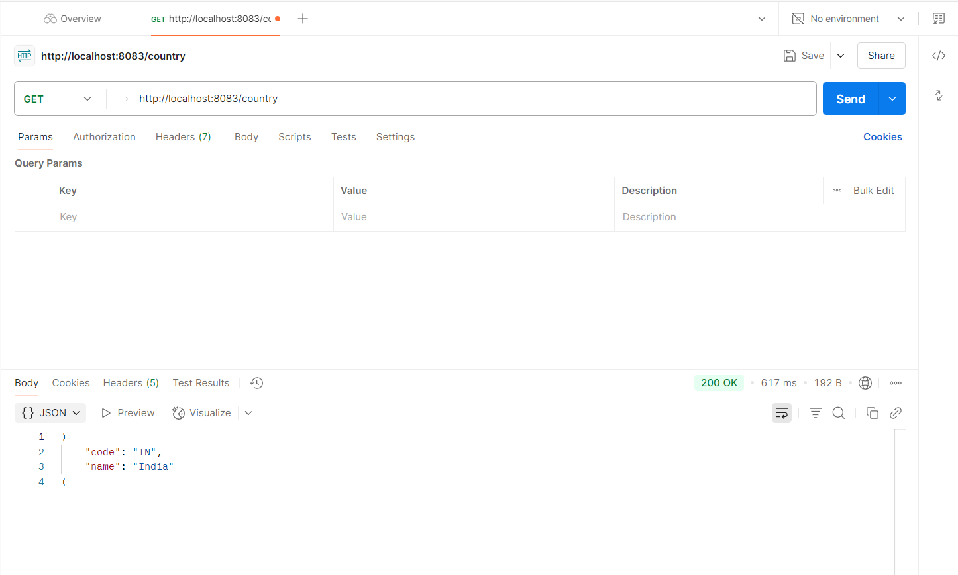
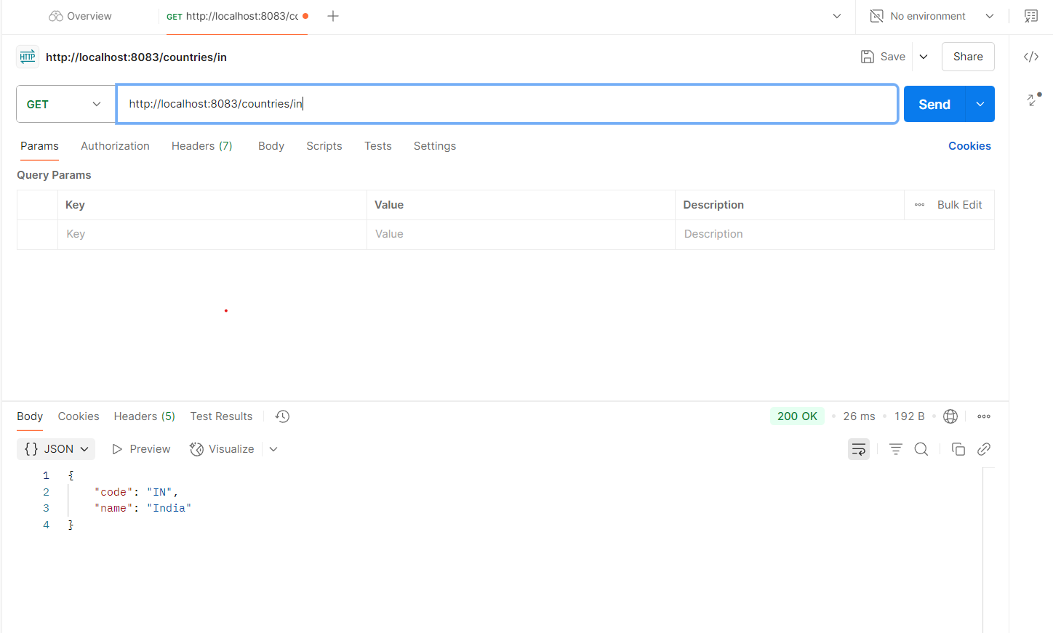
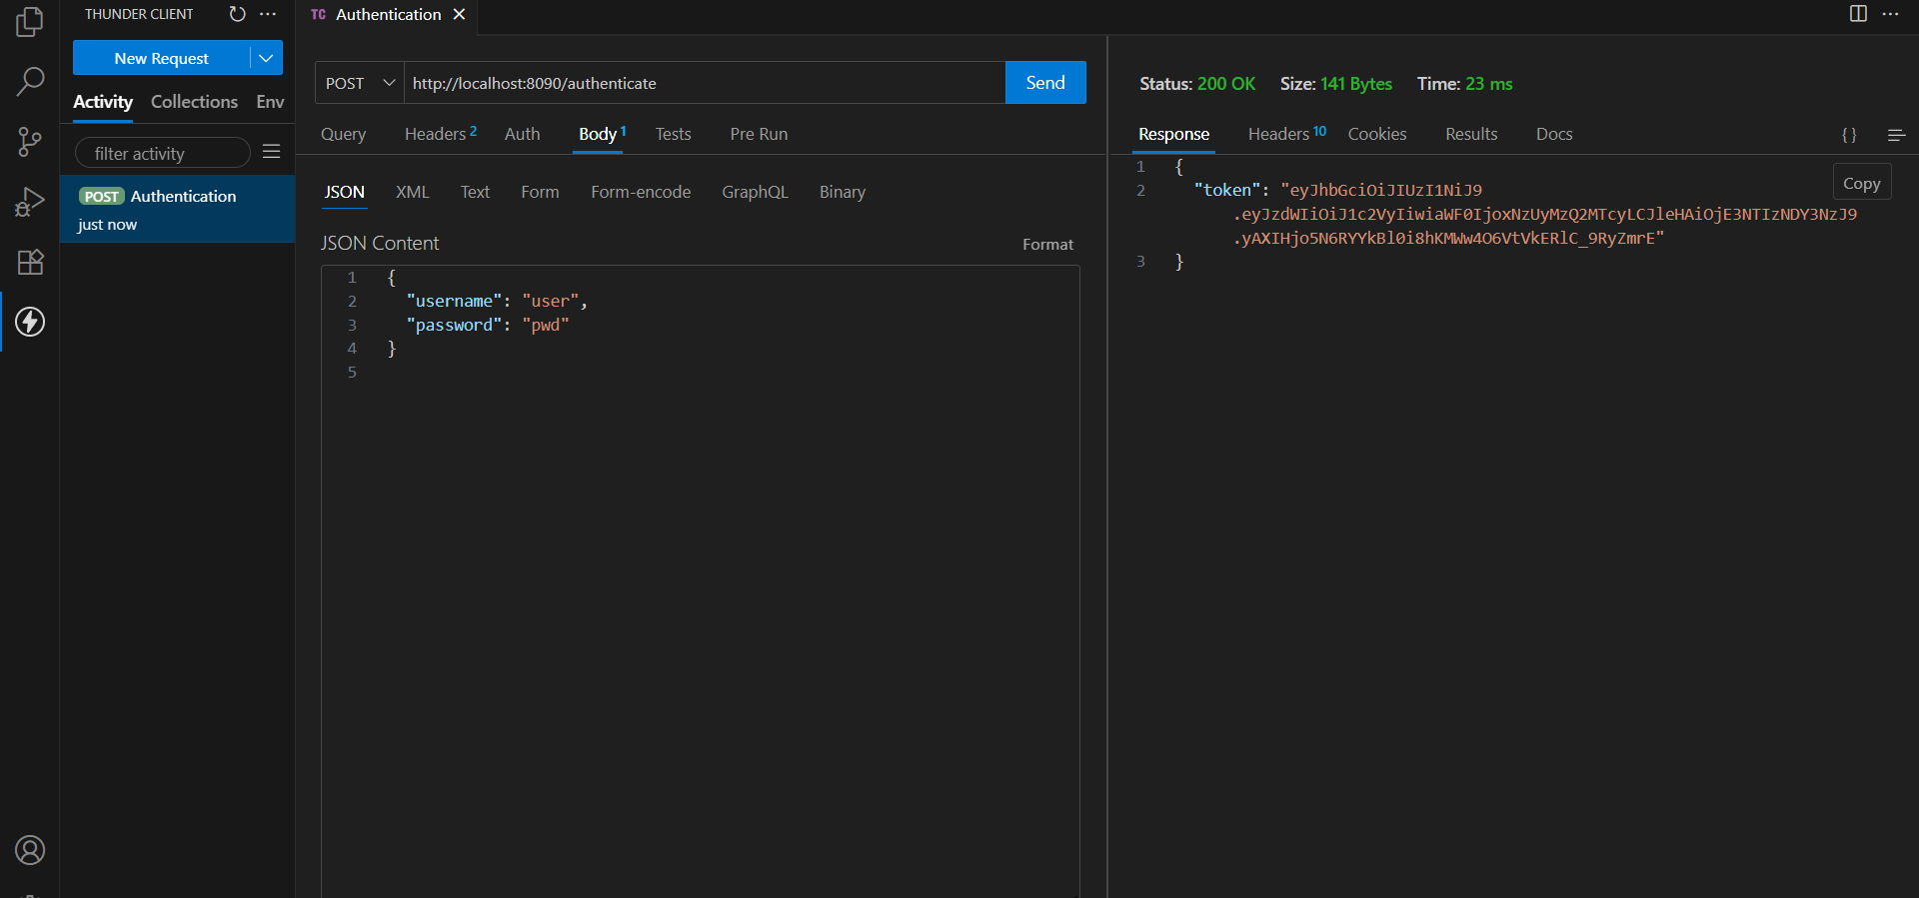
WEEK 4
Topic 1: Spring Rest Using Spring Boot 3
Exercise 1:
Create a Spring Web Project using Maven
Code :
package com.cognizant.springlearn;
import org.springframework.boot.SpringApplication;
import org.springframework.boot.autoconfigure.SpringBootApplication;
@SpringBootApplication
public class SpringLearnApplication {
public static void main(String[] args) {
SpringApplication.run(SpringLearnApplication.class, args);
System.out.println("SpringLearnApplication main() method executed.");
}
}
O/P:
Exercise 2:
Spring Core – Load Country from Spring Configuration XML
Code :
//Country.java
package com.cognizant.spring;
public class Country {
private String code;
private String name;
public Country() {
}
public String getCode() {
return code;
}
public void setCode(String code) {
this.code = code;
}
public String getName() {
return name;
}
public void setName(String name) {
this.name = name;
}
@Override
public String toString() {
return "Country [code=" + code + ", name=" + name + "]";
}
}
O/P:

Exercise 3:
Hello World RESTful Web Service
Code :
//HelloController.java
package com.cognizant.spring.controller;

import org.slf4j.Logger;
import org.slf4j.LoggerFactory;
import org.springframework.web.bind.annotation.GetMapping;
import org.springframework.web.bind.annotation.RestController;

@RestController
public class HelloController {
private static final Logger LOGGER = LoggerFactory.getLogger(HelloController.class);
@GetMapping("/hello")
public String sayHello() {
LOGGER.debug("START sayHello()");
String message = "Hello World!!";
LOGGER.debug("END sayHello()");
return message;
}
}
O/P:
Exercise 4:
REST - Country Web Service
Code :
//SpringApplication.java
package com.cognizant.spring;
import org.slf4j.Logger;
import org.slf4j.LoggerFactory;
import org.springframework.context.ApplicationContext;
import org.springframework.context.support.ClassPathXmlApplicationContext;

public class SpringApplication {
private static final Logger LOGGER = LoggerFactory.getLogger(SpringLearnApplication.class);
public static void displayCountry() {
ApplicationContext context = new ClassPathXmlApplicationContext("country.xml");
Country country = context.getBean("country", Country.class);
LOGGER.debug("Country : {}", country.toString());
}
public static void main(String[] args) {
LOGGER.debug("START of main()");
displayCountry();
LOGGER.debug("END of main()");
}
}

O/P:
Exercise 5:
REST - Get country based on country code
Code:
//CountryController.java
package com.cognizant.spring.controller;

import com.cognizant.spring.Country;
import com.cognizant.spring.service.CountryService;
import org.slf4j.Logger;
import org.slf4j.LoggerFactory;
import org.springframework.beans.factory.annotation.Autowired;
import org.springframework.web.bind.annotation.*;
@RestController
public class CountryController {
private static final Logger LOGGER = LoggerFactory.getLogger(CountryController.class);
@Autowired
private CountryService countryService;
@GetMapping("/countries/{code}")
public Country getCountry(@PathVariable String code) {
LOGGER.debug("START getCountry() with code: {}", code);
Country country = countryService.getCountry(code);
LOGGER.debug("END getCountry() : {}", country);
return country;
}
}
//CountryService.java
package com.cognizant.spring.service;

import com.cognizant.spring.Country;
import org.springframework.context.ApplicationContext;
import org.springframework.context.support.ClassPathXmlApplicationContext;
import org.springframework.stereotype.Service;
import java.util.List;
@Service
public class CountryService {
public Country getCountry(String code) {
ApplicationContext context = new ClassPathXmlApplicationContext("country.xml");
List<Country> countryList = context.getBean("countryList", List.class);
return countryList.stream()
.filter(c -> c.getCode().equalsIgnoreCase(code))
.findFirst()
.orElse(null);
}
}

O/P:
Exercise 6:
Create authentication service that returns JWT
Code:
//AuthController.java
package com.cognizant.springlearn.controller;
import io.jsonwebtoken.Jwts;
import io.jsonwebtoken.SignatureAlgorithm;
import io.jsonwebtoken.security.Keys;
import org.springframework.http.ResponseEntity;
import org.springframework.web.bind.annotation.GetMapping;
import org.springframework.web.bind.annotation.RestController;

import jakarta.servlet.http.HttpServletRequest;
import java.security.Key;
import java.util.Base64;
import java.util.Date;
@RestController
public class AuthController {
private static final Key SECRET_KEY = Keys.secretKeyFor(SignatureAlgorithm.HS256);
@GetMapping("/authenticate")
public ResponseEntity<?> authenticate(HttpServletRequest request) {
String authHeader = request.getHeader("Authorization");
if (authHeader == null || !authHeader.startsWith("Basic ")) {
return ResponseEntity.status(401).body("Missing or invalid Authorization header.");
}
String base64Credentials = authHeader.substring("Basic ".length());
String credentials = new String(Base64.getDecoder().decode(base64Credentials));
String[] values = credentials.split(":", 2);
String username = values[0];
String password = values[1];

if (!"user".equals(username) || !"pwd".equals(password)) {
return ResponseEntity.status(401).body("Invalid credentials.");
}
String jwt = Jwts.builder()
.setSubject(username)
.setIssuedAt(new Date())
.setExpiration(new Date(System.currentTimeMillis() + 10 * 60 * 1000))
.signWith(SECRET_KEY)
.compact();
return ResponseEntity.ok().body("{\"token\":\"" + jwt + "\"}");
}
}
O/P:

