WEEK 5
Exercise 1 Microservices on Account and Loan
//AccountController.java
package com.cognizant.account;
import org.springframework.web.bind.annotation.*;
import java.util.Map;
@RestController
@RequestMapping("/accounts")
public class AccountController {
@GetMapping("/{number}")
public Map<String, Object> getAccountDetails(@PathVariable String number) {
return Map.of(
"number", number,
"type", "savings",
"balance", 234343
);
}
}

O/P
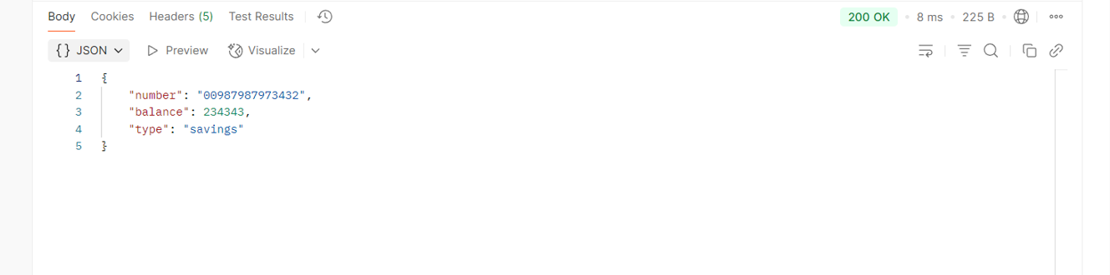
// Loan Controller.java
package com.cognizant.loan;
import org.springframework.web.bind.annotation.*;
import java.util.Map;
@RestController
@RequestMapping("/loans")
public class LoanController {
@GetMapping("/{number}")
public Map<String, Object> getLoanDetails(@PathVariable String number) {
return Map.of(
"number", number,
"type", "car",
"loan", 400000,
"emi", 3258,
"tenure", 18
);
}
}

O/P
