FIRMIVRA
Communications Module — Developer Handoff
Super Admin / Owner Portal
Item | Details
Prepared for | Firmivra development team
Prepared on | October 14, 2026
Scope | Main Communications dashboard, Broadcasts, Templates, Create/Edit Template, New Message/Compose, and message states/behaviors
Primary user context | CEO / Owner / Super Admin view; role permissions can be narrowed later
Design rule | Keep the approved Firmivra left navigation and visual language consistent across all Communications screens

Important: the counts, names, dates, email addresses, phone numbers, and message text visible in mockups are sample UI data. They must be dynamic and must not be hard-coded.

1. Global Communications Rules
Requirement | Developer instruction
Navigation | Communications remains a top-level item in the master Super Admin sidebar. Preserve the approved shared sidebar across every Communications screen.
Top-level page header | On the main Communications page, use the page title and subtitle only. Do not add a “Dashboard > Communications” breadcrumb.
Channels | Support Email, SMS, and Internal messages in the conversation center. Broadcasts additionally support In-App and combined multi-channel sends.
Contact history | Every outbound or inbound communication must be written to the applicable contact/firm/client/lead conversation history with timestamp, channel, sender, delivery state, and related activity.
Dynamic data | All KPIs, counts, status badges, conversation lists, recipient details, template counts, and dates are data-driven.
Search/filter behavior | Search and filters should update results without requiring a full page reload. Keep the selected filter visible.
Auditability | Record creator/sender, created timestamp, modified timestamp, scheduled time (if applicable), and final delivery status.

2. Main Communications Dashboard
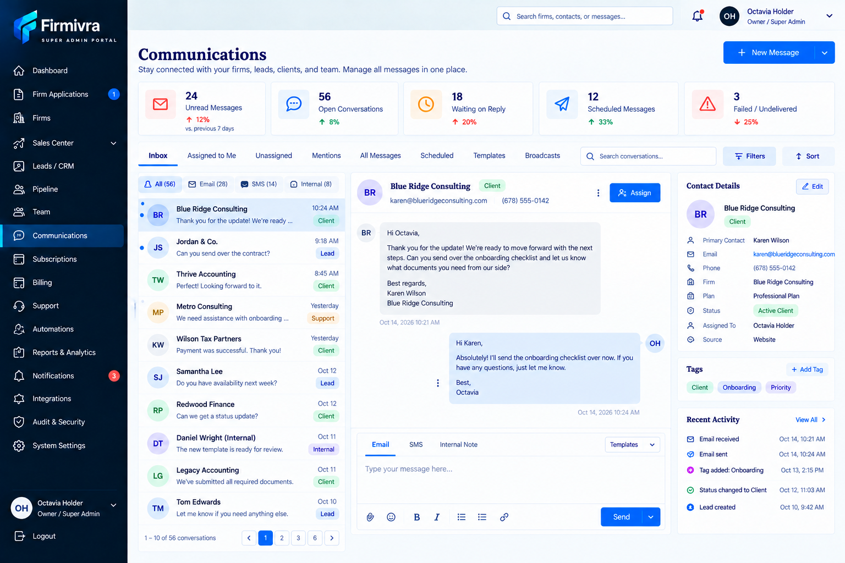
Approved reference — Main Communications dashboard
Area | UI / behavior
Header | Title: Communications. Subtitle communicates that firms, leads, clients, and team messages are managed in one place. Primary action: New Message.
KPI cards | Unread Messages, Open Conversations, Waiting on Reply, Scheduled Messages, Failed / Undelivered. Values and trend indicators are dynamic.
Primary tabs | Inbox, Assigned to Me, Unassigned, Mentions, All Messages, Scheduled, Templates, Broadcasts.
Channel filters | All, Email, SMS, Internal.
Conversation list | Show sender/contact, message preview, timestamp/date, and contact type/status badge. Unread items must be visually distinct.
Thread panel | Show selected conversation history in chronological order. Support reply by Email, SMS, or Internal Note based on context.
Composer | Message text area with template picker, attachment control, basic formatting where applicable, and Send action.
Right panel | Contact Details, Tags, and Recent Activity. Contact details should link to the underlying record when available.
Assignment | Allow authorized users to assign/unassign a conversation to a team member.
Search / Filters / Sort | Search conversations and filter/sort by status, assignment, channel, contact type, and date as supported by backend data.

3. Broadcasts
The Broadcast flow was already approved as a multi-step full-page workflow. No additional Broadcast screenshots are required for implementation; the behavior below is the developer source of truth.

3.1 Broadcast entry and management
Requirement | Developer instruction
Entry point | Broadcasts is accessible from the Communications dashboard tab set.
Primary action | Create Broadcast opens a full-width creation workspace, not a small modal.
Statuses | Support Draft, Scheduled, Sent, and Failed. Status must drive available actions.
Sent actions | View details/performance, Preview, Duplicate, View Recipients, Export, Archive. Sent broadcasts cannot be edited or deleted.
Draft actions | Edit, Preview, Duplicate, Send Test, Schedule, Delete.
Scheduled actions | Edit, Reschedule, Send Now, Duplicate, Cancel.
Failed actions | View Error, Retry, Duplicate, Archive.
History | Broadcast sends should write appropriate message/activity entries to recipient histories when technically applicable.

3.2 Create Broadcast — 4-step flow
Step | Required content / behavior
1 — Basic Information | Broadcast name/internal label; channel selection. Channels: All Channels, Email, SMS, In-App. All Channels preselects all three, but the user may deselect individual channels.
2 — Audience | Select an existing audience/segment and show recipient count. Include a clear button/page to create a new audience segment without leaving the workflow permanently. After saving the segment, return to the broadcast audience step with it selectable.
3 — Message | Full message design center. For Email: subject plus rich editor with font size, bold, color controls, links, merge fields/personalization, inline images/photo upload, and file attachments. For SMS/In-App, show channel-appropriate editors. Provide channel preview and Send Test.
4 — Review & Send | Show broadcast name, selected channels, audience/recipient count, message preview by channel, attachments, and send timing. Allow Send Now or Schedule. User can go back to earlier steps without losing work.

3.3 Broadcast validation and send behavior
Scenario | Expected behavior
Missing required data | Block progression/send and clearly identify the missing field or required step.
Audience count = 0 | Do not allow final send; show an explicit empty-audience warning.
Send Test | Test send does not change broadcast status to Sent and must be clearly labeled as a test.
Schedule | Store selected send date/time and timezone. Scheduled item remains editable/reschedulable/cancelable until dispatch begins.
Send Now | Require final confirmation if the send is to a large/multi-channel audience; then transition to sending/sent state based on backend result.
Partial channel failure | Preserve per-channel delivery results; do not mark an entire multi-channel broadcast successful if one channel failed.
Failure | Expose useful error information and Retry where retry is safe. Preserve the original attempt in audit history.

4. Templates Library
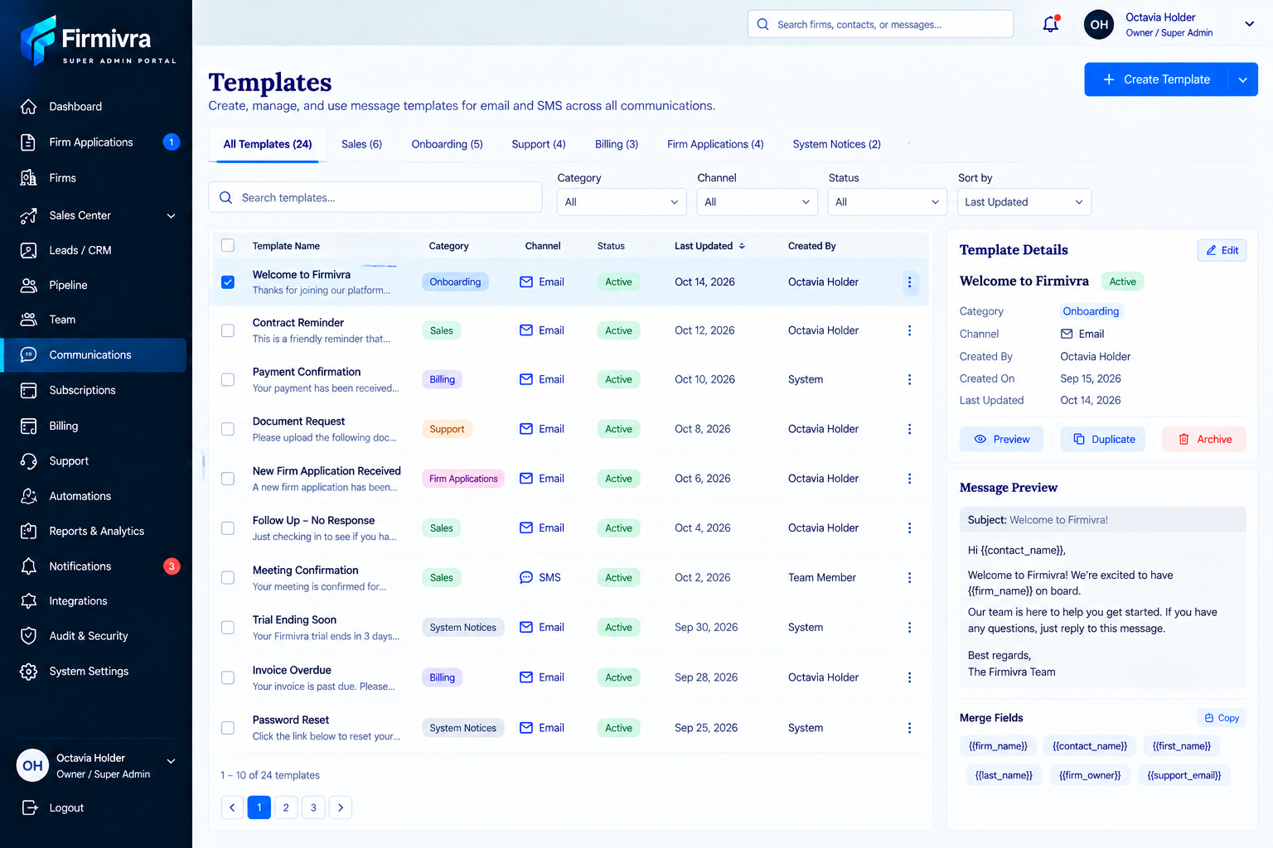
Approved reference — Templates library
Area | UI / behavior
Header | Title: Templates. Primary action: Create Template.
Category tabs | All Templates plus category tabs such as Sales, Onboarding, Support, Billing, Firm Applications, and System Notices. Categories should be data-driven.
Filters | Search templates; Category, Channel, Status, and Sort by.
Template list | Template Name, Category, Channel, Status, Last Updated, Created By, row actions. Support pagination.
Details panel | Show selected template metadata and actions: Edit, Preview, Duplicate, Archive.
Message preview | Render subject/body for email templates and show merge fields available to that template.

5. Create / Edit Template
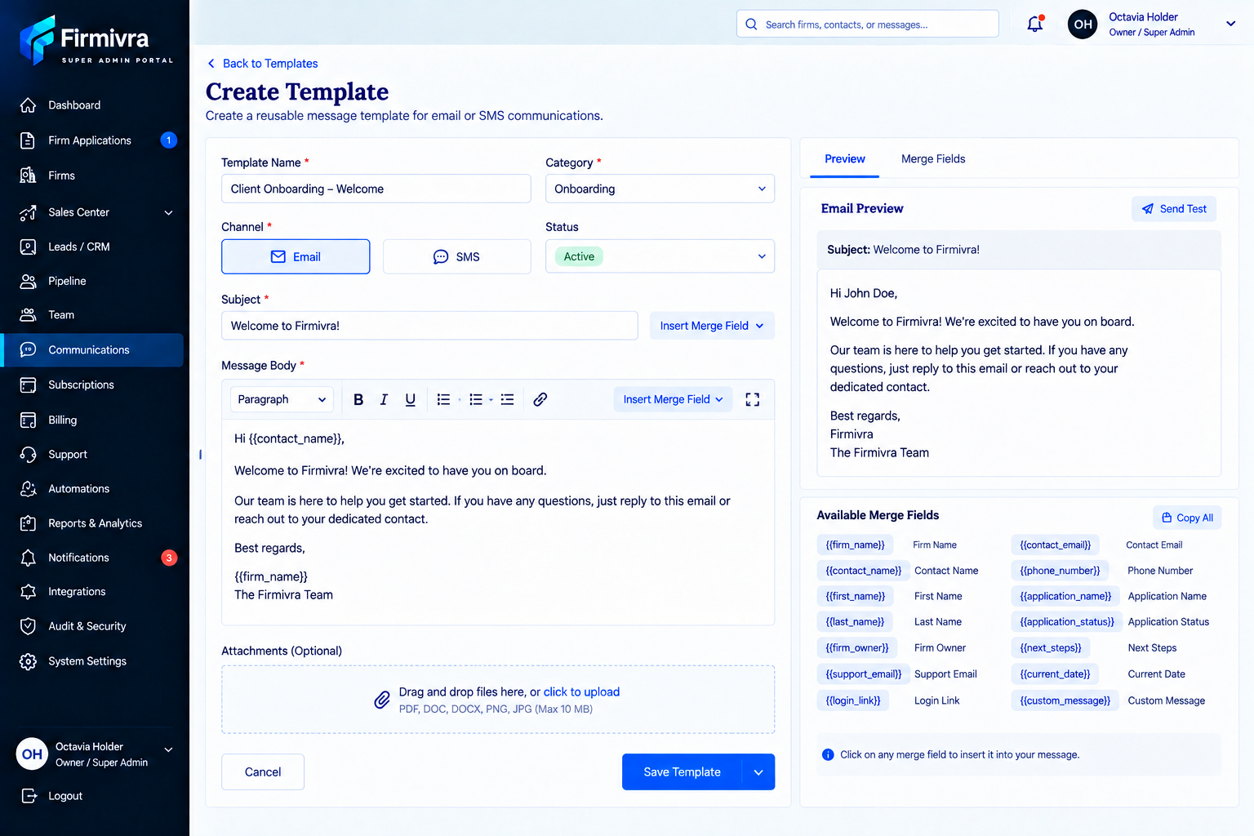
Approved reference — Create Template page
Field / control | Developer instruction
Template Name | Required text field.
Category | Required category selector.
Channel | Email or SMS. UI changes based on selected channel.
Status | Support Active and inactive/archived state as defined by backend.
Subject | Required only for Email. Hide for SMS.
Message Body | Rich editor for Email; simpler text editor for SMS.
Formatting | Email editor supports paragraph style/font sizing, bold, italic, underline, lists, links, and standard text formatting.
Merge Fields | Insert merge field into subject/body at cursor position. Available tokens should be centrally defined and consistently rendered.
Inline Images | Image icon in the body toolbar inserts an image inside the email body. This is separate from attachments.
Attachments | Separate attachment area for files that should be delivered as attachments rather than rendered inline.
Preview | Live or refreshable preview of the final email/SMS with representative values substituted for merge tokens.
Send Test | Allow user to send a test without activating/sending the template to real recipients.
Save | Save Template; Cancel returns safely. Warn before discarding unsaved changes.

5.1 Insert Image behavior
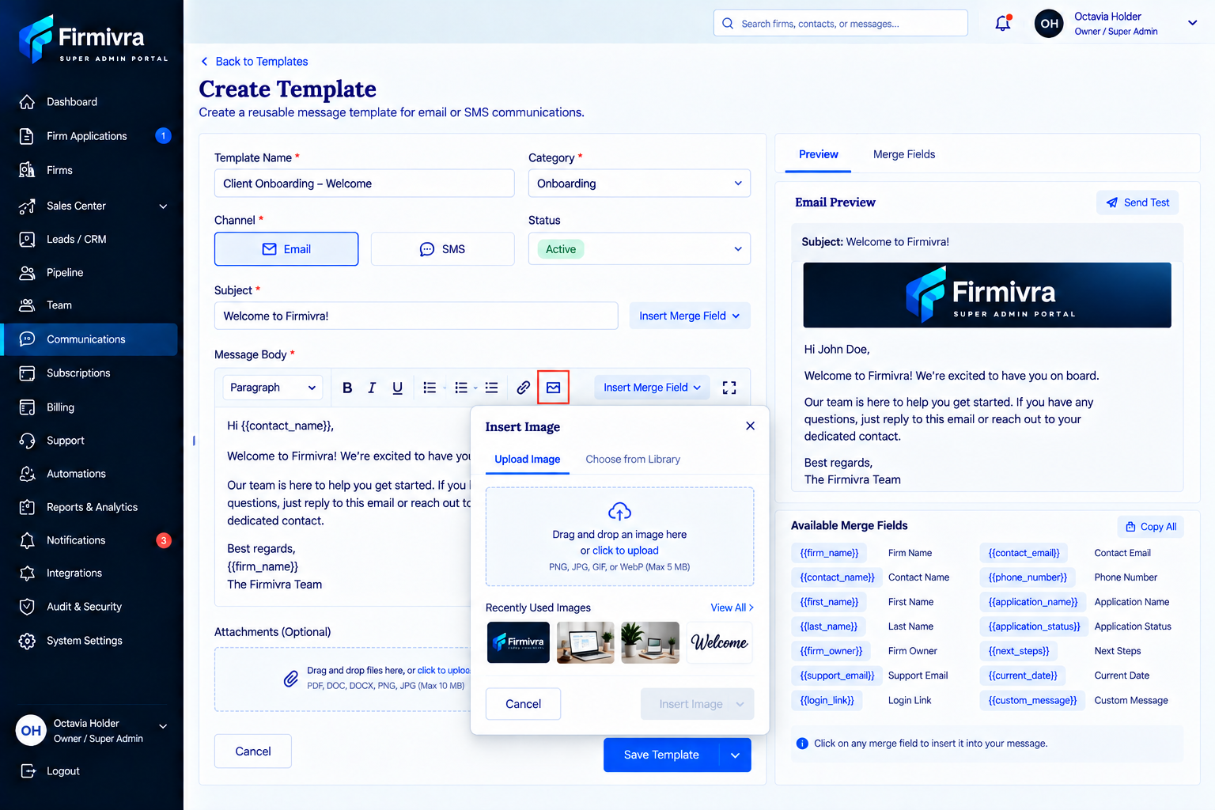
Approved reference — Insert Image modal and inline image toolbar control
Requirement | Developer instruction
Toolbar control | Place an image icon in the Message Body toolbar near the link control.
Modal tabs | Upload Image and Choose from Library.
Upload | Drag-and-drop and click-to-upload. Accept common web image formats; enforce backend size/security rules.
Library | Allow selection from previously stored/recent images.
Insertion point | Insert the selected image into the body at the current cursor location.
Preview | Preview must render inline images in the same order/placement as the message body.
Attachments distinction | Do not treat inline images as ordinary file attachments in the recipient experience.

6. New Message / Compose
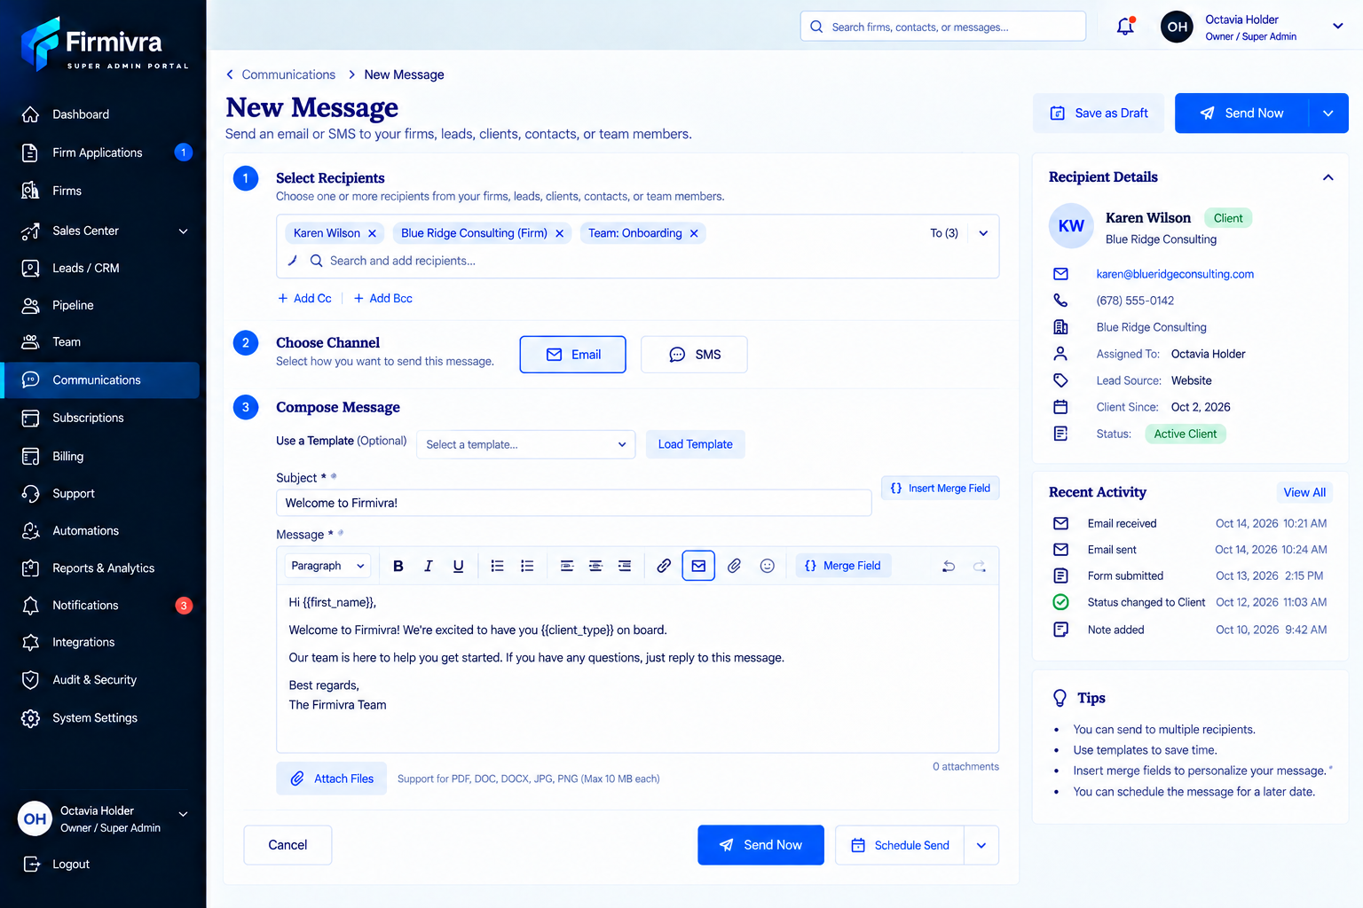
Approved reference — New Message / Compose
Area | UI / behavior
Recipients | Search/select one or more recipients from firms, leads, clients, contacts, or team members. Display selected recipients as removable chips/tokens.
Cc / Bcc | Available for Email. Hide or disable when SMS is selected.
Channel | Email or SMS. Selecting SMS hides Email-only fields and controls.
Use a Template | Optional template selector; Load Template populates message fields while still allowing edits for this one send.
Subject | Email only.
Message editor | Use the same core editor capabilities as Templates: formatting, links, merge fields, inline images for Email, and attachments.
Recipient details panel | Show selected recipient/contact summary, including contact info, firm/client/lead status, assignee, source, and recent activity where available.
Save as Draft | Persist message, recipients, channel, content, and attachments without sending.
Send Now | Validate required fields and recipient channel availability before sending.
Schedule Send | Select future date/time and preserve timezone.
Cancel | Return to Communications without sending; confirm if unsaved changes exist.

7. Message States and Required Behaviors
State | UI treatment | Allowed actions / rules
Draft | Clearly marked Draft in list/detail. | Open/Edit, Send Now, Schedule, Delete. Preserve autosaved/manual saved content.
Scheduled | Show scheduled date/time and timezone. | Edit, Reschedule, Send Now, Cancel. Lock once dispatch has actually begun.
Sent | Show sent timestamp and delivery state. | View, Reply/Continue thread, Duplicate content where applicable. Do not allow destructive editing of the historical sent message.
Failed / Undelivered | Show visible error indicator and reason when available. | Retry, correct recipient/channel data where allowed, or compose a new message. Preserve the failed attempt in history.
Partial delivery | Show per-recipient/per-channel result where a bulk or multi-recipient action partially succeeds. | Retry only failed recipients/channels when supported.

8. Delivery, Validation, and Data Rules
Rule | Implementation requirement
Recipient validation | Before send, verify required destination exists for selected channel (valid email for Email; valid phone/SMS-capable destination for SMS).
Merge fields | If a merge value is missing, follow a consistent fallback policy; never expose raw unresolved tokens to end recipients without a clear product decision.
Attachments | Validate allowed type/size and surface upload failures before send.
Duplicate sends | Protect against accidental double-submission of the same send action.
Timestamps | Store system timestamp and display in the user-facing timezone consistently.
Activity feed | Sent, received, scheduled, canceled, failed, retried, and assignment/status changes should appear in Recent Activity where relevant.
Permissions | This handoff is for the CEO/Owner/Super Admin build. Fine-grained role permissions are intentionally deferred and can be layered on later.

9. Developer Acceptance Checklist
☐ Main Communications dashboard matches approved layout and top-level navigation.
☐ No breadcrumb is added to the main Communications page.
☐ Dashboard KPI values, lists, tabs, filters, and contact panels are dynamic.
☐ Broadcast status-aware actions behave exactly as defined for Draft, Scheduled, Sent, and Failed.
☐ Create Broadcast uses the approved four-step flow: Basic Information → Audience → Message → Review & Send.
☐ Audience step can create a new audience segment and return to the broadcast flow.
☐ Broadcast Message step provides full Email design controls including font size, bold, color, merge fields, inline photos/images, attachments, preview, and test send.
☐ Templates library supports search/filter/category/channel/status/sort and template detail actions.
☐ Create/Edit Template supports Email/SMS, preview, merge fields, inline images, attachments, test send, and save/cancel.
☐ New Message supports multi-recipient selection, Email/SMS, templates, drafts, send now, schedule, and recipient details.
☐ Draft, Scheduled, Sent, Failed/Undelivered, and partial-delivery states are persisted and displayed correctly.
☐ All sends and relevant state changes are recorded in conversation/contact history and audit metadata.
☐ Sample content visible in mockups is not hard-coded.

10. Screenshot Reference Map
Reference | Use
Main Communications dashboard | Primary reference for overall layout, KPI cards, tabs, conversation center, contact panel, tags, recent activity, and New Message entry point.
Templates library | Primary reference for template list, filters, details panel, preview, and merge-field display.
Create Template | Primary reference for the full template creation workspace and live preview structure.
Insert Image modal | Primary reference for inline image insertion; keep separate from attachments.
New Message | Primary reference for recipient selection, channel, template loading, compose controls, recipient details, draft/send/schedule actions.
Broadcasts | Use the approved four-step and state/action requirements in this document as source of truth; no extra screenshot is required.

