FIRMIVRA
Sales & Full Sales Pipeline
Developer Instructions
Directional guide for page structure, pipeline behavior, views, controls, synchronization, permissions, and acceptance testing.
CORE RULE: Sales, Leads/CRM, and Transactions must reference the same underlying firm, contact, opportunity, assignment, activity, and transaction relationships. Do not create duplicate or disconnected records to support different screens.

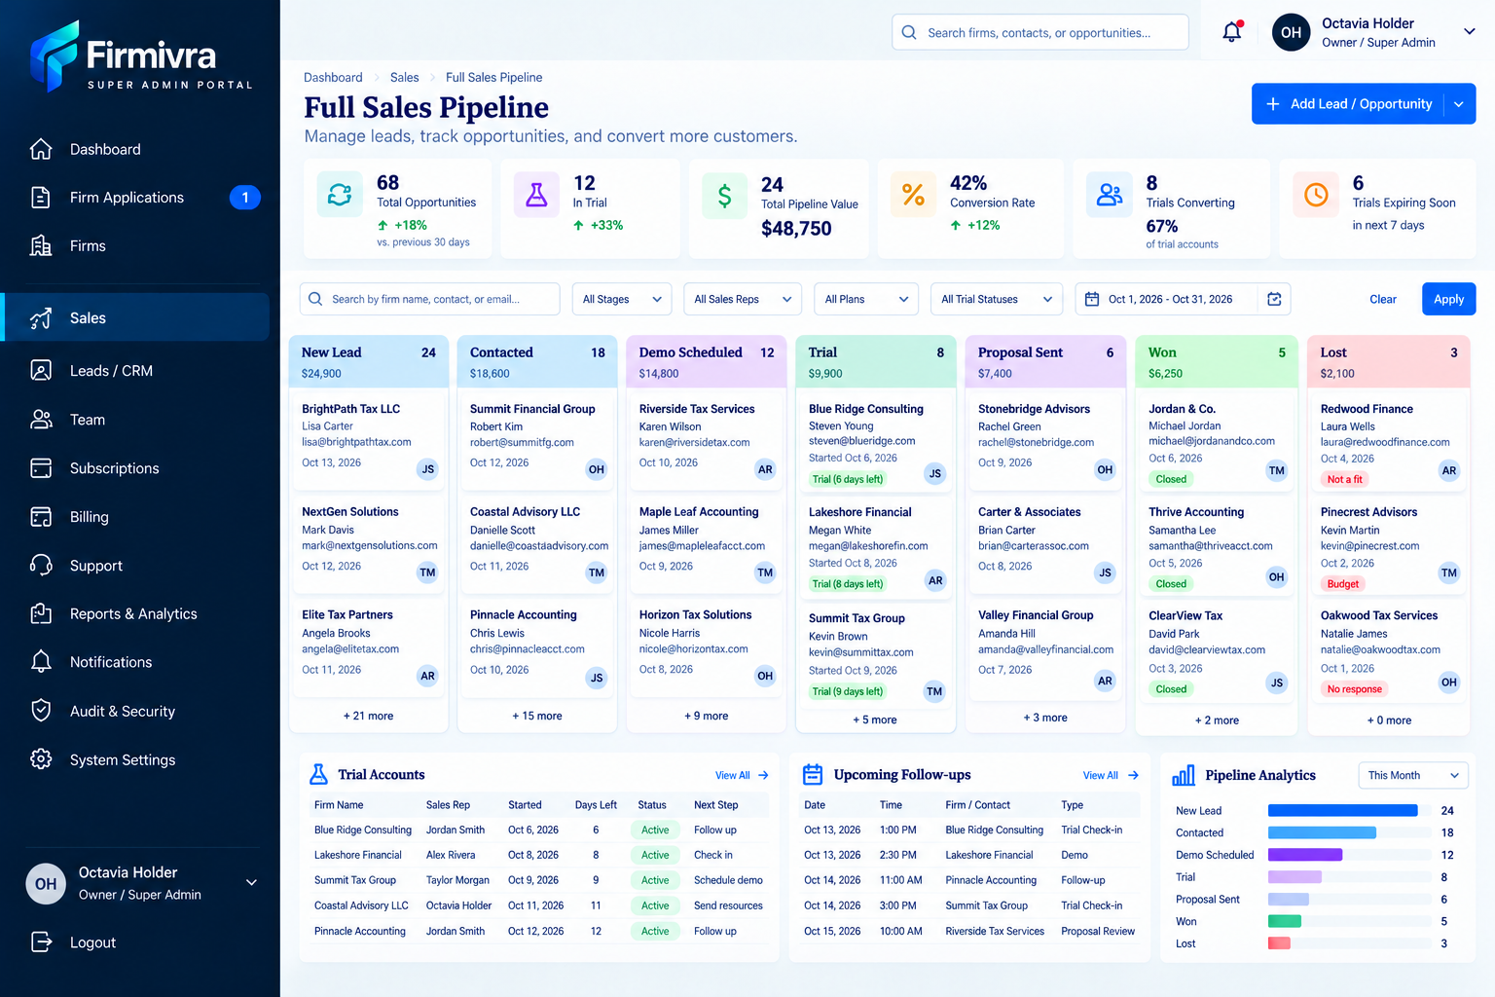
Reference screen: approved Firmivra Full Sales Pipeline visual direction. Written requirements below control behavior where the mockup is ambiguous.

1. Purpose & Scope
Area | Developer Requirement
Sales Module | Central workspace for managing leads and opportunities from initial inquiry through conversion, active-client status, contract activity, closing, or loss.
Visual Direction | Keep the approved Firmivra Super Admin visual system: sidebar, page header, KPI row, compact filters, pipeline workspace, and lower activity/analytics panels.
Clutter Rule | Add functionality without crowding the screen. Use compact controls, badges, progressive disclosure, and the Card/List toggle rather than adding large permanent panels.
Data Rule | Use one underlying opportunity dataset across cards, list view, KPIs, filters, activity, analytics, and reporting.

2. Sales Navigation & Page Header
Item | Developer Behavior
Sidebar > Sales | Opens the main Sales Pipeline workspace and highlights Sales as the active navigation item.
Breadcrumb | Dashboard > Sales > Pipeline (or Full Sales Pipeline). Use one naming convention consistently.
Page Title | Sales Pipeline or Full Sales Pipeline. Subtitle should communicate managing leads, opportunities, and conversion.
Global Search | Search permitted firms, contacts, and opportunities. Results must respect tenant and role permissions.
Add Lead / Opportunity | Prominent top-right action. Opens the appropriate create flow; dropdown may separate Add Lead and Add Opportunity if both concepts are retained.

3. KPI Summary Row
KPI | Required Logic / Click Behavior
Total Opportunities | Count unique active/eligible opportunities in the current permitted scope. Clicking filters to the relevant dataset.
In Progress | Count opportunities in active non-terminal pipeline stages.
Pipeline Value | Sum current active opportunity values; exclude Unqualified/Lost and closed revenue unless a separate metric intentionally includes them.
Conversion Rate | Use one documented formula consistently across the product. Do not calculate differently on this page versus reports.
Active Clients | Count records in Active Client and/or other approved converted-client states according to the final data model.
Needs Attention | Count overdue/no-activity/unassigned/other configured attention conditions. Clicking filters the pipeline to those records.

4. Approved Pipeline Lifecycle
Order | Stage | Required Meaning / Rule
1 | New Lead | Newly created/imported lead or opportunity with no completed outreach.
2 | Attempted Contact | At least one outreach attempt has been made, but meaningful contact has not yet been completed.
3 | Contacted | Two-way contact or qualifying conversation has occurred.
4 | Qualified | Lead meets the firm/product qualification criteria.
5 | Appointment Set | Demo, consultation, or other sales appointment has been scheduled.
6 | Nurturing | Qualified or viable opportunity not ready for immediate conversion; active nurture/follow-up continues.
7 | Active Client | Customer has converted to an active client but is not yet in an Under Contract transaction state.
8 | Under Contract | Linked transaction has entered the applicable contract-execution status. Prefer transaction-driven synchronization.
9 | Closed / Past Client | Linked transaction is closed or the client has completed the relevant sales lifecycle.
Side Exit | Unqualified / Lost | Not part of the successful path. Requires a reason and preserves history.

5. Unqualified / Lost
Item | Developer Requirement
Disposition | Treat as a side exit, not as the next successful stage after Closed / Past Client.
Reason Required | Require a reason before the move is completed.
Suggested Reasons | Not a Fit; Budget; No Response; Chose Competitor; Timing; Duplicate; Invalid Lead; Other.
Other Reason | If Other is selected, require or allow an explanatory note based on configuration.
Reporting | Lost reason must be reportable and available in analytics.
History | Keep the full prior pipeline and communication history after loss/unqualification.

6. Card View / List View Toggle
Control / View | Developer Requirement
View Toggle | Display Card View | List View above the workspace. Make the active selection visually clear.
Persistence | Remember the user’s most recently selected view where practical.
Same Dataset | Both views must read/write the same records; switching views must not duplicate or alter data.
Filter Continuity | Keep active filters, search, date range, and assignment scope when switching views.
Card View | Use the Kanban pipeline. Support drag-and-drop stage movement where user permissions allow.
List View | Use a sortable/paged table for dense review, bulk selection, assignment, and actions.

7. Card View
Card / Board Element | Developer Requirement
Stage Header | Show stage name, record count, and value total where applicable.
Card Essentials | Firm/company, contact, value, assigned rep/avatar initials, relevant date, and concise status/attention badges.
Card Detail | Opening a card launches the full record/detail view. Do not cram full history into the card.
Drag-and-Drop | Moving a card changes stage only after validation/permission checks. Log actor, timestamp, old stage, and new stage.
Empty Stage | Keep the stage visible with an empty-state message and Add action where permitted.
Horizontal Overflow | Because the pipeline has many stages, keep usable card width and allow horizontal scrolling instead of shrinking columns until unreadable.

8. List View
Column / Control | Developer Requirement
Recommended Columns | Firm / Opportunity; Contact; Stage; Assigned To; Source; Plan; Value; Last Activity; Next Follow-Up; Attention Status; Created Date.
Sorting | Allow sensible column sorting.
Pagination | Support pagination or virtualized paging for large datasets.
Selection | Allow row selection and bulk actions where authorized.
Open Record | Clicking a row opens the same underlying opportunity/contact record used by Card View.
Bulk Actions | May include assign/reassign, stage change, tags, and other approved actions. Always respect permissions and confirm affected count.

9. Search & Filters
Filter / Control | Required Behavior
Search | Search firm/company name, contact name, email, phone, or opportunity identifier/name.
Stage | Filter by one or multiple pipeline stages.
Agent / Sales Rep | Filter by assigned owner.
Plan | Filter by subscription/product/plan where relevant.
Source | Filter by lead source.
Tags | Filter by reusable tags.
Date Range | Apply the approved reporting/date rule consistently.
Show Overdue Only | Toggle to show records with overdue required follow-up/activity.
Show Unassigned | Toggle to show records without an assigned owner.
Clear Filters | Reset filters to default permitted scope.
Apply | If filters are not live, Apply commits the selected filter set. Do not mix live and Apply behavior inconsistently.

10. Assignment & Ownership
Action | Developer Requirement
Assign | Authorized user can assign an opportunity to a permitted team member.
Reassign | Authorized user can transfer ownership without losing history.
Unassigned | Support explicit unassigned state and filtering.
Bulk Assign | List View may support assigning multiple selected records at once.
Audit | Record previous assignee, new assignee, actor, and timestamp.
Permissions | Do not hard-code role names into component logic; check centralized permissions/capabilities.

11. Attention Indicators
Indicator | Rule
No Contact Yet | Use when a new lead has no completed outreach/contact event within the configured threshold.
Overdue | Use when required follow-up/task date has passed.
No Response | Use when configured outreach attempts have not produced a response.
Follow-Up Due | Use for imminent required follow-up.
Unassigned | Use when ownership is required but no rep is assigned.
No Activity | Use when no qualifying activity has occurred within the configured number of days.
Visual Treatment | Use compact badges/markers; do not add bulky attention panels to every card.
Needs Attention KPI | Aggregates configured attention rules; clicking it applies the corresponding filter.

12. Pipeline Stage Movement & History
Event | Required Behavior
Stage Change | Update the current stage and record old stage, new stage, actor, and timestamp.
Backward Move | Allow only where business rule and permission permit; never erase prior stage history.
Automation Move | Record the system/automation as actor and show the triggering source where practical.
Dependent Validation | If a target stage requires data (for example lost reason or linked transaction), block completion until required information is supplied.
Analytics Refresh | Refresh counts, values, KPIs, and pipeline analytics after a stage change.

13. Active Client
Rule | Developer Requirement
Definition | Represents a converted customer actively working with the business but not yet in an Under Contract transaction state.
Entry | Do not automatically convert every Qualified or Appointment Set record. Use the defined client-conversion event.
Data Linkage | Maintain one master contact/client relationship; do not create a duplicate person record when a lead becomes a client.

14. Transactions Synchronization
Transaction Event | Sales/Pipeline Behavior
Transaction Created / Linked | Maintain durable two-way linkage between opportunity/client and transaction.
Under Contract | When the linked transaction reaches the approved Under Contract state, automatically update the Sales opportunity to Under Contract and display a compact Synced to Transactions indicator.
Closed | When the linked transaction closes, update Sales to Closed / Past Client and preserve lead, opportunity, communications, and history.
Terminated / Cancelled | Remove the opportunity from Under Contract and return it to the configured appropriate active/nurture stage without losing history.
No Double Entry | When a linked transaction controls the status, do not require a user to update the same status separately in Sales.

15. Build Pipeline / Pipeline Builder
Capability | Developer Requirement
Access | Provide Build Pipeline / Manage Pipeline to authorized administrators only.
Create Pipeline | Allow creation of additional pipelines for future sales processes without requiring code changes.
Edit Pipeline | Allow authorized users to rename pipelines, update description, and manage allowed stages.
Stage Management | Allow add, rename, reorder, activate/deactivate, and configure stages.
Stage Type | Support stage classification such as active, converted/client, transaction-synced, closed/success, or lost/exit.
Required Fields | Allow a stage to require specific information before entry, such as lost reason.
Automation Hooks | Allow approved triggers/actions to be associated with stage entry/exit where automation is supported.
Delete Protection | Do not delete a stage containing records without requiring the admin to map/move those records to another stage first.
History Protection | Renaming/reordering stages must not erase historical stage events.
Default Pipeline | The approved Firmivra default pipeline should ship with the lifecycle defined in Section 4.

16. Add Lead / Opportunity
Field / Step | Developer Requirement
Required Identity | Firm/company and/or primary contact based on data model.
Contact Data | Name, email, phone as applicable.
Sales Data | Source, plan/product/service interest, estimated value, assigned rep, starting stage, tags, notes.
Duplicate Check | Check probable duplicates using normalized email/phone and other available identifiers before silently creating a new person or firm.
Create Result | After save, new record appears in the correct stage, counts/KPIs update, and activity history records creation.

17. Lead Source & Tags
Feature | Developer Requirement
Source | Reusable/reportable field retained through the full lifecycle. Example sources: Website, Referral, Social Media, Paid Advertising, Organic Search, Event, Partner, Manual Entry, Other.
Tags | Reusable objects. Authorized users can add/remove tags and use them in filters/reporting/automation.
Separation | Tags must not replace pipeline stage.
Attribution | Preserve source so later reporting can measure conversion and revenue by origin.

18. Pipeline Value & Conversion
Metric | Developer Requirement
Opportunity Value | Store on the opportunity; do not invent a value when none is provided.
Pipeline Value | Sum only the stages defined as active pipeline. Exclude Unqualified/Lost and, where reporting separates it, Closed revenue.
Closed Revenue | Track separately where reports need realized/closed values.
Conversion Rate | Use one documented numerator/denominator consistently across dashboard, Sales, and Reports.

19. Recent Activity
Requirement | Developer Behavior
Events | Examples: lead added, assignment, reassignment, stage change, appointment scheduled, follow-up completed, lost/unqualified, transaction linked, under contract, closed.
Fields | Action, related firm/contact/opportunity, user/system actor, date/time.
Open | Clicking an activity item should open the related permitted record/context.
Audit Relationship | Recent Activity is a user-facing feed; the underlying audit trail must remain complete even if the feed shows only recent items.

20. Upcoming Appointments / Follow-Ups
Item | Developer Requirement
Panel | Retain a compact panel below the pipeline.
Fields | Date, time, firm/contact, type, assigned user.
Click | Open the related sales/CRM record or appointment context.
Status | Reflect reschedule/cancel/complete changes from the underlying appointment/follow-up record.

21. Pipeline Analytics
Requirement | Developer Behavior
Stages | Use the same final stage structure as the operational pipeline, including Unqualified / Lost.
Counts | Must match current records and the applicable filter/permission scope.
Period Selector | Support useful ranges such as This Month, Last 30 Days, Quarter, Year, Custom.
No Stale Data | Refresh when filters, permissions, records, or stage assignments change.
Click-Through | Where practical, clicking a stage metric filters/opens the corresponding records.

22. Opening a Lead / Opportunity
Area | Required Behavior
Core Data | Contact, firm, stage, assignment, source, tags, opportunity value.
Relationship Data | Notes, communications, tasks/follow-ups, appointments, activity history, linked transaction, relevant documents.
Single Record Rule | Do not create separate disconnected copies of contact, transaction, or history data for the Pipeline page.
Permissions | Only show/actions the user is allowed to access.

23. Permissions & Scope
Role / Rule | Developer Requirement
Super Admin / Owner | May view all Firmivra sales activity allowed by product/system configuration.
Manager | May view/manage authorized teams or scope.
Sales Rep / User | May view/manage assigned records unless broader permission is granted.
Backend Enforcement | Permissions must be enforced server-side/API-side, not only by hiding controls.
Tenant Isolation | A firm/account must never see another tenant’s sales data.

24. Audit Trail
Action to Audit | Required Data
Record Creation | Actor, timestamp, source, initial owner/stage.
Assignment / Reassignment | Old owner, new owner, actor, timestamp.
Stage Change | Old stage, new stage, actor/system source, timestamp.
Value / Source / Tag Change | Before/after values where appropriate.
Lost / Unqualified | Reason, optional note, actor, timestamp.
Transaction Link / Sync | Transaction reference, triggering status/event, actor/system, timestamp.
Automation | Record automation/system actions distinctly from manual user actions.

25. Empty, Loading, Error & No-Permission States
State | Developer Requirement
Empty Pipeline | Show useful empty state; keep stage structure visible in Card View.
No Filter Results | State that no records match current filters and provide Clear Filters.
Loading | Use stable skeleton/loading behavior that does not cause large layout jumps.
Error | Show actionable error and retry where appropriate; do not display stale values as if current.
No Permission | Show controlled access-denied state rather than leaking record details.

26. Responsive & Usability Rules
Rule | Developer Requirement
Desktop | Use the approved wide dashboard layout.
Pipeline Width | Do not force all stages into unreadably narrow columns. Use horizontal scroll for Card View.
List View | Provide the dense alternative for users who want to scan more records at once.
Accessibility | Keyboard access, visible focus, meaningful control labels, and status communication that does not rely on color alone.
Consistency | Use the same Firmivra spacing, typography, buttons, cards, and status treatment across Sales and related modules.

27. End-to-End Workflow Tests
# | Test Flow | Expected Result
1 | Create new lead/opportunity | Record appears in New Lead, counts/KPIs update, creation is logged.
2 | Attempt outreach | Move to Attempted Contact; attempt data remains in history.
3 | Complete contact and qualify | Move through Contacted to Qualified; stage history remains complete.
4 | Schedule appointment | Appointment Set reflects the scheduled event and appears in Upcoming Appointments.
5 | Move to Nurturing | Record remains active and follow-up/attention logic continues.
6 | Convert to Active Client | Master person/client record remains the same; no duplicate client is created.
7 | Create/link transaction and set Under Contract | Sales automatically updates to Under Contract and shows transaction sync.
8 | Close linked transaction | Sales automatically updates to Closed / Past Client; history remains intact.
9 | Terminate linked transaction | Sales exits Under Contract and returns to the configured active/nurture stage.
10 | Mark record Unqualified / Lost | Reason is required, stored, reportable, and visible in history.
11 | Switch Card/List views with filters active | Same records and filter state remain; no data duplication or reset unless explicitly designed.
12 | Use Show Overdue / Show Unassigned | Results match configured rules and Needs Attention count.
13 | Reassign one or many records | Ownership updates, permissions are respected, and audit history records the change.
14 | Create/edit a custom pipeline | Authorized admin can add/reorder/configure stages without breaking existing records/history.
15 | Login with different roles | Super Admin, Manager, and User see only the data/actions permitted by centralized permissions.

28. Developer Acceptance Criteria
Acceptance Item | Pass Condition
Card View | Kanban board renders the final pipeline, supports authorized drag/drop, and preserves readable column width.
List View | Sortable/paged list uses the same records as Card View and supports authorized bulk actions.
View Toggle | Switching Card/List retains current search and filters and does not change data.
Lifecycle | New Lead > Attempted Contact > Contacted > Qualified > Appointment Set > Nurturing > Active Client > Under Contract > Closed / Past Client is implemented.
Lost Exit | Unqualified / Lost is separate, requires a reason, and retains history.
Build Pipeline | Authorized admin can create/edit/reorder/configure pipelines and stages with deletion/history safeguards.
Filters | Stage, rep, plan, source, tags, date range, overdue, and unassigned filters work correctly.
Attention | Compact card badges and Needs Attention KPI use the same configured attention rules.
Assignment | Assign/reassign/bulk assign work where permitted and are audited.
Transactions Sync | Under Contract and Closed / Past Client can be transaction-driven; terminated contracts return correctly.
No Double Entry | Linked transaction status does not require duplicate manual sales status updates.
Analytics | Pipeline Analytics uses the final stage model and matches operational counts under the same scope.
Search | Search works across permitted firm/contact/opportunity fields.
Duplicate Control | Probable duplicate people/firms are flagged before silent duplicate creation.
Permissions | Server-side permissions and tenant isolation are enforced.
Audit | Material changes include actor/system source and timestamp.
State Handling | Empty, loading, error, no-results, and no-permission states are implemented.
Visual Consistency | Final screen remains consistent with the approved Firmivra design and does not become unnecessarily cluttered.

29. Final Implementation Rule
The approved screenshot controls visual direction; this document controls behavior. If a visual label conflicts with the final lifecycle or rules above, use the final written requirements. Build the Sales Pipeline as one connected operational workspace, not a set of disconnected mock screens.

