FIRMIVRA
SUPER ADMIN PORTAL
MASTER SYSTEM STATEMENT & DEVELOPER GUIDE
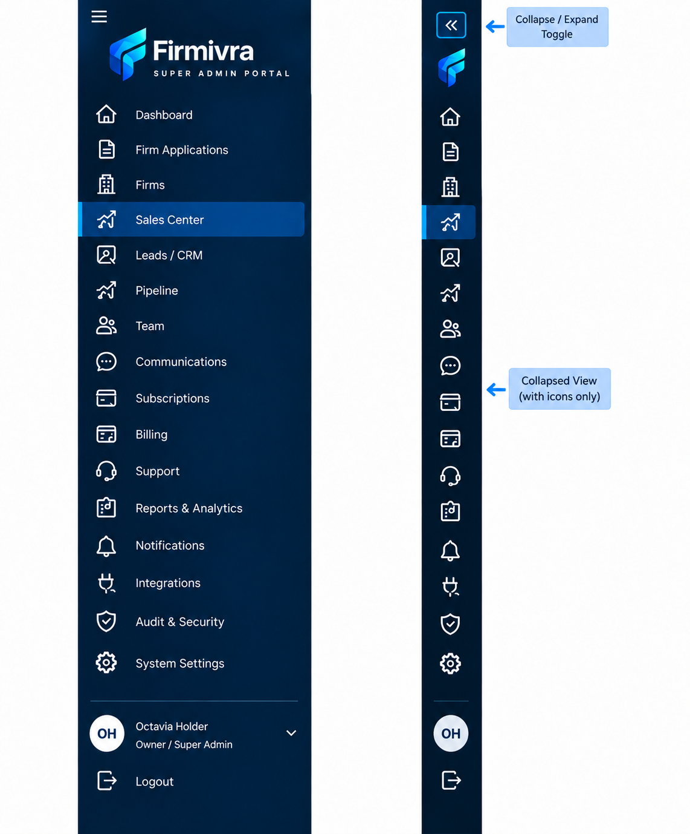
Purpose: define what the Super Admin system is, what each module must accomplish, how modules connect, and the minimum platform-wide behaviors required for a production-ready implementation.

1. Executive System Statement
Firmivra Super Admin Portal is the central control plane for operating the Firmivra platform. It is designed for the platform owner and authorized internal administrators—not for clients or ordinary firm users—to oversee the complete lifecycle of firms, users, revenue, support, communications, security, integrations, and global system behavior from one secure backend.
The Super Admin experience must operate as one connected administrative system rather than a collection of isolated screens. Every module should read from and write to shared system data in a controlled way, use consistent permissions, produce traceable status changes, and surface downstream effects in related modules.
The developer should treat this guide as the umbrella specification. Page-specific developer instructions define individual screens in detail; this guide defines the system-wide purpose, cross-module logic, role boundaries, and non-negotiable behavior that all of those screens must follow.
Objective | What It Means for Development
Centralized platform control | Give authorized Super Admins one place to oversee firms, users, subscriptions, revenue, support, communications, integrations, security, and settings.
Operational visibility | Provide current, reliable information about platform activity and business health, not static display data.
Controlled administration | Require appropriate permissions, confirmations, validation, and audit logging for sensitive actions.
Connected workflows | Ensure actions in one module create the correct updates in all related modules.
Scalability | Support growth in firms, users, plans, transactions, integrations, support volume, and reporting without redesigning the core administrative model.
Traceability | Maintain a defensible record of important administrative, security, billing, and configuration changes.

2. Administrative Audience, Roles & Permission Model
The Super Admin Portal must enforce role-based access control. A user should only see and perform the actions that their assigned role permits. Hiding a button in the interface is not sufficient; server-side authorization must also enforce the restriction.
Role / Actor | Required Boundary
Owner / Super Admin | Full platform-level authority subject to high-risk safeguards. Can manage firms, platform configuration, subscriptions, billing administration, integrations, security, and other Super Admins where permitted.
Super Admin Staff / Internal Admin | Delegated platform operations. Access must be permission-scoped by function, such as firms, support, billing, reporting, or communications.
Firm-Level Admin | Not a Super Admin role. Firm administrators should only access their own firm-facing application and data unless an explicit cross-portal administrative feature is designed.
Regular Firm User / Client | No access to the Super Admin Portal. Must never be able to reach platform-wide administration by URL manipulation or client-side changes.

Permission Principles
- Use least privilege by default.
- Protect high-risk actions such as account suspension, subscription overrides, refunds/credits, data deletion, integration changes, role changes, and security policy changes with stronger permission checks.
- Require confirmation for destructive or high-impact actions and show the consequence before the user confirms.
- Log material administrative changes with actor, timestamp, target record, previous value/state where practical, new value/state, and source context.
- Do not allow one firm to access another firm’s data through the Super Admin interface, APIs, exports, or search results unless the user has explicit platform-level authority.

3. Super Admin System Map
The sidebar is the primary system map. The following modules are part of the Super Admin Portal and must be treated as connected operational domains.
Module | System Responsibility
Dashboard | Cross-platform operating summary and action center.
Firm Applications | Intake, review, approval, rejection, and onboarding initiation for firms applying to join Firmivra.
Firms | Master firm account administration and lifecycle management.
Sales Center | Sales performance, conversions, targets, opportunities, and sales-related administrative visibility.
Leads / CRM | Central lead and prospect record management.
Pipeline | Stage-based workflow management for leads/opportunities.
Team | Internal Super Admin team administration and/or platform-side user administration as defined by the page specifications.
Communications | Platform-side email, messaging, announcements, templates, and communication records.
Subscriptions | Plan enrollment, plan status, renewals, upgrades/downgrades, entitlements, and subscription lifecycle.
Billing | Invoices, charges, credits, payment status, balances, billing exceptions, and financial administration.
Support | Firm/user issue management, case routing, history, escalation, and resolution tracking.
Reports & Analytics | Cross-module reporting, trends, operational KPIs, exports, and decision support.
Notifications | System alerts, Super Admin notifications, rules, delivery status, and actionable events.
Integrations | Third-party connection status, credentials/configuration references, sync health, and integration controls.
Audit & Security | Audit trail, security events, policies, access-related controls, and investigation support.
System Settings | Global backend configuration, branding, platform defaults, feature management, data/retention rules, maintenance, and default firm/user behavior.

4. Module-by-Module Functional Guide

Dashboard
Area | Developer Requirement
Purpose | Provide a current, consolidated view of platform health and immediately surface items requiring attention.
Must Display | Key metrics and actionable summaries from firms, applications, sales/CRM, subscriptions, billing, support, notifications, and security where applicable.
Connects To | Every operational module. Dashboard cards should deep-link to the relevant filtered record list or detail page.
Required Behavior | Data must be derived from source modules; card counts and totals must reconcile with the underlying records. Avoid duplicate calculations with inconsistent logic.
Key Flow | Login → review platform summary → identify exception/opportunity → open related module/detail → take action → dashboard reflects updated state.

Firm Applications
Area | Developer Requirement
Purpose | Manage prospective firm applications from submission through decision and onboarding handoff.
Must Support | Queue, search/filter, applicant details, document/status review, notes, approval, rejection, hold/request-more-information where defined, and decision history.
Connects To | Firms, Communications, Notifications, Subscriptions, Team/User provisioning, Audit & Security, Reports.
Required Behavior | Approval should create or activate the corresponding firm record and trigger the next onboarding steps; rejection should preserve a historical record and reason.
Key Flow | Application submitted → validation/review → decision → notifications → approved application creates/activates firm → onboarding/subscription setup.

Firms
Area | Developer Requirement
Purpose | Serve as the authoritative administrative record for each firm on the Firmivra platform.
Must Support | Firm profile/status, contacts, plan/subscription context, billing context, usage/entitlements, team/user summary, integrations, support history, notes, lifecycle actions.
Connects To | Applications, Subscriptions, Billing, Team, Communications, Support, Reports, Integrations, Audit & Security, System Settings defaults.
Required Behavior | Firm status changes must propagate to access/entitlements as defined. High-impact actions such as suspension or closure require confirmation and audit logging.
Key Flow | Open firm → review 360-degree record → perform authorized action → related modules update → action logged.

Sales Center
Area | Developer Requirement
Purpose | Give the Super Admin visibility into sales operations and revenue-generating activity.
Must Support | Sales metrics, conversions, targets/goals, opportunity performance, source performance, and drill-down where defined by page specs.
Connects To | Leads/CRM, Pipeline, Firms, Subscriptions, Billing, Reports & Analytics.
Required Behavior | Sales metrics should be computed from defined source records and use consistent date/status rules.
Key Flow | Review sales performance → drill into lead/opportunity source → follow pipeline state → conversion results in firm/subscription/billing activity where applicable.

Leads / CRM
Area | Developer Requirement
Purpose | Manage prospect records before they become active firms/customers.
Must Support | Lead creation/import, source, ownership, contact data, status, activities, notes, search/filter, deduplication strategy, and conversion.
Connects To | Sales Center, Pipeline, Communications, Notifications, Reports, Firms/Application records on conversion as applicable.
Required Behavior | One canonical lead record should drive pipeline and activity history. Conversion must preserve historical attribution.
Key Flow | Lead captured → assigned → contacted → activities recorded → pipeline stage updated → converted/lost → downstream records created/updated.

Pipeline
Area | Developer Requirement
Purpose | Represent progress of leads/opportunities through defined stages and make stalled or high-value work visible.
Must Support | Stage movement, owner, value/priority where applicable, date tracking, filters, stage totals, aging, and history.
Connects To | Leads/CRM, Sales Center, Communications, Notifications, Reports & Analytics.
Required Behavior | Stage changes must update metrics and retain history; invalid stage transitions should be prevented where business rules require sequencing.
Key Flow | Open pipeline → inspect stage/aging → move opportunity → save → CRM and sales metrics update → notification/workflow may trigger.

Team
Area | Developer Requirement
Purpose | Administer authorized people who operate the platform-side environment and/or provide the platform-side user directory defined in the detailed Team specifications.
Must Support | User identity, status, role, permission set, invitations/provisioning, deactivation, and access history as defined.
Connects To | Audit & Security, Notifications, Communications, Support, Firms where users are related, System Settings defaults.
Required Behavior | Role and permission changes must take effect promptly, be enforced server-side, and be logged.
Key Flow | Create/invite user → assign role/permissions → user activates → user operates within scope → changes/deactivation logged.

Communications
Area | Developer Requirement
Purpose | Provide a controlled platform-side communication capability and communication history.
Must Support | Templates, email/message creation, recipient targeting, delivery status, history, and system-generated communication references where page specs call for them.
Connects To | Applications, Firms, Leads/CRM, Pipeline, Support, Notifications, Subscriptions/Billing events.
Required Behavior | Messages must attach to the correct record/audience, respect permissions and opt-out/compliance rules where applicable, and preserve delivery history.
Key Flow | Trigger/manual compose → select template/audience → validate → send/queue → delivery result stored → related record displays history.

Subscriptions
Area | Developer Requirement
Purpose | Control plan membership, entitlements, renewal state, and subscription lifecycle for firms.
Must Support | Plan assignment, active/trial/past-due/canceled states, upgrades/downgrades, renewal data, plan history, entitlement references, administrative overrides with reason.
Connects To | Firms, Billing, Sales Center, Notifications, Reports, System Settings/feature entitlements, Audit & Security.
Required Behavior | Subscription state must govern plan-based access/entitlements; administrative overrides must be traceable and should not silently bypass billing logic.
Key Flow | Plan selected/assigned → billing relationship established → subscription active → renewal/plan change → entitlements updated → status and history retained.

Billing
Area | Developer Requirement
Purpose | Provide platform-level financial administration for firm charges, invoices, payment status, credits, and billing exceptions.
Must Support | Invoice/payment views, balances, transaction status, credits/adjustments where authorized, refunds if supported, failed-payment handling, billing history, export/reporting.
Connects To | Subscriptions, Firms, Notifications, Support, Reports & Analytics, Audit & Security.
Required Behavior | Financial values require strong validation and auditability. Changes to balances, credits, or payment-related records must never be client-side only.
Key Flow | Charge/invoice generated → payment succeeds/fails → billing/subscription statuses update → notifications/support actions may trigger → reports update.

Support
Area | Developer Requirement
Purpose | Track and resolve firm/user issues while preserving context and accountability.
Must Support | Case/ticket creation, category, priority, status, assignee, related firm/user, messages/notes, attachments if designed, escalation, resolution, timestamps.
Connects To | Firms, Billing, Subscriptions, Integrations, Communications, Notifications, Reports, Audit & Security where security-relevant.
Required Behavior | Support history must remain tied to the affected entity. Escalation/status changes should notify the correct internal owner.
Key Flow | Issue received → triage → assign → investigate using related module context → communicate → resolve/close → metrics update.

Reports & Analytics
Area | Developer Requirement
Purpose | Turn data across the Super Admin Portal into consistent operational and business intelligence.
Must Support | Defined KPI dashboards, filters/date ranges, drill-down, exports where appropriate, trend comparisons, and source reconciliation.
Connects To | All data-producing modules.
Required Behavior | Metric definitions must be centralized and documented. The same KPI must not have different formulas across Dashboard, Sales Center, and Reports.
Key Flow | Choose report → set filters/date range → query authorized data → display totals/trends → drill down/export.

Notifications
Area | Developer Requirement
Purpose | Surface actionable system events and route alerts to appropriate Super Admin users.
Must Support | Notification center, unread/read state, severity/type, related record link, preferences/rules as designed, delivery status for supported channels.
Connects To | Applications, Firms, Billing, Subscriptions, Support, Integrations, Audit & Security, System Settings.
Required Behavior | Notifications should be event-driven and deduplicated where necessary. Opening a notification should navigate to the correct context.
Key Flow | System event occurs → rule evaluates → notification created/routed → admin opens → linked record/action → state updated.

Integrations
Area | Developer Requirement
Purpose | Administer and monitor external services connected to Firmivra.
Must Support | Connection state, enable/disable where allowed, configuration references, credential handling through secure secret storage, sync status/errors, test connection/reconnect where applicable.
Connects To | Modules consuming integration data, Notifications, Support, Audit & Security, System Settings.
Required Behavior | Never expose secrets in plaintext after storage. Integration failures must be visible and recoverable without corrupting core records.
Key Flow | Configure/connect → validate credentials → sync/use service → monitor health → error triggers alert/support → reconnect/update configuration.

Audit & Security
Area | Developer Requirement
Purpose | Provide traceability, security oversight, policy control, and investigation support across the platform.
Must Support | Audit events, event detail, security policies/settings, access/security alerts, filtering/search, retention consistent with policy, and investigation context.
Connects To | Every module that performs sensitive, administrative, authentication, authorization, financial, data, or configuration changes.
Required Behavior | Audit records should be tamper-resistant in normal admin workflows and should not be editable like ordinary business records.
Key Flow | Sensitive event occurs → audit/security event written → policies/rules may trigger alert → Super Admin investigates → remediation/action also logged.

System Settings
Area | Developer Requirement
Purpose | Maintain Firmivra’s global backend behavior and defaults. This is platform administration, not client-facing content management.
Must Support | General settings, branding/appearance, email/notification defaults, feature management, data & retention, system configuration & maintenance, default user & firm settings.
Connects To | All modules that consume global settings/defaults; Audit & Security for material changes.
Required Behavior | Settings must be permission-gated, validated, versioned/history-aware where appropriate, and applied consistently. Firm/user overrides must follow a clear inheritance model.
Key Flow | Open settings area → review/edit → validate → confirm high-impact change → save → system applies new configuration → audit entry created where applicable.

5. Core Cross-Module Workflows
Workflow | Expected End-to-End Flow
Firm onboarding | Firm Application → review/decision → approved Firm record → subscription/plan setup → billing relationship → initial users/team setup → integrations/default settings → active firm → dashboard/reporting visibility.
Lead-to-customer conversion | Lead/CRM → pipeline progression → sales conversion → firm/application record as business rules require → subscription → billing → revenue/reporting updates.
Payment failure | Billing failure → billing record status → subscription status/risk logic → notification → firm/support follow-up → successful recovery or suspension/cancellation according to policy → all actions audited.
Support escalation | Support ticket → related firm/user/billing/integration context → assignment/escalation → communications → resolution → support metrics/reporting → audit/security handoff if issue is security-relevant.
Security investigation | Security/audit event → notification/alert → event detail → identify actor/target/related records → corrective action in relevant module → corrective action itself logged.
System setting change | Authorized Super Admin → settings edit → validation/confirmation → apply global/default change → affected modules consume new value → audit record → optional notification if high impact.

6. System-Wide Functional Requirements
Requirement | Minimum Expected Behavior
Authentication & Session Security | Secure login/session handling; revoke access when users are deactivated or permissions materially change; follow the security specification for MFA/session policy if enabled.
Authorization | Enforce permissions on both UI and backend/API layers. Never rely on hidden buttons as the only control.
Search | Search should target meaningful fields, return only authorized records, handle partial input where designed, and have a predictable no-results state.
Filters | Filters must be combinable where useful, clearly visible when active, resettable, and reflected in exports/counts.
Sorting & Pagination | Large lists require stable sorting and scalable pagination or virtual loading; totals must remain accurate.
Record Detail Views | Detail pages should provide enough context to act without unnecessary navigation and should link to related entities.
Statuses | Use controlled status values, visible labels, documented transitions, and downstream rules. Avoid free-text statuses.
Validation | Validate required fields, formats, dependencies, and business rules on the backend as well as the UI.
Confirmations | Destructive or high-impact actions need explicit confirmation that states the effect.
Success / Error Feedback | Every save/action needs a clear result. Errors should be actionable and must not falsely imply success.
Notifications | Generate alerts from defined events; link them to the underlying record/context.
Audit Logging | Log sensitive and material actions consistently across modules using a shared event approach.
Exports | Exports must obey permissions and active filters, use stable columns, and avoid exposing unauthorized data.
Date & Time | Store timestamps consistently (prefer UTC internally) and display them using the relevant configured/user timezone. Preserve exact event time in audit/billing records.
Data Integrity | Use canonical record IDs and relationships. Avoid duplicate copies of authoritative values that can drift.
Concurrency | Prevent silent overwrites when multiple admins edit the same sensitive record where practical; detect stale updates for configuration/high-value records.
Accessibility | Use semantic labels, keyboard navigation, sufficient contrast, focus states, and table/form accessibility appropriate to a professional admin application.
Responsive Admin UI | Primary workflows must remain usable at supported desktop/tablet widths; collapsed sidebar state must preserve navigation meaning and tooltips/accessible labels.

7. Data, State & Integration Principles
Principle | Implementation Expectation
Single source of truth | Each core entity (firm, user, subscription, invoice/payment, lead, support ticket, notification, audit event) should have an authoritative record rather than competing copies.
Event-driven updates | When an action should affect multiple modules, prefer a defined service/event workflow so all consumers update consistently.
Idempotency | Payment webhooks, integration callbacks, imports, and retryable background jobs should not create duplicate outcomes when the same event is received more than once.
Background jobs | Long-running syncs, exports, batch communications, reports, and integration tasks should run asynchronously with visible status/error handling rather than blocking the UI.
Secret management | Credentials, tokens, API keys, and sensitive integration secrets belong in secure secret storage; never expose them back to the UI in full.
Soft delete / archival where appropriate | Business records with historical, billing, audit, or compliance value should generally be archived/deactivated rather than hard-deleted unless policy explicitly permits deletion.
Retention | Data retention rules should be governed through the approved policy/settings layer and must not silently remove records required for audit, billing, or security history.

8. Global Settings and Inheritance Model
System Settings define platform-wide behavior and defaults. The implementation must distinguish between a global default and a firm/user-specific override. A change to the global default should not silently overwrite an explicit override unless the product requirement specifically says it should.
Condition | Expected Resolution
No override exists | Use current global/default value.
Firm override exists | Use firm override for that firm; preserve it when the global default changes unless reset is explicitly requested.
User override exists and is allowed | Use user override within the boundaries allowed by policy and firm settings.
Feature disabled globally | Firm/user settings cannot enable it unless an explicit exception mechanism exists.
Security policy is mandatory | Firm/user preferences cannot weaken the enforced minimum.

9. Navigation & Sidebar Behavior
Navigation Area | Required Behavior
Expanded sidebar | Show icon + module label; clearly highlight the active module.
Collapsed sidebar | Show icons only while preserving accessible names/tooltips; active state remains visible.
Collapse/Expand toggle | State should update predictably and may persist per Super Admin user/device if that behavior is desired.
Deep links | Opening a direct detail URL should load the correct module context and permissions without requiring a prior navigation sequence.
Breadcrumbs / context | Use page titles and/or breadcrumbs where a user can move multiple levels deep so the current location is always clear.
Logout | Terminate the authenticated session and prevent the browser back button from restoring protected content without re-authentication.

10. Developer Non-Negotiables
- Pages are not considered complete because they visually match a mockup. Controls, data, permissions, states, actions, and cross-module effects must function.
- Do not hard-code production metrics, counts, names, statuses, billing values, or report totals. UI examples are placeholders unless explicitly defined as static content.
- Do not implement isolated mock data per page when the same entity exists elsewhere. Related screens should resolve to the same underlying record.
- Do not expose Super Admin routes or APIs to ordinary firm users.
- Do not store secrets, payment credentials, passwords, or access tokens in client-side code, browser storage, logs, or readable database fields.
- Do not allow destructive/high-risk actions without authorization, validation, confirmation, and appropriate audit logging.
- Do not change a subscription, billing record, security policy, permission set, or global setting without ensuring the downstream state is updated consistently.
- Every major list page must define loading, empty, error, no-results, and permission-denied states—not only the ideal populated state.
- Every integration/webhook/background task must have retry/error behavior and a way for administrators to understand failure state.
- Reporting and dashboard metrics must use shared definitions that can be reconciled to underlying records.

11. System-Level Acceptance Checklist
Area | Acceptance Standard
Navigation | All sidebar modules route correctly in expanded and collapsed states; active state is correct; deep links enforce authorization.
Permissions | Role restrictions are enforced in the backend; unauthorized direct API/URL access is denied.
Firm lifecycle | Application approval can produce the intended firm/onboarding state and all linked modules reflect the change.
CRM/Pipeline | Lead stage and conversion changes reconcile across CRM, Pipeline, Sales, and Reports.
Subscriptions/Billing | Plan, billing, and entitlement states stay synchronized under success, failure, upgrade, downgrade, cancel, and administrative exception scenarios.
Support | Tickets link to correct firms/users and can be assigned, escalated, resolved, and reported.
Notifications | Defined system events create the right notification for the right administrative audience with a working context link.
Integrations | Connection state, failure state, reconnection, and secret protection are verified.
Audit & Security | Sensitive actions generate traceable audit events; audit records are not normally editable/deletable by operators.
System Settings | Authorized changes apply correctly, respect inheritance/overrides, and are auditable where material.
Reporting | Dashboard and report metrics reconcile with source records for the same filters/time window.
Error States | Critical flows are tested for validation errors, API failures, timeouts, duplicate callbacks, and partial failures.

12. Recommended Implementation & QA Sequence
1. Establish identity, authentication, roles, permissions, firm/user data model, and shared status/event conventions.
2. Build navigation shell and common components (tables, filters, detail panels, confirmations, notifications, audit event writer).
3. Implement Firms + Firm Applications and validate onboarding flow.
4. Implement CRM / Pipeline / Sales Center using shared lead/opportunity records.
5. Implement Subscriptions + Billing together so financial and entitlement state remain synchronized.
6. Implement Support, Communications, Notifications, and cross-record linking.
7. Implement Integrations with secure secret handling and sync/error observability.
8. Implement Audit & Security and confirm all high-risk modules emit required events.
9. Implement System Settings and global/default inheritance behavior.
10. Implement Dashboard and Reports after source modules are stable so metrics are based on production data contracts.
11. Run system-level QA across end-to-end workflows, permission boundaries, failure states, and reporting reconciliation.

13. Final Product Standard
Firmivra Super Admin Portal should function as the operating system for Firmivra’s platform administration: secure, connected, traceable, and operationally reliable. An authorized Super Admin should be able to understand what is happening, open the relevant record, take an authorized action, and trust that related modules update correctly.

