Introduction
In these last couple of decades, many developing countries around the world have experienced an increase in population levels, growth in economy and a growth in urbanization. This has greatly affected the generation of municipal solid waste (MSW) and at the same time put pressure on municipalities of many urban cities for a provision of better waste-management services. However a lot of cities experience great waste management problems that pose a challenge to municipal authorities due to lack of organization, financial resources complexity and system multi dimensionality (1, 2, 3).
India, particularly the national capital territory of Delhi, has been experiencing the consequences of poor waste management. Due to lack of service provision by the municipal authorities, waste is piled up on streets, left uncollected in community dustbins (Dhalaos), dumped uncontrollably in landfill sites or just burned out in the open on the streets. These practices create a lot of risks which include: disruption of public health, environmental disasters and environmental degradation (4, 5)
The Centre for science and environment India (CSE) is a public interest research and advocacy organization. CSE researches into, lobbies for and communicates the urgency of development that is both sustainable and equitable, with the aim to raise concerns in environmental “issues” and rapid industrialization. In this particular issue (MSW in Delhi) they play a key role in raising awareness and proposing a sustainable solution that not just replaces the current MSW system, but aids in transforming it into one that is suitable for Delhi
In providing alternative solutions for Delhi’s current municipal solid waste management (MSWM) system, a research project was conducted on the current system of waste management and Decentralized waste management systems, with the help of a “volunteer intern” from Avans Hogeschool Breda, Netherlands.

Goal
The Goal of the project is to provide within a time period of 20 weeks a research report which will include the following information:
A literature review on the Current waste management practices in India, particularly: Generation of MSW, composition, services, limitations and consequences and legislation.
A literature review on the Status of Municipal Solid Waste Management in Delhi: Generation of MSW, Composition, Legislation, Stakeholders Involved, Waste management Flow scheme and Expenditure
Research and documentation on case studies related to Decentralized waste management: Explaining the need of decentralized waste management, an analysis of implementation which must include the technological and financial approach of the system.

Boundaries
The research project will focus solely on decentralized waste management systems and the existing technologies associated in aiding the successful development of these systems. Next, research will cover all the aspects in this territory (economic, social, and technological). Furthermore, the research will only cover aspects that are applicable and suitable to Delhi.

Reading guide
First, Chapter 2 of this report will give an introduction to the status of MSWM in India, it will cover the following topics:
- Generation of MSW
- Composition of MSW
- MSW treatment and services
- Limitations and consequences
- Legislation
Second, chapter 3 will focus on the current MSWM system in Delhi and will present information on the following topics:
- Generation of MSW
- Composition of MSW
- Legislation framework
- Stakeholder involved in the MSWM
- Flow Scheme of MSW
- Financial analysis of MSWM
Thirdly, chapter 4 will present the case studies on decentralized waste management schemes in Delhi and in other countries around the globe, topics will include:
- Local Case studies
- International Case studies
And finally, chapter 5 will conclude findings of the research project and give an advice on the most suitable scenario of waste management for Delhi.

status of Municipal solid waste management in India
India, known as the second largest nation (population wise) in the world, has a growing populous of over 1.2 billion. In the last decade alone the population has experienced an increase of about 17.7 % (more than 181 million). The biggest increase was observed – from analysis of the census India 2011 data - in the urban population (about 31.8 %).
Even though the “average growth rate” of the population is declining, the urban population is growing. In fact analysis of data provided by the World Bank, shows that in the past three decades alone India’s urban population has increased with about 252 million (see figure 1).
“Metropolitanization” has been observed by experts, to be one of the main drivers of “urbanization” of Indian Cities, it seems the major contributing factor to urban growth is the migration of people in search for work. from rural areas to urban cities (6).

Figure 1 Population and urbanisation trend

MSW GENERATION
It has been observed that there is a relationship between generation and growth in GDP municipal solid waste (MSW) (gross domestic product) (7). A growing population, a growing economy and a change in lifestyles and consumption patterns, has resulted in an increase in waste generation in the country (8, 9). Furthermore, the MSW generation in India has increased from about 24 million tons per/year, to about 62 million tons per year (10) (see fig 2). Projected data also shows a further exponential growth of MSW in India of about 160 million tons in the coming 3 decades, that is a three-fold increase (see fig 3).

Figure 2 MSW and GDP trend in India (4) Figure 3 Projected MSW in India (4)

msw COMPOSITION
Population growth, economic growth and “metropolinization” have also aided in the growth in complexity of the MSW (11). For example, the MSW generated in India in 1971, was comprised of small amounts of plastic (0.7%), paper (4.1%) and metals (0.4%), whereas in 2005, these materials have increased to approx. 9.22 % plastic, 8.18 % paper and 1.01 % metals (10) (see fig 4). Furthermore, it can also be observed from figure 4 that the Biodegradable waste has been steadily declining.

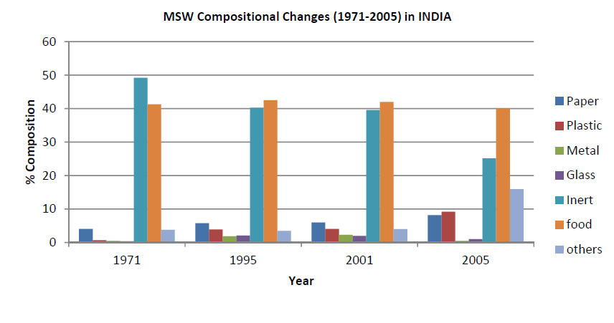
Figure 4 Compositional changes in India's MSW (10)

MSW Treatment and services
The continuous increase in MSW has not been proportionate with the expansion of civic services and therefore, tremendous pressure has been put on the provision on civic cervices (9). Hence, India has been experiencing an accumulation of MSW at every “nook and corner” of its cities since, the provision of waste management services – which includes: collection, transportation treatment and unscientific disposal of MSW- has been largely inconsistent and poor (8).
According to CPCB (central pollution control board) in the period of 2008-2009 MSW collected in some major cities across India was on average around 80 %. In the period of 2012, around 70 % of the total MSW generated in India was collected and in 2014 that number was around 80 %. Furthermore, in 2012 12, 5 % of the total MSW generated in India was treated and the same was observed for the period of 2014 (see fig 5).
Most of the waste generated in Indian cities and towns is disposed of in community dumpsites, dumped on the streets or unscientifically (openly) disposed of on landfills (about 90 % of MSW generated) (12, 13). In 2014 there where a total of 91 landfills constructed, of these landfills, around 71 landfills are exhausted of which most of them are still used today as dumping sites (See ANNEX I).
Despite fairly high financial expenditure on MSW in India, the service level is very low. This is due improper investment in MSW management (14)

Figure 5 status of MSW management in India

limitations and consequences
Improper solid waste management (open dumping) can have serious consequences on human health and the environment. A 1999 report from the Urban Development Sector Unit East Asia and Pacific Region (15) revealed that these consequences include:
- Air pollution (see fig 6)
- Water pollution (see fig 7)
- Soil pollution
- Stagnant water creates a perfect environment for insect breading, due to clogged drains (see text Box 1)
Text Box 1 Case study of Surat, 1994
- Floods during rainy seasons (see text Box 1)
In the decades leading to 1994, Surat witnessed an increased growth in its populous, this growth was not effectively met with the infrastructure necessary for the adequate provision of waste management services. As a consequence, in 1994, unmanaged MSW clogged the rainwater drains and that resulted in major flooding that brought with it a plague like epidemic that victimized 693 people and killed 56. It was the worst epidemic, experienced in the country in decades. (42)
- Greenhouse gasses emitted from decomposing organic waste on landfills (see fig 8)
- Spread of diseases like cholera and dengue, through insect and rodent vectors attracted by MSW (see text Box 1)
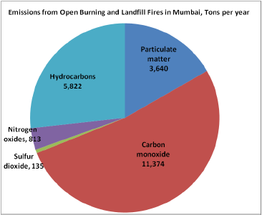
- Health issues linked to improper waste management: Nose throat infections, lung infections, Breathing problems, infection, inflammation, high PM10 exposure, high pollution load, bacterial infections, obstruction of airways, elevated mucus production, covert lung hemorrhage, chromosome break, anemia, cardiovascular risk, altered immunity, allergy asthma and other infections

Figure 6 Open Burning of MSW and landfill fires Releases 22,000 tons per year of CO, HCs, PM, NOx, and SO2 into Mumbai’s Lower Atmosphere (4)
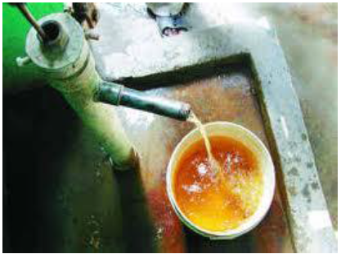
Figure 7 Polluted Groundwater from a resettlement colony in Bhalswa, Delhi
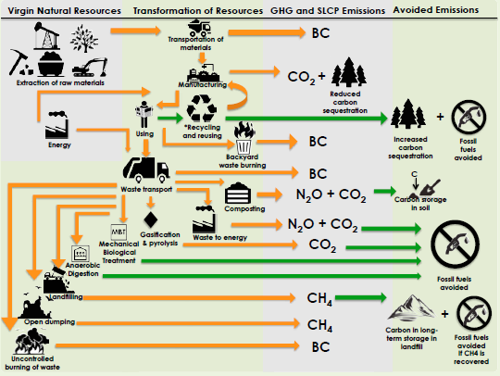
Figure 8 Schematic of Waste management and Climate Change

leGISLATION
Legislation on MSW in India has taken shape in different steps. Firstly, the fourth 5-year plan laid down by the Government of India (GoI) in 1969 paved way for improving MSW management by establishing better facilities for MSW, through loans and grants aimed at constructing MSW composting facilities. In 1975 a high-level committee, appointed by the GoI, reviewed the problem of MSW in India and made 76 recommendation covering over 8 MSW management areas. Furthermore, the national scheme (1975-1980) of solid waste disposal led to the set-up of 10 mechanical composting plants in several Indian cities with populations over 300.000 (16, 17). However, at present these facilities are either non-operational or their operation is limited due to issues related to: quality of the waste, technology, production, distribution, management and planning (17, 18). Yet, in the recent decade, centralized and decentralized composting projects have been set up and assessment of the technical, operational, organizational, financial and social factors of these projects showed that composting could be a viable MSW management option in large and small towns, given their economic and environmental benefits (19, 20, 21).
Secondly, the National Waste Management Council (NWMC), constituted in 1990, by the Ministry of Environment and Forests (MoEF), analyzed the quantity and waste flow of 22 municipalities and constituted in 1993 a national plastic waste management task force which would suggest measures to minimize adverse environmental and health impacts related to plastic recycling. The recommendations of task force, formed the bases for The MoEF's; draft Recycled Plastic Usage Rules 1998, which bans the storage, carriage packaging of food items in plastic bags, it also set specific quality standards for the manufacturing of recycled plastic bags.
Thirdly, as a consequence of the incident in Surat (see box 1) a high powered committee (bajaj committee) was constituted to review urban solid waste management. Their suggestions included: the need for source segregation, community based door-to-door collection and transportation, charging user fees, standardization of design of municipal vehicles for transportation, the need for composting and use of appropriate technologies for treatment and disposal
Next, a public interest litigation - filed in 1996 by the Supreme Court of India - against the GoI, state governments and municipal authorities, for failure to perform their MSW management duties led to the formation of an expert committee (Asim Burman committee) in 1998. This committee analyzed and submitted a report in 1999 to the Supreme Court, which included detailed recommendations on the improvement of MSW management in Class I cities. These recommendations where then incorporated into the Municipal Solid Waste (Management and handling Rules) 2000 which was notified by the MoEF. The MSW rules 2000 laid down the framework of successful waste management practice for urban local bodies. It describes the responsibilities of all the governmental bodies (Urban local bodies, Central- and State- Pollution Control Boards/Committee’s and Urban Development Departments) in the provision of MSWM services.
Also, a deadline/schedule was mandated to ensure the completion of the implementation of the MSW Rules (see table 1).However, a book on the improvement of MSW management in India, revealed that these deadlines had not been met and that compliance to the MSW Rules was far from reached. Alongside the MSW Rules 2000, the GoI and state governments have drafted several other rules to deal with MSW management (see table 2).
Lastly, an implementation guide/manual was published by the Central Public Health Environmental Engineering Organization (CPHEEO) under guidance of the Ministry of Urban Developement (MoUD), this guide was created to assist Municipalities in the implementation of the MSW rules 2000.
While there have been consistent efforts from regulatory bodies and directives from the supreme court of India, the implementation of the MSW management and handling rules have remained poor (22). A Study conducted in 2004 on the status of compliance with MSW Management and Handling Rules 2000 by Class I cities and t revealed that there has been insignificant progress in some of the activities related to the rules (See figure 9). It was also noted in a 2006 report on India’s infrastructure, that waste management was overall very poor (23).
Presently a draft has been issued by the MoEF – now referred to as Ministry of Environment Forest and Climate Change (MoEFCC) - has issued a draft of “Waste Management Rules 2015” which represents an improved version of the MSW Rules 2000, However the final version of these rules still remain to be published, adopted and put into force.

Table 1 Implementation Schedule I, MSW Rules 2000
Criteria | Completion date
Set up waste processing and disposal facilities | December 2003
Monitor the performance of processing and disposal facilities | Once every 6 months
Improve existing landfill sites as per provisions of rules | December 2002 or earlier
Identify landfill sites for future use and make sites ready for operation | December 2002 or earlier

Table 2 Other Acts and Rules related to MSW management (22)
Act and Rules |  | Brief description | Issue
Municipal Solid Waste (Management and  Handling) Rules, 2000 | Set criteria and procedure for municipal authorities for collection, segregation, storage, transportation processing and disposal of MSW  The criteria and procedure for management and handling of MSW are specified in schedule II, specifications for landfill sites in schedule III and setting up of waste processing facilities with the adoption of appropriate technology in schedule IV |  | MoEF, Government of India
The Delhi plastic bag (Manufacture, Sales and  Usage) And Non-Biodegradable Garbage  (Control) Act, 2000 | Prevents manufacturing, sale, etc. of recycled plastic bags for food packaging and also prohibits throwing or depositing non-biodegradable garbage in public drains, roads and places open to public view  Act also defines that the placement of receptacles and places for deposit of garbage is the responsibility of MCD, NDMC or CDB |  | Legislative Assembly of the National Capital Territory of Delhi
Hazardous Wastes (Management and Handling)  Rules, 1989 and Amendment Rules, 2000 and  2003 | Specify the processes, hazardous wastes, constituents,  Concentration limits and waste applicable for import and export.  The occupier should take responsibility for proper management and handling of waste either himself or through the operator of a facility  The different categories of hazardous waste are specified in  schedule 1 |  | MoEF, Government of India
The Bio-Medical Waste (Management and Handling) Rules, 1998 and Amendment Rules,2003 | Recommended treatment and disposal options according to the 10 different categories of biomedical waste generated are defined in schedule 1 of the rules. Standards for the treatment technologies are given in schedule V |  | MoEF, Government of India
Delhi Municipal Corporation Act, 1957 | Early legislation, deals with the environment pollution caused by MSW  The provisions related to MSW are defined under chapter 3  ‘Functions of the Corporations’ and chapter 7 ‘Sanitation and  public health’ |  | Act of Parliament,  Government of India
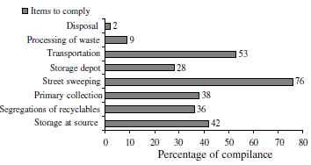
Figure 9 Status of compliance of MSW Rules 2000 by Class-1 cities (24)

Current Status on MSW management in Delhi
As the National (northern) Capital District of India, Delhi is the largest city area-wise (573 mi²), with its own legislature, high court and an executive council of ministers headed by a Chief Minister. In total Delhi has five municipal bodies that govern the state namely: North-, East- and South- Delhi Municipal Corporation- used to be known as the Municipal Corporation of Delhi (MCD)-, the New Delhi Municipal Council and the Delhi Cantonment Board (see fig 10 & table 3 and ANNEX II). According to census India 2011, together, these local municipal bodies govern a (growing) population of about 17 million persons.
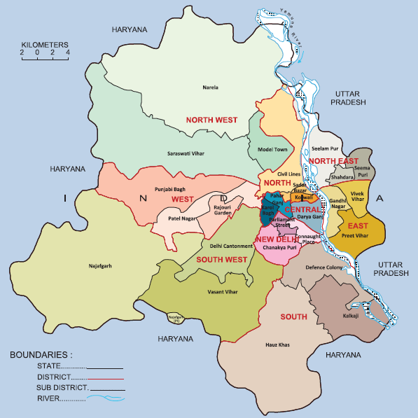
Figure 10 NCT of Delhi, Administrative divisions (2011)
Table 3 The Municipal authorities of Delhi with respected districts of governance (25)
Municipal council | District of governance | Population density per km²
North Delhi Municipal Corporation | Central, North and North West Districts | 13200
South Delhi Municipal Corporation | South, West, South West and South East Districts | 8525
East Delhi Municipal Corporation | East, North East and Shahdra Districts | 37743
New Delhi Municipal Council | New Delhi District | 10514
Delhi Cantonment board | Delhi cantonment area | 3023

Generation of MSW
Currently the NCT of Delhi is generating around 8000 TPD of MSW (see fig 11), with EDMC and NDMC generating the highest amount of MSW per capita, this is most likely due to EDMC being the most densely populated area and NDMC being a high income area. It is important to note that in the past decade alone MSW has increased with about 56% (see fig 12) and according to Delhi master plan 2021 the current amount is projected to increase to around 15750 TPD (a 70% increase). A 2008 study on the state of municipal solid waste in Delhi, revealed that the projected figure of MSW generated, will be between 84% - 170% in 2021 (22).

Figure 11 Current MSW generation in Delhi, in tons/day (TPD) and gram/person/day

Figure 12 Delhi's MSW generation in correlation with population growth (5)

Composition of MSW
There are different types and sources of MSW generation (see table 4). As per a 2007 study on MSW in Delhi (22), a survey was conducted in some municipal areas around Delhi and identified the composition waste of different MSW generation sources. From the data it was concluded that high- and middle-income groups produced the highest amount in recyclables (see table 5). Though the moisture content of MSW among all the different sources was relatively the same, it was still high enough to assume that the composition waste consisted mostly of biodegradable waste (between 58-78 %).
Table 4 Sources of MSW generation (26)
Types | Source
Domestic waste | Household waste comprising kitchen, house cleaning, old papers, packaging, bottles, crockery waste, furnishing materials, garden trimmings etc.
Commercial waste | Waste generated at business premises, shops, offices, markets, departmental stores (paper, packaging material, spoiled, discarded Goods), organic, inorganic, chemically reactive and hazardous waste.
Institutional waste | Schools, colleges, hospitals, large hotels, and restaurants, markets selling vegetables, fruits, fish, etc., community halls, religious places etc.
Street weeping | Unconcerned throwing, littering made by pedestrians, traffic, vehicular traffic, stray animals, road side tree leaves, rubbish from drain cleanings, debris, etc.
Industrial waste | Manufacturing and material processing trade generated waste
Construction and Demolition | Frequent digging of roads by various utilities comprising earth, brick, stones, wooden logs, etc.
Waste-offal, Dead animals etc | Offal waste generated from slaughter- houses, food, packing institutions and cold storage.

Table 5 Composition (as wt. %) of MSW generating from various sources in Delhi and its calorific value (22)
 | Typical distribution of components in MSW (average)
 | Residential waste
Parameters | Low income group | Middle income group | High income group | JJ Clusters (Slums) | Vegetable markets | Institutional areas | Streets | Commercial areas | Landfills
Food waste | 58.4 | 76.6 | 71.9 | 69.4 | 97.2 | 59.7 | 28.4 | 15.6 | 73.7
Recyclables | 15.7 | 21.2 | 23.1 | 14.1 | 2.3 | 33.8 | 12 | 68 | 9.2
Inert | 22.8 | 0.5 | 0.3 | 15.8 | 0.5 | 4 | 56.1 | – | 10.8
Others | 3.1 | 1.7 | 4.7 | 0.7 | – | 2.5 | 3.5 | 16.4 | 6.3
Moisture | 54 | 65 | 59 | 63 | 76 | 50 | 19 | 18 | 47
Ash content | 21.8 | 6.3 | 10.9 | 15.6 | 3.3 | 6.7 | 56.7 | 8.8 | 15.3
C/N ratio | 39 | 30 | 31 | 46 | 16 | 35 | 51 | 158 | 38
Lower CVa (kcal/kg) | 754–2226 | 732–1939 | 1300–1887 | 204–1548 | 0–1309 | 129–3778 | 1007–2041 | 1815–4593 | 191–4495
Higher CVa (kcal/kg) | 2238–4844 | 3415-6307 | 4503–5359 | 1582–4912 | 3083–4442 | 2642–5459 | 1188–3289 | 3373–6185 | 2042–5315

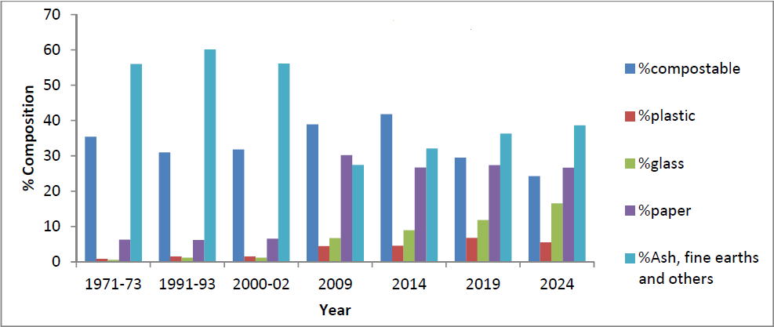
Figure 13 Composition of municipal solid waste in Delhi (10)
It has also been noted and observed in a 2012 review on MSW in India, that the percentage of plastics glass and paper in MSW has increased and is projected to increase even more until 2024 (see figure 11). This signifies that there will also be an increase in the demand for facilities required for processing these recyclable materials. Furthermore, a 2004 report on the feasibility of and a master plan for optimal waste treatment in Delhi, found that the waste produced from all the different sources around Delhi, was more suitable for biomethanisation or composting(27).

Legislation framework
The MSW (management and handling) Rules 2000, describes the exact responsibilities of governmental bodies on the central, state and local level (see table 6). In Delhi, these governmental bodies include: the Municipal Corporation of Delhi (MCD), New Delhi Municipal Council (NDMC), Delhi Cantonment Board (DCB), Delhi Pollution Control Committee (DPCC), the Department of Urban Development and the District Magistrate.
Table 6 Responsibilities of Governmental bodies under the MSW Rules, 2000⁹
Governmental Body | Responsibility
Central Pollution Control Board | Overlook coordination between state pollution control boards/committees in reference to implementation, review of standards and guidelines, compile monitoring data in annual review reports
Delhi Pollution Control Committee | Examine and authorize proposals from municipalities for waste treatment and or processing facilities.  Monitor compliance to standards regarding groundwater, ambient air, leachate quality compost quality and incineration standards.  Submit annual reports with regard to implementation of MSW Rules.
MCD, NDMC and DCB | Implementation of provisions of MSW Rules 2000.  Provide infrastructure and services with regard to collection, storage, segregation, transport, treatment and disposal of MSW.
Department of Urban Development | Enforcement of provisions MSW Rules 2000 in metropolitan cities.
District Magistrate | Enforcement of provisions MSW Rules 2000 within the territorial limits of their jurisdiction

Status of implementation of MSW Rules 2000 in Delhi
There are still many challenges that Delhi faces with regard to the implementation of the MSW Rules 2000, these include:
- Even with all the facilities and workforce for waste management in place, 15-20 % of the total MSW is left unattended
- Only a few zones Delhi, are covered for door-to-door collection in
- Households still openly dump waste onto roads, streets, parks etc.
- Provided dustbins are of very low quantity and not properly maintained
- Community Dustbins are not cleaned regularly
- Source segregation is still very minimal
- Transportation trucks are very old and there exist no proper transport routes
- Waste is not properly disposed of at landfill sites since there is a lack of sand layering
- Only 7-8 % of the total MSW waste is processed
The poor implementation of the MSW Rules 2000, was observed to be the direct result of inconsistent service of waste management at the local level. An inspection report (2005) on the status of MSW in Delhi, done by CPCB, revealed the intensity and consequences of poor service, delivered by municipal corporations in Delhi, by inspecting the conditions of the waste receptacles (dhalaos) of each governed area (see table 7). The reasons behind these discrepancies was also noted and these included:
- Lack of loaders for MSW management in MCD areas
- Irregular cleaning of receptacles
- Poor trained, loader operators
- MCD composting at Okhla and Bhalswa did not have clearance of DPCC and thus operated below capacity
- Iron trolleys for collection and transportation where in bad condition
Although there the service level of waste management was mostly poor in MCD Areas, areas of other municipalities like DCB and NDMC where showing some progress (28).
Table 7 status of waste receptacles in Delhi (28)
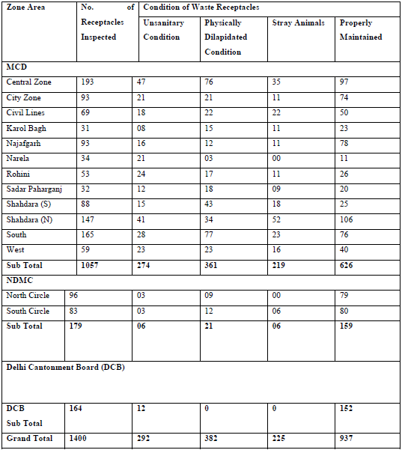

As for the implementation schedule I of the MSW rules 2000, Delhi is far from meeting the deadlines. And annual report by the Delhi Pollution Control Committee (DPCC) showed that none of the schedule I criteria have been realized within the laid down deadlines. Three of the criteria have been met but are not fully realized and one of the criteria has not been met yet (see table 8). It is important to note that it’s been a decade already since these deadlines have been laid down. This goes to show how negligible MSW management in Delhi really is, this fact has also been concluded in a study by the Centre for Science and environment (5).
Table 8 Status of implementation of Schedule one of MSW rules 2000 in Delhi
criteria | Completion date | Status
Set up waste processing and disposal facilities | December 2003 | - Compost plant at SLF Bhalaswa having a capacity of 500 MT of MSW per day has been closed by DPCC since 28.3.2014  - Integrated waste processing/disposal facilities at Narela-Bawana having capacity of 1500 TPD is working  - Construction and demolition (C&D) plant of 2000 MT per day at Burari is working  - Compost Plant at Okhla having capacity of 200 MT per day is working  - WTE plant Okhla having capacity of 1950 MT of MSW per day is working
Monitor the performance of processing and disposal facilities | Once every 6 months | Already conducted
Improve existing landfill sites as per provisions of rules | December 2002 or earlier | Being processed
Identify landfill sites for future use and make sites ready for operation | December 2002 or earlier | Status report is same as per annual report for the year 2012-2013

Delhi Master plan 2021
Delhi Master 2021, is a plan for Urban Development developed by the Delhi development authority with the stated vision to “make “Delhi a global metropolis and world-class city”, wherein people resources would have conductive atmosphere and infrastructure to conduct themselves in productive work with a better quality of life, living in a sustainable environment.
In this master plan a time schedule for the implementation of treatment and disposal activities –which include the infrastructure for technologies need in MSW management- in MSW management has also been laid down. It serves as a format that can be taken over by Municipal Corporation and used for monitoring purposes.
The treatment and disposal activities are constructed in an action plan which is dived into the following three phases:
- The short-term period 2005-2009 (years)
- The medium-term 2010-2014
- The long-term period 2015-2024
The plan focuses more on the implementation rather than engaging to much in details and interlinkages between tasks. The plan states what the municipal will have accomplished in the periods its describes, however it does not describe how the municipality will goes about achieving those set targets. Table 9 & 10 give an overview of the stated targets of the Delhi master plan.

The plan goes further to estimate the required and availability of area and land that is needed for the implementation of all these targets.
Furthermore, the implementation phases described in the master plan, require investments which the municipalities need to either internalize or through an investor (private player) (28). Tables 11 and 12 give a overview of the assumptions of a 2004, “feasibility study and master plan for optimal waste treatment and disposal for the entire state of Delhi based on public private partnership solutions”, in which the costs potential and the revenue potential of the technologies mentioned in the Delhi master plan 2021 where in analyzed.

Even though the potential of the revenue seems quite a large sum, it is mostly dependent on the successful operation of the technologies implemented. If the technologies don’t function at optimality, then the risks of suffering losses will remain.

Table 9 Targets for waste treatment (percentage of the waste stream collected) ¹⁷
Category | 2005 | 2009 | 2014 | 2019 | 2024
Composting | 6 | 10 | 14 | 15 | 12
Methanisation | 0 | 1 | 5 | 5 | 6
RDF | 0 | 1 | 5 | 7 | 9
C&D Waste processing | 9 | 14 | 14 | 14 | 14
Waste for sanitary landfilling including residues | 87 | 77 | 69 | 69 | 67

Table 10 Targets for waste treatment and landfilling (tonnes per day) ¹⁷
Category | 2005 | 2009 | 2014 | 2019 | 2024
Total waste collected daily | 5711 | 7086 | 9000 | 11345 | 14302
Waste for treatment | 850 | 1882 | 3350 | 4797 | 5839
Waste for (directly) landfilling | 4861 | 5203 | 5650 | 6549 | 8462
Waste for landfilling including residues | 4949 | 5431 | 6246 | 7483 | 9613

Table 11 Estimates for investments, Operation and Maintenance Cost (27)
Technology Option | Investments/Capital Costs (2005-2024) (INR Crores) | O&M Costs(2005-2024) (INR Crores)
Composting | 122.6 | 224.43
Methanisation | 480.23 | 119.88
RDF With power Generation | 300.05 | 536.42
C&D Waste processing Facility | 77.50 | 97.58
Sanitary Landfilling with gas recovery and power generation, including closure costs | 1,122.29 | 639.14
Total | 2,102.43 | 1,617.45

Table 12 Summary of Revenue Streams (27)
Revenue Source | Estimated Revenue (2005-2024) (INR Crores)
Revenue from power generation | 1473.13
Revenue from sale of compost | 175.93
Revenue from sale of carbon credits | 413.15
Revenue from sale of C&D waste products | 314.91
Scrap value of plants & machinery | 478.58
Total | 2,855.70

Stakeholders Involved in MSWm
Stakeholders involved in waste management in Delhi assert influence from different levels governance: the level of central governance, the state level of governance and the local level of Governance. On the level of central governance, the stakeholders authorize projects and create Rules and Guidelines which are then translated and implemented by stakeholders on the state level through participation with stakeholders on the local level.
Stakeholders on the central Government include: Ministry of Environment, Forest and Climate Change (MoEF), Center pollution control board (CPCB), Ministry of Urban Development (MoUD) – with organisations such as the Central Public Health and Environmental Engineering Organisation (CPHEEO) and TPCEO working as the MoUD’s technical wings (See table 13).
Stakeholders on the level state government Include (see table 14): The Urban local bodies of the state (MCD, NDMC and DCB), Delhi Pollution Control Committee (DPCC), Delhi Development Authority (DDA) and the state Departments for urban development under Delhi administration; Delhi Energy Development Agency (DEDA), Department of Non-conventional Energy sources (DNES) and Department of flood control of Delhi Administration.
Stakeholders on the local level are divided into 4 categories; the formal sector, the informal sector, the private sector and NGO’s & CBO’s. Each stakeholder on this level is contributing (see table 15) in some way or form in municipal solid waste management in Delhi.
Table 13 MSWM Stakeholders on Central Government
Stake Holder | Role in MSWM
MoEF | Laid down “Management and handling Rules, 2000”,  Published a draft of “Waste management Rules, 2015”
CPCB | Authorizes the set-up of waste processing or waste disposal facilities
MoUD | Published, Manual on Municipal Solid Waste Management and handling 2000  Draft Manual Municipal Solid Waste 2014  Tag Report on Municipal Solid waste management (Published in 2005)  Undertook in conjunction with Ministry of Agriculture and the Interministerial Task Force, a study on integrated Plan Nutrient Management (published in 2005)  Prepared the National Urban Sanitation Policy (NUSP)  Established the Service Level Benchmark (SLB)  National Sustainable Habitat Standards for Municipal Solid waste management  Developed- with the help of Jawaharlal Nehru National Urban Renewal Mission- a toolkit for Solid Waste Management from an implementer’s perspective
Table 14 Stakeholders (state level) in SWM (5)
Stakeholder | Responsibility
ULB’s | Responsible for Collection, processing and disposal of municipal solid waste  Monitoring pollution  Carrying out awareness programs on waste
DPCC | Authorizes the set-up of waste-disposal facilities and landfills
DDA | Responsible for siting and allotting land for sanitary landfilling and waste processing plants
DA, DEDA, DNES, DoFCoDA | Responsible for solid waste utilization (bio-gas, energy generation)  Responsible for the supply of sand as sanitary landfill cover

Table 15 Stakeholders and Responsibilities (local level)
Stake Holder |  | Role
Formal & Informal | Waste-pickers (informal)  (4, 29(4, 29) | - Work directly with households in (paid) collection and transportation of waste door to door.  - Segregate and recycle waste from houses, streets, dumpsites (Dhalaos) and/or landfills for value extraction in the “informal waste trade”. Their activities directly: attribute to the life extension of landfills, add value to the waste producer’s income, reduce government expenses on waste and preserve the environment.  - Are sometimes hired by other contractors or organizations (ex. Street cleaners and Chintan) whom have secured contracts from the MCD’s for the management of waste in certain areas. But there are incidents where arrangement like these are not favourable for the waste-pickers, but do provide a livelihood for the waste-picker.
Formal & Informal | Pathia (formal) | - Have secured a contract with DCB and are involved in collection and transportation in that area. They collect waste from households and dispose of it in Dhalao
Formal & Informal | Resident welfare associations RWA (formal) | - hire rage-pickers for waste management on a micro scale (in their colonies) and  - set-up waste management projects (ex. Composting facility in defence colony)
Formal & Informal | Street sweepers (safai karacharies)(formal) | - Individual organizations involved in the sweeping of streets and keeping them clean (Hired by ULB’s).  - Hire rag-pickers for waste collection door to door of the sect or area they are assigned to, by arrange settlements with the rag-pickers in which the rag-pickers pay an amount to the street cleaner so that they can collect the waste from the households. They also charge the households for arranging their waste collection.
Formal & Informal | Home maids (informal) | Are hired directly by consumers, they are involved in waste management by making sure that waste in households is disposed of, next, they recycle what waste they can and resell them on the informal market.
Formal & Informal | MCD Workers (formal) | - Waste collectors contracted by MCD  - Collect and transport waste from source to dhalao without segregating any waste.  - Their duties are irregular and inefficient in low income parts & slums of Delhi, which constitute for around half of the entire city of Delhi.  - Some MCD workers in Delhi outsource their work to “rag-pickers” and profit from them.
Formal & Informal | Musical Vehicle (MCD, Formal) (5(5) | - Collect waste door to door but are inefficient due to; Collection of waste ad odd hours (when residents are not present, don’t stop for collection, transports and dumps mainly unsegregated waste, corruption involved in which the driver of the vehicle leaves waste behind at the Dhalao’s on payment request of the rag-pickers.
Formal & Informal | Thiawala, small recyclable waste dealer (informal) (30) | - Buy “high value” recyclables (e.g. glass bottles, newspapers, metals and cardboard) from households and resell to Medium and/or Specific Junk Dealers in the neighbourhood.
Formal & Informal | Medium Junk Dealer (small kabari) | - Buy recycled waste from waste-pickers (in bulk and unsegregated) and/or Thiawalas  - hires Waste pickers or their own employees for further segregation of recyclables into specific material  - Sell recycled material (Plastic, Paper, Glass and metals) to specific waste dealers
Formal & Informal | Specific Waste Dealer, Big recyclable dealer (Big Kabari) | - Deals in Specific recyclable waste (plastics, paper & carton, metals or glass)  - Buys recycled waste from Medium Junk Dealers  - Sells recyclables to Recycling Units
Formal & Informal | Recycling Units(informal) | - Buys Recyclables from Medium Junk Dealers  - Recycles recyclable material into reusable material and the resupplies the formal chain with new (recycled) products.
Private sector | DWM | Is involved in secondary Collection and transportation
Private sector | Metro waste | Is involved in secondary Collection and transportation
Private sector | AVG Enviro | Is involved in secondary Collection and transportation
Private sector | Ramky (Newly founded; Delhi MSW solution ltd.) | - Primary and Secondary Collection and transportation  - Composting plant at Narela Bawana (capacity 1500 TPD)  - Set-up sanitary landfill at Narela Bawana (capacity 326 TPD)²³  - Waste to energy plant at Narela Bawana, In operation (capacity 1500 TPD)²³  - Set up a RDF plant in north Delhi
Private sector | Infrastructure Leasing and Financial Services Limited (IL&FS) | - Has set up a (centralized) composting plant in Okhla under a Public partnership model (200 TPD)  - Has set-up (Burari) Construction and Demolition plant at Jhangirpuri (capacity 1200 TPD)  - Set-up Construction and Demolition shrashtri park (capacity 500 TPD)  - Existing mandate under implementation in Ghazipur Delhi (Landfill gas recovery plant)
Private sector | Waste management company private ltd. (100 % subsidiary of JITF urban infrastructure ltd. | - Has set up a waste to energy plant in Okhla, Delhi (capacity 2050 TPD)  - Waste to energy plant in Ghazipur, under installation (capacity 1300 TPD)
Private sector | M/s Nature and Waste Management Pvt Ltd | - Has set-up a composting Plant at Bhalaswa, but it is no longer operational (capacity 500 TPD)²³
Private sector | Enzyme Infra | - Through private public partnership with NBCC, has set-up an “onsite” C&D plant at East kidwai Nagar (capacity 150 TPD)
Private sector | Green Bhandu | Technology contractor, they provide “sustainable” technology for waste management. Involved in mirandha house composting site Delhi university
Private sector | Green planet waste management (GPWM) | A contractor for “sustainable” technologies for waste management (green waste management). They are involved in projects like New Moti Bagh zero waste management facility and Lodhi Garden.
NGO | Chintan  (30) | - Involved in conducting research and publishing reports on waste management issues in Delhi.  - They have also secured some waste collection contracts from (ULB’s and some companies in the commercial sector) for collection and transportation of waste. They then informally hire waste-pickers to carry out the work. However they are involved in controversies in which they are exploiting waste-pickers by paying them much less then they charge the households.
NGO | AIKMM | AIKKM is a non-governmental association that basically represents the waste workers in Delhi. They extensively lobby for the inclusion of the waste workers as a formal body in the waste management system of Delhi, the safety of the waste workers and the right to minimum wage.
NGO | Safai sena | - A registered group of waste pickers, doorstep waste collectors, itinerant and other small buyers, small junk dealers, and other types of recyclers.  - According to the leader of AIKMM they are just a front from which Chintan hires its waste-picker workforce.
NGO | Toxic Link | - Toxics Link is an environmental NGO, dedicated to bring toxics related information into the public domain, both relating to struggles and problems at the grassroots as well as global information to the local levels. Toxics Link also engages in on-the ground work especially in areas of municipal, hazardous and medical waste management and food safety among others  - They were also involved in setting up the composting facility in defence colony.
NGO | Centre for Science and Environment (CSE) | Conducts research on Municipal solid waste management to bring awareness to any issues related to it

flow scheme of MSW
The figure below gives an impression of what route MSW in Delhi takes after the consumer/producer has disposed product. The waste flow consists of the waste going through a series of stages (i.e. Generation, Collection and Transport, Recycling and Treatment) before being disposed of in a landfill. The following paragraphs will give an analysis of these stages.
Table 16 Flow scheme for municipal solid waste in Delhi
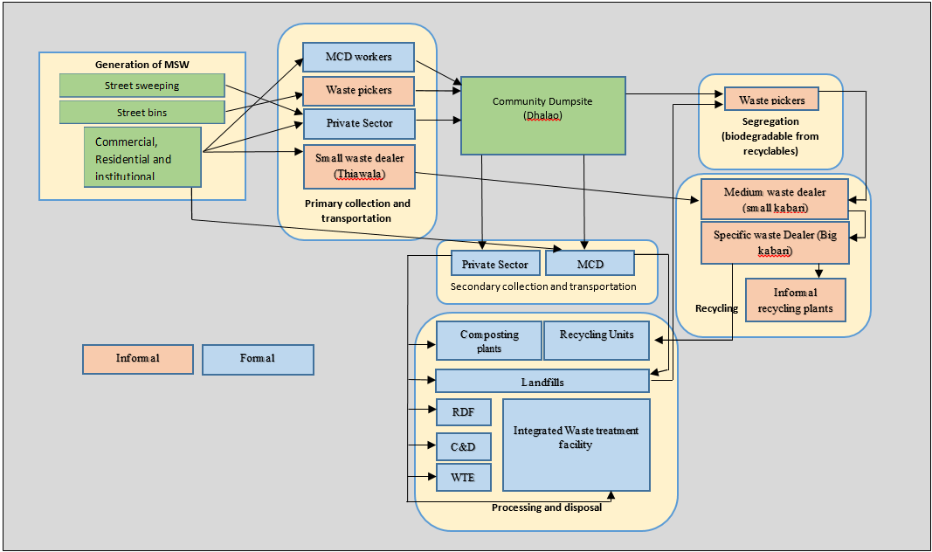

Collection and transport
There exist 2 types of collection and transport of waste; primary collection and transport and secondary collection and transport.
Primary collection and transportation entails that MSW is collected door to door and transported to the community dustbin where it is then dumped (stored) in the Dhalao. Stakeholders that are involved in primary door to door collection include: Municipal Corporation of Delhi (MCD workers and vehicles), Waste pickers, Smalls waste dealers and the Private Sector (see table 14).
Secondary collection and transportation involves the collection of MSW from Dhalaos and then transporting it to the designated treatment facility or disposal site (landfill). Stakeholders involved are mostly those of the private sector, MCD musical vehicles are also involved in secondary C&T but they collect from door to door directly to the landfill (see table 14).

Issues
Since there is little to no segregation of MSW at source, most of the MSW collected is stored at the dhalao without segregation. Next to foul smell, this creates a perfect breeding ground for pests and stray animals, thus increasing the risks for the spread of epidemic like diseases (cholera, dengue etc.) (See text box 1).
The private players contracted for primary and secondary C&T don’t segregate waste either in fact, since the tipping fee is paid for the amount of MSW transported, most waste is just dumped at the disposal sites. Even though there exists new MSW practices, like in the case of the “integrated waste treatment facility in Nareala bhawana” (see case studies) primary collection still involves transporting unsegregated waste to dhalaos, next to that, only the higher income areas are serviced for private primary collection while most of the city consists of lower income areas (5).

Recycling
Recycling in India, is almost entirely undertaken by the informal sector, which recycles about 56 % of the total recyclable waste produced which contributes to combating climate change by reducing GHG emissions (4). In Delhi, the recycling sector contributes to reducing around 962,133 tons equivalent in CO2, per year (31). Also, around 17 % of the handling of MSW – from collection to treatment – is done by the informal sector, saving the government of Delhi around Rs 600,000 daily (32). However, the informal sector is not integrated into the waste management system the work done by the informal sector is not politically acknowledged (33).
The “recycling” informal sector in Delhi, constitutes of a hierarchical waste-trade-chain, which comprises of waste-pickers, small-, medium- and big- recyclable waste dealers and Recyclers (Recycling Units) (see figure 14 and table 14).
Waste pickers segregate waste into biodegradables and recyclables, at the source – in trollies (see fig 15) - and at the dhalao’s (see figure 16) and sells of the recyclables to small kabaris in that are situated in the neighbourhoods that they have serviced. The thiawala (small junk dealer) buys in recyclables at source and then trades it with the players higher up in the hierarchy. Also, the small kabari employs waste-pickers -or immigrants from other states- to further segregate the recyclables into specific material (see fig 17) and stores it (see fig 18) at the makeshift “material recovery facilities” he operates.
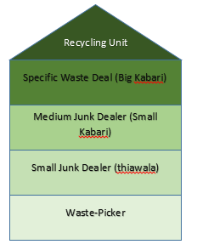
Figure 14 Hierarchical structure of the "recycling" informal sector (source: author)

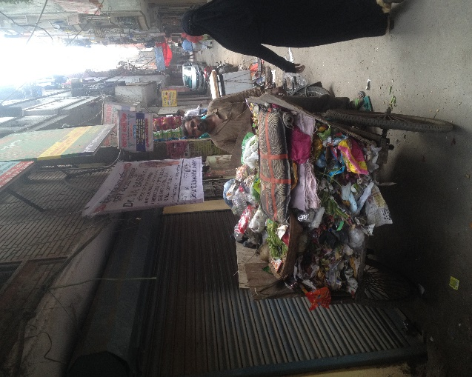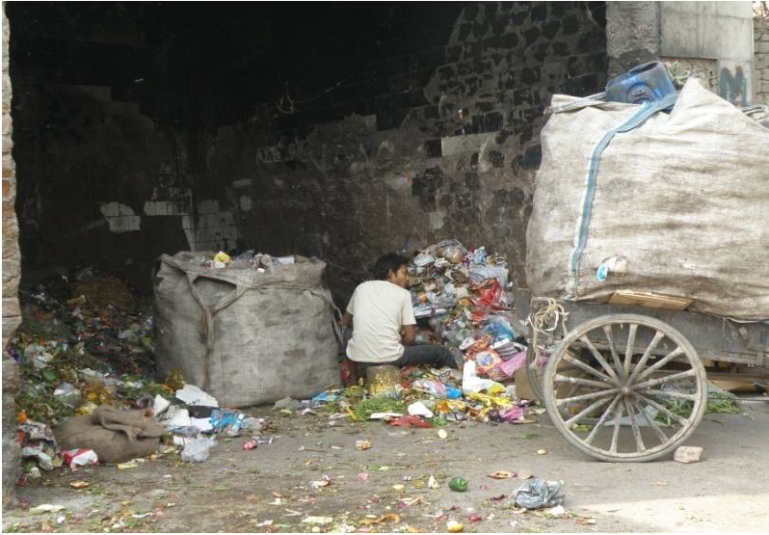
Figure 15 waste picker and trollies Figure 16 waste picker segregating waste at the dhalao (5)
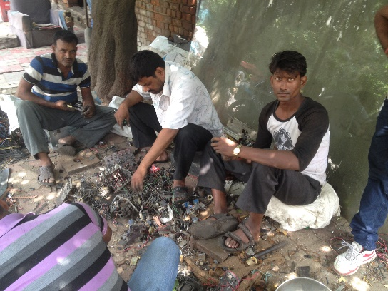
Figure 17 Employee (rag-picker) at small junk dealer's waste processing facility (source: field visit medium junk dealer at Mata sundry)
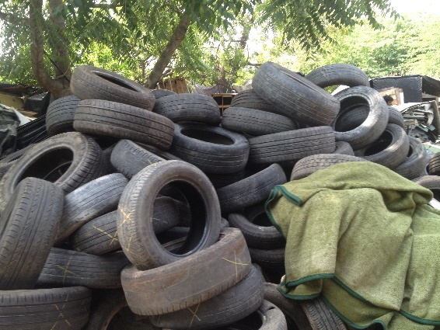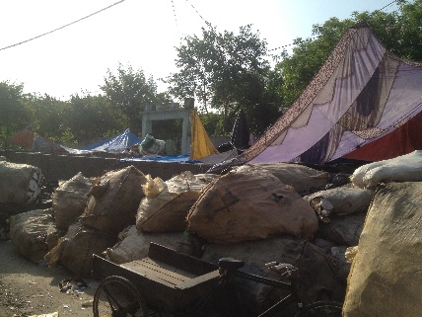
Figure 18 Different kinds of recyclables stored at medium junk dealer’s storage facility (source: field visit medium junk dealer at Mata sundry)
The stored recyclables are then sold (in bulk) to specific waste dealers, whom collect the materials on trucks (see fig 11) and then store (see fig 12) them in their own storage compounds in order for them to be re-sold for profit at the Recycling Units.
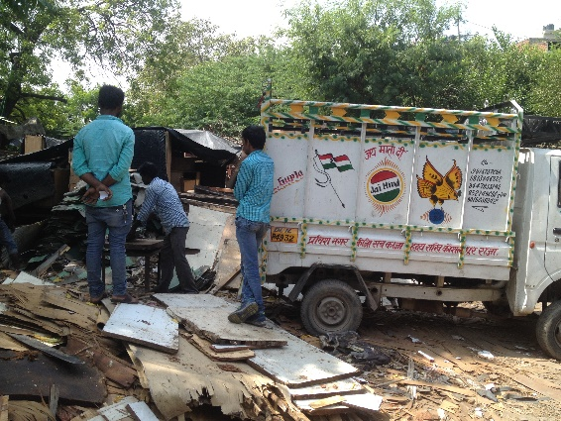
Figure 19 Trucks loading recycled material to be transported to specific waste dealer’s storage facilities (source: field visit medium junk dealer at Mata Sundry)
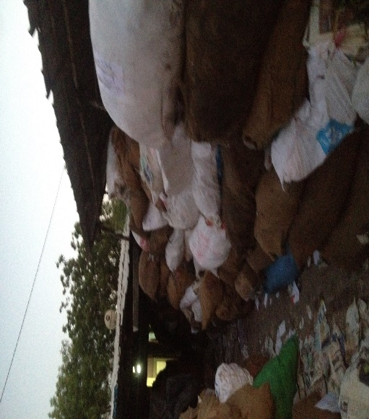
Figure 20 Storage facility of specific recycled paper dealer (source: field visit medium junk dealer at Mata Sundry)
The recycling units (informal and formal) then buy the recycled waste in (in bulk) from the specific waste dealers at face value, and then convert it into reusable materials (see fig 21) so it can be resold for profit.
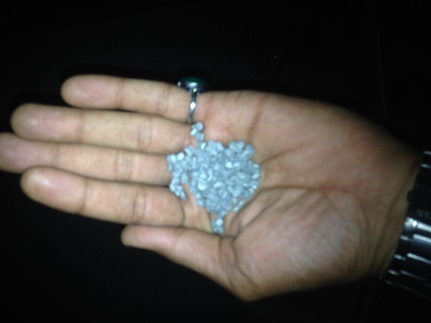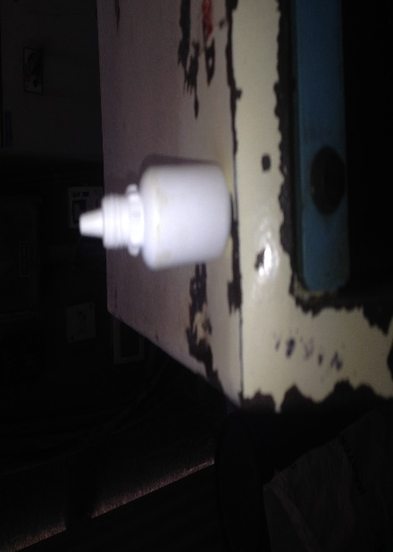
Figure 21 End products from "plastic" recycling units

Issues
The stakeholders that are involved in the informal sector face a series of issues that affect their overall health in turn effects their work efficiency, for instance:
- Waste-pickers work intensively for about 6 days per week and around 9-12 hours per day, without earning the minimum wage (see table 16)
- Waste-pickers work without protective gear, thus experience injury often (cuts, bruises etc.)
- There are Reported cases of waste-pickers being bitten by dogs
- Waste-pickers, Small kabaris and Big kabaris often face harassment from police, whom demand money in order for them to continue with their business
- Waste-pickers and Small kabaris have no legal protection
- No local security
- Waste-pickers endure unfair practices by traders
- Waste-pickers have an Increased vulnerability to skin, gastro-intestinal and musculoskeletal ailments
- Waste-pickers or other workers employed by waste traders, work and live in very poor working conditions see fig 22 and 23.
- Small kabari’s lack (government) financing to improve the material recovery facilities
Table 17 Average payment for a waste picker in Delhi (30)
Source | Amount earned in Rs | Percentage
Waste dealer | 6000 | 71 %
Metals | 1500 | 18 %
Hair | 500 | 6 %
Roti | 500 | 6 %
Total | 8500 | 100 %

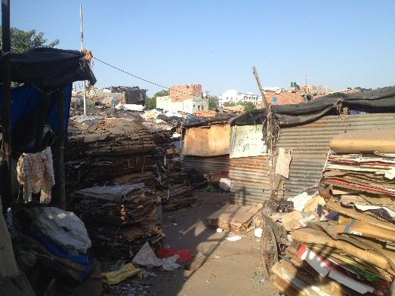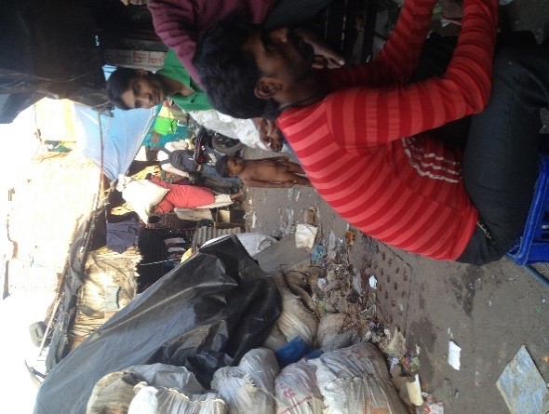
Figure 22 Waste storage facility of small kabari

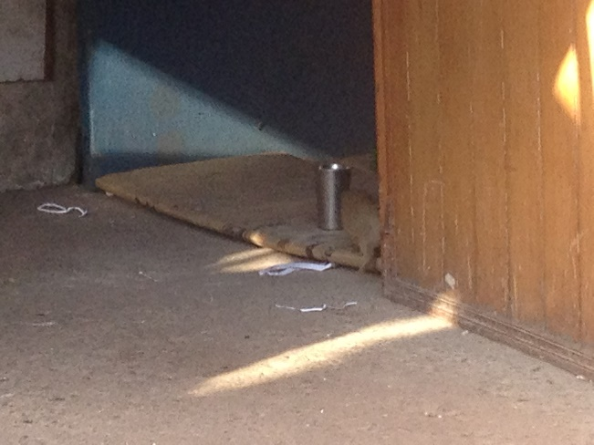
Figure 23 Rodents at small kabari's storage facility
These issues ail the overall efficiency of the informal sector, but if addressed can significantly improve the waste recycling efficiency in Delhi, overall.

Processing and Disposal
After the municipal solid waste is collected by the MCD or Private sector it is then transported to the designated processing facilities around Delhi. A 2014 survey conducted by the Centre for science and environment revealed; that from the 5 municipalities only 3 are engaged in the processing of MSW, the other two are engaged only in the disposal of MSW (see fig 24).

Figure 24 Analysis on waste management in Delhi (5)
Furthermore, the survey revealed that of the total waste generated, only 35 % was processed, the rest (75%) was just dumped at the landfill sites (see fig 25).

Figure 25 Amount of waste processed in relation to dumping (5)

Also, figure 26 shows the different methods that where –and currently still are- being adopted for the treatment of MSW in Delhi. According to official records in 2014, Composting is comprised of only 10 % of the donut while waste to energy is comprised of around 24 %, RDF around 10 % and landfilling around 57 %.

Figure 26 Methods adopted for the processing of waste in Delhi

Composting
Composting can be defined as the natural decomposition of biodegradable solid waste under predominately aerobic conditions to a state that is stable enough for storage and handling and is satisfactorily matured for safe use in agriculture (United Nations Environmental Program). It can be defined in two ways:
- Aerobic digestion: This biological decomposition is described as the oxidation of carbon present in the organic waste to produce organic manure (compost).
- Anaerobic digestion: This is a process where microorganisms break down the organic material in the absence of oxygen, from energy can be recovered in the form of biogas (methane & Carbon dioxide) and an organic residual that can be used as fertilizer.(4)
The 2014 DPCC annual report, that there are three existing central composting facilities –applying aerobic digestion- available across Delhi of which only two are operational, but they are operating below their capacity. There are other composting facilities available but they are not treating the MSW of residential and commercial areas, instead they are only treating park waste, these composting facilities are located in a few parks and gardens across the area government by the New Delhi Municipal council (NDMC) (see table 18).

Table 18 Composting Facilities in Delhi
Site name. | Location | Status | Capacity  (MTPD) | Quantity processed or disposed (MTPD)
 |  |  |  | North Delhi Municipal corporation | South Delhi Municipal Corporation | East Delhi Municipal Corporation | New Delhi Municipal Council | Delhi Cantonment Board
Nature and waste Management Pvt. Ltd. | Bhalaswa | Closed (noncompliance of MSW,rules) | 500 | 55 | 55 | - | 28-33 local composting(lodhi garden, Nehru Park, Talkatora Garden) | -
IL&FS Compost plant | Okhla | operational | 200 | - | 88 | - |  | -
M/s Delhi MSW solutions ltd. | Narela Bawana road | operational | 1500 | 700 | - | - |  | -

Issues
The composting facility in Bhalaswa was not fulfilling the terms of agreements it had made with the Municipal Corporation of Delhi (MCD). The facility was supposed to treat around 500 MT (metric tons) of MSW per day, but failed to meet the capacity after a few years of operation. Furthermore, the facility was violating pollutions norms under the water and air prevention acts (34). The composting facilities in Okhla and in Narela Bawana are both also operating below their intended capacities. The reasons for the failure of the Bhalswa composting plant and the inefficiency of the other two composting plants include:
- Market constraints: there is little market for the trade of organic manure, since Indian government norms require that at only 15 % - 20 % of fertilizers sold by companies, should be organic, thus affecting the demand for compost.
- Unsegregated waste has a negative effect on the overall process of composting which in turn effects the quality of the compost. The compost can get laden with toxins, heavy metals and glass (4).
Segregation of MSW remains an important part for the composting process, unsegregated MSW will surely render the technology inefficient.

wASTE tO eNERGY (wte)
Waste to Energy technology (WTE) can be defined as a process of controlled combustion, in which waste is thermally broken down to ash in an enclosed device and energy recovered from the heat produced in the process (see fig 26 & 28). WTE technology is successful in the reduction of volume on landfills and reducing the GHG emissions through point source pollution control, furthermore the residue (Ash) can be used for construction materials (4).
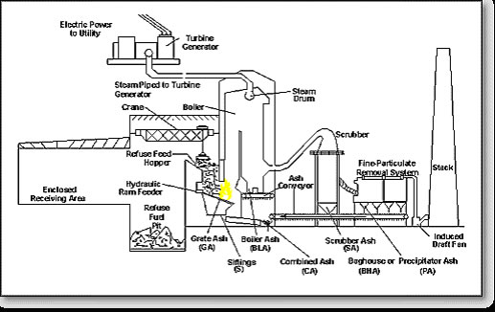
Figure 27 typical waste incineration facility
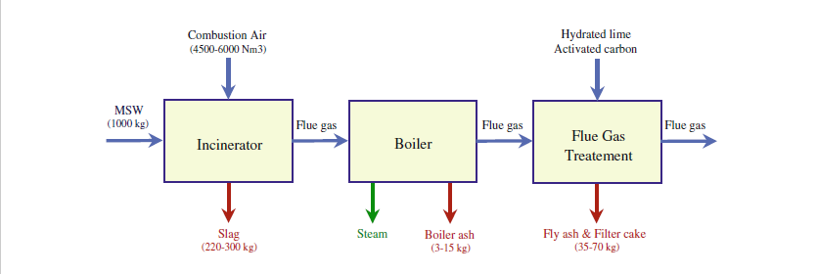
Figure 28 Typicial flow diagram of waste incineration plants (35)
In Delhi there are three WTE facilities; one in Okhla, one in Ghazipur and one in Narela Bawana (see table 20). The WTE facility in Okhla was the first one of its kind in Delhi and the one in Ghazipur has just started operation in 2015. According to the 2014 annual report of the DPCC, Okhla has a capacity of around 1950 TPD and is incinerating around 1747 TPD, however, currently they are burning around 1500 TPD of MSW. Also, according to the 2014 CSE survey around 700 TPD of RDF (refuse derived fuel) was being produced (5).
The waste to Energy facility in Ghazipur has just recently started its operations and it has a capacity of 1300 TPD as well. However, there is no official data available yet on the amount of waste processed at Ghazipur. An Indian times News article does seem to point out that the faicility is currently operating under its intentioned capacity (34).
Table 19 Waste to energy facilities in Delhi (2014) ³³
Site name. | Location | Status | Capacity  (TPD) | Quantity processed or disposed (TPD)
 |  |  |  | North Delhi Municipal corporation | South Delhi Municipal Corporation | East Delhi Municipal Corporation | New Delhi Municipal Council | Delhi Cantonment Board
Timarpur-Okhla Waste Management company private ltd. | Okhla compost site | Operational | 1950  (16MW) | 400  700 (RDF) | 1100 | - | 247 | -
M/s East Delhi waste processing company Ltd. | Ghazipur | Operational | 1300  (12MW) | - | - | - |  | -
Delhi MSW solutions Ltd. | Narela Bawana Road Delhi-39 | Under installation | 3000  (24 MW) | - | - | - | - | -

Issues
The mere adoption of incineration technology as a “quick fix” for waste management, does not necessarily resolve the environmental, social and economic issues related to waste management. In fact, Waste incineration technologies come with liabilities these include (36):
- Pollution generation
- Harm to Public health
- Financial burden on host communities
- Financial resources of local communities are burdened
- Energy and material loss
- Thwarting of local economic development
- Undermining waste prevention and rational approach to discard management
- Operating experience checkered with problems, in industrialized countries
- Often exceed pollution standards
- Creates toxic ash
- The taxpayers and citizens often pays the bill
In Delhi some of these liabilities have manifested itself in reality, this applies particularly to the Timarpur-Okhla waste management company in Okhla and since its conception in 1986 it has already been facing issues which include:
- Upon its conception in 1986 it was shut down after just 21 days due to poor quality of waste coming in: the MSW coming in has a high moisture content - to a high percentage of biodegradable waste available in the mixed waste- and as well the high percentage of inert’s available in the waste (36).
- It has also already violated emission standards of PM
- Major deviations in the design of the project from initial proposed plan (see table 21)
- The project is facing litigation by the public and facing risks of closure, for environmental pollution and compromise of public health (34, 37)
- The facility is contested by the people that depend on the informal recycling sector, because it is destroying their livelihoods (burning their resources) (38)
- It has experienced mechanical failures in the boiler systems ³⁴
- RDF produced is not suitable for burning in most plants (e.g. cement kilns) other than for the use as fuel in waste incineration plants.
Table 20 Deviation since Timarpur-Okhla project approval (39)
Original proposal by the company (as approved by MoEF) | Deviations
The plant at Timarpur will process 650 TPD of garbage to produce 225 TPD of RDF. The Okhla site will process 1300 TPD of mixed garbage into RDF, and burn this along with the 225 TPD of RDF from Timarpur to produce 16MW of power. | The Timarpur plant has been dropped. All the RDF production and combustion (2050 TPD) will take place at Okhla.
The Okhla plant will include a biodigester for 100 TPD of green waste. | Biodigestion is no longer included.
The power plant will have single boiler - single turbine combination. | The power plant is to now have 3 boilers - single turbine combination.
There will be provision in the plant for firing methane gas produced from bio-methanation plant. | The bio-methanation plant is not included in the new plan. 100 TPD of green waste may be burned directly to produce power.
There will be a 4 TPD capacity pelletising facility to  produce RDF pellets from the biomass and horticultural  Waste. | This is not part of the new plan.
Depending on many factors, the gross calorific value of the fuel should be around 2600 cal/kg. | The gross calorific value of the fuel is now estimated to be 1100 - 1500 kcal/kg.
For reducing moisture in the waste, a hot air generator will be provided. | The altered plan envisages a drying mechanism built into the boilers which requires 45-60 minutes to reduce the moisture.

C&D
According to the 2014 annual report of the DPCC and the 2014 CSE survey, there are 4 construction and demolition waste treatment plants installed in the city. One of which is operational but operating under its intended capacity (see table 21). The C&D waste is being processed to produce tiles/pavement blocks and also ready mix concrete, aggregates etc. It is known in the literature that the C&D waste is being utilized as cover for landfilling, this can be used as an explanation for the reason why the C&D treatment plants is operating under capacity (22).
Table 21 Construction and demolition treatment facilities in Delhi ³⁴ (5)
Location |  | Status | Capacity  (TPD) | Quantity processed or disposed (MTPD)
 |  | Status | Capacity  (TPD) | North Delhi Municipal corporation | South Delhi Municipal Corporation | East Delhi Municipal Corporation | New Delhi Municipal Council | Delhi Cantonment Board
Shrastry park | Commissioning by june 2015 |  | 500 | - | - | - | - | -
Burari, at jahangirpuri | Operational |  | 2000 | 500 | - | - | - | -
Gummaharhera | Commissioned, 2014 |  | 500 | - | - | - | - | -
East Kidwai Nagar | Proposed |  | 150 | - | - | - | - | -

Landfilling
In total there are around four operational landfill available in Delhi (see table 22). Three of them have reached their intended capacity (Okhla, Ghazipur, Bhalswa) and are still being used to dump waste on a daily bases, even though the authorization of dumping at these landfills has been refused by CPCB (under the MSW 2000 rules). The height of the fill of the landfills at Bhalswa, Okhla and Gazipur ranges between 45-55 meters. Also, the conditions of the landfill site are poor in that there exist no leachate treatment plan, no access control, no fire protection system and no gas control (5).
Table 22 Landfill sites in Delhi ³⁴
Site name. | Location | Status | Capacity  (TPD) | Quantity processed or disposed (TPD)
 |  |  |  | North Delhi Municipal corporation | South Delhi Municipal Corporation | East Delhi Municipal Corporation | New Delhi Municipal Council | Delhi Cantonment Board
Bhalswa sanitary landfill site  (1994) | Bhalaswa, Near mukarba Chowk on GT. Karnal Road | Operational (authoration refused) | Exceeded capacity | 1050 + 120 (C&D as cover, Malba) | - | - | - | -
Okhla sanitary landfills site  (1986) | Okhla ph-I, Anand Mai Road | Operational (authorization refused) | Exceeded Capacity | - | 110 + 500 (C&D cover, Malba) | - | - | 77  -
M/s Delhi MSW solutions  ( 1997) | Narela Bawana Road | Operational (authorization granted) | 21000 m³ | 700 | - | - | - | 77  -
M/s Delhi MSW solutions | Narela Bawana Road | Operational (authorization granted) | 21000 m³ | 700 | - | - | - | -

issues
The fact that dumping continues given status of the scientific landfills raises major points of concern which have already been felt or are yet to occur, these include:

- Ground water pollution: at Bhalswa landfill there are major concerns and issues noted, it is located near a major city water drain and several other water bodies (see fig 7, 29 & 30)
- Risks of spread of disease carried over by stray animals and waste-pickers
- Environmental methane pollution
- landfill fires
- landslides
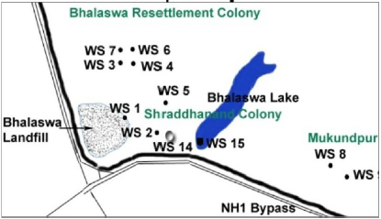
Figure 29 Colonies affected by ground water pollution
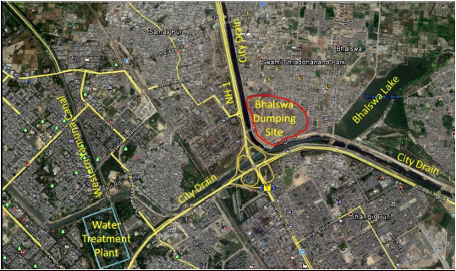
Figure 30 location of Bhalswa dumping site source (5)

Financial analysis in MSWM
The Supreme Court appointed committee in 1999 estimated that the costs for the improvement of SWM – this included collection, transportation, processing and disposal- in urban cities of India would amount to about Rs. 1.5 crores per 100000 population.
The expert committee appointed by the MoUD, wrote a manual on SWM²⁰, which laid down standard cost estimates for the modernization of SWM practices (see table 12) (28).
Table 23 Expenditure on SWM in India (28)
City population (In million) | Cost of vehicles, tools and equipment (in Rs.lakh) | Cost of Composting (Rs.lakh)
<0.1 | 50.97 | 20
0.1-<0.5 | 295.00 | 150
0.5-<1.0 | 511.00 | 500
>2.0 | 948.00 | 1000

A 2006 report (23) on solid waste management revealed that, of the municipal budget expenditure, around 10-50 percent was is spent on SWM. The main expenses where on, salaries and allowances, consumables, vehicles repair and maintenance, contingencies and others. Furthermore, sanitation workers in class-I and class-II cities received salaries that constituted about 75 percent and 80 percent of the total SWM expenditure.
Even-though 15-20 % of the total budget of the Municipal Corporation of Delhi (MCD) is spent on SWM services, the funds remain insufficient to keep the city clean. This is due to the fact the a large proportion of the expenditure is incurred on the maintenance –salaries, allowances and other benefits- of the huge staff of the Department of Environmental Services and low technological application. The salary bills account to for the biggest share of the DEMS because of the labor intensive nature of the Jo
The total expenses on MSW made by the MCD on SWM has increased in the period of 2001-2002-> 2007-2008, with about Rs. 2761.34 lakh (see table 13) (28).

Table 24 MCD total expenditure on SWM (28)
Item | 2001-2002 | 2007-2008
Transport Item (rickshaw and other) | 100.21 | 298.00
Dhalao (maintenance & new built) | 566.34 | 705.77
Vehicles (maintenance) | 460.55 | 549.00
SLF sites | 133.72 | 352.00
Heavy Equipment’s | 0 | 255.00
Vehicle (purchase)  (Bullozers,Trucks, Other Machines) | 761.96 | 2280.00
Safai-karamcharies (street sweepers) | 275.00 | 400.00
Private Transportation (for waste disposal) | 250.65 | 470.00
Total | 2548.43 | 5309.77

A survey conducted in 2009 by FICCI, found that Delhi has the highest per capita expenditure (Rs. 431) on municipal solid waste management in the country.

Decentralized waste management
Solid waste management is regarded as being one of the challenges facing the urban cities across the globe. In developed countries the solid waste management is satisfactorily organised by the municipal governments. In contrast, developing nations are experiencing problems in MSW, which is largely related to rapid urbanization. Increase in municipal tax and fee revenues is not necessarily keeping up with the population growth and services expenses, since most urbanization is mostly attributed to poor people migrating from rural areas to urban cities. Given the broad spectrum of problems related to poor waste management, an integrated approach is needed, that will cover all aspects of the waste management system (technology, social, economic and environmental) instead of just one aspect (ex. technology). Since in many developing nations (ex. India) the organic fraction of solid wastes comprises of more than 50 %, the most suitable approach for waste treatment is composting (40).
Given the current situation of MSW management in Delhi, alternative options need to be pursued so that environmental and public health risk are minimized. The following case studies represent the steps that the MCD of Delhi has taken as well as initiatives undertaken by other stake holders through for sustainable management of waste.

Local Case Studies

Succesfull international Case studies

Decentralized composting Dhaka, Bangladesh
In 1995 the Dhaka City Corporation- municipal body of Dhaka- established a decentralized community composting scheme – in Mirpur, Dhaka- with the help of Waste concern - a research based NGO- with the aim of developing a low-cost technique for composting of MSW, developing public-private-community partnerships in solid waste management and creating job opportunities for the urban poor. The composting procedure involves using the “Indonesian Windrow Technique” for the conversion of organic waste into compost. The scheme has been largely successful in that the product has been able to get approval from the Bangladesh Agriculture Research council, the scheme has gotten policy support from the Ministry of Agriculture and the scheme has also experienced financial success (41).

Data
According to the assessment report (41) at the first half of 2001 the plant was treating around 1.7 tons of municipal waste per day and serving around 790 households in Mirpur. The full capacity of 3 tons per was reached at the second half of 2001 and serving around 1430 households. In total around 10 people are employed at the plant.

Composting process
The decomposition of the organic waste is reached using the “Indonesian Windrow Composting technique”. This is a labour intensive aerobic thermophile composting procedure in which pre-sorted waste is mixed with additives and piled around in a triangular aerator – rack made of bamboo- for better aeration.
The complete composting process lasts for around 53 days which is described into a thermophilic phase (27 days, 40-70 ºC) and a mesophilic phase (26 days, 20-40 ºC). During the first phase the waste is frequently turned in order to regulate the temperature for equal decomposition and in the second phase the waste is left to mature without turning or watering. After maturing the compost is then packed. Figure 31 and table 25 gives an overview of the composting scheme and the actors involved (41).
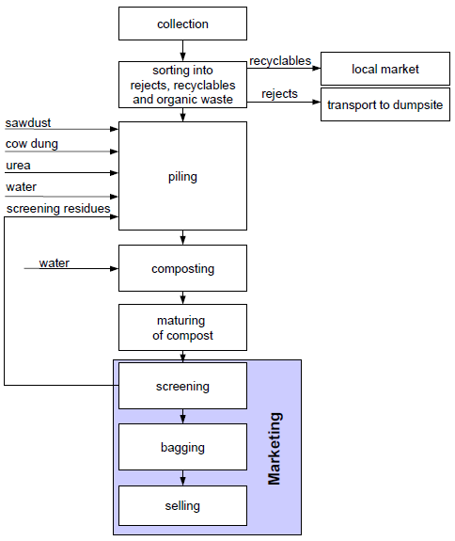
Figure 31 Flow Chart of the Composting Process (41)
Table 25 Actors of the decentralized composting scheme in Mirpur (WC= Waste Concern) (41)
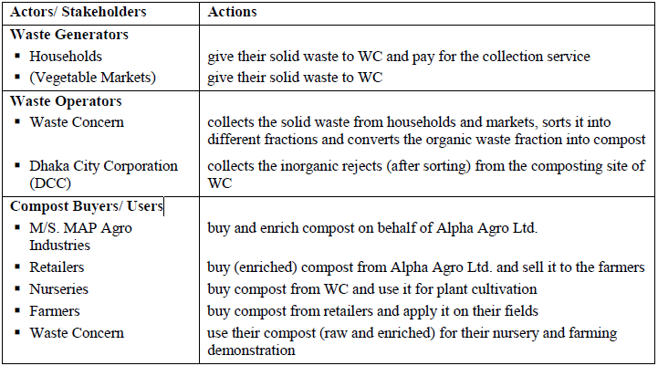

Financial analysis
The costs for land was free, it was just given to waste concern by the Lions Club, Dhaka northern (governmental body). Table 26 gives an overview of the yearly costs and the revenues of the Mirpur Composting Pant. Three types of revenues where categorized from the composting scheme:
- Income from collection fees (Tk. 17/household and month according to their financial situation)
- Proceeds from compost sales (Tk. 2.5/kg)
- Proceeds from the sale of recyclables like hard plastic, cardboard, glass and metal
Table 26 Yearly Costs and Revenues of Mirpur Composting Plant (including waste collection) according to conversion rate in Feb. 2002 (1 US$=TK 58)
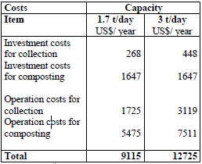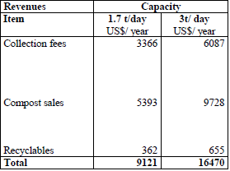
It can be observed that the plant is barely financially viable when operating below full capacity. However, when the plant is operating at full capacity the economic viability becomes very attainable. The revenues cover around 91 % of the operation costs and 76 % of the total annual costs of the scheme. The annual profit amounts to 3745 US$.

marketing
The report goes on to stress that a detailed assessment of the market for compost in the respective region should be done in order to guarantee the success of any composting project. The lack of market is the major cause for failures in composting schemes like this one. The potential of the market determines the size of the composting facility and the technique of the composting process, since costumers have specific needs for the application of compost. Therefore, to ensure the sustainability of the composting scheme a market analysis and development should be undergone before the product is produced. The demand of the compost is influenced by various factors which can be assessed beforehand by a market study for compost, these include:
- The current use of organic municipal waste (e.g. life stock farming or fertiliser)
- The customer segments (e.g. agriculture, horticulture, land reclamation, bulk suppliers or public agencies)
- The type and place of application
- Perceptions versus compost and knowledge of its use
- The potential demand
- The required quality and state of maturity of compost and the availability of competitive products (e.g. cow and poultry manure, residues from agro-industries, municipal waste or artificial fertilisers)
A good marketing strategy must contain the factors above and as well, a good distribution strategy. Some distribution strategies for compost can be described as:
- Direct marketing to end users
- Marketing trough retailer or bulk supplier
The distribution strategy depends on the resources available for transportation which in a lot of cases are a limiting factor.
Waste concern markets their product-obtained from the Mirpur composting plant- through a fertilizer company in Dhaka (MAP Agro Industries), this company then further processes the composts by grinding it and enriching it with additional nutrients. Then a fertilizer trading company (Alpha Agro Ltd.) distributes the final product through their distribution network all over the country. The final products are sold as organic fertilizers for vegetables and many other crops to farmers. Also nurseries buy some compost directly from the composting site. Waste concern also tries to raise awareness by launching an information campaign using a farming demonstration site.
Through their marketing strategy, waste concern has successfully reduced the transportation and marketing costs. This enables the organisation to solely concentrate on the production of the compost while benefiting of the distribution network of the fertilizer company (41).

Summary and Conclusion

Annexures

ANNEX I Setting up of landfill facilities for waste disposal
 |  |  | Reported during 2013-2014 |  |  |  | Reported till 2012-13
SI No. | States/UT | Total Landfills constructed | New Landfill Constructed | Initiative taken | No. of landfill site identified | Name of Sites | Existing Exhausted landfills | Initiatives taken | No. of Sites Identified | Name of Landfill sites constructed or Identified
1 | Andaman Nicobar | 0 | 0 | 1 | 1 | Shahbad | INR | INR | INR
2 | Andhra Pradesh | 2 | 1 (Hyderabad) | INR | 1 (Kadapa) |  | 1 | INR | INR | 4 Nalgonda , vizag, vijaywada & Guntur
3 | Arunachal Pradesh | 0 | 0 | 2 | Nil | Itanagar & Pasighat | Nil | Nil | 1 | Itanagar
4 | Assam | 1 | 1 | 2 | 1 | Guwahati *Dibrugarh & Silchar | Nil | 1 | 1 | Guwahati
5 | Bihar | 0 | 0 | 0 | 1 | Patna | Nil | 55 | 3 | 'Narketiaganj, Muzaffarpur & Patna
6 | Chandigarh | 1 | 0 |  |  |  | 1 | 1 | - | Dadumjara
7 | Chhattisgarh | 0 | 0 | 16 | 64 | - | Nil | 35 | 73
8 | Daman Diu | Nil | Nil | 3 | Nil | Daman, Diu & DNH | Nil | Nil | Nil | -
9 | Delhi | 4 | 1 | INR | 26 | Ghazipur, Bhalswa, Okhla & Narela-Bawana | 3 | 3 | 2 | Bhalswa, Okhla & Ghazipur/Narela
10 | Goa | 7 | INR |  | 0 | Pernem, Bicholim, Sanquelim, Quepem, Margao, Cuncolim & Canacona | 7 | 4 | 14 | Pernem, Bicholim, Sanquelim, Quepem & Concolim
11 | Gujarat | 12 | 4 | 11 | 64 | Rajkot, Rajpipla, Surat & Vadodara | 8 | 69 | 172 | Anjar, Bhachau, Halvad, Morbi &  Wankaner. Earlier landfills —Surat,  Alang, Ahmedabad (AR:2007-08).
12 | Haryana | 4 | 2 | 4 | 53 | Faridabad/Gurgaon, Yamuna nagar, Sirsa & Ambala | 2 | INR | INR | Sirsa & Ambala (AR: 2007-08)
13 | Himachal Pradesh | 0 | 0 | 2 | 48 | (Nalagarh & Baddi) | Nil | INR | 50 | -
14 | Jharkhand | 3 | 3 | INR | 3 | Ranchi, JSA & Dhanbad | Nil | 1 | 3 | Ranchi, Jamshedpur & Dharibad
15 | Jammu & Kashmir | 1 | 1 | 2* | 1 | Bhaderwah *achan & Jammu #Jammu | Nil | 4 | INR | Chandoora, Badgam, Samboora &  Pul;wama
16 | Kerala | 0 | 0 | 0 | 7 |  | Nil | 27 | 2 | Capping of old dump site completed  one corporation
17 | Karnataka | 12 | INR | INR | INR | INR | 12 | 53 | 190 | Mangalore +Ullal, Karwar, Udupi,  Puttur & Ankola. Landfills reported  earlier- Yelahanka & Byataryanpura  (AR: 2007-08) Mysore, Bellary,  Mangalore ,In 2009-10, Simoga &  Belgam
18 | Lakshadweep | Nil | Nil | Nil | Nil |  | INR | INR | INR
19 | Madhya Pradesh | 5 | 1# | 4 (Sagar, Chattarpur, Satna & Chitrakoot) | 308 | Ujjain | 4 | 5 | 306 | Gwalior, Indore, Jabalpur & Dabra
20 | Maharashtra | 6 | 0 |  | 0 |  | 6 | INR | 220 | Nashik, Sonpeth, Ambad, Pune,  Navapur & Navi-Mumbai (AR:2007-  08)
21 | Manipur | 1 | 1 |  | 8 | Imphal | Nil | 10 | 10 | Lamdeng Khunao, Imphal West,  Kakching, Jiribam, Bishnupur, Mayang  Imphal, Ningthoukhong, Thoubal,  Nambol & Moirang
22 | Mizoram | 0 | 0 | 0 | 1 | Aizwal | Nil | 9 | 2 | Turial (Aizwal) & Lengte (Mami )
23 | Meghalaya | 0 | 0 | 3 | 3 | Shiling, Tura & Jowai | Nil | 1 | 1 | 6 Nos. Open dumps
24 | Nagaland |  |  |  | 1 | Kohima (lerie) | Nil | Nil | 1 | Kohima
25 | Orissa | 0 | 0 | 4 | 83 | Bhubneswar, Cuttack, Berhampur & Rourkela) | Nil | 2 | 82 | Bubaneswar & Cuttacka
26 | Punjab | 1 | 0 | 26 | 26 | NA | 01 (exhausted) | 8 | 8 | Adampur(AR:2007-08)/ •Kalanaur
27 | Puducherry | 0 | 0 | 1 | 1 | Kurumbapet | Nil | 1 | INR | -
28 | Rajasthan | 1 | INR | 18 | 25 |  | 1 | 16 | 68 | Jodhpur
29 | Sikkim | 0 | 0 | 2 | 2 | Martam & Sipchu | Nil | 8 | 2 | common facility at Sipchu for 8  towns
30 | Tamil Nadu | 3 | 3 | 1 (Tiruneveli | 113 | Coimbatore, Madurai & Salem | Nil | 24 | 1 | Udumalpet
31 | Tripura | 1 | 0 | 1 (Agartala) | 18 | In 13 ULBs | 1 | 1 | 13 | Agartala (Hapania- exhausted)
32 | Uttar Pradesh | 16 | 16 | 03 Jhansi, Sambai & Mirzapur | 04 Ghaziabad, meerut, Gorankhpur & Saharanpur | Kanpur, Agra, Lucknow, Moradabad, Aligarh, Varanasi, Allahabad, Muzaffamagar, Mainpuri, Etawah, Raebarelli, Barabanki, Fatehpur, Kannauj, Mathura & Bareily (closed) | Nil | 18 | 19 | Agra, Aligarh, mainpuri, Badam,  Firozabad, Etwah, Sambhal, Kanpur  nagar, Kannij, Moradabad,  Gorakhpur, Basti, Balia, Varanasi,  Raebareilly, Allahbad, Ghaziabad,  Lucknow and Bareily. .
33 | Uttarakhand | 0 | 0 | 3 | 3 | Dehradun, Haridwar & Nainital | INR | INR | 1 | Dehradun
34 | West Bengal | 13 | 0 | 28 | 29 | *Garulia, N, Barrackpore, Kamarhati, Bhadreswar, Chandernagore, Bally and Haldia, Dum Dum/S DumDum, Barangar, Barracjpore, Budge Budge, Bansbaria, Uttarpara, Konnagar, Rishra, Serampore, Champadani & Baidyanagar | 24ULBs (some exhausted) | 39 | - | Garulia, N Barrackpore; Kamarhati,  Bhadreswar, Chandernagore,  Durgapur, Asansol, Jamuria, Bally,  Raniganj and Haldia are operational.  Landfill is ready at Dum Dum, S  DurnDum, Baranagar, Barrackpore,  Budge Budge, Bansbaria, Hoogly,  Chinsuria .
 | Total | 94 | 34 | 127 | 895 |  | 71 | 179 | 384

ANNEX II Map of Delhi with administrative areas (28)

As written on the website at: http://www.cseindia.org/content/about-cse
Analysis on Census India 2011: http://www.censusindia.gov.in/2011census/PCA/PCA_Highlights/pca_highlights_file/India/4Executive_Summary.pdf
World Bank Data retrieved at: http://data.worldbank.org/
Data GDP Data Gathered from: http://data.worldbank.org Data on from MSW generation was retrieved from CPCB reports and Planning commission “Task Force” report on integrated waste management: http://planningcommission.nic.in/reports/genrep/rep_wte1205.pdf
As per CPCB 2008-2009 annual report: http://cpcb.nic.in/upload/AnnualReports/AnnualReport_37_ANNUAL_REPORT-08-09.pdf
Data retrieved from CPCB annual reports available ate the following links: http://www.cpcb.nic.in/divisionsofheadoffice/pcp/MSW_Report.pdf and www.cpcb.nic.in/divisionsofheadoffice/pcp/MSW_Report.pdf
Verifiable with studies conducted by the Central Pollution Control Board: http://cpcb.nic.in/wast/municipalwast/Studies_of_CPCB.pdf
Source: http://www.indiawaterportal.org/sites/indiawaterportal.org/files/bhalaswa-groundwater-and-health-report_hazards-centre-2012.pdf
Scheme retrieved from the global waste management outlook: http://www.unep.org/publications/
Manual can be downloaded at: http://moud.gov.in/advisory/swm_manual
The draft can be retrieved from this website: http://www.moef.nic.in/sites/default/files/SWM%20Rules%202015%20-Vetted%201%20-%20final.pdf
As written in the MSW rules http://www.moef.nic.in/legis/hsm/mswmhr.html
source census India 2011: http://www.censusindia.gov.in/2011-prov-results/paper2-vol2/data_files/Delhi/Provisional_Rural_Urban.pdf)
Source Delhi Pollution Control Board: http://www.dpcc.delhigovt.nic.in/WMCII_page.htm, Delhi master plan and CSE’s (center for science ad environment) status report on Delhi’s waste management
Census India, CPCB report 2011: http://www.cpcb.nic.in/divisionsofheadoffice/pcp/MSW_Report.pdf and DPCC 2013-2014 annual report available at: http://www.dpcc.delhigovt.nic.in/WMCII_page.htm
Data retrieved from DPCC governmental website: http://dpcc.delhigovt.nic.in/waste-msw.html
Quoted from: http://delhi-masterplan.com/
The master plan is available online here: https://dda.org.in/ddanew/pdf/Planning/reprint%20mpd2021.pdf
The document can be found at: http://bbmp.gov.in/documents/10180/512162/MSW+RULES+2000.pdf/7224e973-4d26-4afe-a997-cb4ee63521c2
The document can be found at: http://www.moef.nic.in/sites/default/files/Solid%20Waste%20Management%20rule.pdf
Manual can be found on: http://moud.gov.in/advisory/swm_manual
Manual can be found on: http://moud.gov.in/sites/upload_files/moud/files/pdf/Draft%20on%20manual.pdf
Report can be downloaded from: http://moud.gov.in/sites/upload_files/moud/files/tag_swm.pdf
Report can be downloaded from: http://moud.gov.in/sites/upload_files/moud/files/imtf_pnm.pdf
pdf can be downloaded from: http://moud.gov.in/policies/NUSPpolicy
Information on SLB can be found at: http://moud.gov.in/policies/servicelevel
Document can be downloaded from: http://moud.gov.in/sites/upload_files/moud/files/mswm.pdf
Document can be downloaded from: http://jnnurm.nic.in/wp-content/uploads/2012/11/SWM-toolkit.pdf
As written on the corporate website http://www.ilfsindia.com/projects.aspx?prid=7&catid=1&slnk=118&cid=5
The project details can be found on this website http://towmcl.com/content.aspx?MKey=33
As described in this news article http://www.thehindubusinessline.com/news/variety/construction-debris-still-finds-the-landfill/article6458555.ece
As written on their website: http://www.safaisena.net/index.htm
As written on toxic links website: http://toxicslink.org/?q=profile
Can be downloaded from here: http://dpcc.delhigovt.nic.in/waste-msw.html
Source: http://tritecroc.com/wp-content/uploads/2011/04/faq-img17.jpg
Retrieved from the 2014 DPCC report on the status of MSW management: http://dpcc.delhigovt.nic.in/waste-msw.html
Source: http://www.indiawaterportal.org/sites/indiawaterportal.org/files/bhalaswa-groundwater-and-health-report_hazards-centre-2012.pdf
https://www.globalmethane.org/Data/292_2_ficci_survey_09.pdf

