Advice Report

on appsung’s compliance to the European Union’s chemical legislation on safety, handeling and storage

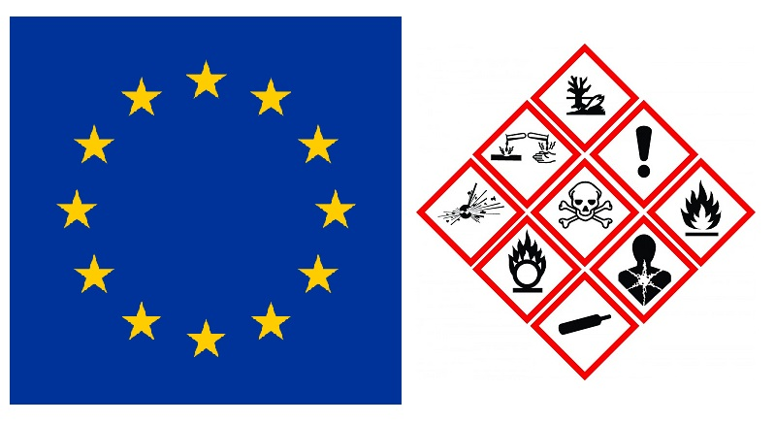

Tutors: Femke Brouwer

Mari Marinussen

Author

Fernando Trouw

Contents

1.1. Goal 4

1.2. Boundaries 4

1.3. Reading guide 5

Theoretical background 5

2.1 REACH 5

2.1.1 How REACH functions 5

2.1.2 Actors within REACH 6

2.1.3 REACH methodology 7

2.2 Classification, Labeling and packaging of chemicals (CLP) 11

2.2.1 Global Harmonized Systems (GHS) 12

2.2.2 Classification Process 12

2.2.4 Labeling 13

2.2.5 Notification procedure 15

2.3 Seveso Directive 16

2.3.1 PGS-15 16

2.4 Dutch risk map 18

2.5 BREF-documents 18

Relationship with REACH and CLP 19

2.6 QSAR 19

Ld50 20

3 Products and Results 21

3.1 Registration Format REACH 21

3.2 Labelling Format CLP 23

3.3 The Storage Plan 24

3.4 Suitability of location 24

Advice 24

Bibliography 24

1 Introduction

Because of the chemical Industry our quality of life has improved; plastic bags keep our lunch fresh, we have dedicated cleaning products, medicines to treat diseases, colorants to make our food and clothes attractive and we have pesticides that can increase our yield of crops. But all these benefits also bring negative effects with them, like: natural disasters related to the chemical industry and transport, negative impacts on the environment and a lot of issues concerning human health. For these reasons there are strict regulations bound to the production, use and waste-treatment of chemicals.

*Appsung*, a Chinese mobile phone producer, wants to open a mobile phone factory in Breda close to Avans Hogeschool. Since the factory will produce and assemble *Appsung* mobile phones for the whole European Union (EU), raw materials for the production of these phones & the hard plastic casings will be imported directly from China and Brazil.

Because *Appsung will be* working with chemicals, they will need to comply with all types of legislation to make sure that there are no risks for their workers and surroundings (for example in the case of a fire). That’s why they tasked the **Avans student consultancy group** to help them with identifying the environmental risks and risks related to human health, involved in the production of these *Appsung* mobile phones by monitoring the compliance of legislation (REACH & CLP) in the country that *Appsung* is situated in (**Netherlands).** (1)

## Goal

The Goal of the project is to make and provide an action plan within the following ten weeks that will provide the details on how *Appsung* can meet all demands regarding the compliance of the European waste management legislation (REACH and CLP), concerning *Appsung’s* mobile phone production process.

Next, a detailed design and manual must be provided for the storage of each chemical needed for their mobile phone production process. This includes a design for the labels for chemicals that need to be stored next to the mobile phone factory within the guidelines of CLP.

Finally, the suitability of the location found for the factory must be determined, specifically by considering the availability of issues concerning the chosen location.

## 1.2. Boundaries

This report will only describe the different measures needed to take in order to comply with the European legislation on chemical safety and does not concern the costs of compliance with European regulations.   
Furthermore the information will be brought forward only in the form of an advice and will not concern the actual implementation of the provided information, that is the responsibility of the client.

## 1.3. Reading guide

Chapter 1 provides an introduction to the project, it states the goal as well boundaries of the project. Chapter 2 discribes the Theoretical background and will cover information on topics such as REACH Legislation, “Classification, labeling and packaging”, Seveso directive, Bref-documents and Qsars.   
Chapter 3 provides information on the products and results of the project these include, Registration format (REACH), Labeling format (CLP), Storage plan and the location suitability.   
Chapter 4 will provides the advice to the Appsung.

# Theoretical background

This chapter provides an overview of what was researched in the theoretical background. It covers the European legislation (REACH, CLP and GHS protocols and standards). It also shines a light on other legislations like the Dutch risk map, PGS-15 and external safety. Furthermore it gives a description of BREFF-documents and Qsars.

## 2.1 REACH

Chemicals can pose a lot of risks for human health and the environment, which is why it is important to assess the hazards of chemicals that are being used in the chemicals industry. But current methods of hazard assessments require a lot of animal testing, which is considered unethical by the public. These issues have led to the adoption of new regulation like REACH by the European Union. REACH stands for; Registration, Evaluation, Authorization and Restriction of Chemicals and was adopted on December eighteenth 2006 and brought into force by the EU on June first 2007.

The aim of the European Union with REACH is to improve the protection of human health and environment from the risks mentioned above and minimize the use of hazard assessment methods in which animal testing is required, while enhancing the sphere of competitiveness in the European chemicals industry.

Initially, REACH impacts most companies across the European Union, because it applies to all chemical substances ranging from cleaning products to electrical appliances, produced/used in the chemical industry and our daily lives, moreover in chapter 2.1.2.

Since Reach belongs to European law and regulation, companies in the EU have to comply with it by identifying and managing the risks linked to the substances they manufacture and market in the EU. In other words, the company has to demonstrate and communicate the substance safety and risk management measures to the European chemicals agency and to the users (clients).

The main Idea is that the most hazardous substances should be substituted with less dangerous ones. If the risks of the substance cannot be managed, then its use can be restricted by authorities. (2)

### 2.1.1 How REACH functions

First off, REACH creates procedures which are used for collecting and assessing information on the properties and hazards of substances. It commands companies to **register** their substances through combined effort (for duplicate registrations).

Next, there is the involvement of the European chemical agency (ECHA) in the reception and **evaluation** of individual registrations for compliance to REACH legislation.

The evaluation of the substances itself are carried by other bodies mainly, EU member states; they clarify the concerns for human health and/or the environment.

The assessment on the risk-management of substances is done by the authorities and ECHA’s scientific committees. Their sphere of influence includes: the banning of substances, the restriction of substance use and the subjecting of substances to a prior **authorization**. (2)

### 2.1.2 Actors within REACH

Reach’s Sphere of influence on companies is so wide that even companies that do not regard themselves as being involved chemicals are effected.

Therefore, REACH divides the companies that fall under its legislation in different roles *see Table 1.*

Table 1 roles of actors under REACH

|  |  |
| --- | --- |
| Role | Definition |
| Manufacturer | A company falling under this role, either makes chemicals for its own use or for the supply to other people (even export) and therefore, will probably have important responsibilities under REACH. |
| Importer | A company falling under this role is one that buys anything from outside of the EU/EEA, may it be individual chemicals or mixtures for onwards sale or finished products (clothes, furniture or plastic goods), is likely to have some responsibilities under REACH. |
| Downstream User | Companies falling under this role intermittently utilize chemicals without even realizing it, therefore “downstream users” need to check their obligations. If they are handling any chemicals in their activities (industrially, professionally) they might have some responsibilities under reach. |
| Companies established outside of the EU | Companies falling under this role are companies that are established outside of the European Union, They are not bound by the obligations of REACH even if they export their products into EU customs Territory. Only importers or representatives of non-EU manufacturers established in the European Union, are responsible for the fulfilment of the requirements (pre-registration, Registration etc.) of REACH. |

### 

### 2.1.3 REACH methodology

To comply with all the regulations, actors under reach have to go through a certain processes mainly: substance identification, registration, and evaluation and restriction (*See Figure 1)*. This chapter sheds a light on the different steps in the process of complying to REACH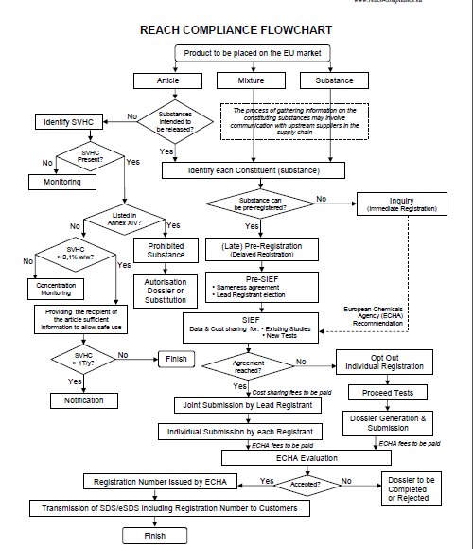

Figure 1 Reach Compliance Flowchart (32)

#### Substance identification

One of the first processes in complying under REACH is **substance identification** or the **requirement of information** on the substance in question.   
Information requirement/substance identification refers to the information that is needed in a registration dossier (see article 10, and annexes VI to XI). The type of information that is required in this step includes: Information on inherent properties of the substance, information on manufacture, use and exposure. But it can also refer to information on intrinsic properties of the substance.  
Initially, the information requirement depends on tonnage of the substance but it can also be influenced by certain substance characteristics like usage and exposure. The specific information requirements for substances manufactured or imported in huge amounts (between 1-10 tonnes) can also be affected by the classification of the substance (ex. Phase in /non-phase in). Annex VII to X of REACH regulation describes the standard information requirements for each tonnage band. Proper substance identification will facilitate the process to complying with REACH *see table 2*. (3)

Table 2 facilitations of a proper substance identification

|  |
| --- |
| **Proper substance Identification** |
| Enables the sharing of information by potential registrants and data holders to prevent the duplication of testing on animals and unnecessary costs |
| Enables the assessment of the applicability of test data across companies who registered the same substance, the assessment of read-across proposals (categorization approach) or the use of non-test information |
| Enable the assessment if a substance is included in the Authorization List, the list of restrictions or if its classification and labelling has been harmonized |

For the proper of identification of a manufactured or imported substance the following information must be included in the dossier:

* + Substance name and related identifiers, molecular and structural formulae, if applicable
  + Information on the composition and purity of the substance
  + Spectral data and analytical information to verify the identity and composition of the substance
  + Clear and concise description of the analytical methods (4)

#### Registration

|  |
| --- |
|  |

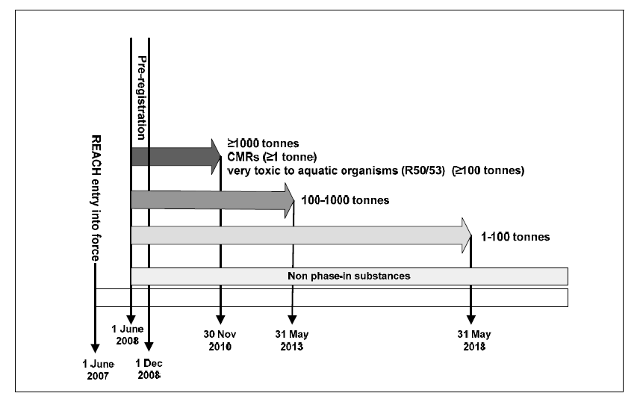Substances are not allowed to be manufactured or imported into the EU without them being registered under REACH.   
  
The registration proceeds by submitting to the European Chemical Agency (ECHA) before the registration deadlines (*see figure 1)*, according to Articles 10, 11, 12, 17 and 18 of REACH legislation, a **registration dossier**, which consists of a technical dossier and if required a chemicals safety report for the substance(s) that is/are subject to registration. The registration dossier contains a compilation of all the required information for registering a substance. The dossier has to be prepared by using a software application called IUCLID 5. This software application implements harmonized templates that are developed by The Organisation for Economic Co-operation and Development (OECD). After the dossier has been created it has to be submitted to ECHA through REACH-IT, it is a central IT system that supports industry and is utilized by Member state competent authorities and ECHA for securely submitting, processing and managing data dossiers. (5)

Figure 2 registration deadlines (6)

The registration obligations apply to actors that fall under the roles of manufacturers, importers or downstream users handling about one tonne or more per year. They have the responsibility to identify and manage all the risks of the substances they produce and market. The Substances from which the risks are required to be identified and managed are classed under REACH as follows:

* **Substance –** stands for the chemical element and its compounds, it includes: substances obtained by manufacturing processes (ex. formaldehyde or methanol) and substances in their natural state. Additives and impurities are also included in the term substance. Excluded are solvents which can be separated without affecting the stability or composition of the substance.
* **Mixture –** is defined as a mixture or solution that is composed of two or more substances (ex. paints, varnishes and inks). The REACH obligation apply for each individual substance contained in the mixture, whether each individual substance is in the scope of reach.
* **Article –** is defined as an object which during production is given a special shape, surface or design which determines its function to a greater degree than does its chemical composition (e.g textiles, electronic chips, furniture, books, toys, kitchen equipment).

Only the individual substances are tied to the registration obligations, independently of whether they are on their own, in a mixture or in an article. In other words, if the chemical that is subject to registration falls under “article” or “mixture” then each constituent of the chemical must be identified and registered individually.  
However, there are certain substances that are partially or completely exempted from registration obligations. These types of substances are described in Article 2 – Annex IV of REACH regulation, they are already regulated by other legislations such as: medicines radioactive, or radioactive substances.

REACH registration is based on the "one substance, one registration" principle, this implies that actors (e.g. importers, manufacturers and downstream users) of the same substance are obliged to jointly submit their registration. A fee is usually charged for the registration of substances. (6) (7) (8) (9) (10)

#### Evaluation

After the registration dossier is submitted to ECHA, it is evaluated by both ECHA and member states. The dossier is evaluated on the quality of information that is submitted, this information includes: information on testing proposals and the clarification of the risks on human health and environment.

Evaluation under REACH focuses on three different areas:

1. Examination of testing proposals submitted
2. Compliance Check of dossiers submitted by registrants
3. Substance evaluation

ECHA can request more information (if necessary) if the information quality is not sufficient. (11)

#### Authorisation

The authorisation process under REACH has the main goal of identifying substances of very high concern (SVHC), controlling their risks and progressively replacing them with suitable alternatives while ensuring the good functioning of the EU internal market.

Substances may be identified as SHVC when they have the following properties:

* Substances meeting the criteria for classification as carcinogenic, mutagenic or toxic for reproduction category 1A or 1B in accordance with Commission Regulation (EC) No 1272/2008 (CMR substances)
* Substances which are persistent, bio accumulative and toxic (PBT) or very persistent and very bio accumulative (vPvB) according to REACH (Annex XIII)
* Substances identified on a case-by-case basis, for which there is scientific evidence of probable serious effects that cause an equivalent level of concern as with CMR or PBT/vPvB substances

Following a two-step regulatory process, a substance can be included in the authorisation and become subject to authorisation. Once a substance is subject authorisation, it cannot be placed on the market or used (usually after a given date set by ECHA). If a manufacturer, importer or downstream user is utilizing a substance that is on the authorisation list, he can apply for authorisation, in which the substance can be authorized for specific use or can be exempted from authorisation procedure. (12)

#### Restriction

The European commission uses Restriction under REACH as a tool to protect the human health and environment from risks posed by chemicals, though limiting banning the market placement or use of a substance. A Member State or ECHA can apply for the restriction of chemical if they find that risks that need to be addressed on a Union wide basis. The restriction can apply on the following chemicals

* Chemicals in all the categories under REACH (mixture, article or substance)
* Chemicals that do not require registration
* Imports
* Articles containing substances that are in the Authorisation list (Annex XIV)

Comments on the proposal of a restriction on a substance can be made by anyone, including: companies, organizations representing civil industry or civil society, individual citizen and public authorities. In fact comments are welcomed so that they can be revised in order to make a final decision. (13)

## 2.2 Classification, Labeling and packaging of chemicals (CLP)

The CLP legislation is a legal framework founded in 2008 for classifying, labeling and packaging chemicals. Complying with CLP regulation for a company has to classify and label all chemicals used in volumes of 1 ton per year or greater.   
Classification often varies slightly from company to company but the CLP legislation provides standards which all companies need to meet. This includes dimensional requirements for labeling as well as the standardized pictograms that identify the hazards associated with the chemical. The obligations that a supplier needs to meet depends on the supplier’s role in the supply chain. As a supplier you may fall into one of the following roles:

* Manufacturer of substances or mixtures
* Importer of substances or mixtures
* Producer of specific articles
* Downstream user, including formulator and re-importer
* Distributor, including retailer

Upon placement of hazardous substances on the market, it is required to notify ECHA of the substance’s classification and labeling within one month. For importers, the one month counts from the day the substance physically enters the custom territory of the EU.

If the classification of a hazardous substance changes with the implementation of CLP, the safety data sheet needs to be updated according to the potential hazards. It may also be necessary to prepare new safety data sheets if the substance or mixture of chemicals were not classified as a hazard under DSD (Dangerous Substance Directive) or DPD (Dangerous Products Directive).   
(14) (15)

### 2.2.1 Global Harmonized Systems (GHS)

Correct classification, labeling and packaging is essential for safe handling of chemicals. This is the motivation behind the Global Harmonized Systems agreement and the later CLP legislation. Prior to 20th of January 2009 the predecessor to CLP legislation was the United Nations Global Harmonized Systems, which as the name suggests applies to most of the globe. GHS was international voluntary agreement designed to label chemical hazards similarly across the world.

The UN-GHS has set forth classification groups for the following Hazards:

**Physical Hazards** (16 Classes): Explosives, flammable gases, aerosols, oxidizing gases, pressurized gases, flammable liquids, self-reactive substances, pyrophoric liquids, pyrophoric solids, self-heating substances, water reactive, oxidizing liquids, organic peroxides and corrosive to metal.

**Health Hazards** (10 Classes): Acute toxicity, skin corrosion/irritation, aspiration, reproductive toxicant, carcinogenicity, serious eye irritation/damage, respiratory or skin sensitization, germ cell mutagenicity, STOT- single exposure, STOT- repeated exposure

**Environmental Hazards** (2 Classes): Hazardous to ozone layer, hazardous to aquatic environment. (16)

This means that any substance or mixture which can be classified in one of the above classes, it has to be correctly stored and labeled to warn against the risks of working with said substance.

### 2.2.2 Classification Process

The so called ‘self-classification of substance or mixture by the manufacturer, importer or user’ is principle concept of CLP, hazard identification is one of the result of classification. The hazard identification involves physical, health and environmental hazards, or comparison of those hazards, and degree of hazard. Under the CLP there are three steps to apply; identification and examination of relevant data regarding the potential hazards of a substance or mixture, comparison of the data with the classification criteria, and decision on whether the substance or mixture shall be classified as hazardous in relation to the hazard classes provided in CLP Annex I, and the degree of hazard, where appropriate. Classification according to CLP is based on intrinsic hazards.

All substances subject to REACH are also subject to classification, but a number of substances and mixtures are exempted from the classification.

Requirements:

* Radioactive substances and mixtures (Directive 96/29/Euroatom18);
* Certain substances and mixtures which are subject to customs supervision;
* Non-isolated intermediates;
* Certain substances and mixtures for scientific research and development;
* Waste (Directive 2006/12/EC19); and
* Certain substances or mixtures in the finished state, intended for the final user:
* Medicinal products (Directive 2001/83/EC20),
* Veterinary medicinal products (Directive 2001/82/EC21),
* Cosmetic products (Directive 76/768/EEC22),

Medical devices as defined in Directive 90/385/EEC23 (active implantable medical devices) and 93/42/EEC24 (medical devices in general), which are invasive or used in direct physical contact with the human body, and in-vitro diagnostic medical devices (Directive 98/79/EEC25)

Food or feeding stocks (Regulation 178/200226) including food additives (Directive 89/107/EEC27) and flavoring in food products (Directive 88/388/EEC and Decision 1999/217/EC28).

This information can include experimental data generated in tests for physical hazards, toxicological and eco-toxicological tests, historical human data such as accident records or epidemiological studies, or information generated in in vitro tests, QSAR, or category approaches. The data also can be provided through the application of REACH, or be available from other EU legislation for which there are specific requirements for test data to be generated such as Directive 91/414/EEC (Plant Protection Products) and Directive 98/8/EC (Biocidal Products), or from various non-Community programs. When there is no available information, the test can be carried out. The identification of mixture is normally based on the result of tests about themselves, except maybe identifying CMRs or long term effect of mixture.

### 2.2.4 Labeling

According to CLP the labeling of substances should be done whenever:

* A substance is classified as Hazardous
* A mixture contains one or more substances classified as hazardous above a certain threshold

The content and organization of the various labeling elements of the label are defined by CLP. The label should include:

* The name, address and telephone number of the supplier
* The nominal quantity of a substance or mixture in the packages made available to the general public (unless this quantity is specified elsewhere on the package)
* Product identifiers
* Where applicable, hazard pictograms (*see Figure 3)*, signal words, hazard statements, precautionary statements and supplemental information required by other legislation.

Some substances and mixtures contained in packaging (typically less then125ml) are too small or difficult to label. For these substances exemptions are provided by CLP. These exemptions allow hazard and/or precautionary statements or pictograms, usually required by CLP, to be omitted from the label by the supplier. (17)

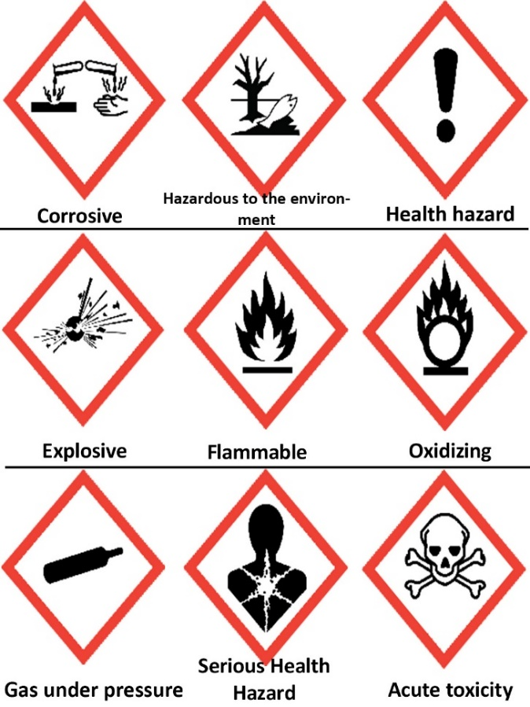  
  
Figure 3 CLP pictograms used for labelling (18)

The pictograms seen in Figure 3 are used in the labelling and packaging of substances or mixtures. They are described more in detail in *Table 3.*

Table 3 Definition of hazard statements (18)

|  |  |  |
| --- | --- | --- |
| Hazard Statement | Symbol | Definition |
| Corrosive | **Corrosion** | May be corrosive to metals  Causes severe skin burns and eye damage |
| Hazardous to the environment | **Environment** | Very toxic to aquatic life with long lasting effects Toxic to aquatic life with long lasting effects |
| Health hazard/Hazardous to ozone layer | **Exclamation mark** | May cause respiratory irritation  May cause drowsiness or dizziness  May cause an allergic skin reaction  Causes serious eye irritation  Causes skin irritation  Harmful if swallowed  Harmful in contact with skin  Harmful if inhaled  Harms public health and the environment by destroying ozone in the upper atmosphere |
| Explosive | **Exploding bomb** | Unstable explosive  Explosive; mass explosion hazard  Explosive; severe projection hazard  Explosive; fire, blast or projection hazard  May mass explode in fire |
| Flammable | **Flame** | Extremely flammable gas  Flammable gas  Extremely flammable aerosol  Flammable aerosol  Highly flammable liquid and vapour  Flammable liquid and vapour  Flammable solid |
| Oxidizing | **Flame over circle** | May cause or intensify fire; oxidiser.  May cause fire or explosion; strong oxidiser. |
| Gas under pressure | **Gas cylinder** | Contains gas under pressure; may explode if heated.  Contains refrigerated gas; may cause cryogenic burns or injury. |
| Serious Health Hazard | **Health hazard** | May be fatal if swallowed and enters airways  Causes damage to organs  May cause damage to organs  May damage fertility or the unborn child  Suspected of damaging fertility or the unborn child  May cause cancer  Suspected of causing cancer  May cause genetic defects  Suspected of causing genetic defects  May cause allergy or asthma symptoms or breathing difficulties if inhaled |
| Acute Toxicity | **Skull and crossbones** | Fatal if swallowed  Fatal in contact with skin  Fatal if inhaled  Toxic: if swallowed  Toxic in contact with skin  Toxic if inhaled |

### 2.2.5 Notification procedure

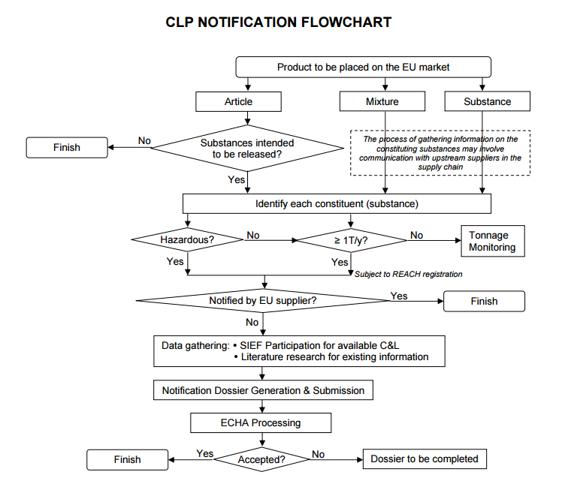In case of a substance/chemical which is hazardous and is not already registered by a European supplier it needs to undergo extensive REACH testing and analysis from ECHA (European Chemicals Agency) to properly classify the risks associated with the substance or chemical. All of which is paid by the company who wants to introduce the substance to the market. The process of registering a substance, mixture or a product on the European market is shown in illustration 1 with a flow chart.

Figure 4 Flowchart describing the CLP notification process (31)

## 2.3 Seveso Directive

After the two major disasters; the 1974 factory explosion in Flixborough (England) and the Chemical accident near Seveso Italy, the European union adopted a directive for the safe handling of hazardous substances in EU’s chemical industry namely, the Seveso-directive (Directive 82/501/EEC). The purpose for adopting this directive was to prevent major disasters from occurring and to minimize chemical accidents when they occurred.   
But despite the adoption of the Seveso I regulations, another chemical disaster occurred at Sandoz in Bazel (1986). This proved that **Seveso-directive (Directive 82/501/EEC)** was incomplete, this lead to improvement of the **Seveso-directive (Directive 82/501/EEC)** to an updated version called the **Seveso-II (Directive 96/82/EC)**. It was constructed with the help of lessons learned from accidents such as Bhopal, Toulouse or Enschede. The last update was the replacement of the previous Seveso II directive by the **Seveso-III (Directive 2012/18/EU**) in 2012, due to the changes of the European Union’s legislation on classification of chemicals and increased rights for citizens to access information and justice.  
  
Nowadays the Directive applies to more the 10000 industrial establishments in the EU, which handle and/or store dangerous/hazardous substances in large quantities, mainly in the chemical, petrochemical logistics and metal refining sectors.  
  
Considering the very high rate of industrialisation in the European Union the Seveso Directive has contributed to achieving a low frequency of major accidents. The Directive is widely considered as a benchmark for industrial accident policy and has been a role model for legislation in many countries world-wide. (19) (20)

### 2.3.1 PGS-15

The Sandoz disaster in Basel in 1986 was the trigger for the development of a number of guidelines for the storage of packaged hazardous substances in the Netherlands namely, the CPR 15 guidelines. These guidelines are the result of the convergence of Seveso regulations into national laws.   
In 2005 These Guidelines merged to form the Dutch serial application dangerous goods or “Publiecatie Reeks Gevaarlijke stoffen (PGS)”. These present the requirements and criteria, which can be used in environmental licensing, drawing up general rules and supervision of companies for occupational safety, environmental and fire safety.   
   
PGS 15 is part of the PGS Series and is the guideline for the storage of packaged hazardous substances, it contains rules to achieve an acceptable level of protection for the storage of packaged hazardous substances and/or CMR substances. The storage of substances are distinguished in two groups; “small storage” (<< 10 ton) of hazardous substances and/or CMR and “big storage” (10 ton >>) of hazardous substances and/or CMR. (20) (21)   
  
ADR   
“Accord européen relatif au transport internation al de marchandises Dangereuses par Route” (European agreement concerning the international carriage of dangerous goods by road), covers all provisions regarding dangerous goods transport by road in the EU. The ADR agreement was done in 1957 at Geneva under the auspices of the United Nations Economic Commission for Europe and entered into force in January 1968. (22)

The UN have defined 9 “ADR” classes of dangerous goods (*see Table 4)*

Table 4 ADR Classes (20)

|  |  |
| --- | --- |
| **ADR Class** | **Description** |
| Class 1 | Explosive substances and artciles |
| Class 2 | Gases |
| Class 3 | Flammable liquids |
| Class 4.1 | Flammable Solids, self-reactive substances and solid desensitized explosives |
| Class 4.2 | Substances liable to spontaneous combustion |
| Class 4.3 | Substances, which in contact with water, emit flammable gases |
| Class 5.1 | Oxidizing substances |
| Class 5.2 | Organic peroxides |
| Class 6.1 | Toxic substances |
| Class 6.2 | Infectious substances |
| Class 7 | Radioactive Material |
| Class 8 | Corrosives |
| Class 9 | Miscellaneous Dangerous Substances and articles |

The scope of PGS 15 is based on the ADR-classifications *(see Table 5)*, this in order to simplify the application of the regulation for companies in practice. The PGS15 influences the storage provisions of many ADR classes.

Table 5 Scope of PGS 15 (20)

|  |  |  |  |
| --- | --- | --- | --- |
| ADR | Description | Covered by PGS15 | Details/lower limit in kg/litres |
| 1 | Explosive substances articles | No | For these substances a specific approach and solution is required in the permit. Part of these substances is covered by the fireworks decree. |
| 2 | Gas Cylinders, Most common gases, appendix 7 PGS 15 | Yes | Water content 115 litres; The basic Dutch environmental rules refers from 125 litres to the PGS 15. However the standard cylinder volume of 60 litres would be a more logical limit. |
| 2 | Aerosols and gas Cartridges | Yes | 50 in case aerosols and gas cartridges are stored in combination with other packed dangerous goods, no limit exists. |
| 2 | Most common gases, appendix 7 PGS 15 | Yes | 50 |
| 2 | Gas cylinders with toxic and corrosive substances | No | For these gases the PGS 15 could function as a basis for the permit authorisation, however additional regulations are required, dependent of the situation. |
| 3 | Flammable liquids | Yes | 25 (packaging group II)  50 (packing group III) |
| 3, 4.1, 4.2, 4.3, 5.1, 6.1, 6.2 and 8 + CMR substances | All substances classified in packaging group I | Yes | 1 (packing group I) |
| 4.1 | Flammable Solids, Self-reactive substances and solid desensitised explosives | Yes | 50 (packing group II and III) |
| 4.2 | Substances liable to spontaneous combustion | Yes | 50 (packing group II and III) |
| 4.3 | Substances which in contact with water, emit flammable gases | Yes | 50 (packing group II and III) |
| 5.1 | Oxidizing substances | Yes | 50 (packing group II and III) |
| 5.2 | Organic peroxides (< 1.000 kg in limited quantities (LQ) packing) | Yes | No lower limit exists |
| 5.2 | Organic peroxides > 1.000 kg or without LQ packing | No | For the stage of organic peroxides the PGS 8 is active, unless < 1000 kg in LQ-packing, when chapter 9 of PGS 15 is valid |
| 6.1 | Toxic substances | Yes | 50 (packing group II and III) |
| 6.2 cat I3, I4 | Infectious substances, solely hospital waste and diagnostic samples | Yes | 50 (packing group II and III) |
| 6.2 not cat I3, I4 |  | No | Because of specific aspects a custom made solution is required |
| 7 | Radioactive material | No | These substances are covered by the nuclear law. |
| 8 | Corrosives | Yes | 250 (packaging group II and III) |
| 9 | Miscellaneous dangerous substances and articles solely environmentally damaging substances fall in the scope of PGS 15 | Yes | 250 (packaging group II and III) especially liquid and solid substances that pollute the aquatic environment like mercurious chloride, diphenylether, chlorhexidine, chlorinated paraffins and disopropylbenzene |
| 9 | Not environmental dangerous goods and articles | No | There is no special need for special storage provisions. However these substances, can be stored as related substances in a storage facility |
| 9 | Genetic modified organisms | No | These substances are covered by the genetic modified organism’s decree. Addition permit is required, with custom made storage provisions |
| 5.1, 9 |  | No | The PGS 7 is applicable |
| Miscellaneous | Pesticides till 400 kg | No | The storage regulations of these goods is covered by the pesticides decree |

## 2.4 Dutch risk map

The Dutch government decided that risks must be better mapped out and that everyone in the Netherlands must be informed about the risks in their own vicinity, after the firework disaster in Enschede and the New Year fire in Volendam.   
Several parties participate in the drawing of the risk map; the Ministry of Infrastructure and the Environment and the Ministry of the Safety and Justice is few of them. The map indicate 18 types of risks in area; accident involving flammable substances, toxic substances and explosive substances, floods, natural fires and so on.

The map helps to draw conclusions about whether or not the location of factory is sufficient, it is suspected hard to get permission on building the factory if risk is too high. And the map can also help to draw building structure like increase the flooding where the risk is about flood. (23)

## 2.5 BREF-documents

BREF stands for BAT reference document, where BAT stands for Best Available Technique as defined by the European IPCC Bureau. BREF is defined as “a document, resulting from the exchange of information organised pursuant to Article 13 of Directive 2010/75/EU, drawn up for defined activities and describing, in particular, applied techniques, present emissions and consumption levels, techniques considered for the determination of best available techniques as well as BAT conclusions and any emerging techniques, giving special consideration to the criteria listed in Annex III to Directive 2010/75/EU. In other words, BREFs give description of a series of industrial processes along with their operating conditions and emission rates. (24) BREF documents usually feature a description of the:

* General information about the industry
* Applied processes and techniques
* Current consumption and emission levels
* Technique to perform for the determination of BAT
* Assessment of the environmental benefits
* Cross media issues
* Applicability of the technique
* Economic information
* Reference plants
* BAT conclusion (25)

This framework is intended to provide information that helps meet the aims and objectives of IPCC. However, each BREF is covering a specific matter with its own concerns.

These reference documents are listed in the Annex I to the European IPCC Directive. When determining the best available techniques for their industrial activities, Member States of the European Union must take into consideration related BREF documents. The guidance BREF documents provide is meant for a wide range of decision makers such as:

* Industry operators needing to apply for a permit
* Permit writers in the competent authorities of Member States
* Policy makers involved generally in environmental regulation and IPCC in particular
* Society at large (25)

### 2.5.1 Relationship with REACH and CLP

As explained in Chapter 2.1 and 2.2, REACH and CLP regulate the registration, transport and storage of chemicals. Yet, the actual use and control of emissions is not taken in account. This is where the Intergovernmental Panel on Climate Change (IPCC) and Industrial Emission Directive (IED) arises. Indeed, these two organizations are the ones that regulate use and emissions of chemicals through the implementation of BREF documents. That is to say all the decision makers listed in section 2.6.1 must use BREF documents along with REACH and CLP regulations in order for the whole process using chemicals to comply with the EU legislation as explained with figure 3.

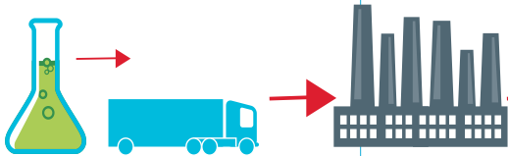 REACH and CLP IPCC and IED

Figure 5 Relation between REACH, CLP and BREFs

Information on chemicals, Use of chemicals and

Restriction on transport, use and storage control of emissions using BREFs

## 2.6 QSAR

QSAR is an abbreviation and stands for quantitative-structure activity relationship and is a model that relates a set structural descriptors of a chemical compound to its biological activity and are used in biological and chemical science and engineering. There are two types of models, QSAR regression models and classification models. The QSAR regression model relates predictor variables to the potency of the response variable, and QSAR classification models are used to relate the predictor variable to a categorical value of the response variable. The QSAR model is used to predict measures of toxicity from the physical characteristics of the molecular descriptors. An example of a measure that can be predicted from a QSAR is an acute toxicity such as the concentration that kills half a mice population or also called LD50.

For simple QSAR models they use the formula: Toxicity = ax1+bx2+c to calculate the toxicity of a chemical. In this formula x1 & x2 represent the independent descriptor variables and a, b and c are the matching parameters. The QSAR toxicity predictions can be used to look at untested compounds to establish priorities for bioassays, which are pretty time consuming and expensive. (26)

#### Ld50

LD50 is an abbreviation and means Lethal Dose for 50% of the subjects. It is the quantity of a substance that will kill 50% of a certain population. The idea with the LD50 is that the substance will be delivered at once, so the LD50 is a measure for acute toxicity of a substance and not for long term toxicity of a substance. The LD50 is mostly expressed in mass of the toxic substance per unit mass of the subject, most of the time this will be mg of substance per kg of body mass of the subject.

The reason for a 50% mortality as reference point is to prevent the testing of individuals under extreme circumstances and it decreases the amount of tests that is necessary. However, because not every individual is equally sensitive to a substance, it will maybe mean that the LD50 is not lethal for all subjects, some will be killed by a lower LD and some will survive the LD50 or even a higher LD. Because of this the toxicity of a substance can also be measured with a LD1 or a LD99, the amount of a substance that is needed to kill 1- and 99% of a population.

A LD50 will not always be very reliable because there could be great differences between different factors such as the kind of species that is tested because a value measured by rats doesn’t need to be the same with humans (for example chocolate, it is harmless to humans but toxic for a lot of animals). Also a big difference can be how the substance enters a body, it can be inhaled, injected, taken up by the skin or eaten. Also different environmental factors and characteristics of the population could cause unreliable results between different testing facilities. The most used routes of administration are by skin and by mouth because those are the parts of your body that frequently often make contact with substances.

A comparable measure of the LD50 is the LC50 and it means Lethal Concentration for 50% of the subjects. With the LC50 they look at the concentration of a substance in the air, water, ground and food. The LC50 is most of the times measured in mg/kg, µg/l of mg/m3. (27) (28)

# 3 Products and Results

## 3.1 Registration Format REACH

For the Registration of the chemicals of Appsung’s substance list certain steps had to be taken. Figure 6 shows a flow scheme which summarizes the different steps taken to determine what actions Appsung needs to take to comply with reach REACH.

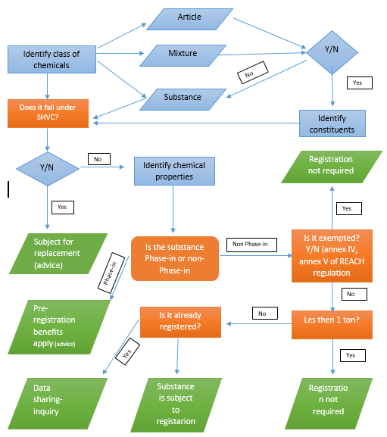

Figure 6 Flow scheme for the identification under REACH

First of all the class of each substance is identified by figuring out if the chemical falls under a mixture, article or substance, if the article doesn’t fall under a substance, then each constituent of the substance has to identified and undergo the registration procedure. Radioactive substances, medicines, waste or pesticides do not require to undergo the registration procedure. In this condition, other legislations apply and these will not be evaluated in this report.

The second step is to find out whether the substance falls under a substance of very high concern (SHVC). If the substance falls under SHVC, then it is advised to replace the substance with an alternative substance. Unless there are no alternatives for the substance and the socio economic benefits of the substance use outweigh the risks the substance poses, then it is advised to send an authorisation inquiry to ECHA. Keep in mind that extra costs come into play when taking this action.

Next is to identify whether the substance is “phase-in” or “non phase-in”. If the substance is a phase-in substance this means that the substance is or may be subject to pre-registration in which “pre-registration benefits” (extended registration deadlines) apply. If the substance is non phase-in then the pre-registration benefits don’t apply and further action has to be taken in the registration procedure.  
  
Next is to find out if the substance in question is in REACH’s “exemption” list, this list is described in Article 2 – Annex IV of REACH (*see chapter 2.1.3)*. No registration is required if the substance is exempted.  
  
Also, the tonnage band of the substance must be identified for the registration procedure. If the substance is manufactured/imported in amounts less than one tonne per year, then the substance does not need to be registered.   
  
The final step to undertake is to figure out whether the substance is registered or not. If the substance is already registered then a data-sharing inquiry must be sent to ECHA I order to get the necessary information for labelling and packaging.   
  
Table 4 shows the results of following the flow scheme (*See fig 6)* for each chemical on Appsung’s chemicals list. It points out which chemical needs to be registered/replaced. A more detailed advice on substance registration is provided to Appsung in the final chapter of this report.

Table 6 Results for the registration of chemicals under REACH

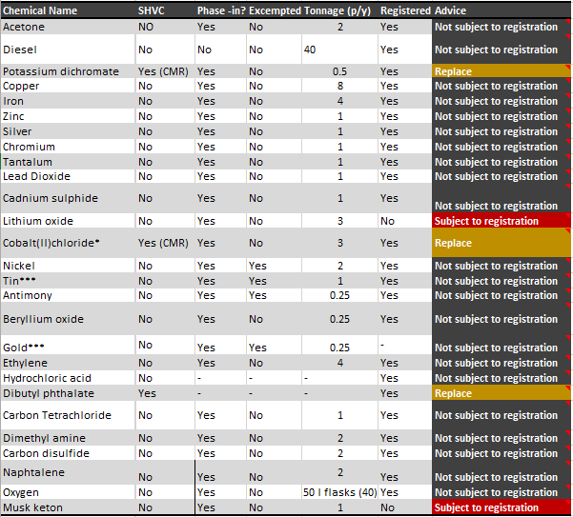

## 3.2 Labelling Format CLP

Figure 7 gives an example of a possible chemical label-design according to CLP. 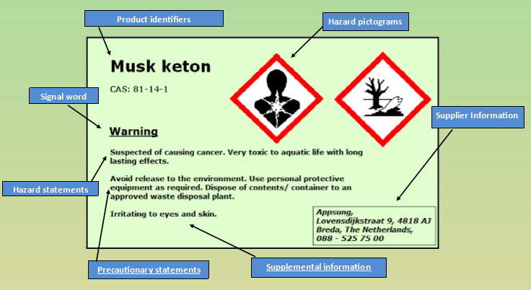

According to CLP, the different components on the label are all required (obligated). The components are described as follows:

* **Product Identifiers:** This includes information such as the Name of the substance and the CAS number.
* **Signal Word:** This word is used to indicate the risks of the substance. “Danger” is used for dangerous substances and “warning” for less dangerous ones.
* **Hazard statement:** A short phrase that describes the risks and harm of the substance.
* **Precautionary statements:** Standardized precautionary statements for the correct handling of the substance.
* **Supplemental information:** Provides important supplemental information of the substance, like: direction for proper use, expiration date, gross weight etc.
* **Supplier information:** Information of the receiver of the substance. This includes information like the name, address etc.
* **Hazard pictograms:** Symbols that warn the user of the substance about the risks that the substance poses (*see Fig 3 & Table 3)*.

All chemicals should have these components on the labels in order to comply with CLP. **Annex I** gives a description on what all has to go on the labels of the chemicals that Appsung is going to use.

## 3.3 Storage plan

This chapter describes what factors need to be taken into consideration for the storage plan.   
  
3.3.1 Categorization of chemicals

The chemicals that Appsung will be handling are all categorized according to the ADR classes (*see Table 4 & 7)*, after the categorization of each chemical a storage design (see figure) is constructed according to the PGS-15 regulations.

Table 7 Categorization of chemicals

|  |  |  |
| --- | --- | --- |
| ADR | Description | Chemical |
| None | Substances that don’t need any special storage requirements | Iron, Silver, Chromium, Tin, Gold, Zinc, Copper, Tantalum, Antimony, Beryllium oxide |
| Class 2 | Gases | Ethylene, Dimethyl amine |
| Class 3 | Flammable liquids | Acetone, Carbon disulphide, Diesel, Lead Dioxide, Cadmium sulphide |
| Class 4.1 | Flammable Solids, self-reactive substances and solid desensitized explosives | Naphthalene, Nickel, Carbon Tetrachloride |
| Class 6 | Oxidizing substances | Nickel, Potassium dichromate, Oxygen |
| Class 8 | Corrosives | Hydrochloric acid, Lithium Oxide |
| CMR | Toxic substances | Dibutyl phthalate, Cobalt(II)chloride, Musk ketone |

### 3.3.2 Requirements for safe storage

This section address the storage requirements according to PGS-15.

#### Overall safety measures

* Storage areas marked with warning signs
* Only authorized employees should enter the storage
* All containers must be have labels
* Cool and dry conditions
* Protection gear (goggles etc.)
* Safety equipment (first aid etc.)
* Chemicals to be stored away from substances they might react with

#### Warehouse requirements

* Leak tight floor
* Drainage system in warehouse and at loading docks
* Ventilation system
* Fire Extinguishers
* Alarms
* Emergency safety plan
* Water/argon sprinkler system

#### Storage requirements for corrosive and toxic materials

* Stored away from production
* Chemicals separated according to classes
* Corrosion resistant floors/cabinets/shelves if corrosive substances are present

must have fire-fighting equipment.

### 3.3.3 Storage Design

For the design of the storage facility, several factors were taken into account, most importantly being the compatibility of storage between all the chemicals. First of the rooms of the storage facility need to large enough to hold the volume of the substances that are going to be imported by Appsung. The spacing of each storage corner has to be a minimum of 3 meter except for spacing between the flammable, corrosive and toxic materials, these have to be spaced about 5 meters from each other. The class of substances with no special storage requirements can be stored outside of the storage area where the rest of the chemicals are being stored (note: inside of the facility).

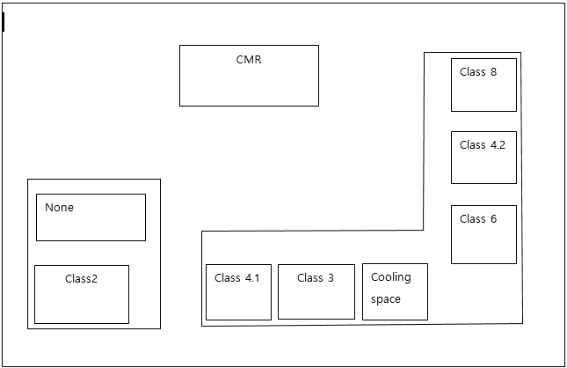 Figure 7 Storage design

## 3.4 Location suitability

Since Appsung is going to transport, handle and store hazardous substances, it poses a risk to human health environment. Therefore, according to Dutch Law (External Security Registration Decision), the company needs to register the necessary information to acquire a permit in order to be able to continue its activities. The information can be found in article 8-14 of the Dutch External security Registration Decision (Registratiebesluit Externe veiligheid). (29)  
The information for registration to the Dutch External Security Registration Decision defines whether the registrant wil receive a permit based on the Dutch Environmental act (Wet milieubeheer). The act describes the condition needed to be met I order for the company to require the permit. If the company has required a permit, it will be checked by the municipality if the company is complying with the conditions of the permit. If there is no compliance, then further activities of the company can be shut down.  
  
According to the Dutch security Regions Act (Wet veiligheidsregio’s), the province has to add the risks the company poses to the Dutch Risk Map after the company has registered. The law describes sensitive objects and high risk areas on the Dutch Risk Map.   
The Public safety Decree (Besluit Externe Veiligheid) contains standards for: limit values for spatial planning permits, location assement and building. The information is used by the government for the consideration of allowing a company to be established at its chosen location. In the case of appsung the location is Lovensdijkstraat Breda. (30)

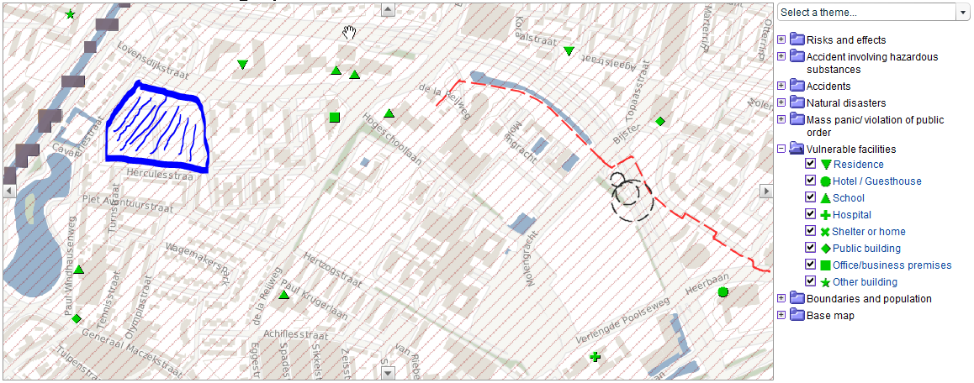The location of appsung is at Lovensdijkstraat 1, 1111 AA near the city centre of Breda. Figure & shows the sensitive objects near the new Appsung building. There are sensitive objects located near the company these include Residence buildings, schools, a hospital, shelters etc. This area poses a risk because of the high concentration of noted human activity. Furthermore there are flood areas and the river Mark right next to the building. All of these factors increase the risks associated with the building the new Appsung phone factory in this area.

Figure 9 Risk map Appsung

# Advice

This section provides a summary of the advice to Appsung.

#### REACH

Table 6 shows the results of all the chemicals of apssung. It describes the the subsequent actions that need to be taken I order for Appsung to comply with REACH. Of all the substances 3 have to be replaced (Postassium dichromate, Cobalt(II)Chloride and Dibutyl phthalate) and 2 have to go through the registration process (Lithium Oxide and Musk ketone).

It is adviced to replace the Potassium dichromate, Cobalt(II)Chloride and Dibutyl phthalate with alternative substances, because all of these substances are classed as substances of very high concern. If no alternative to these substances is found, it is advised to submit an authorization dossier to the European commission they will then analyze the risks of the substance and will have the final decision. Note that the submission to each for authorization requires Appsung to pay.

For the substances; Lithium Oxide and musk ketone, It is advised to submit to echa a registration dossier to undergo the registration process. Note that firstly a joint submission should be explored as it is required by REACH.

For the rest of the substances no registration has done, for the requirement of information regarding properties and risks of the substances (CLP), an inquiry should be sent to ECHA to retrieve the necessary information through “data-sharing”  
  
CLP  
Almost all of the substances that Appsung is going to use in its phone production process pose risks to the environment and to human health. Therefore it is advised to use the information provided in **ANNEX I** when printing out the labels for each Chemical. All the information is in accordance to CLP regulation and will account for a safe working environment in Appsungs storage facility.

#### Storage Design

It is adviced to follow the information provided in chapter 3.3 for the design of the storage facility. All the storage requirements according to PGS-15 are stated in the chapter mentioned above.

#### Location suitability

According to the Dutch Risicokaart, the location at which the factory will be build is not suitable, because the risks surrounding the factory location. Human activity is high, alongside of that there are certain objects of sensitivity (residence building, hospitals etc) and there is a river right next to the factory location. All these factors increase the risks of the factory. It is advised to look for a location that is more suitable for the factory. There is a huge industrial are in Breda, which could serve as a viable option.

# Bibliography

1. **Brouwer, Femke and Marinussen , Mari .** Manual Project Safety and Risk . [Online] 4 2015. https://bb.avans.nl/webapps/blackboard/content/listContent.jsp?course_id=_80058_1&content_id=_5620662_1.

2. **(ECHA), European Chemical agency.** Understanding-reach. [Online] 2015. http://echa.europa.eu/en/regulations/reach/understanding-reach.

3. **consulting, B- lands.** REACH definitions and acronyms . [Online] http://www.reach-compliance.eu/english/REACH-ME/engine/sources/definitions.html#Registration.

4. **European Chemicals Agency (ECHA).** Substance Identity . [Online] http://echa.europa.eu/regulations/reach/substance-identity.

5. **European Chemicals Agency.** REACH-IT. [Online] echa.europa.eu/support/dossier-submission-tools/reach-it.

6. —. Guidance on registration. [Online] May 2012. http://echa.europa.eu/documents/10162/13632/registration_en.pdf.

7. **Online, REACH.** Article 2 application . [Online] http://www.reachonline.eu/REACH/EN/REACH_EN/article2.html.

8. **B-Lands consulting.** Exemptions from the obligation to register - Article 2(7)(a) - Annex IV . [Online] http://www.reach-compliance.eu/english/REACH-ME/engine/sources/reach-annexes/exemptions-annex04.html.

9. **comission, European.** How REACH works. [Online] http://ec.europa.eu/growth/sectors/chemicals/reach/about/index_en.htm.

10. **European Chemicals Agency.** Registration. [Online] http://echa.europa.eu/regulations/reach/registration.

11. —. Evaluation-ECHA . [Online] http://echa.europa.eu/regulations/reach/evaluation.

12. —. Autorisation-ECHA. [Online] http://echa.europa.eu/regulations/reach/authorisation.

13. **European Chemical Agency.** Restriction-ECHA. [Online] http://echa.europa.eu/regulations/reach/restriction.

14. **B-lands Consultancy.** CLP-Notifications. [Online] http://www.reach-compliance.eu/english/compliance/CLP/CLP-Notifications.html.

15. **European Chemicals Agency.** CLP's Effect on companies . [Online] 2015. http://echa.europa.eu/regulations/clp/clps-effect-on-companies.

16. **Chemical inspection and regulation services.** The UN Globally Harmonized System of Classification and Labeling of Chemicals (GHS). [Online] July 2014.

17. **European Chemical Agency .** Labelling . [Online] http://echa.europa.eu/web/guest/regulations/clp/labelling.

18. **European Chemicals Agency.** CLP Pictograms. [Online] 2015. http://echa.europa.eu/chemicals-in-our-life/clp-pictograms.

19. **The European Commission .** Industrial accidents: The seveso Directive - prevention, preparedness and response . [Online] 22 April 2015. http://ec.europa.eu/environment/seveso/.

20. **Vugts, Wouter and Sava, Andi.** Dangerous Goods . [Online] May 2011. http://www.archicom.nl/media/Downloads/Dangerous%20Goods%20Warehousing.pdf.

21. **Kenniscentrum InfoMil.** PGS. [Online] http://www.infomil.nl/onderwerpen/hinder-gezondheid/veiligheid/pgs/.

22. **The United Nations Economic Commission for Europe .** About the ADR. [Online] 2015. http://www.unece.org/trans/danger/publi/adr/adr_e.html.

23. **Risicokaart.** Risicokaart . [Online] www.risicokaart.nl.

24. **European comission .** Reference documents . [Online] http://eippcb.jrc.ec.europa.eu/reference/.

25. *The Sevilla process: A driver for environmental performance in industry.* **European Conference.** stuttgart : s.n., 2000. ISSN 0722-186X.

26. **United states environmental protection agency .** Quantitative Structure Activity Relationship (QSAR) . [Online] http://www.epa.gov/nrmrl/std/qsar/qsar.html.

27. —. Lethal Dosage (LD50) Values. [Online] 2012. http://www.epa.gov/agriculture/ag101/pestlethal.html.

28. **Smither Viscient .** Acute toxicity studies . [Online] http://www.smithersviscient.com/avian/acute-toxicity-studies/.

29. **Risicokaart.** Veiligheid en wet. [Online] http://www.risicokaart.nl/en/veiligheid_en_wet/registratiebesluit_externe_veiligheid/.

30. **Overheid.nl.** Wet en regelgeving . [Online] wetten.overheid.nl.

31. **B-lands Consultancy.** CLP notification flow chart. [Online] http://www.reach-compliance.eu/english/compliance/CLP/docs/CLP-Notification-Flowchart.html.

32. **B-Lands Consultancy.** PDF_REACH_Registration_Flowchart. [Online] http://www.reach-compliance.eu/web/english/services/european_union/REACH/registration/docs/PDF_REACH_Registration_Flowchart.html.

33. **Publicatiereeks Gevaarlijke Stoffen.** [Online] http://content.publicatiereeksgevaarlijkestoffen.nl/documents/PGS15/PGS%2015_2015_Concept_vs_0_1_150611.pdf.

## Appendix I

|  |  |  |  |  |  |  |  |
| --- | --- | --- | --- | --- | --- | --- | --- |
| **Chemical Name** | **Supplier information** | **Product Identifiers** | **hazard pictograms** | **signal word** | **hazard statements** | **Precautionary statements** | **supplemental information** |
| Acetone | Appsung Mobile Lovensdijkstraat 1111AA Breda Tel: 013112255 | Acetone: CAS:67-64-1 | Exclamation mark, flame | Danger | Highly flammable liquid and vapour(H225), Causes serious eye irritation(H319), May cause drowsiness or dizziness(H336) | Keep away from heat, hot surfaces, sparks, open flames and other  ignition sources. No smoking (P210), Avoid breathing vapours (P261), IF IN EYES: Rinse cautiously with water for several minutes. Remove  contact lenses, if present and easy to do. Continue rinsing (P305 + P351 + P338) | Repeated  exposure may cause skin dryness or cracking |
| Diesel | Appsung Mobile Lovensdijkstraat 1111AA Breda Tel: 013112255 | Diesel: CAS:68334-30-5 | Flame, Health hazard, Exclamation mark, Environment. | Danger | Flammable liquid and vapour (H226), May be fatal if swallowed and enters airways (H304), Causes skin irritation (H315), Harmful if inhaled (H332),Suspected of causing cancer (H351), May cause damage to organs through prolonged or repeated exposure (H373), Toxic to aquatic life with long lasting effects (H411). | Avoid release to the environment (P273), Use personal protective equipment as required (P281), IF SWALLOWED: Immediately call a POISON CENTER or doctor/  physician (P301 + P310), Do NOT induce vomiting (P331). | None |
| Potassium dichromate | Appsung Mobile Lovensdijkstraat 1111AA Breda Tel: 013112255 | Potassium dichromate, CAS: 7778-50-9 | Flame over circle, Skull and crossbones, Health Hazard, Corrosion, Environment. | Danger | May intensify fire; oxidiser (H272), Toxic if swallowed (H301), Fatal in contact with skin or if inhaled (H310 + H330), Causes severe skin burns and eye damage (H314), May cause an allergic skin reaction (H317), May cause allergy or asthma symptoms or breathing difficulties if inhaled (H334), May cause genetic defects (H340), May cause cancer (H350), May damage fertility. May damage the unborn child (H360FD), Causes damage to organs through prolonged or repeated exposure (H372), Very toxic to aquatic life with long lasting effects (H410). | Obtain special instructions before use (P201), Keep away from heat, hot surfaces, sparks, open flames and other  ignition sources. No smoking (P210), Do not breathe dust/ fume/ gas/ mist/ vapours/ spray (P260), Wear protective gloves/ protective clothing/ eye protection/ face  protection (P280), Wear respiratory protection (P284), IF SWALLOWED: Immediately call a POISON CENTER or doctor/ physician. Rinse mouth (P301 + P310 + P330), IF ON SKIN (or hair): Take off immediately all contaminated clothing. Rinse skin with water/shower (P303 + P361 + P353), IF INHALED: Remove person to fresh air and keep comfortable for breathing. Immediately call a POISON CENTER or doctor/ physician (P304+ P340 + P310), IF IN EYES: Rinse cautiously with water for several minutes. Remove contact lenses, if present and easy to do. Continue rinsing (P305 + P351 + P338), IF exposed or concerned: Get medical advice/ attention (P308 + P313), Store in a well ventilated place. Keep container tightly closed (P403 + P233) | None |
| Copper | Appsung Mobile Lovensdijkstraat 1111AA Breda Tel: 013112255 | Copper, CAS :7440-50-8 | None | None | Not a hazardous substance or mixture according to Regulation (EC) No. 1272/2008. This substance is not classified as dangerous according to Directive 67/548/EEC. | Not a hazardous substance or mixture according to Regulation (EC) No. 1272/2008. This substance is not classified as dangerous according to Directive 67/548/EEC. | The product does not need to be labelled in accordance with EC directives or respective national laws |
| Iron | Appsung Mobile Lovensdijkstraat 1111AA Breda Tel: 013112255 | Iron / CAS 7439-89-6 | None | None | Not a hazardous substance or mixture according to Regulation (EC) No. 1272/2008. This substance is not classified as dangerous according to Directive 67/548/EEC. | Not a hazardous substance or mixture according to Regulation (EC) No. 1272/2008. This substance is not classified as dangerous according to Directive 67/548/EEC. | The product does not need to be labelled in accordance with EC directives or respective national laws |
| Zinc | Appsung Mobile Lovensdijkstraat 1111AA Breda Tel: 013112255 | Zinc, CAS: 7440-66-6 | Environment | warning | H410: very toxic to aquatic life with long lasting effects | P391: Collect spillage. P501: Dispose of contents/ container. P273:Avoid release to the environment. | Contact with water liberates extremely flammable gases. Spontaneously flammable in air. Keep container tightly closed and dry. |
| Silver | Appsung Mobile Lovensdijkstraat 1111AA Breda Tel: 013112255 | silver, CAS: 7440-22-4 | None | None | Not a hazardous substance or mixture according to Regulation (EC) No. 1272/2008. This substance is not classified as dangerous according to Directive 67/548/EEC. | Not a hazardous substance or mixture according to Regulation (EC) No. 1272/2008. This substance is not classified as dangerous according to Directive 67/548/EEC. | The product does not need to be labelled in accordance with EC directives or respective national laws |
| Chromium | Appsung Mobile Lovensdijkstraat 1111AA Breda Tel: 013112255 | chromium, CAS:7440-47-3 | Environment | Warning | Very toxic to aquatic life (H400) | Avoid release to the environment (P273). | None |
| Tantalum | Appsung Mobile Lovensdijkstraat 1111AA Breda Tel: 013112255 | tantalum / CAS 7440-25-7 | None | None | Not a hazardous substance or mixture according to Regulation (EC) No. 1272/2008. This substance is not classified as dangerous according to Directive 67/548/EEC. | Not a hazardous substance or mixture according to Regulation (EC) No. 1272/2008. This substance is not classified as dangerous according to Directive 67/548/EEC. | The product does not need to be labelled in accordance with EC directives or respective national laws |
| Lead Dioxide | Appsung Mobile Lovensdijkstraat 1111AA Breda Tel: 013112255 | lead dioxide, CAS:1309-60-0 | Flame over cirlcle, Health Hazard, Exclamation mark, Environment | Danger | May intensify fire; oxidiser (H272), Harmful if swallowed or if inhaled (H302 + H332), May damage the unborn child. Suspected of damaging fertility (H360Df), May cause damage t o organs through prolonged or repeated exposure (H373), Very toxic to aquatic life with long lasting effects (H410). | Obtain special instructions before use (P201), Keep away from heat, hot surfaces, sparks, open flames and other  ignition sources. No smoking (P210), Avoid breathing dust/ fume/ gas/ mist/ vapours/ spray (P261), Avoid release to the environment (P273), Wear protective gloves/ eye protection/ face protectio n (P280), IF exposed or concerned: Get medical advice/ attention (P308 + P313). | Restricted to professional users. |
| Cadnium sulphide | Appsung Mobile Lovensdijkstraat 1111AA Breda Tel: 013112255 | cadmium sulphide, CAS:1306-23-6 | Flame, Health Hazard, Exclamation mark. | Danger | H225-Highly flammable liquid and vapour. H304-May be fatal if swallowed and enters airways. H315-Causes skin irritation. H336-May cause drowsiness or dizziness. H350-May cause cancer. H361d-Suspected of damaging the unborn child. H373-May cause damage to organs through prolonged or repeated exposure. | P201-Obtain special instructions before use P210-Keep away from heat/sparks/open flames/hot surfaces. - No smoking. P261-Avoid breathing dust/ fume/ gas/ mist/ vapours/ spray. P281-Use personal protective equipment as required. P301 + P310-IF SWALLOWED: Immediately call a POISON CENTER or doctor/physician. P308 + P313-IF exposed or concerned: Get medical advice/ attention. | Restricted to professional users |
| Lithium oxide | Appsung Mobile Lovensdijkstraat 1111AA Breda Tel: 013112255 | lithium oxide, CAS:12057-24-8 | Corrosion | Danger | H314-Causes severe skin burns and eye damage. | P280-Wear protective gloves/ protective clothing/ eye protection/ face protection. P305 + P351 + P338-IF IN EYES: Rinse cautiously with water for several minutes. Remove contact lenses, if present and easy to do. Continue rinsing. P310-Immediately call a POISON CENTER or doctor/ physician | None |
| Cobalt(II)chloride* | Appsung Mobile Lovensdijkstraat 1111AA Breda Tel: 013112255 | Cobalt(II)chloride, CAS: 7646-79-9 | Health hazard, Environment, Exclamation mark, Corrosion | Danger | H302-Harmful if swallowed. H317-May cause an allergic skin reaction. H318-Causes serious eye damage. H334-May cause allergy or asthma symptoms or breathing difficulties if inhaled. H341-Suspected of causing genetic defects. H350i-May cause cancer by inhalation. H360F-May damage fertility. H410-Very toxic to aquatic life with long lasting effects. | P201-Obtain special instructions before use. P261-Avoid breathing dust/ fume/ gas/ mist/ vapours/ spray. P280-Wear eye protection/ face protection. P280-Wear protective gloves.P284-Wear respiratory protection.P304 + P340-IF INHALED: Remove person to fresh air and keep comfortable for  breathing.P305 + P351 + P338 + P310-IF IN EYES: Rinse cautiously with water for several minutes. Remove contact lenses, if present and easy to do. Continue rinsing. Immediately call a POISON CENTER or doctor/ physician. P308 + P313-IF exposed or concerned: Get medical advice/ attention. | Restricted to professional users |
| Nickel | Appsung Mobile Lovensdijkstraat 1111AA Breda Tel: 013112255 | Nickel, CAS:7440-02-0 | Flame, Health Hazard, Exclamation Mark. | Danger | H250-Catches fire spontaneously if exposed to air. H317-May cause an allergic skin reaction. H351-Suspectedof causing cancer. H372-Causes damage to organs through prolonged or repeated exposure. H412-Harmful to aquatic life with long lasting effects. | P210-Keep away from heat, hot surfaces, sparks, open flames and other ignition sources. No smoking. P273-Avoid release to the environment. P280-Wear protective gloves/ protective clothing/ eye protection/ face protection. P302 + P334-IF ON SKIN: Immerse in cool water/ wrap in wet bandages. P314-Get medical advice/ attention if you feel unwell. P422-Store contents under inert gas | None |
| Tin*** | Appsung Mobile Lovensdijkstraat 1111AA Breda Tel: 013112255 | Tin, CAS: 7440-31-5 | Exclamation Mark. | Danger | H319-Causes serious eye irritation. H335-May cause respiratory irritation. | P261Avoid breathing dust. P305 + P351 + P338IF IN EYES: Rinse cautiously with water for several minutes. Remove contact lenses, if present and easy to do. Continue rinsing. | None |
| Antimony | Appsung Mobile Lovensdijkstraat 1111AA Breda Tel: 013112255 | Antimoney, CAS:7440-36-0 | Exclamation Mark, Environment. | Warning | H302-Harmful if swallowed. H332-Harmful if inhaled. H411-Toxic to aquatic life with long lasting effects. | P273-Avoid release to the environment. | None |
| Beryllium oxide | Appsung Mobile Lovensdijkstraat 1111AA Breda Tel: 013112255 | Beryllium oxide, CAS:1304-56-9 | Skull & Cross bones, Health Hazard. | Danger | H301-Toxic if swallowed. H315-Causes skin irritation. H317-May cause an allergic skin reaction. H319-Causes serious eye irritation. H330-Fatal if inhaled. H335-May cause respiratory irritation. H350i-May cause cancer by inhalation. H372-Causes damage to organs through prolonged or repeated exposure. | P201-Obtain special instructions before use. P260-Do not breathe dust/ fume/ gas/ mist/ vapours/ spray. P280-Wear protective gloves. P284-Wear respiratory protection. P301 + P310-IF SWALLOWED: Immediately call a POISON CENTER or doctor/  physician. P305 + P351 + P338-IF IN EYES: Rinse cautiously with water for several minutes. Remove  contact lenses, if present and easy to do. Continue rinsing. | None |
| Gold*** | Appsung Mobile Lovensdijkstraat 1111AA Breda Tel: 013112255 | Gold, CAS: 7440-57-5 | None | None | Not a hazardous substance or mixture according to Regulation (EC) No. 1272/2008. This substance is not classified as dangerous according to Directive 67/548/EEC. | Not a hazardous substance or mixture according to Regulation (EC) No. 1272/2008. This substance is not classified as dangerous according to Directive 67/548/EEC. | The product does not need to be labelled in accordance with EC directives or respective national laws |
| Ethylene | Appsung Mobile Lovensdijkstraat 1111AA Breda Tel: 013112255 | Ethylene, CAS:74-85-1 | Danger, Exclamation Mark, Gas Cylinder. | Danger | H220-Extremely flammable gas. H280-Contains gas under pressure; may explode if heated. H336-May cause drowsiness or dizziness. | P210-Keep away from heat/sparks/open flames/hot surfaces. -No smoking. P261-Avoid breathing dust/ fume/ gas/ mist/ vapours/ spray. P410 + P403-Protect from sunlight. Store in a well -ventilated place. | None |
| Hydrochloric acid | Appsung Mobile Lovensdijkstraat 1111AA Breda Tel: 013112255 | Hydrochloric acid, CAS: 7647-01-0 | Corrosion, Exclamation Mark | Danger | H290-May be corrosive to metals. H314-Causes severe skin burns and eye damage. H335-May cause respiratory irritation. | P261-Avoid breathing vapours. P280-Wear protective gloves/ protective clothing/ eye protection/ face protection. P305 + P351 + P338-IF IN EYES: Rinse cautiously with water for several minutes. Remove contact lenses, if present and easy to do. Continue rinsing. P310-Immediately call a POISON CENTER or doctor/ physician. | None |
| Dibutyl phthalate | Appsung Mobile Lovensdijkstraat 1111AA Breda Tel: 013112255 | Dybutyl Phthalate, CAS: 84-74-2 | Health Hazard, Environment. | Danger | H360Df-May damage the unborn child. Suspected of damaging fertility. H400-Very toxic to aquatic life | P201-Obtain special instructions before use. P273-Avoid release to the environment. P308 + P313-IF exposed or concerned: Get medical advice/ attention. | None |
| Carbon Tetrachloride | Appsung Mobile Lovensdijkstraat 1111AA Breda Tel: 013112255 | Carbon Tetrachloride, CAS: 56-23-5 | Skull & Cross bones, Health Hazard. | Danger | H301 + H311 + H331-Toxic if swallowed, in contact with skin or if inhaled H317-May cause an allergic skin re action. H351-Suspected of causing cancer. H372-Causes damage to organs through prolonged or repeated exposure. H412-Harmful to aquatic life with long lasting effects. H420-Harms public health and the environment by destroying ozone in the  upper atmosph ere. | P261-Avoid breathing dust/ fume/ gas/ mist/ vapours/ spray. P273-Avoid release to the environment. P280-Wear protective gloves/ protective clothing/ eye protection/ face  protection. P301 + P310 + P330-IF SWALLOWED: Immediately call a POISON CENTER or doctor/  physician. Rinse mouth. P403 + P233-Store in a well-ventilated place. Keep container tightly closed. P502-Refer to manufacturer/ supplier for information on recovery/ recycling. | None |
| Dimethyl amine | Appsung Mobile Lovensdijkstraat 1111AA Breda Tel: 013112255 | Dimetyl amine, CAS:124-40-3 | Flame, Corrosion, Exclamation Mark. | Danger | H220-Extremely flammable gas. H280-Contains gas under pressure; may explode if heated. H315-Causes skin irritation. H318-Causes serious eye damage. H332-Harmful if inhaled. H335-May cause respiratory irritation. H412-Harmful to aquatic life with long lasting effects. | P210-Keep away from heat, hot surfaces, sparks, open flames and other ignition sources. No smoking. P261-Avoid breathing gas. P273-Avoid release to the environment. P280-Wear protective gloves/ eye protection/ face protection. P305 + P351 + P338-IF IN EYES: Rinse cautiously with water for several minutes. Remove  contact lenses, if present and easy to do. Continue rinsing. P410 + P403-Protect from sunlight. Store in a well-ventilated place. | None |
| Carbon disulfide | Appsung Mobile Lovensdijkstraat 1111AA Breda Tel: 013112255 | Carbon disulfide, CAS: 75-15-0 | Flame, Skull & crossbones,Health Hazard | Danger | H225: Highly flammable liquid and vapor. H302: Harmful if swallowed. H312: Harmful in contact with skin. H320: Causes eye irritation. H332: Harmful if inhaled. H336: May cause drowsiness or dizziness. H360: May damage fertility or the unborn child. | P210: Keep away from heat/sparks/open flames/hot surfaces – No smoking. P243: Take precautionary measures against static discharge. P280: Wear protective gloves/protective clothing/eye protection, and face protection. P303+P361+P353: IF ON SKIN (or hair): Remove/Take off immediately all contaminated clothing. Rinse skin with water/shower. P403+P235: Store in well ventilated place. Keep cool. | Highly flammable. Irritating to skin. Risk of serious damage to eyes. |
| Naphtalene | Appsung Mobile Lovensdijkstraat 1111AA Breda Tel: 013112255 | Naphtalene, CAS: 91-20-3 | Flame, Exclamation mark, Health hazard, Environment | Danger | H228: Flammable solid, H302: Harmful if swallowed, H351: Suspected of causing cancer, H410: Very toxic to aquatic life with long lasting effects. | P210: Keep away from heat/sparks/open flames/hot surfaces. — No smoking, P273: Avoid release to the environment, P281: Use personal protective equipment as required, P501: Dispose of contents/container to. | Irritating to eyes. Possible risks of irreversible effects. Harmful: danger of serious damage to health by prolonged exposure if swallowed. Toxic: danger of serious damage to health by prolonged exposure through inhalation. Possible risk of harm to the unborn child. |
| Oxygen | Appsung Mobile Lovensdijkstraat 1111AA Breda Tel: 013112255 | Oxygen, CAS: 7782-44-7 | Flame over circle, Gas cylinder | Danger | H280: Contains gas under pressure; may explode if heated,H270: May cause or intensify fire; oxidizer. | P220:Keep away from combustible materials. P244: Keep valves and fittings free from oil and grease. P370 + P376: In case of fire: Stop leak if safe to do so. P403 Store in a well-ventilated place | May react violently with combustible materials. May react violently with reducing agents. Violently oxidizes organic material. |
| Musk keton | Appsung Mobile Lovensdijkstraat 1111AA Breda Tel: 013112255 | Musk keton, CAS: 81-14-1 | Health hazard, Environment | Warning | H351: Suspected of causing cancer. H410: Very toxic to aquatic life with long lasting effects. | P273: Avoid release to the environment. P281: Use personal protective equipment as required. P501: Dispose of contents/ container to an approved waste disposal plant. | Irritating to eyes and skin. |