# ACS 560 SOFTWARE ENGINEERING

# H.W. Assignment

# NAME: RASENDER SINGH

# DATE: 08 Sept 2014

**1 a) C++ Programming**

Source Code:

#include "stdafx.h"

#include <iostream>

using namespace std;

int main()

{

cout<<"Hello ACS560!";

cin.get();

return 0;

}

Screenshot

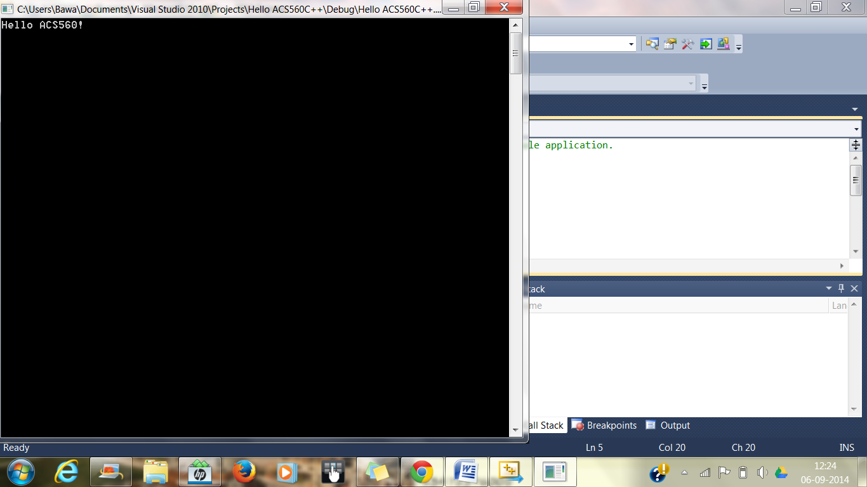

**b) JAVA**

Source Code:

**public** **class** HelloACS {

**public** **static** **void** main(String[] args) {

System.***out***.println("Hello ACS 560!");

}

}

Screenshot

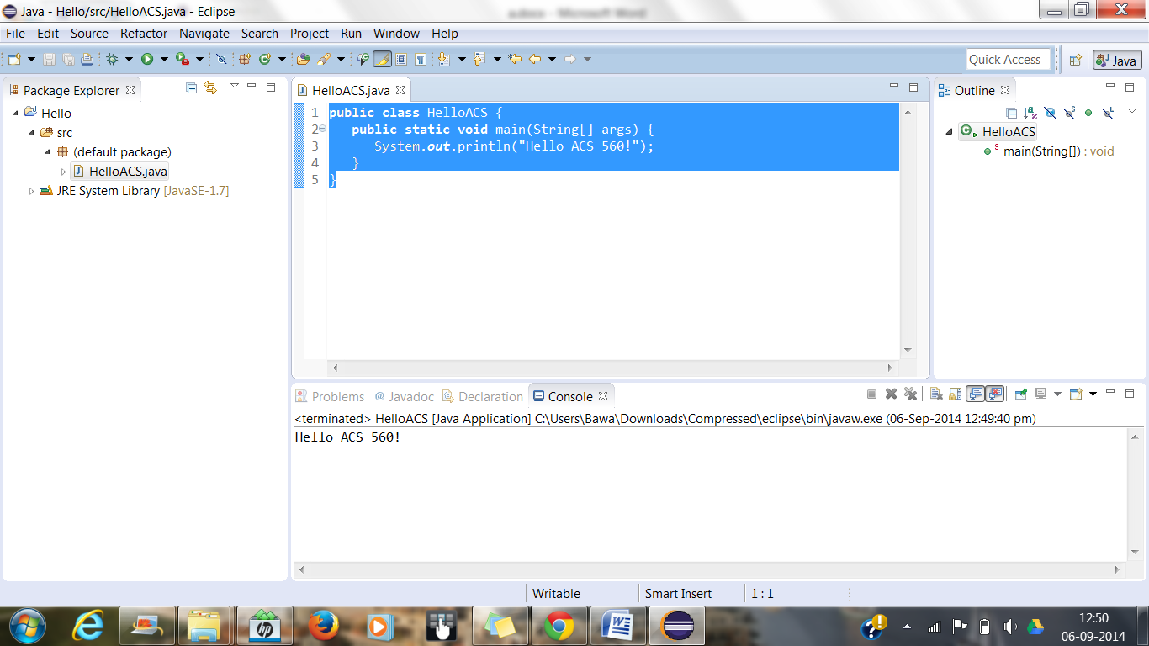

**c) Python 3.4**

Source Code

>>> print ("Hello ACS560!")

Screenshot

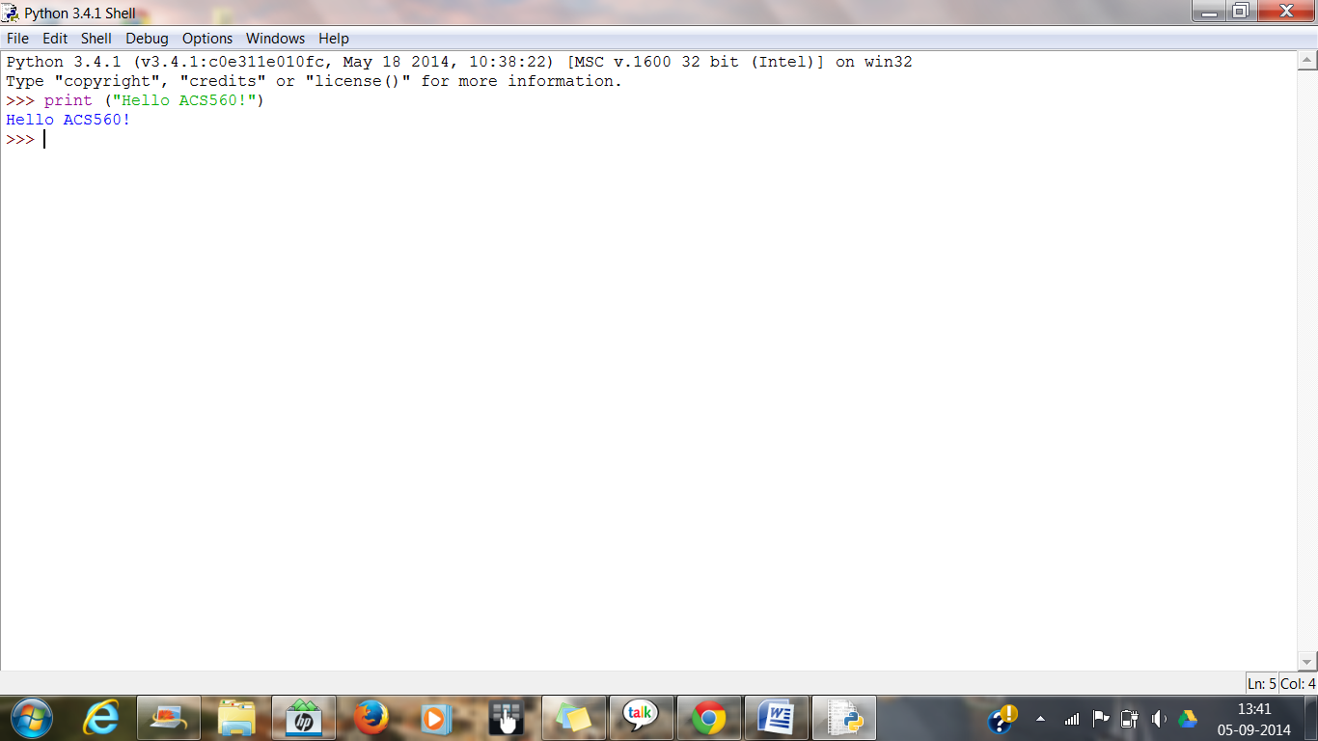

**d) C#**

Source Code:

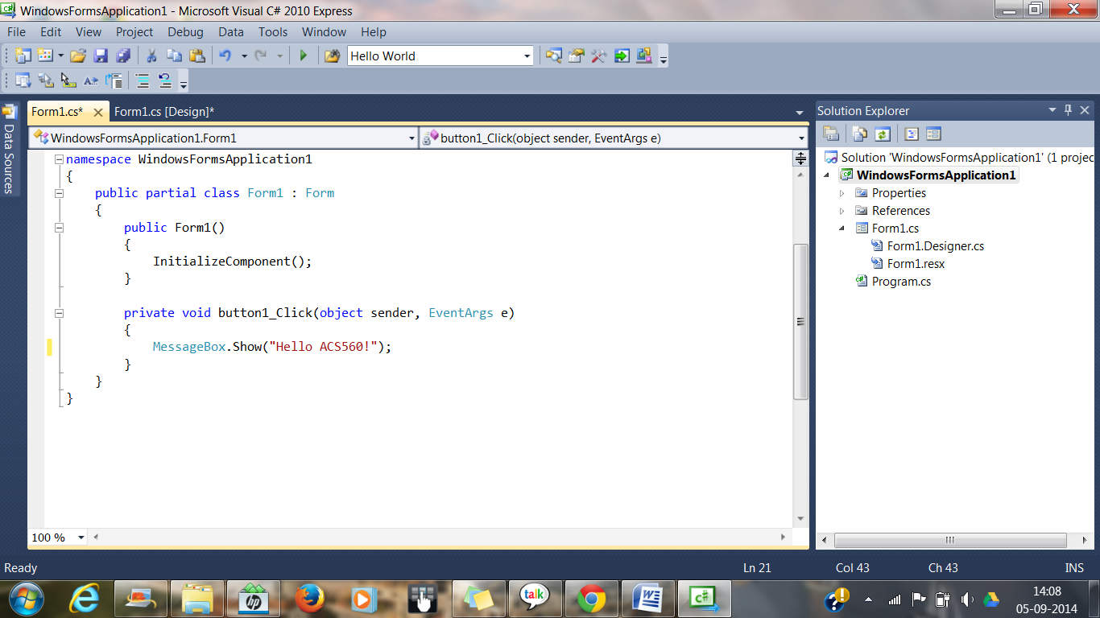

Screenshot

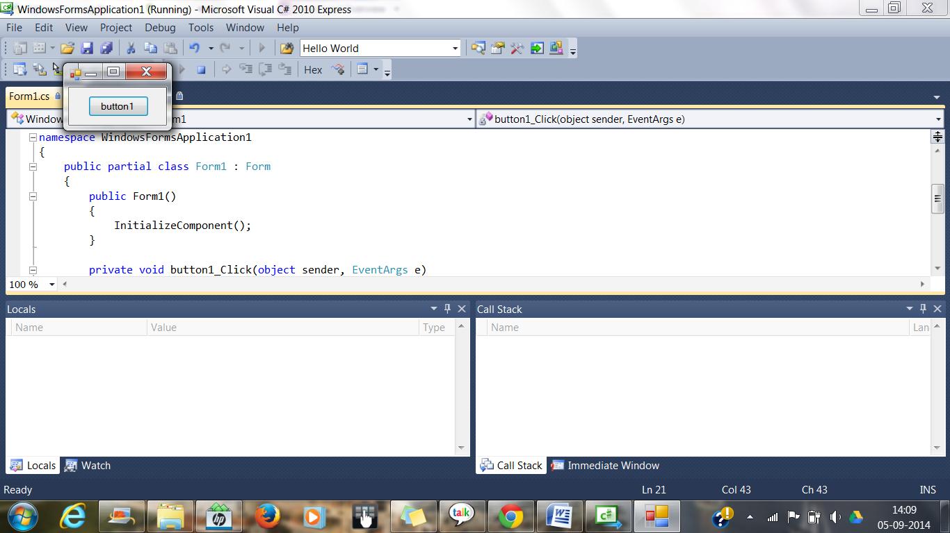

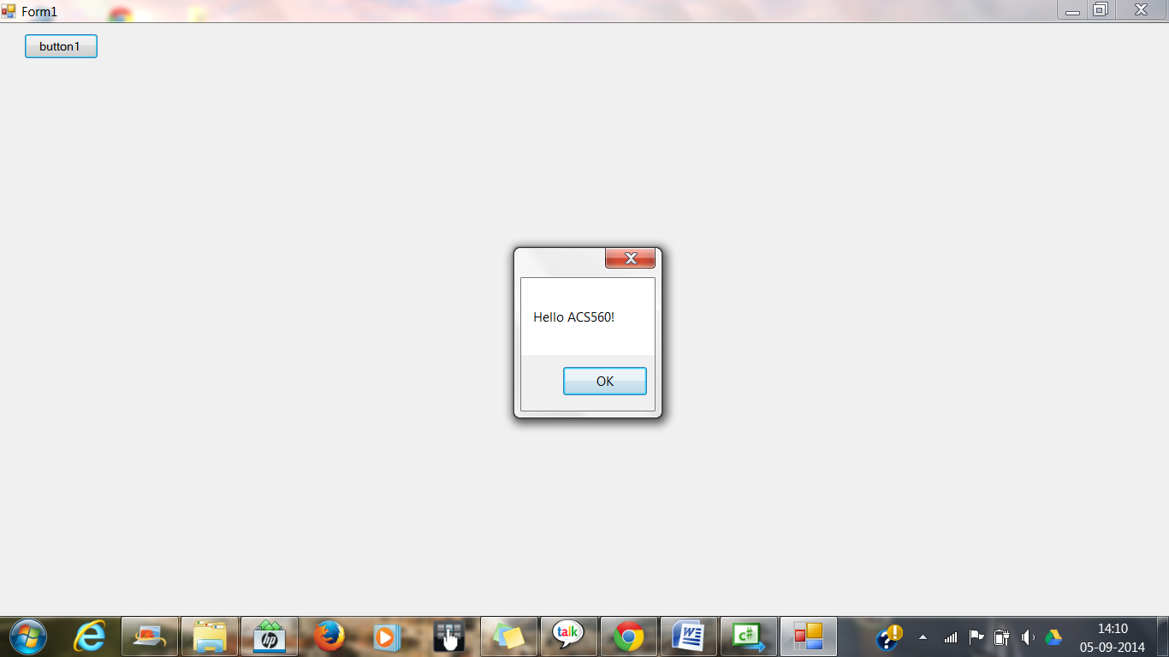

**e) HTML**

SourceCode:

<html>

<body>

"Hello ACS 560!"

</body>

</html>

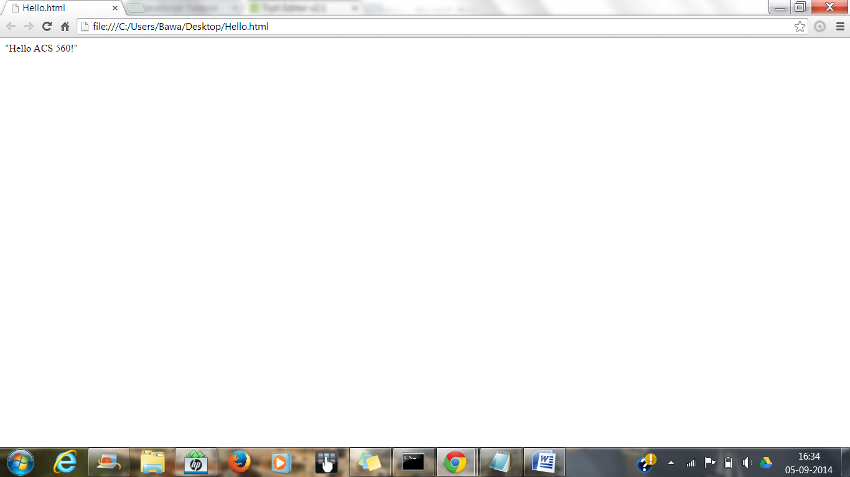

**f) Javascript**

<html>

<body>

<p id="Hi"></p>

<script>

document.getElementById("Hi").innerHTML="Hello ACS560!";

</script>

</body>

</html>

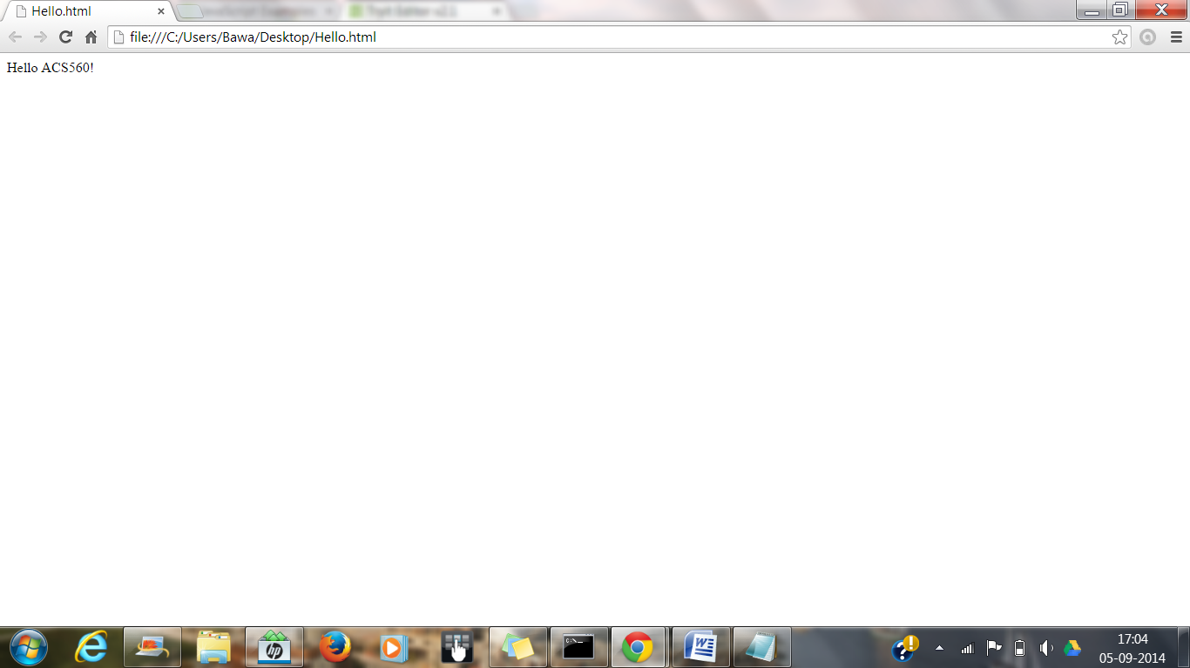

**g) Shell script**

Source Code

Echo Hello ACS 560!

Screenshot

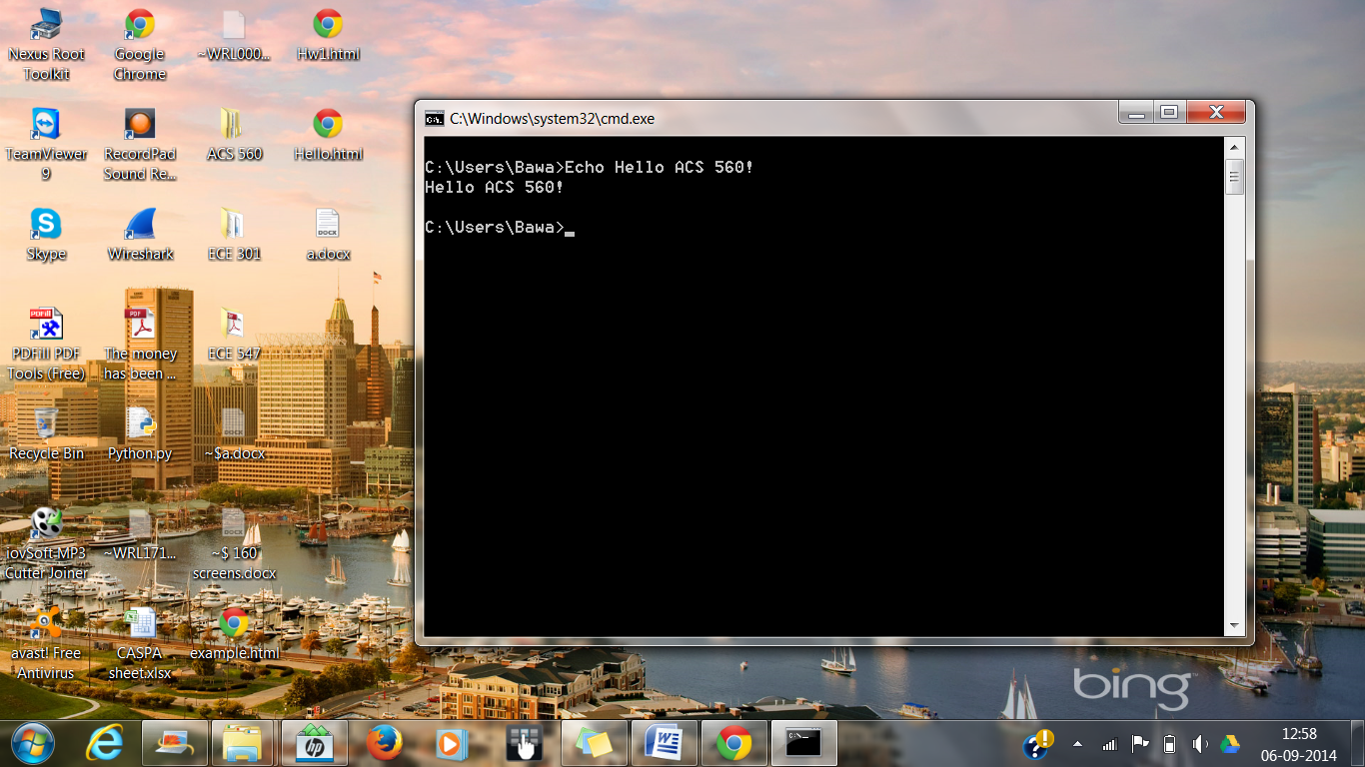

**h) GO Language**

Source Code:

package main

import "fmt"

func main() {

fmt.Println("hello ACS560!")

}

Screenshot

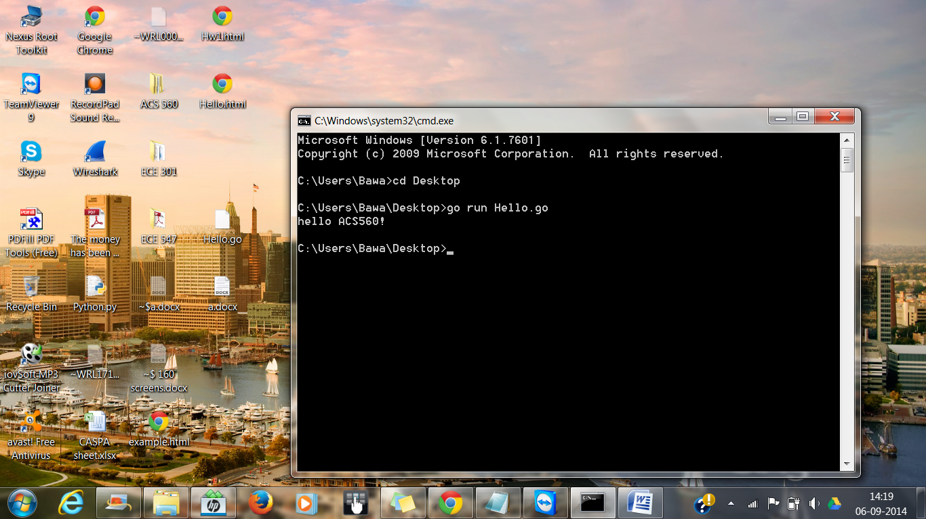

**Q 2 -** Method 1 : awk '{ sub("\r$", ""); print } ' winfile.txt > unixfile.txt

Method 2: tr -d '\15\32' < winfile.txt > unixfile.txt

**Screenshot:**

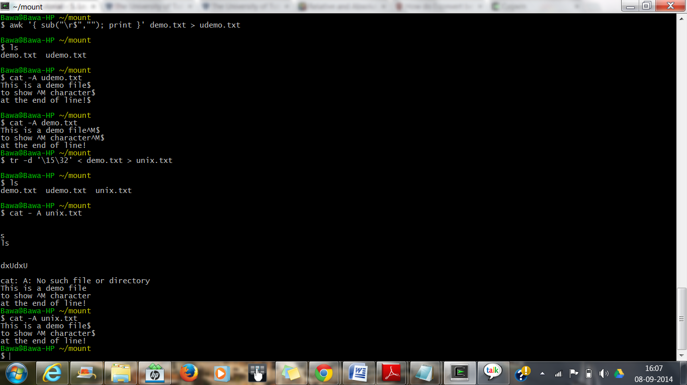

**3) a)Hw1.html**

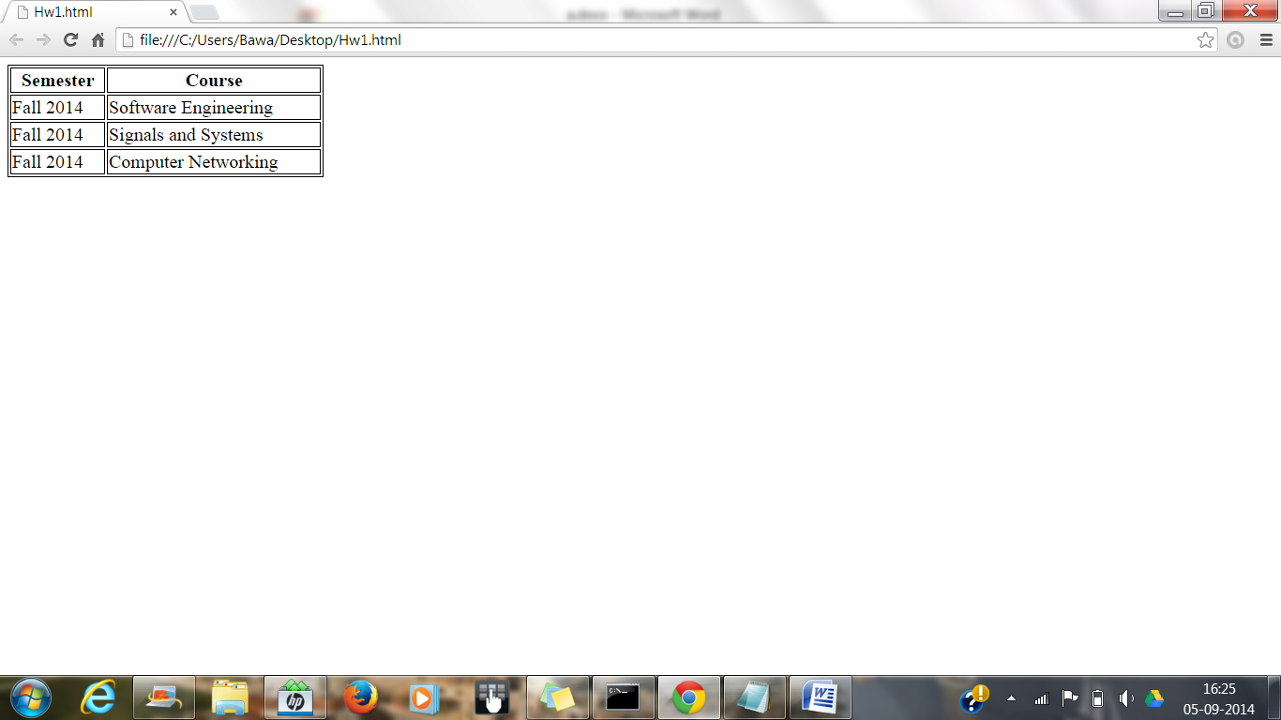

**b) Source Code Using JavaScript:**

<html>

<head>

<style>

table.data

{

border: 1px solid black;

width: 300px;

}

table.data tr

{

padding: 50px;

}

</style>

<script language="javascript">

var data = [

['Semester', 'Course'],

['Fall 2014', 'Software Engineering'],

['Fall 2014', 'Signals and Systems'],

['Fall 2014', 'Computer Networking'],

];

function createTable(data) {

var html = '';

html += '<table class="data">';

for(var row in data) {

var rowData = data[row];

if(row == 0) {

html += '<tr style="font-weight: bold;">';

}

else {

html += '<tr>';

}

for(var col in rowData) {

var colData = rowData[col];

html += '<td>';

html += colData;

html += '</td>';

}

html += '</tr>';

}

html += '</table>';

return html;

}

function insertHTML(id, html) {

var el = document.getElementById(id);

if(!el) {

alert('Element with id ' + id + ' not found.');

}

el.innerHTML = html;

}

function run() {

var html = createTable(data);

insertHTML('tabledata', html);

}

window.onload = run;

</script>

</head>

<body>

<div id="tabledata"></div>

</body>

</html>

Screenshot

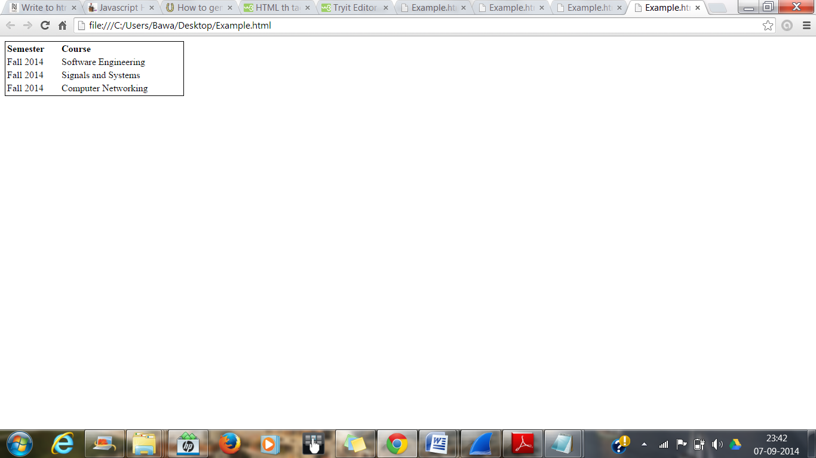

**Reference Links:**

https://gobyexample.com/hello-world

http://www.w3schools.com/js/default.asp

http://www.w3schools.com/html/default.asp

http://msdn.microsoft.com/en-us/library/jj620919.aspx

http://www.wikihow.com/Create-a-'Hello-World'-Console-Application-in-Visual-C%2B

http://www.wikihow.com/Write-a-Hello-World-Program-in-Python

http://www.wikihow.com/Write-%22Hello-World!%22-in-Visual-C-Sharp

http://introcs.cs.princeton.edu/java/11hello/

http://windowsitpro.com/scripting/shell-scripting-101-lesson-1

http://www.caveofprogramming.com/guest-articles/javascript-2

www.cygwin.com

http://ryanstutorials.net/linuxtutorial

https://kb.iu.edu/