**Financial Engineering Lab MA – 374 Lab – 10**

**Name –** Rasesh Srivastava

**Roll Number –** 210123072

**Branch –** Mathematics and Computing

Question 1:

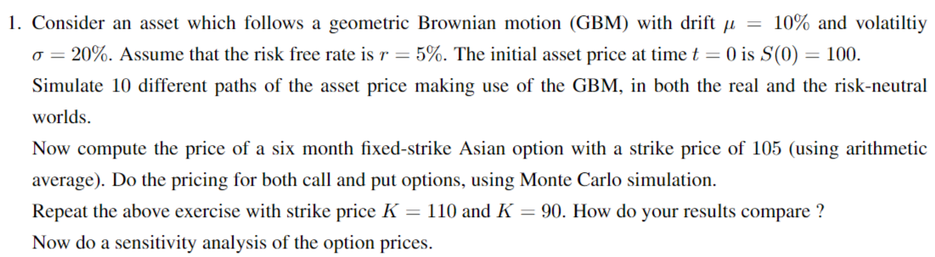

10 different paths of the asset price making use of GBM in real world are as follows:

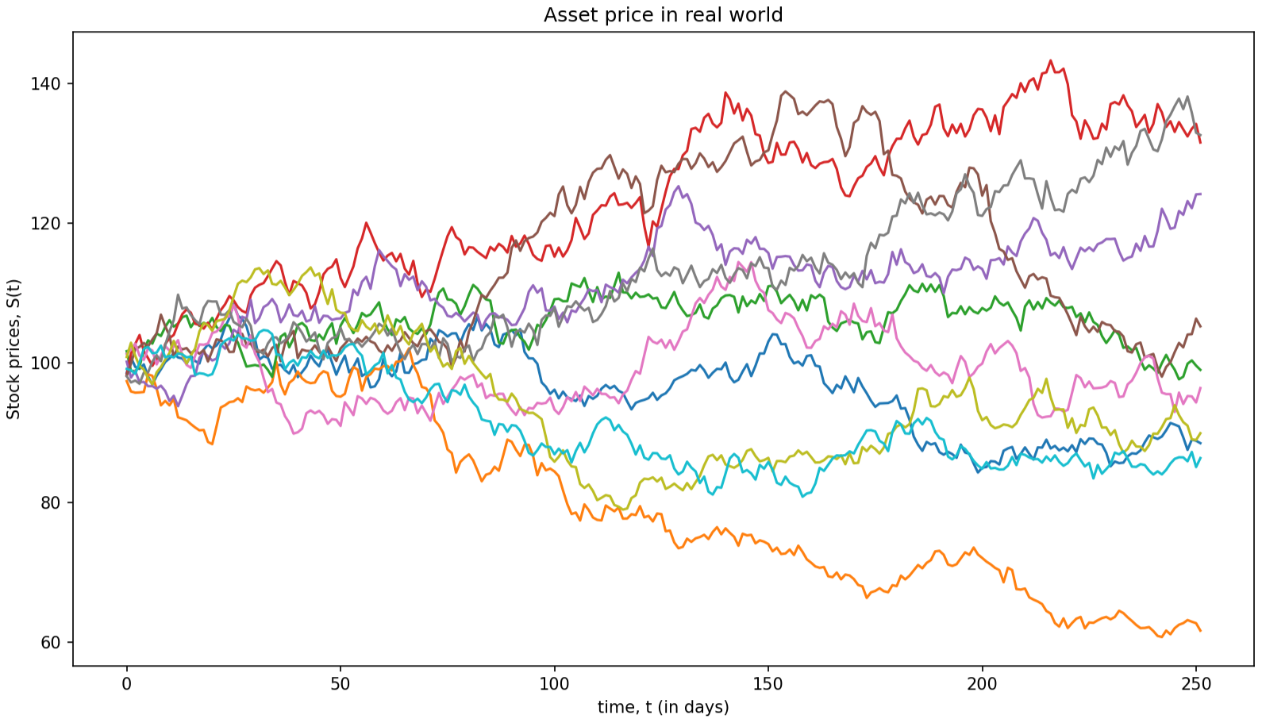

where the evolution of the asset price in real world is given by the following differential equation:

𝑑𝑆(t) = 𝜇𝑆(t)𝑑𝑡 + 𝜎𝑆(t)𝑑𝑊(𝑡)

10 different paths of the asset price making use of GBM in risk-neutral world are as follows:

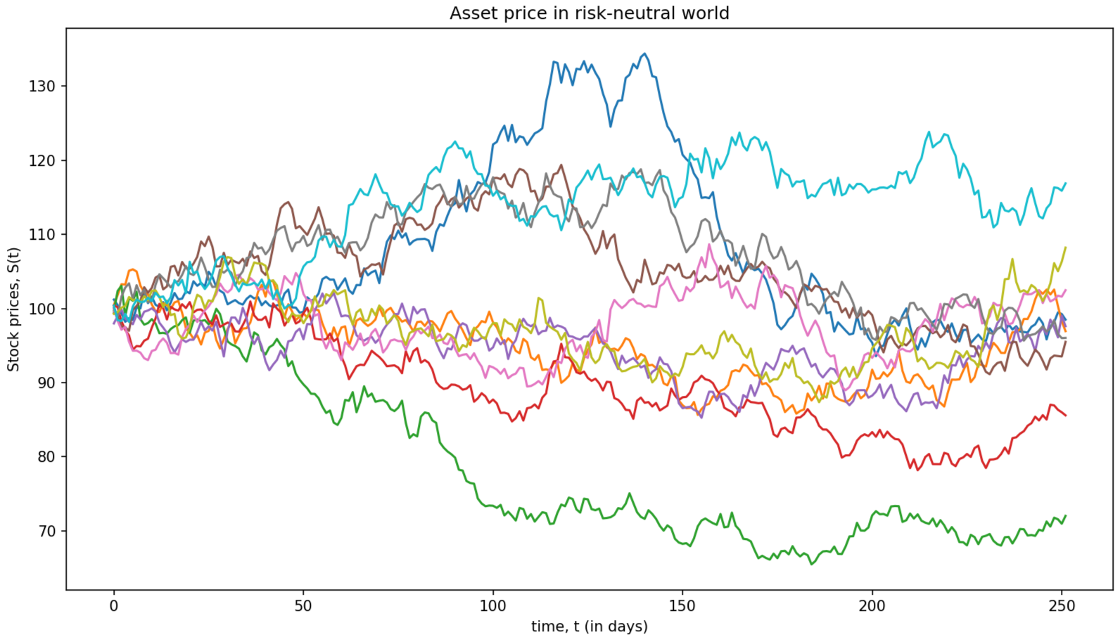

where the evolution of the asset price in the risk-neutral world is given by the following differential equation:





The prices of a six-month fixed-strike Asian option with various strike prices are as follows:

1. **For K = 90,**

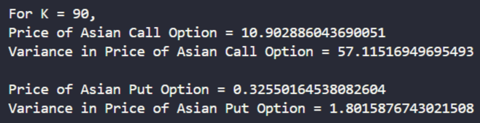

1. **For K = 105,**

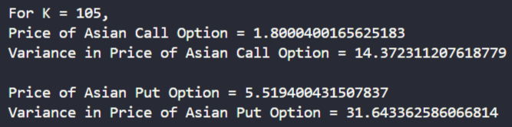

1. **For K = 110,**

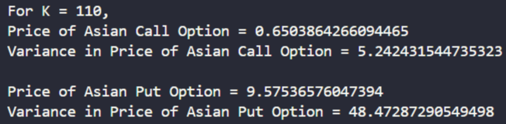

Sensitivity Analysis:

1. Variation of Asian Option Prices with S0:

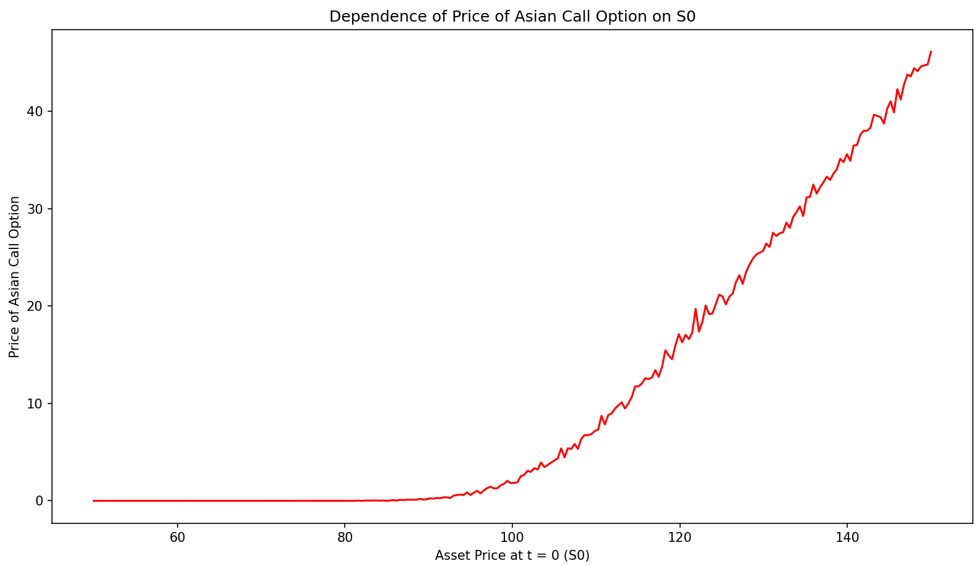

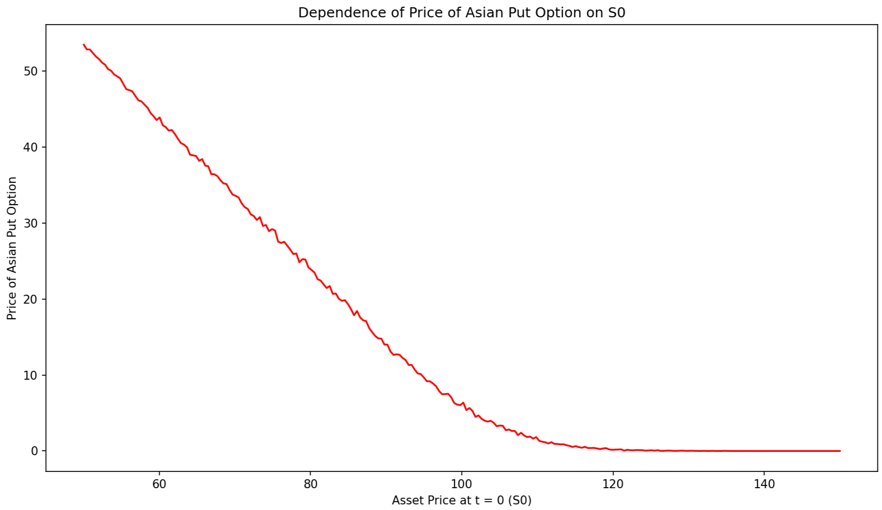

1. Variation of Asian Option Prices with K:

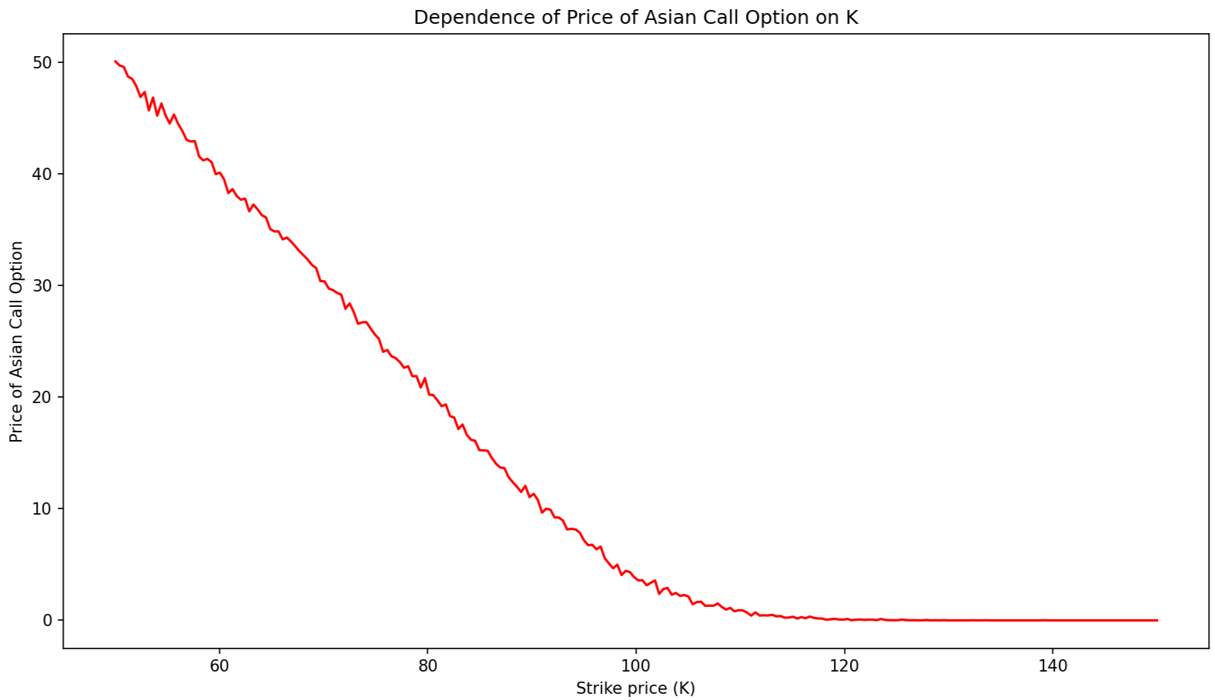

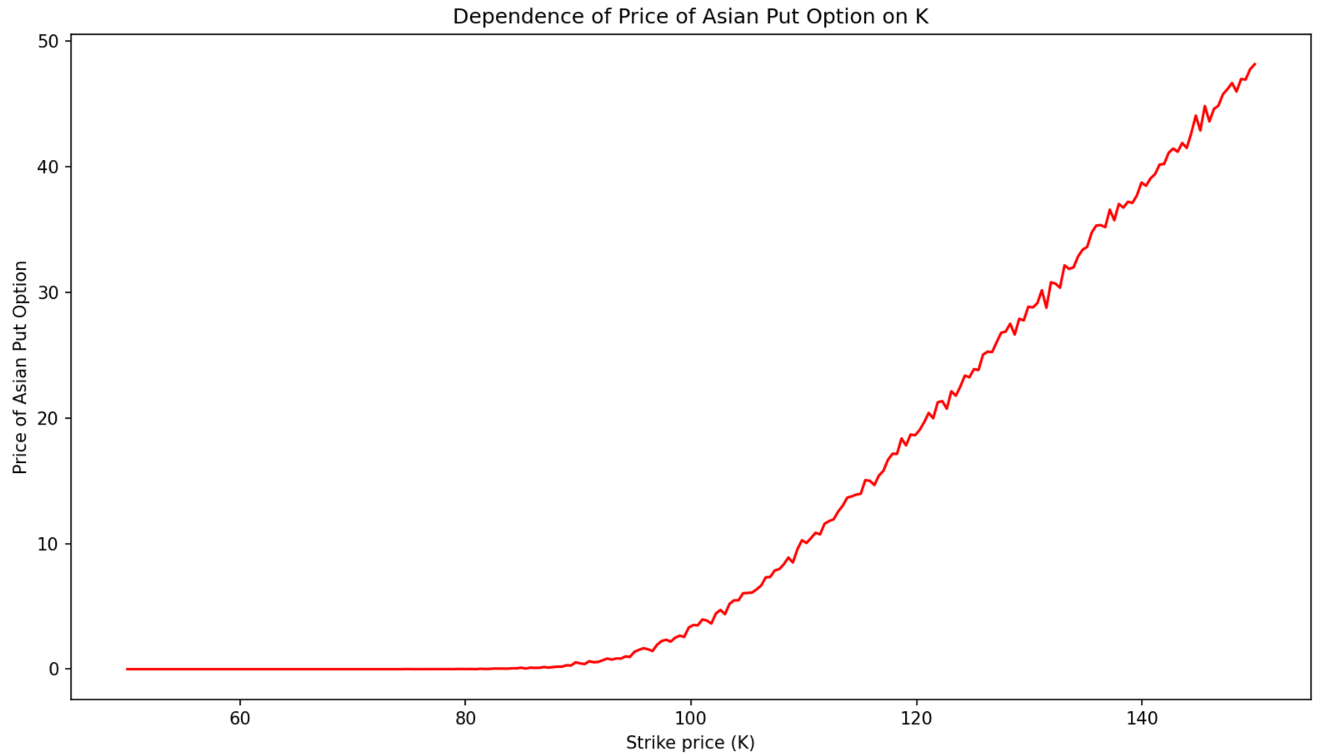

1. Variation of Asian Option Prices with r:

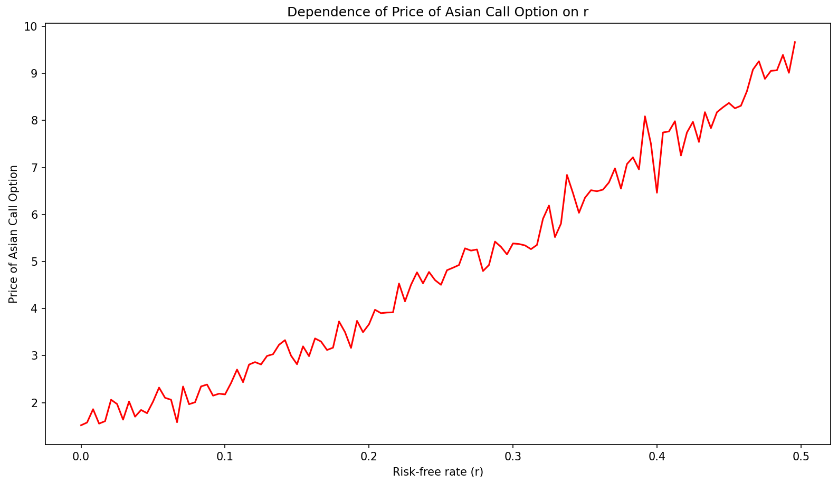

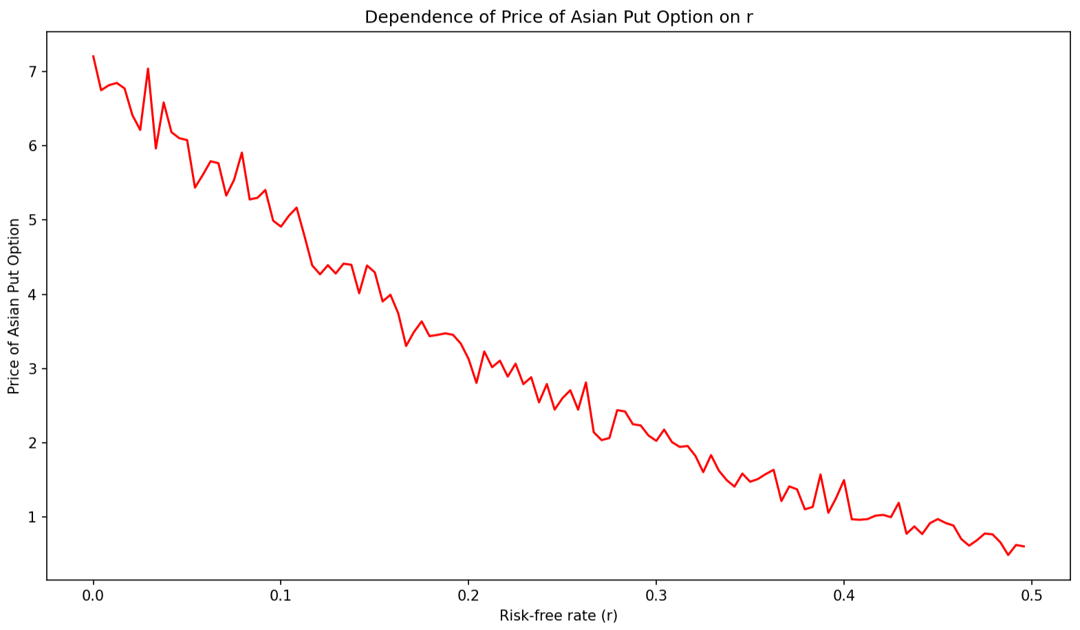

1. Variation of Asian Option Prices with σ:

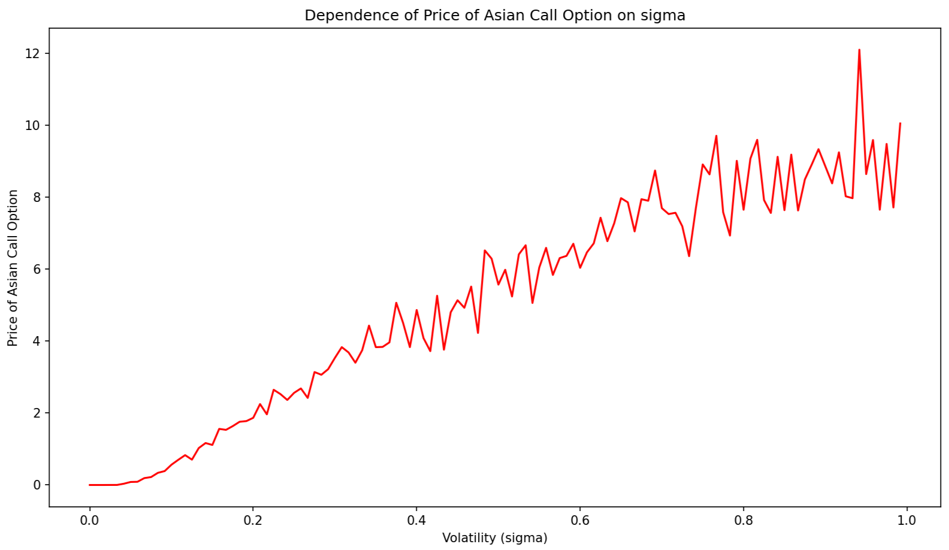

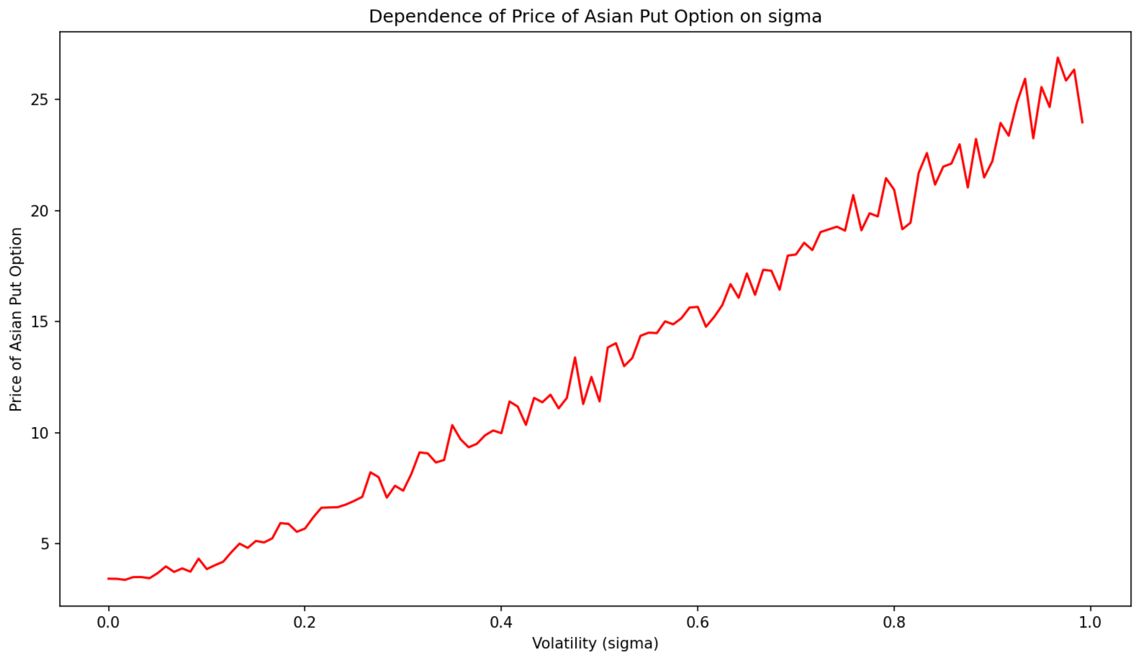

**Observations:**

* The price of both Asian put and Asian call option increases with an increase in the volatility.
* The price of the Asian call option increases while that of the Asian put option decreases, with an increase in risk-free interest rate, r.
* The price of the Asian call option decreases while that of the Asian put option increases, with an increase in the strike price, K.
* The price of the Asian call option increases while that of the Asian put option decreases, with an increase in the initial asset price, S0.
* There appears to be some fluctuations in the plots, which we try to minimize by employing the method of Control Variates as variance reduction technique.

Question 2:



The prices of a six-month fixed-strike Asian option with various strike prices, after employing variance reduction technique are as follows:

1. **For K = 90,**

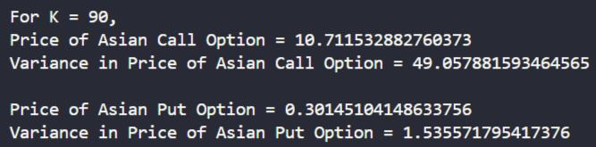

1. **For K = 105,**

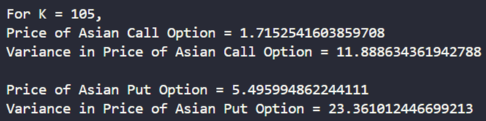

1. **For K = 110,**

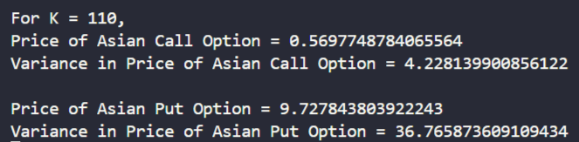

**Observations:**

The prices of both Asian call and Asian put options, obtained with and without the application of variance reduction techniques, demonstrate similar values. The corresponding variances are juxtaposed in the following tables for comparison:

1. For Asian Call Option:

|  |  |  |
| --- | --- | --- |
| Strike Price (K) | Variance (without reduction) | Variance (with reduction) |
| 90 | 57.11516949695493 | 49.057881593464565 |
| 105 | 14.372311207618779 | 11.888634361942788 |
| 110 | 5.242431544735323 | 4.228139900856122 |

1. For Asian Put Option:

|  |  |  |
| --- | --- | --- |
| Strike Price (K) | Variance (without reduction) | Variance (with reduction) |
| 90 | 1.8015876743021508 | 1.535571795417376 |
| 105 | 31.643362586066814 | 23.361012446699213 |
| 110 | 48.47287290549498 | 36.765873609109434 |

So, from these tables, we can observe that the variance reduction technique is successful, and we have reduced the variance in calculating the Asian option prices.

Sensitivity Analysis after employing Variance Reduction Technique:

1. Variation of Asian Option Prices with S0:

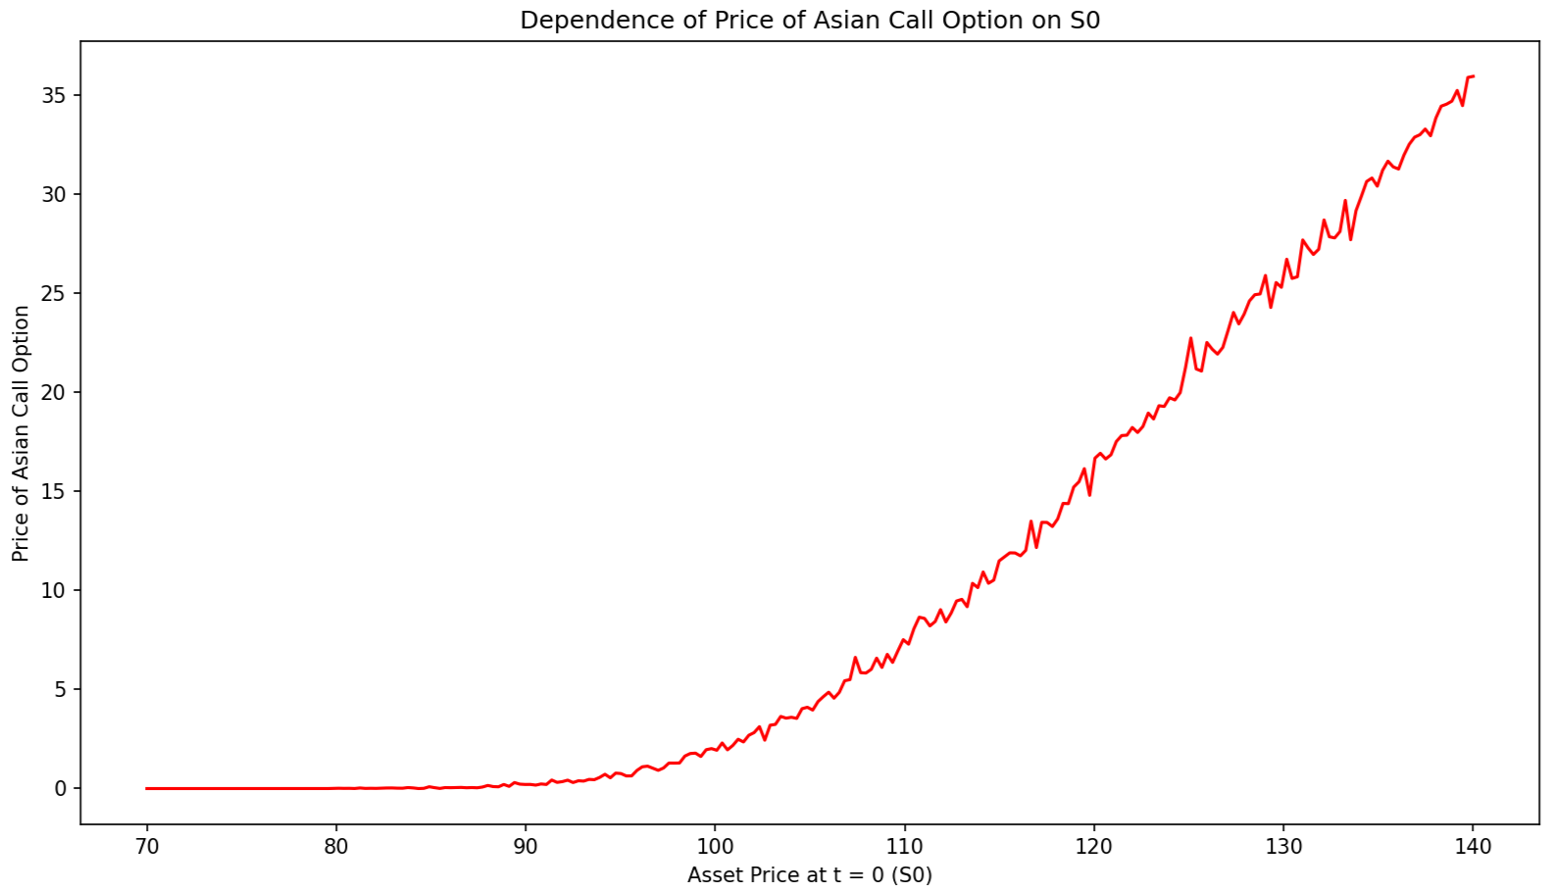

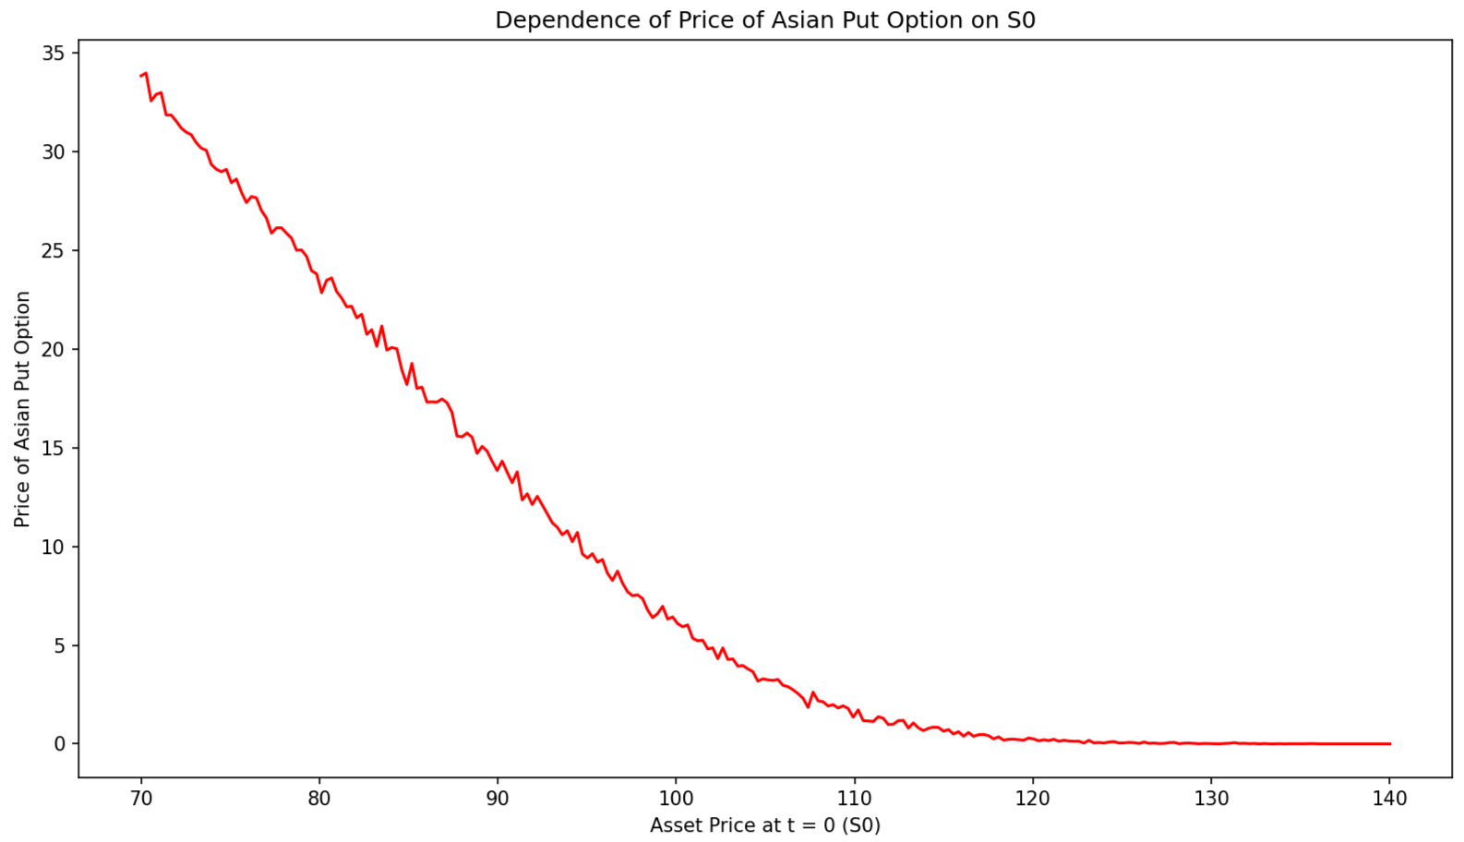

1. Variation of Asian Option Prices with K:

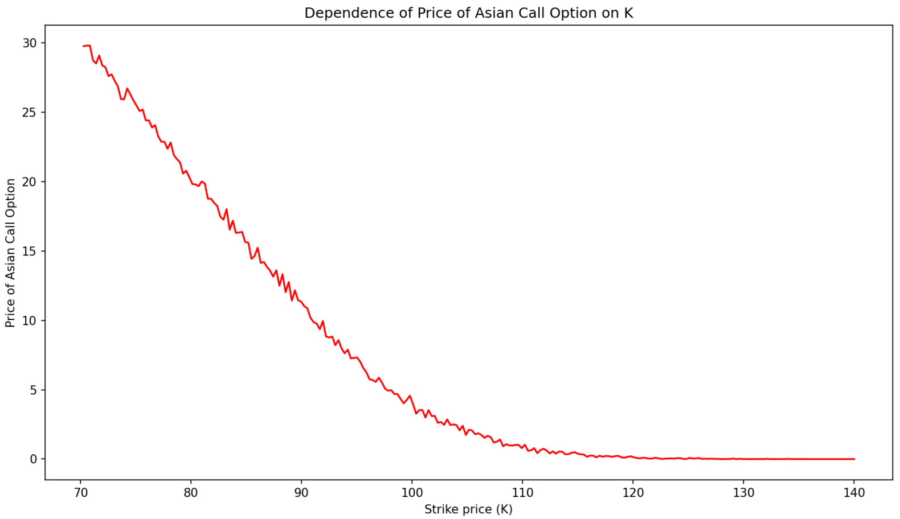

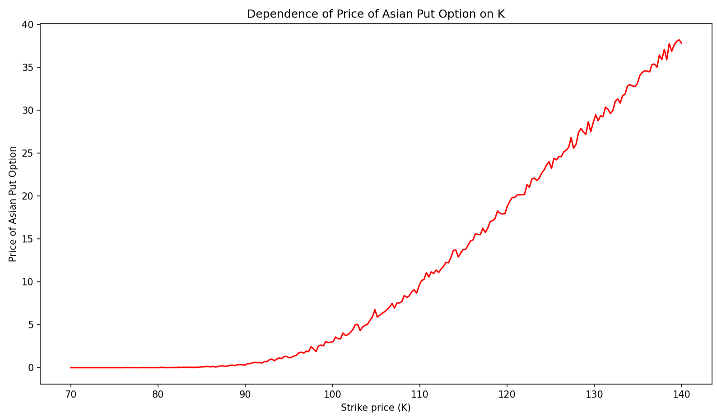

1. Variation of Asian Option Prices with r:

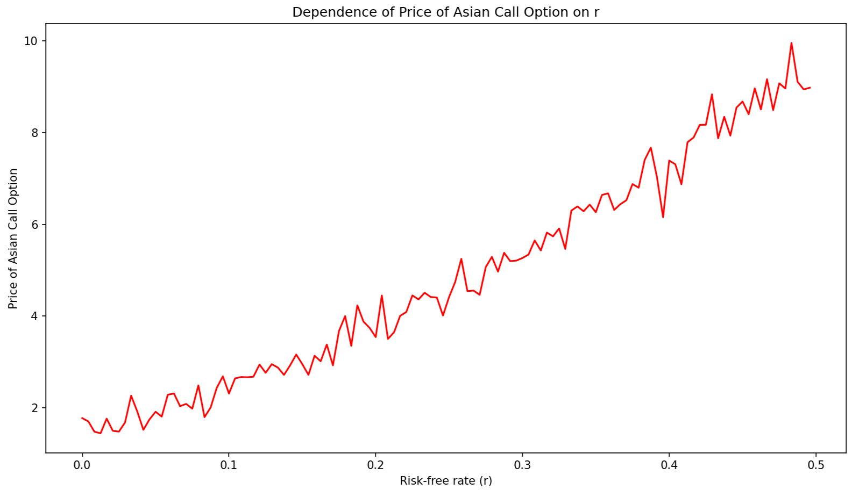

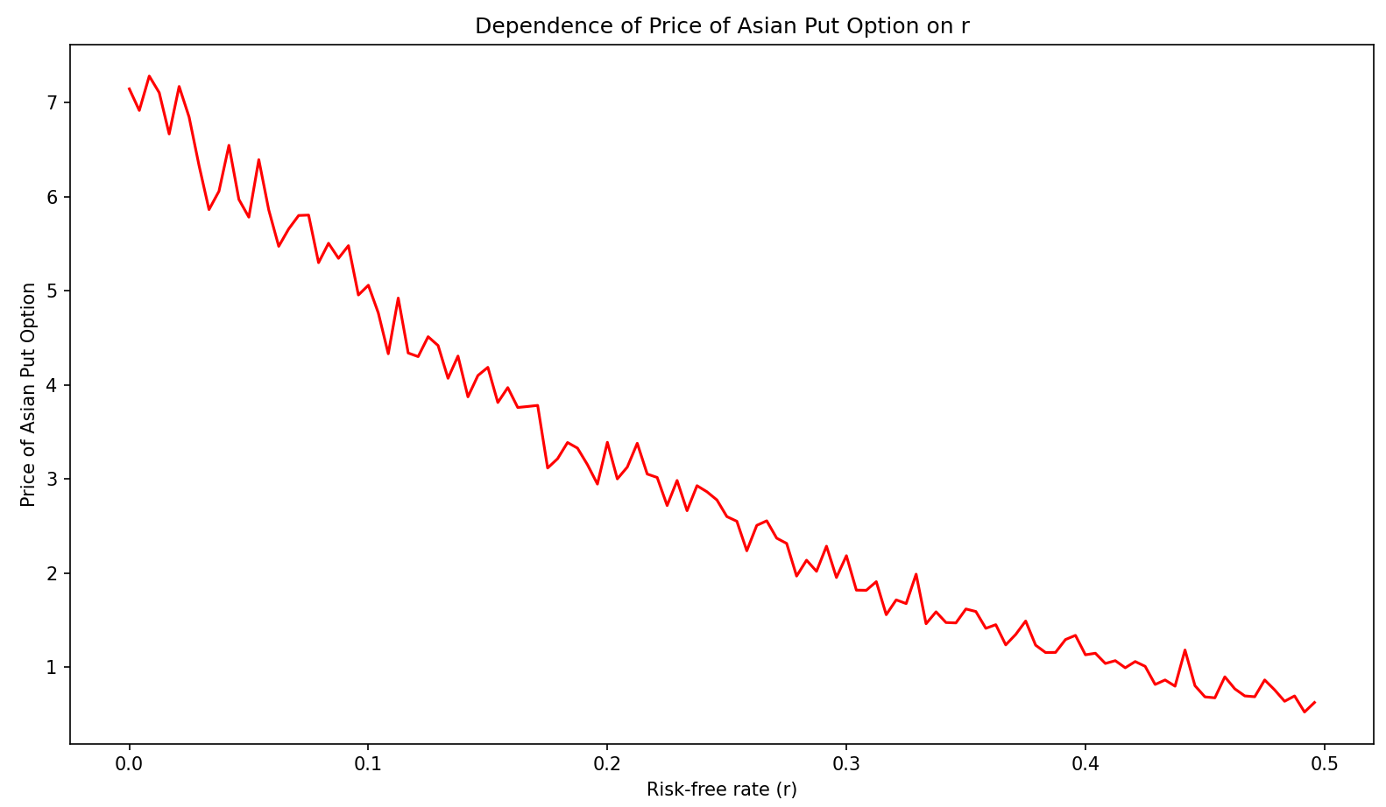

1. Variation of Asian Option Prices with σ:

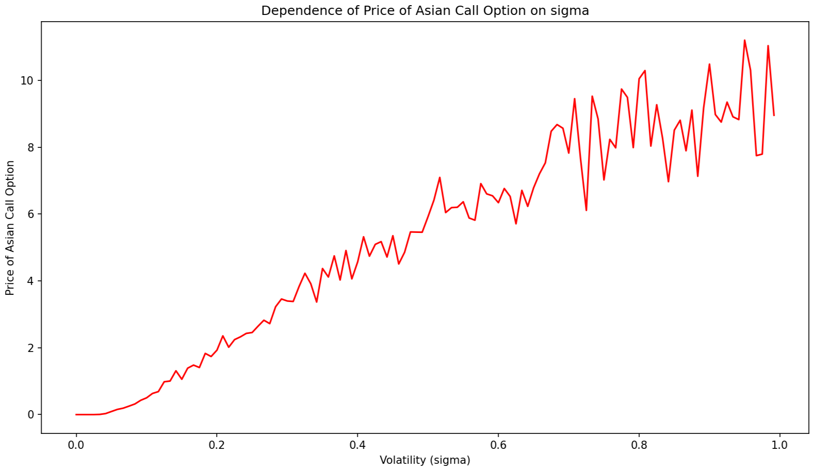

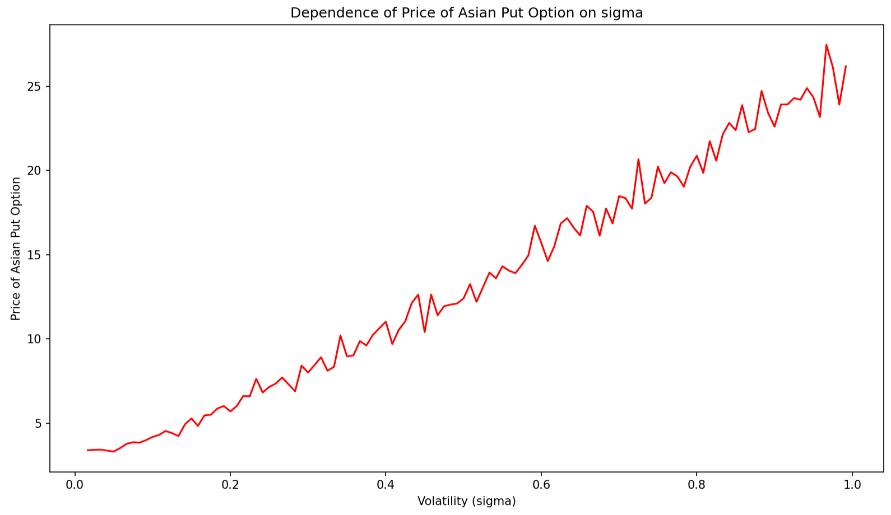

The method of Control Variates is used as the variance reduction technique. Control Variates, as a variance reduction technique, leverages information regarding estimation errors of known quantities to minimize errors in estimating unknown quantities.

**Observations:**

* On careful analysis, we can observe that the fluctuations in the plots are lesser than the case when variance reduction technique was not applied. So, the method of Control Variates for variance reduction achieves its goal.
* The nature of the plots matches our expectations.
* We have quantitatively demonstrated that variance reduction is achieved by using variance reduction technique. This claim is supported by the constructed plots.