**Financial Engineering Lab MA – 374 Lab – 11**

**Name –** Rasesh Srivastava

**Roll Number –** 210123072

**Branch –** Mathematics and Computing



Continuously compounded zero coupon yield is given by:

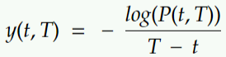

where, P(t, T) is zero coupon bond price, which is calculated using different short rate models like Vasicek model or Cox-Ingersoll-Ross (CIR) model.

Question 1:

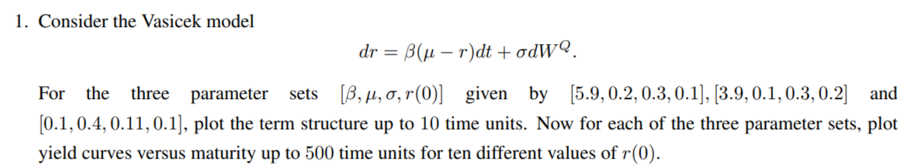

The term structure for the parameter set [5.9, 0.2, 0.3, 0.1] is as follows:

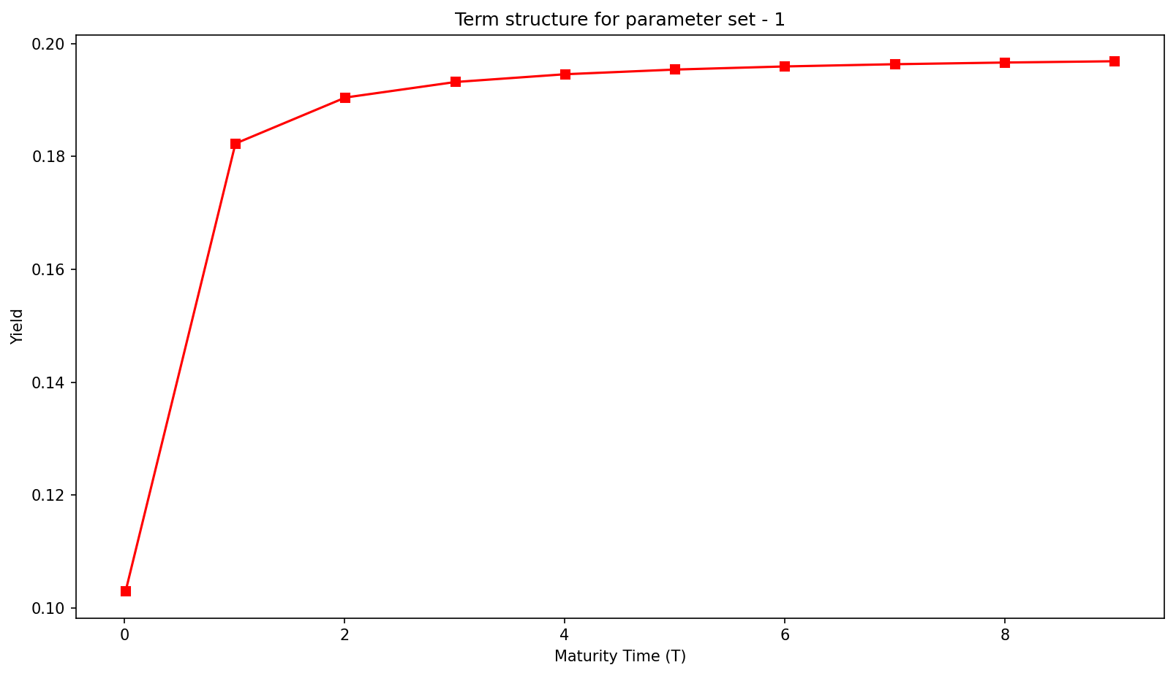

The term structure for the parameter set [3.9, 0.1, 0.3, 0.2] is as follows:

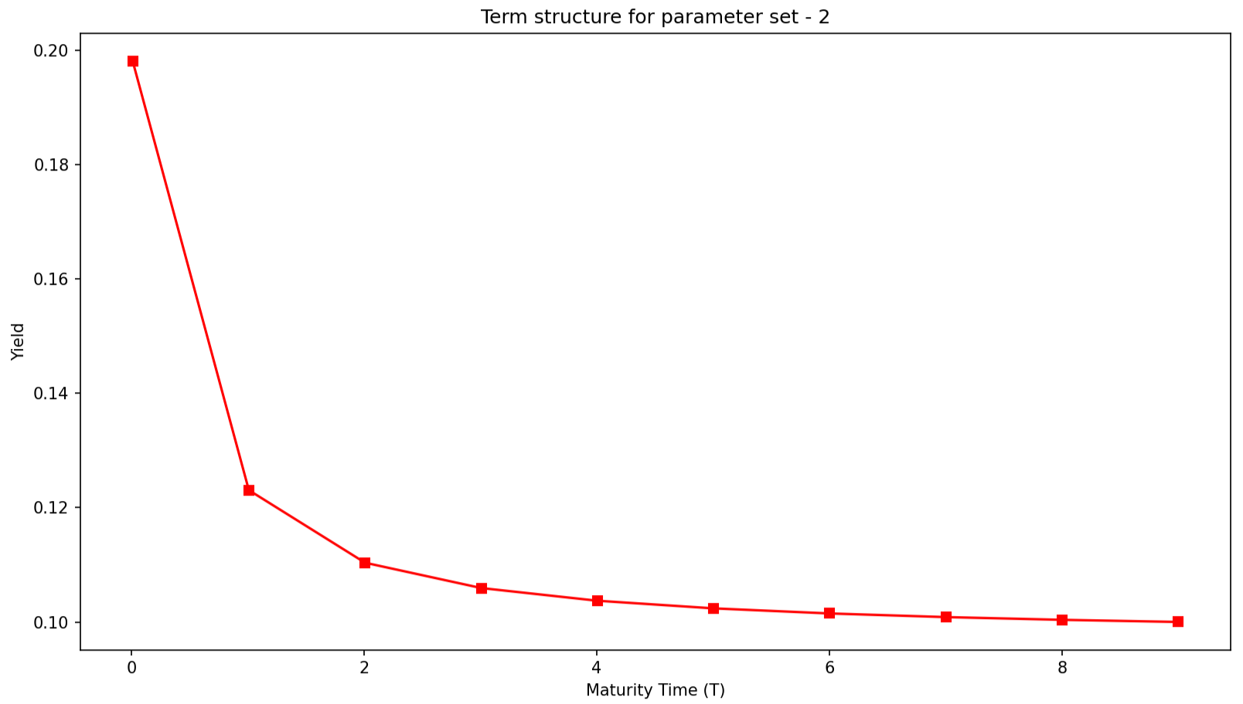

The term structure for the parameter set [0.1, 0.4, 0.11, 0.1] is as follows:

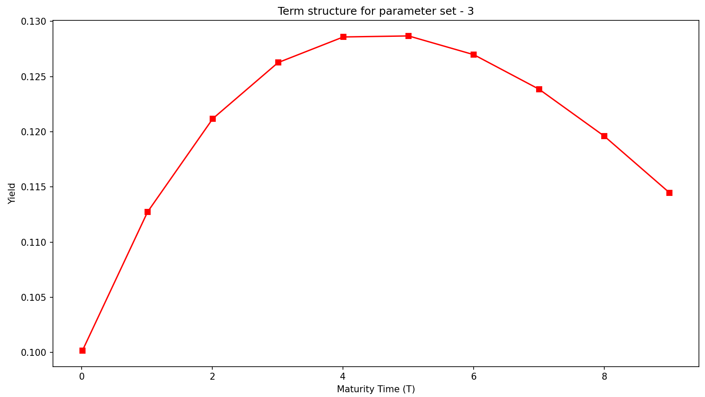

The yield curves versus maturity up to 500 time units for 10 different values of r(0) are as follows:

1. For the Parameter Set [5.9, 0.2, 0.3, 0.1]

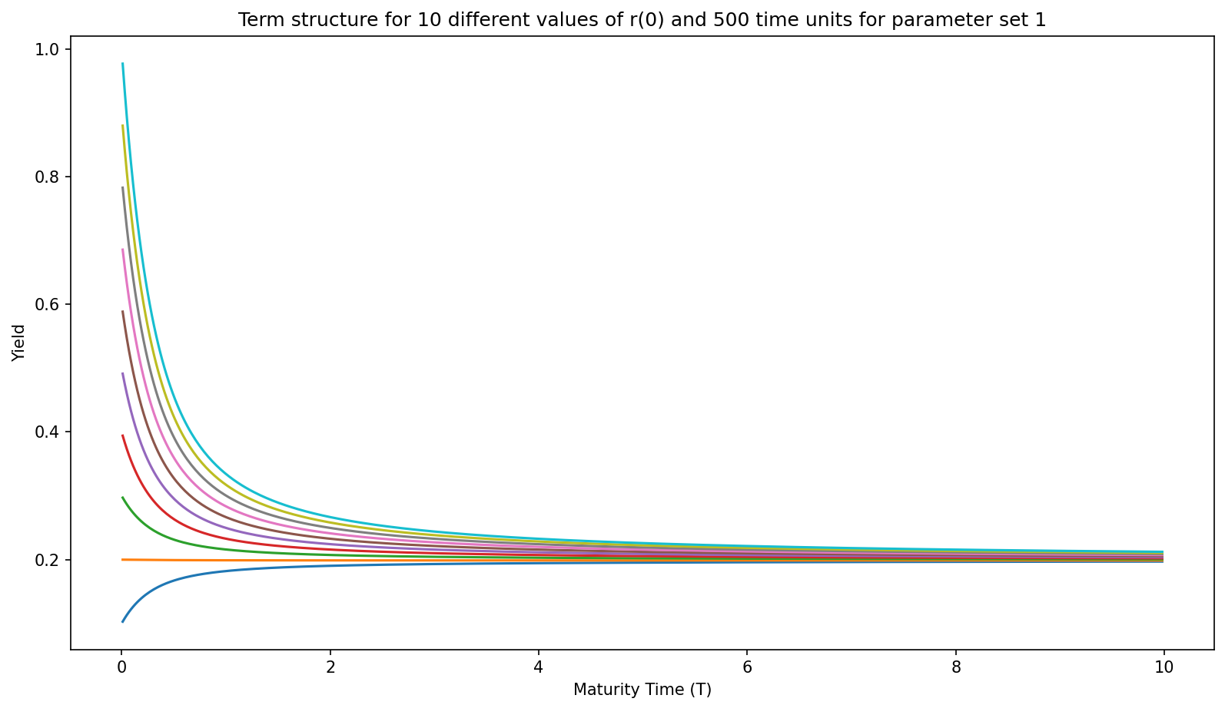

1. For the Parameter Set [3.9, 0.1, 0.3, 0.2]

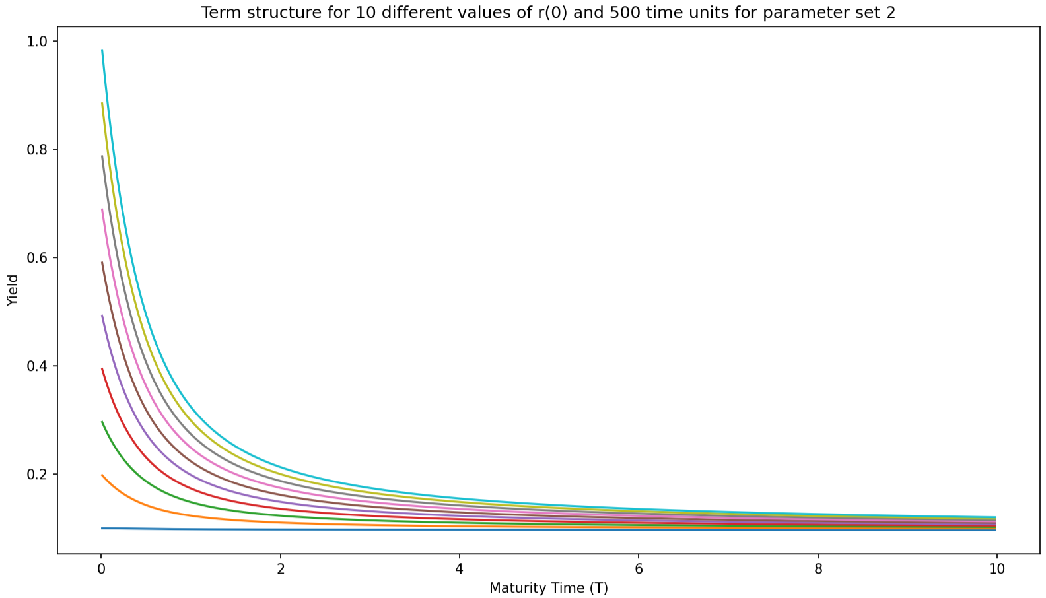

1. For the Parameter Set [0.1, 0.4, 0.11, 0.1]

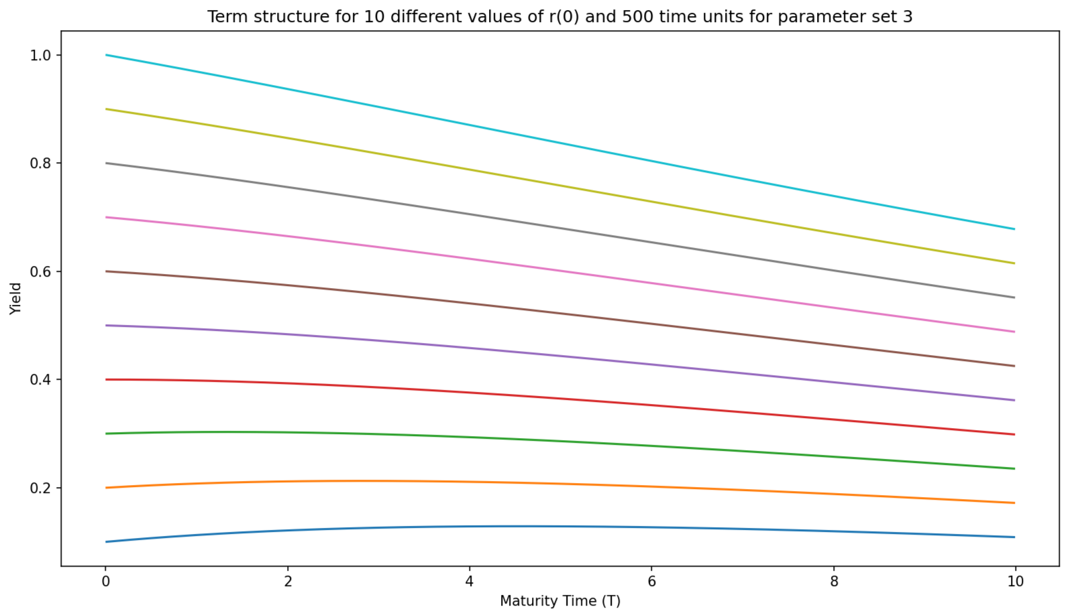

**Observations:**

* The term structure of parameters set for 10 time units show spectacularly different behavior. For the first parameter set, the yield increases and then converges. For the second parameter set, the yield decreases and then converges, while for the third and last parameter set, the yield curve has a hump in it.
* The presence of mean reversion phenomenon is evident as higher interest rates display a downward/negative trend, while lower interest rates exhibit an upward/positive trend towards the reversion level. This phenomenon arises from the inclusion of mean reversion within the Vasicek Model.
* The yield of the bond price converges to a particular value as the maturity period is increased to a sufficiently high value, irrespective of the value of r(0) taken.

Question 2:

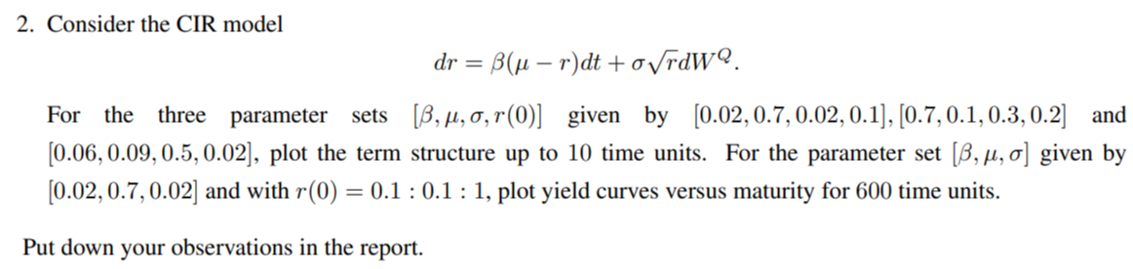

The term structure for the parameter set [0.02, 0.7, 0.02, 0.1] is as follows:

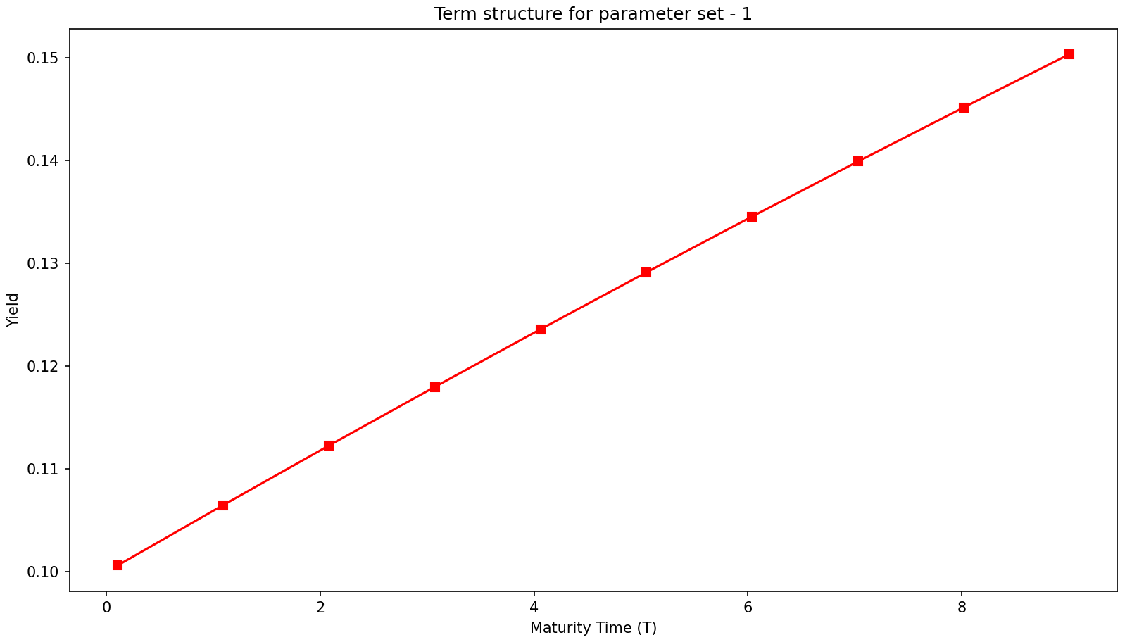

The term structure for the parameter set [0.7, 0.1, 0.3, 0.2] is as follows:

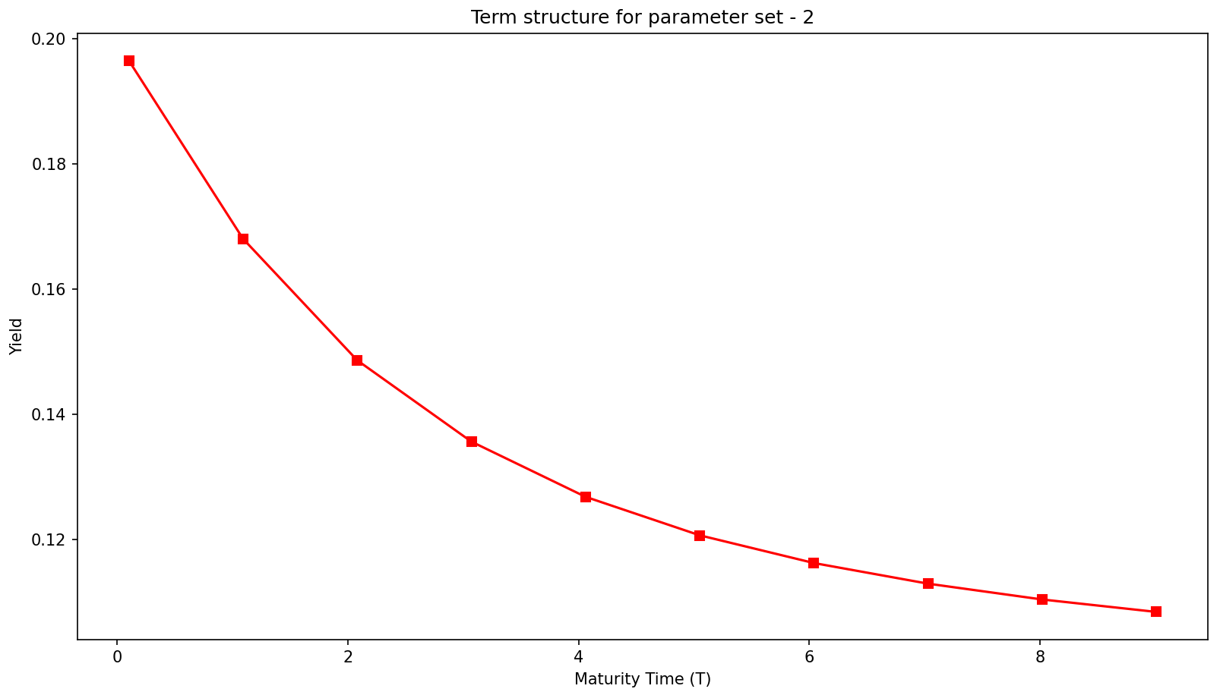

The term structure for the parameter set [0.06, 0.09, 0.5, 0.02] is as follows:

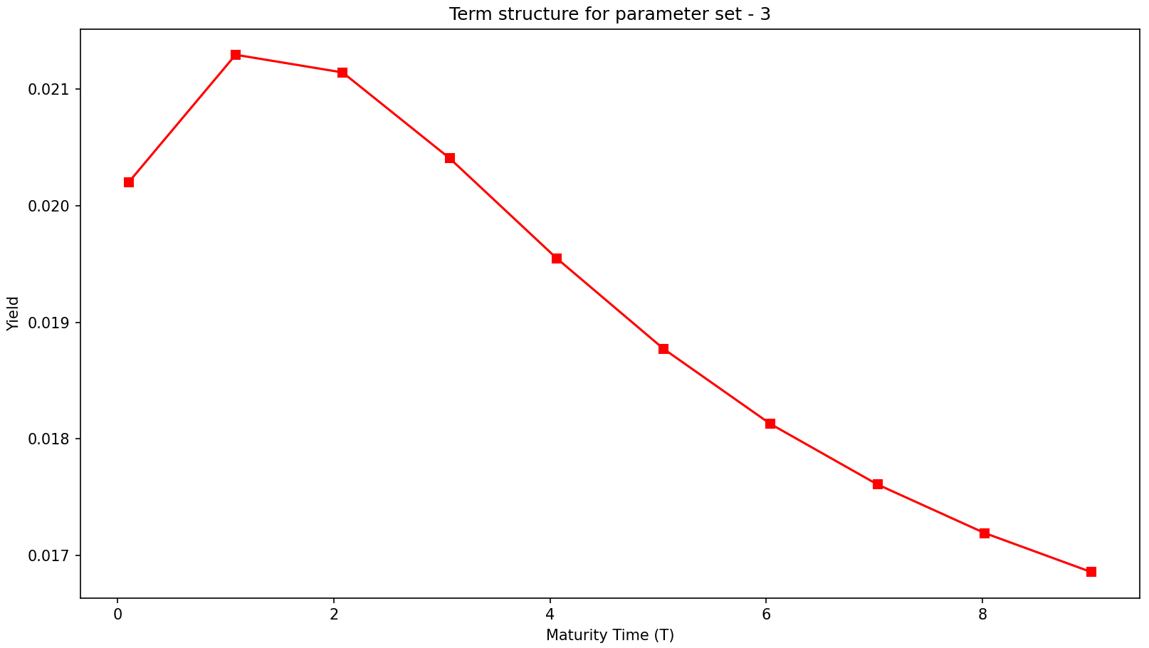

For the parameter set, [β, µ, σ] given by [0.02, 0.7, 0.02] and with r(0) = 0.1 : 0.1 : 1, the yield curves versus maturity for 600 time units are as follows:

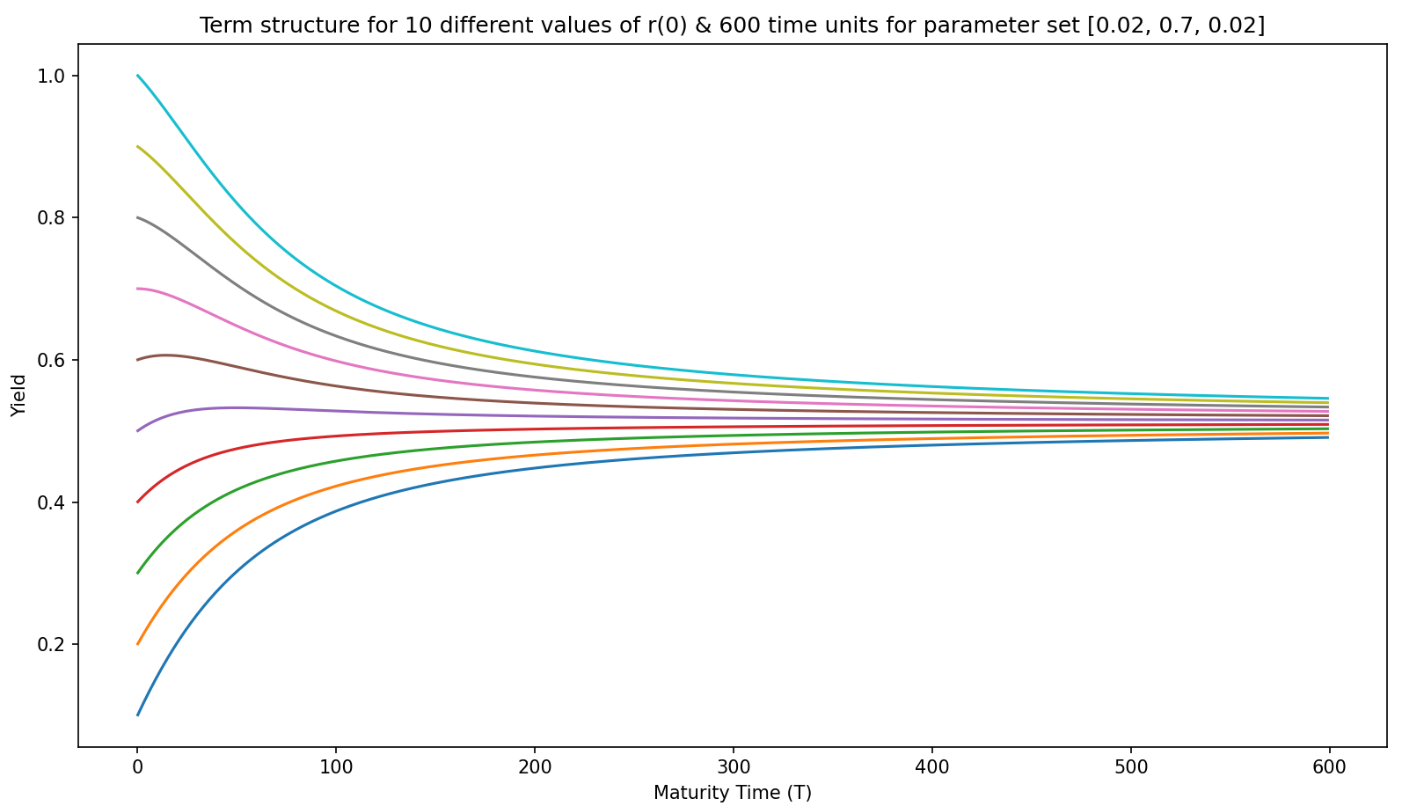

**Observations:**

* The term structure of parameters set for 10 time units show spectacularly different behavior. For the first parameter set, the yield increases and then converges. For the second parameter set, the yield decreases and then converges, while for the third and last parameter set, the yield curve has a hump in it.
* The presence of mean reversion phenomenon is evident from the plots. This phenomenon arises because the CIR Model assumes mean reversion towards a long-term normal interest rate level.
* The yield of the bond price converges to a particular value as the maturity period is increased to a sufficiently high value, irrespective of the value of r(0) taken.

**Some comparisons between Vasicek and CIR Models:**

* Both models exhibit Mean Reversion phenomenon.
* CIR Model has a volatility drift term that increases as r increases, while Vasicek Model assumes constant volatility.
* Both models are one-factor modelling methods. However, Vasicek model allows for negative interest rate since it does not include a square root component.