**Financial Engineering Lab MA – 374 Lab – 4**

**Name –** Rasesh Srivastava

**Roll Number –** 210123072

**Branch –** Mathematics and Computing

Question 1:

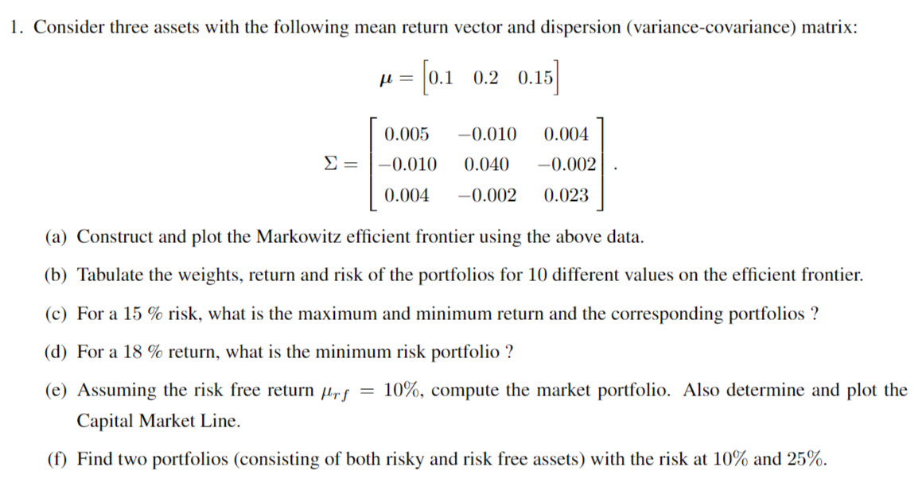

1. The Markowitz efficient frontier is shown in the following plot:

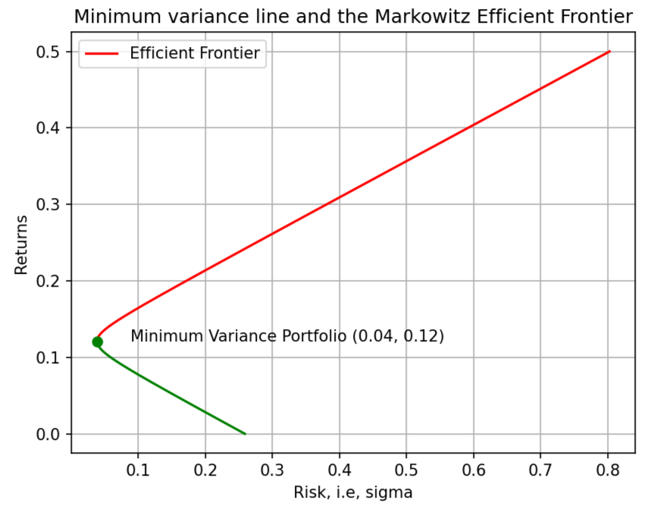

The efficient frontier represents a collection of portfolios that offer the maximum expected return for a given level of risk, specifically characterized by lower standard deviation. In essence, it delineates a boundary where portfolios with higher returns and lower risk exist.

1. The weights, risk and return of the portfolios for ten different values on the efficient frontier are tabulated in the following table:

Index Weights Return Risk

1. [ 1.83550649, -0.1653936, -0.67011288] 0.04995499549954996 0.02405612017613421

2. [ 1.11983859, 0.11903851, -0.2388771 ] 0.09995999599959997 0.0034570647912315974

3. [0.40417069, 0.40347062, 0.19235869] 0.14996499649964998 0.005229455948986979

4. [-0.3114972, 0.68790274, 0.62359447] 0.19996999699969997 0.029373293649400157

5. [-1.0271651, 0.97233485 , 1.05483025] 0.24997499749975 0.0758885778924713

6. [-1.742833 , 1.25676696 , 1.48606604] 0.29997999799979996 0.14477530867820082

7. [-2.4585009, 1.54119907 , 1.91730182] 0.34998499849985 0.23603348600658714

8. [-3.17416879, 1.82563119 , 2.34853761] 0.3999899989999 0.34966310987763205

9. [-3.88983669, 2.1100633 , 2.77977339] 0.44999499949995003 0.4856641802913356

10. [-4.60550459, 2.39449541 , 3.21100917] 0.5 0.6440366972476959

1. For a 15% risk,

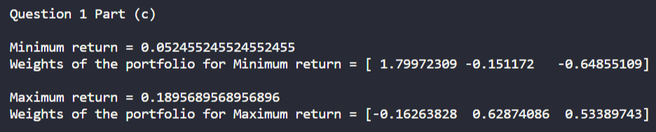

1. For a 18% return, the minimum risk portfolio is as follows:

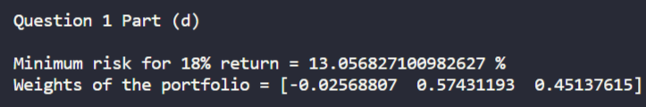

1. Assuming the risk-free return μrf = 10%, the market portfolio is:

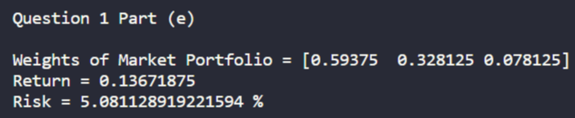

The equation of the capital market line is:

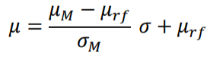

where,

𝜇rf = risk-free return

𝜇M = return corresponding to market portfolio

𝜎M = risk corresponding to market portfolio

On putting the values, we get the equation of Capital market line as:



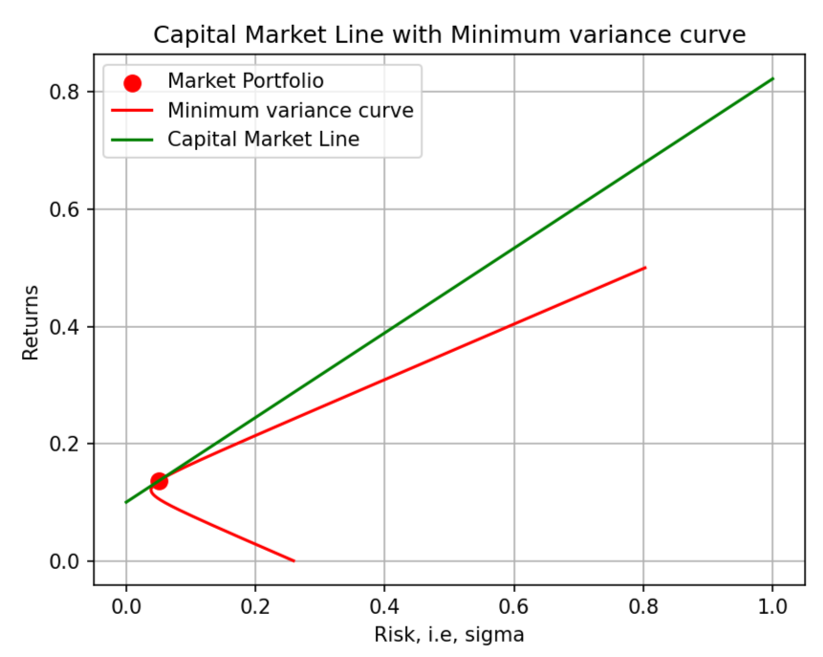

The required portfolio with risk at 10% is:

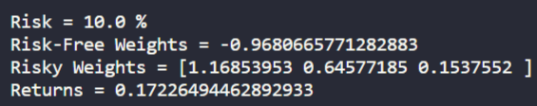

The required portfolio with risk at 25% is:

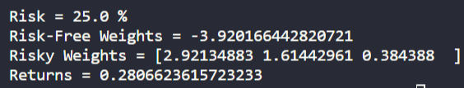

Question 2:

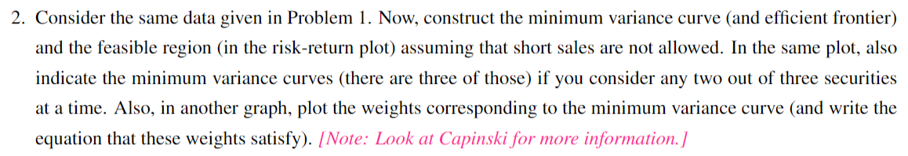

Assuming that the weights are non-negative, that is, short sales are not allowed, the various plots required in the question are as follows:

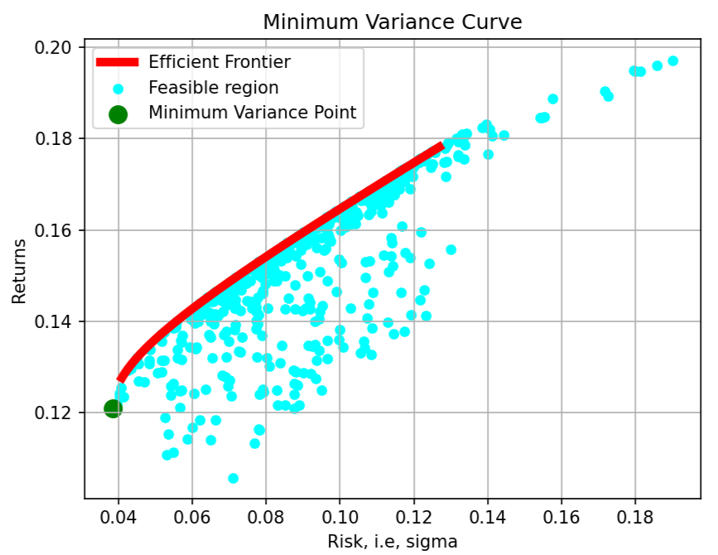

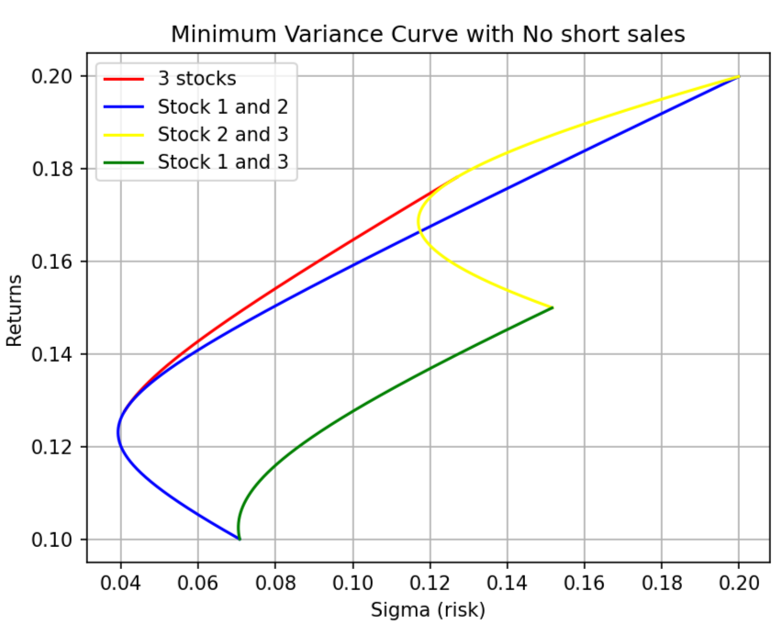

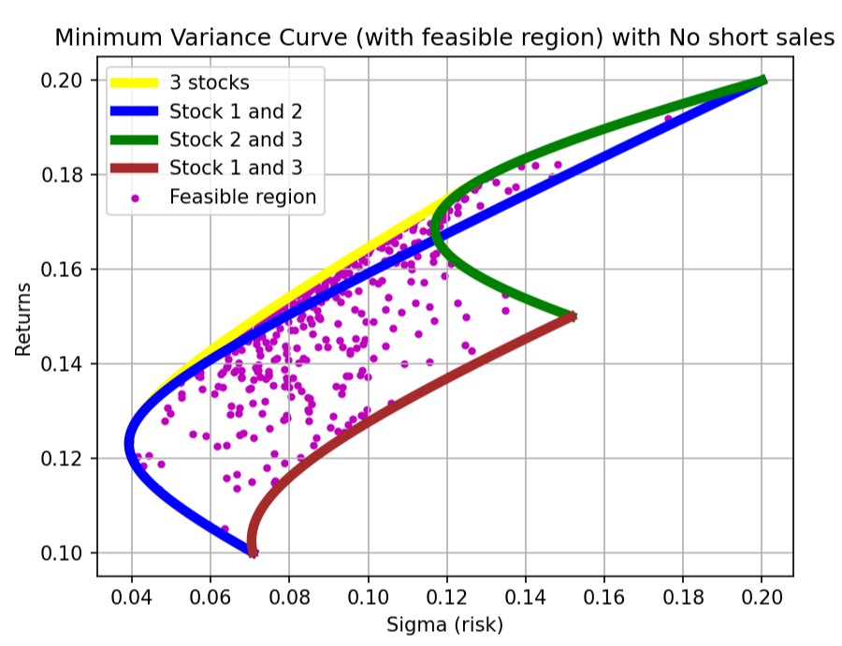

The plots for the weights corresponding to the minimum variance curve are:

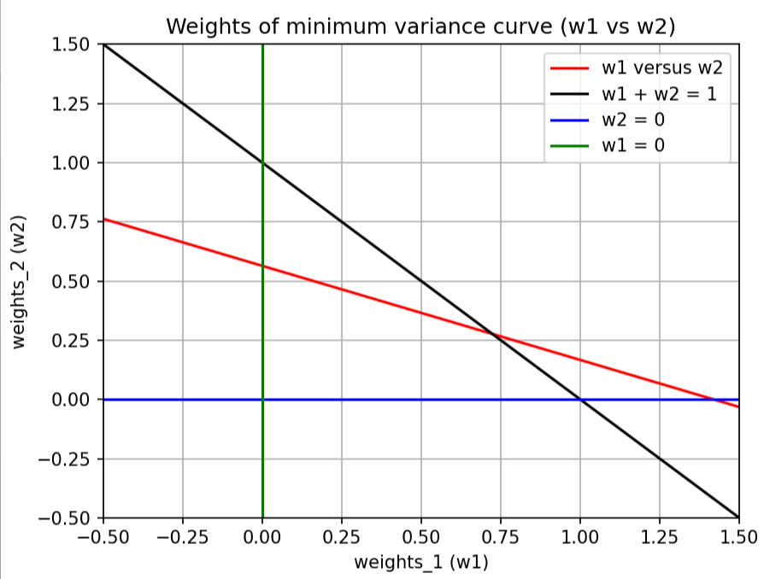



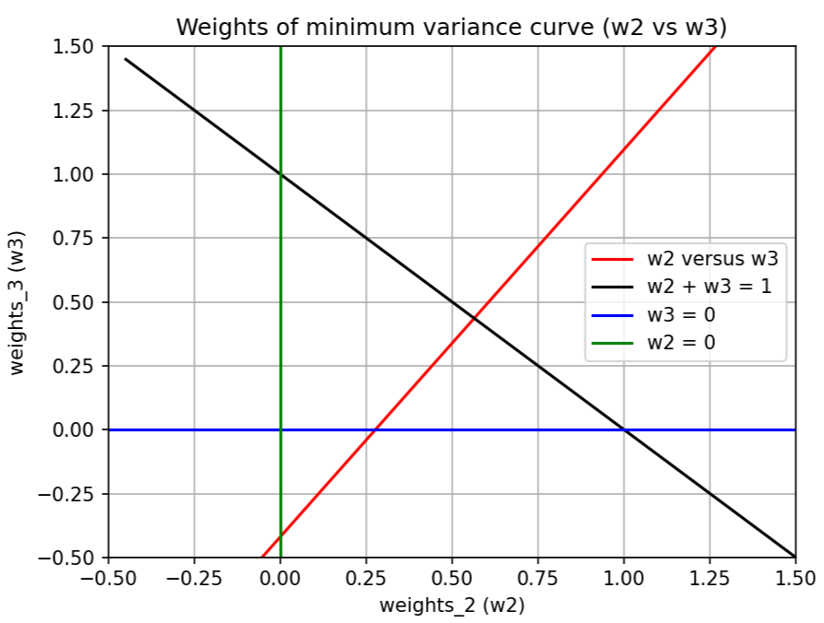



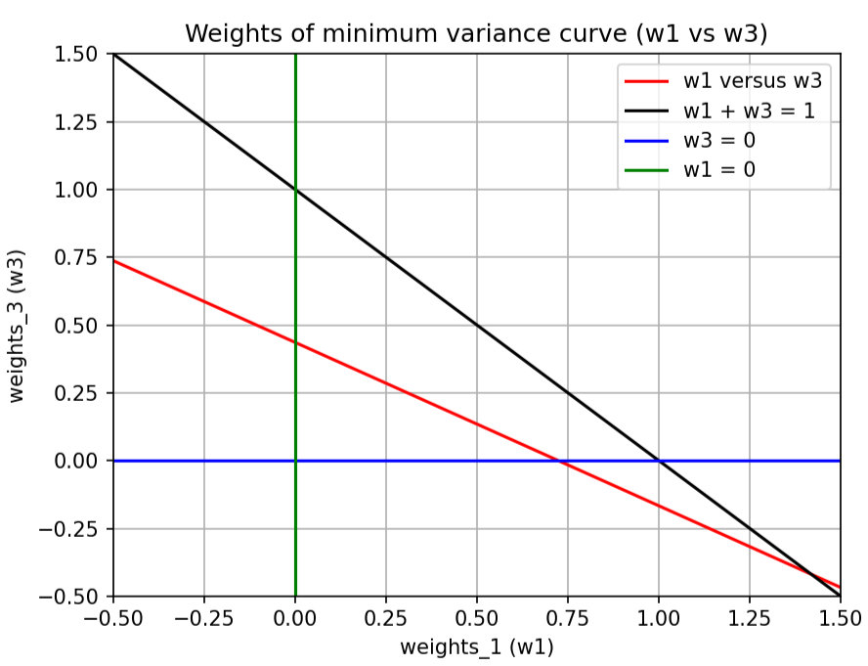



Question 3:

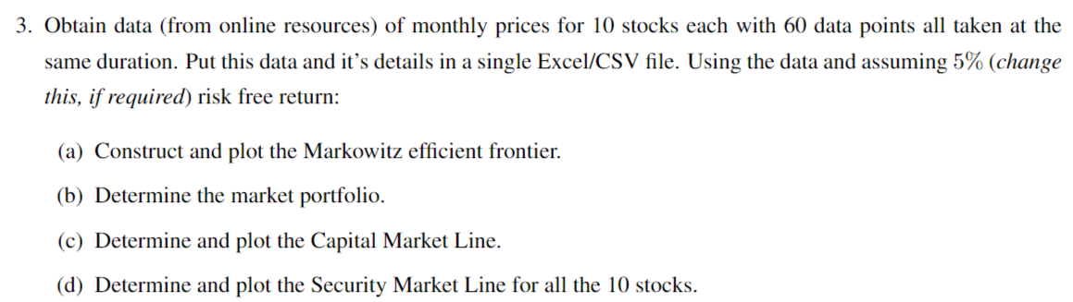

The data of the monthly prices for 10 stocks has been collected from online resources for the period between 01/02/2019 (February 2019) to 01/01/2024 (January 2024). (total 60 data points, 5 years data, so 12 * 5 = 60 data points).

The companies whose monthly stock prices are considered are as follows: Apple, Google, Amazon, Microsoft, Tesla, Nvidia, PayPal, IBM, Cisco and JP Morgan Chase.



The monthly return was obtained as the difference in stock prices between the stock prices at the beginning of two consecutive months. Then, the annual return was calculated accordingly.

1. The plot of the Markowitz efficient frontier is drawn below:

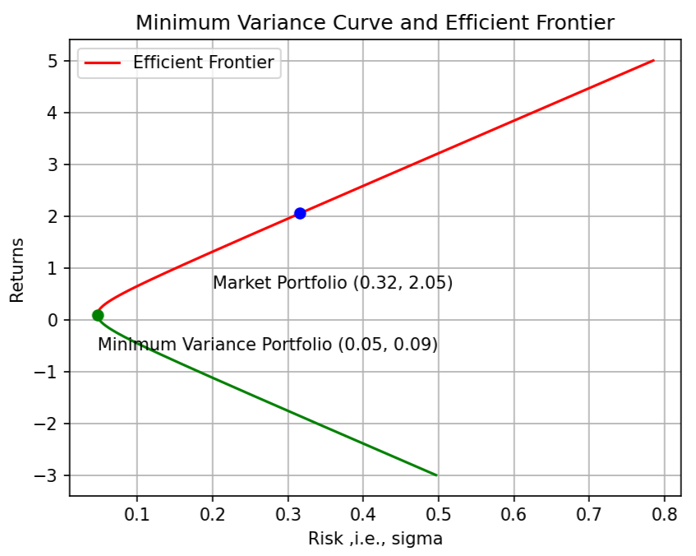

1. The market portfolio is:

Market Portfolio Weights = [1.420507685472, 0.188262831062, -2.933886890194, 3.101708635950, 0.382610962595, 1.395922786459, -0.815839240010, -0.002396260083, -1.486878577970, -0.250011933282]

Return = 2.051729787457427

Risk = 31.61016740366777 %

1. The equation of the Capital Market Line is: y = 6.33 x + 0.05

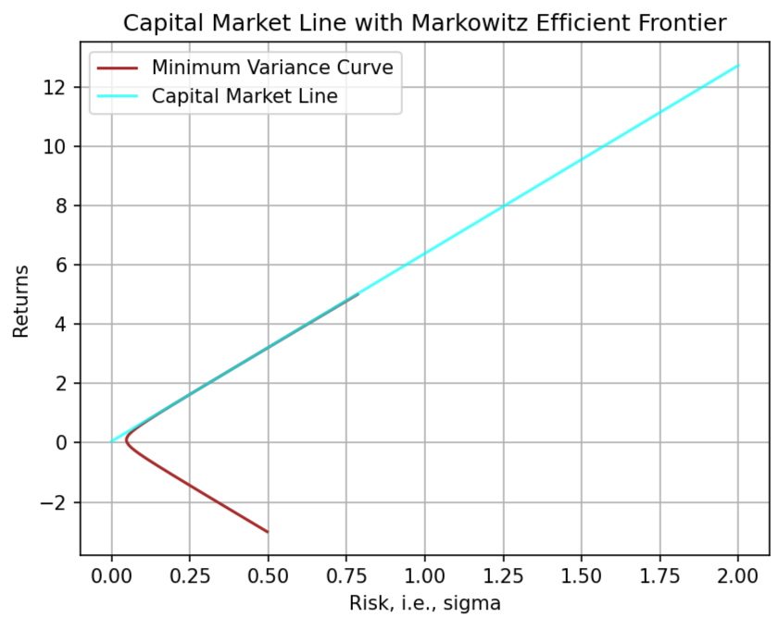

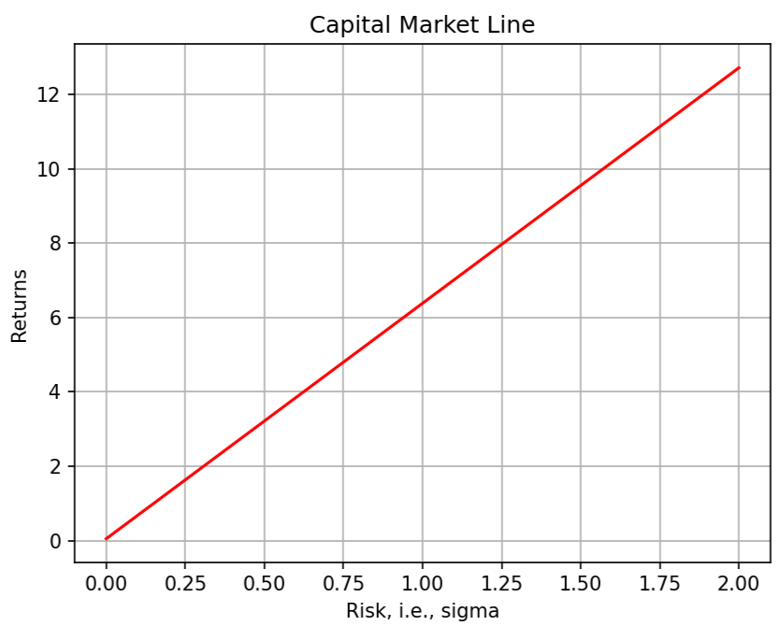

1. The equation of the Security Market Line is obtained by using the following formula:



Where, μrf = risk-free return and μM = return corresponding to market portfolio

So, plugging in the values, the equation of the Security Market Line is:



