**Financial Engineering Lab MA – 374 Lab – 5**

**Name –** Rasesh Srivastava

**Roll Number –** 210123072

**Branch –** Mathematics and Computing

Question 1:

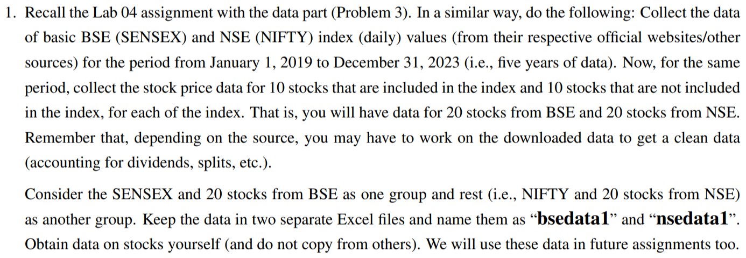

Kindly download all the folders and files submitted along with bsedata1.csv and nsedata1.csv

The stocks used are as follows:

10 stocks included in BSE (SENSEX) index:

* RELIANCE.BO: Reliance Industries Limited
* TCS.BO: Tata Consultancy Services Limited
* HDFCBANK.BO: HDFC Bank Limited
* HINDUNILVR.BO: Hindustan Unilever Limited
* INFY.BO: Infosys Limited
* KOTAKBANK.BO: Kotak Mahindra Bank Limited
* ICICIBANK.BO: ICICI Bank Limited
* LT.BO: Larsen & Toubro Limited
* AXISBANK.BO: Axis Bank Limited
* SBIN.BO: State Bank of India

10 stocks included in NSE (NIFTY) index:

* TCS.NS: Tata Consultancy Services Limited
* HINDUNILVR.NS: Hindustan Unilever Limited
* INFY.NS: Infosys Limited
* KOTAKBANK.NS: Kotak Mahindra Bank Limited
* ICICIBANK.NS: ICICI Bank Limited
* LT.NS: Larsen & Toubro Limited
* SBIN.NS: State Bank of India
* RELIANCE.NS: Reliance Industries Limited
* ITC.NS: ITC Limited
* ONGC.NS: Oil and Natural Gas Corporation Limited

10 stocks not included in BSE (SENSEX) index:

* GOOGL: Alphabet Inc. (Google)
* AAPL: Apple Inc.
* AMZN: Amazon.com Inc.
* MSFT: Microsoft Corporation
* NVDA: NVIDIA Corporation
* ADBE: Adobe Inc.
* NFLX: Netflix Inc.
* TSLA: Tesla Inc.
* ORCL: Oracle Corporation
* CSCO: Cisco Systems Inc.

10 stocks not included in NSE (NIFTY) index:

* NKE: NIKE Inc.
* BIDU: Baidu Inc.
* NVDA: NVIDIA Corporation
* KO: The Coca-Cola Company
* PYPL: PayPal Holdings Inc.
* SNAP: Snap Inc.
* MCD: McDonald's Corporation
* WMT: Walmart Inc.
* BABA: Alibaba Group Holding Limited
* PEP: PepsiCo Inc.



Question 2:

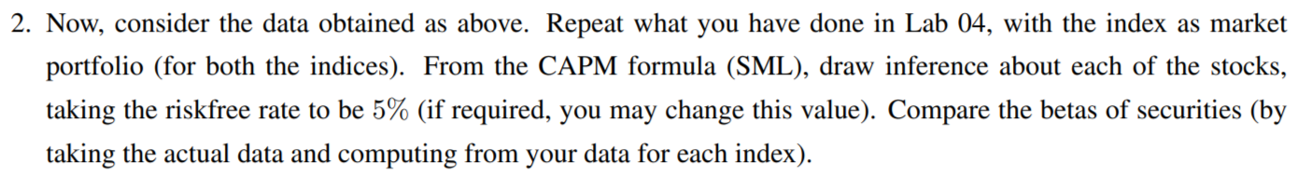

Basic BSE and NSE Index values:

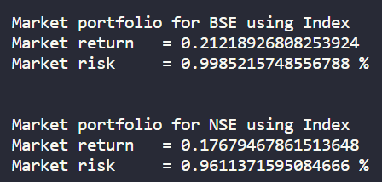

10 stocks included in the BSE Index:

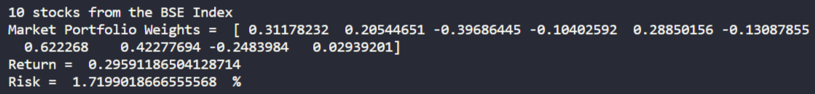

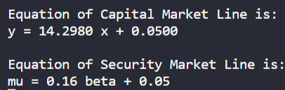

The market portfolio shown is calculated from the values of the 10 stocks, and not taken from the market portfolio found from the index values. The market portfolio mean used in calculating the SML equation is that value which was calculated from the corresponding index values.

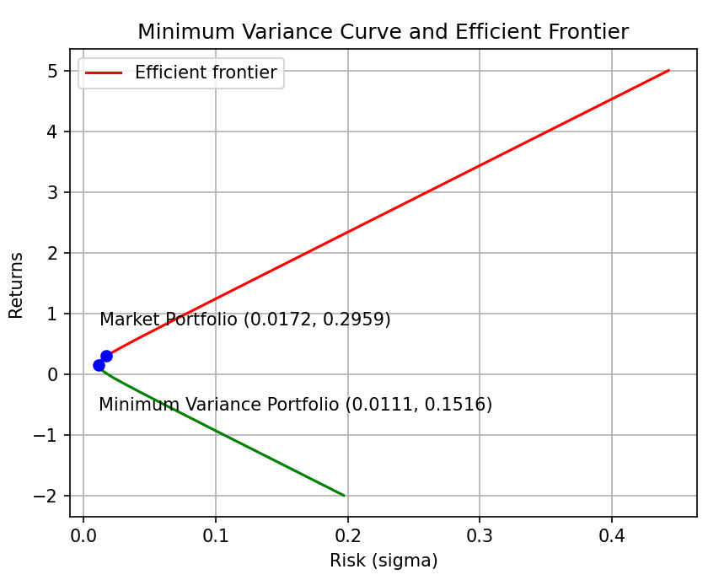

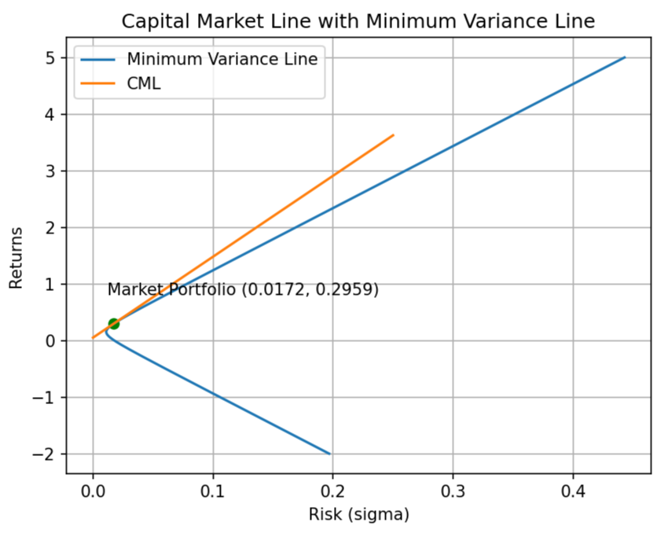

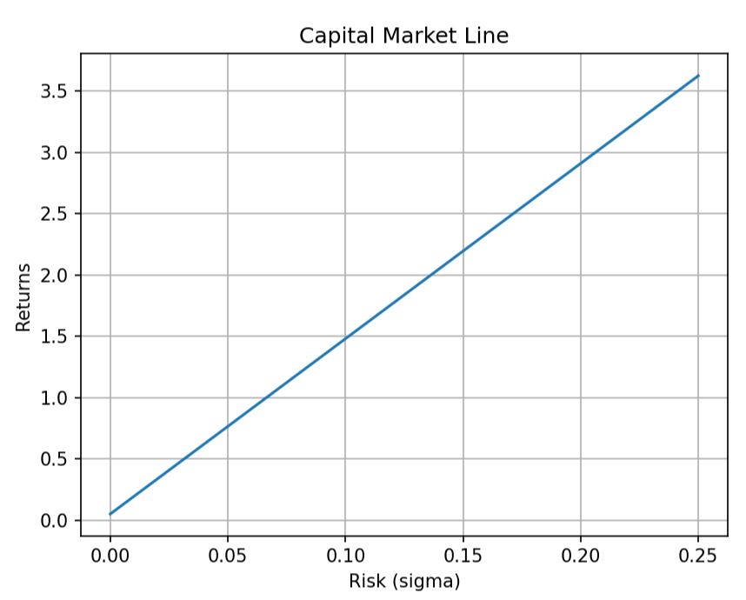

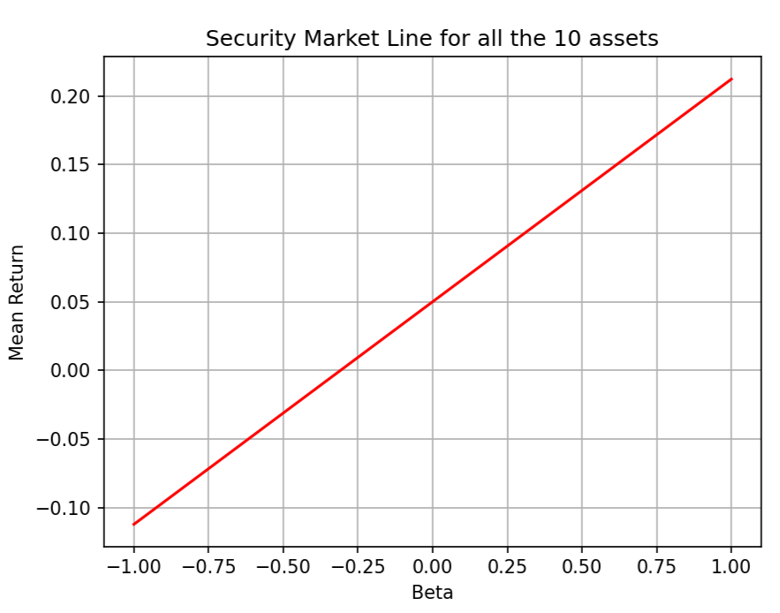

10 stocks included in the NSE Index:

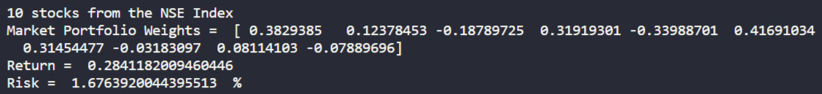

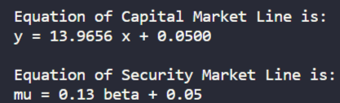

The market portfolio shown is calculated from the values of the 10 stocks, and not taken from the market portfolio found from the index values. The market portfolio mean used in calculating the SML equation is that value which was calculated from the corresponding index values.

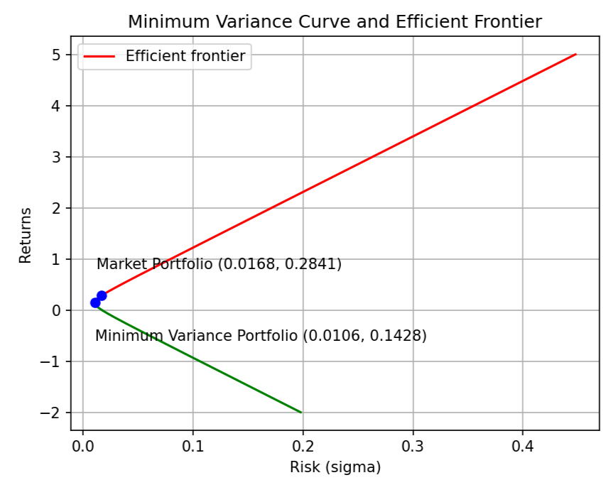

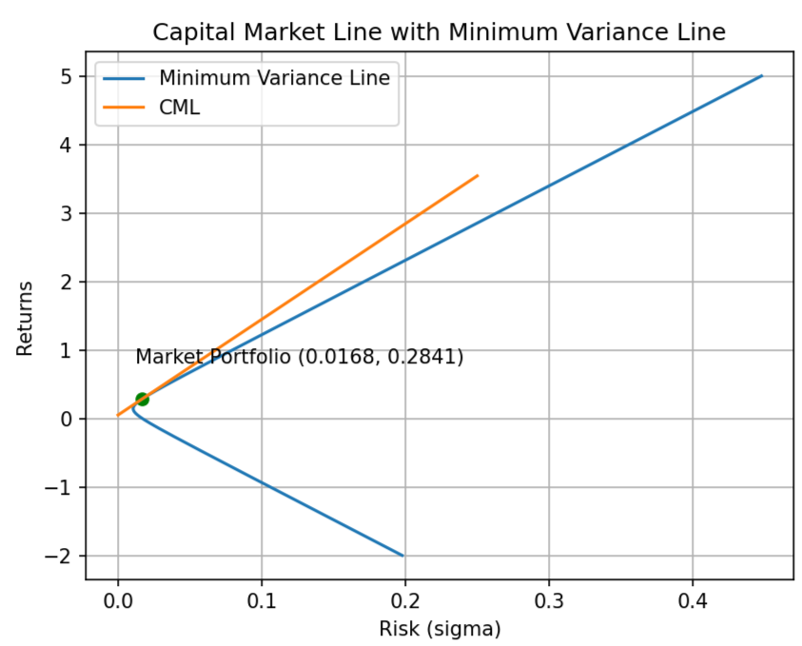

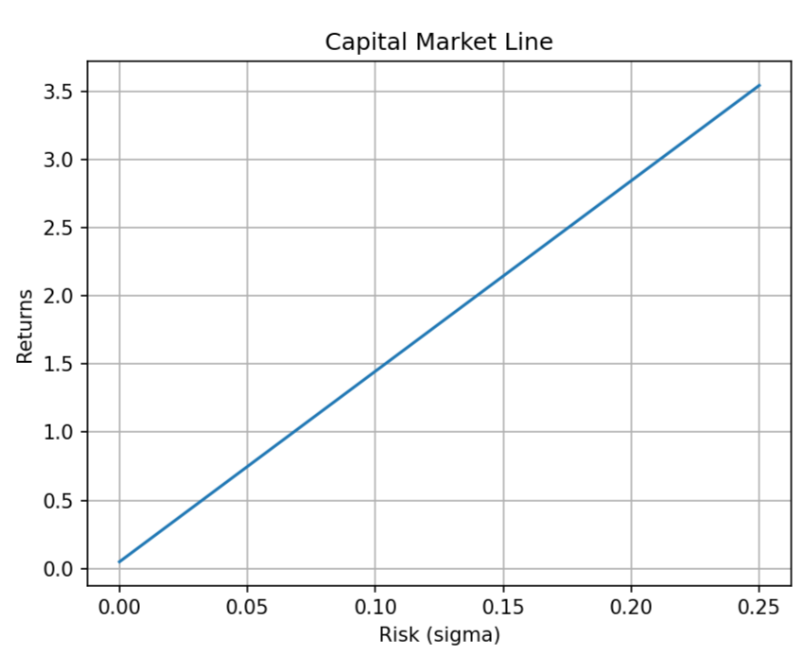

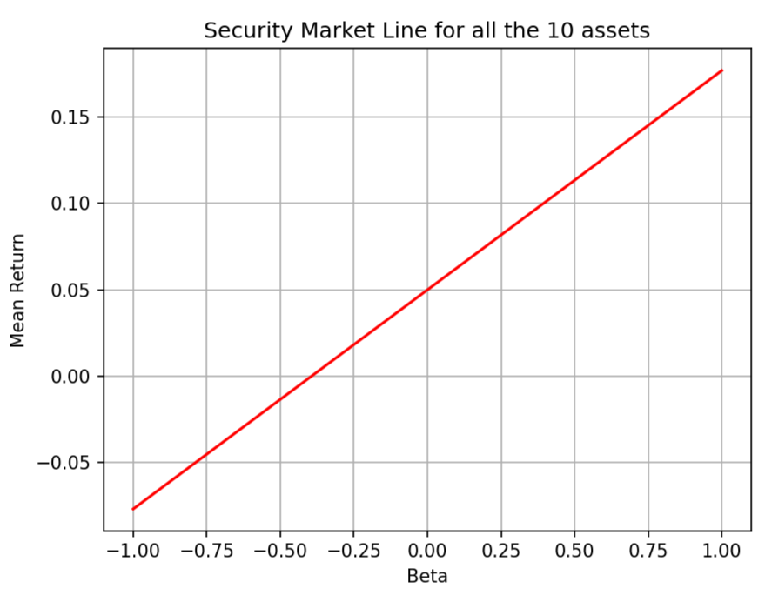

10 stocks not included in the BSE Index:

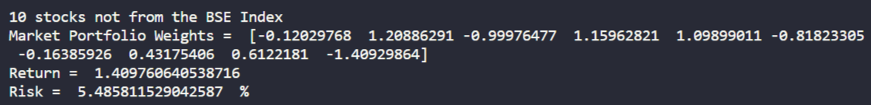

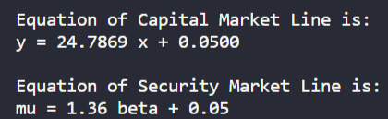

The market portfolio mean used in calculating the SML equation and in the plot for the efficient frontier is found from considering all the 10 stocks in a single portfolio.

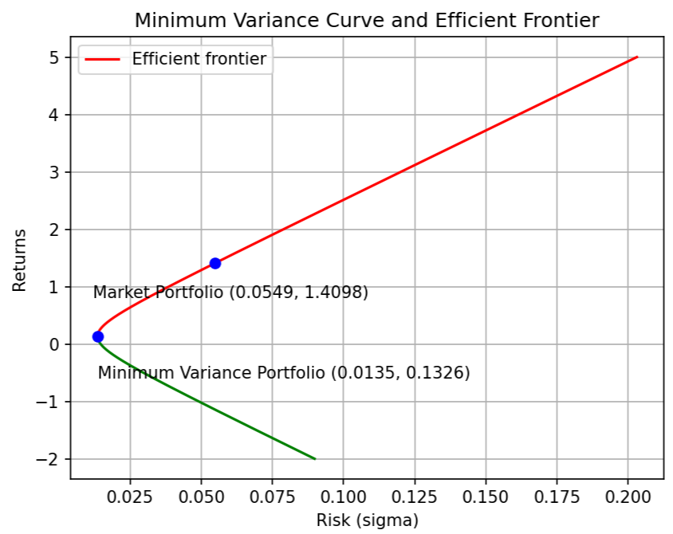

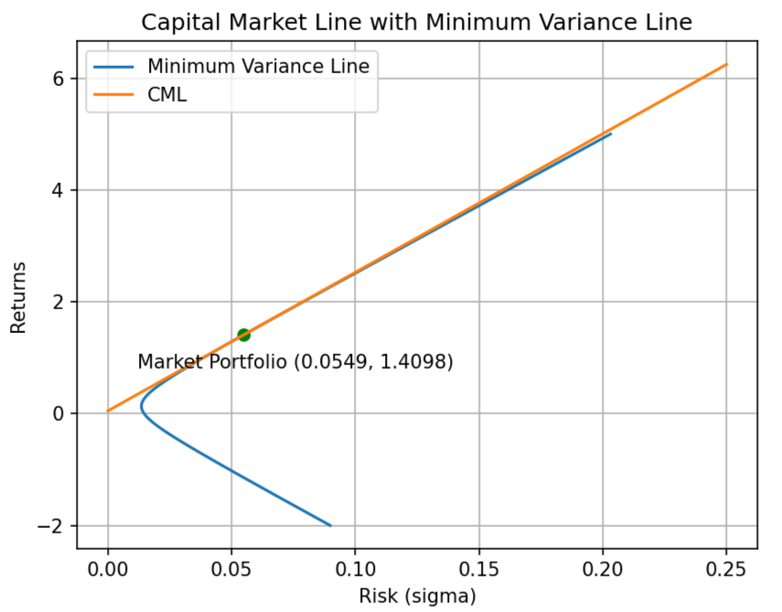

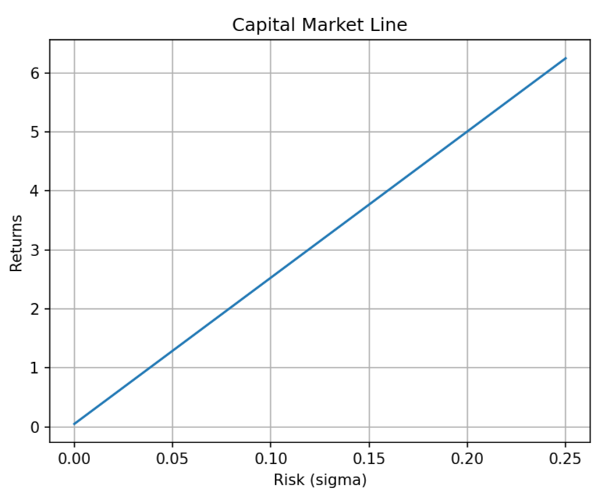

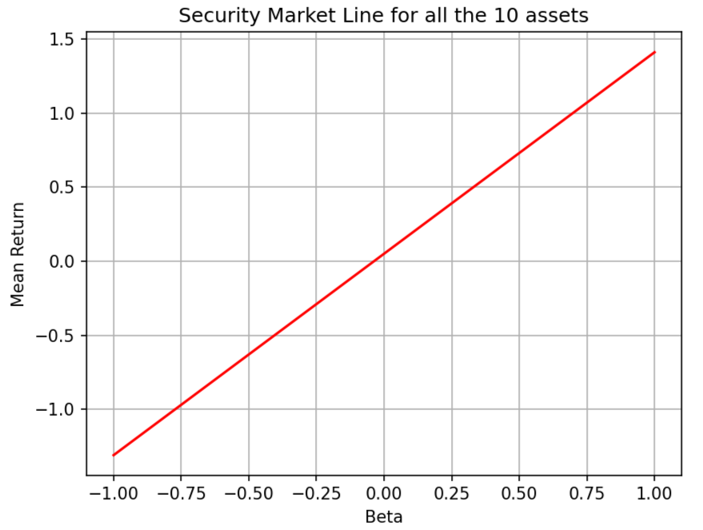

10 stocks not included in the NSE Index:

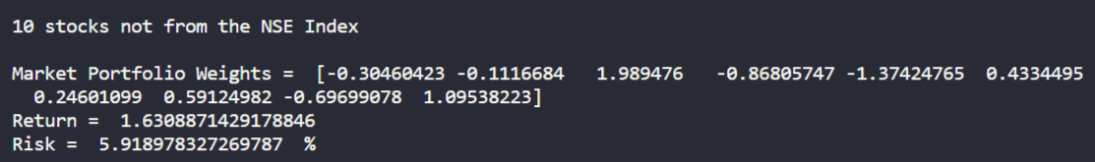

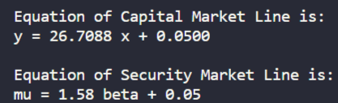

The market portfolio mean used in calculating the SML equation and in the plot for the efficient frontier is found from considering all the 10 stocks in a single portfolio.

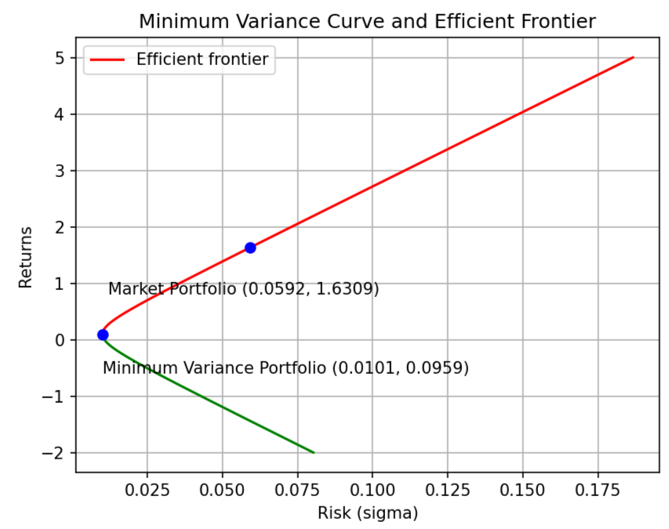

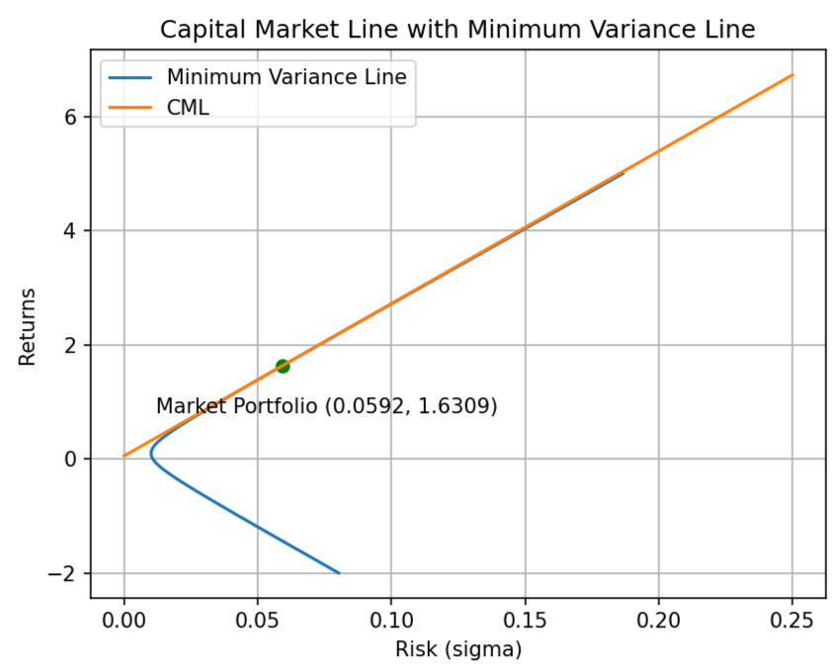

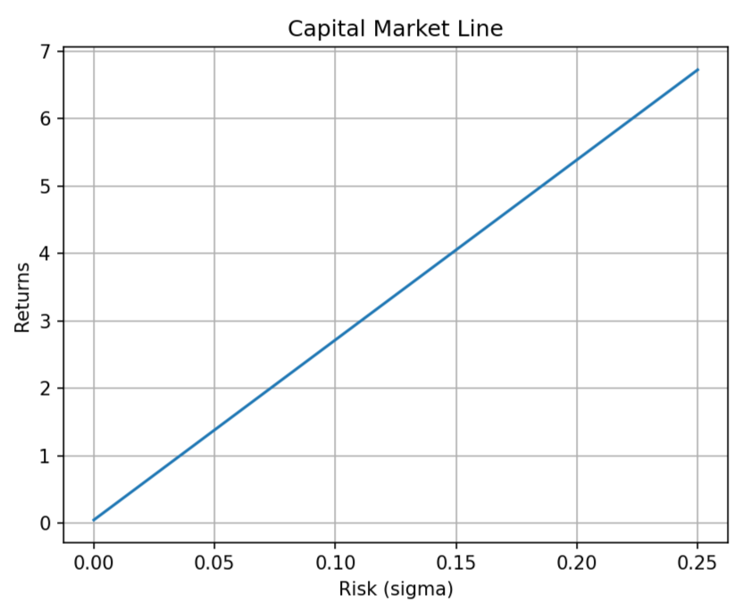

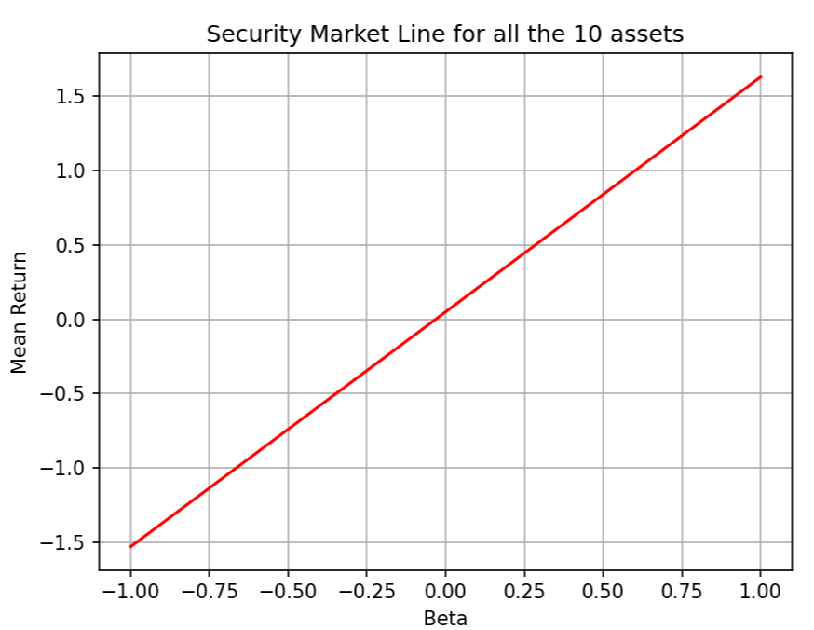

Please ignore the formatting and table spacing during printing, the first column is the ticker symbol for the stock, the second column is the actual return value, and the third column is the expected return value.

Following table compares the actual return and expected return value of each stock, where the expected return value is computed by making use of the security market line equation:

For the 10 stocks included in BSE index:

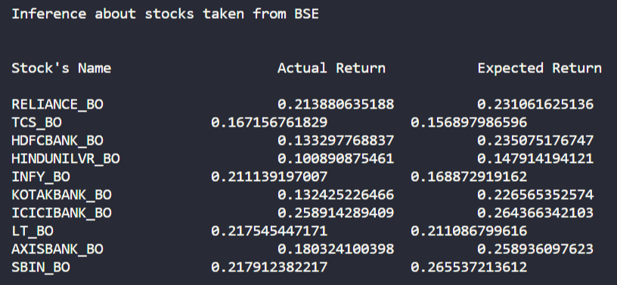

For the 10 stocks included in NSE index:

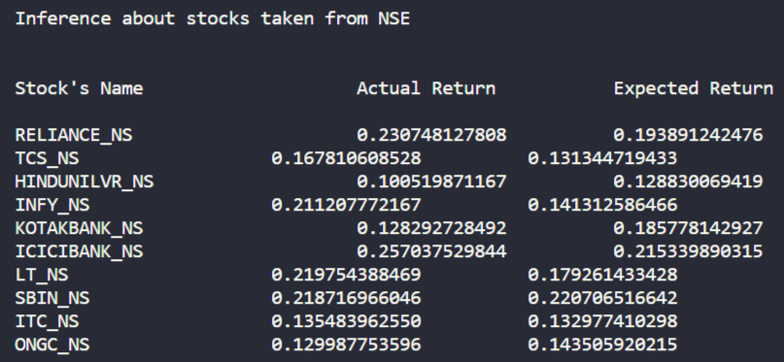

For the 10 stocks not included in BSE index:

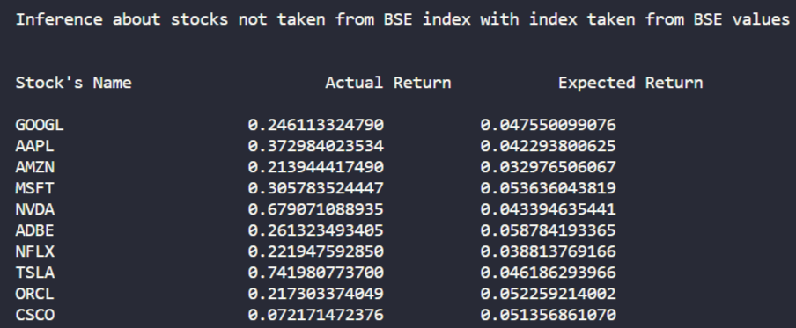

For the 10 stocks not included in NSE index:

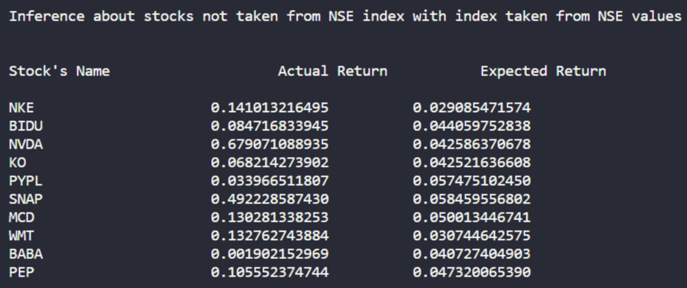

Please ignore the formatting and table spacing during printing, the first column is the ticker symbol for the stock, the second column is the beta value.

The betas of securities (by taking the actual data and computing from our data for each index) are as follows:

The betas of the securities for the stocks from BSE index are as follows:

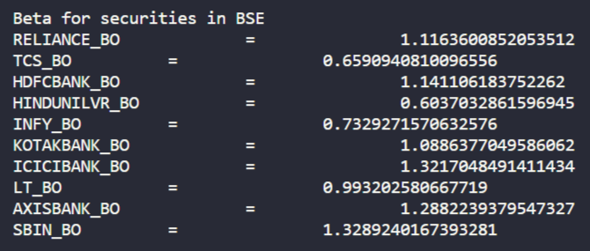

The betas of the securities for the stocks from NSE index are as follows:

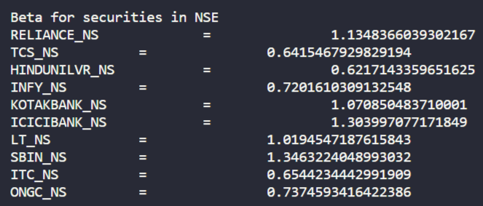

The betas of the securities for the stocks not from BSE index using market portfolio from BSE index are as follows:

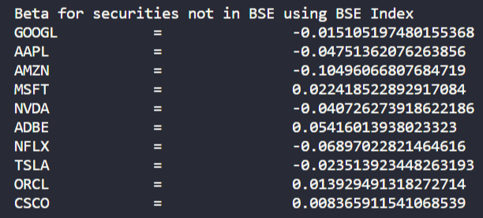

The betas of the securities for the stocks not from NSE index using market portfolio from NSE index are as follows:

