**Scientific Computing Lab MA – 322 Lab – 12**

**Name –** Rasesh Srivastava

**Roll Number –** 210123072

**Branch –** Mathematics and Computing

For each part of all the questions, the five plots are as follows:

(i) t versus actual and approximate solutions

(ii) t versus absolute error

(iii) N versus Order of Convergence

(iv) loglog plot of t versus absolute error

(v) log(EN) versus log(N)

Where, N = (b-a)/h = Number of intervals

Order of convergence = log2(EN/E2N), where EN and E2N and the maximum errors obtained during the computation for that specific value of N

Absolute error = absolute value of the difference between the approximation and the actual solution

1)

a)

Using Adams-Bashforth method,

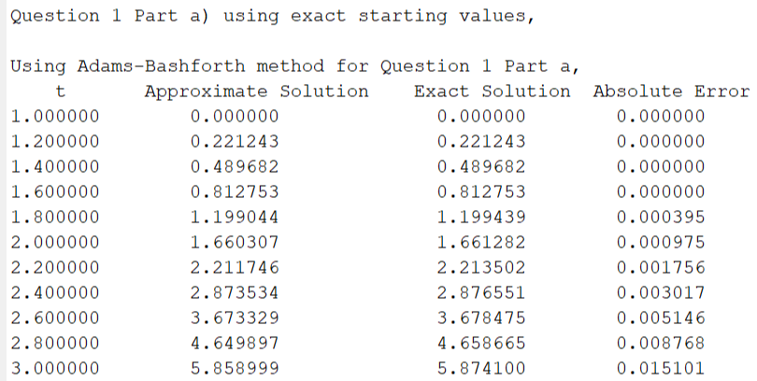

The graphs are as follows:

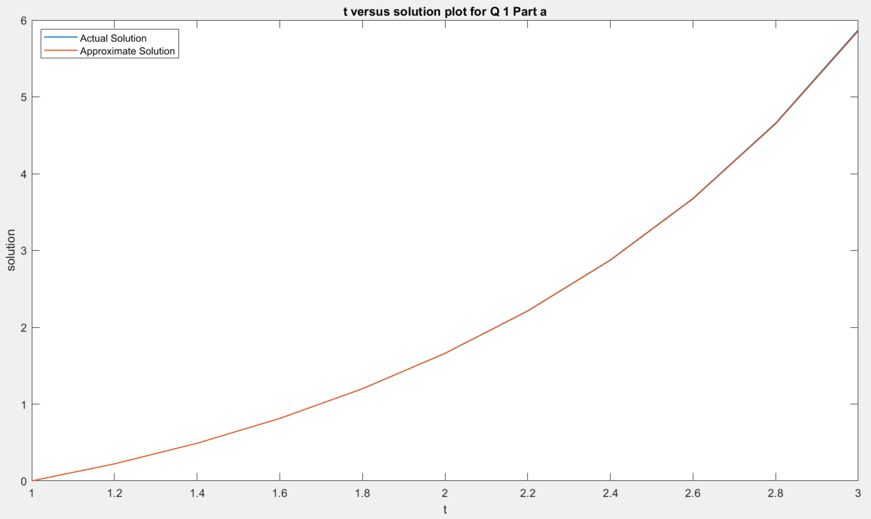

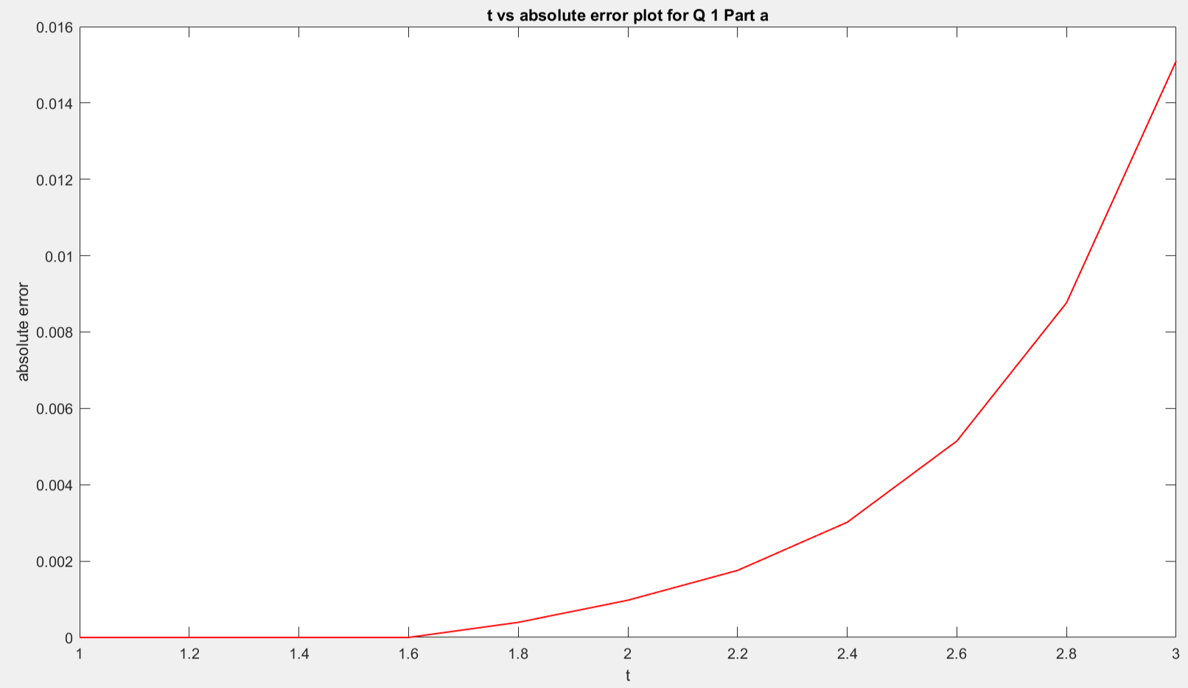

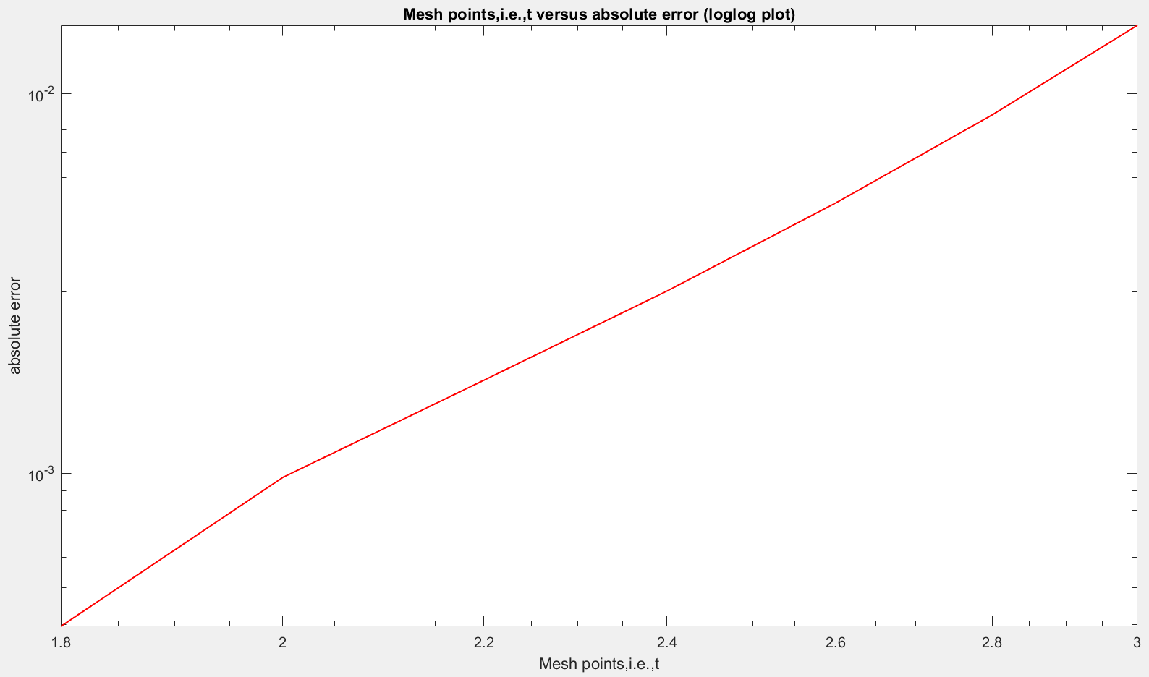

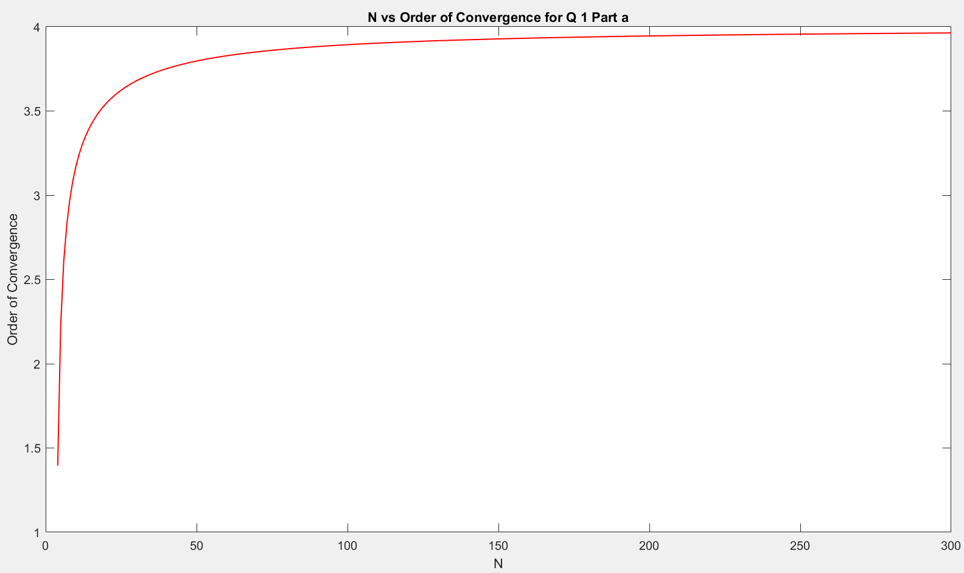

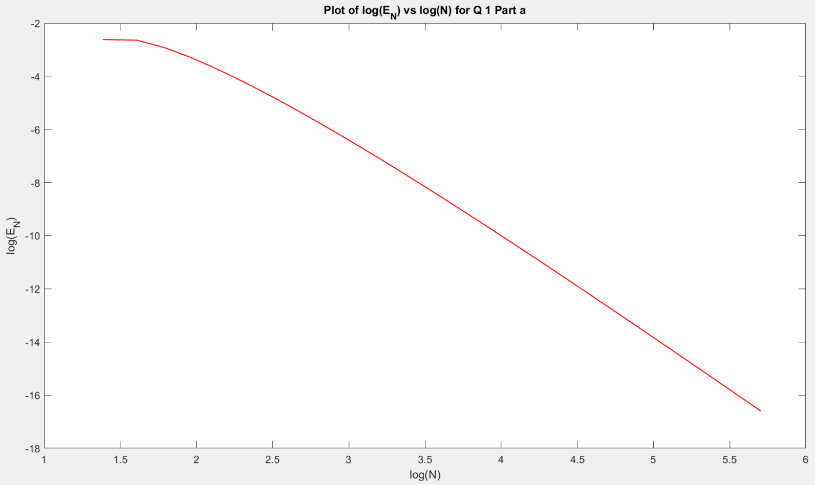

Using Admas-Moulton method,

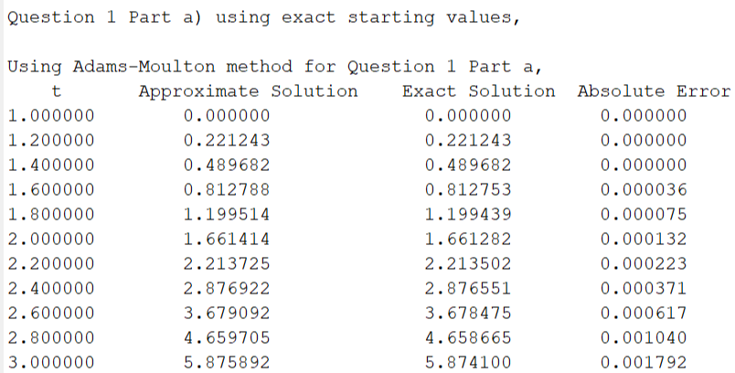

The graphs are as follows:

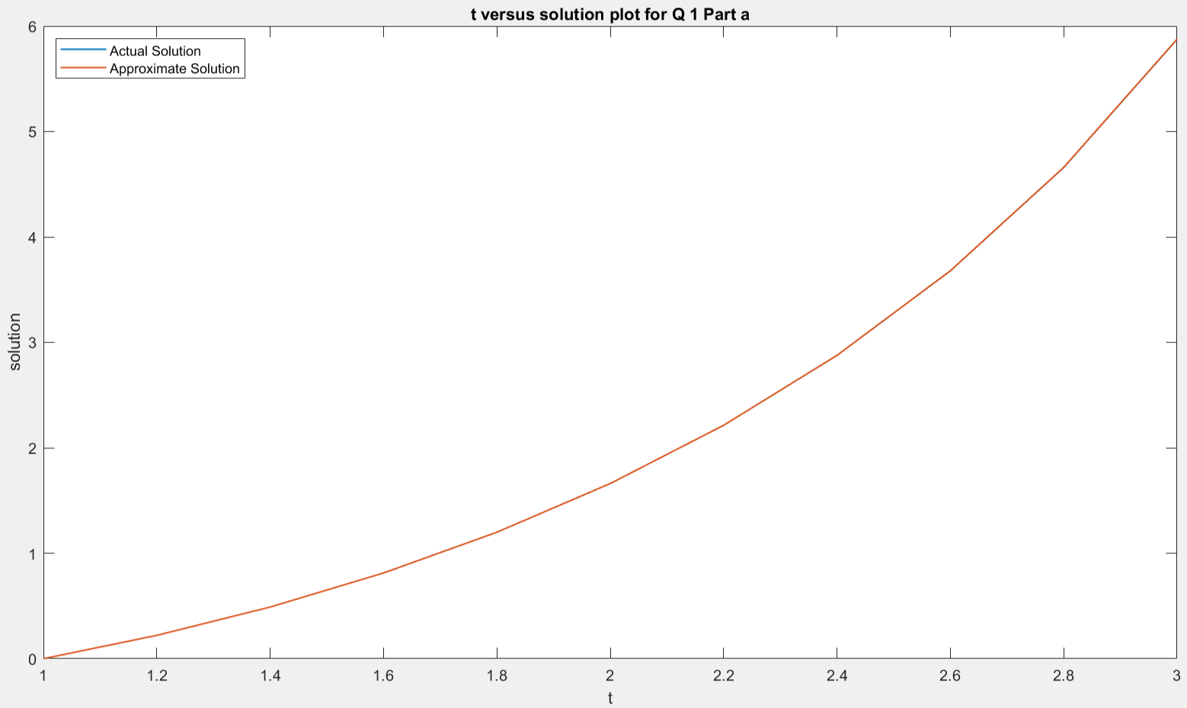

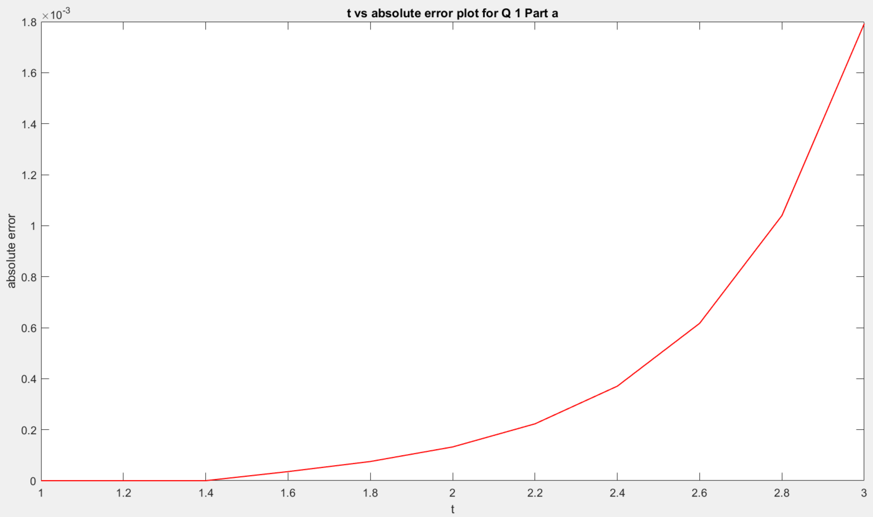

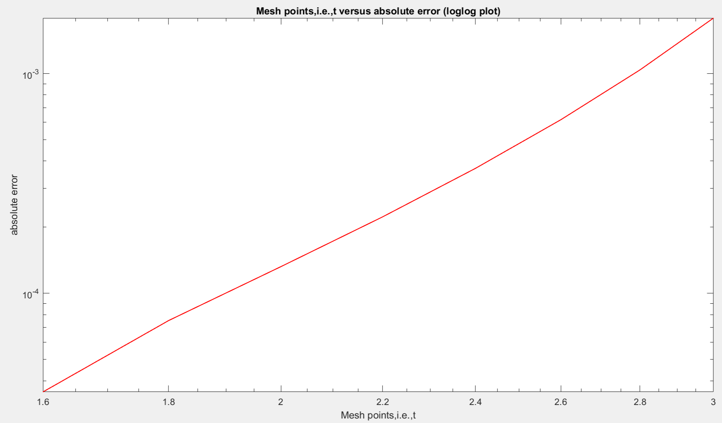

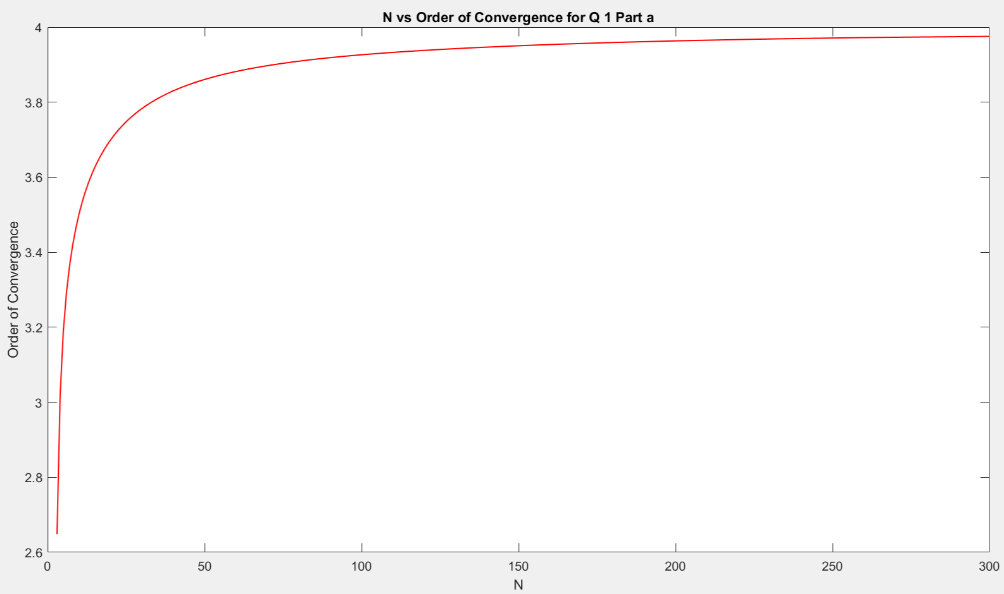

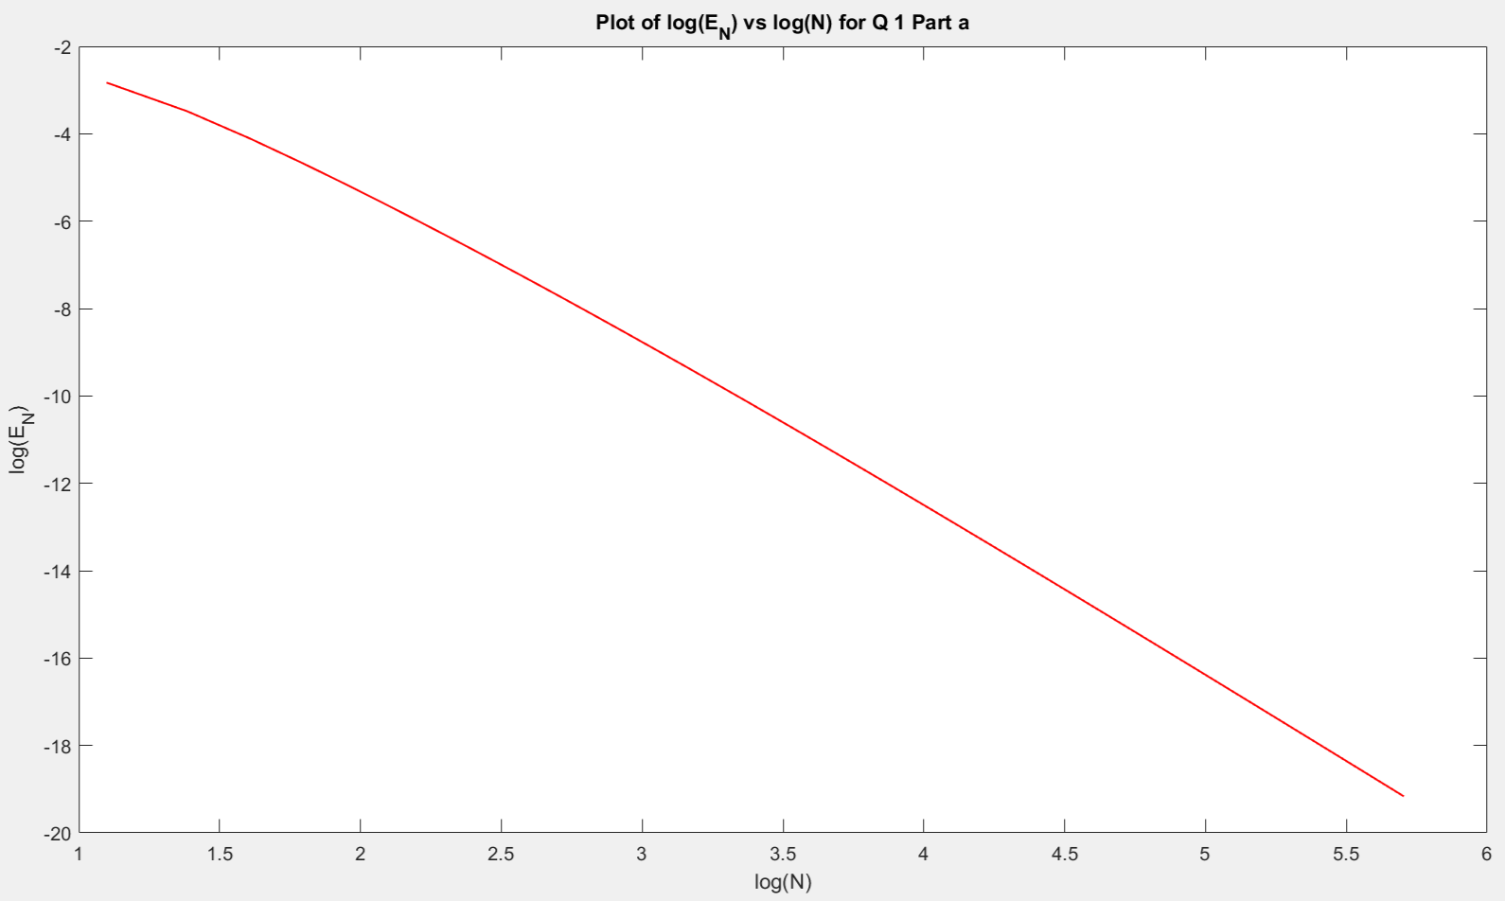

b)

Using Admas-Bashforth method,

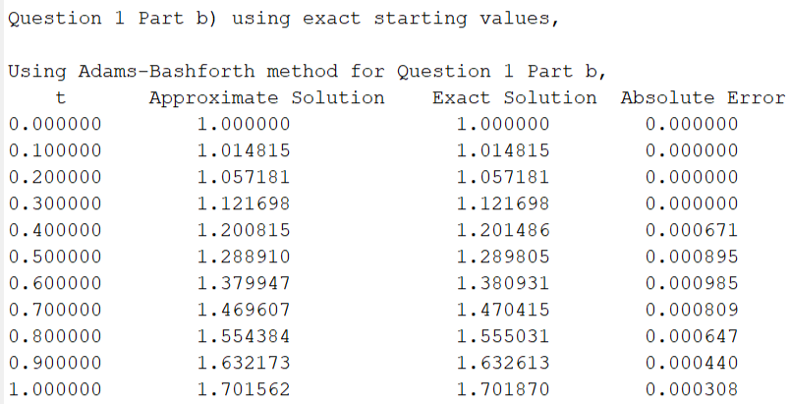

The graphs are as follows:

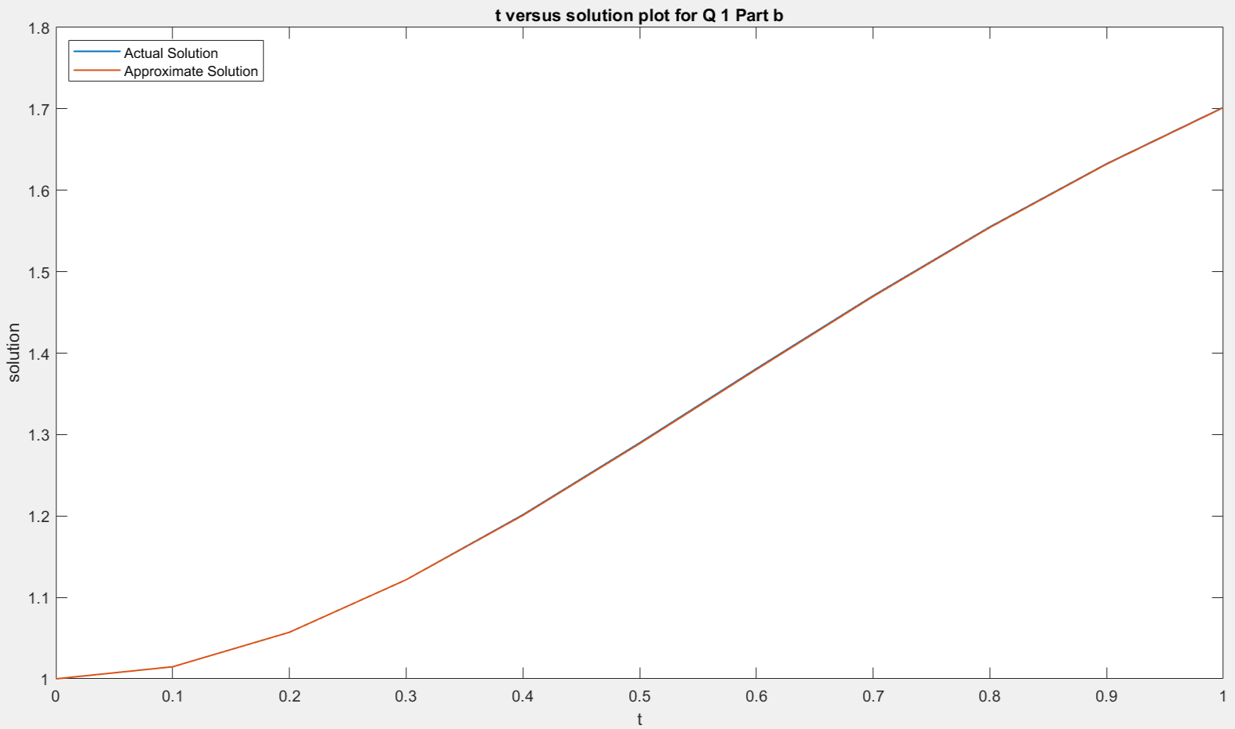

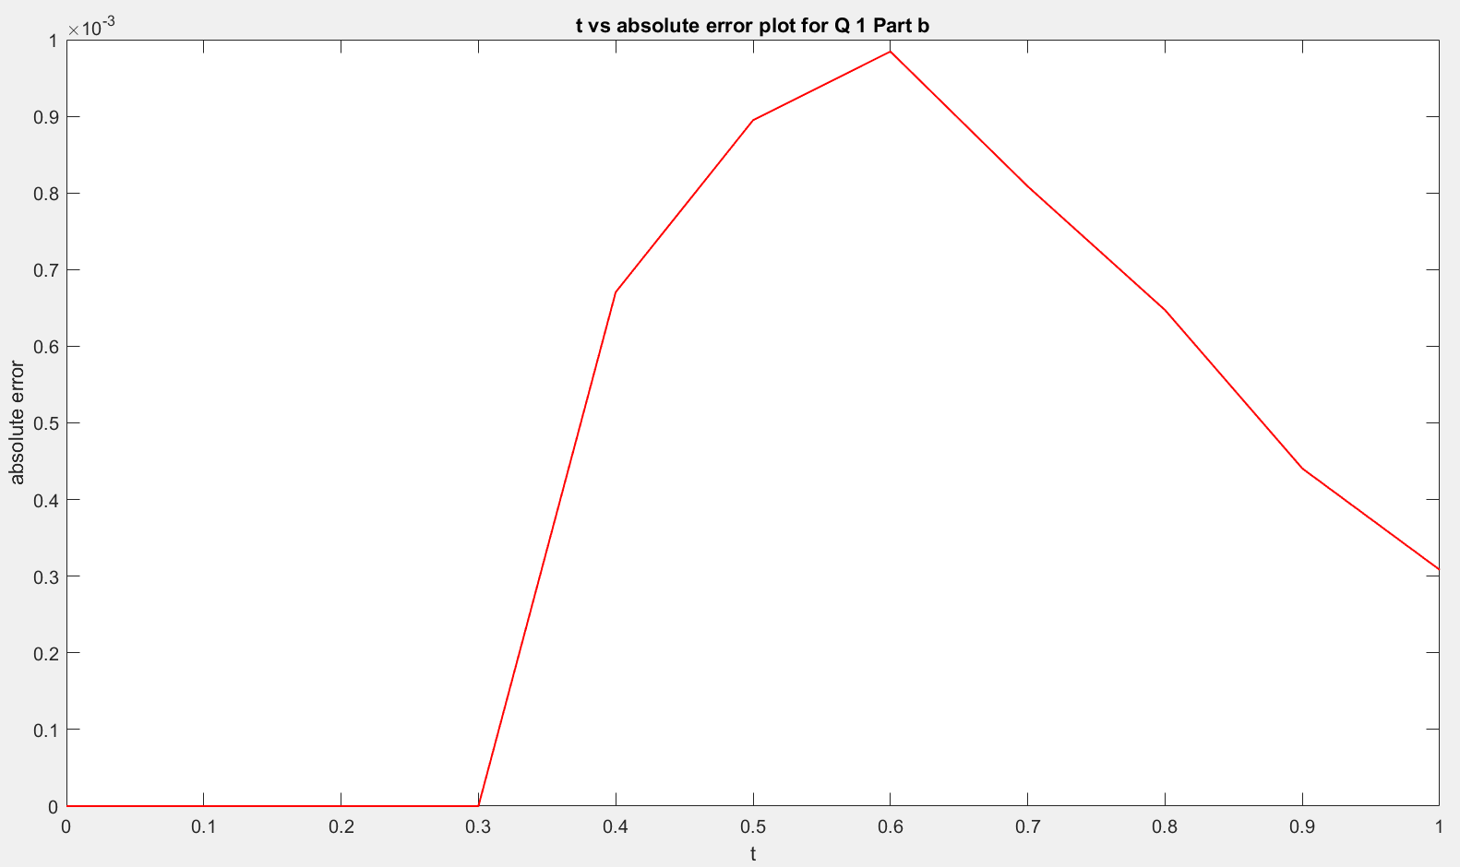

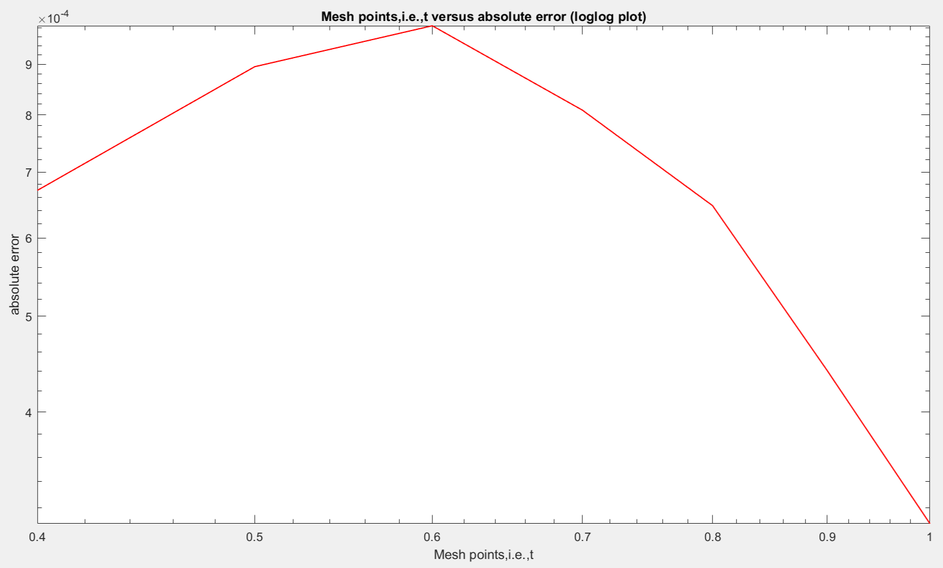

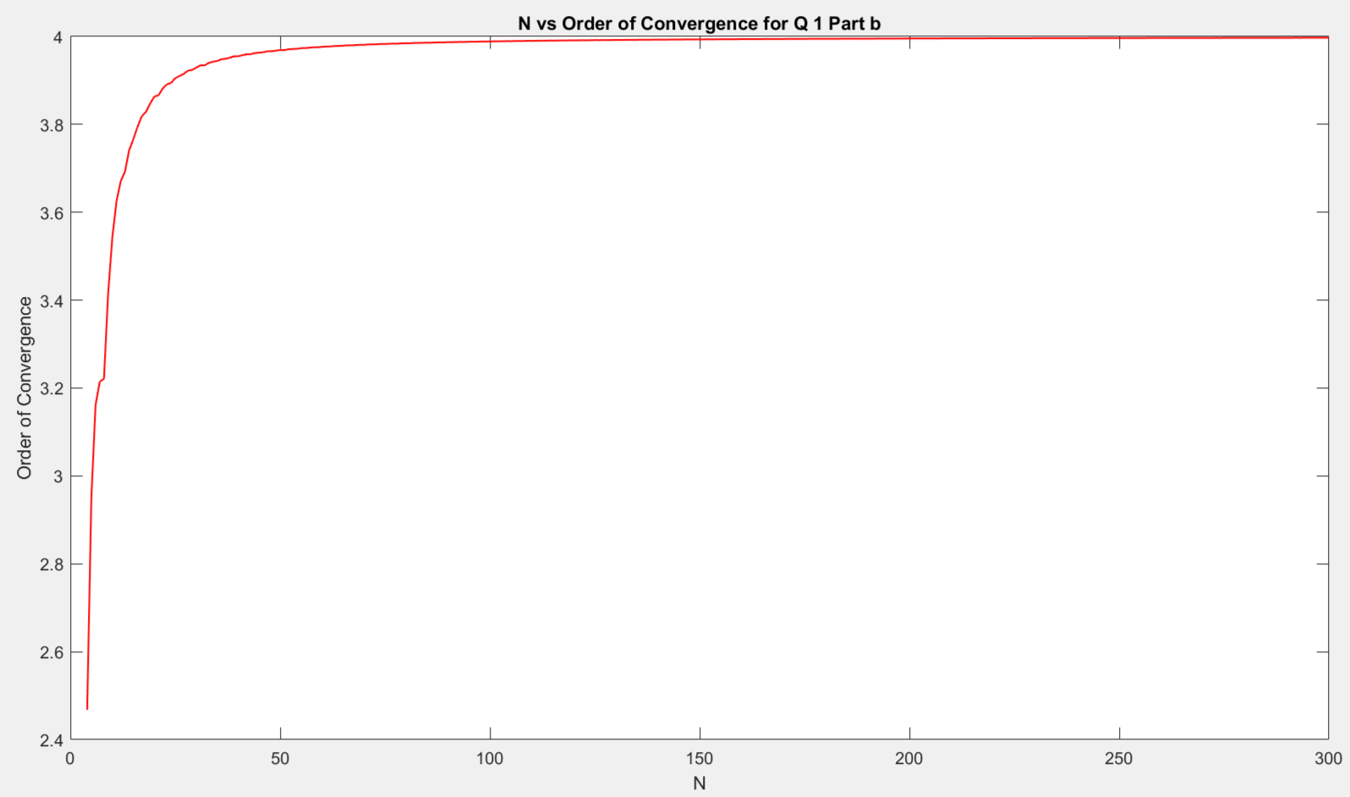

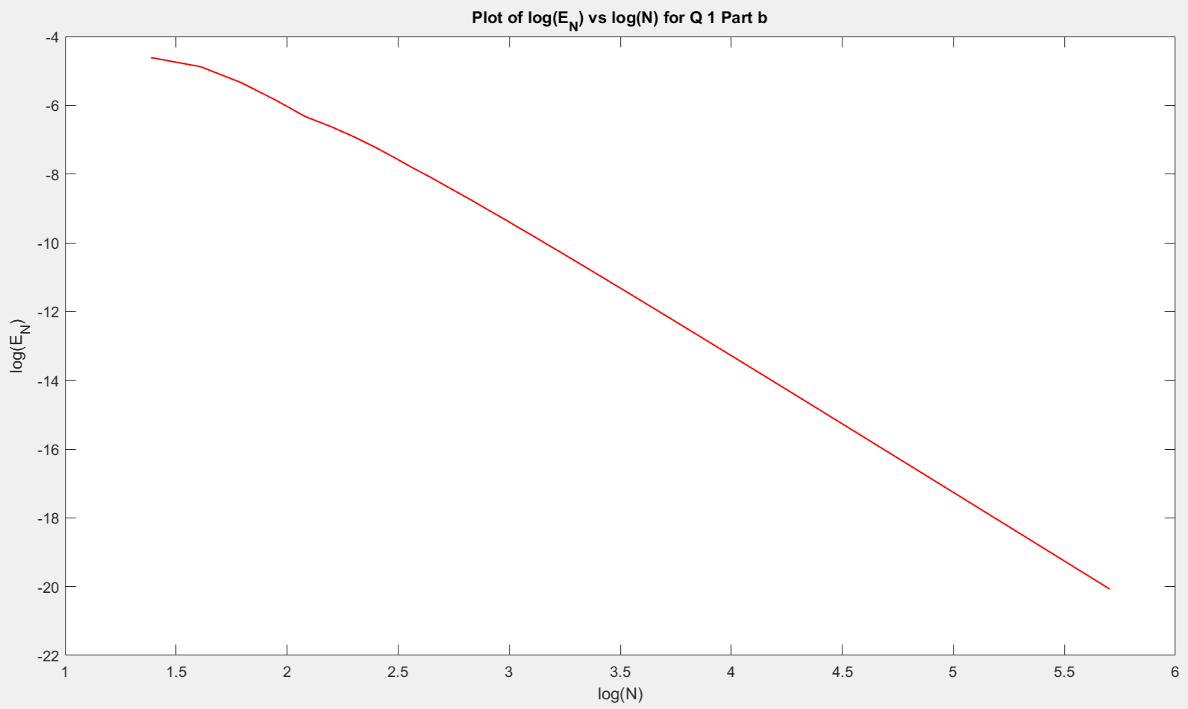

Using Admas-Moulton method,

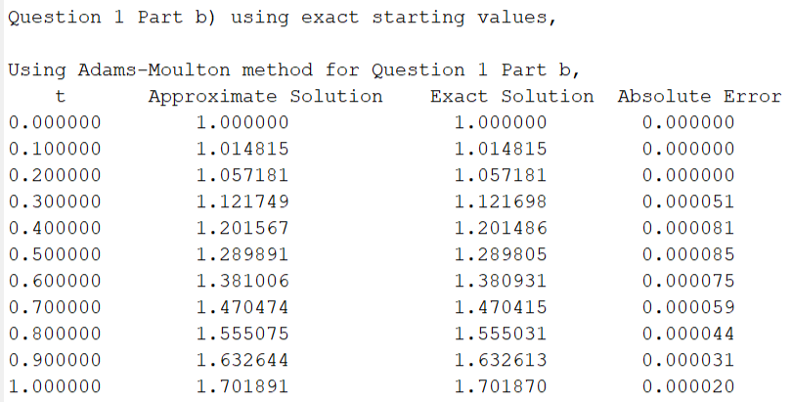

The graphs are as follows:

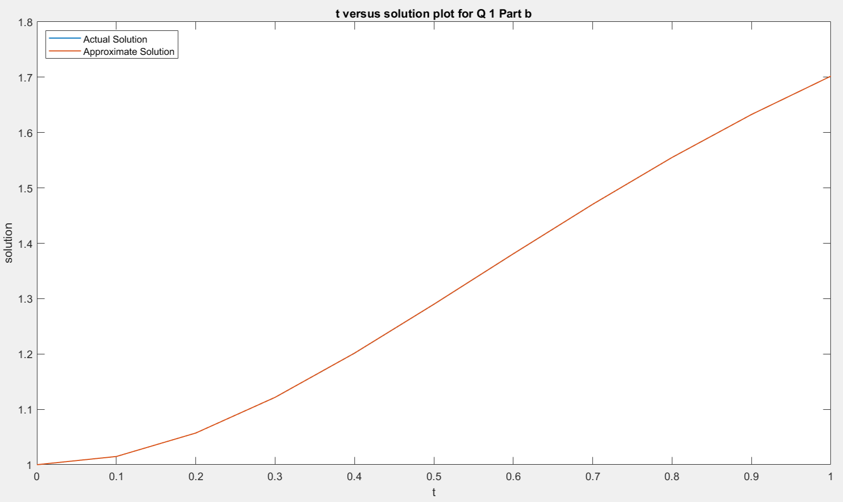

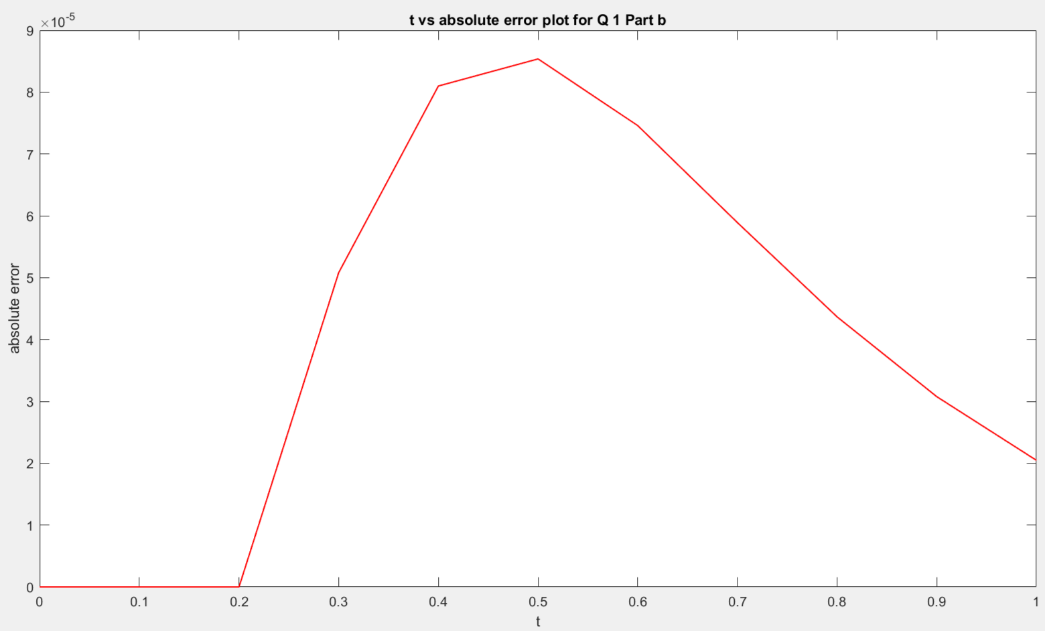

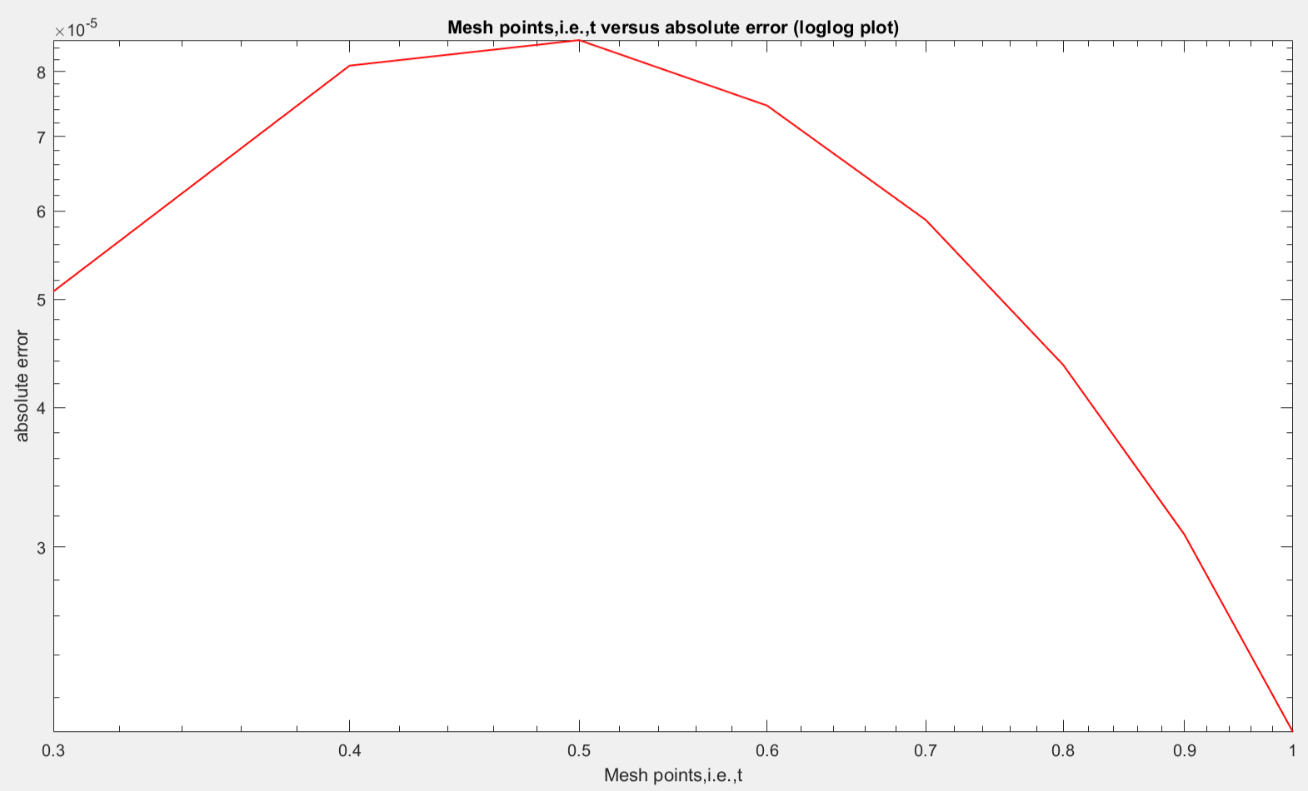

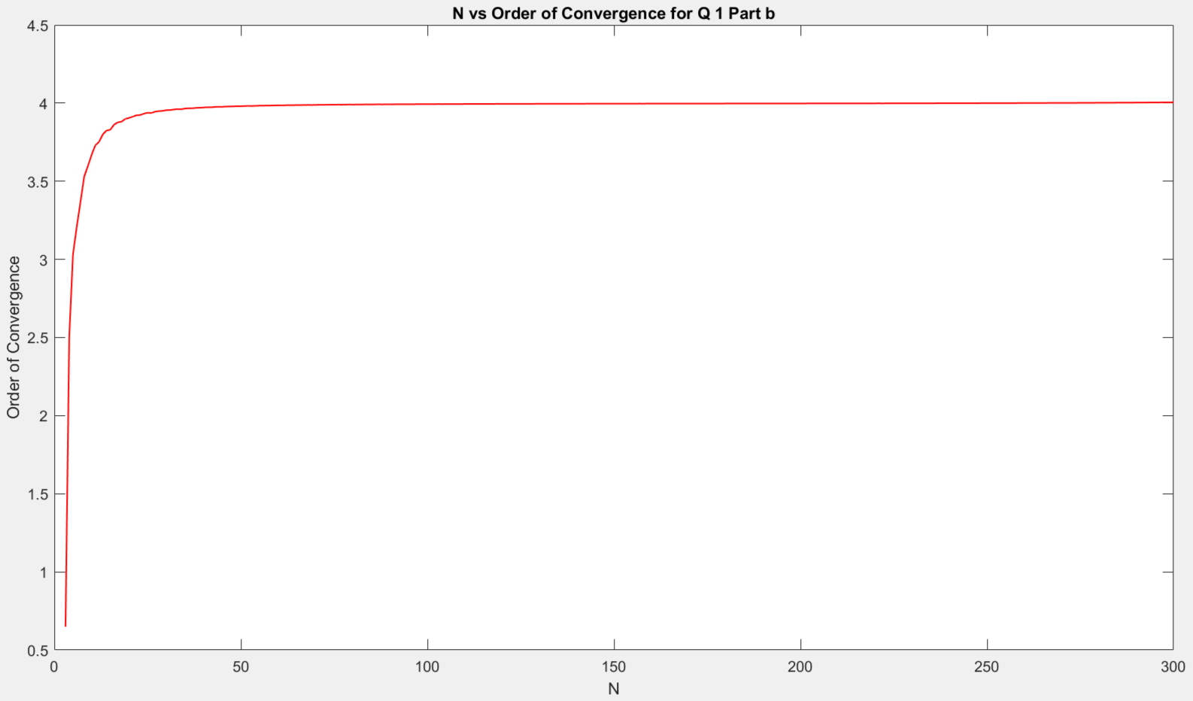

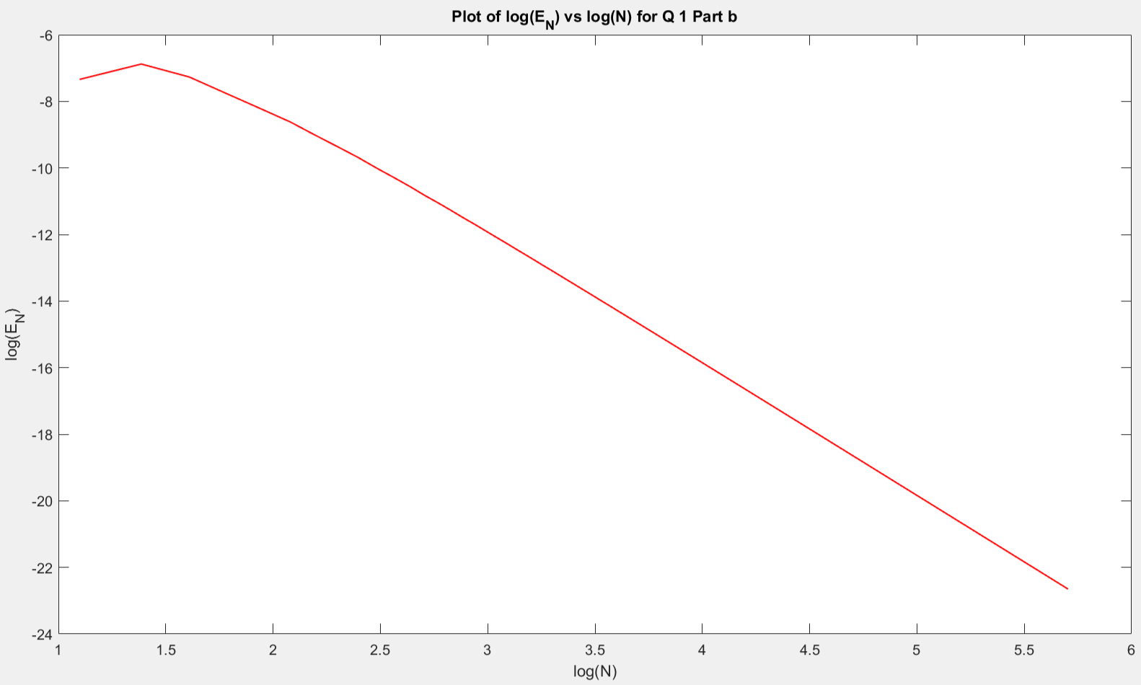

2)

I have solved the given problem with the value of h = 0.25 for the three methods

a) Explicit Euler Method

b) Implicit Euler Method

c) Central Difference method

For checking the stability of each method, we vary the values of h and see whether the graphs are oscillatory or not and hence, the methods are unstable or stable.

a)

Using Explicit-Euler method,

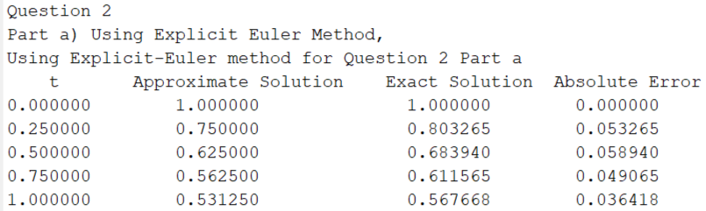

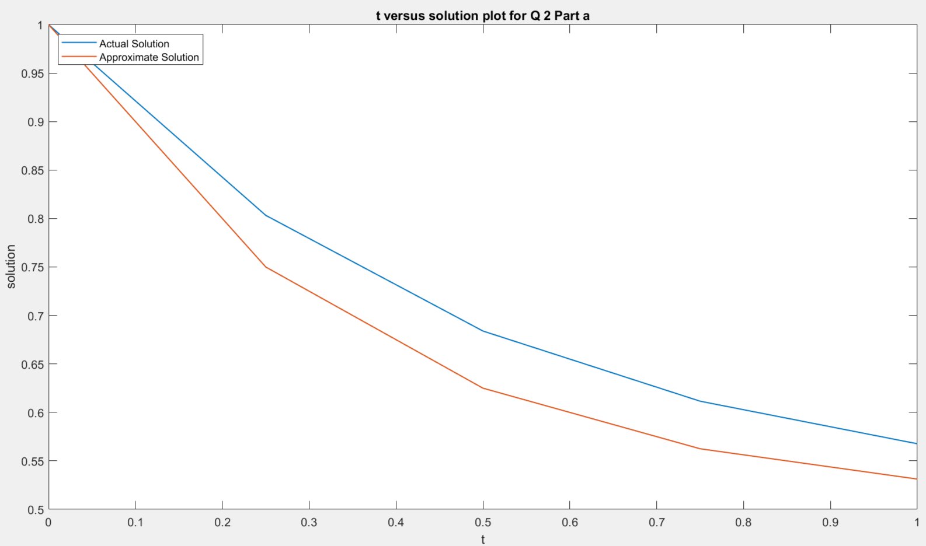

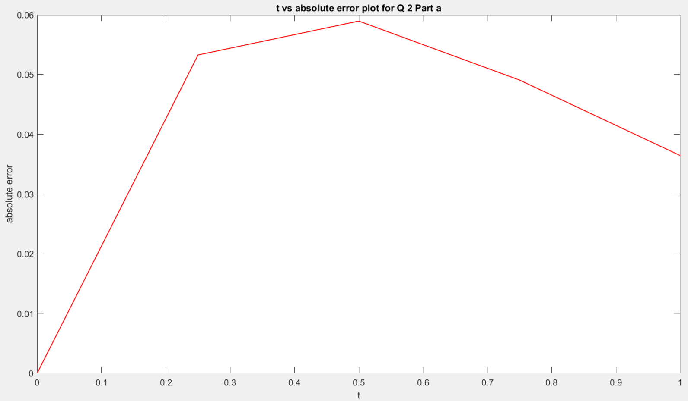

b)

Using Implicit-Euler method,

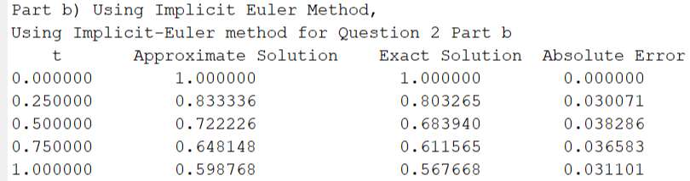

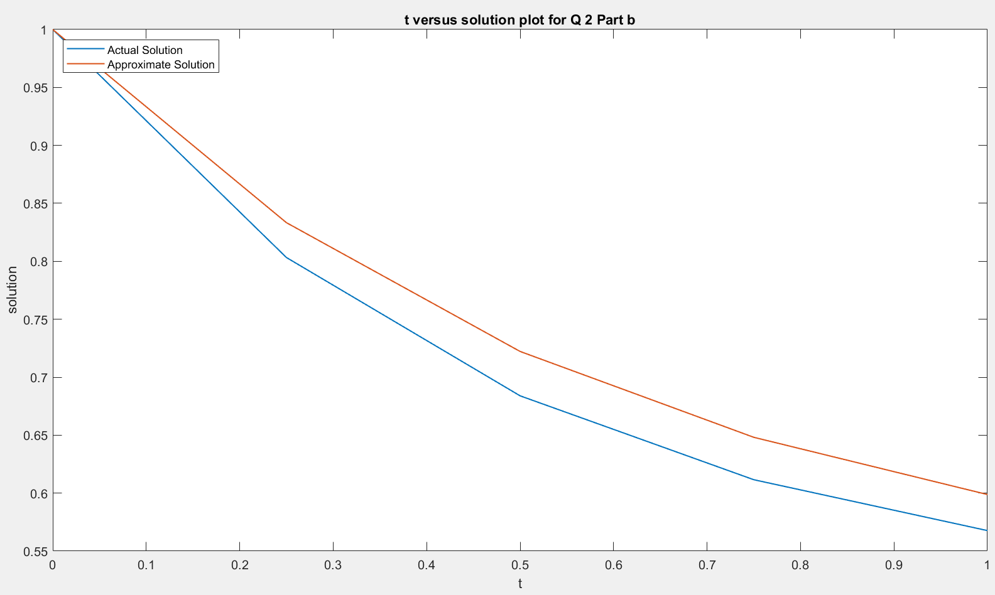

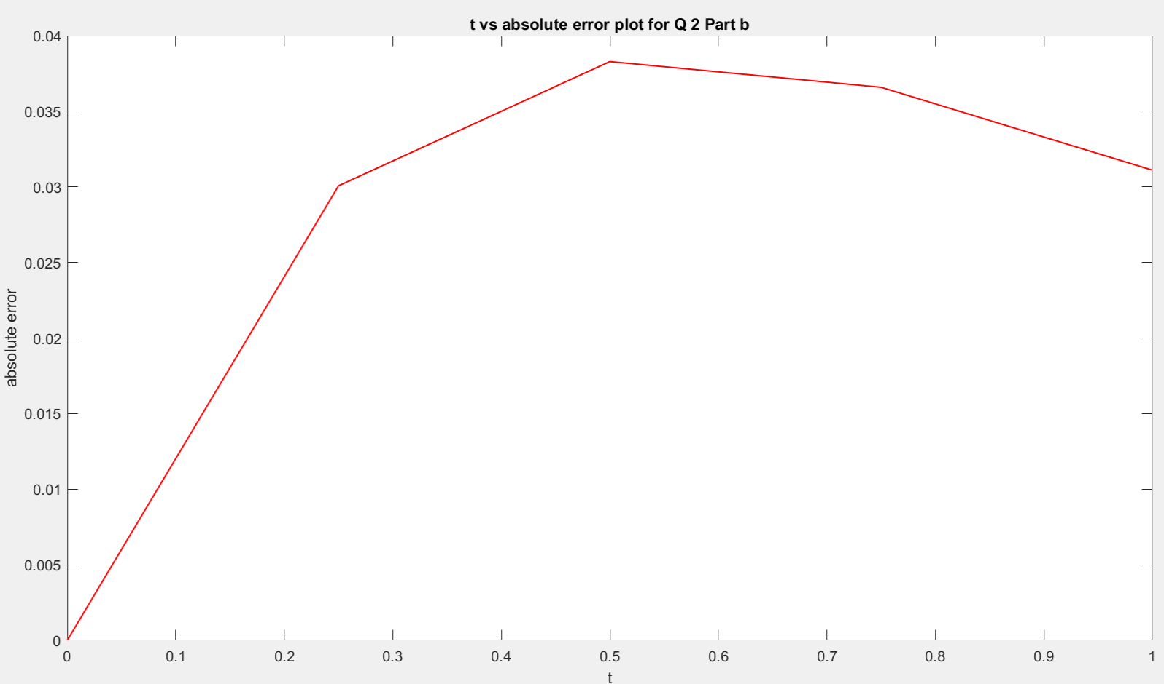

c)

Using Central differences method,

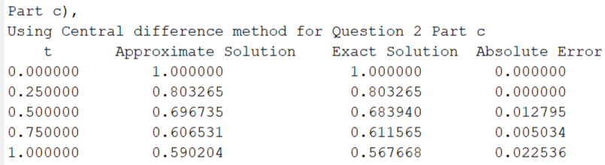

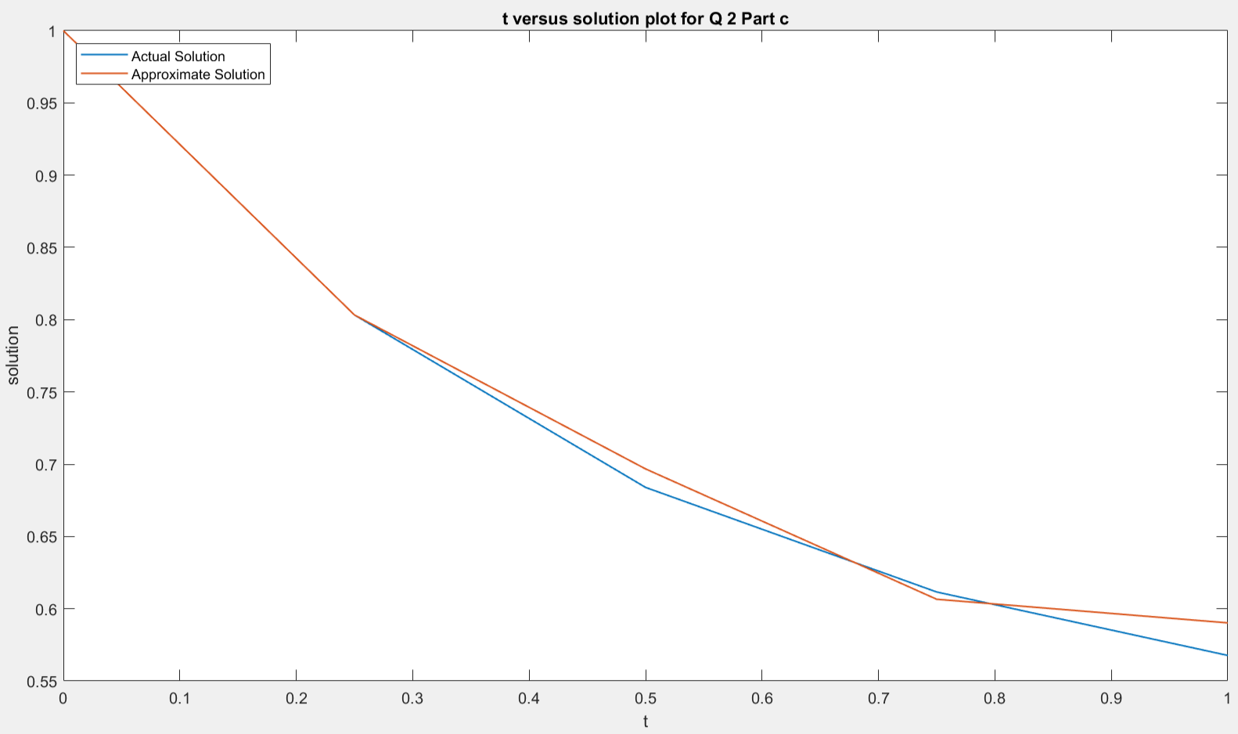

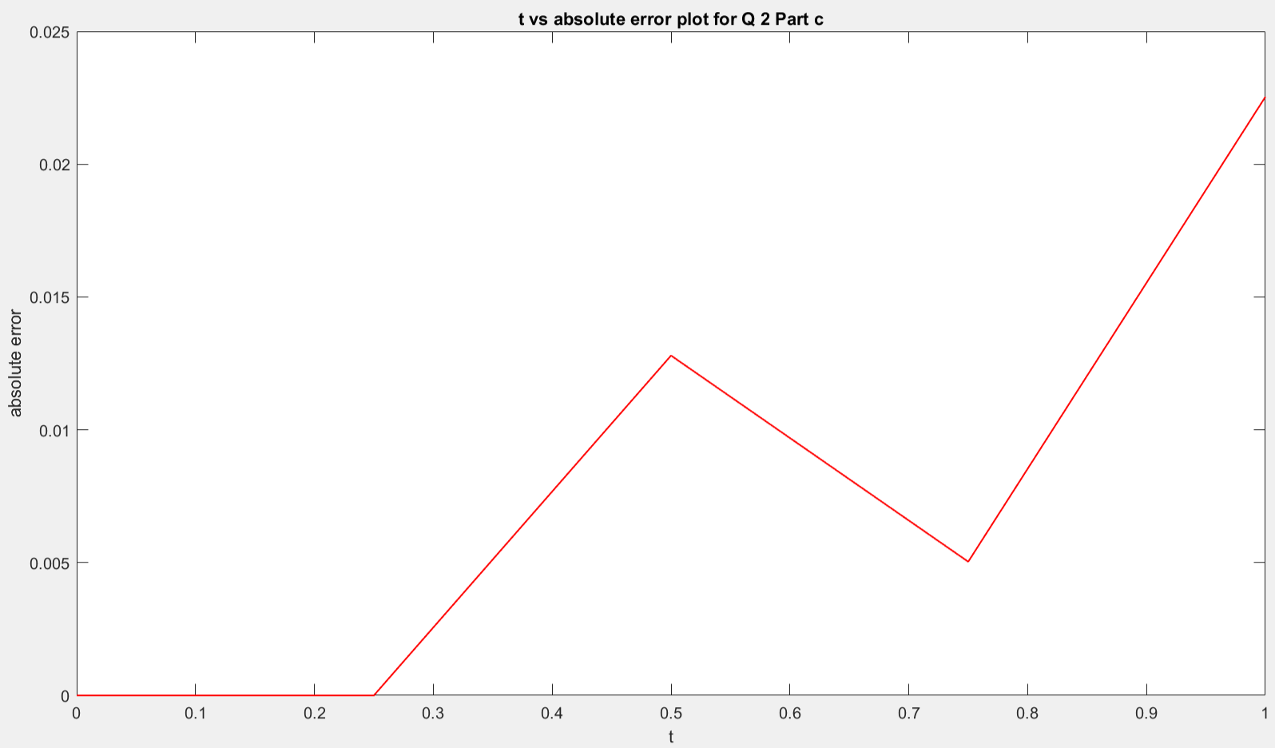

Stability Analysis: (This part is commented out in the output file, else too many graphs would be formed when we run the output_file.m . To run this part, please uncomment those lines in the output_file.m )

1. For Explicit Euler Method,

The Explicit Euler’s method is conditionally stable for the IVP of the form y’ = c*y, with the stability region of step size h is the interval (0,2/|c|). The given solution can be split into a homogeneous solution as well as a particular solution and for the homogeneous solution, the constant c = 2. So, the region of stability for the Explicit Euler Scheme is the interval (0,1) and the graphs for varying h suggest the same too. The given plots are plotted for 5 different values of h = 0.25, 0.2, 0.1, 0.05 and 0.025.

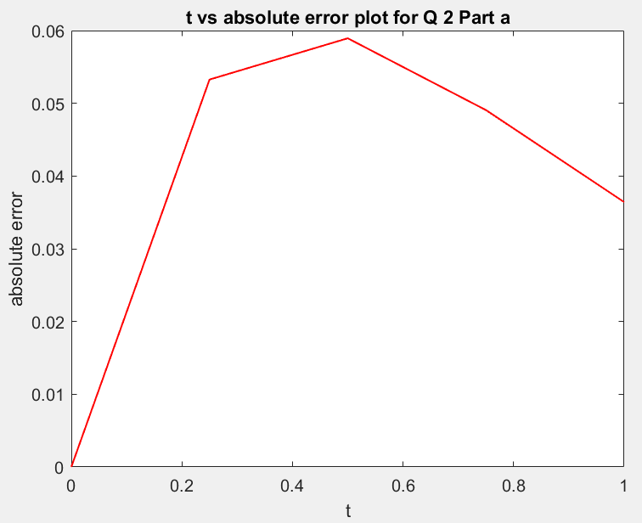 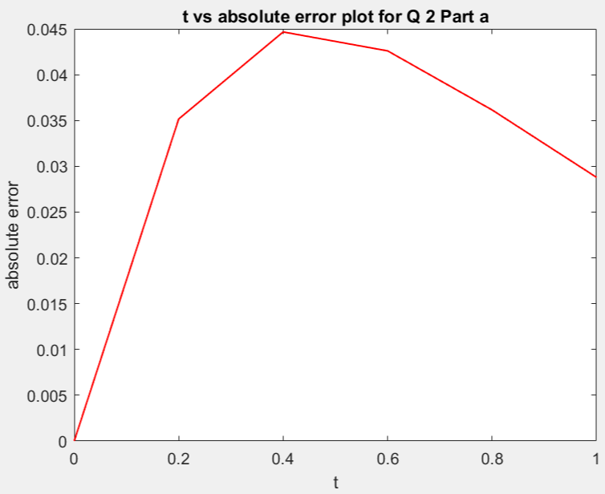

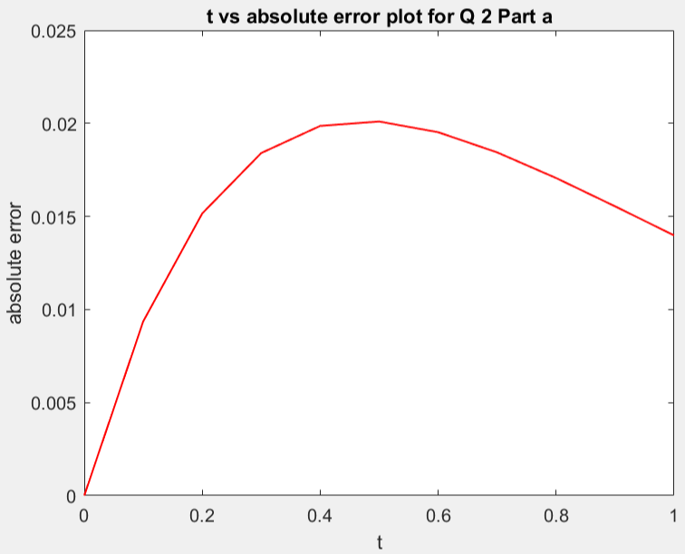 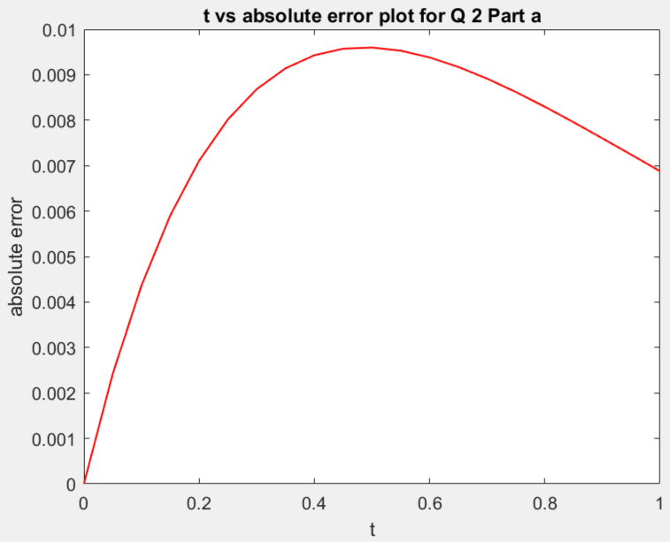

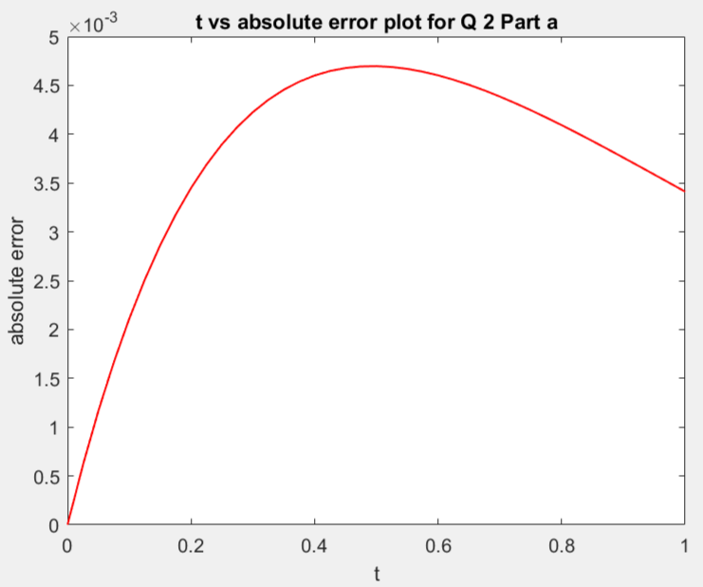

We see that for various values of h, the plots are similar in nature and become smoother as the value of h decreases. The method is stable conditionally for h belongs to (0,1).

The Absolute error vs t plot is getting smoother with decrease in the value of h, the approximation is getting better, and error is not oscillating, this shows that the Explicit-Euler method is stable here.

Implicit-Euler Method

The Implicit Euler’s method is unconditionally stable for the IVP of the form y’ = c*y. So, the method is stable for all values of h from 0 to infinity.

The given plots are plotted for 5 different values of h = 0.25, 0.2, 0.1, 0.05 and 0.025.

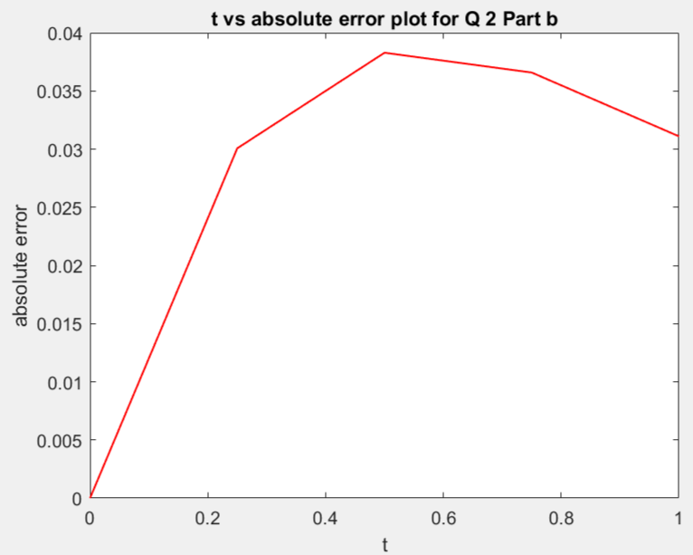 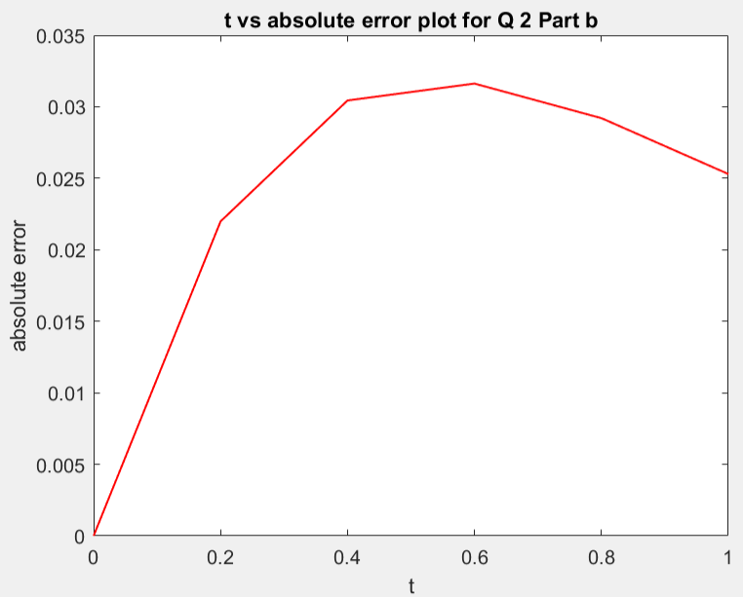

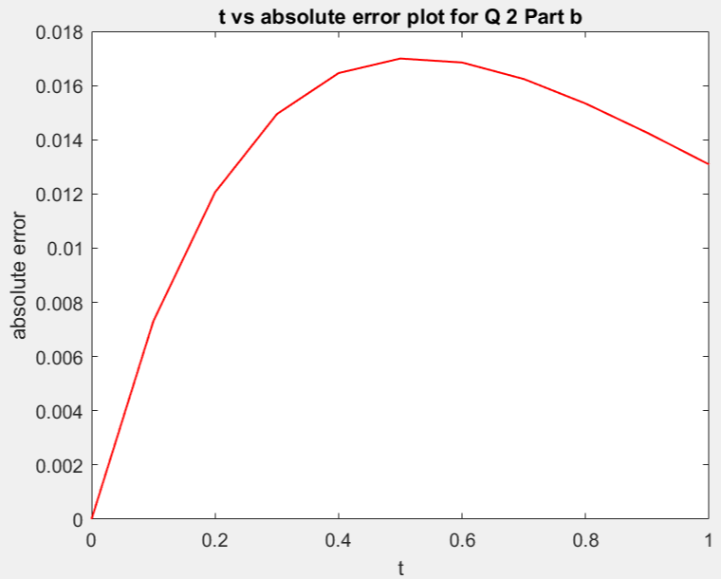 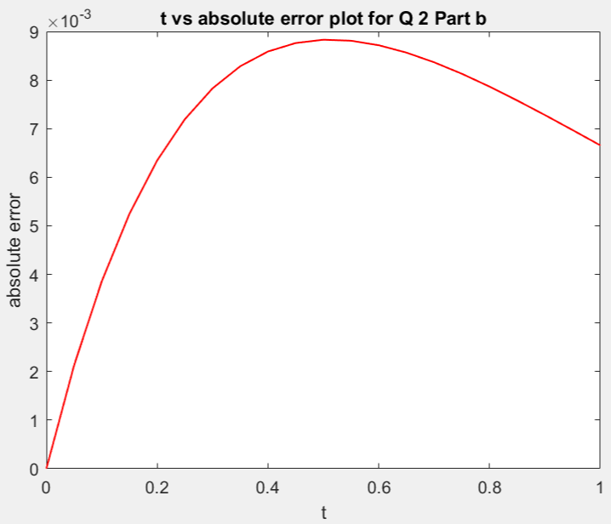

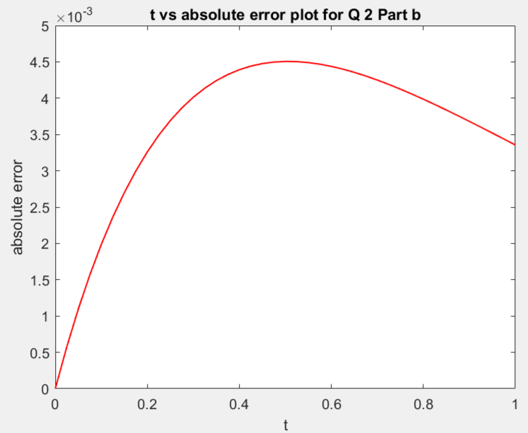

We see that for various values of h, the plots are similar in nature and become smoother as the value of h decreases. The method is stable unconditionally. Regardless of what h we choose, the method is stable.

The Absolute error vs t plot is getting smoother with decrease in the value of h, the approximation is getting better, and error is not oscillating, this shows that the Implicit-Euler method is stable here.

Central Difference Method:

The Central Difference method is of order 2 and there is an extraneous root that is associated when we solve the IVP, which is oscillatory in nature and its amplitude is also increasing. The given plots are plotted for 5 different values of h = 0.25, 0.2, 0.1, 0.05 and 0.025.

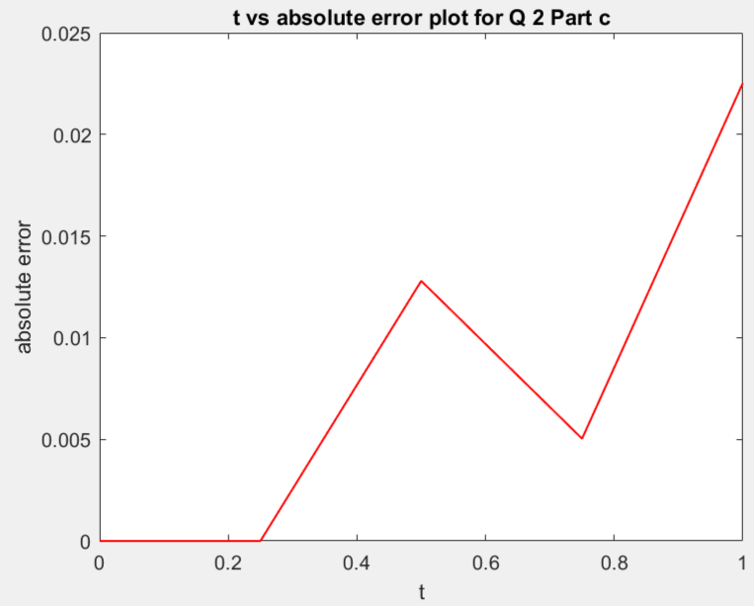 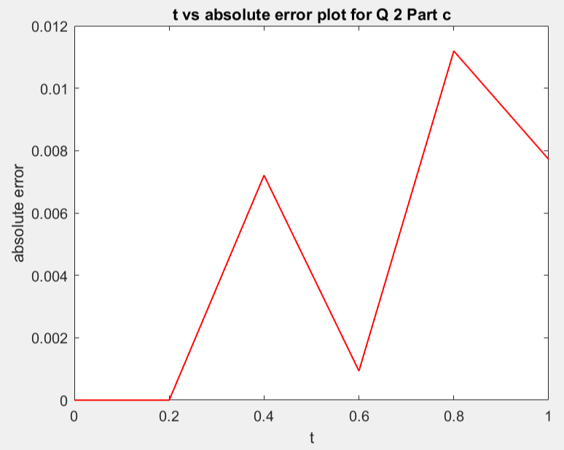

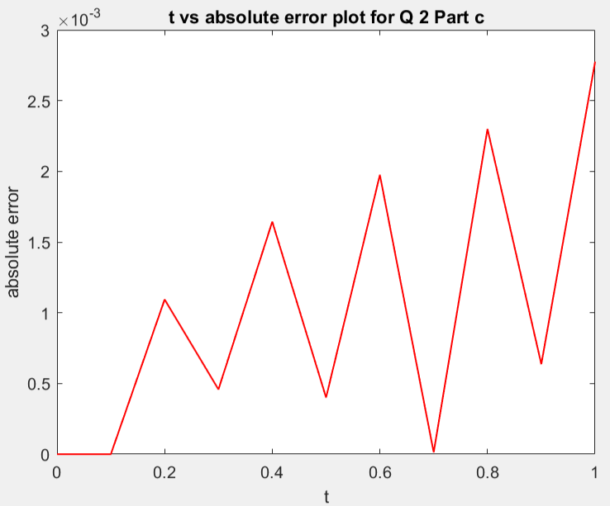 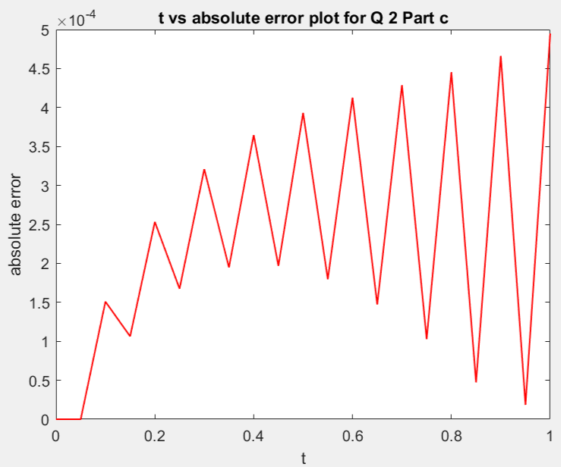

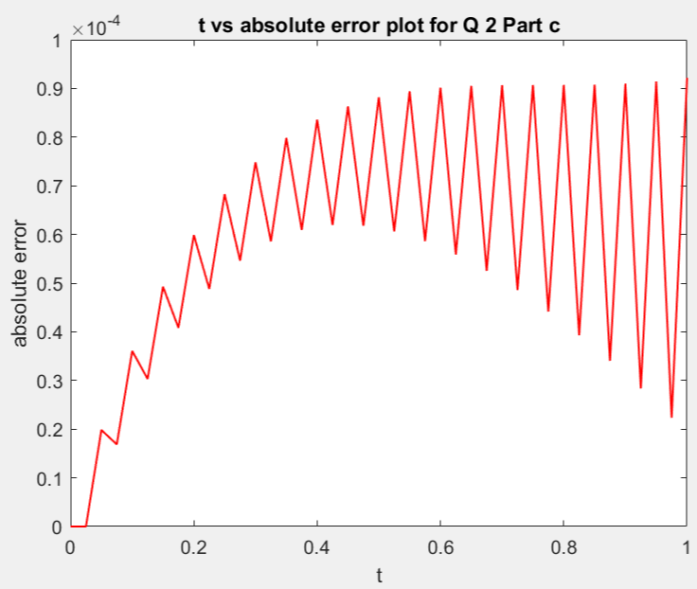

The approximation is getting better with decreasing value of h, but the absolute error is fluctuating a lot with t. This is due to the extra term we got while solving the difference equation. Since central difference method is a second order scheme which is being used to solve a first order IVP, it is resulting in some extra term which is making the error to oscillate, and amplitude of oscillations is increasing with decreasing value of h. This fluctuation in absolute error clearly shows that Central Difference Method is unstable here.

3)

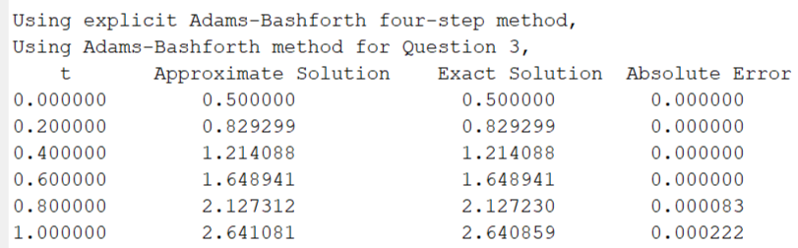

The graphs are as follows:

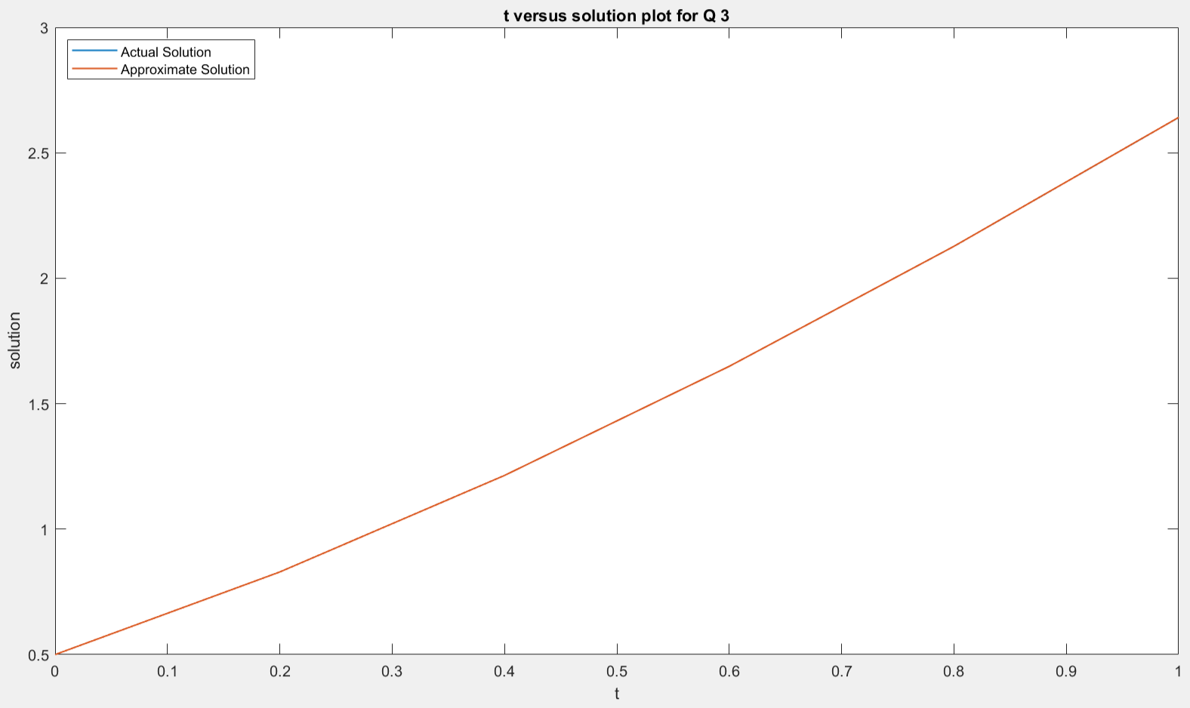

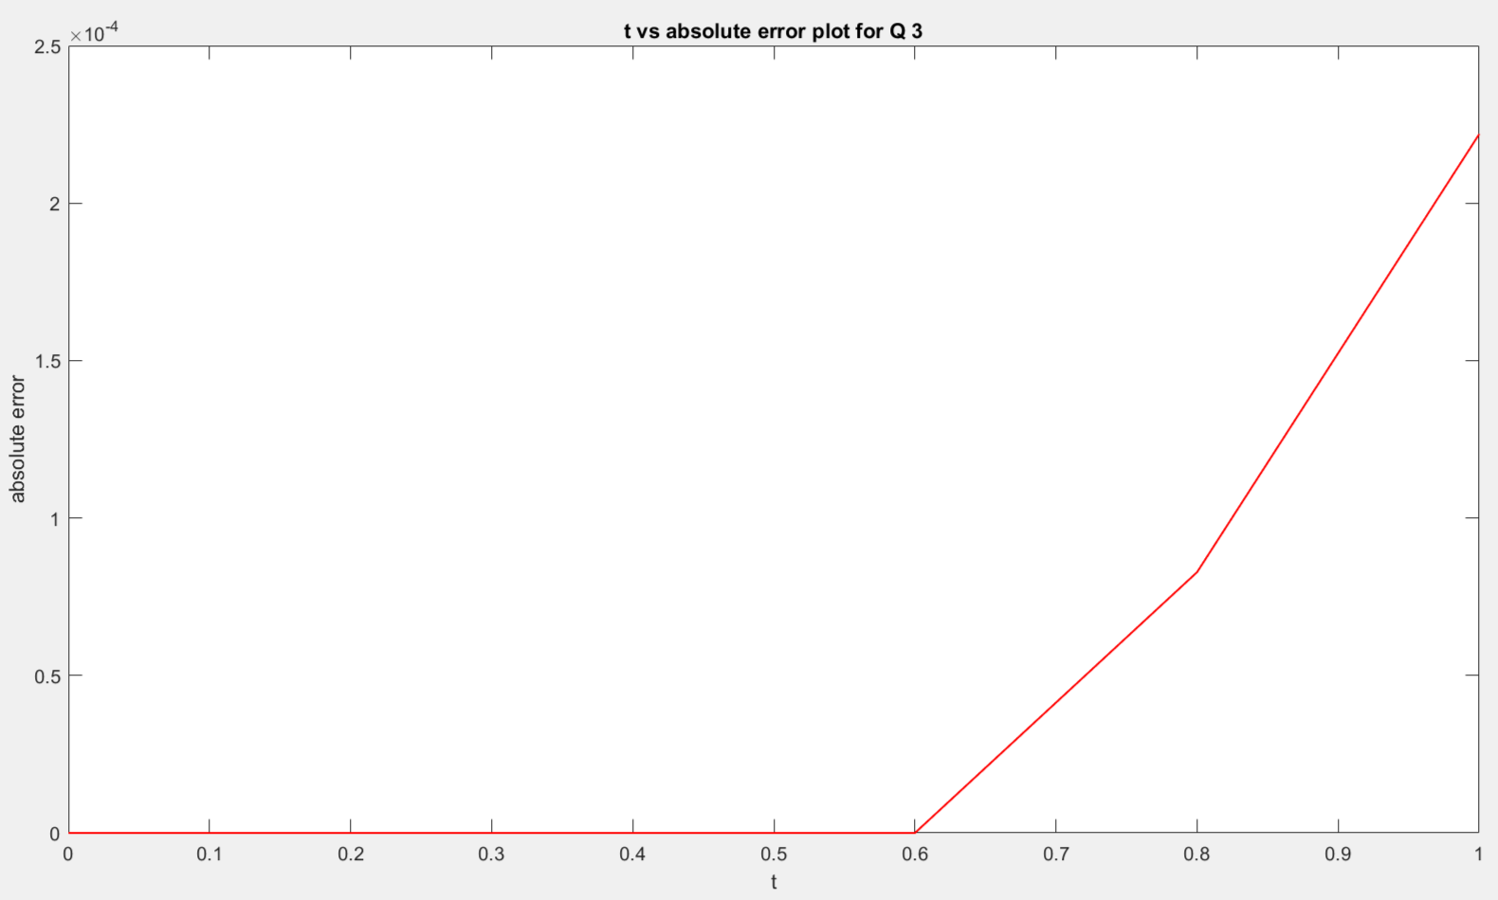

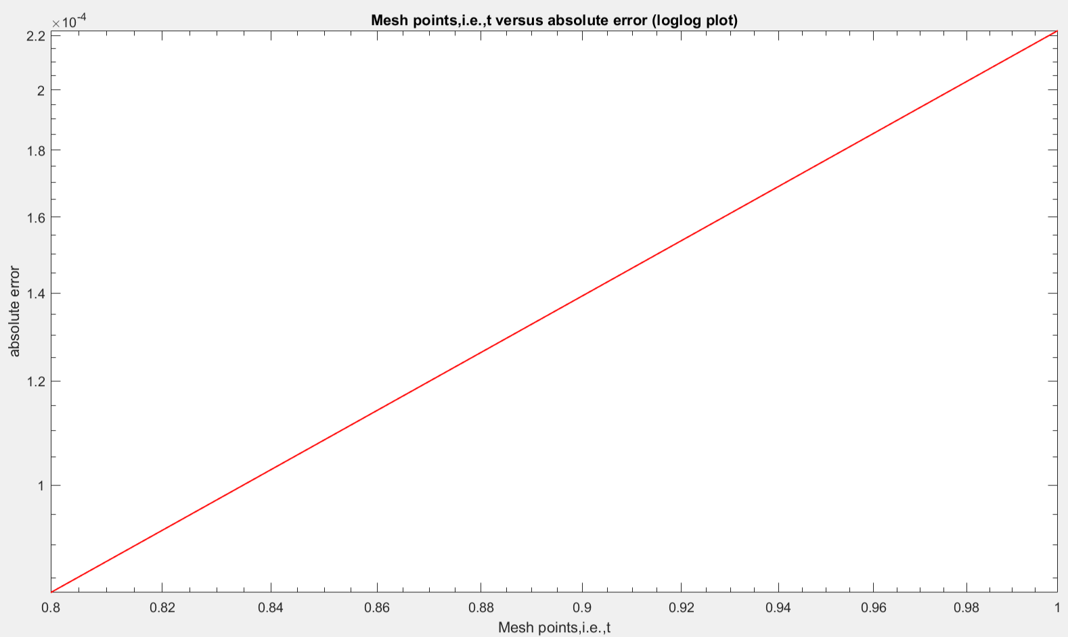

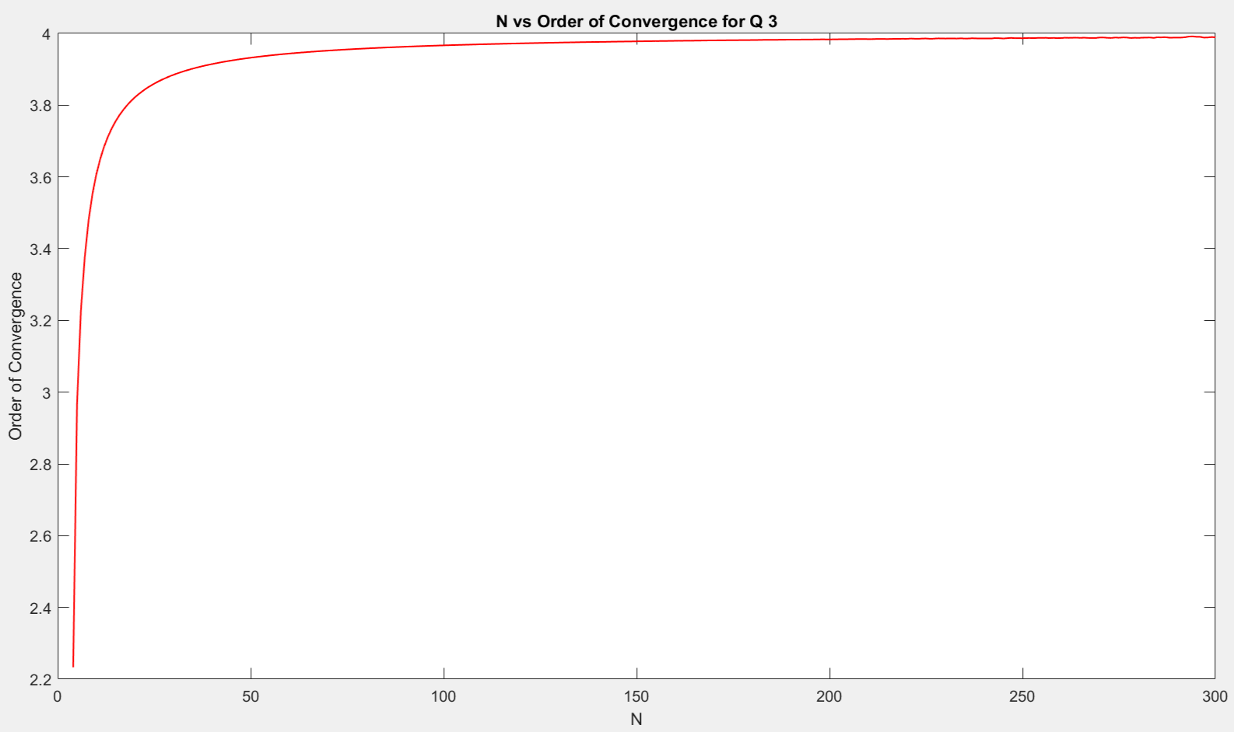

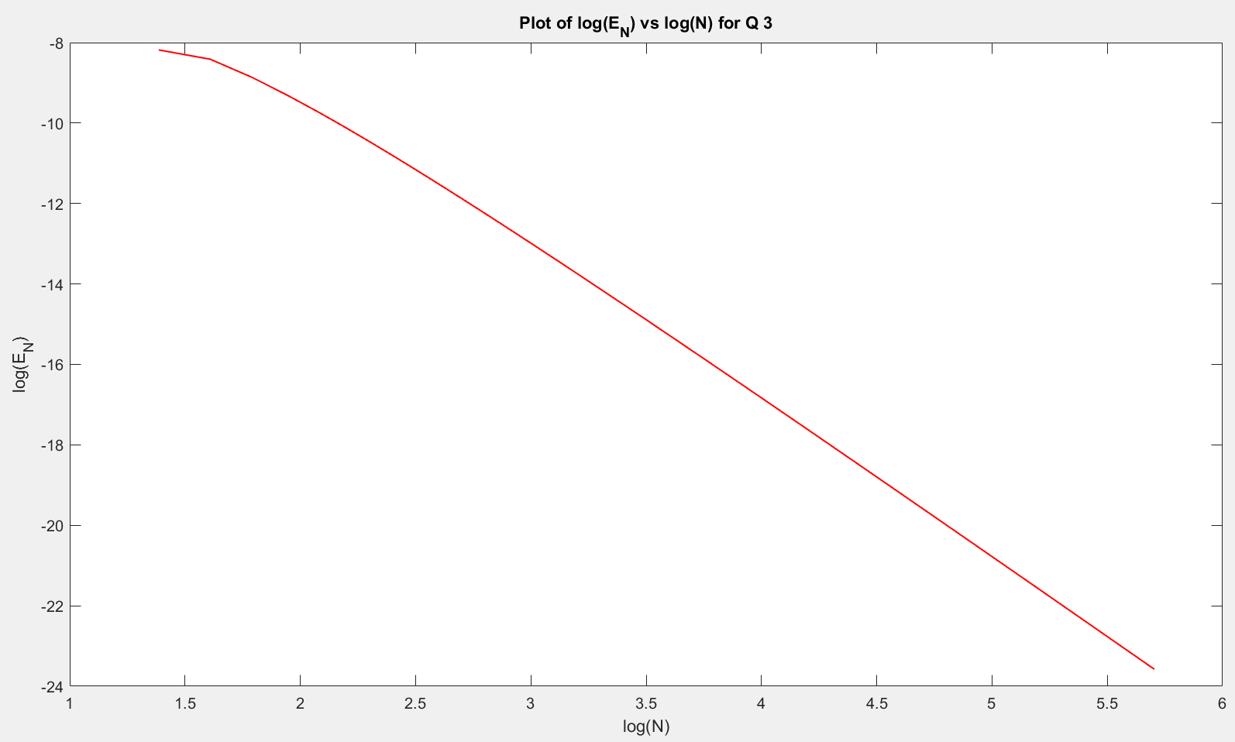

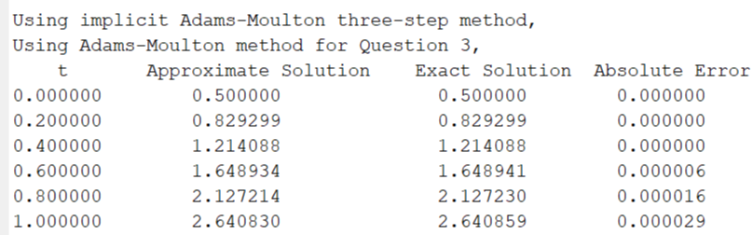

The graphs are as follows:

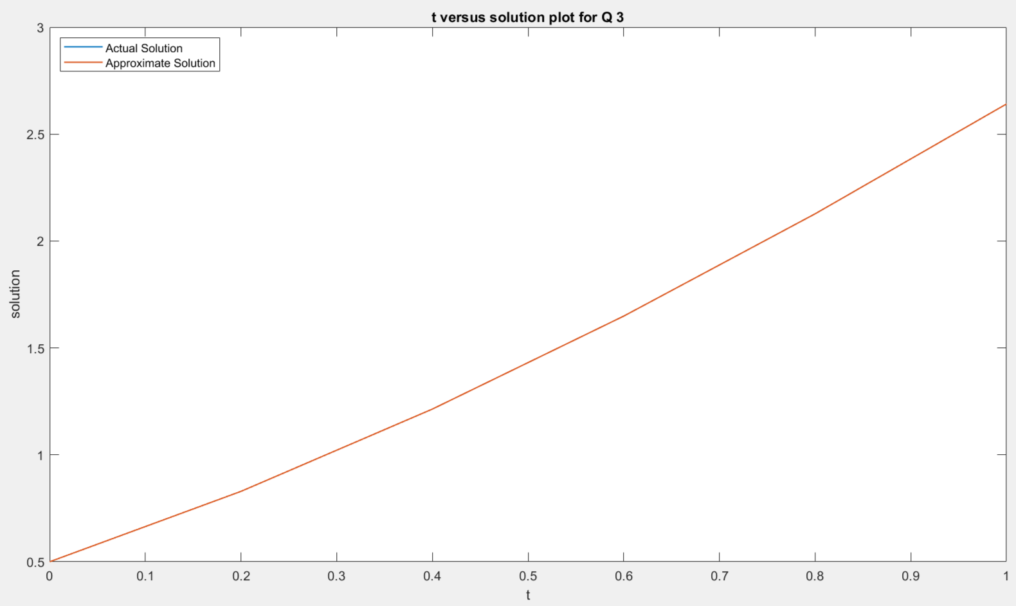

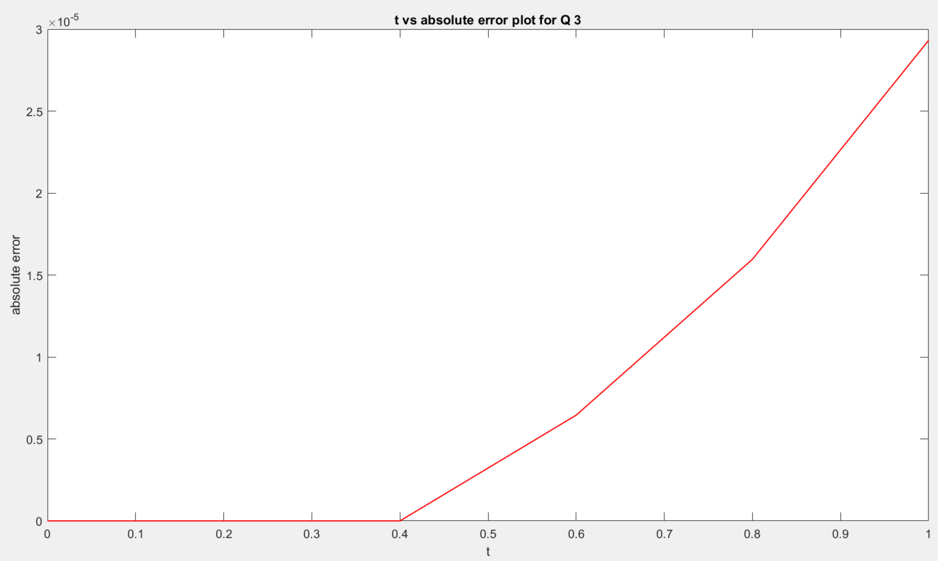

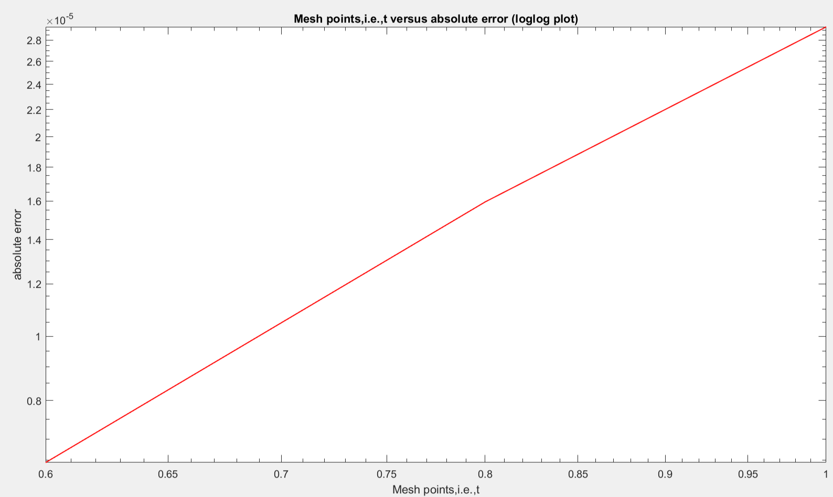

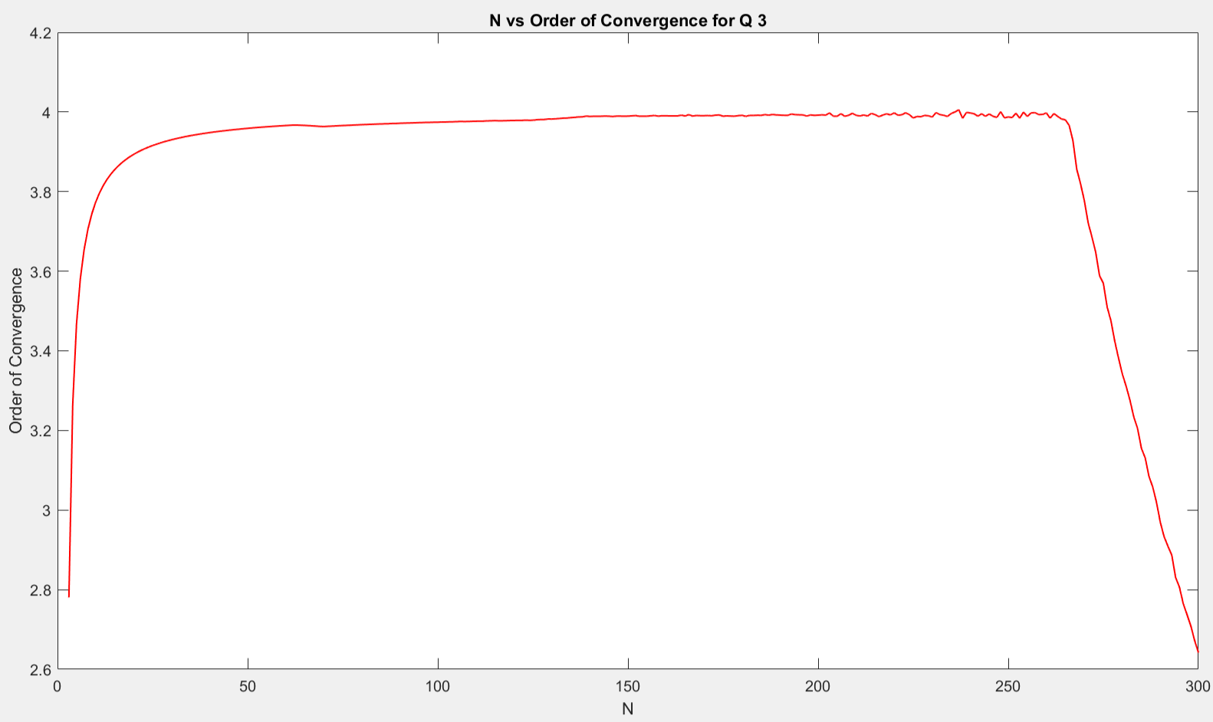

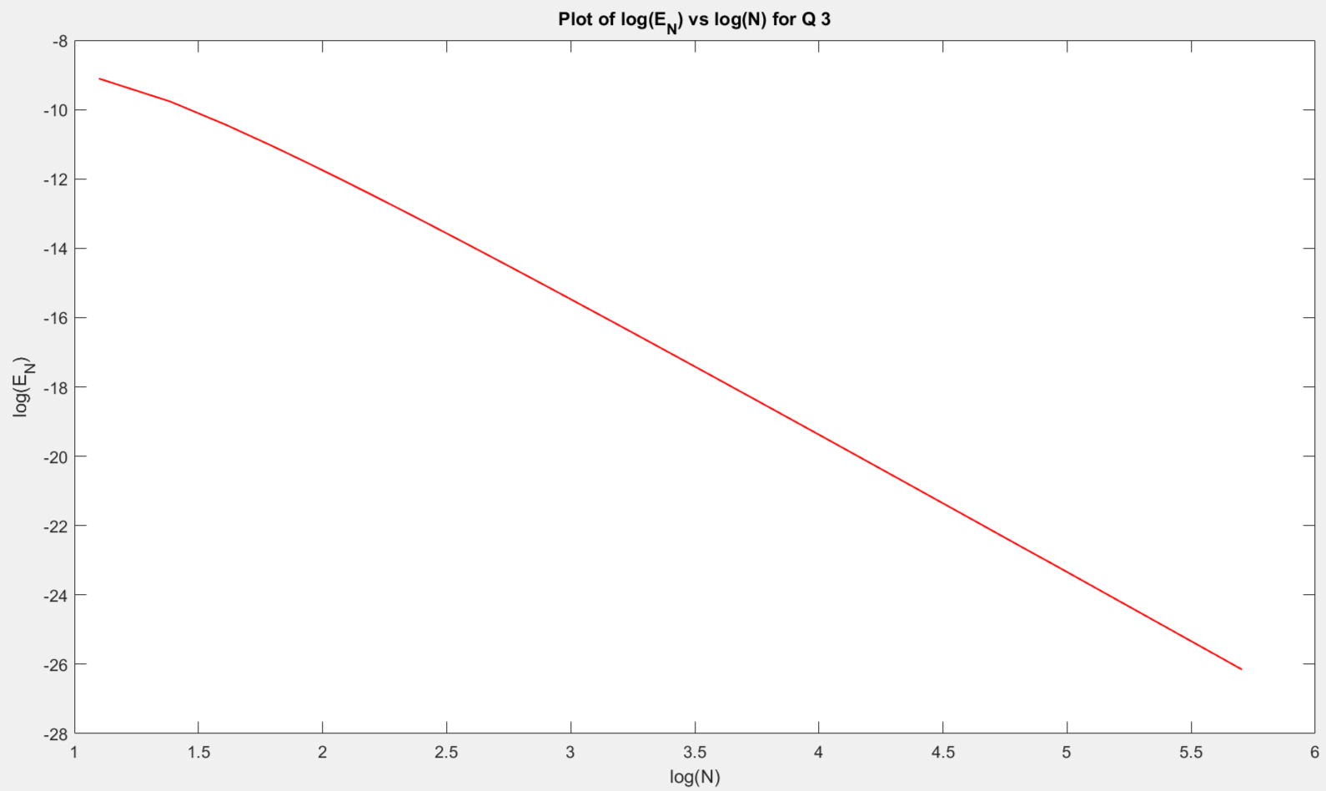

4)

Using the fourth order Runge-Kutta Classical method for starting values,

