**Scientific Computing Lab MA – 322 Lab – 2**

**Name –** Rasesh Srivastava

**Roll Number –** 210123072

**Branch –** Mathematics and Computing

1)

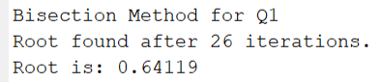

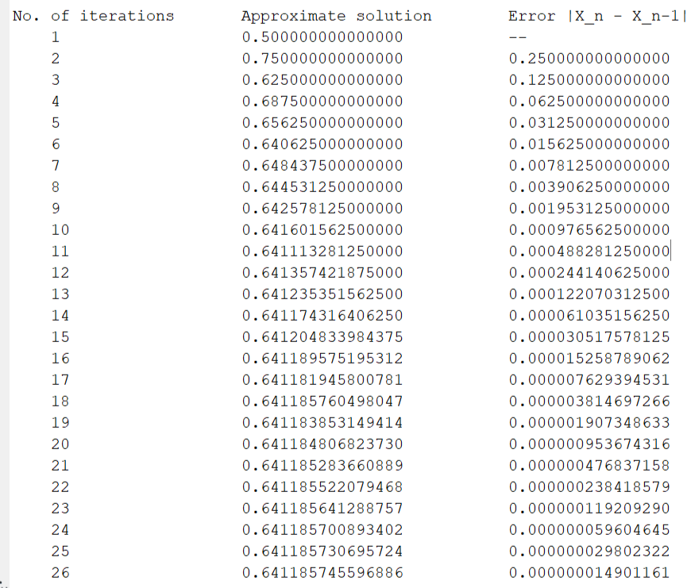

Solution Plot:

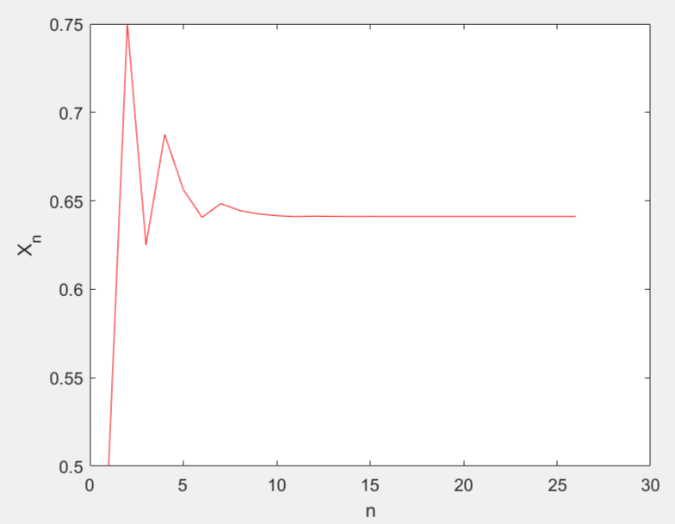

N versus Residue Plot

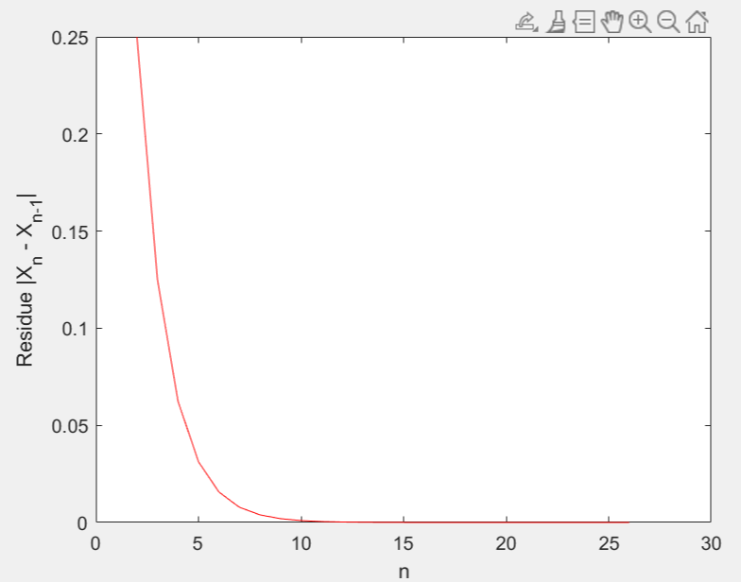

2)

a)

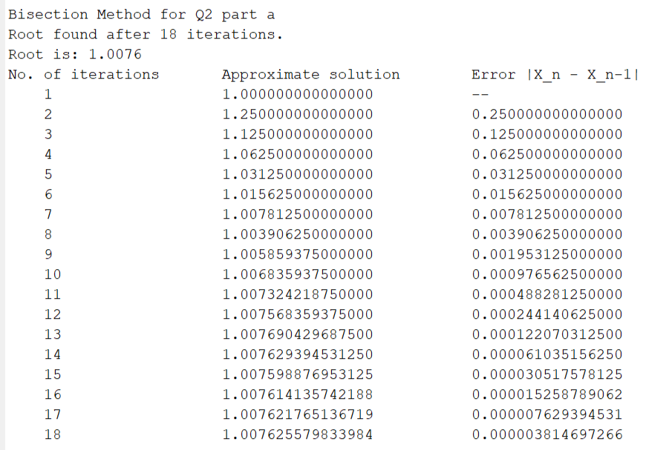

Solution Plot

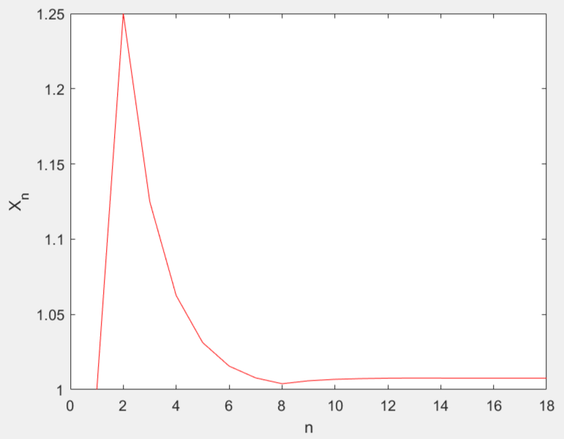

N versus Residue Plot

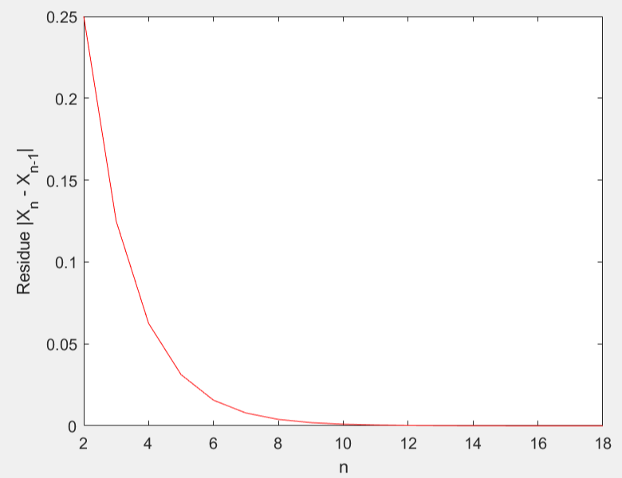

b)

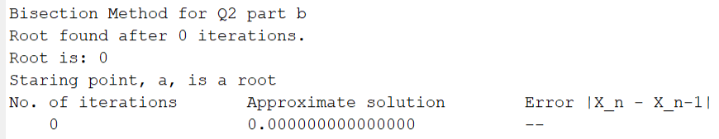

Solution Plot

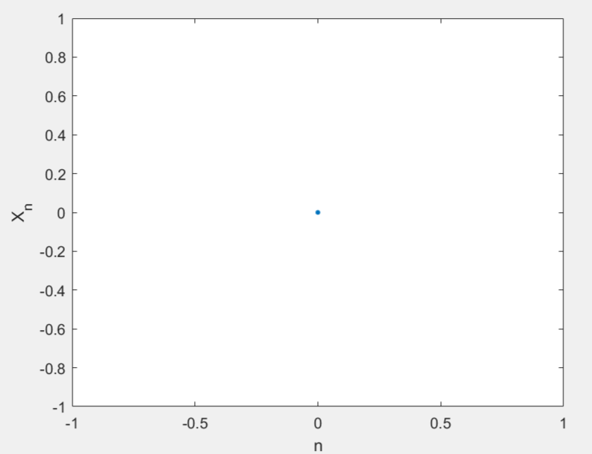

There is no Residue since we found the root at the starting point only, so only Solution Plot is plotted.

c)

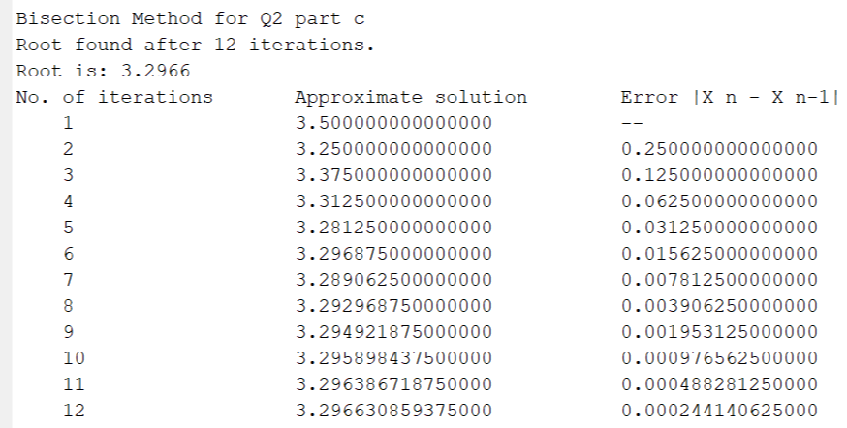

Solution Plot

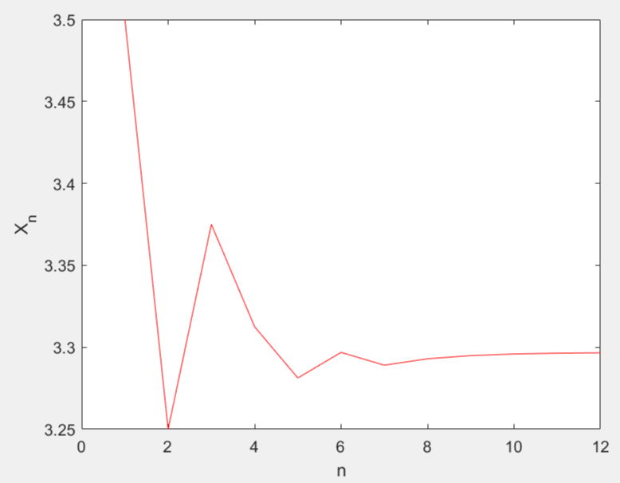

N versus Residue Plot

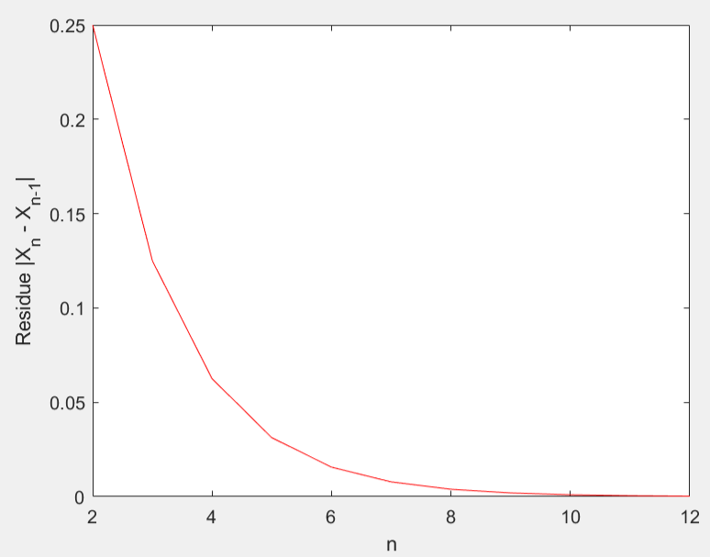

3)

a)

Initial Approximation x0 = 1.75

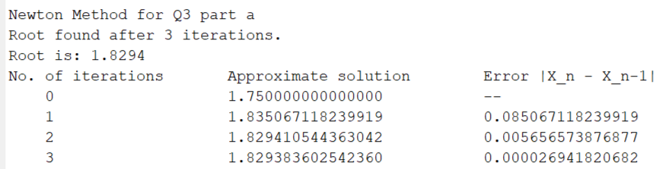

Solution Plot

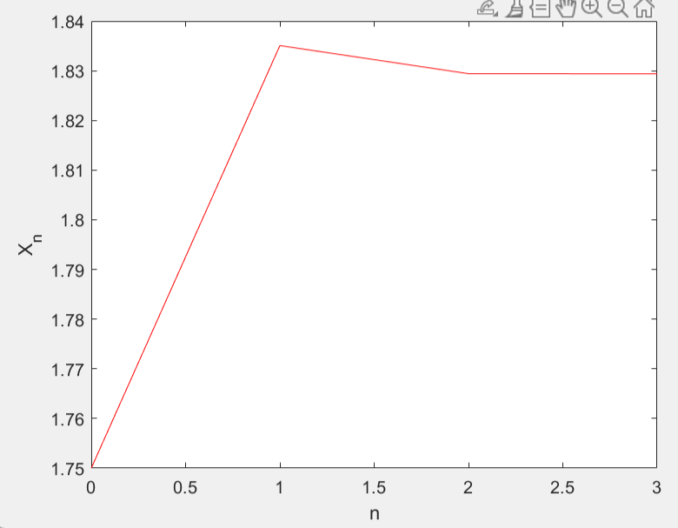

N versus Residue Plot

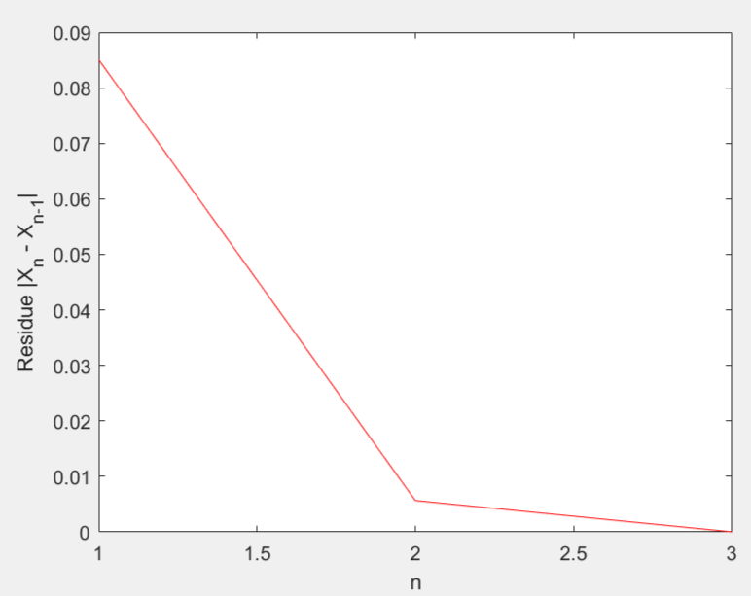

b)

Initial Approximation x0 = 1

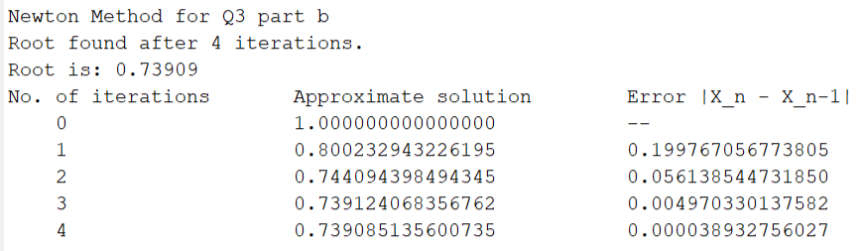

Solution Plot

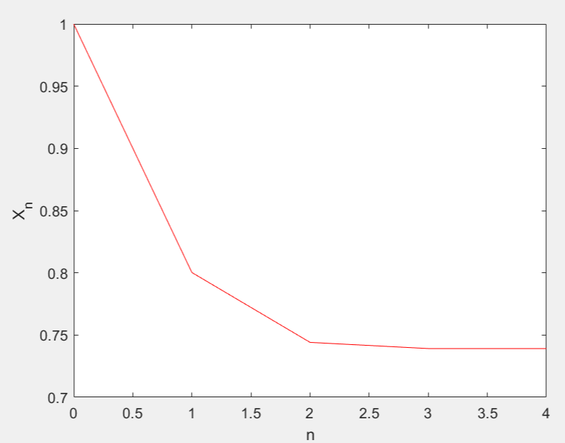

N versus Residue Plot

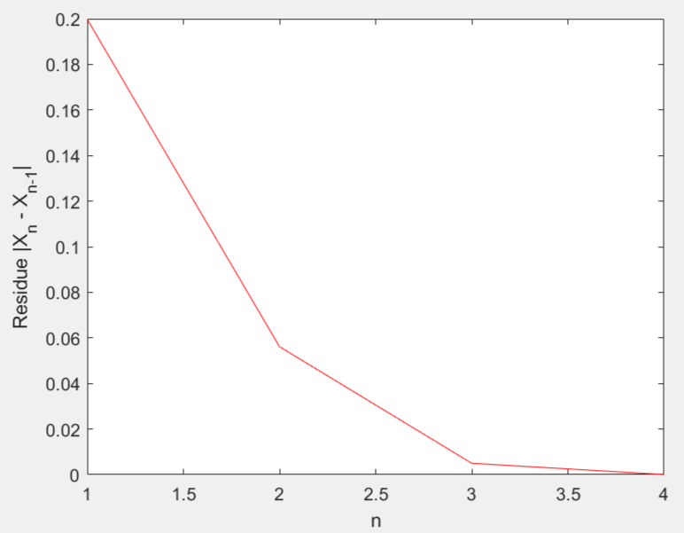

c)

Initial Approximation x0 = 0.5

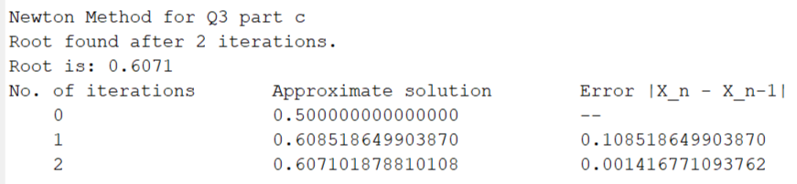

Solution Plot

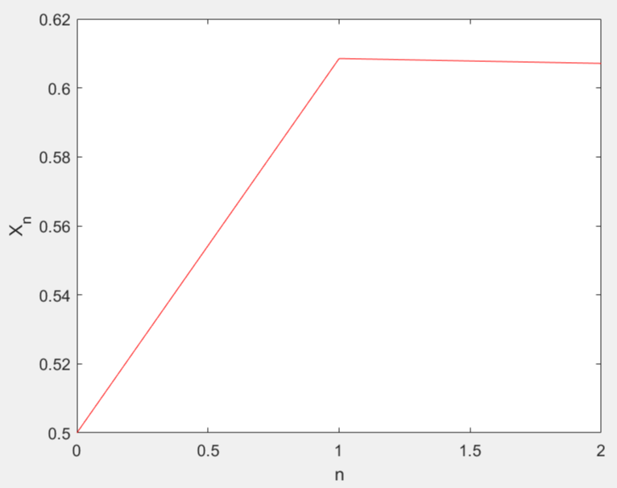

N versus Residue Plot

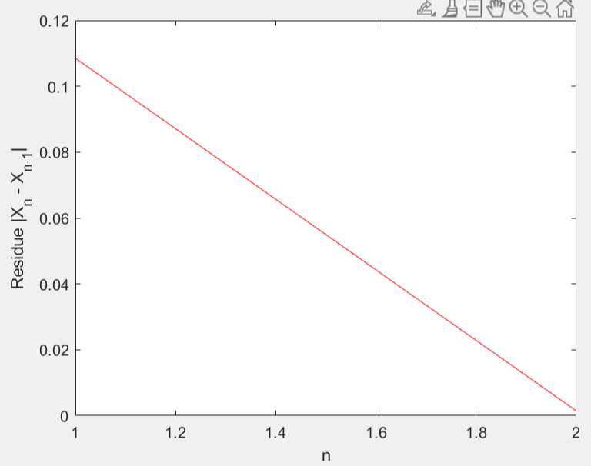

d)

Initial Approximation x0 = 6.5

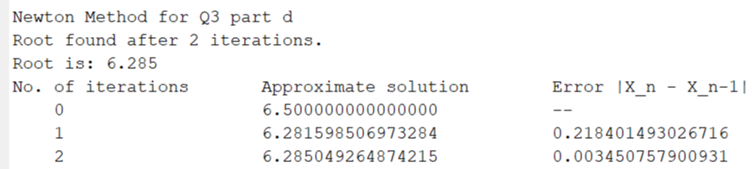

Solution Plot

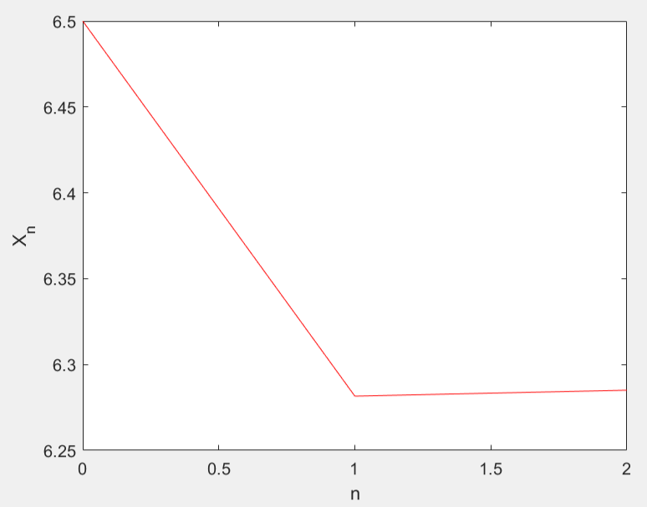

N versus Residue Plot

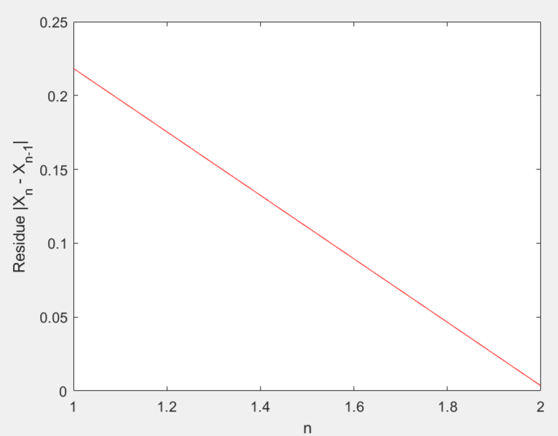

4)

Initial Approximation x0 = 0.0001

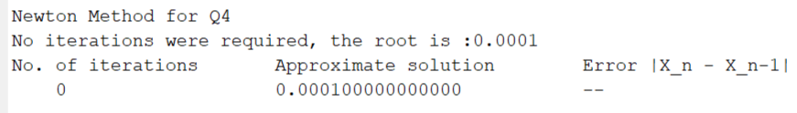

Solution Plot

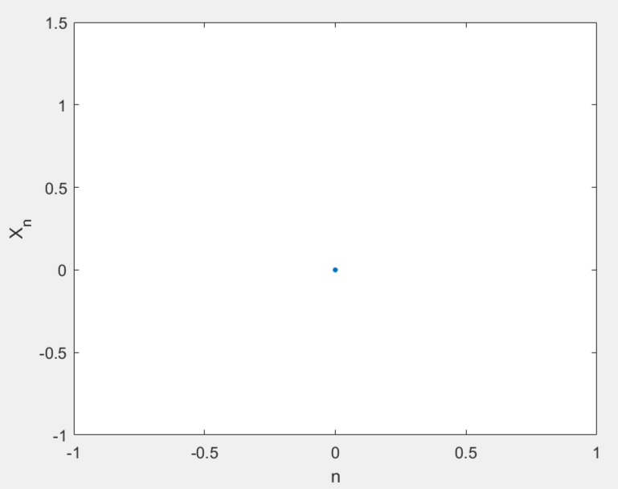

There is no Residue since we found the root at the starting point only, so only Solution Plot is plotted.

The given point x0 = 0.0001 is a very small input to the function f(x) = exp(-1 / x2). Thus, the value of the function at x0 is equal to 0, due to computational limits, and hence, there are no more iterations.

At x0 = 0.0001, which is our initial approximation, the function f(x) takes the value of exp(-108), which is an extremely small number, much smaller than the computer’s value of epsilon (the smallest positive number), and thus evaluates to 0. Since this initial value of f(x0) is evaluated as 0 and hence, less than the tolerance value, so the initial approximation is printed as the final answer as the required root.

It is not possible to go below 0.00005 starting from x0 = 0.0001 as the value of f(x) becomes even smaller than exp(-108), which is evaluated as 0 and hence, the iterations stop. At any x0 < 0.0001 also, the function converges to 0 at that point x0 itself. Hence, we won’t make any progress even if we start with x0 = 0.00005. We cannot go below 0.00005

5)

a) Using Newton’s Method:

(i) For the real zero in [-1, 0]

Initial Approximation x0 = -0.5

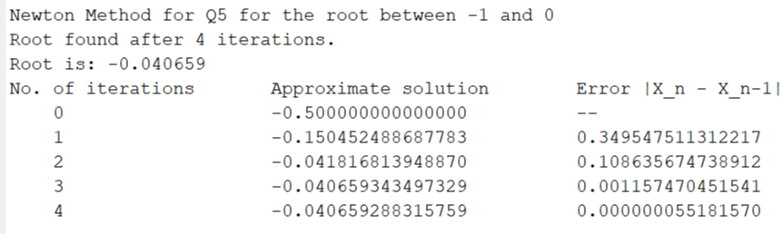

Solution Plot

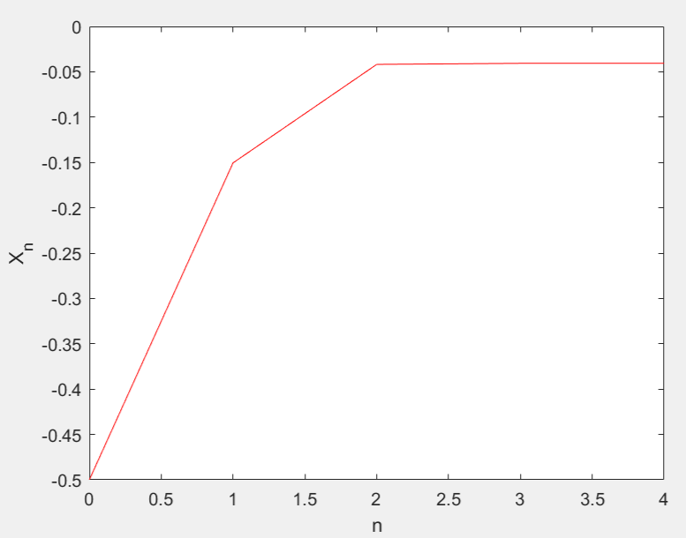

N versus Residue Plot

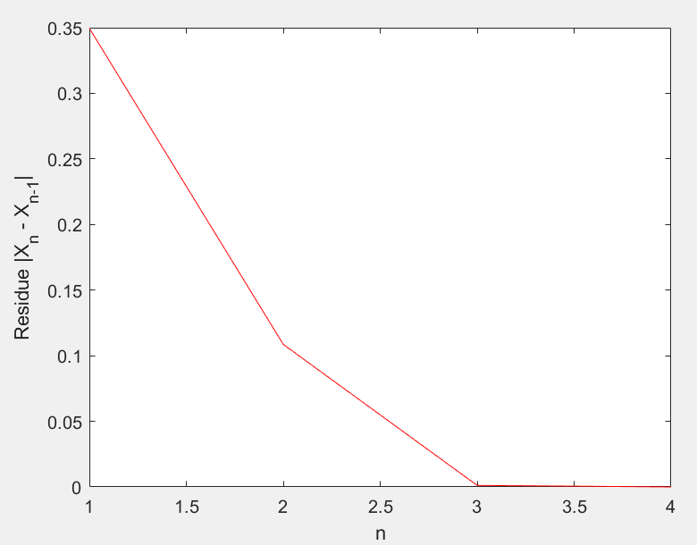

(ii) For the real zero in [0, 1]

Initial Approximation x0 = 0.5

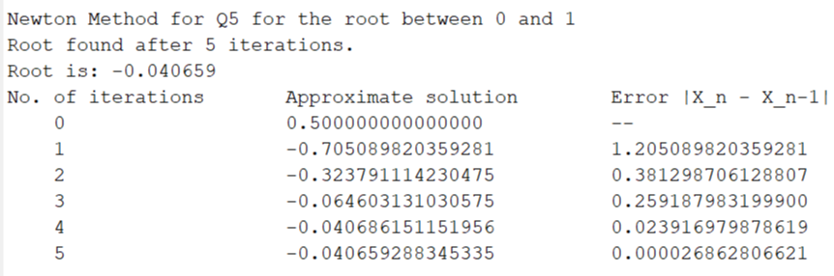

Solution Plot

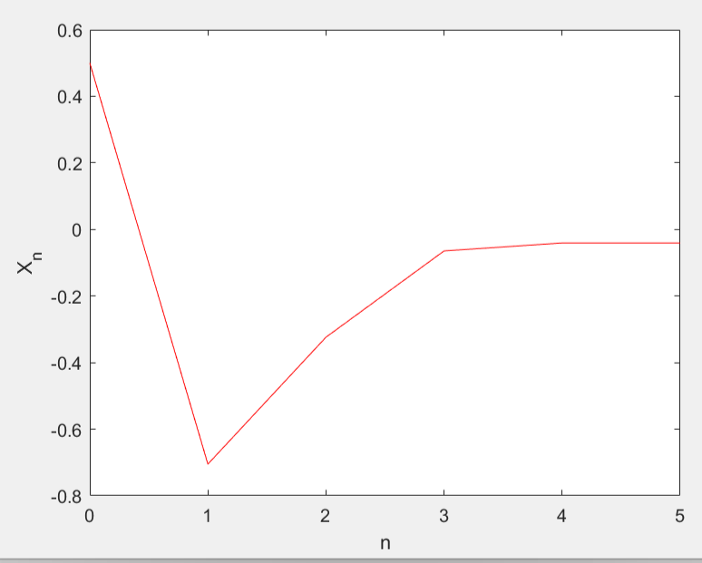

N versus Residue Plot

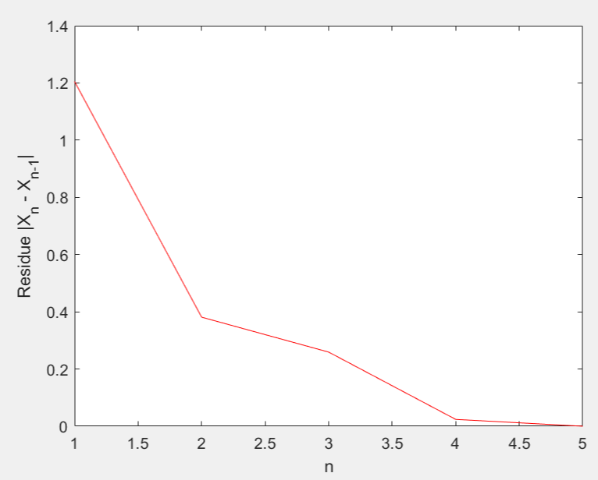

b) Using Bisection Method:

(i) For the real zero in [-1, 0]

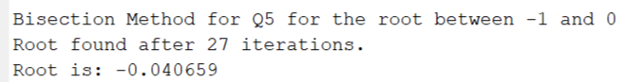

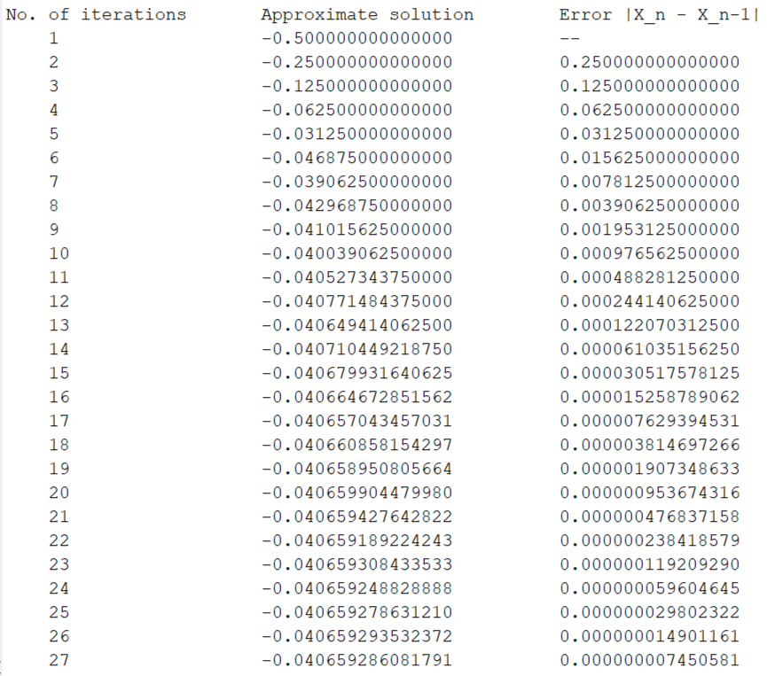

Solution Plot

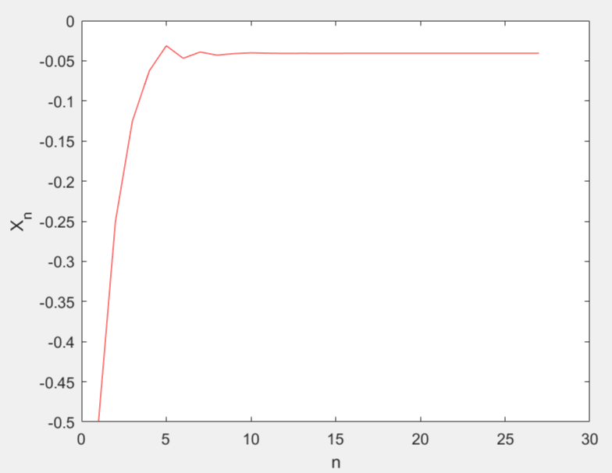

N versus Residue Plot

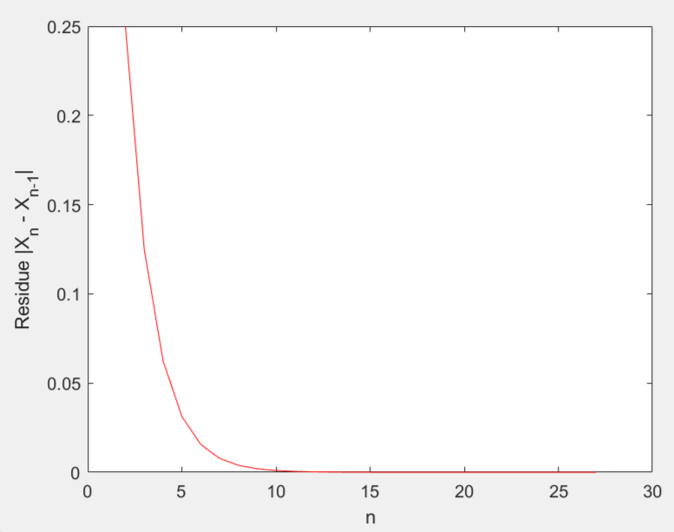

(ii) For the real zero in [0, 1]

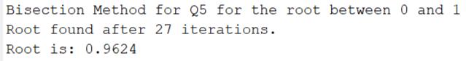

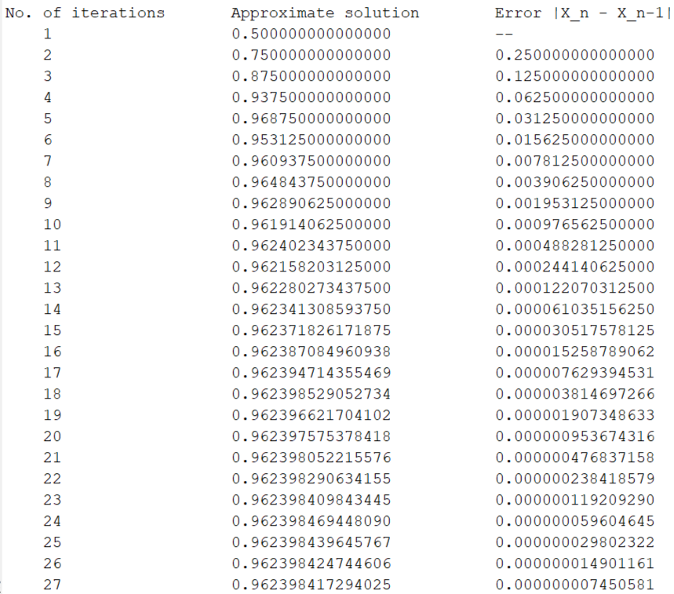

Solution Plot

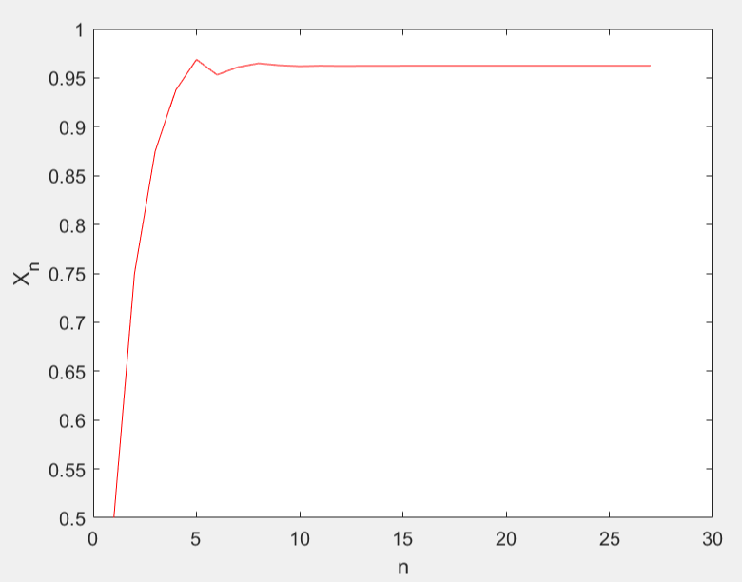

N versus Residue Plot

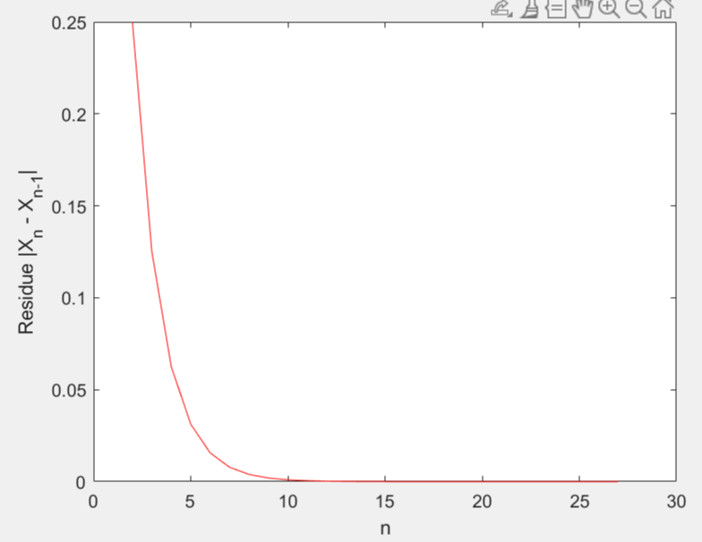

Observations:

We observe that in Newton’s method starting with the midpoints of the intervals as the initial approximations in [-1,0] as well as in [0,1], the sequence {Xn} converges to the same root which is the negative root whose value is -0.04065929 approximately.

However, while using the Bisection method, we observe that starting in the interval [-1,0], the sequence {Xn} converges to the negative root whose value is -0.04065929 approximately while starting in the interval [0,1], the sequence {Xn} converges to the positive root whose value is 0.9623984 approximately.

Since at x = 0.5, the value of f(x) is negative as well as the value of df(x)/dx, that is, f’(x), is also negative, so the iterates start to move towards the negative root in Newton’s method. Hence, we get the negative root using Newton’s method even if we start with the initial approximation of 0.5.

6)

Initial Approximation x0 = 5

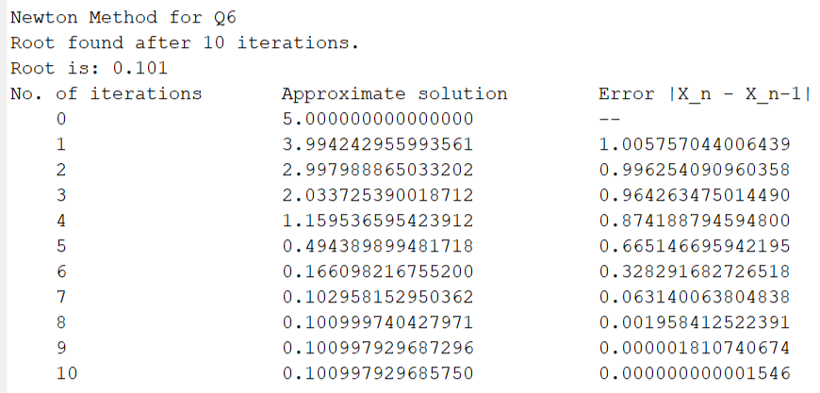

Solution Plot

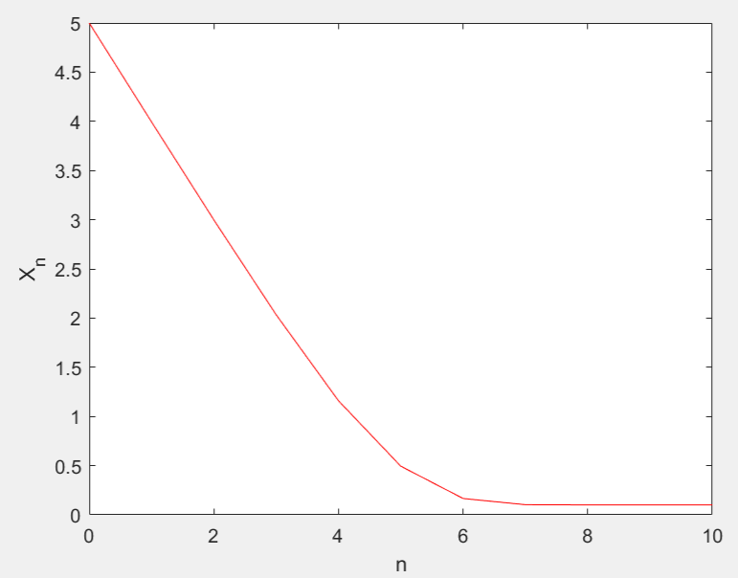

N versus Residue Plot

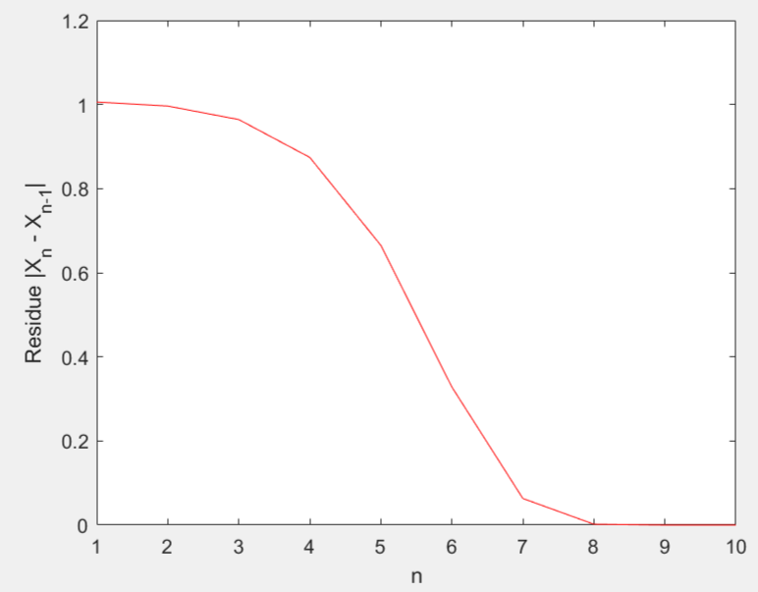

7)

Initial Approximation x0 = 2

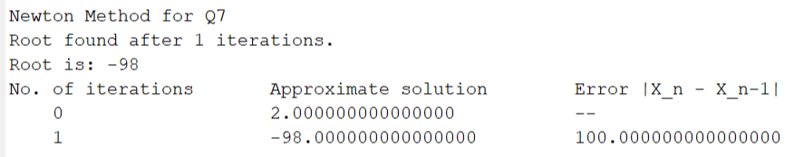

Solution Plot

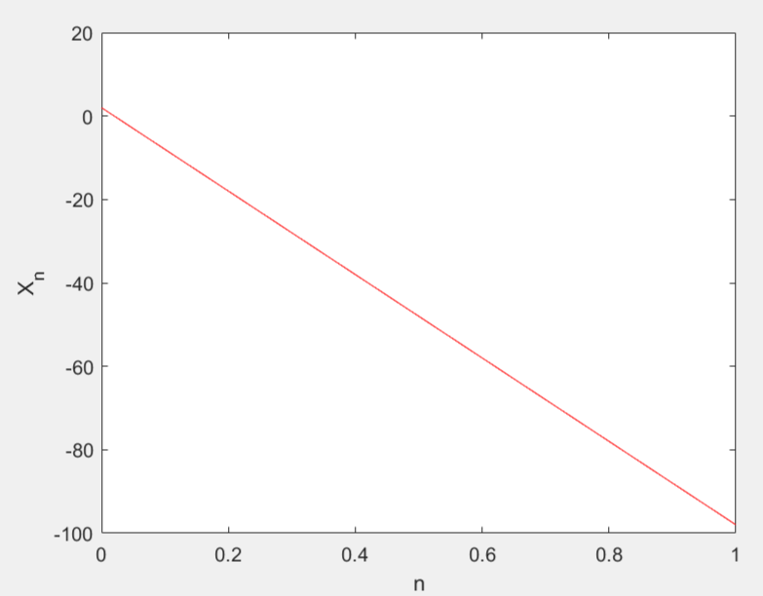

N versus Residue Plot

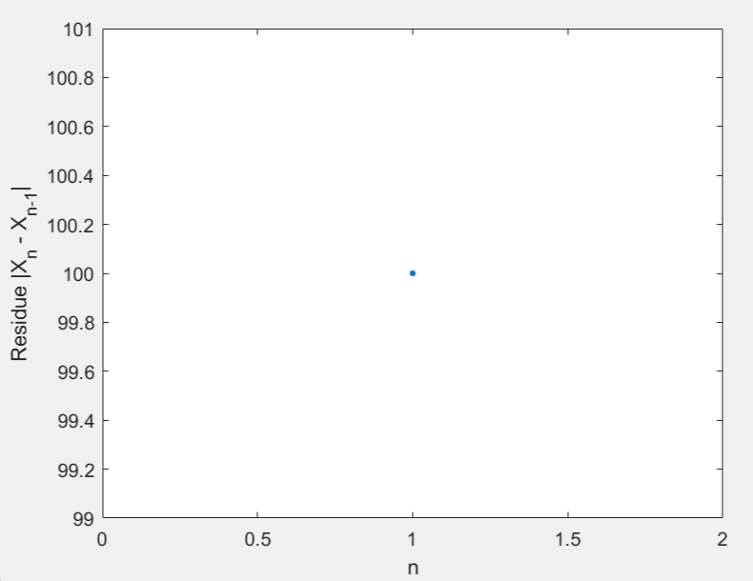

On applying the formula of Newton’s method and carrying out the calculations, in the first iteration itself, the value of Xn becomes –98 at n=1, that is, X0 = 2 and X1 = -98. Since –98 is a root of p(x) as p(-98) = 0, so p(x) becomes 0 at X1 and hence, no further iterations will take place. We obtain the root as –98.