**Scientific Computing Lab MA – 322 Lab – 5**

**Name –** Rasesh Srivastava

**Roll Number –** 210123072

**Branch –** Mathematics and Computing

1)

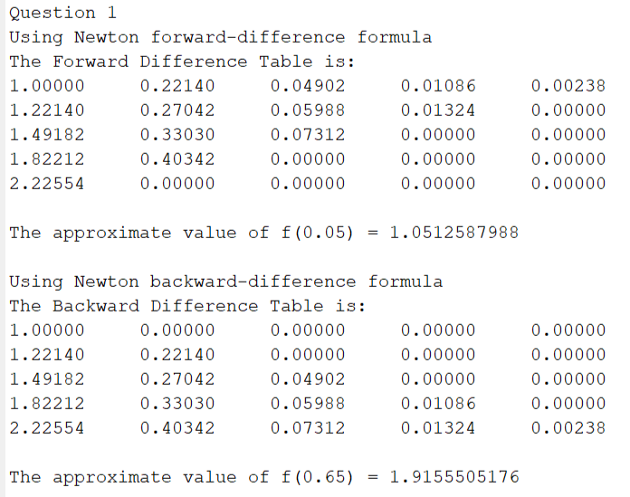

2)

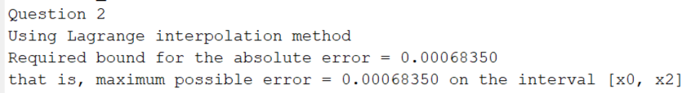

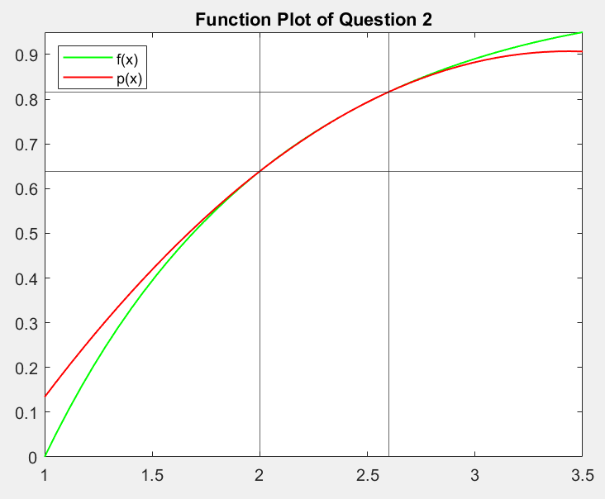

The function plots are drawn by plotting f(x) and p(x). These show that p(x) successfully interpolates f(x) in the interval [2, 2.6].

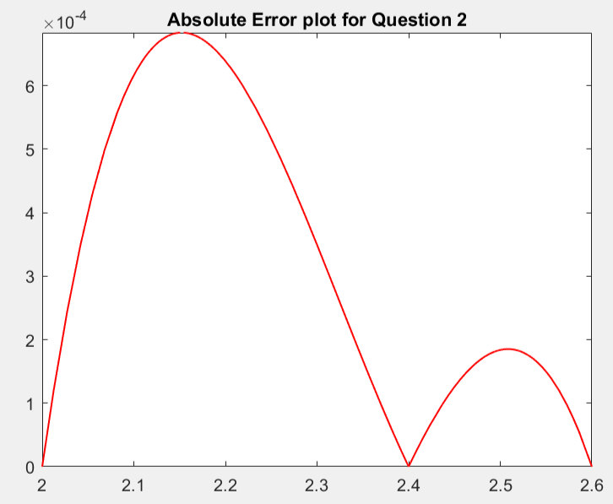

The error plot is drawn by plotting |p(x) – f(x)|

3)

a)



b)

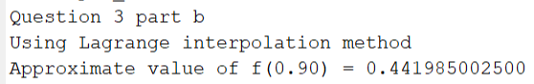

4)

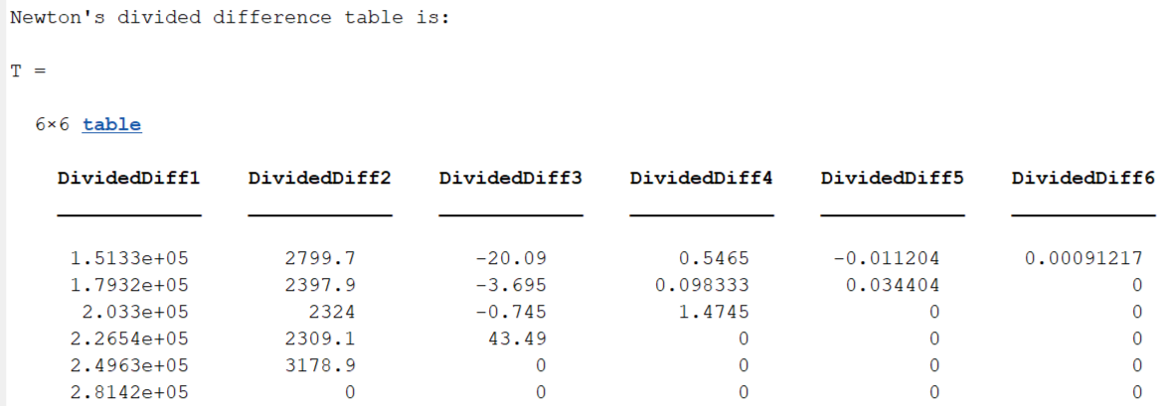







5)

Initially,

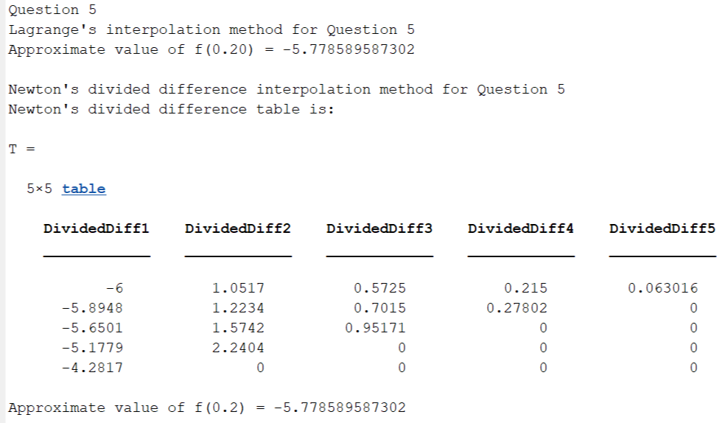

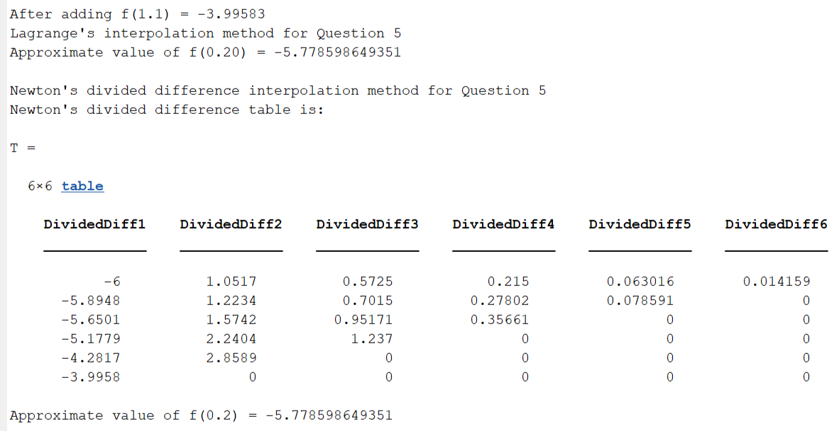

We can observe that both the methods are giving exact same answer for both the tables since the interpolating polynomial p(x) formed by both the methods is completely the same, only the method of calculating the interpolating polynomial is different. Both Lagrange and Newton divided-difference methods are just different representations of each other.

After adding f (1.1) = −3.99583 to the table, the solution is changed but the change is of the order of10-5 which is negligible, that is, we almost get the same answer.