**Scientific Computing Lab MA – 322 Lab – 6**

**Name –** Rasesh Srivastava

**Roll Number –** 210123072

**Branch –** Mathematics and Computing

1)

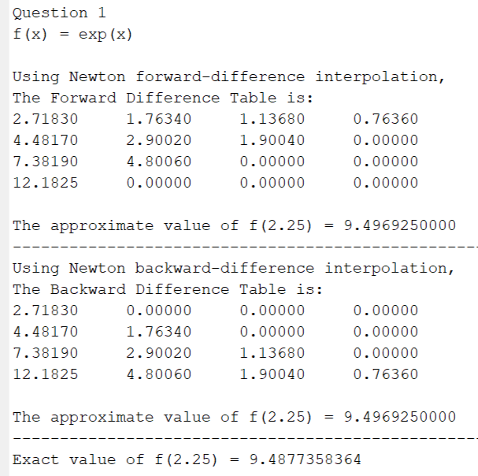

2)

a)

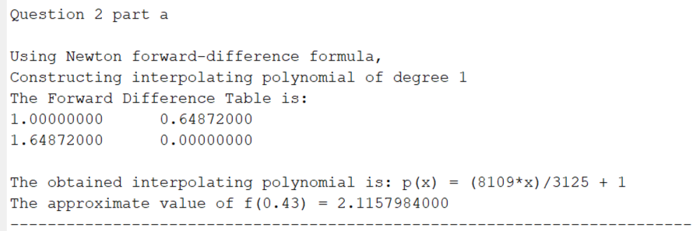

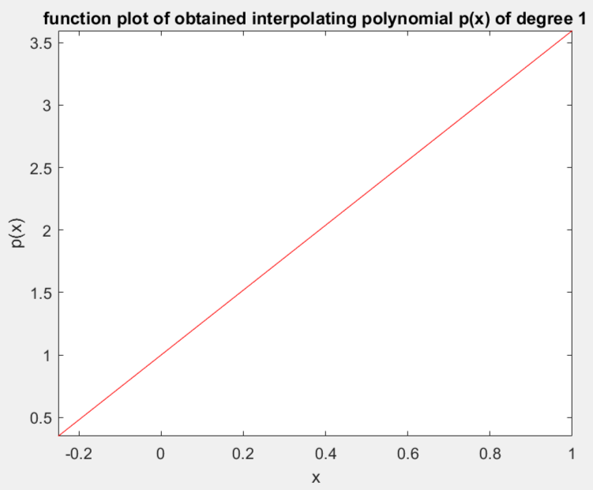

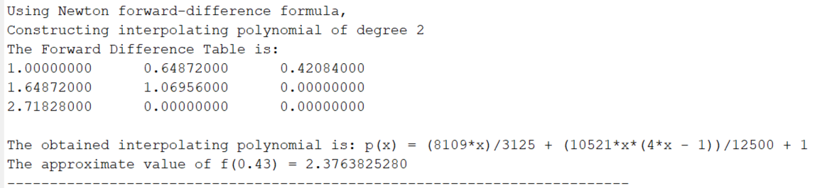

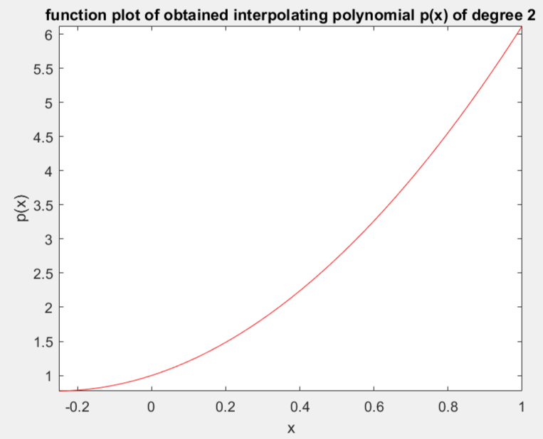

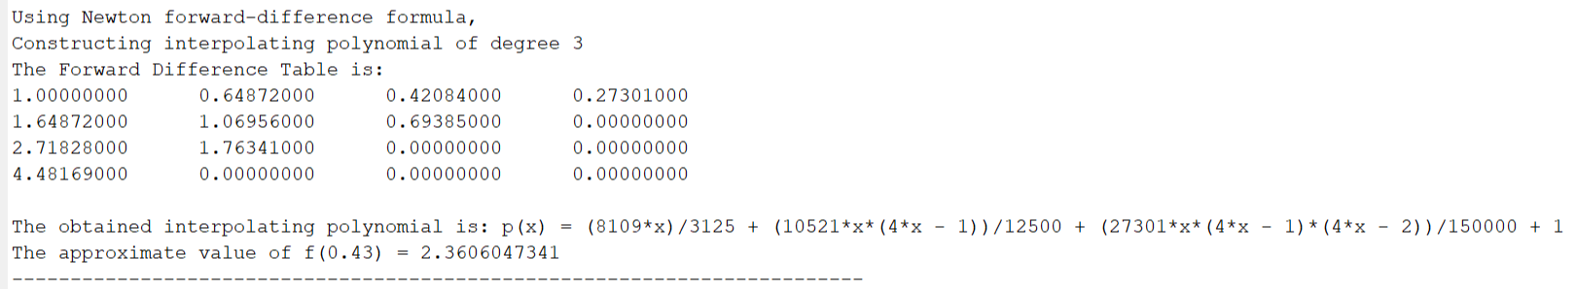

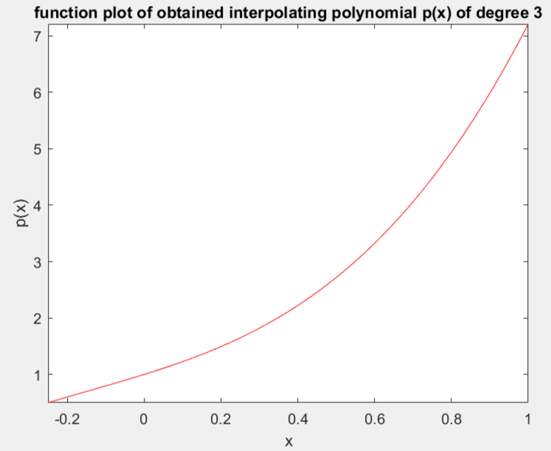

b)

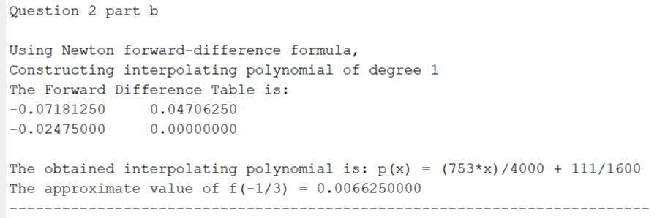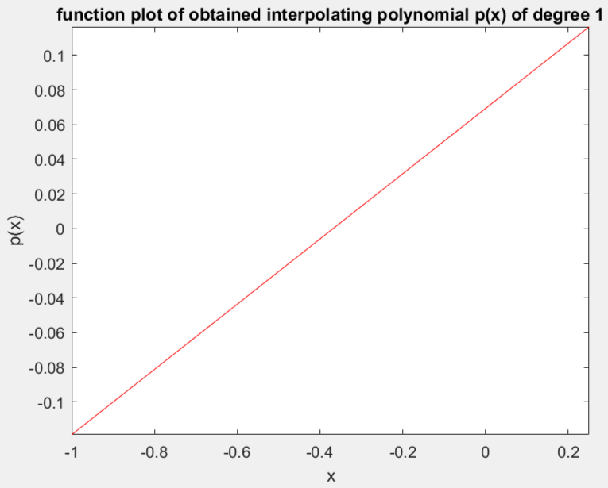

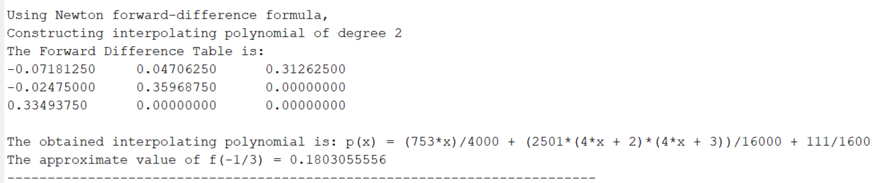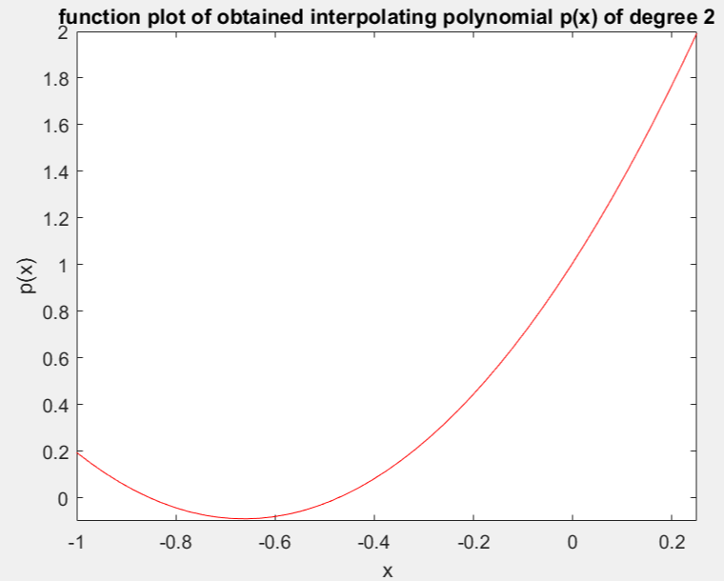

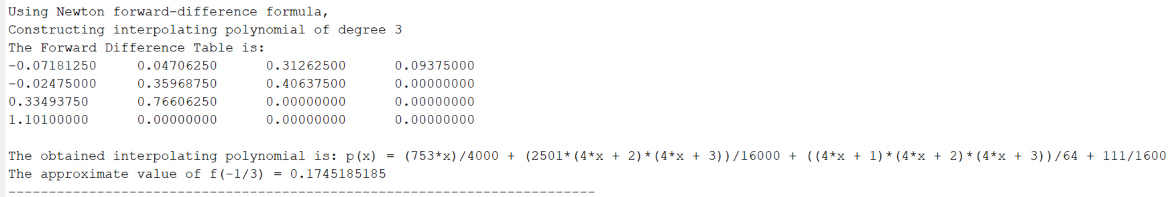

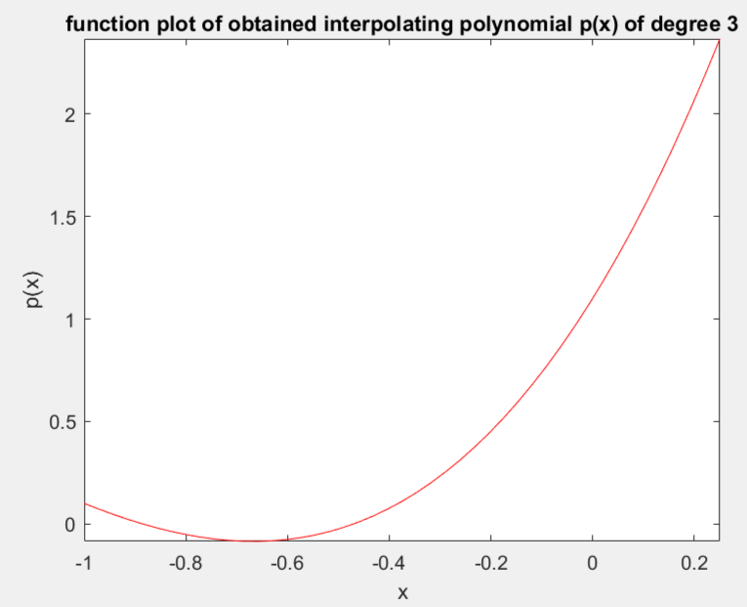

3)

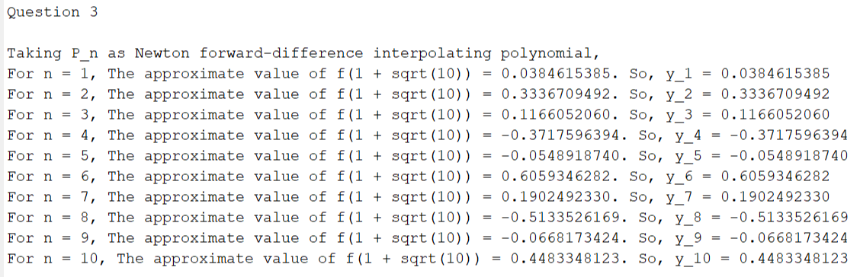

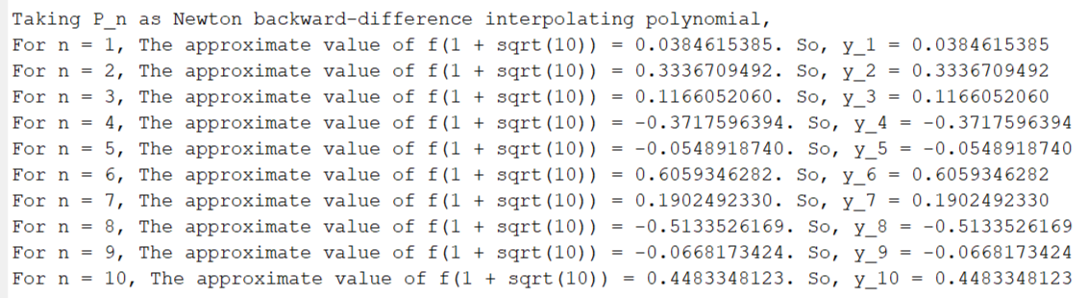

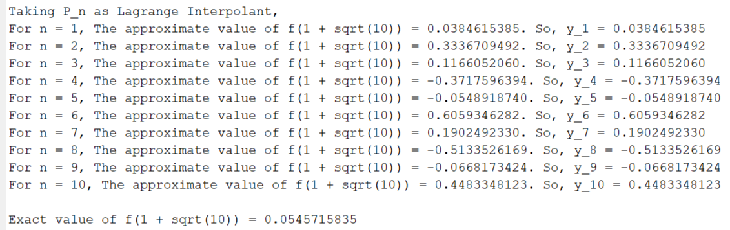

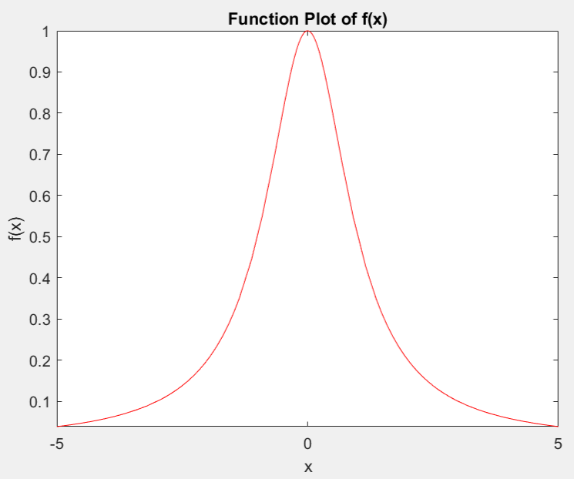 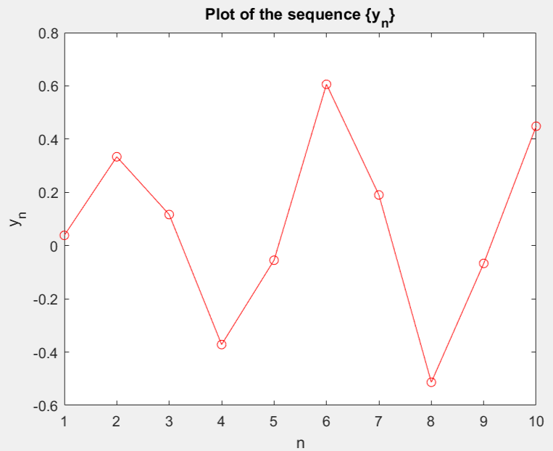

We get the same sequence of {yn} in all the three cases, that is, when we take Pn as Lagrange interpolant, Newton forward-difference interpolant and Newton backward-difference interpolant.

No, the sequence {yn} does not appear to converge to f (1 + sqrt(10)). The sequence {yn} oscillates and diverges and does not converge to f(1+sqrt(10)).

The oscillating patterns evident in the graphs generated by Lagrange interpolation, Newton's forward interpolation, and Newton's backward interpolation can be attributed to a phenomenon known as Runge's phenomenon.

Runge's phenomenon manifests when equidistant interpolation points are utilized to approximate a function with polynomial interpolation. As the number of interpolation points increases, the discrepancies between adjacent points are magnified, resulting in pronounced oscillations or "wiggles" in the interpolated polynomial, particularly near the boundaries of the interpolation interval.

In our question, the following scenario arises:

* Higher Degree Polynomials: The interpolating polynomials employed in Lagrange interpolation, Newton's forward interpolation, and Newton's backward interpolation possess higher degrees, corresponding to the increasing number of interpolation points.
* Equidistant Interpolation Points: Interpolation points are evenly spaced within the range [-5, 5]. Consequently, as the quantity of interpolation points rises, the gap between neighbouring points diminishes.
* Runge's Phenomenon: The use of equidistant interpolation points with higher degree polynomials exacerbates the oscillations between adjacent points, resulting in the observed oscillatory behaviour or "wiggles" in the interpolated polynomial.

To address the oscillations induced by Runge's phenomenon, alternative approaches can be considered, such as employing non-equidistant interpolation points such as Chebyshev nodes or utilizing interpolation methods which are less susceptible to Runge's phenomenon, such as spline interpolation or rational function interpolation.

Furthermore, it is important to note that augmenting the number of interpolation points may not invariably lead to improved approximations due to the amplification of oscillations. Striking a balance between the quantity of interpolation points and the desired accuracy of the approximation is crucial.