**Scientific Computing Lab MA – 322 Lab – 7**

**Name –** Rasesh Srivastava

**Roll Number –** 210123072

**Branch –** Mathematics and Computing

1)

The absolute error is calculated at x = 0.25

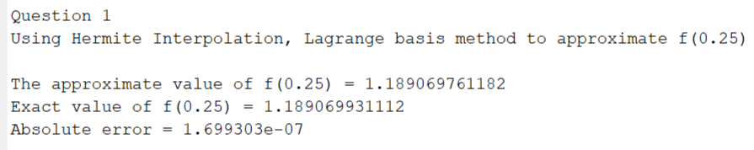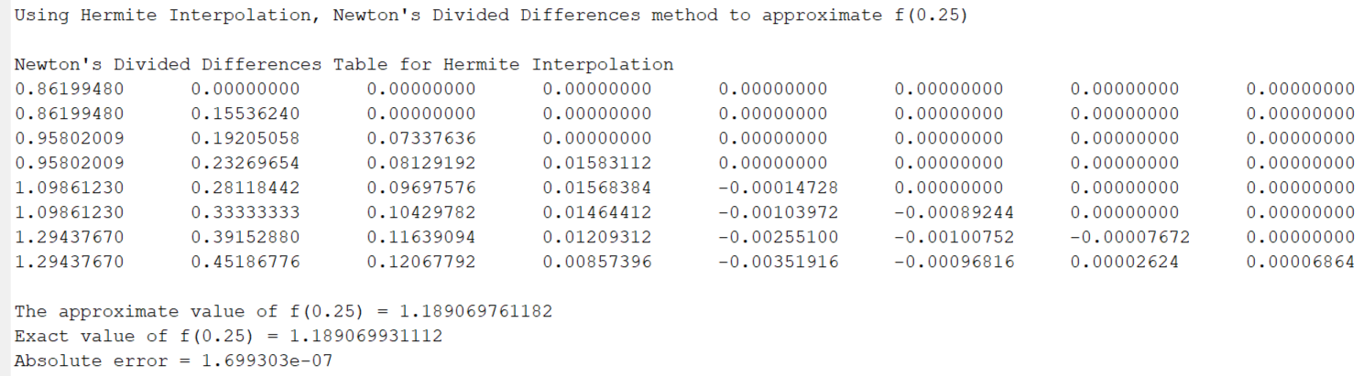

The plot of the function f(x) and interpolating polynomial H(x) is as follows:

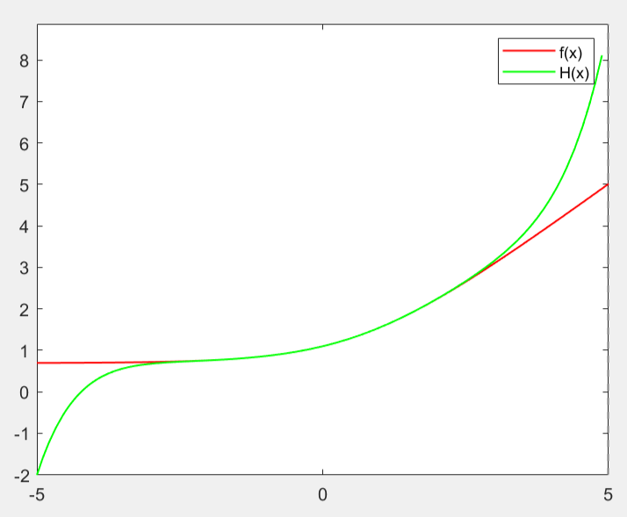

2)

Taking the function f (t) as distance and f’(t) as speed, we can approximate the given data with the help of Hermite interpolation.

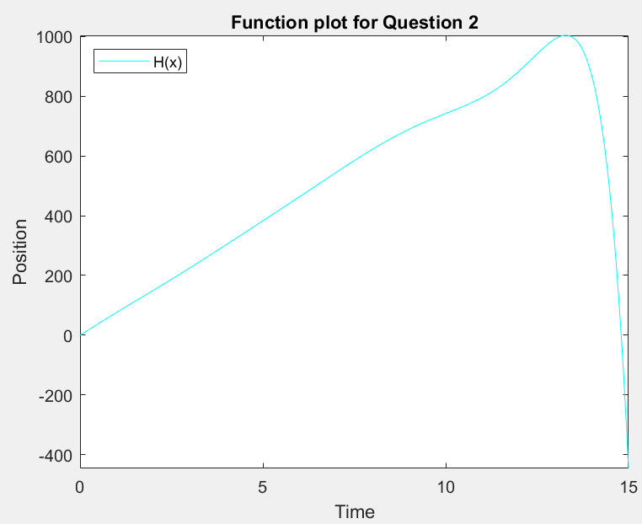

a)



b) and c)

We can observe the speed v/s time graph from the derivative of obtained H (x)

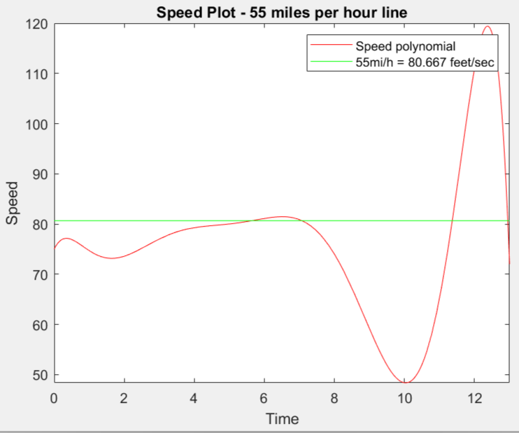

To predict the maximum speed of car, we can observe the speed-time graph. We see that the maxima in speed time graph is obtained somewhere between t = 11 sec and t = 13 sec.

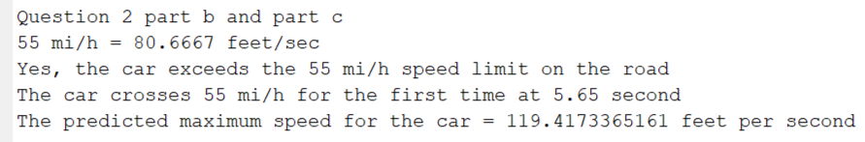

3)

a)

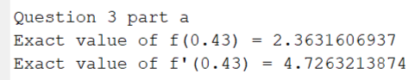

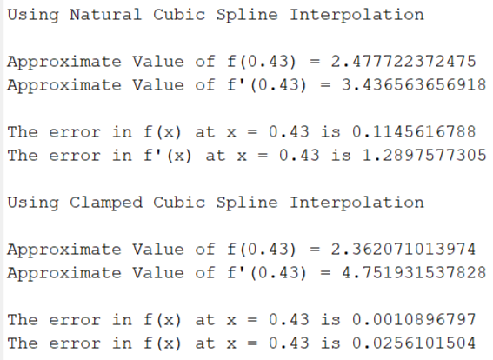

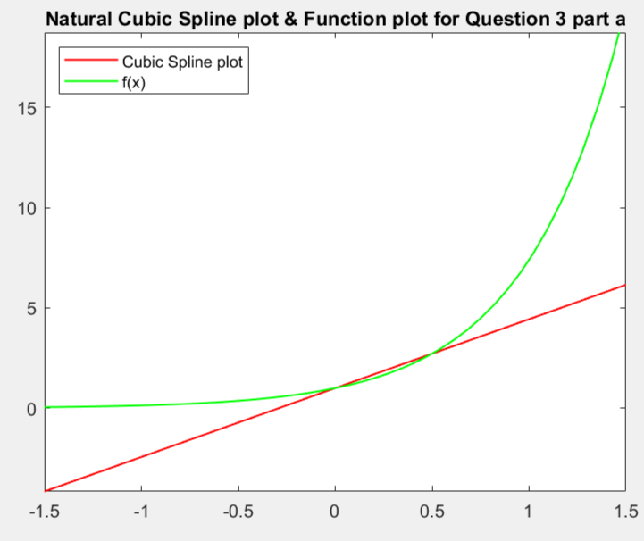

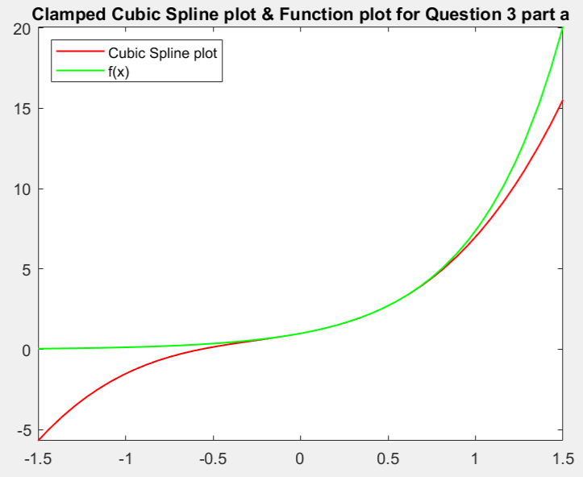

b)

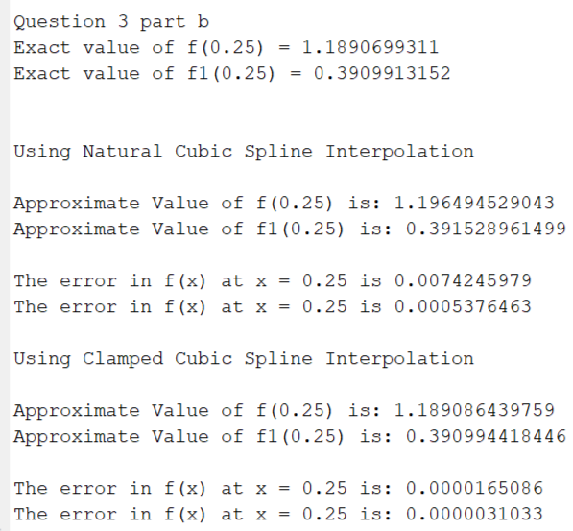

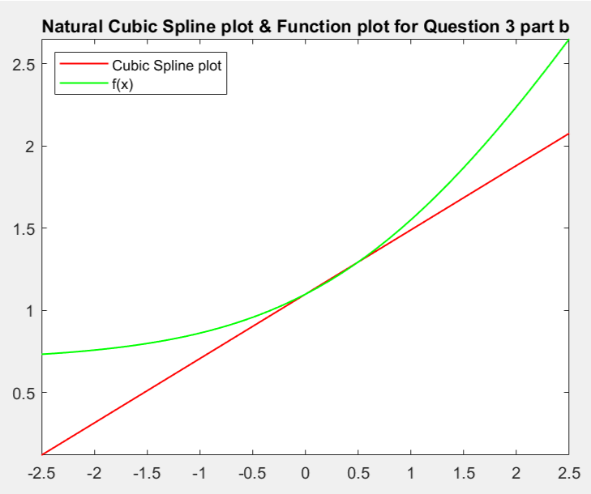

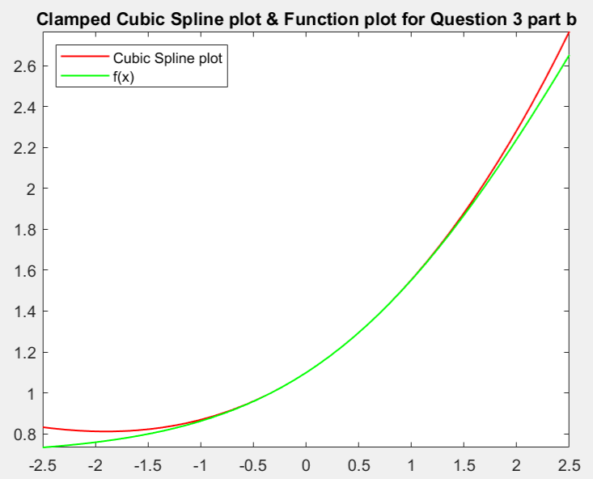

4)

S(x) = clamped cubic spline interpolated polynomial

The obtained S(x) = S1(x), if -1 <= x <= -0.5

S2(x), if -0.5 <= x <= 0

S3(x), if 0 <= x <= 0.5

where, Si(x) = ai + bi(x – xi) + ci(x – xi)2 + di(x – xi)3 for i = 1,2,3 for the nodes {x1, x2, x3, x4}.

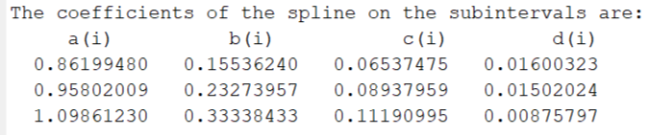

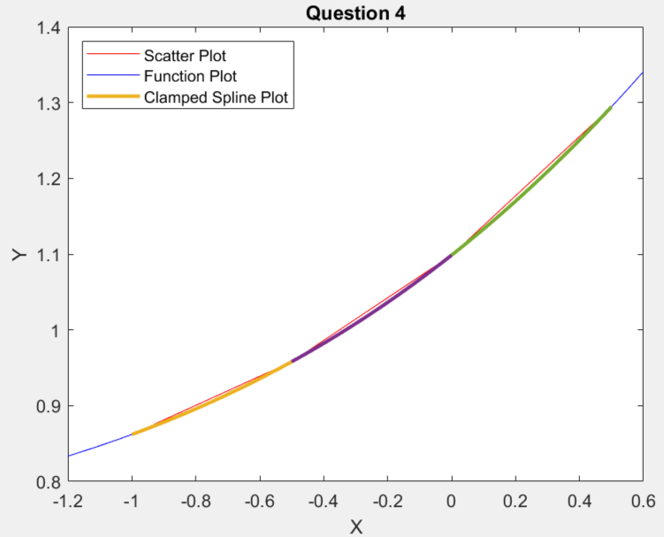

5)

a)

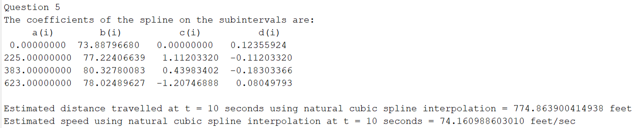

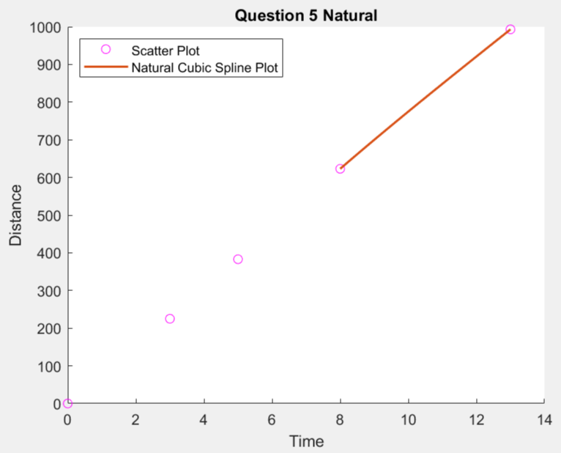

b)

