**Scientific Computing Lab MA – 322 Lab – 8**

**Name –** Rasesh Srivastava

**Roll Number –** 210123072

**Branch –** Mathematics and Computing

To calculate the exact value of the integral, I have used the inbuilt integral(f, a, b) function in MATLAB.

Absolute Error = | Exact Value – Approximate Value of the integral |

1. Using Rectangle Rule,

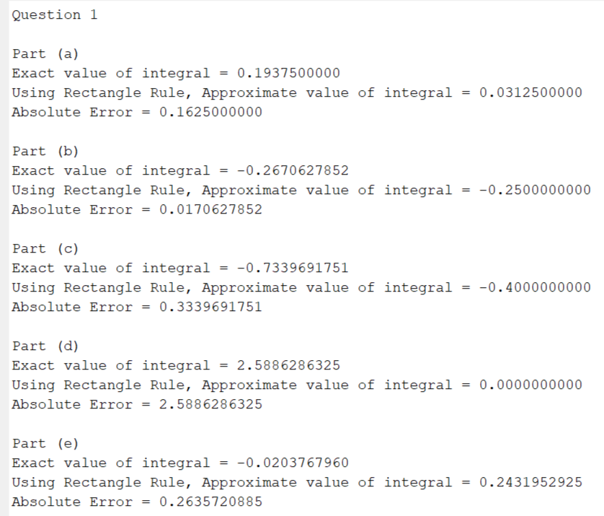

Using Midpoint Rule,

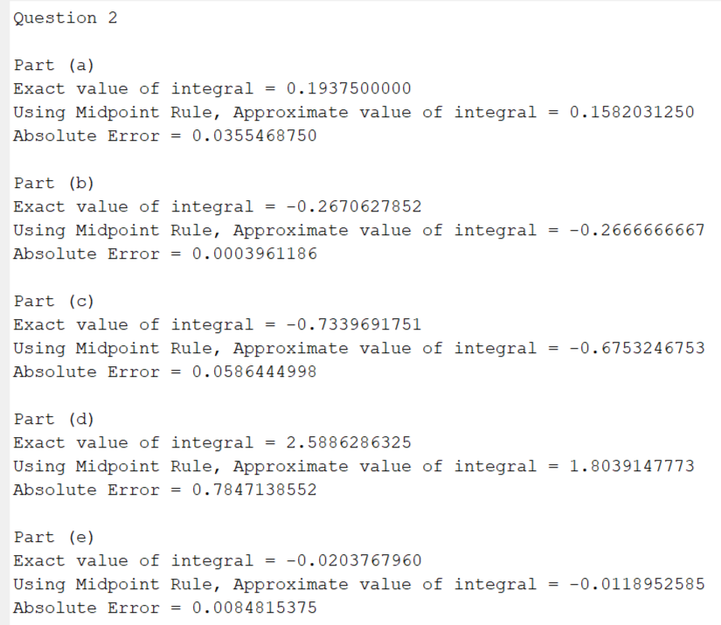

Using Trapezoidal Rule,

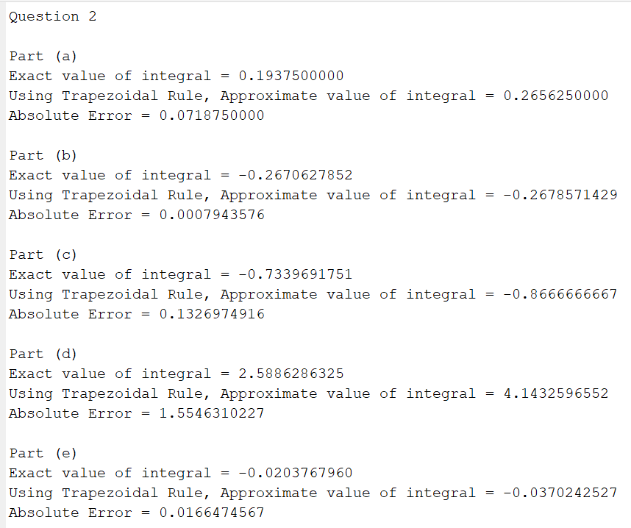

Using Simpson’s Rule,

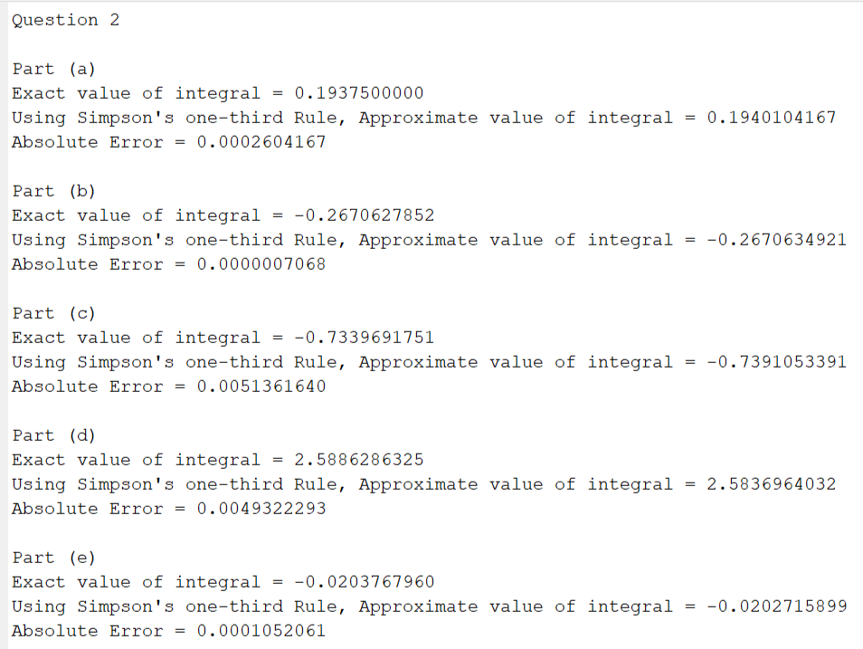

3)

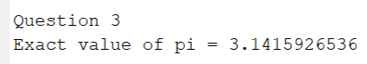

Using Rectangle Rule,

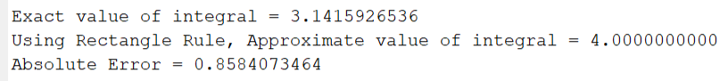

Using Trapezoidal Rule,

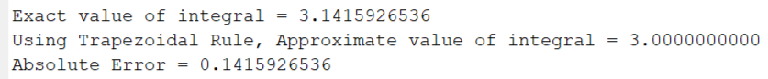

Using Simpson’s one-third Rule,



Using Simpson’s three-eighth Rule,



The worst approximation is given by Rectangle Rule, then Trapezoidal Rule, then Simpson’s one-third Rule and finally, the best approximation is given by Simpson’s three-eighth Rule.

We observe that the Simpson’s one-third and Simpson’s three-eight rules are giving an approximate value significantly closer to the actual value of the integral, and relatively lesser error than other methods.

Absolute Error in Rectangle Rule > Trapezoidal Rule > Simpson’s one-third Rule > Simpson’s three-eighth Rule.

We can get better approximations of the integral value by using the composite versions of these methods.

4)



5)

For determining such n and h, we iterate over n starting from 1, take h = (b-a)/n and consider n+1 equally spaced points x0, x1, …, xn with xi = a + ih, i = 0, 1, …, n. Now we apply the given composite rules on these points and find an estimate of the integral, and check if the Absolute Error is less than or equal to the required tolerance of 10-5. We repeat this process until the tolerance condition is satisfied and then break the loop to get the required value of n and h.

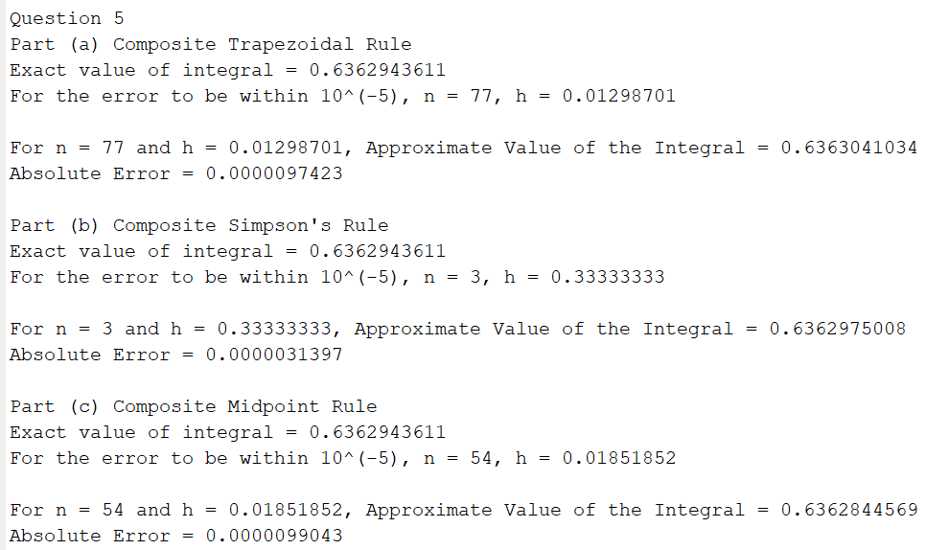

6) Distance = integral of speed with respect to time

