**Scientific Computing Lab MA – 322 Lab – 9**

**Name –** Rasesh Srivastava

**Roll Number –** 210123072

**Branch –** Mathematics and Computing

To calculate the exact value of the integral, I have used the inbuilt integral(f, a, b) function in MATLAB.

Absolute Error = | Exact Value – Approximate Value of the integral |

1)

a)

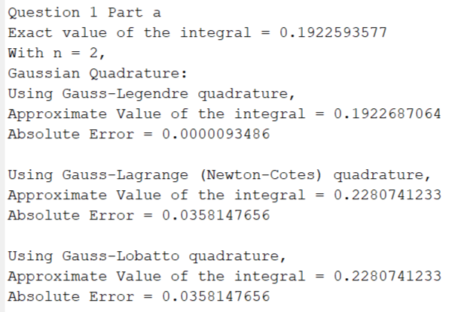

b)

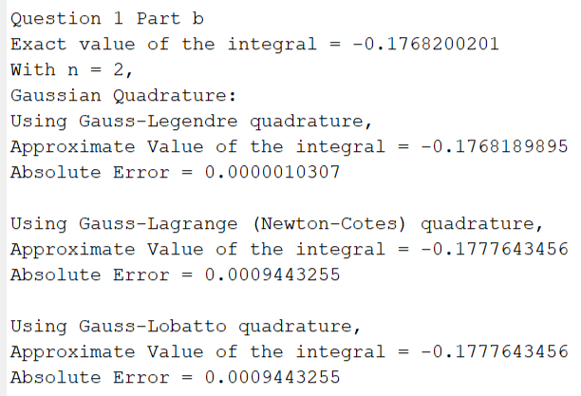

2)

a)

With n = 2,

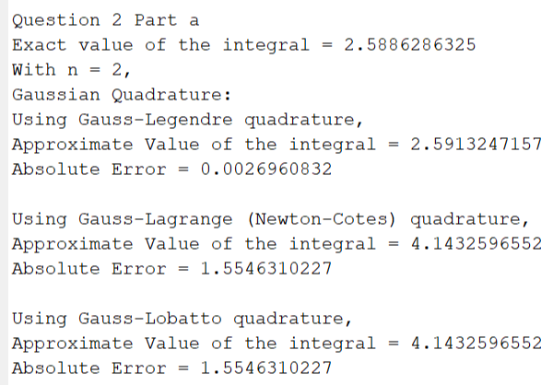

With n = 3,

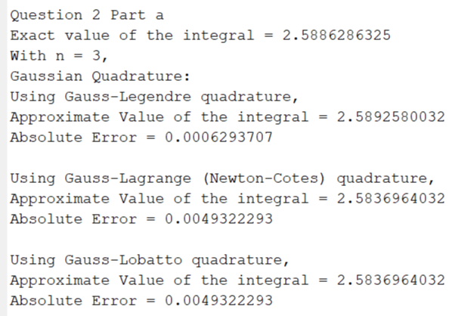

With n = 4,

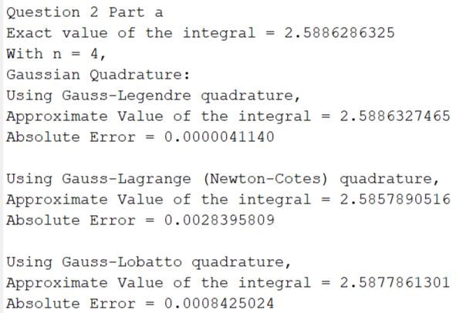

With n = 5,

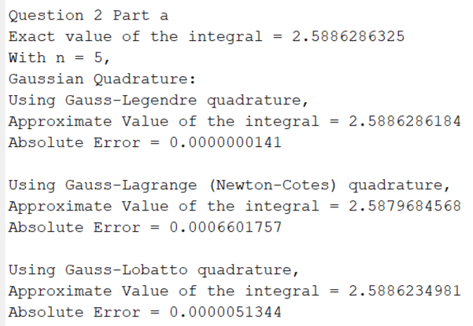

b)

With n = 2,

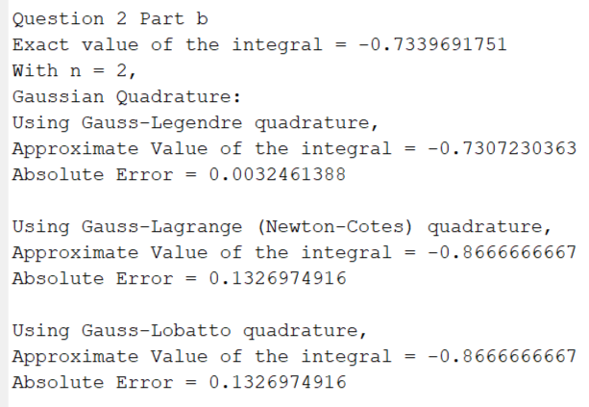

With n = 3,

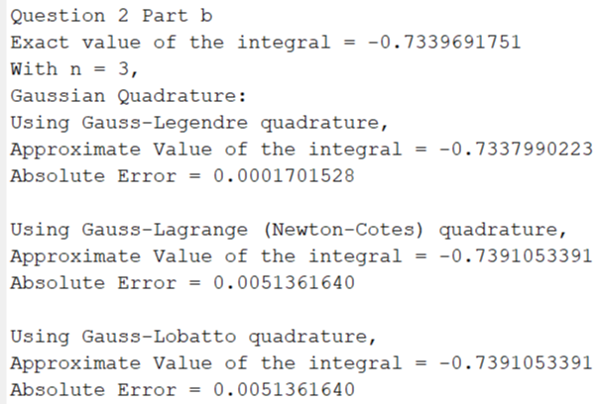

With n = 4,

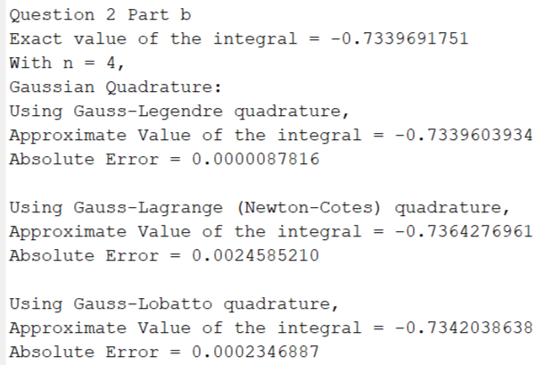

With n = 5,

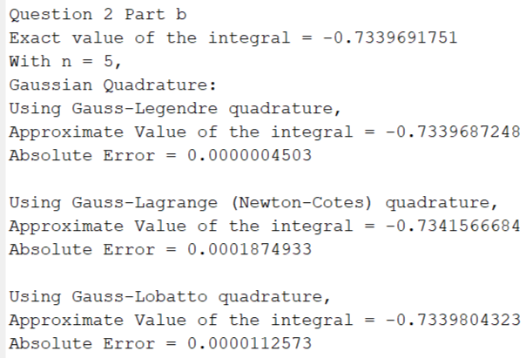

We can observe that the approximate values of the integral by Gauss-Lobatto Quadrature and Gauss-Lagrange (Newton-Cotes) Quadrature are the same for n = 2 and n = 3 and for n > 3, Gauss-Lobatto Quadrature is giving better approximate values of the given integrals.

3)

a)

With n = 2,

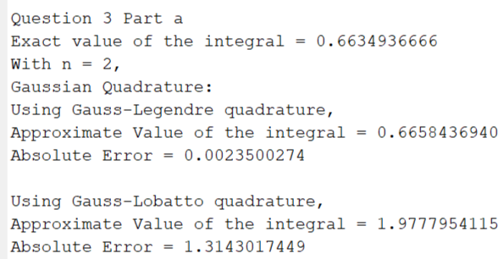With n = 4,

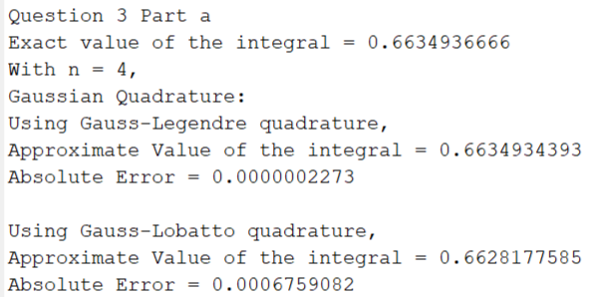

b)

With n = 2,

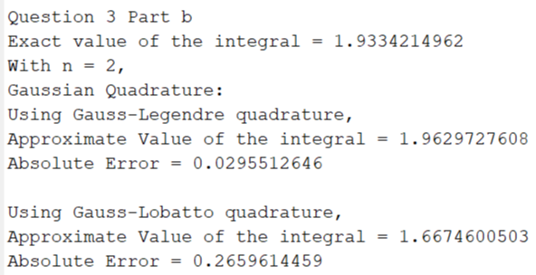

With n = 4,

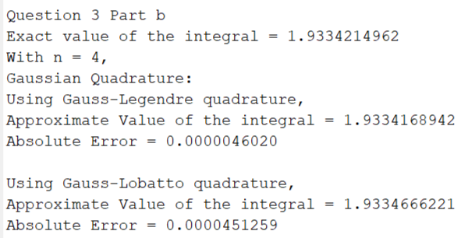

4)

a)

With n = 2,

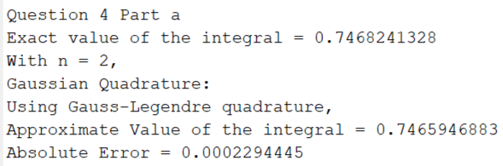

With n = 4,

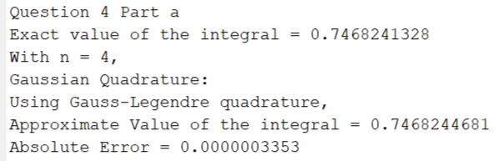

With n = 6,

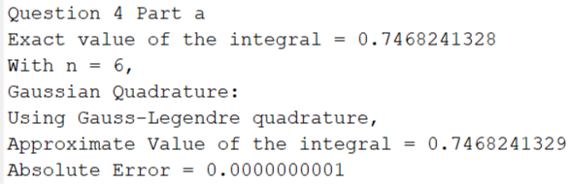

b)

With n = 2,

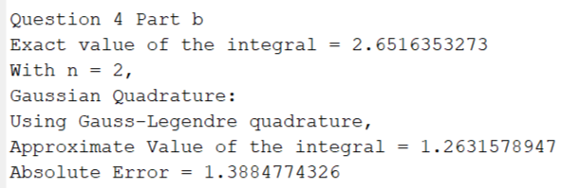

With n = 4,

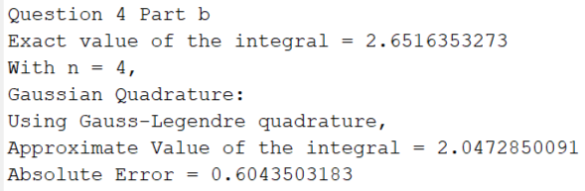

With n = 6,

