Project Name: Machine Learning Model Deployment on Heroku.

Internship Batch: LISUM01

Submission Date: 11-07-2021

Submitted By: Rashmikant Shukla

# Aim:

This project is a demo for ML model deployment using flask API on Heroku.

# Prerequisites:

* Heroku Account

# Project Structure:

Project has following steps

* Toy Data Selection and Model Creation
* Flask Application
* HTML Page for the Application
* File Procfile
* File requirements.txt

## Toy Data Selection and Model Creation:

This project is using ‘hiring.csv’ file for model creation. File ‘model.py’ has the codes for prediction model which is trying to predict salary of employee based on their experience, test score and interview score.

## Flask Application:

File ‘app.py’ contains Flask API which receives data from API calls and returns the predicted value.

## HTML Page for the Application:

File ‘index.html’ contains template which allows user to enter the employee data.

## File Procfile:

Procfile is compulsory file for Heroku deployment which declare the type of application which is web in our case

## File requirements.txt

In this text file all the required libraries are mentioned which will initiate their installation in Heroku environment.

# Running the Project:

* On command prompt ensure that project home directory is selected. To run the ML model, write following command

This will create serialization version of model in pickle file ‘model.pkl’.

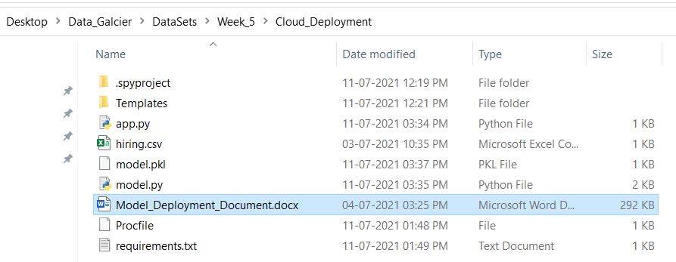

* Run app.py using below command to start Flask API.

$$python app.py$$

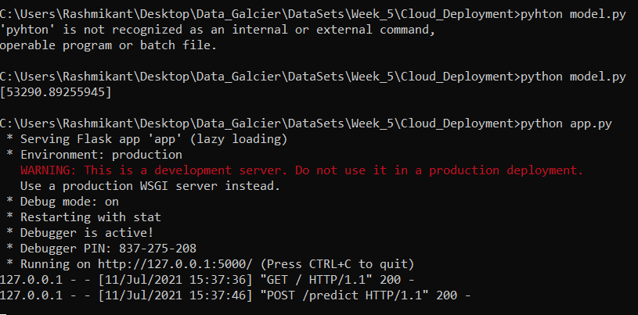

Flask API will run on port 5000 as shown in the image.

This shows that our application is running proper in our local.

* After this Login into Heroku account add click on create application option.

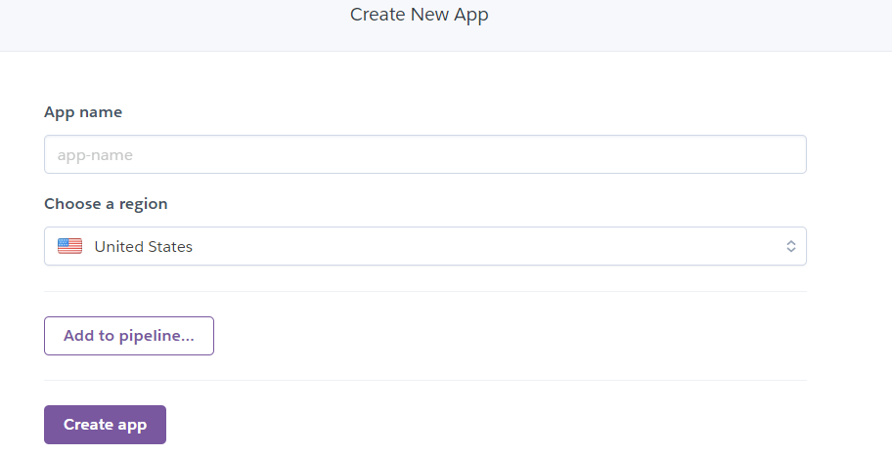

It will navigate to this type of page. Type your application name.

Our application name is salaryprediction-flask .

* Now go to deploy tab under the application name there will be deployment method option. As shown in below image.

We are going to use GitHub Option. Once you will click on this it will ask for credential to connect to your git account.

This repositoy should have your model.pkl, app.py, Procfile, index file and requirement files.

Our files are in repository <https://github.com/Rash1425/heroku-deployment.git> on git.

* Now connect your git add search for the repository. In our case it is “/Heroku-deployment”

As shown in above image click on “connect” option add your repository will be connected to your heroku account.

You will get options like :

* Automatic Deploys and
* Manual Deploys

We are going to use Manual Deploys options.

* As shown in above screenshot click on “Deploy Branch” option and your model will be deployed and log will bw generated. If there is any problem you can check the logs.
* Once the deployment is done you will get following kind of option

* That means app was successfully deployed and you can view the link when you click on the “View” button.
* Our app link is <https://salaryprediction-flask.herokuapp.com/>

On this link one can see our web app hosted on Heroku.