University College of Applied Sciences

Engineering Department

Introduction to Database

HW2

Student Name: رشا علي أبوركاب

Student No: 220210069

Answer the following five questions:

Q1

Discuss the role of a high-level data model in the database design process

| It provides concepts for presenting data in a manner that approximates human perception of data and describes basic data structure concepts and constraints |
| --- |

Q2

What is a relationship type? Explain the differences among a relationship instance, a relationship type, and a relationship set.

| Relationship Type: This is a schema description of the relationship, identifying the relationship name and the entity types involved, and also identifying some relationship constraints. (one-to-one, one-to-many, many-to-many)  Relationship Set: The current state of the current set of relationship instances and relationship types represented in the database.  Each instance in the sentence refers to each participating entity |
| --- |

Q3

When is the concept of a weak entity used in data modeling? Define the terms owner entity, weak entity, identifying relationship, and partial key.

| ** An entity with no key properties identifies an entity that depends on another entity type.  ** Entities are identified by composition  Subkeys for weak entity types  and specific entities related to them in identifying relationship types |
| --- |

Q4

Consider the ER diagram in Figure 3.21, which shows a simplified schema for an airline reservations system. Extract from the ER diagram the requirements and constraints that produced this schema. Try to be as precise as possible in your requirements and constraints specification.

| (1) The database represents each AIRPORT, keeping its unique AirportCode, the AIRPORT Name,  and the City and State in which the AIRPORT is located.  (2) Each airline FLIGHT has a unique number, the Airline for the FLIGHT, and the Weekdays on  which the FLIGHT is scheduled (for example, every day of the week except Sunday can be coded as X7).  (3) A FLIGHT is composed of one or more FLIGHT LEGs (for example, flight number CO1223 from New York to Los Angeles may have two FLIGHT LEGs: leg 1 from New York to Houston and leg 2 from Houston to Los Angeles). Each FLIGHT LEG has a DEPARTURE AIRPORT  and Scheduled Departure Time, and an ARRIVAL AIRPORT and Scheduled Arrival Time.  (4) A LEG INSTANCE is an instance of a FLIGHT LEG on a specific Date  (for example, CO1223 leg 1 on July 30, 1989). The actual Departure and Arrival AIRPORTs and  Times are recorded for each flight leg after the flight leg has been concluded. The  Number of available seats and the AIRPLANE used in the LEG INSTANCE is also kept.  (5) The customer RESERVATIONs on each LEG INSTANCE include the Customer Name, Phone,  and Seat Number(s) for each reservation.  (6) Information on AIRPLANEs and AIRPLANE TYPEs is also kept. For each AIRPLANE  TYPE (for example, DC-10), the TypeName, Manufacturing Company, and  Maximum Number of Seats are kept. The AIRPORTs in which planes of this type  CAN LAND are kept in the database. For each AIRPLANE, the airplane, Total number of seats,  and TYPE are kept. |
| --- |

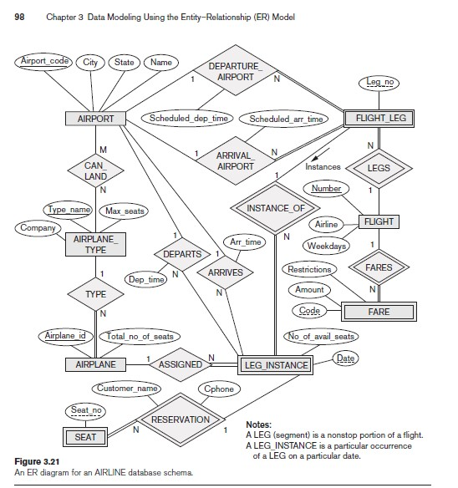

Q5

Consider the ER diagram shown in Figure 3.22 for part of a BANK database. Each bank can have multiple branches, and each branch can have multiple accounts and loans.

a. List the strong (nonweak) entity types in the ER diagram.

| There are BANK, ACCOUNT, LOAN, and CUSTOMER nonweak entity types. |
| --- |

b. Is there a weak entity type? If so, give its name, partial key, and identifying relationship.

| There is a weak entity type **BANK-BRANCH.**  Its partial key is **BranchNo**.  Its identifying relationship is **BRANCHES** |
| --- |

c. What constraints do the partial key and the identifying relationship of the weak entity type specified in this diagram?

| **The partial key BranchNo in BANK-BRANCH specifies that the same BranchNo value may occur  under different BANKs.  **The identifying relationship BRANCHES specifies that BranchNo values are uniquely assigned for those BANK-BRANCH entities that are related to the same BANK entity.  Hence, the combination of BANK Code and BranchNo together constitutes a full identifier for a BANK-BRANCH. |
| --- |

d. List the names of all relationship types, and specify the (min, max) constraint on each participant of an entity type in a relationship type. Justify your choices.

| BANK -(1, N)- BRANCHES -(1,1)- BANK−BRANCH  ACCOUNT -(1,1)- ACCTS -(0,N)- BANK−BRANCH  ACCOUNT -(1,N)- A − C (0,N) CUSTOMER  CUSTOMER -(0,N)- L − C -(1,N)- LOAN  BANK−BRANCH -(0,N)- LOANS -(1,1)- LOAN |
| --- |

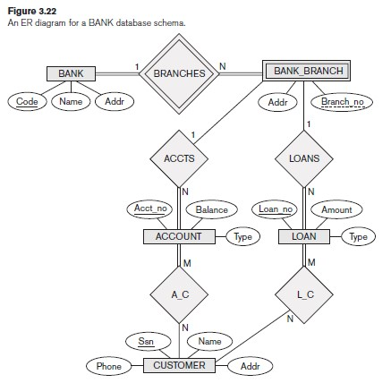

That's all

Best wishes