Article
A Leakage-Free Small-Data Benchmark for Force- and Vibration-Based Chatter Detection in Thin-Wall Milling of Wire-Arc Additively Manufactured and Wrought Al–Mg Walls
[Author names and affiliations – author to complete]
Abstract: Small machining datasets make optimistic chatter-detection results easy to obtain. We re-analysed force and vibration records from face-milling of thin wire-arc additively manufactured (WAAM) ER5356 and wrought AA 5052 walls (16 trials, 48 zones) with a leakage-free protocol. Spindle speeds measured from the force spectra contradicted the archived trial mapping for 3 trials, and no trial had a confirmed material, so no result uses material identity. Zones were labelled by a fixed spectral rule (a non-synchronous 2.5–5.5 kHz force peak above a prominence threshold). The labels depended strongly on the threshold: 25, 1 and 0 of 48 zones were unstable at 15, 20 and 25 dB, so only 15 dB could be evaluated. Under leave-one-trial-out validation with five seeds, pooled ROC-AUC ranged from 0.65 to 0.74 for all models using hand-crafted features (random forest highest), against a permutation-null band of 0.34–0.67. No model differed from logistic regression (0.69) in trial-level paired tests, graph edges added nothing, and a 1D-CNN on raw signals performed at chance. Removing two weakly aligned trials lowered the AUC of every feature-based model. The dominant uncertainty is the label definition, not the classifier.
Keywords: chatter detection; thin-wall milling; wire arc additive manufacturing; Al–Mg alloys; cutting force; vibration; graph neural networks; leakage-free evaluation; small data

1. Introduction
Wire arc additive manufacturing (WAAM) builds near-net metal parts bead by bead, and almost every functional WAAM part is finish-machined. The deposited material differs from wrought stock in ways that matter for machining: WAAM deposits are prone to defects such as porosity [2], Al–Mg deposits can lose magnesium and show anisotropic microstructure and properties [3], and each new layer reheats the layers below it, which acts as an uncontrolled in-situ heat treatment [2]. In our earlier study of WAAM ER5356 walls [1], the deposited material was stronger than a wrought Al–Mg reference yet gave rougher machined surfaces, and porosity was proposed as a trigger of dynamic instability during machining. Thin walls add low and position-dependent stiffness, so finish milling of WAAM walls is a natural setting for chatter monitoring.
Machine-learning chatter detection has been studied on turning and milling signals with a range of featurisations, from wavelet packets and empirical mode decomposition to topological and similarity-based descriptors [4,5], and public multi-sensor datasets now exist for turning [6] and for industrial CNC milling with force, acceleration and controller signals [7,8]. Graph neural networks [9,10] are an attractive way to let neighbouring cutting zones share information. Small machining datasets, however, make it easy to report optimistic results: zones of the same cut are correlated, labels derived from spectral rules can hinge on arbitrary thresholds, early stopping on tiny validation sets leaks information, and baselines are often weaker than the proposed model by construction.
This paper is a deliberately conservative re-analysis of the force and vibration records of [1]. A pre-analysis audit of the data archive and of an earlier modelling pipeline found that (i) the trial-to-condition mapping was partly wrong and the trial-to-material mapping could not be confirmed, (ii) the earlier labels used nominal spindle speeds, which are too inaccurate for a ±2 Hz harmonic test near 3.5 kHz, and (iii) several evaluation choices could inflate or deflate scores. The contributions are:
(1) an evidence-based reconstruction of the trial-to-cutting-condition mapping from the measured spindle speed, the force level and file provenance, without inferring material from signal differences;
(2) a chatter labelling rule that uses the measured spindle frequency, and a quantification of how strongly the labels depend on the prominence threshold;
(3) a leakage-free leave-one-trial-out benchmark of three classical and six deep models, including two spatio-temporal graph networks, a graph network with fewer than 5000 parameters and no-edge ablations, with trial-bootstrap confidence intervals, label-permutation nulls and trial-level paired tests;
(4) a frank statement of what the data cannot support, as a basis for the additional measurements needed.

2. Materials and Methods

2.1. Specimens, Cutting Experiments and Sensors
The specimens and cutting plan are those of [1]. Walls of WAAM ER5356 and of wrought AA 5052 were face-milled with a 4-flute carbide end mill of 10 mm diameter at a constant feed of 80 mm/min across a wall width of 30 mm, at two nominal spindle speeds (1000 and 1400 rpm) and depths of cut from 0.5 to 1.5 mm in steps of 0.25 mm. Cutting forces were recorded with a Kistler 9257B dynamometer at 25 kHz and vibration with a triaxial accelerometer at 25 kHz on a separate acquisition computer; the accelerometer model and mounting position are not recorded in the data archive. Infrared images were recorded in [1] but are not used here (Section 5).
The archive contains 21 trial recordings. Force records exist for 17 of them; one force record starts mid-cut, leaving 16 usable trials. The two computers were not synchronised, so the accelerometer record was aligned to the force record by maximising the correlation between the log-RMS envelope of the acceleration and a step template marking the cut in the force record. The alignment correlation ranged from 0.43 to 0.97; 2 trials (trials 04 and 06) fell below r = 0.7 and were flagged for a sensitivity analysis.

2.2. Trial Mapping from Measured Spindle Speed and Force
The trial-to-condition and trial-to-material assignments in the archive were provisional (assigned by trial number, without a laboratory log). Because the labelling rule needs an accurate spindle frequency, the spindle-rotation frequency of every trial was measured from its force record with a harmonic comb: with $P(f)$ the periodogram of the summed, de-meaned three-axis force over the retained cut,
${\overset{^}{f}}_{0}={argmax}_{f_{0}∈[12,30]Hz}\frac{1}{60}\sum_{n=1}^{60}{\log_{10}}P(nf_{0})$ (1)
evaluated on a 0.0005 Hz grid and refined to 0.00002 Hz. The search range covers both nominal speeds with a wide margin and does not use the nominal value. Speeds were then compared with the provisional mapping, and the mean resultant cutting force was compared with the trial order inside each block of equal measured speed, since the cutting plan of [1] runs five depths per speed. Material was never inferred from signal or material-property differences; the only admissible material evidence is file provenance.

2.3. Zones and Windows
The cut was detected in the force envelope as the longest sustained burst above the air-cutting level (detected cuts of 20.9–24.3 s, i.e., 27.9–32.5 mm of tool travel). Because the cutter is 10 mm wide, zones narrower than the tool overlap heavily, and the first and last zones contain the engagement transients. The detected cut $\left[t_{s} , t_{e}\right]$ was therefore divided into 3 zones of equal length, and one tool radius (5 mm, 3.75 s at the feed used) was removed at each end:
$Z_{k}=\left[max\left(t_{s}+\frac{k−1}{3}Δ,t_{s}+δ_{e}\right) , min\left(t_{s}+\frac{k}{3}Δ,t_{e}−δ_{e}\right)\right],Δ=t_{e}−t_{s},k=1,2,3$ (2)
with $δ_{e}$ = 3.75 s. Retained zones lasted 3.23–8.11 s. A zone is a bin of tool-centre positions; each window integrates material within one tool radius of the centre. In each zone, $T$ = 16 windows of 100 ms were spread evenly over the retained span. This layout was fixed from the tool geometry before any model was rerun.

2.4. Chatter Labelling Rule
Each zone was labelled from the Welch power spectral density of its full retained force record (segments of 32768 samples, 0.76 Hz bins), summed over the three axes, $S_{z}(f)$. Within the band $B$ = 2.5–5.5 kHz, which contains the dominant structural modes near 3.5 and 4.3 kHz reported in [1], the highest peak $f_{z}$ and its prominence over the band median are
$f_{z}={argmax}_{f∈B}S_{z}(f),Π_{z}=10\log_{10}\frac{S_{z}(f_{z})}{{median}_{f∈B}S_{z}(f)}$ (3)
The distance of the peak to the nearest spindle-rotation harmonic, using the measured ${\overset{^}{f}}_{0}$, is
$d_{z}=\left|f_{z} − round\left(f_{z} / {\overset{^}{f}}_{0}\right){\overset{^}{f}}_{0}\right|$ (4)
and the zone is labelled unstable when the peak is not forced and is prominent enough:
$y_{z}=I\left[d_{z}>δ_{h}∧Π_{z}≥τ\right]$ (5)
where $I[·]$ is 1 if the condition holds and 0 otherwise, $δ_{h}$ = 2 Hz and $τ$ ∈ {15, 20, 25} dB. Spindle-rotation rather than tooth-passing harmonics are excluded because cutter runout forces vibration at every multiple of the spindle frequency. In the chatter band the harmonic numbers of the observed peaks range from 104 to 215, so a ±2 Hz test needs the spindle frequency to about 0.01 Hz; nominal speeds are far less accurate (Section 3.1).

2.5. Features
For each window and each of the six channels (three force axes, three acceleration axes), 10 features were computed: RMS, peak-to-peak value, kurtosis, crest factor, the log energy within ±150 Hz of each structural mode (1024-point Welch spectrum), a chatter indicator, the wavelet energy entropy and log energy of a complex Morlet transform with 24 scales, and the spectral centroid in the chatter band. The chatter indicator uses the same harmonic definition as the label. It is computed on a 0.5 s context centred on the window (periodogram, 2 Hz bins), because 100 ms windows cannot resolve spindle harmonics:
$CI=\frac{\sum_{f∈B,d(f)>δ_{h}}{P_{c}}(f)}{\sum_{f∈B}{P_{c}}(f)}$ (6)
where $P_{c}$ is the context periodogram and $d(f)$ the distance to the nearest spindle harmonic. Two kinematic/geometric inputs were added per zone: the measured spindle speed and the zone-centre position along the wall, giving 62 inputs per window. Depth of cut was not used because its mapping to trials is not confirmed. Raw windows were decimated to 12.5 kHz (anti-aliased) for the convolutional encoders.

2.6. Models
Classical models (logistic regression, a random forest with 300 trees, and an RBF support vector machine, all class-balanced) used the window-averaged features of each zone. The deep models were a 1D-CNN on raw windows only, a bidirectional LSTM over the window sequence of features, a fusion MLP that combines features and CNN encodings per zone without any edges, two spatio-temporal graph networks (ST-GCN and ST-GAT) and a small GNN. In the graph models each trial is a path graph of 3 zones whose kinematic edges join consecutive zones along the tool path ($A_{ij}=1$ if $|i−j|=1$). The graph convolution [9] is
$H^{\left(l + 1\right)}=σ\left({\overset{\sim }{D}}^{−1/2}(A+I){\overset{\sim }{D}}^{−1/2}H^{\left(l\right)}W^{\left(l\right)}\right)$ (7)
and the attention layer [10] weights the neighbours $j$ of zone $i$ (including $i$ itself) with a learned bias $b$ on the edge weight, the softmax running over those neighbours:
$α_{ij}={softmax}_{j}\left(LeakyReLU\left(a_{1}^{⊤}Wh_{i} + a_{2}^{⊤}Wh_{j} + bA_{ij}\right)\right)$ (8)
Both ST models apply two blocks of a graph layer followed by a gated temporal convolution over the windows. The small GNN projects the hand-crafted features to 16 channels and applies two graph convolutions. Every model maps a zone to one logit using the same window-to-zone rule, the mean over the $T$ windows of the last per-window representation:
$s_{z}=w^{⊤}\frac{1}{T}\sum_{t=1}^{T}{h_{z,t}}+c$ (9)
where $h_{z,t}$ is the last hidden representation of window $t$ in zone $z$, and $w$, $c$ are the weights and bias of the output layer; $σ(s_{z})$ is the predicted probability of instability. No-edge ablations replace $A$ by zero (self-loops only), so the graph models reduce to per-zone models with otherwise identical architecture. Force-only and acceleration-only ablations zero the other modality. Table 1 lists the parameter counts.
Table 1. Model capacity. The dataset has 48 zones from 16 trials.
Model | Trainable parameters
Logistic regression | 63
1D-CNN | 5665
Small GNN | 1569
Fusion MLP | 13793
BiLSTM | 65665
ST-GCN | 67745
ST-GAT | 67881
Logistic regression: one weight per input plus an intercept. Random forest and SVM are non-parametric.

2.7. Training and Evaluation Protocol
Evaluation used leave-one-trial-out (LOTO) cross-validation: each trial is the test fold once and never appears in training. Every model was trained with 5 seeds, and probabilities were averaged over seeds per zone before scoring. Inputs were standardised with training-trial statistics. The deep models were trained for a fixed 30 epochs (Adam, learning rate 0.001, decoupled weight decay 0.0001, one trial per step) without a validation split or early stopping, because most trials contain no unstable zone and an inner validation set would usually have no positives. The epoch count was fixed before the runs and not tuned. The only loss is the class-weighted binary cross-entropy
$ℒ=−\frac{1}{N}\sum_{z=1}^{N}{\left[w_{+}y_{z}lnσ(s_{z})+(1−y_{z})ln\left(1−σ(s_{z})\right)\right]},w_{+}=\frac{N_{neg}}{N_{pos}}$ (10)
computed on the training trials of each fold. A fold whose training trials contain no unstable zone cannot train a classifier; it predicts the training prevalence and is reported.
Metrics are computed on the pooled out-of-fold predictions: ROC-AUC, average precision (AP), F1, precision and recall at a probability of 0.5. Confidence intervals (95%) come from 2000 bootstrap resamples of whole trials. The chance level of AUC is shown by a null distribution from 2000 permutations of the zone labels. Model comparisons use only trial-level paired tests: a paired trial bootstrap of the AUC difference, and a paired permutation test that swaps the two models' scores for randomly chosen whole trials. Tests that treat zones as independent (e.g., DeLong) were not used, because zones of one trial are correlated. Sensitivity runs repeated the benchmark without the two weakly aligned trials and re-labelled the zones with harmonic tolerances of 0.5, 1 and 2 Hz, with measured and nominal spindle frequencies.

3. Results

3.1. The Trial Mapping Had to Be Reconstructed
The measured spindle speeds formed two tight classes, 1031 and 1462 rpm, against nominal 1000 and 1400 rpm (Figure 1a). The comb contrast was at least 10.0 dB in every trial. The provisional mapping gave the wrong speed for 3 trials (06, 11, 16). Trials with equal measured speed formed consecutive blocks, and inside every block of three or more trials the mean cutting force rose monotonically with trial order (Spearman ρ = 1.00 in each block; Figure 1b). This is the pattern expected if each block runs the planned depths in increasing order. The largest recording gap and a change of the force-file folder both occur between trials 11 and 12. Together these suggest that one specimen was cut in trials 12–20 (complete speed blocks of five and four usable trials) and another up to trial 11, with a boundary one trial later than the provisional mapping assumed.
None of this identifies the material. The only file-level material evidence concerns two trials recorded in a different session without force data, so no trial with a force record has a confirmed material. All results below are therefore reported without reference to material, and the material-specific analysis planned as supplementary material was omitted (it required at least 4 confirmed trials per material). The full evidence table is provided with the code (audit/trial_mapping_evidence.md).
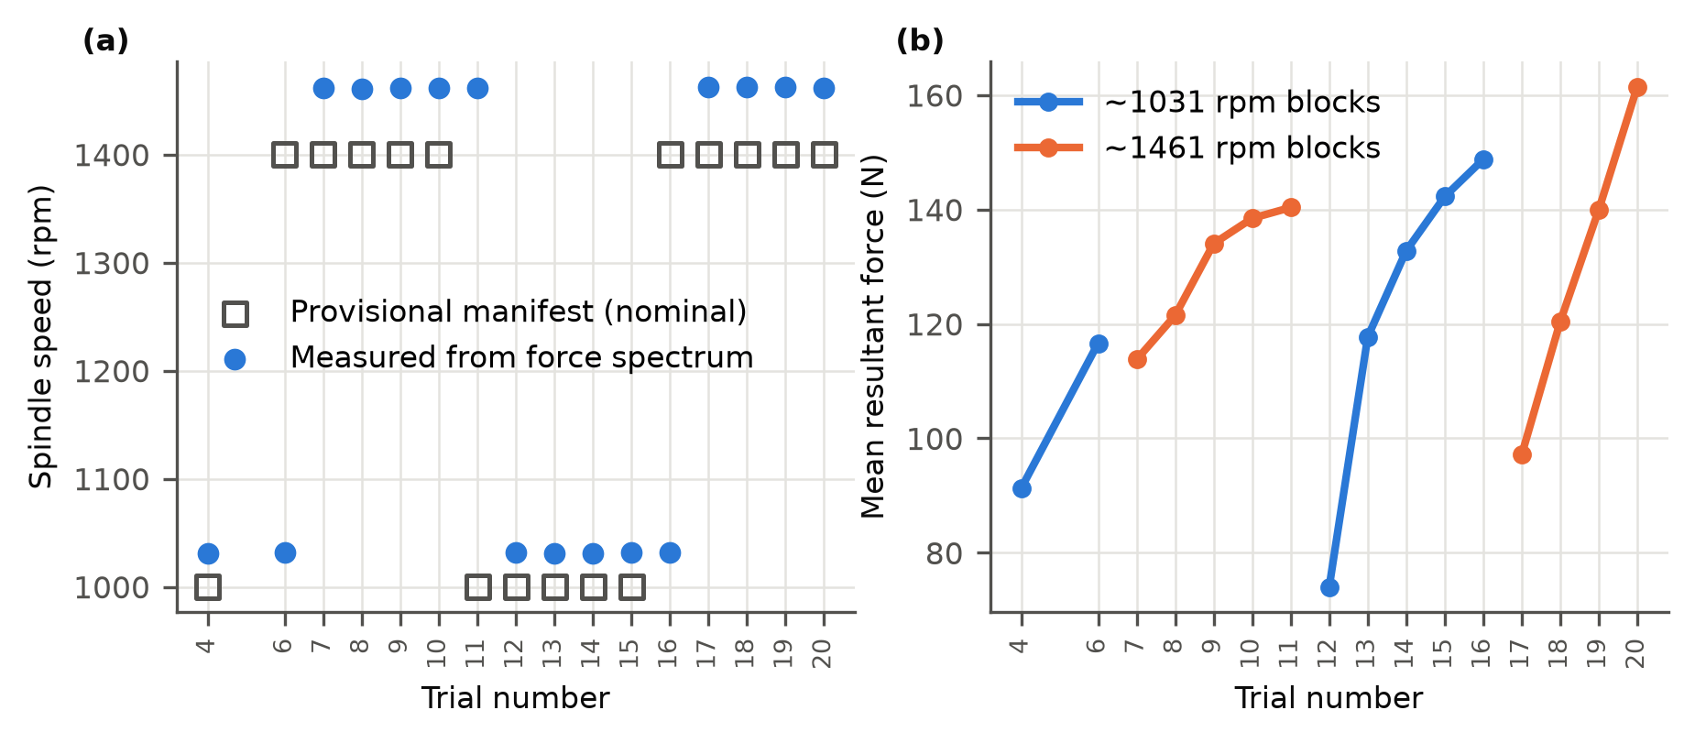
Figure 1. (a) Spindle speed per trial: provisional (nominal) value from the archive and value measured from the force spectrum with the harmonic comb (Eq. 1). (b) Mean resultant cutting force over the retained cut, connected within blocks of equal measured speed.

3.2. Labels Depend Strongly on the Prominence Threshold
Table 2. Zone labels at the three prominence thresholds (measured spindle frequency, ±2 Hz harmonic tolerance).
Threshold τ (dB) | Unstable zones | Trials with ≥1 unstable zone | Zones within ±2 dB of τ
15 | 25 / 48 | 12 | 24
20 | 1 / 48 | 1 | 12
25 | 0 / 48 | 0 | 1

At 15 dB, 25 of 48 zones were unstable, spread over 12 trials. At 20 dB only 1 zone remained, and at 25 dB none (Table 2, Figure 2). 24 of 48 zones lie within ±2 dB of the 15 dB threshold, so small changes in the threshold or in the spectral estimate flip many labels; at 15 dB the 'unstable' class even contains 0.52 of all zones, which is a high rate for chatter in finishing cuts. A classifier can only be trained and tested in LOTO when unstable zones occur in several trials, so the benchmark is reported at 15 dB. At 20 dB, the single unstable zone means that every fold has either no positive training zone or no positive test zone; the pooled AUC then rests on one zone and is not a meaningful estimate (Section 3.5). Using the nominal instead of the measured spindle frequency changed 11 labels at 15 dB, and narrowing the harmonic tolerance to 0.5 Hz changed 4 labels.
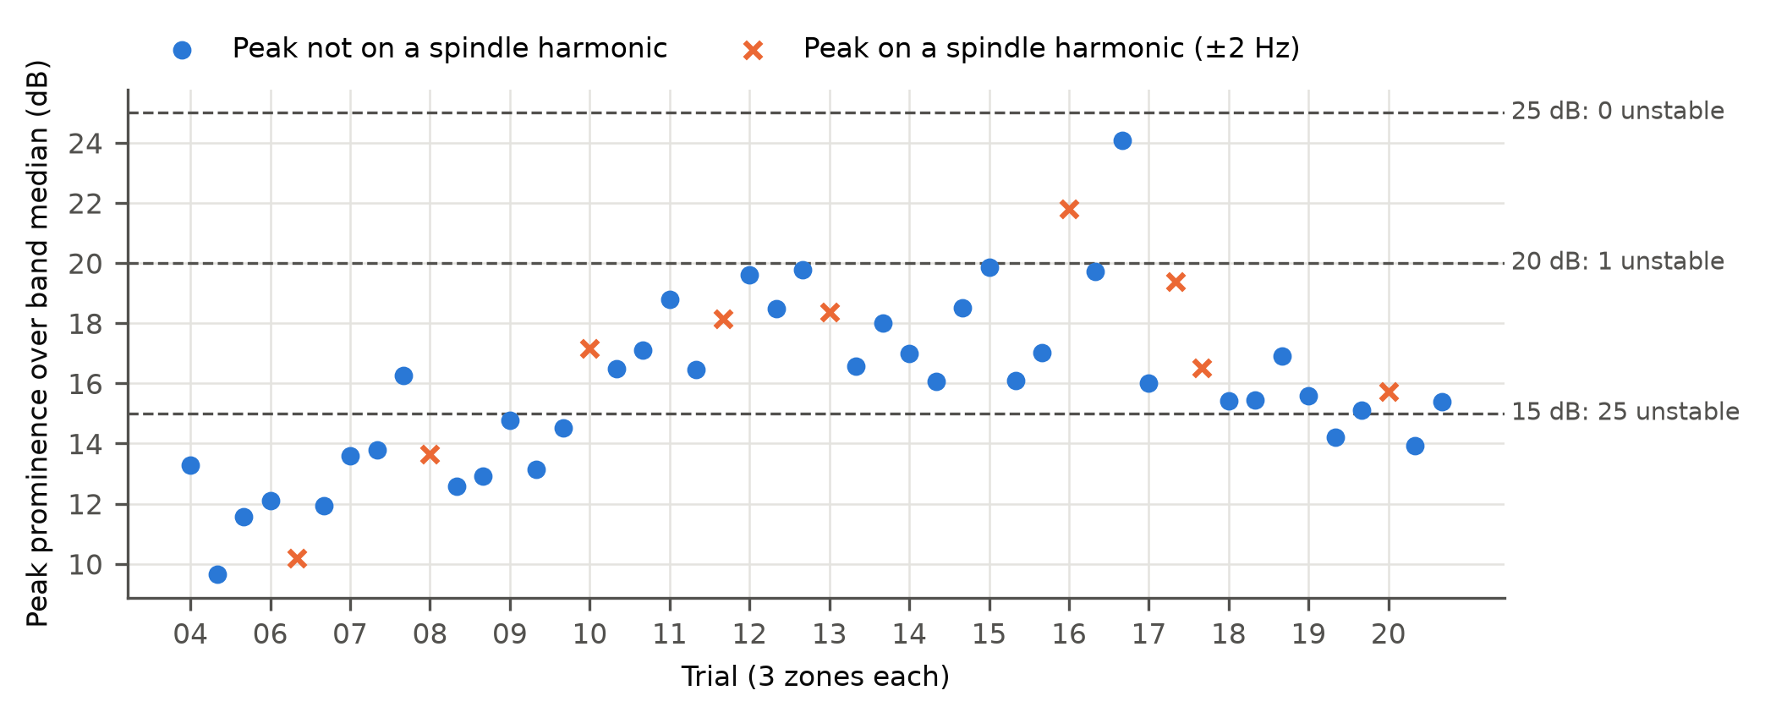
Figure 2. Prominence of the dominant chatter-band force peak over the band median for every zone, with the three thresholds. Crosses mark peaks within ±2 Hz of a spindle-rotation harmonic (forced, never labelled unstable).

3.3. Benchmark at 15 dB
Table 3. Leave-one-trial-out results at τ = 15 dB (25 unstable of 48 zones; prevalence 0.52). Pooled out-of-fold predictions, 5 seeds averaged.
Model | ROC-AUC (95% CI) | AP (95% CI) | F1 | Precision | Recall | Perm. p
Logistic regression | 0.69 (0.50–0.86) | 0.66 (0.48–0.91) | 0.67 | 0.70 | 0.64 | 0.027
Random forest | 0.74 (0.55–0.89) | 0.79 (0.60–0.92) | 0.65 | 0.67 | 0.64 | 0.002
SVM (RBF) | 0.65 (0.47–0.83) | 0.68 (0.55–0.88) | 0.69 | 0.71 | 0.68 | 0.079
1D-CNN | 0.44 (0.21–0.66) | 0.53 (0.31–0.76) | 0.58 | 0.49 | 0.72 | 0.479
BiLSTM | 0.73 (0.55–0.87) | 0.76 (0.55–0.91) | 0.70 | 0.76 | 0.64 | 0.007
Fusion MLP | 0.71 (0.50–0.89) | 0.68 (0.49–0.93) | 0.71 | 0.74 | 0.68 | 0.012
Small GNN | 0.72 (0.51–0.87) | 0.69 (0.52–0.89) | 0.68 | 0.68 | 0.68 | 0.008
ST-GCN | 0.70 (0.52–0.85) | 0.70 (0.50–0.91) | 0.68 | 0.68 | 0.68 | 0.014
ST-GAT | 0.69 (0.50–0.84) | 0.66 (0.47–0.90) | 0.65 | 0.63 | 0.68 | 0.031
CI: 2000 trial-bootstrap resamples. Permutation p: two-sided, 2000 zone-label permutations; the 95% null band of AUC is 0.34–0.67. F1, precision and recall at probability 0.5; Perm. p: permutation p-value.
The highest pooled AUC was obtained by the random forest, 0.74 (0.55–0.89), and the best deep model was the BiLSTM, 0.73 (0.55–0.87) (Table 3, Figure 3). The 95% permutation null band of AUC was 0.34–0.67. Of the 9 models, 7 scored above this band; SVM and 1D-CNN did not. The trial-bootstrap intervals are wide for every model and overlap almost completely. Average precision should be read against the prevalence of 0.52. The 1D-CNN, the only model without hand-crafted features, reached 0.44 (0.21–0.66), inside the null band.
Pooled AUC mixes two abilities: ranking whole trials and ranking zones within a trial. Only 8 trials contain both stable and unstable zones, each with 3 zones, so within-trial AUC is coarse. Averaged over those trials it was 0.81 for logistic regression and between 0.44 and 0.62 for all other models. Most of the pooled discrimination therefore comes from separating trials, not from locating unstable zones along a wall.
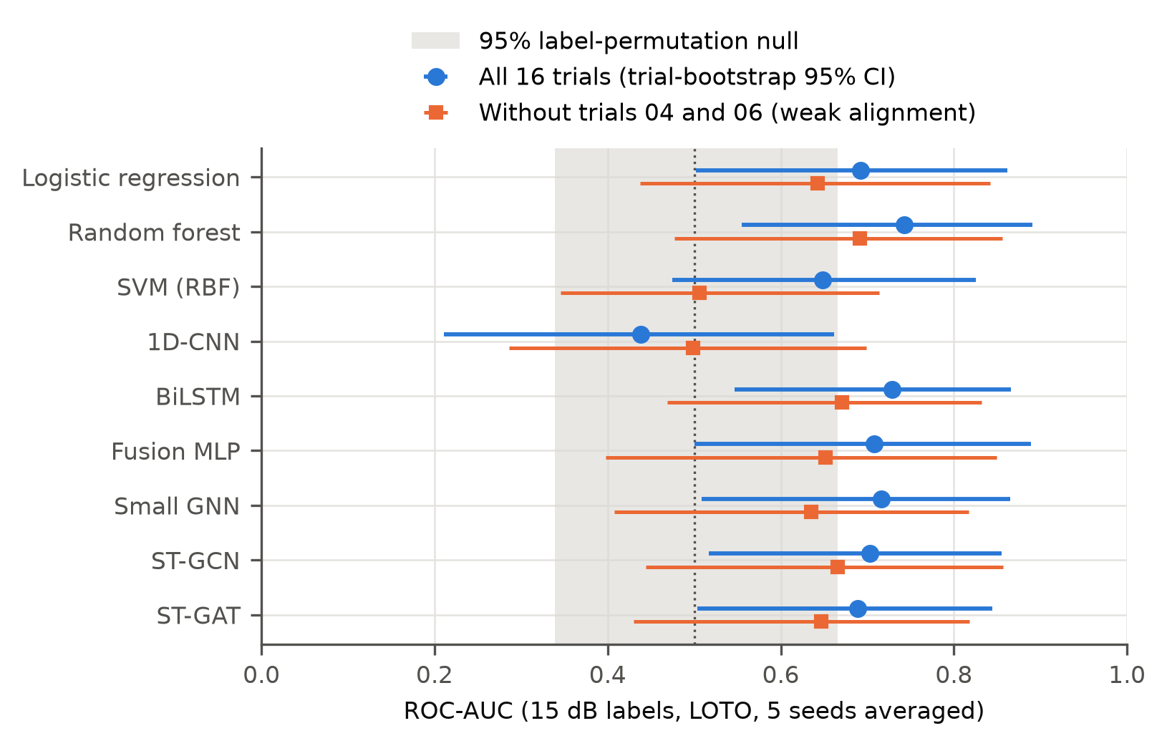
Figure 3. Pooled ROC-AUC at τ = 15 dB with trial-bootstrap 95% CIs, for all trials and without the two weakly aligned trials. The shaded band is the 95% label-permutation null.

3.4. Paired Comparisons and Ablations
Table 4. Trial-level paired comparisons at τ = 15 dB.
Comparison (A − B) | ΔAUC | 95% CI (trial bootstrap) | p (paired trial permutation)
Random forest − Logistic regression | 0.05 | −0.08 to 0.16 | 0.437
SVM (RBF) − Logistic regression | −0.04 | −0.21 to 0.10 | 0.596
1D-CNN − Logistic regression | −0.25 | −0.49 to −0.02 | 0.061
BiLSTM − Logistic regression | 0.04 | −0.10 to 0.13 | 0.614
Fusion MLP − Logistic regression | 0.02 | −0.08 to 0.10 | 0.765
Small GNN − Logistic regression | 0.02 | −0.08 to 0.11 | 0.642
ST-GCN − Logistic regression | 0.01 | −0.09 to 0.09 | 0.847
ST-GAT − Logistic regression | 0.00 | −0.10 to 0.05 | 0.950
ST-GAT − Fusion MLP | −0.02 | −0.08 to 0.04 | 0.519
ST-GCN − Fusion MLP | −0.01 | −0.07 to 0.06 | 0.884
Small GNN − Fusion MLP | 0.01 | −0.11 to 0.13 | 0.912
ST-GAT: full − no edges | 0.01 | −0.04 to 0.07 | 0.721
ST-GCN: full − no edges | 0.02 | −0.05 to 0.07 | 0.642
Small GNN: full − no edges | −0.01 | −0.09 to 0.07 | 0.866
ST-GAT: full − no force | 0.06 | −0.04 to 0.16 | 0.277
ST-GAT: full − no acceleration | −0.06 | −0.16 to 0.02 | 0.213
Logistic regression: full − no force | −0.02 | −0.08 to 0.06 | 0.570
Logistic regression: full − no acceleration | −0.08 | −0.19 to −0.01 | 0.071

No model differed from logistic regression at p < 0.05 (Table 4, Figure 4). Removing the graph edges did not produce a reliable change for any graph model (ST-GAT: ΔAUC = 0.01 (95% CI −0.04 to 0.07; p = 0.721); ST-GCN: ΔAUC = 0.02 (95% CI −0.05 to 0.07; p = 0.642); small GNN: ΔAUC = −0.01 (95% CI −0.09 to 0.07; p = 0.866)).
For the modality ablations, removing force from the ST-GAT gave ΔAUC = 0.06 (95% CI −0.04 to 0.16; p = 0.277) and removing acceleration gave ΔAUC = −0.06 (95% CI −0.16 to 0.02; p = 0.213). For logistic regression the corresponding values were ΔAUC = −0.02 (95% CI −0.08 to 0.06; p = 0.570) and ΔAUC = −0.08 (95% CI −0.19 to −0.01; p = 0.071). A positive ΔAUC means the full model was better.
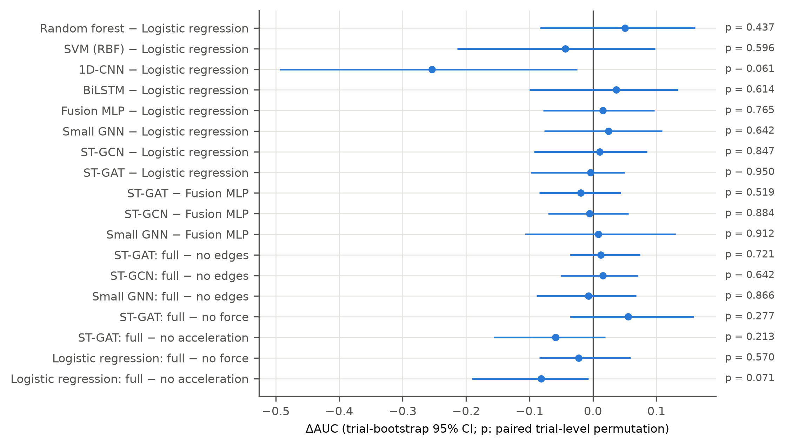
Figure 4. Trial-level paired differences in AUC (A − B) with trial-bootstrap 95% CIs; p-values from the paired trial-level permutation test.

3.5. Sensitivity Analyses and Training Behaviour
Without the two weakly aligned trials (04 and 06), the best AUC was 0.69 (0.48–0.86) (random forest); logistic regression gave 0.64 (0.44–0.84) and the ST-GAT 0.65 (0.43–0.82) (Figure 3). At τ = 20 dB the classical models, the BiLSTM and the small GNN were run for completeness. With one unstable zone, 1 fold had no positive training zone, and the pooled AUC (logistic regression 0.02) reflects only where that single zone was ranked; it is not an estimate of detection performance. At 25 dB no zone was unstable and no model could be evaluated.
The fixed epoch count was not tuned, and the deep models responded to it differently (Figure 5). At the last epoch the BiLSTM, fusion MLP, ST-GAT and ST-GCN had driven their mean training loss to 0.01–0.09 (from 0.65–0.68 after the first epoch), i.e., they fitted the training trials almost perfectly, while the 1D-CNN and small GNN remained at 0.36–0.50. Neither near-perfect fitting nor under-fitting translated into better held-out AUC than the linear model: the bottleneck is data, not optimisation.
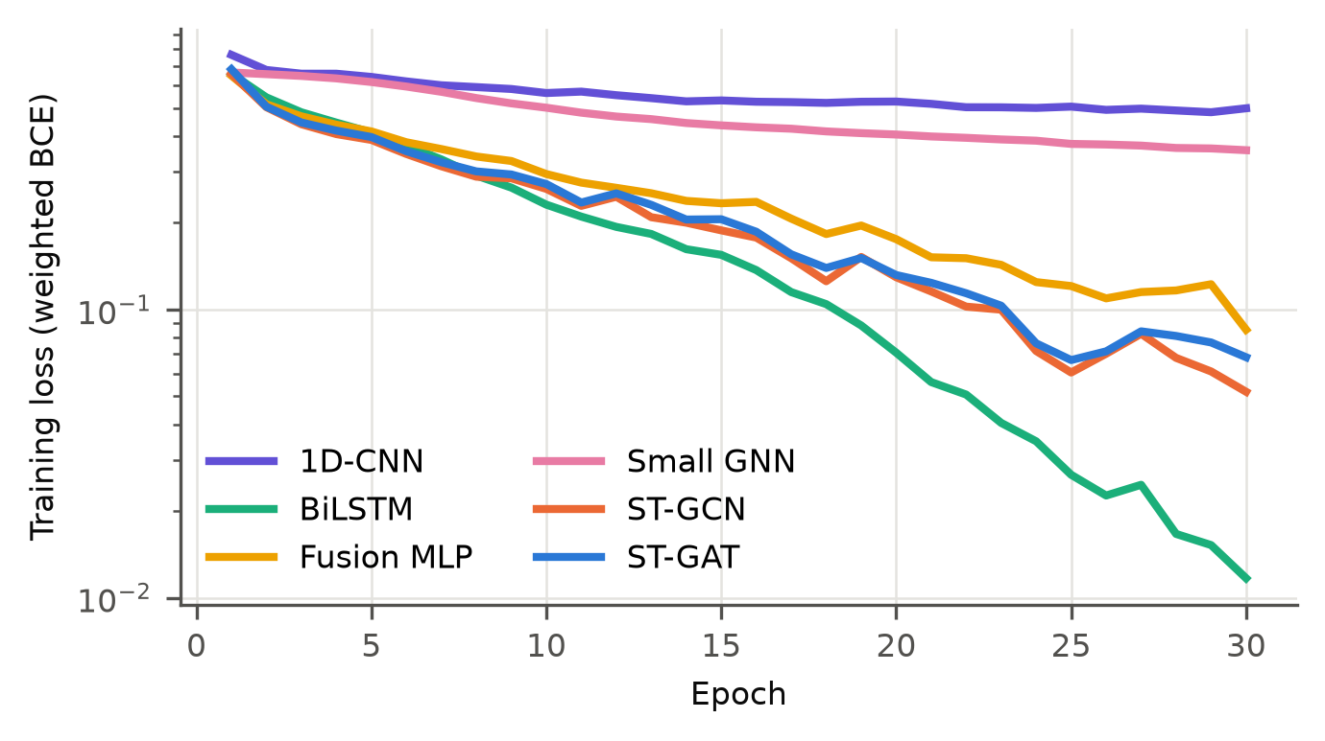
Figure 5. Mean training loss per epoch (all folds and seeds) of the deep models at τ = 15 dB.

4. Discussion
The main result is negative for model complexity and cautionary for labels. With 48 zones from 16 trials, every model that used the physics-based spectral features reached a pooled AUC between 0.65 and 0.74, and none differed from logistic regression in trial-level paired tests (the largest difference, for the random forest, was ΔAUC = 0.05 (95% CI −0.08 to 0.16; p = 0.437)). Deep and graph networks with up to 67881 parameters therefore added no measurable value over a linear model, whereas the raw-signal 1D-CNN without these features failed. The useful information sits in the hand-crafted spectral features, not in the architecture. Graph message passing between zones did not matter: the no-edge ablations were indistinguishable from the full graph models. With three zones per wall and one kinematic edge type, a graph is a weak inductive bias. The heat-kernel edges of an earlier version were constant across trials and were removed.
Two observations limit even this modest result. First, within-trial ranking was near chance for every model except logistic regression, so the models mostly separate trials rather than locate instability along a wall. Second, removing the two weakly aligned trials, which contain no unstable zone, lowered the pooled AUC of every feature-based model (Figure 3), consistent with part of the discrimination coming from easy-to-separate negative trials.
The labels are the larger problem. A fixed spectral rule is transparent and reproducible, but its output changed from 25 to 1 to 0 unstable zones as the threshold moved from 15 to 25 dB. Replacing the measured by the nominal spindle frequency changed 11 labels at 15 dB, so labels built on nominal speeds, as in the earlier pipeline, are partly arbitrary. Without an independent reference, such as chatter marks on the surface, zone roughness or expert-labelled signals, the reported AUC measures agreement with a rule, not detection of chatter. External validation of the rule on the public turning dataset [6], whose signals were labelled by inspection, is the most direct next check (Section 5).
For WAAM machining, the results argue against reading material differences into monitoring scores on data of this size. Porosity, magnesium loss and layer-wise reheating [1–3] are plausible reasons for zone-to-zone variation in cutting dynamics, and position-dependent wall stiffness adds to them. Testing these mechanisms requires confirmed material identity per trial, repeated walls per material and zone-resolved surface measurements. None of these is available here, and no conclusion about WAAM versus wrought behaviour is drawn.
Practically, dynamometers are rarely available on production machines. For logistic regression, force features alone gave an AUC of 0.77 (0.60–0.91) and acceleration features alone 0.71 (0.53–0.88), with overlapping intervals. Because the labels are themselves derived from the force spectrum, force features have an inherent advantage here. The accelerometer's model and mounting were not recorded, so the acceleration-only result cannot yet be generalised.

5. Limitations
- Material mapping unresolved. No trial with a force record has a confirmed material; the specimen grouping rests on timing, measured speed and file provenance. No material-specific result is reported.
- Label threshold sensitivity. Labels change strongly between 15, 20 and 25 dB; only 15 dB yields enough unstable zones for evaluation, and the rule has not been validated against an independent reference.
- Small sample. 16 trials and 48 zones; unstable zones are clustered in few trials, so confidence intervals are wide and per-fold AUC is mostly undefined.
- No zone roughness. Zone-level Ra was not measured, so no roughness model is fitted; specimen-mean Ra from [1] cannot serve as a zone target.
- Infrared not used. Thermal images were recorded in [1] but could not be calibrated (vendor format, emissivity and frame rate not recorded, no thermocouple reference, no link to trial numbers).
- Accelerometer metadata missing. Model, sensitivity and mounting position are unknown; two trials have weak force–acceleration alignment.
- Dynamometer dependence. Force-based features are not practical on production machines.
- External validation not yet run. The public turning dataset [6] was not available locally when this draft was prepared, so the planned check of the labelling rule against its published labels and the leave-one-overhang-out feature test were not run. The KIT milling dataset [7,8] contains a single chatter trial and was not used.
- Compute-driven settings. Window count per zone and epoch count were fixed by the compute budget before any model was evaluated; they were not tuned.

6. Conclusions
A leakage-free re-analysis of force and vibration records from thin-wall milling of WAAM and wrought Al–Mg walls showed that: (i) the archived trial-to-condition mapping was partly wrong, and the measured spindle speed and force level allow it to be reconstructed without assuming material; (ii) spectral chatter labels depend on the prominence threshold more than on any classifier; (iii) on this small dataset, simple models on physics-based spectral features perform as well as deep and graph networks, graph edges between zones add no measurable value, and a raw-signal CNN without these features fails; and (iv) most of the discrimination separates whole trials rather than locating unstable zones within a wall. Before stronger modelling claims can be made, the confirmed trial log, repeated walls, zone-level surface measurements and an externally validated labelling rule are needed.
Supplementary Materials: The planned material-specific analysis is omitted because no trial with a force record has a confirmed material (Section 3.1). Code, result tables (results/*.csv) and the audit are provided in the repository.
Author Contributions: [author to complete].
Funding: [author to complete].
Data Availability Statement: Processed results, code and audit files are available at [repository DOI – author to supply]. Raw force and vibration records are available from the authors on request. The public datasets referred to are the turning chatter dataset of Khasawneh, Otto and Yesilli (Mendeley Data, doi:10.17632/hvm4wh3jzx.1) [6] and the KIT multimodal CNC milling dataset (doi:10.35097/hvvwn1kfwf7qt48z) [8], described in [7]; neither was used in the analyses reported here.
Acknowledgments: During the preparation of this manuscript, the authors used Claude (Anthropic) to audit and rewrite the analysis code, run the analyses and draft the text from the computed results. The authors reviewed and edited the output and take full responsibility for the content of this publication.
Conflicts of Interest: The authors declare no conflicts of interest.

References
1. Sundaram, S.; Mohanavelu, T.; Arangot, S.; Petru, J.; Ruthramoorthy, M.; Rowther, R.S.; Senthilkumar, K. Comparative Evaluation of Mechanical Behaviour and Machinability of WAAM-Fabricated Aluminium Alloys. Materials 2026, 19, 2653. https://doi.org/10.3390/ma19122653
2. Wu, B.; Pan, Z.; Ding, D.; Cuiuri, D.; Li, H.; Xu, J.; Norrish, J. A review of the wire arc additive manufacturing of metals: properties, defects and quality improvement. J. Manuf. Process. 2018, 35, 127–139. https://doi.org/10.1016/j.jmapro.2018.08.001
3. Zhao, D.; Long, D.; Niu, T.; Zhang, T.; Hu, X.; Liu, Y. Effect of Mg Loss and Microstructure on Anisotropy of 5356 Wire Arc Additive Manufacturing. J. Mater. Eng. Perform. 2022, 31, 8473–8482. https://doi.org/10.1007/s11665-022-06802-8
4. Yesilli, M.C.; Khasawneh, F.A.; Otto, A. Chatter Detection in Turning Using Machine Learning and Similarity Measures of Time Series via Dynamic Time Warping. arXiv 2019, arXiv:1908.01678.
5. Yesilli, M.C.; Khasawneh, F.A.; Mann, B.P. Transfer Learning for Autonomous Chatter Detection in Machining. arXiv 2022, arXiv:2204.05400.
6. Khasawneh, F.; Otto, A.; Yesilli, M. Turning Dataset for Chatter Diagnosis Using Machine Learning. Mendeley Data, V1, 2019. https://doi.org/10.17632/hvm4wh3jzx.1
7. Ströbel, R.; Kuck, M.; Oexle, F.; Kader, H.; Puchta, A.; Noack, B.; Fleischer, J. A multimodal dataset for process monitoring and anomaly detection in industrial CNC milling. Data Brief 2025, 63, 112207. https://doi.org/10.1016/j.dib.2025.112207
8. Ströbel, R.; Kuck, M.; Oexle, F.; Kader, H.; Puchta, A.; Noack, B.; Fleischer, J. A Multimodal Dataset for Process Monitoring and Anomaly Detection in Industrial CNC Milling [Dataset]. Karlsruhe Institute of Technology, 2025. https://doi.org/10.35097/hvvwn1kfwf7qt48z
9. Kipf, T.N.; Welling, M. Semi-Supervised Classification with Graph Convolutional Networks. In Proceedings of the International Conference on Learning Representations (ICLR), 2017. arXiv:1609.02907.
10. Veličković, P.; Cucurull, G.; Casanova, A.; Romero, A.; Liò, P.; Bengio, Y. Graph Attention Networks. In Proceedings of the International Conference on Learning Representations (ICLR), 2018. arXiv:1710.10903.

