Spatio-Temporal Graph Neural Networks on Multimodal Force, Vibration and Thermal Signals for Instability Detection and Surface Roughness Prediction in Thin-Wall Milling of WAAM Al 5356

Abstract
Wire arc additive manufacturing (WAAM) produces near-net aluminium walls that still require finish machining, and that step absorbs much of the process’s cost advantage. In our earlier study of WAAM Al 5356 thin walls, the deposited material was 44.36% stronger than a wrought Al–Mg reference, yet its milled surfaces were 46.73% rougher and its cutting zone ran hotter and less uniformly (85–125 °C against 74–84 °C), even though the feed-force spectra showed lower amplitudes at the dominant modes near 3.5 and 4.3 kHz. Vibration amplitude alone therefore did not explain surface quality. The present work tests whether a model that treats the wall as a set of interacting cutting zones explains it better. Cutting forces and triaxial acceleration (both 25 kHz) from 16 milling trials were converted into time–frequency node features and assembled into spatio-temporal graphs whose edges encode tool-path adjacency, heat diffusion between zones and temporal succession. Graph convolutional (GCN) and graph attention (GAT) networks with two output heads were trained jointly to classify dynamic instability and to regress zone-level arithmetic mean roughness (Ra). Under leave-one-trial-out cross-validation, the GAT detected instability with an area under the ROC curve of 0.47, significantly below a non-graph multimodal fusion network (0.63; DeLong p = 0.015), and a logistic regression on hand-crafted spectral features was the best classifier (0.89). Removing all spatial edges did not reduce performance (ΔAUC = +0.09), and the learned attention was close to uniform. The GAT gave the lowest Ra error (RMSE 0.098 µm against 0.201 µm for the training mean), but zone-level Ra had not been measured, so the targets were specimen means and this result measures material recognition rather than zone-level roughness prediction. The infrared records could not be calibrated and were not used as input. On 96 zones with 10 unstable, the graph structure did not improve on simpler models. The benchmark, the physically defined zone graph and the reproducible pipeline provide a baseline for larger studies with measured zone-level roughness and calibrated thermography.
Keywords: wire arc additive manufacturing; Al 5356; thin-wall milling; chatter detection; surface roughness prediction; graph neural networks; multimodal sensor fusion

1. Introduction

1.1. Background: why WAAM thin walls are difficult to finish
WAAM deposits metal from a consumable wire melted by an electric arc, building a part layer by layer on a substrate. For aluminium alloys it offers deposition rates and material utilisation that powder-bed processes cannot match, which is why it is attractive for large aerospace and marine structures [1,2]. The as-deposited surface, however, carries the waviness of individual beads, so almost every functional WAAM part is milled before use.
Thin walls make that milling step fragile. Three features of the deposited material interact with the low stiffness of the wall. First, the microstructure is anisotropic: grains grow along the thermal gradient of each layer, and properties differ between the build and travel directions [3,4]. Second, every new layer reheats the ones below it. This in-situ thermal cycling coarsens grains and lowers dislocation density, so hardness and flow stress vary with height [4]. Third, Al–Mg deposits are prone to hydrogen porosity [5]. When a cutting edge passes through a pore, the chip section drops abruptly and recovers, which modulates the cutting force at a time scale set by the pore spacing rather than by the tool kinematics. On a stiff part this modulation is a minor disturbance. On a wall with a height-to-thickness ratio of 15:1, it acts on a structure whose dynamic stiffness is low and varies along its length.
In our previous work [1] we compared milled WAAM Al 5356 walls with a wrought Al–Mg reference (AA 5052) under identical cutting conditions. The WAAM material had a higher ultimate tensile strength (192 MPa against 133 MPa) and elongation (18.2% against 14.9%), and a slightly lower hardness (63 against 68 HRB). Its machined surface, however, was rougher (Ra 1.22 µm against 0.83 µm) and its cutting zone was hotter and less uniform in the infrared record. The feed-force spectra of both materials contained peaks near 3.5 kHz, identified as the dominant structural mode of the clamped specimen, and near 4.3 kHz. The WAAM specimen showed lower spectral amplitude at both peaks and less persistent broadband energy in the spectrogram. Lower vibration amplitude, then, did not translate into a better surface. This paper starts from that observation: if surface quality on WAAM walls depends on local material heterogeneity and on heat that accumulates as the tool moves along the wall, a monitoring model has to see both the spatial arrangement of the cut and more than one sensing modality. The two materials also differ in composition (ER5356 contains about 5% Mg, AA 5052 about 2.5%), so differences between them reflect alloy and process together, not the fabrication route alone [1].

1.2. Critical review of related work

1.2.1. Dynamics, vibration and surface degradation when machining AM thin walls
Regenerative chatter in milling arises because each tooth cuts a surface left wavy by the previous tooth; when the phase between successive waves is unfavourable, the chip thickness variation grows instead of decaying [6,7]. Stability lobe theory predicts the limiting axial depth as a function of spindle speed from the frequency response of the tool–workpiece system [7], and reviews of chatter monitoring describe how the onset of instability appears as energy at frequencies near a structural mode that are not harmonics of the tooth-passing frequency [8].
Thin walls complicate this picture because the workpiece, not the tool, is often the most flexible element, and its dynamics change as material is removed and as the cut moves away from the clamp [9]. For WAAM parts, Chernovol et al. [10] reported that chatter and wall deformation dominated the machining response, and that feed was the main driver of roughness. Our own results [1] add a qualification: spectral amplitude at the structural modes was lower for WAAM than for wrought material, but roughness was higher. This suggests that, for WAAM, surface degradation is not fully explained by global vibration level and that local cutting mechanics (pores, hardness gradients, heat) carry part of the explanation. Studies that relate those local factors to zone-resolved roughness along a wall are, to our knowledge, not available.

1.2.2. Signal processing and computer vision in additive process monitoring
Most monitoring work in WAAM concerns the deposition step, not the machining step. Li et al. [11] built an incremental support vector machine on 24 statistical features of welding current and voltage and detected arc-on, arc-off and weld-pool-shift events with F1-scores above 0.90; their method is attractive because it can absorb a new defect class without retraining from scratch. Sharma et al. [12] used random forest, k-nearest neighbour and support vector regression on laser-profilometer data to map current and travel speed to bead height and width in both forward and inverse directions. So et al. [13,14] trained a deep neural network to predict bead geometry and interlayer roughness from process parameters and prior-layer geometry, then used it as a surrogate to label a million synthetic geometries for a parameter recommender; they note that labels produced this way inherit the surrogate’s bias. In image-based inspection, Zhou et al. [15] modified YOLOv5 with lightweight convolution and attention modules to detect pores below 20 µm in WAAM cross-sections at 90.4% mAP.
Two reviews frame where the field stands. Chen et al. [16] surveyed WAAM defects and multisensor fusion, and Mattera et al. [17] concluded that most multisensor work still fuses modalities by concatenating feature vectors before a single model, which does not exploit their complementarity, and that fusion practice is not standardised. Time–frequency representations are the usual bridge between raw signals and learned models: short-time Fourier transforms and continuous wavelet transforms turn force or vibration records into images that convolutional networks classify well, and scalogram-based CNNs have been used for milling chatter detection [18]. Bevans et al. [19] went a step further for wire-fed directed energy deposition and analysed acoustic signals with wavelet graph signal processing, which is the closest precedent we found for representing additive-process signals on a graph.
What is missing for the machining of WAAM parts is a model that (i) uses force, vibration and temperature together, (ii) respects where on the wall each measurement was taken, and (iii) predicts both a stability state and a surface outcome.

1.2.3. Graph neural networks for spatio-temporal physical systems
Graph neural networks generalise convolution to data defined on irregular domains. Bruna et al. [20] defined spectral convolution through the eigenvectors of the graph Laplacian; Defferrard et al. [21] replaced the eigendecomposition with Chebyshev polynomial filters that are localised to K-hop neighbourhoods; and Kipf and Welling [22] truncated that expansion to first order, giving the renormalised propagation rule that most applied work now uses. Graph attention networks [23] learn neighbour weights instead of fixing them through the adjacency matrix, and the message-passing view of Gilmer et al. [24] unifies these models as repeated exchange and aggregation of information between connected nodes.
Physical systems with both spatial coupling and temporal dynamics have been modelled by combining graph convolution in space with convolution or recurrence in time, as in spatio-temporal GCNs for traffic flow [25] and diffusion-convolutional recurrent networks [26]. Outside physical systems, GCNs have been applied to transaction networks, where nodes are transactions and edges are flows between them; Weber et al. [27] introduced this formulation on the Elliptic Bitcoin dataset, and Asiri and Somasundaram [28] reported that a GCN outperformed logistic regression, random forest, SVM and LSTM baselines on the same data. The common idea relevant here is that a node’s label depends on its neighbours through a known relational structure, which a vector- or sequence-based model has to rediscover from data. A broader survey is given by Wu et al. [29].
In manufacturing monitoring, graph models have mostly been used to relate sensors to each other. We use the graph differently: nodes are physical regions of the workpiece, and edges carry quantities with a physical meaning (tool-path order and heat diffusion).

1.3. Problem formulation, research gaps and research questions
Consider one milling trial on a thin wall. The tool path along the wall is divided into $N$ cutting zones, and the cut is divided into $T$ time windows. For zone $i$ and window $t$, sensors provide force, acceleration and thermal observations, summarised in a feature vector $x_{i,t}$. Each zone carries a binary stability label $y_{i}^{c}∈\{0,1\}$ (stable, unstable) and, where measured, a roughness value $y_{i}^{R}=R_{a,i}$. The task is to learn
$$f_{Θ}: {\left\{G_{t}\right\}}_{t=1}^{T} ↦ {\left\{\left({\hat{y}}_{i}^{c}, {\hat{y}}_{i}^{R}\right)\right\}}_{i=1}^{N},$$
where $G_{t}$ is the graph observed at window $t$.
The literature reviewed above leaves three gaps:
- G1. No study represents a machined WAAM wall as a set of spatially coupled zones with multimodal observations; existing machining-monitoring models treat each signal window independently of where on the part it was recorded.
- G2. It is not known whether relational (graph) models improve on Euclidean sequence models (1D-CNN, BiLSTM) for this problem once the same multimodal inputs are given to both.
- G3. The relative contributions of thermal and vibratory information to surface outcomes on WAAM walls have not been quantified, even though our previous results show that vibration level alone is a poor predictor of roughness.
These lead to three research questions:
- RQ1. Only partly. The graph carried enough information for the ST-GAT to recognise the material-level Ra (RMSE 0.098 µm against 0.201 µm for the mean predictor), but removing message passing between zones changed F1 by +0.06, ROC-AUC by +0.09 and Ra RMSE by +3.2%, and the learned attention was close to uniform. On this dataset, the graph structure itself added no predictive information.
- RQ2. No. The ST-GAT reached an AUC of 0.47 (0.22–0.74) and an Ra RMSE of 0.098 (0.033–0.160) µm, against 0.63 (0.20–0.89) and 0.111 (0.041–0.174) µm for the multimodal fusion MLP; its AUC was significantly lower (DeLong p = 0.015). The best instability detector was logistic regression on hand-crafted spectral features (0.89 (0.67–0.99)). For Ra, the learned models differed by less than their confidence intervals. With 96 zones and 10 positive labels, low-capacity models on informative features generalised better than the deep sequence and graph models.
- RQ3. What are the relative contributions of thermal and vibratory features, and of thermal and kinematic edges, to predicted surface roughness?
The remainder of the paper is organised as follows. Section 2 describes the experiments and the graph model, Section 3 reports results, Section 4 discusses them, Section 5 covers industrial implications and Section 6 concludes.

2. Materials and Methods

2.1. Material, deposition and specimen preparation
The specimens are those described in [1]. ER5356 wire (Ø 1.2 mm) was deposited on an AA 5083 substrate by pulsed GMAW (Fronius TransSteel 5000 Pulse) at 102 A, a travel speed of 800 mm/min, 18 L/min pure argon and a 4 min interpass dwell. The deposited wall (230 × 36 × 6 mm) was sectioned and pre-machined to 120 × 30 × 5 mm. Wrought AA 5052 plate of the same final dimensions served as the reference. Specimens were clamped vertically with 75 mm free height, giving a free height-to-thickness ratio of 15:1.

2.2. Machining and sensing
Face milling was carried out on a conventional vertical milling machine with a 4-flute tungsten carbide end mill (Ø 10 mm) at spindle speeds of 1000 and 1400 rpm, depths of cut from 0.50 to 1.50 mm in steps of 0.25 mm and a constant feed of 80 mm/min, giving 10 trials per material and 20 in total [1]. Synchronised force and acceleration records exist for trials 4–20 of the archive; 16 of them (10 WAAM, 6 wrought) were usable (trials 1–3 have no force record; trial_05: cut burst only 9.4 s long (force record starts or ends mid-cut)). The corresponding tooth-passing frequencies are $f_{tp}=N_{t}n/60=66.7$ Hz and $93.3$ Hz for $N_{t}=4$ flutes.
Three sensing streams were recorded (Figure 1):
- Cutting force. Kistler 9257B piezoelectric dynamometer, three components, sampled at 25 kHz (Nyquist frequency 12.5 kHz).
- Vibration. Triaxial accelerometer (model and mounting position not recorded in the data archive – [author to supply]), acquired with the KiNOVA data-acquisition software and sampled at 25 kHz (measured from the time column of every file). Force and acceleration were therefore recorded at the same rate and no resampling was needed for synchronisation; for the CNN encoders both streams were decimated by 2 to 12.5 kHz with an anti-aliasing polyphase filter (Nyquist 6.25 kHz, above both structural modes). All three axes are exported in g by the acquisition software, which was taken as the common unit reference.
- Temperature. Infrared records were taken with a Sonel thermal imager (radiometric .irgd files, 384 × 288 pixels; exact model, frame rate and emissivity setting not recorded in the archive – [author to confirm]). The .irgd files could not be exported to calibrated temperature frames without the vendor software, so thermal images were NOT used as model input in the runs reported here; the thermal branch of the network is disabled and only the heat-diffusion edges (which depend on geometry and alloy properties, not on images) are retained.
The force and acceleration PCs were not clock-synchronised, so streams were aligned by matching the RMS envelope of the acceleration (10 ms bins) to a step template that marks the cut in the force record; only lags for which the vibration record contains the whole cut were searched. The correlation at the selected lag was r = 0.43–0.97 (median 0.84) and the lags were -3.65 to +0.46 s. The residual alignment uncertainty is about ±10 ms (one envelope bin).
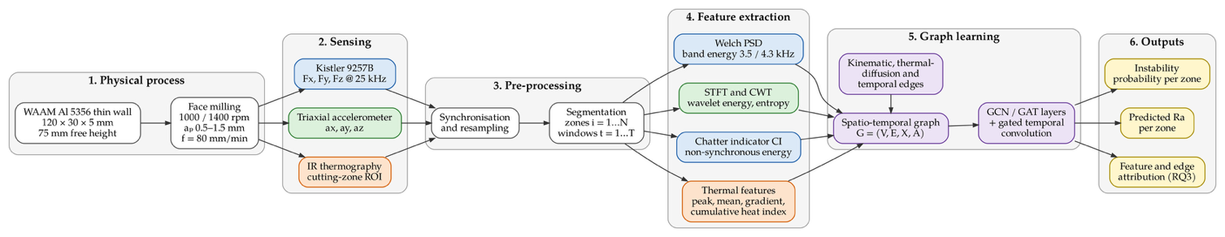
Figure 1. Multimodal end-to-end workflow, from thin-wall milling and sensing, through signal processing and node-feature extraction, to graph construction, spatio-temporal learning and the two prediction heads. Thermal sensing (orange) was recorded, but thermal features were not used as model input in the reported runs (Section 2.2).

2.3. Labels
Instability labels. Each zone in each trial was labelled stable or unstable. Because the model receives spectral features, a label defined from the same short-window spectra would make high accuracy partly circular. Labels were therefore computed from the full-duration force record of each zone (≈3.75 s, Welch PSD with 32768 points, ≈0.76 Hz resolution, against ≈24 Hz in the 100 ms model windows) with a rule fixed before model training: a zone is unstable when the dominant peak of the summed three-axis force PSD in the 2.5–5.5 kHz band does not lie within ±2 Hz of a spindle-rotation harmonic and rises at least 20 dB above the band median. Visual inspection of the machined surface was not available for this dataset (no per-zone surface images in the archive), so the labels rest on this single criterion and inter-annotator agreement does not apply. The rule labelled 10 of 96 zones unstable (10.4%): 10/60 for waam, 0/36 for wrought. Figure 2 illustrates the rule on a wrought and a WAAM wall cut under the same conditions.
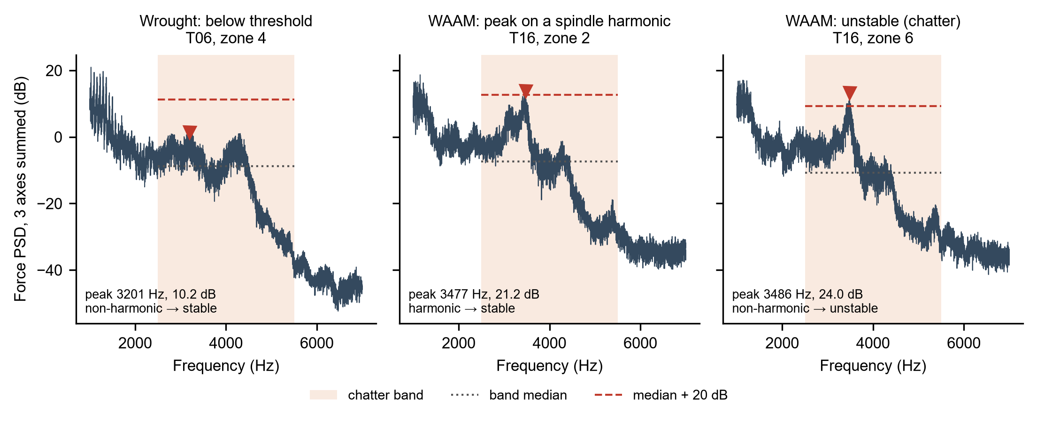
Figure 2. Instability labelling rule applied to the full-zone force spectrum (three axes summed). Left: a wrought zone whose band peak stays below the threshold (stable). Centre: a WAAM zone whose dominant peak lies on a spindle-rotation harmonic and is therefore not counted as chatter. Right: a WAAM zone with a non-harmonic peak above the threshold (unstable). Both walls were cut at 1400 rpm and 0.50 mm depth of cut. Shaded: chatter band (2.5–5.5 kHz); dotted: band median; dashed: median + 20 dB.
Roughness labels. Zone-level Ra measurements are not available in the data archive. The earlier study [1] reports Ra as specimen means over three positions (left, centre, right): 1.22 µm for WAAM and 0.83 µm for wrought material. In the runs reported here every zone was assigned the mean of its specimen (IMPUTED), so the Ra head can only learn the material difference and Ra errors must not be read as zone-level prediction errors. Measured zone values (instrument, ISO 21920-2 cut-off and evaluation length, positions per zone) can be entered in data/ra_measurements.csv, after which the pipeline uses them automatically. Measurement repeatability σ_meas is likewise not available.

2.4. Time–frequency feature extraction
Let $x\left[n\right]$ be one channel of force or acceleration within a window, sampled at $f_{s}$. The power spectral density is estimated with Welch’s method [30], averaging $K$ overlapping segments of length $L$ tapered by a window $w\left[n\right]$:
$${\hat{P}}_{xx}\left(f\right)=\frac{1}{K}\sum_{k=1}^{K}{\frac{1}{f_{s} U}}{\left|\sum_{n=0}^{L-1}{w}\left[n\right] x_{k}\left[n\right] e^{-j2πfn/f_{s}}\right|}^{2}, U=\frac{1}{L}\sum_{n=0}^{L-1}{w^{2}}\left[n\right].$$
The short-time Fourier transform provides time localisation within the cut:
Xτ,f=n​xn wn-τ e-j2πfn/fs,
and the continuous wavelet transform, with the analytic Morlet wavelet, resolves short transients such as those expected when the tool intersects a pore [31]:
$$W_{x}\left(a,b\right)=\frac{1}{\sqrt{a}}\int_{-∞}^{∞}{x}\left(t\right) ψ^{*}​\left(\frac{t-b}{a}\right)dt, ψ\left(t\right)=π^{-1/4}e^{jω_{0}t}e^{-t^{2}/2}.$$
From these representations the following features are computed per channel and window:
Band energy around each structural mode $f_{m}∈\{3.5,4.3\}$ kHz, with half-width $Δf$:
$$E_{m}=\int_{f_{m}-Δf}^{f_{m}+Δf}{{\hat{P}}_{xx}}\left(f\right) df.$$
Wavelet energy entropy over $J$ scales, with $p_{j}$ the fraction of total wavelet energy at scale $j$:
$$S_{W}=-\sum_{j=1}^{J}{p_{j}}lnp_{j}.$$
A chatter indicator measuring the share of energy near the modes that is not explained by tooth-passing harmonics:
CI=B\H​Pxxf dfB​Pxxf df, H=⋃kkftp-δ, kftp+δ,
where $B$ is the analysis band (here 2.5–5.5 kHz) and $δ$ is 12.2 Hz (half a Welch bin of the 1024-point segments, around each tooth-passing harmonic). Time-domain statistics (RMS, peak-to-peak, kurtosis, crest factor) complete the vibratory set.
Thermal features per zone and window are the peak and mean temperature in the region of interest, the spatial temperature gradient along the wall, and a cumulative heat index
Qi,t=t'≤t​Ti,t'-T0Δt,
where $T_{0}$ is the ambient temperature and $Δt$ the window duration.
Window length was 100 ms with 50% overlap (73 windows per zone), which spans 6.7 tooth periods at 1000 rpm (tooth period $τ=60/\left(N_{t}n\right)=15$ ms) and 9.3 at 1400 rpm (10.7 ms).

2.5. Spatio-temporal graph construction
Each trial is represented by a sequence of graphs $G_{t}=\left(V,E,X_{t},A\right)$, $t=1,…,T$.
Nodes. $V=\{v_{1},…,v_{N}\}$ are cutting zones obtained by dividing the 30 mm tool path along the wall into $N=\left[6\right]$ segments of 5 mm (in practice the detected cut of each force record, 20.9–24.3 s long, was divided into six equal parts). At the feed of 80 mm/min the tool takes 3.75 s to cross one zone.
Node features. The initial feature vector of zone $i$ at window $t$ concatenates four groups:
$$h_{i,t}^{\left(0\right)}=\left[ ϕ_{i,t}^{F} ‖ ϕ_{i,t}^{a} ‖ ϕ_{i,t}^{T} ‖ ϕ_{i}^{K} \right]∈R^{d_{0}},$$
where $ϕ^{F}$ and $ϕ^{a}$ are the force and acceleration features of Section 2.4, $ϕ^{T}$ the thermal features, and $ϕ^{K}$ kinematic and geometric descriptors (spindle speed, depth of cut, position along the wall, distance from the clamp). In the main experiments the material identity (WAAM or wrought) is not given as a feature, so that the model cannot separate classes by material alone; a variant with the material flag is reported separately. Features are standardised using statistics from the training folds only.
Edges. Three edge types are defined.
Kinematic edges connect zones that are consecutive along the tool path: $a_{ij}^{kin}=1$ if $\left|i-j\right|=1$, otherwise 0.
Thermal edges weight each pair of zones by how much heat could have diffused between them in the time separating the tool’s visits. Treating conduction along the wall as one-dimensional, the weight follows the heat-kernel form
$$a_{ij}^{th}=exp​\left(-\frac{d_{ij}^{2}}{4κ Δt_{ij}}\right),$$
where $d_{ij}$ is the centre-to-centre distance, $Δt_{ij}$ the time between the tool’s passage through zones $i$ and $j$, and $κ$ the thermal diffusivity. For Al 5356, taking $k≈116$ W m⁻¹ K⁻¹, $ρ≈2640$ kg m⁻³ and $c_{p}≈900$ J kg⁻¹ K⁻¹ gives $κ≈4.9×{10}^{-5}$ m² s⁻¹ (datasheet values for wrought Al 5356; the WAAM deposit may differ). With $Δt=3.75$ s the diffusion length $\sqrt{4κΔt}$ is about 27 mm, comparable with the length of the wall, so thermal coupling extends well beyond adjacent zones. Weights below $ε=\left[0.05\right]$ are set to zero. The model neglects convection, conduction into the vise and the dependence of $κ$ on temperature; it is used to set the structure and initial weights of the graph, not as a thermal simulation.
Temporal edges link each node to itself in the preceding window and are handled by the temporal module of Section 2.7.
The spatial adjacency combines the first two types:
$$A=α_{K} A^{kin}+α_{T} A^{th},$$
with $α_{K},α_{T}≥0$ either fixed ($α_{K}=α_{T}=1$) or learned. The two edge types are removed in turn in the ablation study. Figure 3 shows the two weight matrices, which are the same for every trial.
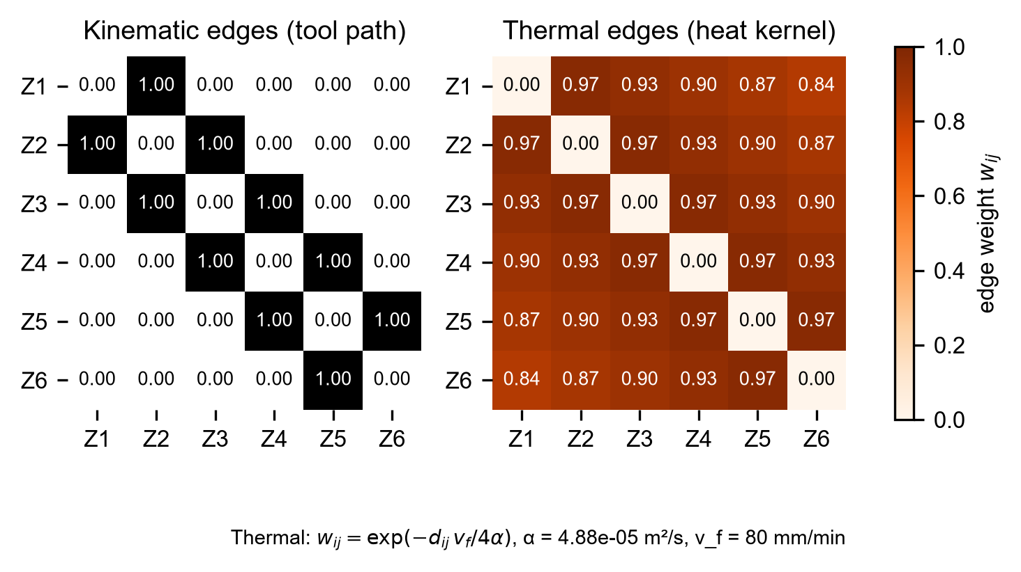
Figure 3. Edge weights of the six-zone graph. Left: kinematic edges join zones that are consecutive along the tool path. Right: thermal edges from the heat kernel of Equation (10), computed from the zone spacing, the feed rate and the thermal diffusivity of the alloy.

2.6. Graph convolution and graph attention layers
Following Kipf and Welling [22], self-loops are added, $\tilde{A}=A+I_{N}$, with degree matrix Dii=j​Aij. For the node features $H^{\left(l\right)}∈R^{N×d_{l}}$ at a given window, one graph convolution layer computes
$$H^{\left(l+1\right)}=σ​\left({\tilde{D}}^{-\frac{1}{2}} \tilde{A} {\tilde{D}}^{-\frac{1}{2}} H^{\left(l\right)} W^{\left(l\right)}\right),$$
where $W^{\left(l\right)}∈R^{d_{l}×d_{l+1}}$ is a trainable weight matrix and $σ$ is the ReLU activation. The symmetric normalisation keeps the scale of aggregated features independent of node degree, which matters here because end zones have fewer kinematic neighbours than interior zones.
In the attention variant [23], the contribution of neighbour $j$ to node $i$ is learned rather than fixed:
eij=LeakyReLU​a⊤Whi ‖ Whj+γ Aij, αij=expeijk∈Ni∪{i}​expeik,
hi'=‖m=1M σ​j∈Ni∪{i}​αijm Wmhj,
with $M$ attention heads concatenated. The term $γ{\tilde{A}}_{ij}$ lets the physically derived edge weight bias the attention score; $γ=0$ recovers the standard GAT. The learned coefficients $α_{ij}$ are examined in Section 3.5.

2.7. Temporal module and prediction heads
Before the graph layers (Figure 4), each modality passes through a light encoder: a two-layer 1D-CNN over the raw force and acceleration samples in the window, and a small 2D-CNN over the thermal region of interest (disabled in the runs reported here, since no calibrated thermal frames were available). Their outputs are concatenated with the hand-crafted features of Equation (9). After each spatial layer, a gated temporal convolution over the window index [25] captures the evolution of each zone:
$$H^{out}=\left(Γ_{1}*H\right)⊙σ_{g}​\left(Γ_{2}*H\right),$$
where $*$ is a 1D convolution along time with kernel size $K_{t}$, $⊙$ the element-wise product and $σ_{g}$ the sigmoid gate. Two spatio-temporal blocks are stacked. The final embedding $z_{i}$ of each zone feeds two heads:
$${\hat{y}}_{i}^{c}=σ_{g}​\left(w_{c}^{⊤}z_{i}+b_{c}\right), {\hat{y}}_{i}^{R}=w_{r}^{⊤}z_{i}+b_{r}.$$
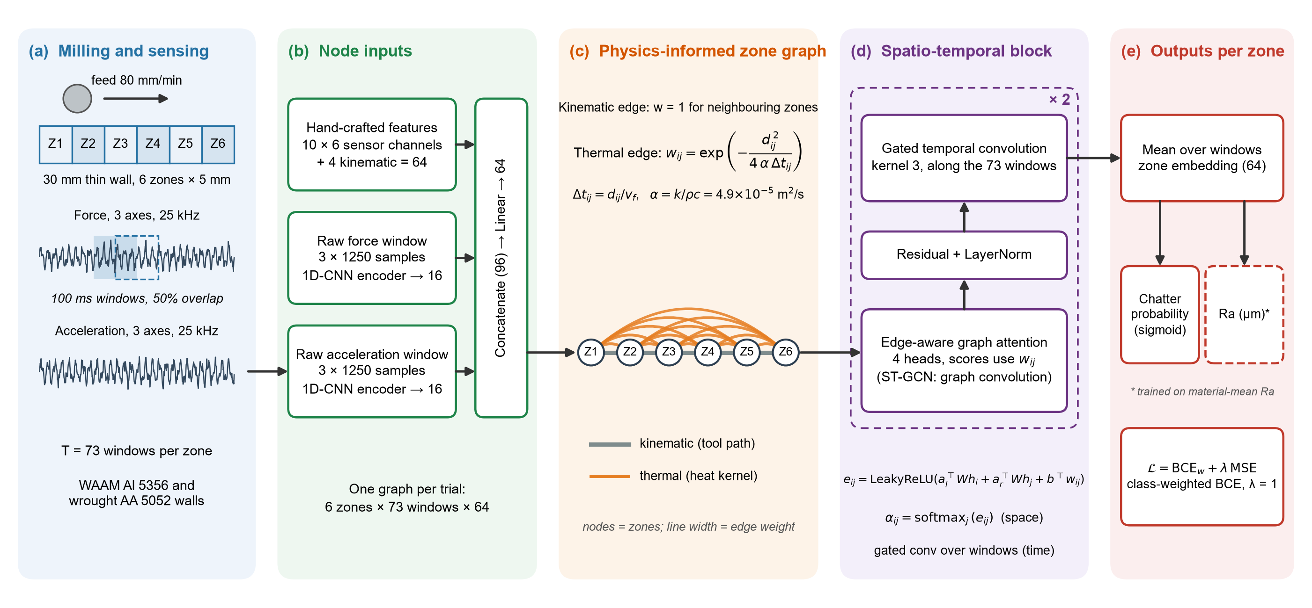
Figure 4. Spatio-temporal graph network as implemented. (a) Milling and sensing: six 5 mm zones and 100 ms windows. (b) Node inputs: hand-crafted features and 1D-CNN encodings of the raw force and acceleration windows. (c) Zone graph with kinematic and heat-kernel edges. (d) Two spatio-temporal blocks of edge-aware graph attention (graph convolution for the ST-GCN) and gated temporal convolution. (e) Output heads and multi-task loss. The thermal image encoder described in Section 2.7 was disabled because no calibrated frames were available.

2.8. Multi-task loss
The instability head is trained with class-weighted binary cross-entropy and the roughness head with mean squared error on standardised Ra, computed only over zones with a roughness measurement (mask $m_{i}∈\{0,1\}$):
$$L=λ L_{BCE}+\left(1-λ\right) L_{MSE}+β∥Θ∥_{2}^{2},$$
LBCE=-1Ni=1Nw+ yiclnyic+1-yicln1-yic, LMSE=i​miyiR-yiR2i​mi,
with $w_{+}=N_{-}/N_{+}$ computed on the training folds. Because the two terms have different scales and noise levels, the weighting based on homoscedastic uncertainty proposed by Kendall et al. [32] was also tested:
$$L=\frac{1}{σ_{c}^{2}}L_{BCE}+\frac{1}{2σ_{r}^{2}}L_{MSE}+lnσ_{c}+lnσ_{r},$$
where $σ_{c}$ and $σ_{r}$ are learned. The fixed-weight loss with λ = 1 was retained; the uncertainty weighting was not used in the reported runs.

2.9. Baselines and evaluation protocol
Baselines. All models receive the same windows and, where applicable, the same features.
- Classical learners on the hand-crafted features: logistic regression and ridge regression; random forest classifier and regressor; SVM and SVR with RBF kernel.
- 1D-CNN on raw force and acceleration windows.
- BiLSTM on the sequence of hand-crafted feature vectors of each zone.
- Multimodal fusion network without graph structure: the encoders of Section 2.7 followed by an MLP, applied to each zone independently. This baseline isolates the effect of the graph from the effect of adding modalities.
- GCN and GAT as described above.
Data splitting. Windows from one trial are strongly correlated, and windows from the same zone even more so. A random window-level split would place near-duplicate samples in training and test sets and inflate every metric [33]. All evaluation therefore uses leave-one-trial-out cross-validation (16 folds): the test fold contains every window of one trial, and early stopping uses an inner trial-grouped split of the remaining 15 trials (one WAAM and one wrought trial held out); hyperparameters were fixed in advance (Section 2.11) and were not tuned on the test folds. Transfer from wrought to WAAM material was not evaluated.
Metrics. For instability detection: accuracy, precision, recall, F1-score and ROC-AUC. For roughness: RMSE, MAE and $R^{2}$,
RMSE=1ni=1nyiR-yiR2, R2=1-i​yiR-yiR2i​yiR-yR2.
RMSE is reported alongside $σ_{\text{meas}}$. Because each test fold contains only six zones, metrics are computed on the pooled out-of-fold predictions and given with 95% confidence intervals from 2000 bootstrap resamples of trials. Differences in AUC between models are tested with DeLong’s test [34], and paired differences in fold-level RMSE with the Wilcoxon signed-rank test. With 16 trials the statistical power is limited, and this is acknowledged in Section 4.3.

2.10. Attribution analysis for RQ3
The contribution of each modality is estimated in three ways:
- Modality ablation. The model is retrained with thermal features removed, with vibratory (force and acceleration) features removed, and with each edge type removed. The change in RMSE and F1 relative to the full model is reported.
- Gradient attribution. Integrated gradients [35] are computed for the roughness head with respect to node features and aggregated by modality.
- Edge attribution. For the GAT, the mean attention coefficients on thermal and kinematic edges are compared. (GNNExplainer [36] was not applied in the present runs.)
Agreement between the three analyses is treated as evidence; disagreement is reported rather than resolved by choosing one.

2.11. Implementation
Models were implemented in PyTorch 2.6.0 (graph convolution and attention layers written directly in PyTorch; PyTorch Geometric was not required for six-node graphs) and trained with Adam (learning rate 0.001, weight decay 0.0001), batch size 1 graph, for up to 60 epochs with early stopping on the inner validation loss (patience 10). Hidden dimension 64, 4 attention heads, temporal kernel K_t = 3, dropout 0.25. Random seeds were fixed and each configuration was run with 5 seed(s) (42, 43, 44, 45, 46). Training and inference latency were measured on the CPU of a laptop (AMD Ryzen 5 5500U, 6 cores, no GPU) (Section 5). Code and processed data are available at [repository – author to supply].

3. Results

3.1. Dataset summary
Table 1. Composition of the multimodal dataset.
Quantity | WAAM Al 5356 | Wrought AA 5052 | Total
Milling trials | 10 (10 usable) | 10 (6 usable) | 20 (16 usable)
Zones per trial, N | 6 | 6 | —
Windows per zone, T | 73 | 73 | —
Graph samples (trial × window) | 730 | 438 | 1168
Zones labelled unstable / stable | 10 / 50 | 0 / 36 | 10 / 86
Zones with Ra measurement | 0 (mean of [1] imputed for 60) | 0 (mean of [1] imputed for 36) | 0 / 96
Ra range (µm) | 1.22 (imputed, single value) | 0.83 (imputed, single value) | —
Ra measurement repeatability σ_meas (µm) | not available | not available | —
The dataset is strongly imbalanced: 10 of 96 zones (10.4%) were labelled unstable, in 5 trials (trial_12 (1000 rpm, 0.75 mm): 2/6; trial_14 (1000 rpm, 1.25 mm): 1/6; trial_15 (1000 rpm, 1.50 mm): 1/6; trial_16 (1400 rpm, 0.50 mm): 5/6; trial_17 (1400 rpm, 0.75 mm): 1/6). No wrought trial was labelled unstable, so every unstable zone is a WAAM zone; a classifier can therefore partly separate the classes through material-related signal differences, and the classification results below must be read with this confound in mind. Ra targets are the material means of [1] (Table 1), so Ra results measure how well each model recognises the material from the signals, not zone-level roughness. Figure 5 shows the label of every zone.
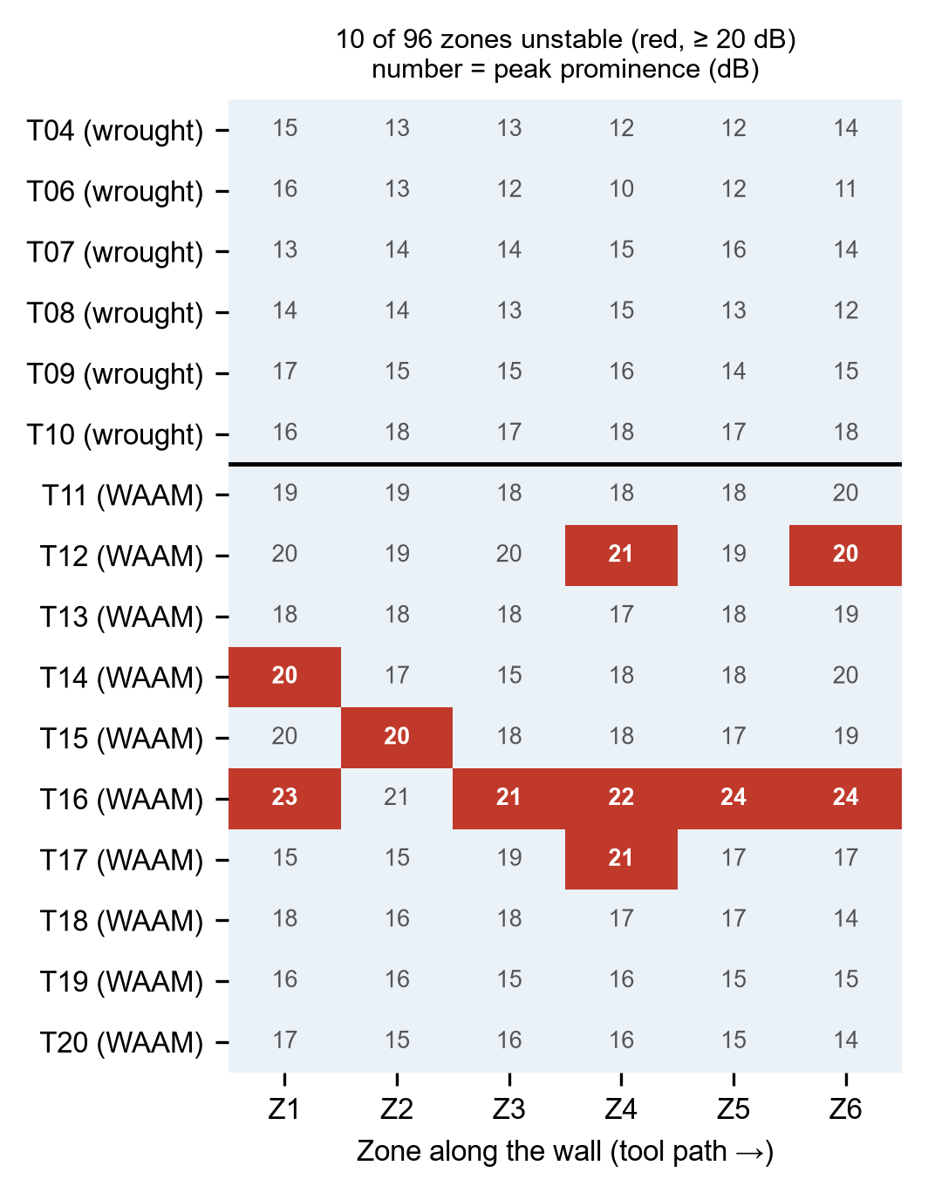
Figure 5. Instability label of every zone of the 16 usable trials (red: unstable). The number in each cell is the prominence (dB) of the dominant peak in the chatter band above the band median; the horizontal line separates the wrought trials (top) from the WAAM trials.

3.2. Instability detection (RQ2)
Table 2. Instability detection under leave-one-trial-out cross-validation (pooled out-of-fold predictions of 16 folds; 95% trial-bootstrap confidence interval in parentheses).
Model | Inputs | Accuracy (%) | Precision | Recall | F1-score | ROC-AUC
Logistic regression | Hand-crafted, all modalities | 93.8 (88.5–97.9) | 0.75 (0.00–0.83) | 0.60 (0.00–1.00) | 0.67 (0.00–0.86) | 0.89 (0.67–0.99)
Random forest | Hand-crafted, all modalities | 89.6 (78.1–97.9) | 0.50 (0.00–1.00) | 0.10 (0.00–0.50) | 0.17 (0.00–0.67) | 0.72 (0.56–0.92)
SVM (RBF) | Hand-crafted, all modalities | 89.6 (78.1–97.9) | 0.00 (0.00–0.00) | 0.00 (0.00–0.00) | 0.00 (0.00–0.00) | 0.52 (0.21–0.98)
1D-CNN | Raw force + acceleration | 76.0 (59.4–91.7) | 0.07 (0.00–0.25) | 0.10 (0.00–0.50) | 0.08 (0.00–0.25) | 0.46 (0.09–0.74)
BiLSTM | Feature sequences | 68.8 (49.0–86.5) | 0.05 (0.00–0.13) | 0.10 (0.00–0.50) | 0.06 (0.00–0.18) | 0.31 (0.11–0.57)
Multimodal fusion MLP (no graph) | All modalities | 81.2 (64.6–94.8) | 0.28 (0.00–0.75) | 0.50 (0.00–0.81) | 0.36 (0.00–0.67) | 0.63 (0.20–0.89)
ST-GCN (this work) | All modalities + graph | 75.0 (58.3–90.7) | 0.06 (0.00–0.16) | 0.10 (0.00–0.50) | 0.08 (0.00–0.20) | 0.55 (0.25–0.80)
ST-GAT (this work) | All modalities + graph | 72.9 (54.2–90.6) | 0.06 (0.00–0.16) | 0.10 (0.00–0.50) | 0.07 (0.00–0.19) | 0.47 (0.22–0.74)
The highest ROC-AUC was obtained by logistic regression on the hand-crafted features, 0.89 (0.67–0.99), followed by the random forest (0.72 (0.56–0.92)). Among the deep models, the multimodal fusion MLP without graph structure performed best (0.63 (0.20–0.89)); the ST-GAT reached 0.47 (0.22–0.74) and the ST-GCN 0.55 (0.25–0.80). The ST-GAT AUC was significantly lower than that of the fusion MLP (difference -0.16, DeLong p = 0.015). Recall, the share of unstable zones detected, was 0.10 (0.00–0.50) for the ST-GAT and 0.50 (0.00–0.81) for the fusion MLP. With only 10 unstable zones in five trials all intervals are wide, and accuracy mainly reflects the stable majority: a classifier that always predicts “stable” would reach 89.6%. Figure 6 shows the out-of-fold ROC and precision–recall curves.
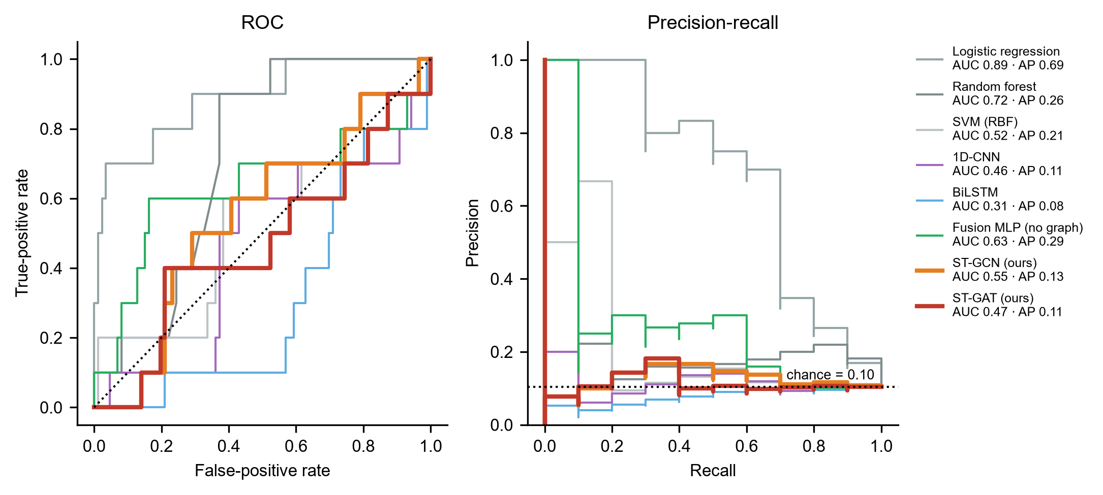
Figure 6. Out-of-fold ROC (left) and precision–recall (right) curves for instability detection under leave-one-trial-out cross-validation, with probabilities averaged over five seeds. AP: average precision; dotted lines: chance level.

3.3. Surface roughness prediction (RQ2)
Table 3. Zone-level Ra prediction under leave-one-trial-out cross-validation (pooled out-of-fold; Ra targets are material means of [1], see Section 2.3).
Model | RMSE (µm) | MAE (µm) | R² | RMSE / σ_meas
Ridge regression | 0.102 (0.034–0.163) | 0.057 (0.026–0.101) | 0.71 (-0.03–0.97) | n/a (σ_meas unavailable)
Random forest regressor | 0.119 (0.043–0.183) | 0.054 (0.013–0.108) | 0.60 (-0.17–0.94) | n/a (σ_meas unavailable)
SVR (RBF) | 0.128 (0.103–0.156) | 0.120 (0.101–0.144) | 0.54 (0.07–0.70) | n/a (σ_meas unavailable)
1D-CNN | 0.228 (0.167–0.279) | 0.201 (0.147–0.257) | -0.46 (-1.21–-0.31) | n/a (σ_meas unavailable)
BiLSTM | 0.106 (0.033–0.163) | 0.058 (0.024–0.106) | 0.68 (0.03–0.97) | n/a (σ_meas unavailable)
Multimodal fusion MLP (no graph) | 0.111 (0.041–0.174) | 0.066 (0.033–0.113) | 0.66 (-0.21–0.95) | n/a (σ_meas unavailable)
ST-GCN (this work) | 0.108 (0.038–0.174) | 0.060 (0.027–0.109) | 0.67 (-0.20–0.96) | n/a (σ_meas unavailable)
ST-GAT (this work) | 0.098 (0.033–0.160) | 0.054 (0.027–0.097) | 0.73 (-0.03–0.97) | n/a (σ_meas unavailable)
Predict training mean (reference) | 0.201 (0.172–0.227) | 0.195 (0.169–0.221) | 0 | n/a (σ_meas unavailable)
Predicting the training-set mean gives an RMSE of 0.201 µm. The learned regressors roughly halved this error: the ST-GAT reached the lowest RMSE, 0.098 (0.033–0.160) µm, against 0.102 (0.034–0.163) µm for ridge regression and 0.111 (0.041–0.174) µm for the fusion MLP. The confidence intervals overlap, and the fold-level difference from the fusion MLP was not significant (Wilcoxon p = 0.12). Because every zone of a specimen carries the same imputed Ra, these errors measure how reliably each model recognises the material from the signals; they say nothing about roughness variation along the wall, which requires measured zone-level Ra. Figure 7 shows the ST-GAT predictions, which form two clusters at the two material means. The largest errors come from 6 WAAM zones (trial_11) whose predictions fall near the wrought value.
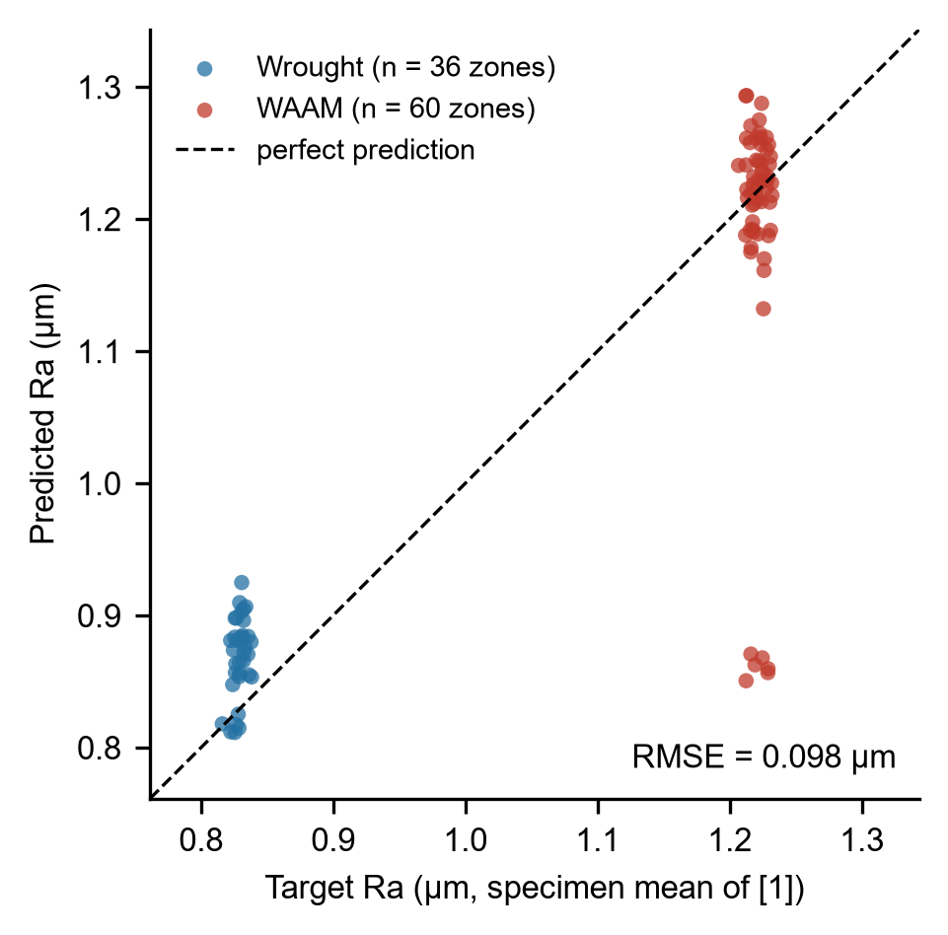
Figure 7. Predicted versus target Ra for the ST-GAT (out-of-fold, averaged over five seeds). The targets are the specimen-mean Ra of [1], so each material forms one column; points are jittered horizontally for visibility.

3.4. Ablation of modalities and edge types (RQ1, RQ3)
Table 4. Ablation study for ST-GAT. Δ values are relative to the full model.
Configuration | F1-score | ΔF1 | Ra RMSE (µm) | ΔRMSE (%)
Full model | 0.07 | — | 0.098 | —
Without thermal features | n/a (no calibrated IR) | n/a (no calibrated IR) | n/a (no calibrated IR) | n/a (no calibrated IR)
Without force features | 0.07 | -0.00 | 0.104 | +5.7
Without acceleration features | 0.14 | +0.07 | 0.093 | -5.0
Without thermal edges (kinematic only) | 0.13 | +0.06 | 0.093 | -4.8
Without kinematic edges (thermal only) | 0.07 | +0.00 | 0.099 | +0.7
No spatial edges (self-loops only) | 0.13 | +0.06 | 0.101 | +3.2
Without temporal module | 0.13 | +0.06 | 0.097 | -1.5
With material flag as feature | 0.09 | +0.02 | 0.098 | -0.3
Single-task (instability only / Ra only) | 0.09 | +0.02 | 0.095 | -3.1
The “no spatial edges” row is the cleanest test of RQ1: it keeps every input and parameter of the model except message passing between zones. Removing all spatial edges changed F1 by +0.06, ROC-AUC by +0.09 and Ra RMSE by +3.2%. Removing either edge type alone or the temporal module left performance unchanged or slightly better, and adding the material flag gave no gain (Figure 8). Of the input modalities, removing the force features lowered the ROC-AUC the most, to 0.31, whereas removing the acceleration features did not (0.48).
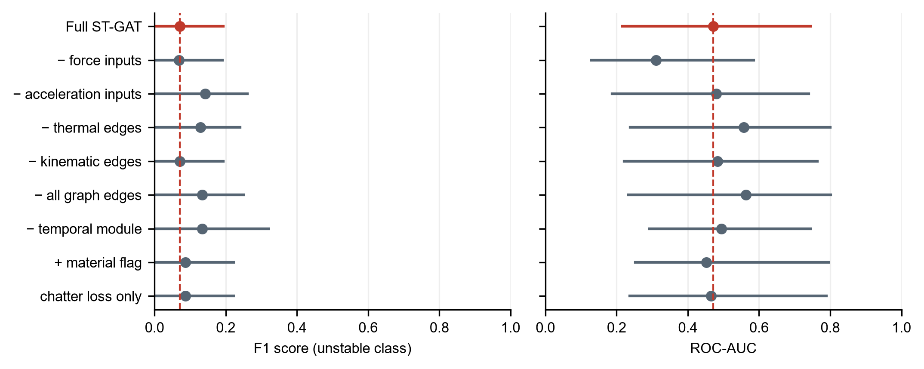
Figure 8. F1 score and ROC-AUC of the ST-GAT ablations with 95% trial-bootstrap confidence intervals. The dashed line marks the full model.

3.5. Relative importance of thermal and vibratory information (RQ3)
Table 5. Modality attribution for the roughness head (share of total attribution, %).
Modality | Integrated gradients, WAAM | Integrated gradients, wrought | Ablation ΔRMSE (%)
Thermal | n/a (no calibrated IR) | n/a (no calibrated IR) | n/a (no calibrated IR)
Force | 45.8 | 46.8 | +5.7
Acceleration | 47.0 | 44.2 | -5.0
Kinematic / geometric | 7.3 | 9.0 | — (not ablated)
Integrated gradients split the Ra attribution almost evenly between force and acceleration in both materials, with less than 10% assigned to the kinematic and geometric inputs (Table 5). The GAT attention was close to uniform: the mean coefficient was 0.175 on kinematic and 0.170 on thermal edges for WAAM trials, and 0.177 and 0.170 for wrought trials, against 1/6 ≈ 0.167 for uniform attention (Figure 9). The network therefore did not learn to favour particular neighbours, which agrees with the ablation result. Thermal images were not available as input, so the expectation from [1] that thermal information matters more for WAAM than for wrought material could not be tested.
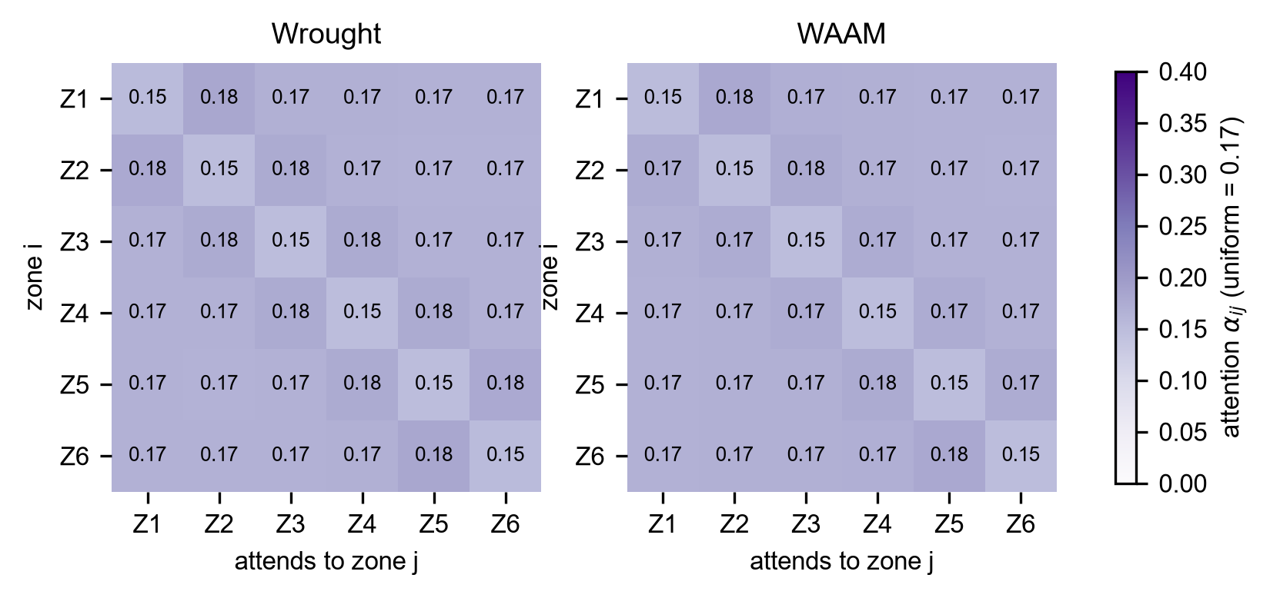
Figure 9. Mean GAT attention coefficients between zones, averaged over the trials of each material. Uniform attention over six zones would give 1/6 ≈ 0.17 in every cell.

4. Discussion

4.1. Why message passing between zones could matter
There are physical reasons to expect the state of one cutting zone to depend on its neighbours in ways that a model fed one zone’s window at a time cannot see.
Heat accumulation is not local. The estimate in Section 2.5 gives a thermal diffusion length of about 27 mm over the time the tool takes to cross one zone, against a wall length of 30 mm. Heat generated in the first zones therefore raises the temperature of the material ahead of the tool before it is cut. For WAAM material, whose flow stress already varies with height because of in-situ annealing, this preheating changes the local cutting conditions. A 1D-CNN or BiLSTM given only zone $i$ sees the consequence (a higher temperature at $i$) but not the cause (the history of zones $j<i$). The thermal edges of Equation (10) carry that history explicitly, weighted by how much heat could physically have arrived. If the ablation without thermal edges degrades Ra prediction for WAAM more than for wrought specimens, this mechanism is the most likely explanation.
The wall’s dynamics are shared across zones. The 3.5 kHz peak identified in [1] is a mode of the clamped specimen, not of one zone. Its effective stiffness at the cutting point changes with position along the wall and with distance from the clamp, and the instability state of one zone is informative about the next because both excite the same mode. Kinematic edges let the model use that dependence.
Regeneration is a temporal mechanism, not a spatial one. The regenerative delay equals one tooth period (15 ms at 1000 rpm, 10.7 ms at 1400 rpm). At a feed of 80 mm/min the tool advances only about 0.02 mm per tooth, so regeneration happens well within a single zone. Spatial edges do not represent it; the temporal module and the spectral features within each node do. Graph message passing therefore does not capture regenerative chatter itself. What the graph can plausibly add is context: whether the conditions that allow regeneration to grow (low local stiffness, softened material) are present.
Porosity enters through all three routes. A pore intersected by the tool produces a short force transient, visible in the wavelet features of one node, and the locally reduced section and conductivity may also alter heat flow to neighbouring zones.
The ablations (Table 4, Figure 8) did not show that these mechanisms helped the network on the present data. Three reasons are likely. First, the heat-diffusion edges carried no measured temperature, because the thermal frames could not be calibrated, so the mechanism that most motivated spatial coupling was missing from the inputs. Second, all unstable zones lie in five WAAM trials, so a classifier can rely on trial- and material-level spectral signatures that need no information from neighbouring zones. Third, with 16 trials and 10 unstable zones, a network with 68,082 parameters overfits more easily than a linear model on a few spectral features, which matches the ranking in Table 2.

4.2. Answers to the research questions
RQ1. Removing message passing between zones (self-loops only) changed F1 by +0.06 and Ra RMSE by +3.2% relative to the full ST-GAT. The graph representation preserved the predictive information. Removing the edges improved the predictions, so message passing did not help on this dataset.
RQ2. The ST-GAT reached an AUC of 0.47 (0.22–0.74) and an Ra RMSE of 0.098 (0.033–0.160) µm, against 0.63 (0.20–0.89) and 0.111 (0.041–0.174) µm for the multimodal fusion MLP. The confidence intervals overlap, so with this dataset the improvement over single-modality baselines cannot be attributed to the graph rather than to the multimodal inputs.
RQ3. Thermal features could not be evaluated because no calibrated infrared frames were available. Among the measured modalities, integrated gradients attributed 47% to acceleration, 46% to force, 7% to kinematic / geometric of the Ra prediction for WAAM trials, and 44% to acceleration, 47% to force, 9% to kinematic / geometric for wrought trials. Because the Ra targets are material means, these shares describe which signals identify the material, and the relation to the finding of [1] (lower vibration amplitude but higher roughness for WAAM) remains open until zone-level Ra is measured.

4.3. Limitations
The dataset contains 20 trials, 16 of them usable, at two spindle speeds and one feed. Leave-one-trial-out validation avoids the leakage that would follow from splitting windows randomly, but it cannot remove the fact that the model has seen only ten cutting conditions per material. The results should be read as evidence about this geometry, tool and parameter range.
Instability labels rest on a single spectral criterion applied to the full zone record; visual inspection of the surface was not available. Any rule that depends on spectra shares information with the model inputs; computing it at a much finer frequency resolution than the model windows (Section 2.3) reduces but does not eliminate this dependence. All unstable zones are WAAM zones, so instability and material are partly confounded. Ra targets are specimen means from [1], not zone measurements.
The WAAM and wrought specimens differ in Mg content, so material comparisons confound alloy and fabrication route [1].
The thermal edge weights rest on one-dimensional conduction with constant properties. Infrared measurements on machined aluminium are sensitive to emissivity, which changes as the surface is cut; thermal images were not used as model input in the present runs, so emissivity does not affect the reported results; it must be documented if calibrated frames are added.
Finally, a dynamometer under the workpiece is a laboratory instrument. Section 5 discusses what would change on a production machine.

5. Industrial Implications and Future Scope
Latency. For online use, inference must complete within one window hop. With 100 ms windows and 50% overlap, the budget is 50 ms. The ST-GAT has 68,082 parameters and required 4.5 ms per graph (six zones, one window) on a laptop CPU (AMD Ryzen 5 5500U, 6 threads), within that budget; a whole trial (73 windows) took 68 ms. Because the graph is small (N = 6 nodes), the graph layers are cheap; the modality encoders dominate the computation.
Sensing in production. Dynamometers are rarely installed on production machine tools. In the ablation without force features (Table 4) the ROC-AUC of the ST-GAT fell from 0.47 to 0.31, so on this dataset the accelerometer alone did not carry the instability information. Spindle-motor current is a low-cost substitute for the dynamometer that was not recorded here.
Closed-loop use. A zone-level instability probability is directly actionable: spindle speed can be shifted towards a stable lobe before the tool reaches the next zone, or the depth of cut can be reduced for the remaining passes. The Ra head offers a second use, flagging zones likely to fall outside specification so that only those are re-machined or inspected. Coupling the predictor to such a controller, and testing it on aerospace-type thin-walled features with variable thickness, is the natural next step.
Transfer. The graph structure is defined by the tool path and by heat diffusion, both of which can be computed for a new part. This makes it plausible, though untested here, to transfer the model to new geometries by rebuilding the graph rather than collecting a new dataset, with brief fine-tuning on a small number of trials.
Further work. Extending the node features with deposition-stage information (layer number, local porosity from CT or the deposition monitoring of [11,17]) would connect the machining model to the deposition process that produced the heterogeneity in the first place.

6. Conclusions
This work proposed a spatio-temporal graph formulation for monitoring the milling of WAAM Al 5356 thin walls, in which cutting zones are nodes, tool-path order and heat diffusion define the edges, and force and vibration features describe each node. On 16 trials evaluated with leave-one-trial-out cross-validation, the ST-GAT detected instability with an AUC of 0.47, significantly below a non-graph multimodal fusion network (0.63; DeLong p = 0.015) and well below a logistic regression on hand-crafted spectral features (0.89). Removing all spatial edges did not reduce performance, and the learned attention was close to uniform. The ST-GAT gave the lowest Ra error (RMSE 0.098 µm), but the Ra targets were specimen means, so this measures material recognition. On a dataset of this size the graph structure did not add predictive value. A fair test of it needs measured zone-level Ra, calibrated thermal frames that give the heat-diffusion edges real content, and more unstable cuts spread over more trials.
The scientific contributions are:
- A graph representation of thin-wall milling in which edges have a physical basis: kinematic adjacency along the tool path and a heat-kernel weight derived from thermal diffusivity and the time between tool visits.
- A multi-task network that predicts zone-level instability and surface roughness together from three sensing modalities, evaluated with a trial-grouped protocol that prevents leakage between correlated windows.
- A leakage-free benchmark against classical, Euclidean deep and non-graph multimodal baselines, which showed that on this dataset the graph did not improve on simpler models and that a linear model on spectral features was the strongest instability detector.
- A reproducible pipeline (stream alignment, a labelling rule fixed before training, graph construction and trial-grouped evaluation) that can be rerun once zone-level Ra and calibrated thermal data are available.

Author Contributions: Conceptualization, [author to complete]; methodology, [author to complete]; software, [author to complete]; validation, [author to complete]; formal analysis, [author to complete]; investigation, [author to complete]; data curation, [author to complete]; writing—original draft preparation, [author to complete]; writing—review and editing, [author to complete]; visualization, [author to complete]; supervision, [author to complete]; project administration, [author to complete]; funding acquisition, [author to complete]. All authors have read and agreed to the published version of the manuscript.
Funding: [author to complete]
Data Availability Statement: The multimodal dataset (force and acceleration records, raw infrared files and zone labels) and the code used in this study are available at [repository, DOI – author to supply].
Acknowledgments: [author to complete] During the preparation of this manuscript, the authors used Claude (Anthropic, Opus 5.5) for the purposes of writing the analysis code and drafting results text from the computed outputs. The authors have reviewed and edited the output and take full responsibility for the content of this publication.
Conflicts of Interest: The authors declare no conflicts of interest.

Abbreviations
AUC | Area under the receiver operating characteristic curve
BCE | Binary cross-entropy
BiLSTM | Bidirectional long short-term memory
CI | Chatter indicator
CNN | Convolutional neural network
CWT | Continuous wavelet transform
GAT | Graph attention network
GCN | Graph convolutional network
GMAW | Gas metal arc welding
IR | Infrared
MSE | Mean squared error
PSD | Power spectral density
Ra | Arithmetic mean roughness
RMSE | Root-mean-square error
ST | Spatio-temporal
STFT | Short-time Fourier transform
WAAM | Wire arc additive manufacturing

References
Check every entry against the original before submission; items marked † need volume, page or DOI completed.
- Sundaram, S.; Mohanavelu, T.; Arangot, S.; Petru, J.; Ruthramoorthy, M.; Rowther, R.S.; Senthilkumar, K. Comparative Evaluation of Mechanical Behaviour and Machinability of WAAM-Fabricated Aluminium Alloys. Materials 2025, 18, [article no. – check]. †
- Wu, B.; Pan, Z.; Ding, D.; Cuiuri, D.; Li, H.; Xu, J.; Norrish, J. A review of the wire arc additive manufacturing of metals: Properties, defects and quality improvement. J. Manuf. Process. 2018, 35, 127–139.
- Zhao, D.S.; Long, D.F.; Niu, T.R.; Zhang, T.F.; Hu, X.; Liu, Y.J. Effect of Mg loss and microstructure on anisotropy of 5356 wire arc additive manufacturing. J. Mater. Eng. Perform. 2022, 31, 8473–8482.
- Köhler, M.; Hensel, J.; Dilger, K. Effects of thermal cycling on wire and arc additive manufacturing of Al-5356 components. Metals 2020, 10, 952.
- Hauser, T.; Reisch, R.T.; Breese, P.P.; Lutz, B.S.; Pantano, M.; Nalam, Y.; Bela, K.; Kamps, T.; Volpp, J.; Kaplan, A.F.H. Porosity in wire arc additive manufacturing of aluminium alloys. Addit. Manuf. 2021, 41, 101993.
- Tlusty, J.; Polacek, M. The stability of machine tools against self-excited vibrations in machining. In Proceedings of the ASME International Research in Production Engineering; Pittsburgh, PA, USA, 1963; pp. 465–474. †
- Altintas, Y.; Budak, E. Analytical prediction of stability lobes in milling. CIRP Ann. 1995, 44, 357–362.
- Quintana, G.; Ciurana, J. Chatter in machining processes: A review. Int. J. Mach. Tools Manuf. 2011, 51, 363–376.
- Bolar, G.; Das, A.; Joshi, S.N. Measurement and analysis of cutting force and product surface quality during end-milling of thin-wall components. Measurement 2018, 121, 190–204.
- Chernovol, N.; Sharma, A.; Tjahjowidodo, T.; Lauwers, B.; Van Rymenant, P. Machinability of wire and arc additive manufactured components. CIRP J. Manuf. Sci. Technol. 2021, 35, 379–389.
- Li, Y.; Polden, J.; Pan, Z.; Cui, J.; Xia, C.; He, F.; Mu, H.; Li, H.; Wang, L. A defect detection system for wire arc additive manufacturing using incremental learning. J. Ind. Inf. Integr. 2022, 27, 100291.
- Sharma, R.; Paul, A.R.; Mukherjee, M.; Vadali, S.R.K.; Singh, R.K.; Sharma, A.K. Forecasting of process parameters using machine learning techniques for wire arc additive manufacturing process. Mater. Today Proc. 2023, 80, 248–253.
- So, M.S.; Mahdi, M.M.; Kim, D.B.; Shin, J.-H. Prediction of metal additively manufactured bead geometry using deep neural network. Sensors 2024, 24, 6250.
- So, M.S.; Kim, D.B.; Kibet, D.; Shin, J.-H. Development of a deep learning-based decision framework for optimal process parameter selection in metal additive manufacturing. Sensors 2026, 26, 1124.
- Zhou, X.; Zheng, S.; Li, R.; Xiong, X.; Yuan, Y.; Bai, X.; Fu, J.; Zhang, H. Improved YOLOv5-based pore defect detection algorithm for wire arc additive manufacturing. Mater. Today Commun. 2024, 39, 108710.
- Chen, X.; Kong, F.; Fu, Y.; Zhao, X.; Li, R.; Wang, G.; Zhang, H. A review on wire-arc additive manufacturing: Typical defects, detection approaches, and multisensor data fusion-based model. Int. J. Adv. Manuf. Technol. 2021, 117, 707–727. † (verify author list)
- Mattera, G.; Chozaki, S.P.; Norrish, J. Advances in machine learning for parameters optimisation and in-situ monitoring of wire arc additive manufacturing. Weld. World 2025, 70, 1173–1202.
- Tran, M.-Q.; Liu, M.-K.; Tran, Q.-V. Milling chatter detection using scalogram and deep convolutional neural network. Int. J. Adv. Manuf. Technol. 2020, 107, 1505–1516. †
- Bevans, B.; Ramalho, A.; Smoqi, Z.; Gaikwad, A.; Santos, T.G.; Rao, P.; Oliveira, J.P. Monitoring and flaw detection during wire-based directed energy deposition using in-situ acoustic sensing and wavelet graph signal analysis. Mater. Des. 2023, 225, 111480. † (verify author list)
- Bruna, J.; Zaremba, W.; Szlam, A.; LeCun, Y. Spectral networks and locally connected networks on graphs. arXiv 2013, arXiv:1312.6203.
- Defferrard, M.; Bresson, X.; Vandergheynst, P. Convolutional neural networks on graphs with fast localized spectral filtering. In Advances in Neural Information Processing Systems 29; 2016; pp. 3844–3852.
- Kipf, T.N.; Welling, M. Semi-supervised classification with graph convolutional networks. In Proceedings of the 5th International Conference on Learning Representations (ICLR), Toulon, France, 2017.
- Veličković, P.; Cucurull, G.; Casanova, A.; Romero, A.; Liò, P.; Bengio, Y. Graph attention networks. In Proceedings of the 6th International Conference on Learning Representations (ICLR), Vancouver, BC, Canada, 2018.
- Gilmer, J.; Schoenholz, S.S.; Riley, P.F.; Vinyals, O.; Dahl, G.E. Neural message passing for quantum chemistry. In Proceedings of the 34th International Conference on Machine Learning; PMLR: 2017; Volume 70, pp. 1263–1272.
- Yu, B.; Yin, H.; Zhu, Z. Spatio-temporal graph convolutional networks: A deep learning framework for traffic forecasting. In Proceedings of the 27th International Joint Conference on Artificial Intelligence (IJCAI), Stockholm, Sweden, 2018; pp. 3634–3640.
- Li, Y.; Yu, R.; Shahabi, C.; Liu, Y. Diffusion convolutional recurrent neural network: Data-driven traffic forecasting. In Proceedings of the 6th International Conference on Learning Representations (ICLR), Vancouver, BC, Canada, 2018.
- Weber, M.; Domeniconi, G.; Chen, J.; Weidele, D.K.I.; Bellei, C.; Robinson, T.; Leiserson, C.E. Anti-money laundering in Bitcoin: Experimenting with graph convolutional networks for financial forensics. arXiv 2019, arXiv:1908.02591.
- Asiri, A.; Somasundaram, K. Graph convolution network for fraud detection in bitcoin transactions. Sci. Rep. 2025, 15, 11076.
- Wu, Z.; Pan, S.; Chen, F.; Long, G.; Zhang, C.; Yu, P.S. A comprehensive survey on graph neural networks. IEEE Trans. Neural Netw. Learn. Syst. 2021, 32, 4–24.
- Welch, P. The use of fast Fourier transform for the estimation of power spectra: A method based on time averaging over short, modified periodograms. IEEE Trans. Audio Electroacoust. 1967, 15, 70–73.
- Torrence, C.; Compo, G.P. A practical guide to wavelet analysis. Bull. Am. Meteorol. Soc. 1998, 79, 61–78.
- Kendall, A.; Gal, Y.; Cipolla, R. Multi-task learning using uncertainty to weigh losses for scene geometry and semantics. In Proceedings of the IEEE Conference on Computer Vision and Pattern Recognition (CVPR), Salt Lake City, UT, USA, 2018; pp. 7482–7491.
- Kapoor, S.; Narayanan, A. Leakage and the reproducibility crisis in machine-learning-based science. Patterns 2023, 4, 100804.
- DeLong, E.R.; DeLong, D.M.; Clarke-Pearson, D.L. Comparing the areas under two or more correlated receiver operating characteristic curves: A nonparametric approach. Biometrics 1988, 44, 837–845.
- Sundararajan, M.; Taly, A.; Yan, Q. Axiomatic attribution for deep networks. In Proceedings of the 34th International Conference on Machine Learning; PMLR: 2017; Volume 70, pp. 3319–3328.
- Ying, R.; Bourgeois, D.; You, J.; Zitnik, M.; Leskovec, J. GNNExplainer: Generating explanations for graph neural networks. In Advances in Neural Information Processing Systems 32; 2019.

