Analyzing the U.S. H-1B Market: Identifying High-Demand Roles and Optimal Locations for MBAN STEM Graduates (FY2024)
A data-driven analysis of H-1B Labor Condition Applications (LCAs) to identify the most sponsored job functions and high-opportunity regions and understanding their wage patterns for STEM-designated MBAN graduating in the U.S. labor market.

The analysis of H-1B LCAs reveals strong sponsorship demand in technology and analytical roles, led by Software Developers, Data Scientists, and Business Intelligence Analysts. The geographic analysis shows that hiring is concentrated in major innovation and financial hubs such as California, Texas, and Washington, that dominate technology sponsorships. Other states like New York, California, New Jersey and Illinois lead in finance and analytics. Although regional differences in living costs and salary levels reshape how competitive these markets truly are. While expensive metropolitan areas such as San Jose or Seattle report higher salaries, their benefits narrow after cost-of-living adjustments (Bureau of Economic Analysis, 2025). In contrast, cities like Austin, Atlanta, and Dallas offer comparable or even higher Cost-Of-Living (COL) adjusted wages.
To identify the most strategic paths for F-1 MBAN graduates, we focus on three high-demand roles aligned with their skill sets: Information Technology Project Managers, Business Intelligence Analysts, and Financial and Investment Analysts. These three roles together represent over 7% of all LCA filings and average $108,072 in nominal annual wages.
Analyzing the MBAN target roles, we can find that filings for IT Project Managers are very concentrated, with California, Washington, and Texas having 45% of the cases and where employers request an average of 2.4 workers per filing. This shows evidence of project management talent needs in those areas. Business Intelligence Analysts group up in California, Washington, Texas and New Jersey, however, other states with less demand attract talent with higher COL–adjusted pay, like Arkansas with the highest COL-adjusted salary ($120K). Financial and Investment Analysts remain concentrated in New York, New Jersey, and Illinois (around 50% of filings)⁵. However, Florida and Texas now deliver the strongest real-wage value, indicating a geographic rebalancing of financial talent as corporations relocate to lower-tax southern states (Bohn et al., 2023). This trend aligns with broader national data showing accelerated tech and analytics job growth in Texas, Georgia, and Florida, driven by expanding digital infrastructure and competitive labor markets (CompTIA, 2024).
Beyond the data, immigration policy continues to shape access to H-1B opportunities. Historically, Democratic administrations have supported broader visa availability, while Republican administrations have emphasized restriction and compliance oversight. As of 2025, new USCIS policies have introduced higher scrutiny and rising legal costs, raising the value of employers with established immigration teams and those willing to cover legal risk.
Based on these findings, MBAN students should position themselves as low-risk, high-value candidates. Recent policies changes have raised costs for new overseas H-1B applicants, making current F-1 STEM graduates, who are already legally in the U.S., the most attractive talent pool. Therefore, the main recommendation is to fully leverage the 36-month STEM-OPT period, which gives employers up to three H-1B lottery cycles to secure sponsorship. Lastly, graduates should target high-growth, low-COL locations (such as Texas, Georgia, and North Carolina) and apply to firms with consistent LCA activity like Infosys or Amazon. This dual focus, data-driven geographic strategy and sponsor reliability, will maximize both H-1B success and long-term career sustainability.

Appendix

Professor Credentials to the server:
- Hostname: h-rps.mysql.databse.azure.com
- Username: ******
- Password: ******

SQL Query 1: Top job functions by cases and positions (FY2024)

USE h1b_rps;

SELECT
soc_title,
COUNT(*) AS total_cases, -- total sponsorship activity (cases)
ROUND(SUM(total_worker_positions), 0) AS total_positions, -- total headcount demand (positions)
ROUND(AVG(annual_wage), 0) AS avg_annual_wage,
ROUND(AVG(col_adjusted_wage), 0) AS avg_col_adj_wage
FROM v_wage_standardized
WHERE decision_date >= '2023-10-01'
AND decision_date < '2025-01-01'
AND is_full_time_position = 1
AND is_willful_violator = 0
GROUP BY soc_title
HAVING COUNT(*) >= 50
ORDER BY total_positions DESC, total_cases DESC
LIMIT 15;

SQL Query 2A: Top H1-B sponsoring states

USE h1b_rps;

SELECT
v.state_name,
COUNT(*) AS total_cases, -- total LCA filings
ROUND(SUM(v.total_worker_positions), 0) AS total_positions, -- headcount demand
ROUND(AVG(v.annual_wage), 0) AS avg_nominal_wage, -- unadjusted annual salary
ROUND(AVG(v.col_adjusted_wage), 0) AS avg_col_adj_wage -- cost-of-living adjusted salary
FROM v_wage_standardized v
WHERE v.decision_date >= '2023-10-01'
AND v.decision_date < '2025-01-01'
AND v.is_full_time_position = 1
GROUP BY v.state_name
HAVING COUNT(*) > 50
ORDER BY total_positions DESC
LIMIT 15;

SQL Query 2B: Geographic concentration of H-1B job functions by state

USE h1b_rps;

SELECT
V.soc_title,
V.state_name,
COUNT(*) AS total_cases, -- total sponsorship activity (cases)
ROUND(SUM(v.total_worker_positions), 0) AS total_positions, -- total headcount demand (positions)
ROUND(AVG(v.annual_wage), 0) AS avg_nominal_wage,
ROUND(AVG(v.col_adjusted_wage), 0) AS avg_col_adj_wage
FROM v_wage_standardized v
WHERE v.decision_date >= '2023-10-01'
AND v.decision_date < '2025-01-01'
AND v.is_full_time_position = 1
GROUP BY v.soc_title, v.state_name
HAVING COUNT(*) >= 50
ORDER BY total_positions DESC, avg_nominal_wage DESC
LIMIT 200;

SQL Query 2C: Geographic concentration of H-1B job functions by city

USE h1b_rps;

SELECT
v.soc_title,
v.city_name,
v.state_name,
COUNT(*) AS total_cases, -- total sponsorship activity (cases)
ROUND(SUM(v.total_worker_positions), 0) AS total_positions, -- total headcount demand (positions)
ROUND(AVG(v.annual_wage), 0) AS avg_nominal_wage, -- Unadjusted pay as per LCA data
ROUND(AVG(v.col_adjusted_wage), 0) AS avg_col_adj_wage -- COL-adjusted pay with data from the BEA
FROM v_wage_standardized v
WHERE v.decision_date >= '2023-10-01'
AND v.decision_date < '2025-01-01'
AND v.is_full_time_position = 1
AND v.is_willful_violator = 0
AND v.col_adjusted_wage IS NOT NULL
AND v.annual_wage IS NOT NULL
GROUP BY v.soc_title, v.city_name, v.state_name
HAVING COUNT(*) >= 25
ORDER BY total_positions DESC, avg_nominal_wage DESC
LIMIT 250;

SQL Query 3A: MBAN target roles: share of total H-1B market (FY2024)
USE h1b_rps;

SELECT
'MBAN Target Roles' AS role_group, -- IT Project Managers, Business Intelligence Analysts and Financial and Investment Analysts
COUNT(*) AS total_cases,
ROUND(SUM(v.total_worker_positions), 0) AS total_positions,
ROUND(AVG(v.annual_wage), 0) AS avg_nominal_wage,
ROUND(AVG(v.col_adjusted_wage), 0) AS avg_col_adj_wage,
ROUND(
COUNT(*) * 100.0 / (
SELECT COUNT(*)
FROM v_wage_standardized
WHERE decision_date >= '2023-10-01'
AND decision_date < '2025-01-01'), 2)
AS percent_of_total_cases
FROM v_wage_standardized v
WHERE v.decision_date >= '2023-10-01'
AND v.decision_date < '2025-01-01'
AND v.is_full_time_position = 1
AND v.is_willful_violator = 0
AND v.soc_title IN (
'Information Technology Project Managers',
'Business Intelligence Analysts',
'Financial and Investment Analysts');

SQL Query 3B: MBAN target roles: descriptive analysis of the salaries for given roles

USE h1b_rps;

SELECT
v.soc_title,
COUNT(*) AS total_cases,
ROUND(SUM(v.total_worker_positions), 0) AS total_positions,
ROUND(AVG(v.annual_wage), 0) AS avg_nominal_wage,
ROUND(STDDEV(v.annual_wage), 0) AS std_nominal_wage,
ROUND(MIN(v.annual_wage), 0) AS min_nominal_wage,
ROUND(MAX(v.annual_wage), 0) AS max_nominal_wage,
ROUND(AVG(v.col_adjusted_wage), 0) AS avg_col_adj_wage,
ROUND(STDDEV(v.col_adjusted_wage), 0) AS std_col_adj_wage
FROM v_wage_standardized v
WHERE v.decision_date >= '2024-01-01'
AND v.decision_date < '2025-01-01'
AND v.is_full_time_position = 1
AND v.is_willful_violator = 0
AND v.soc_title IN (
'Information Technology Project Managers',
'Business Intelligence Analysts',
'Financial and Investment Analysts')
GROUP BY v.soc_title
HAVING COUNT(*) >= 100
ORDER BY total_positions DESC, avg_col_adj_wage DESC;

SQL Query 4: Geographic concentration and wage patterns for MBAN target roles
SELECT
v.soc_title,
v.state_name,
COUNT(*) AS total_cases,
ROUND(SUM(v.total_worker_positions), 0) AS total_positions,
ROUND(AVG(v.annual_wage), 0) AS avg_nominal_wage,
ROUND(AVG(v.col_adjusted_wage), 0) AS avg_col_adj_wage
FROM v_wage_standardized v
WHERE v.decision_date >= '2022-01-01' AND v.decision_date < '2025-01-01'
AND v.soc_title IN (
'Information Technology Project Managers',
'Business Intelligence Analysts',
'Financial and Investment Analysts')
GROUP BY v.soc_title, v.state_name
HAVING COUNT(*) >= 20
ORDER BY v.soc_title, total_positions DESC;

SQL Query 5: Top employers sponsoring chosen MBAN target roles
SELECT
v.employer_name,
v.soc_title,
COUNT(*) AS total_cases,
ROUND(SUM(v.total_worker_positions), 0) AS total_positions,
ROUND(AVG(v.annual_wage), 0) AS avg_nominal_wage,
ROUND(AVG(v.col_adjusted_wage), 0) AS avg_col_adj_wage
FROM v_wage_standardized v
WHERE v.decision_date >= '2023-10-01'
AND v.decision_date < '2025-01-01'
AND v.is_full_time_position = 1
AND v.is_willful_violator = 0
AND v.soc_title IN (
'Information Technology Project Managers',
'Business Intelligence Analysts',
'Financial and Investment Analysts')
GROUP BY v.employer_name, v.soc_title
HAVING COUNT(*) >= 20
ORDER BY total_positions DESC, avg_nominal_wage DESC
LIMIT 20;
Artificial Intelligence Acknowledgement: Insights were refined using OpenAI’s ChatGPT (Nov 2025 version) to ensure precision and consistency in query interpretation and phrasing (OpenAI, 2025).

AI Conversation Screenshots:
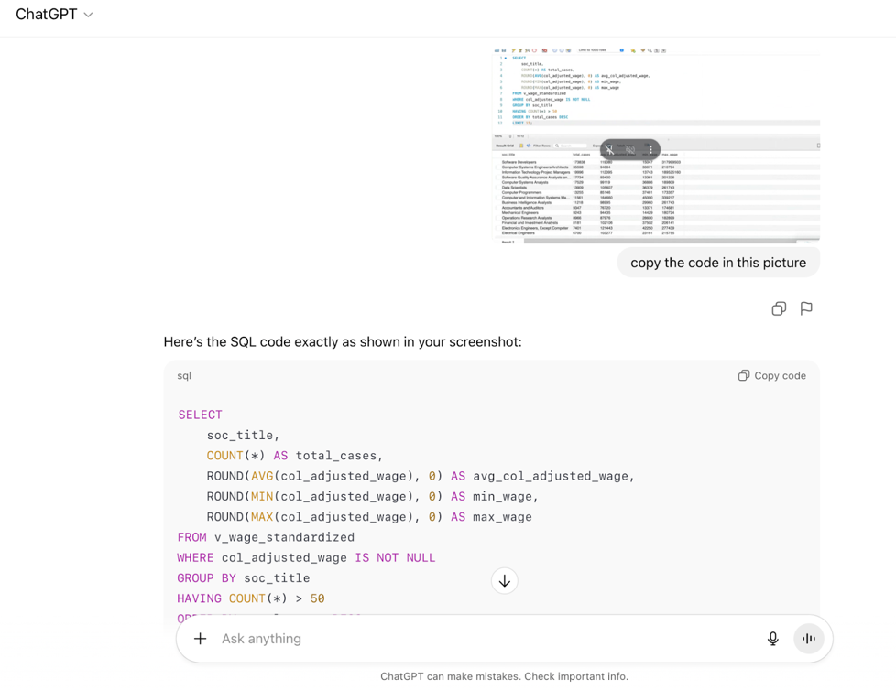

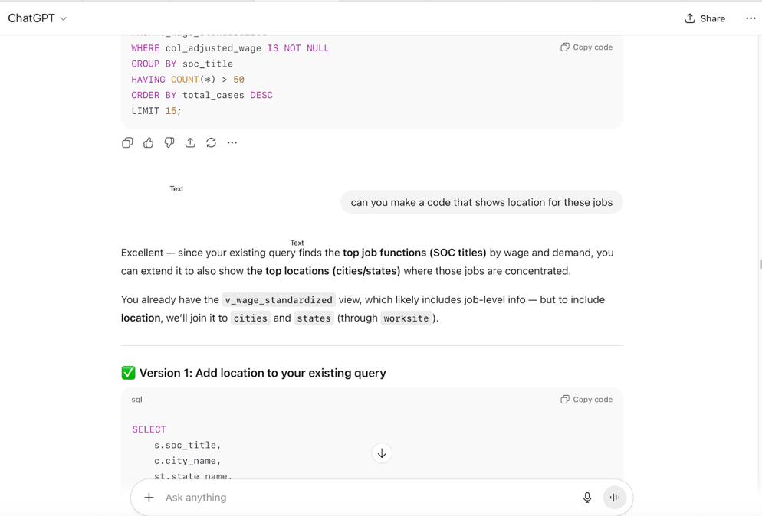

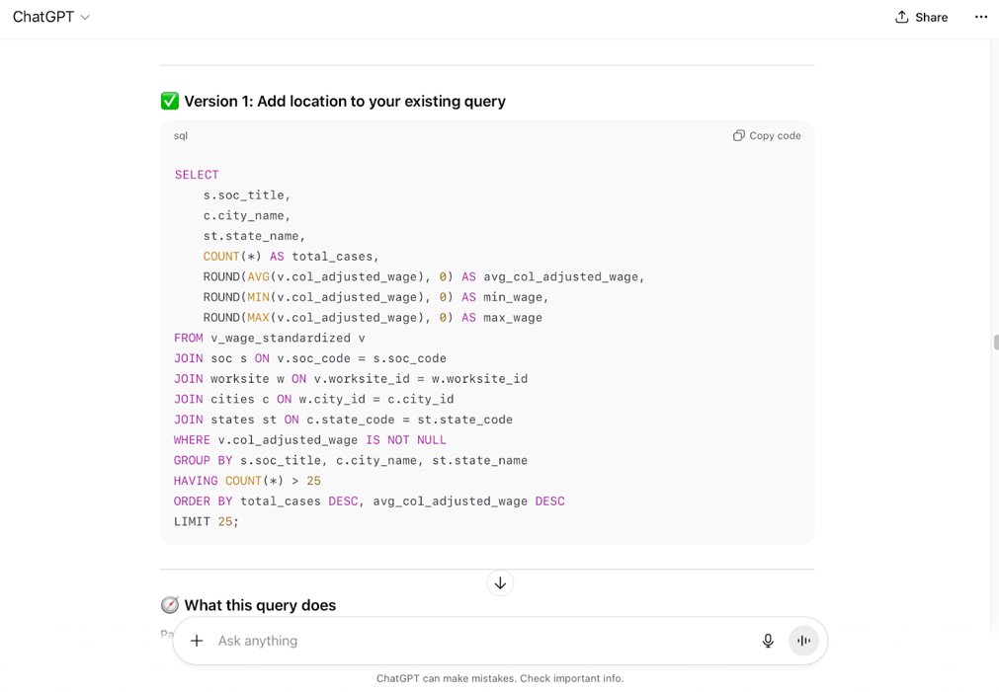

References:
Bohn, S., Neumark, D., & Li, Z. (2023, October). Are company headquarters leaving California? Public Policy Institute of California. https://www.ppic.org/publication/are-company-headquarters-leaving-california/
Bureau of Economic Analysis. (2025, May 12). Regional price parities by state and metro area. U.S. Department of Commerce. https://www.bea.gov/data/prices-inflation/regional-price-parities-state-and-metro-area
CompTIA. (2024). State of the tech workforce 2024. Computing Technology Industry Association. https://www.comptia.org/en/resources/research/state-of-the-tech-workforce-2024
Escamilla, L. (2025, October 2). The case for how the $100,000 H-1B fee increases the value of F-1 OPT two-year-extension holders. https://www.dropbox.com/scl/fi/umjj67mzabblbsnkooh51/Escamilla-L-20251002-The-Case-for-How-the-100-000-H-1B-Fee-Increases-the-Value-of-F-1-OPT-Two-Year-Extension-Holders.pdf?rlkey=vka8j8z44xvm9oifq326yva4h&e=3&st=05nrek3u
OpenAI. (2025). ChatGPT (Nov 2025 version) [Large language model]. https://chat.openai.com/
U.S. Citizenship and Immigration Services. (2025, April 29). Characteristics of H-1B specialty occupation workers: Fiscal year 2024 report to Congress. U.S. Department of Homeland Security. https://www.uscis.gov/sites/default/files/document/reports/ola_signed_h1b_characteristics_congressional_report_FY24.pdf

MBAN (Master’s in Business Analytics) is in most cases a STEM designated degree.
See Query 1 (Top job functions by cases and positions (FY2024) in the SQL document for supporting output
See Query 2A, 2B and 2C (Top H1-B Sponsoring States and Geographic Concentration of H-1B Job Functions by State and Cities)
See Query 3A and 3B (MBAN target roles: share of total H-1B market and descriptive analysis of the salaries)
See Query 4 (Geographic concentration and wage patterns for MBAN target roles)
See Query 5 (Top employers sponsoring chosen MBAN target roles) Data implications: The dataset corresponds to FY2024, but some applications in late 2023 are included, consistent with DOL reporting. States and cities assigned a “not mapped” result correspond to reported mistakes in original data. Only full-time jobs and non-willful violators have been considered for this analysis.

