**Performance of Matched Filters and Correlators**

**&**

**Line Code**

|  |  |
| --- | --- |
| **ID** | **الاسم** |
| 19016377 | محمد سامي محمد عبدالعزيز |
| 19015660 | رشاد السيد ابراهيم احمد |
| 19015336 | تسنيم عبدالصمد رزق محمد |

Part 1  
Plot

a matched filter will provide a lower bit error rate than a simple detector for the same level of noise.  
transmitted power =0.5027

Simple Detector.

A Simple detector is a device or circuit that is used to detect the presence of a digital signal and to recover the original information bits from the received signal. The main function of a detector is to distinguish between the two possible signal levels, which are typically represented as binary 1 and binary 0  
  
Matched Detector   
A matched detector is a type of detector used in digital communication systems to recover the transmitted data from the received signal. The matched detector is designed to maximize the signal-to-noise ratio and minimize the probability of errors in the received data.  
The advantage of the matched detector is that it maximizes the signal-to-noise ratio, which results in better performance and lower error rates. This is because the reference signal is optimized to match the channel characteristics, and therefore provides the best possible match between the transmitted and received signals   
correlator Detector  
A correlator detector is a type of detector used in digital communications systems to detect and recover the transmitted data from the received signal. The correlator detector works by correlating the received signal with a known signal to extract the transmitted information.  
The output of the correlator is a correlation function that indicates the presence and timing of the signal

Part 2  
 Line code  
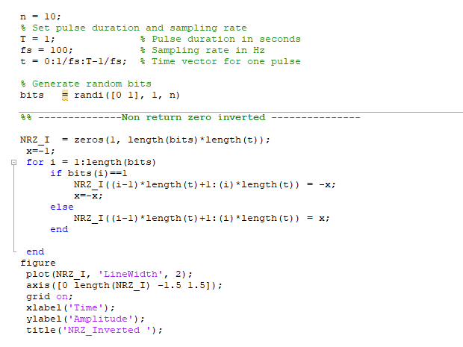  
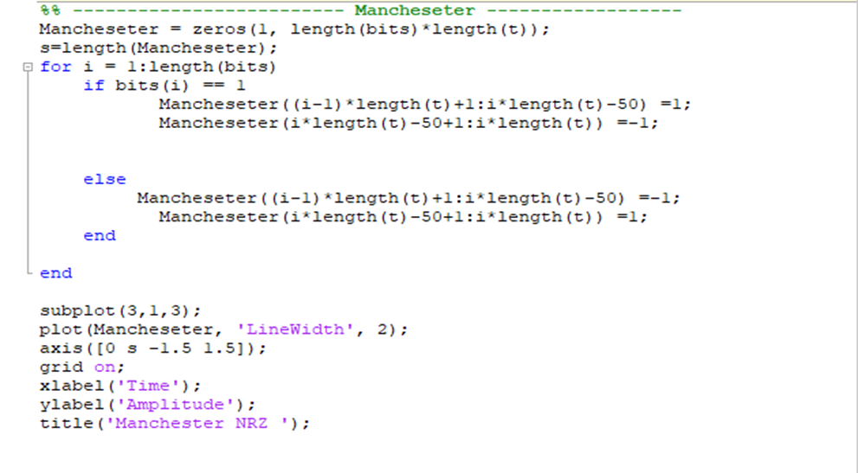  
  
Plots:  
  
PSD  
  
  
  
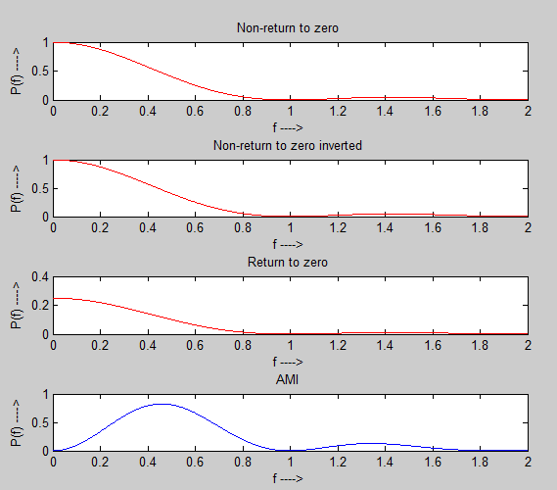

Another soln PSD:  
Comments:  
notes:  
- In NRZ line coding, a binary 0 is represented by a constant "0" voltage level, while a binary "1" is represented by a constant non-zero voltage level.  
  
- In RZ line coding, a binary "0" is represented by a zero voltage level, while a binary "1" is represented by a non-zero voltage level that returns to zero midway through the bit duration.

2- Polar:  
 Polar line codes are a type of line code that uses a positive signal represents a logical 1 and a negative signal represents a logical 0.  
 +V >> 1 -V >> 0  
**Advantages:** 1- Better Bandwidth Efficiency: Polar line codes are more efficient than unipolar line codes, as they use less bandwidth to transmit the same amount of data.  
 2- No DC component: Polar NRZ has no DC component, which makes it suitable for long-distance transmission.  
3-Simple: Polar NRZ is a simple line code to implement.  
4-Easy to Implement: Polar RZ line codes are easy to implement and can be used in both hardware and software-based communication systems.  
5- NRZ-I (NRZ-Inverted) helps in synchronization at the receiver due to use of transition to map binary '1'  
6- Polar RZ solves synchronization problem observed in polar NRZ type.  
Disadvantages:  
1-Limited DC Balance: Polar RZ line codes do not have perfect DC balance, meaning that the number of positive and negative voltage transitions may not be equal.  
2-Not self-clocking: Polar NRZ is not a self-clocking line code. This means that the receiver needs to have a separate clock signal to synchronize with the incoming data  
-3 Polar RZ requires two signal changes to encode bit and hence it occupies more bandwidth.  
3- Bipolar  
Bipolar line codes are a type of line code that uses two voltage levels to represent logical 1 and logical 0 bits. The voltage level is positive or negative   
for logical 1 bits and zero voltage for logical 0 bits. $±$ 
 V >> 1  
 0 V >> 0   
**AMI (alternate mark inversion):** AMI is a type of bipolar line code that uses a mark-space ratio of 1:1. This means that the number of mark (positive) symbols is equal to the number of space (negative) symbols.  
**Advantages:  
1-No DC component:** Bipolar line codes have no DC component, which makes them suitable for long-distance transmission.  
2-**Efficient:** Bipolar line codes are efficient in terms of bandwidth usage.  
3-DC Balanced: Bipolar line codes maintain a balance of positive and negative voltage levels.  
4-Good Bandwidth Efficiency: Bipolar line codes are more bandwidth efficient than unipolar line codes because they use two voltage levels to represent two binary states.  
5- Single error detection is possible using bipolar coding technique.  
**Disadvantages:  
1-** **More complex: Bipolar line codes are more complex to implement than unipolar line codes  
2-** No clock signal is present for use.  
3- Bipolar line codes require more power to transmit the signal since they use both positive and negative voltage levels.  
4- Manchester   
Manchester encoding is a type of line coding used in digital communication systems to represent binary data using transitions in the signal. In Manchester encoding, a binary 1 is represented by a transition from a positive voltage level to a negative voltage level, while a binary 0 is represented by a transition from a negative voltage level to a positive voltage level  
advantage :  
1- **Bandwidth efficiency:** Manchester encoding is bandwidth-efficient, which means that it uses less bandwidth than other line codes, such as unipolar NRZ. This is because the signal level changes at the middle of each bit time, which reduces the amount of time that the signal is at a constant level  
  
2-N**oise immunity:** Manchester encoding is more noise-immune than other line codes,  
3- **Self-clocking:** Manchester encoding is self-clocking, which means that the receiver can recover the clock signal from the signal itself.  
**Disadvantages**:  
1- **Complexity:** Manchester encoding is more complex to implement than other line codes, because the receiver needs to be able to detect the transitions in the signal.  
2- Higher Bandwidth: Manchester encoding requires a higher bandwidth than other encoding techniques because it uses more transitions per bit.  
3- Lower Spectral Efficiency: Manchester encoding has a lower spectral efficiency than other encoding techniques because it requires more bandwidth to transmit the same amount of data.  
  
MLT-3 encoding:  
MLT-3 encoding uses three levels (+V, 0, -V) and three transition rules to move between levels. It is similar to NRZ-I. Following rules are applied to encode bit pattern in the example below.   
• If the next bit is zero ('0'), there is no transition.   
• If the next bit is one ('1) and current level is not zero '0', the next level is 0.   
• If the next bit is one ('1) and current level is zero ('0'), the next level is the opposite of the last nonzero level  
Advantages:  
1- It has signal rate which is (1/4)th of the bit rate  
2- Due to its signal shape, it reduces required bandwidth.

Disadvantages:  
1- It does not support self-synchronization for long string of zeros ('0').  
2- It is more complex than NRZ-I due to use of three levels and complex transition rules.  
  
**Which type of line code has the highest bandwidth?**  
The type of line code with the highest bandwidth is Manchester encoding.   
  
  
-Manchester encoding is a line code in which the signal level changes at the middle of each bit time. This ensures that there is always a transition in the signal, which makes it easy for the receiver to synchronize with the signal. Manchester encoding is also self-clocking, which means that the receiver can recover the clock signal from the signal itself. Manchester encoding has a bandwidth of twice the data rate.  
 This is because the signal level changes twice per bit time .  
 ------------------------------------------  
**Mention 2 other used line codes and explain them mentioning the main advantages and disadvantages**:  
Unipolar:  
In this type of line coding, the signal is represented by a single voltage level, usually positive.  
Advantages:  
1- It is simple encoding technique.  
2- Unipolar NRZ : It requires less bandwidth for transmission.  
3- Unipolar RZ : The spectral line present at the symbol rate can be used as clock signal.  
Disadvantages:  
1- Average amplitude of unipolar encoded signal is nonzero. This creates DC component which shifts zero level of the signal which can’t travel through some medium such as microwave.  
2-Unipolar encoding leads to synchronization issue at the receiver when long string of ones and zeros are present in the binary data. This is because such data do not produce any transitions which may create problems in error detection and recovery.  
3- It does not have any error handling technique (i.e. Error correction)  
4- It suffers from "Signal Droop" issue due to presence of low frequency components.  
5- Unipolar RZ consumes twice bandwidth than unipolar NRZ.  
B8ZS (Bipolar with 8 Zero Substitution:  
- This code replaces any sequence of eight zeros with a special pattern consisting of alternating positive and negative pulses.  
Advantages:  
1- The coded signal does not contain D.C. component  
2- It maintain synchronization  
Disadvantages:  
1- its complexity as well as its requirement for special hardware for implementation