Technical Report:

Rashad Hummatov
ADA University
INFT 4836: Intro to Big data Analytics
12.04.2025

1. Introduction
In this homework, I utilized Apache Spark (PySpark) to process a real-world large dataset. The goal was to demonstrate distributed data processing using three core Spark components: RDDs (Resilient Distributed Datasets), Spark SQL, and DataFrames.
I selected the NYC Yellow Taxi Trip Records (March 2016) for this analysis. This dataset contains over 12 million rows of transportation data, satisfying the assignment requirement for a large dataset.
Table of Contents:
- Introduction
- Task 1: Spark RDDs - Core Transformations & Actions
- Task 2: Spark SQL - Querying Distributed Data
- Task 3: Spark Data Frames - Data Cleaning & Transformations
- Conclusion

2. Task 1: Spark RDDs - Core Transformations & Actions
2.1 Setup and Data Loading
First, I configured the environment. Due to a version conflict between the system Java and Spark, I explicitly set JAVA_HOME to Java 17. I then initialized the SparkSession and loaded the dataset using the CSV reader.
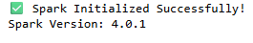
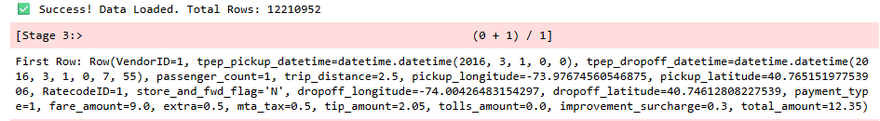

2.2 RDD Transformations
I performed the following 5 operations on the RDD:
- Filter(): I removed noisy records by keeping only trips where the trip_distance was greater than 0. This removes system errors or cancelled trips.
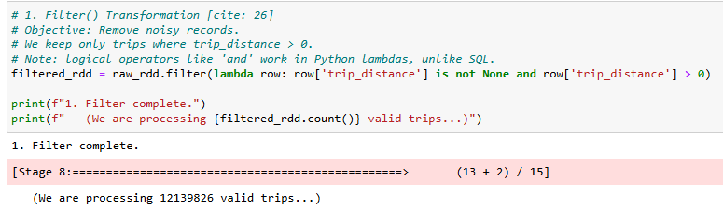
2. Map(): I extracted a structured tuple of (VendorID, TripDistance) to isolate the specific features needed for analysis.
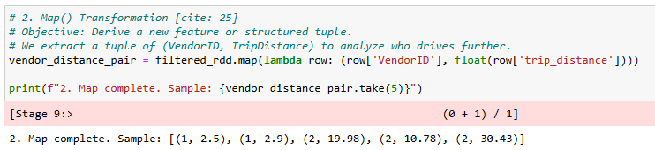
3. FlatMap(): I split the tpep_pickup_datetime field (e.g., "2016-03-01 00:00:00") into individual list elements [Date, Time]. This simulates breaking complex logs into smaller tokens.
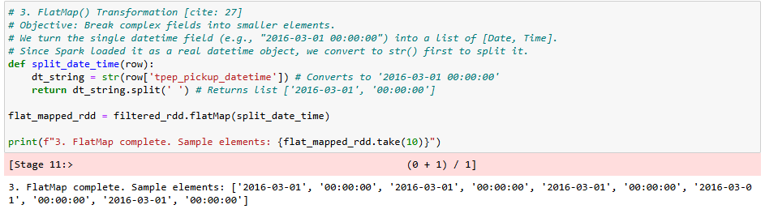

4. ReduceByKey(): I aggregated the data to calculate the total distance driven by each vendor. This is an efficient distributed operation that sums values locally before shuffling.
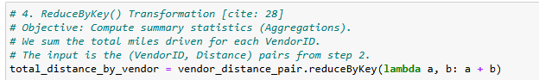
5. Collect(): I retrieved the final results to the driver.
Results (Total Miles per Vendor): The analysis shows that Vendor 1 covered significantly more distance than Vendor 2.
- Vendor 1: 55,384,892.00 miles
- Vendor 2: 19,489,854.25 miles
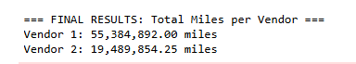

3. Task 2: Spark SQL - Querying Distributed Data
I registered the dataframe as a temporary view named taxi_trips to perform SQL queries.
3.1 Aggregation Query
I calculated the average fare and total trip count grouped by the number of passengers. This helps analyze if group size impacts fare pricing.
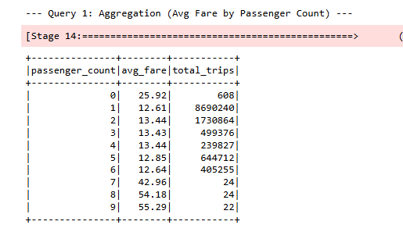
3.2 Filtering Query
I filtered for "High Value" trips defined as having a Fare > $50 AND a Distance > 10 miles.
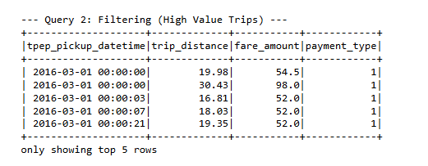

3.3 Join Query
The dataset uses numeric IDs for payment types. I created a helper lookup table payment_lookup and joined it with the main table to get human-readable descriptions (e.g., "Credit Card").
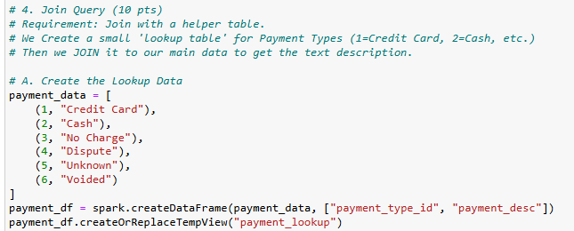
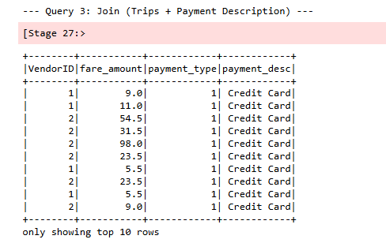
4. Task 3: Spark DataFrames - Data Cleaning & Transformations
4.1 Data Cleaning
I attempted to drop rows containing Null values in critical columns (passenger_count, trip_distance, fare_amount).
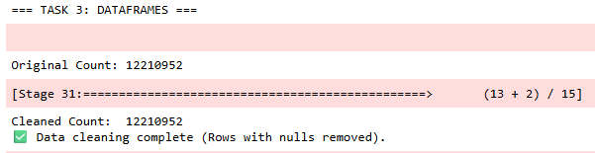
The counts remained identical, indicating the dataset did not have null values in these specific columns.
4.2 GroupBy + Aggregation
I grouped the data by VendorID to compute statistical summaries.
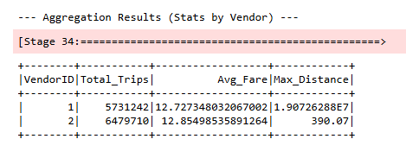

4.3 Sorting and Insights
I sorted the data by passenger_count (Ascending) and fare_amount (Descending). This operation revealed significant data quality issues.
- Zero Passengers: The sorting showed 608 trips with 0 passengers, some with fares over $200.
- Extreme Outliers: After filtering out the 0-passenger rides, I found a single trip with 1 passenger that charged $429,496.72 for a distance of 0.0 miles.
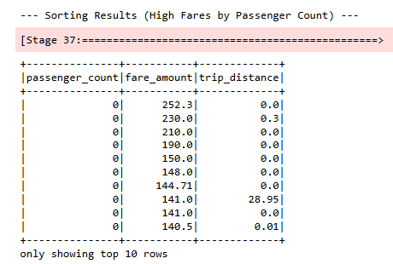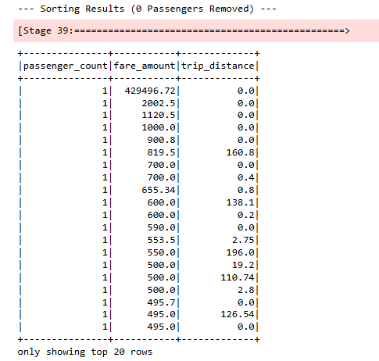

Conclusion:
While the dataset was technically "clean" regarding Null values, the DataFrame sorting analysis revealed logical errors (0 passengers) and extreme outliers (massive fares for 0 distance), suggesting that further cleaning rules are required for production analysis.

