**Scientific Calculator**

**Introduction:**

Software that calculates all data of every task, and used for scientific purposes is called scientific calculator. We are going to build Calculator based on java and its FX library. This type of software plays a great role and has a potential effect on day-to-day performance measures, this type of applications have highly evolved from decades due to high demand for their use, effective and efficiency in any given institutions. Due to the rapid change of technology, the use of such system has become a necessity to any given high learning institution for better performance and be used with quite a large number of users at the same time but it can save time, resources and creates awareness of the evolving technology.

**Tools:**

* Programming Language: JAVA & its FX library
* Eclipse IDE
* FX Screen Builder

**Features:**

* It can Calculates Basic calculation like addition, Subtraction, Division, Multiplication
* It can be used for scientific calculation such as calculation of Sin value
* It can convert degree value to radian value
* Check in into the hotel for the duration

**Classes to use:**

* Main class: This is the driver class used for launching the application
* Controller Class: This class used for all logic implantations, calling method and showing value to the screen. Moreover, it has some event listeners that helps to perform the pressed actions.
* UI FXML: This is the Screen file that is built using the Screen Builder Application
* CSS: This is the auto-generated file; it has no use on our project.

**Screen Shots of Project:**

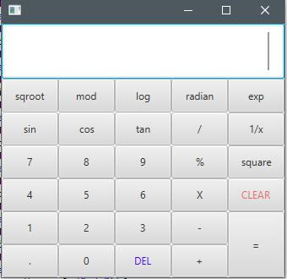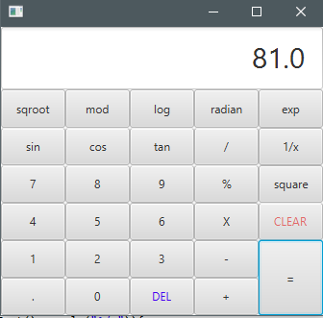

**Scientific equation logics:**

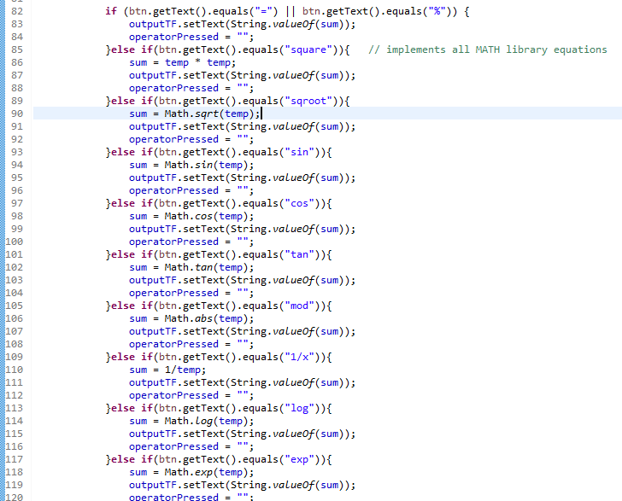

**Project File Structure:**

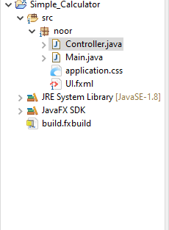

**Thank you!**