INDEX

Experiment  No | Experiment Name | Page No
1 | Write and execute a machine-language program in MTS86  trainer board to perform the logical AND operation: A AND B=? , A OR B= ?; Where A=02,B=A3. | 2-4
2 | Write and execute a machine language program in MTS86 trainer board to solve the logical NOT operation, A’ = ?  Where A = 02. | 5-6
3 | Write and execute a machine language program in MTS86 trainer board to perform the logical XOR operation A ⊕  B = ? Where A = 06 and B = 5E. | 7-8
4 | Write and execute a machine language program in MTS86  trainer board to solve the shift-left operation. E.g. A<<1=? Where A =3C. | 9
5 | Write and execute a machine language program in MTS86  trainer board to solve the shift-right operation. E.g. A>>1=? Where A=5D. | 10
6 | Write and execute a program in MTS86 trainer board and show hexadecimal value (0,1, ...F) on the seven-segment  display. | 11-12
7 | Write and execute a program in MTS86 trainer board to  display any value on the LED display | 13-14
8 | Write and execute a program in MTS86 trainer board to  interface and display output using the D/A converter. | 15-16
9 | Write and execute a program in MTS86 trainer board to  display output on the LED MATRIX. | 17
10

Experiment No-01
Experiment Name: Write and execute a machine-language program in MTS86 trainer board to perform the logical AND operation:
A AND B=? , A OR B= ?; Where A=02,B=A3.

Objective: The 8086 kit MTS86 is use to perform machine language program on it to solve any operations. This has I/O facilities and built in with different interfacing devices such as 8255, 8251, 8259, 8253, 8254 etc.

Specification:

CPU: 8086
- Display Unit: LCD(16x2)
- RAM: 64kb
- ROM: 64kb
- User Memory: 64kb
Procedure: A AND B

Assembly Language | Machine Language
MOV AL, 02 | B0, 02
AND AL, A3 | 24, A3

Truth Table:

A | B | A AND B
0 | 0 | 0
0 | 1 | 0
1 | 0 | 0
1 | 1 | 1

INPUT: A = 02 B = A3

OUTPUT: A = 02 → 0000 0010
B = A3 → 1010 0011

AB = 02 → 0000 0010
Procedure: A OR B

Assembly Language | Machine Language
MOV AL, 02 | B0, 02
OR AL, A3 | OC, A3

Truth Table:

A | B | A OR B
0 | 0 | 0
0 | 1 | 1
1 | 0 | 1
1 | 1 | 1

INPUT: | A = 02
 | B = A3
OUTPUT: | A = 02 → | 0000 0010
 | B = A3 → | 1010 0011
 | AB = 02 → | 1010 0011

Experiment No-02
Experiment Name: Write and execute a machine language program in MTS86 trainer board to solve the logical NOT operation, Á = ? Where A = 02.

Objective: The 8086 kit MTS86 is use to perform machine language program on it to solve any operations. This has I/O facilities and built in with different interfacing devices such as 8255, 8251, 8259, 8253, 8254 etc.

Specification:

CPU: 8086
- Display Unit: LCD(16x2)
- RAM: 64kb
- ROM: 64kb
- User Memory: 64kb

Procedure:

Assembly Language | Machine Language
MOV AL, 02 | B0, 02
NOT AL | F6, DO

Truth Table:

A | Á
0 | 1
1 | 0

INPUT: A = 02

OUTPUT: A = 02 → 0000 0010

Á = FD → 1111 1101

Experiment No-03
Experiment Name: Write and execute a machine language program in MTS86 trainer board to perform the logical XOR operation A ⊕ B = ? Where A = 06 and B = 5E.

Objective: The 8086 kit MTS86 is use to perform machine language program on it to solve any operations. This has I/O facilities and built in with different interfacing devices such as 8255, 8251, 8259, 8253, 8254 etc.

Specification:

CPU: 8086
- Display Unit: LCD(16x2)
- RAM: 64kb
- ROM: 64kb
- User Memory: 64kb

Procedure:

Assembly Language | Machine Language
MOV AL, 06H | B0, 06
MOV BL, 5EH | B3, 5E
XOR AL, BL | 30, D8

Truth Table:

A | B | A ⊕ B
0 | 0 | 0
0 | 1 | 1
1 | 0 | 1
1 | 1 | 0

INPUT: A = 06 → 0000 0110
B = 5E → 0101 1110

OUTPUT: A = 06 → 0000 0110
B = 5E → 0101 1110

AB = 02 → 0101 1000

Experiment No-04
Experiment Name: Write and execute a machine language program in MTS86 trainer board to solve the shift-left operation. E.g. A<<1=? Where A

=3C

Objective: The 8086 kit MTS86 is use to perform machine language program on it to solve any operations. This has I/O facilities and built in with different interfacing devices such as 8255, 8251, 8259, 8253, 8254 etc.

Specification:

CPU: 8086
- Display Unit: LCD(16x2)
- RAM: 64kb
- ROM: 64kb
- User Memory: 64kb

Procedure:

Assembly Language | Machine Language
MOV AL, 3C | B0, 3C
SHL AL, 1 | D0, E0

INPUT: | AL = 3C → | 0011 1100
OUTPUT: | AL = 3C → | 0011 1100
 | SHL → | 0111 1000

Experiment No-05
Experiment Name: Write and execute a machine language program in MTS86 trainer board to solve the shift-right operation. E.g. A>>1=? Where A=5D.
Objective: The 8086 kit MTS86 is use to perform machine language program on it to solve any operations. This has I/O facilities and built in with different interfacing devices such as 8255, 8251, 8259, 8253, 8254 etc.

Specification:

CPU: 8086
- Display Unit: LCD(16x2)
- RAM: 64kb
- ROM: 64kb
- User Memory: 64kb

Procedure:

Assembly Language | Machine Language
MOV AL, 5D | B0, 5D
SHR AL, 1 | D0, D8

INPUT: AL = 5D → 0101 1101

OUTPUT: AL = 5D → 0101 1101
SHR → 0010 1110

Experiment No-06

Experiment Name: Write and execute a program in MTS86 trainer board and show hexadecimal value (0,1, ...F) on the seven-segment display.

Objective: The 8086 kit MTS86 is use to perform machine language program on it to solve any operations. This has I/O facilities and built in with different interfacing devices such as 8255, 8251, 8259, 8253, 8254 etc.

Specification:

CPU: 8086
- Display Unit: LCD(16x2)
- RAM: 64kb
- ROM: 64kb
- User Memory: 64kb

Procedure:

Assembly Language | Machine Language
MOV AL,1000 0000B | B0, 80
OUT PORT-CR, AL | E6, 1F
MOV AL, 1111 0000B | B0, F0
OUT PORT-B, AL | E6, 1B
MOV AL, 0000 0000B | B0, 00
OUT PORT-C, AL | E6, 1D
MOV AL, C0 | B0, C0
OUT PORT-A, AL | E6, 19

Code change for(0,1,2, ……9) as C0/F9/A4/B0/99/82/F8/80/F9…….

Example:

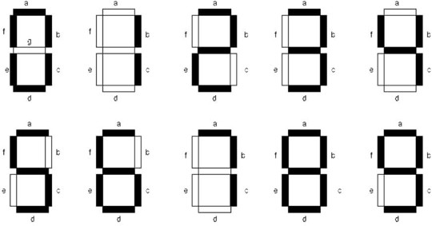

Experiment No-07

Experiment Name: Write and execute a program in MTS86 trainer board to display any value on the LED display.

Objective: The 8086 kit MTS86 is use to perform machine language program on it to solve any operations. This has I/O facilities and built in with different interfacing devices such as 8255, 8251, 8259, 8253, 8254 etc.

Specification:

CPU: 8086
- Display Unit: LCD(16x2)
- RAM: 64kb
- ROM: 64kb
- User Memory: 64kb

Procedure:

Assembly Language | Machine Language
MOV AL,1000 0000B | B0, 80
OUT PORT-CR, AL | E6, 1F
MOV AL, 1111 1111B | B0, FF
OUT PORT-B, AL | E6, 19
MOV AL, 0000 0000B | B0, 00
OUT PORT-C, AL | E6, 1D
MOV AL, 1111 0001B | B0, F1
OUT PORT-B, AL | E6, 1B

Code change ( By SHL): 1111 0001B/1111 0010B/ 1111 0100B/ 1111 1000B
like this. By this way colour will change in different shape.

OUTPUT:
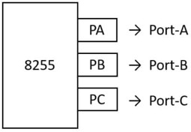

Experiment No-08

Experiment Name: Write and execute a program in MTS86 trainer board to interface and display output using the D/A converter.

Objective: The 8086 kit MTS86 is use to perform machine language program on it to solve any operations. This has I/O facilities and built in with different interfacing devices such as 8255, 8251, 8259, 8253, 8254 etc.

Specification:

CPU: 8086
- Display Unit: LCD(16x2)
- RAM: 64kb
- ROM: 64kb
- User Memory: 64kb

Procedure:

Assembly Language | Machine Language
MOV AL,1000 0000B | B0, 80
OUT PORT-CR, AL | E6, 1F
MOV AL, 1111 1111B | B0, FF
OUT PORT-B, AL | E6, 19
MOV AL, 1111 0000B | B0, F0
OUT PORT-B, AL | E6, 1B
MOV AL, 00 → 05 | B0, 00
OUT PORT-C, AL | E6, 1D

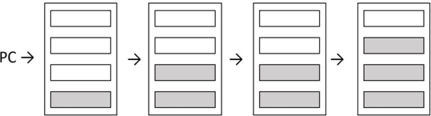

Code change: 00/ 01/ 05/ 10/ 0F
By this coding the light level will increase or decrease.
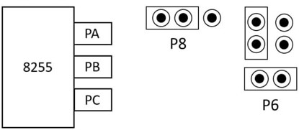

Experiment No-09

Experiment Name: Write and execute a program in MTS86 trainer board to display output on the LED MATRIX.

Objective: The 8086 kit MTS86 is use to perform machine language program on it to solve any operations. This has I/O facilities and built in with different interfacing devices such as 8255, 8251, 8259, 8253, 8254 etc.

Specification:

CPU: 8086
- Display Unit: LCD(16x2)
- RAM: 64kb
- ROM: 64kb
- User Memory: 64kb

Procedure:

Assembly Language | Machine Language
MOV AL,1000 0000B | B0, 80
OUT PORT-CR, AL | E6, 1F
MOV AL, 1111 1111B | B0, FF
OUT PORT-A, AL | E6, 19
MOV AL, 1111 0000B | B0, F0
OUT PORT-B, AL | E6, 1B
MOV AL, 0000 0001B | B0, 01
OUT PORT-C, AL | E6, 1C

