Module 1

Robertson, Rashai

Bellevue University, CSD325

Assignment 1.2

3/23/2025

Link: <https://github.com/Rashair1/CSD-325.git>

Screenshot GitHub: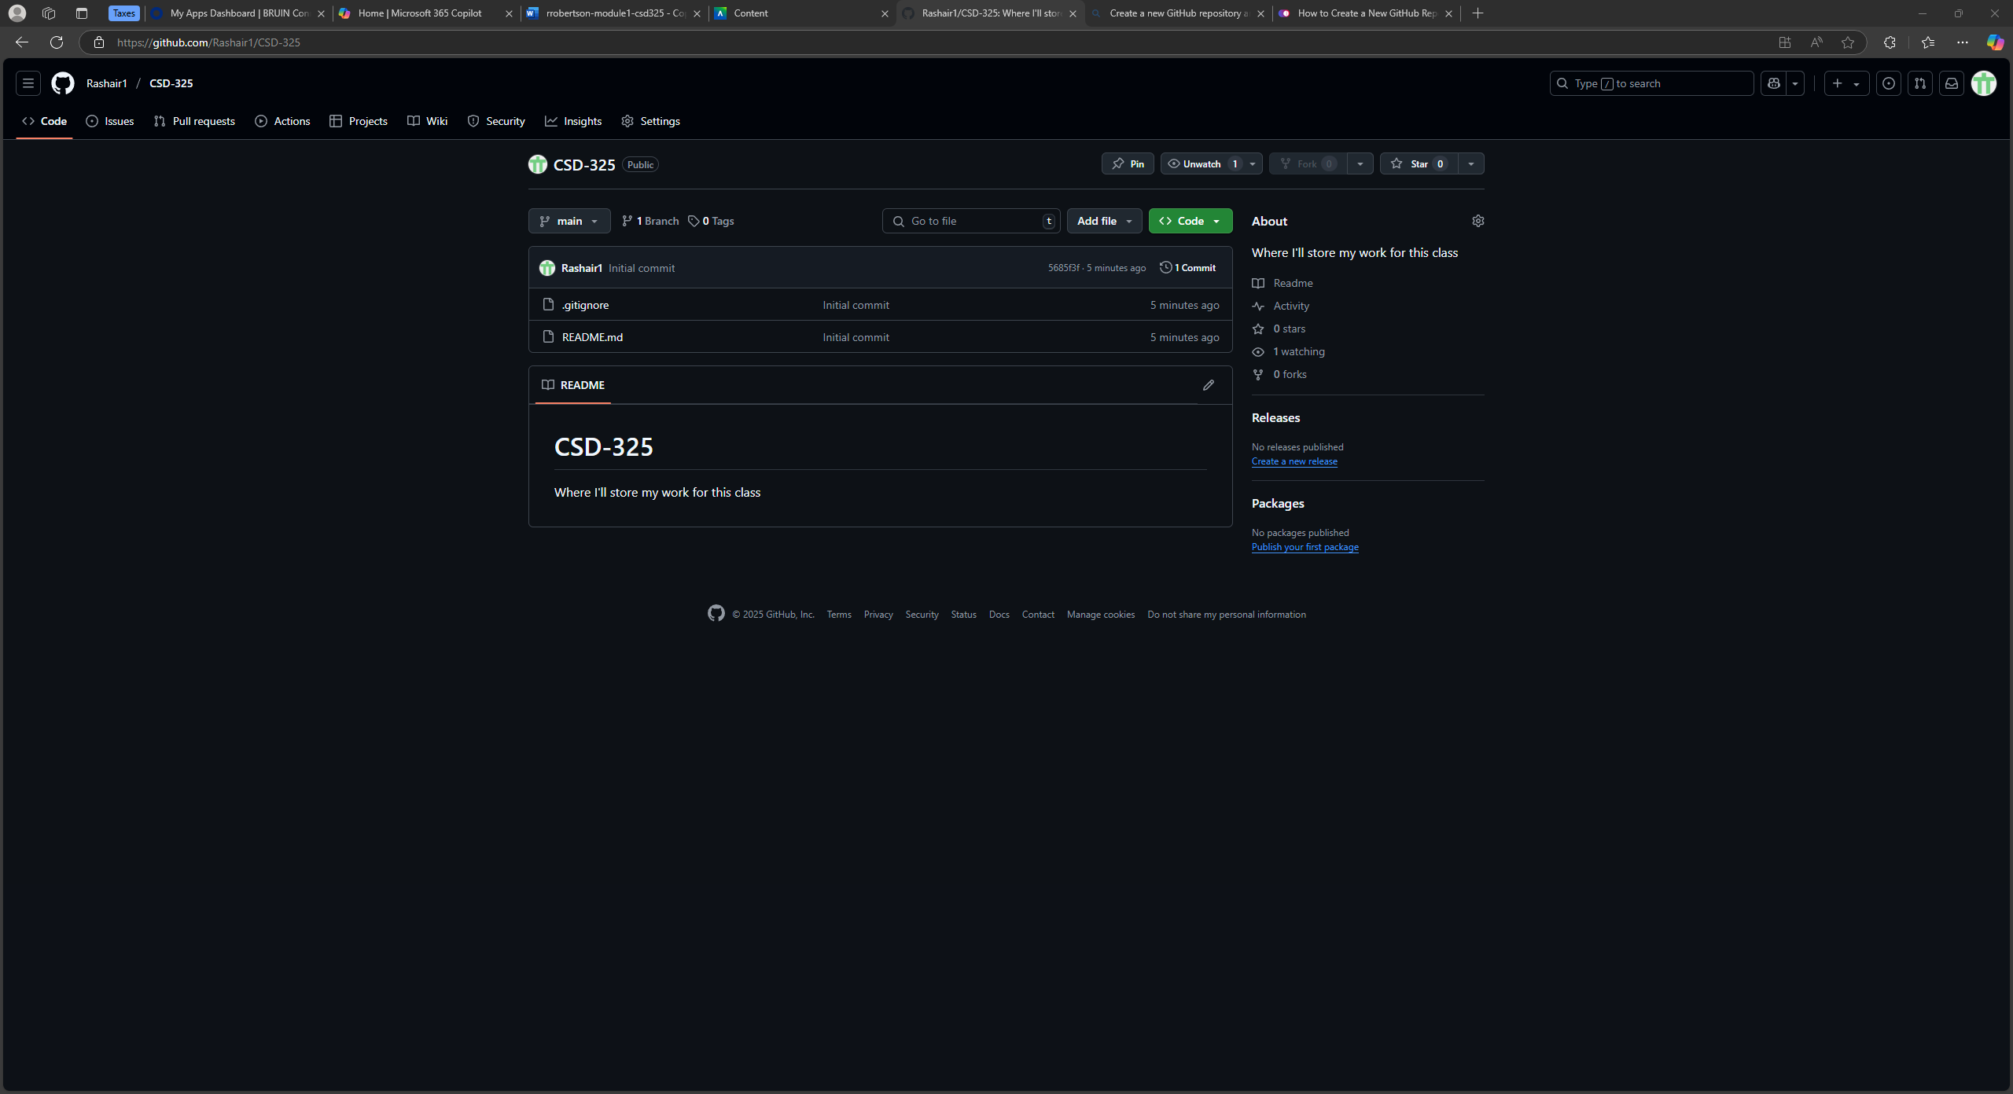

Screenshot Local Directory: