Module 10

Robertson, Rashai

Bellevue University, CSD325

Assignment 10.2

05/4/2025

Tkinter:

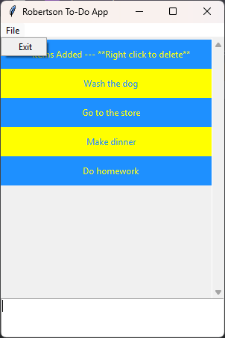

Tkinter with “go to store” deleted:

