Module 11

Robertson, Rashai

Bellevue University, CSD325

Assignment 11.2

05/11/2025

Django server connect:

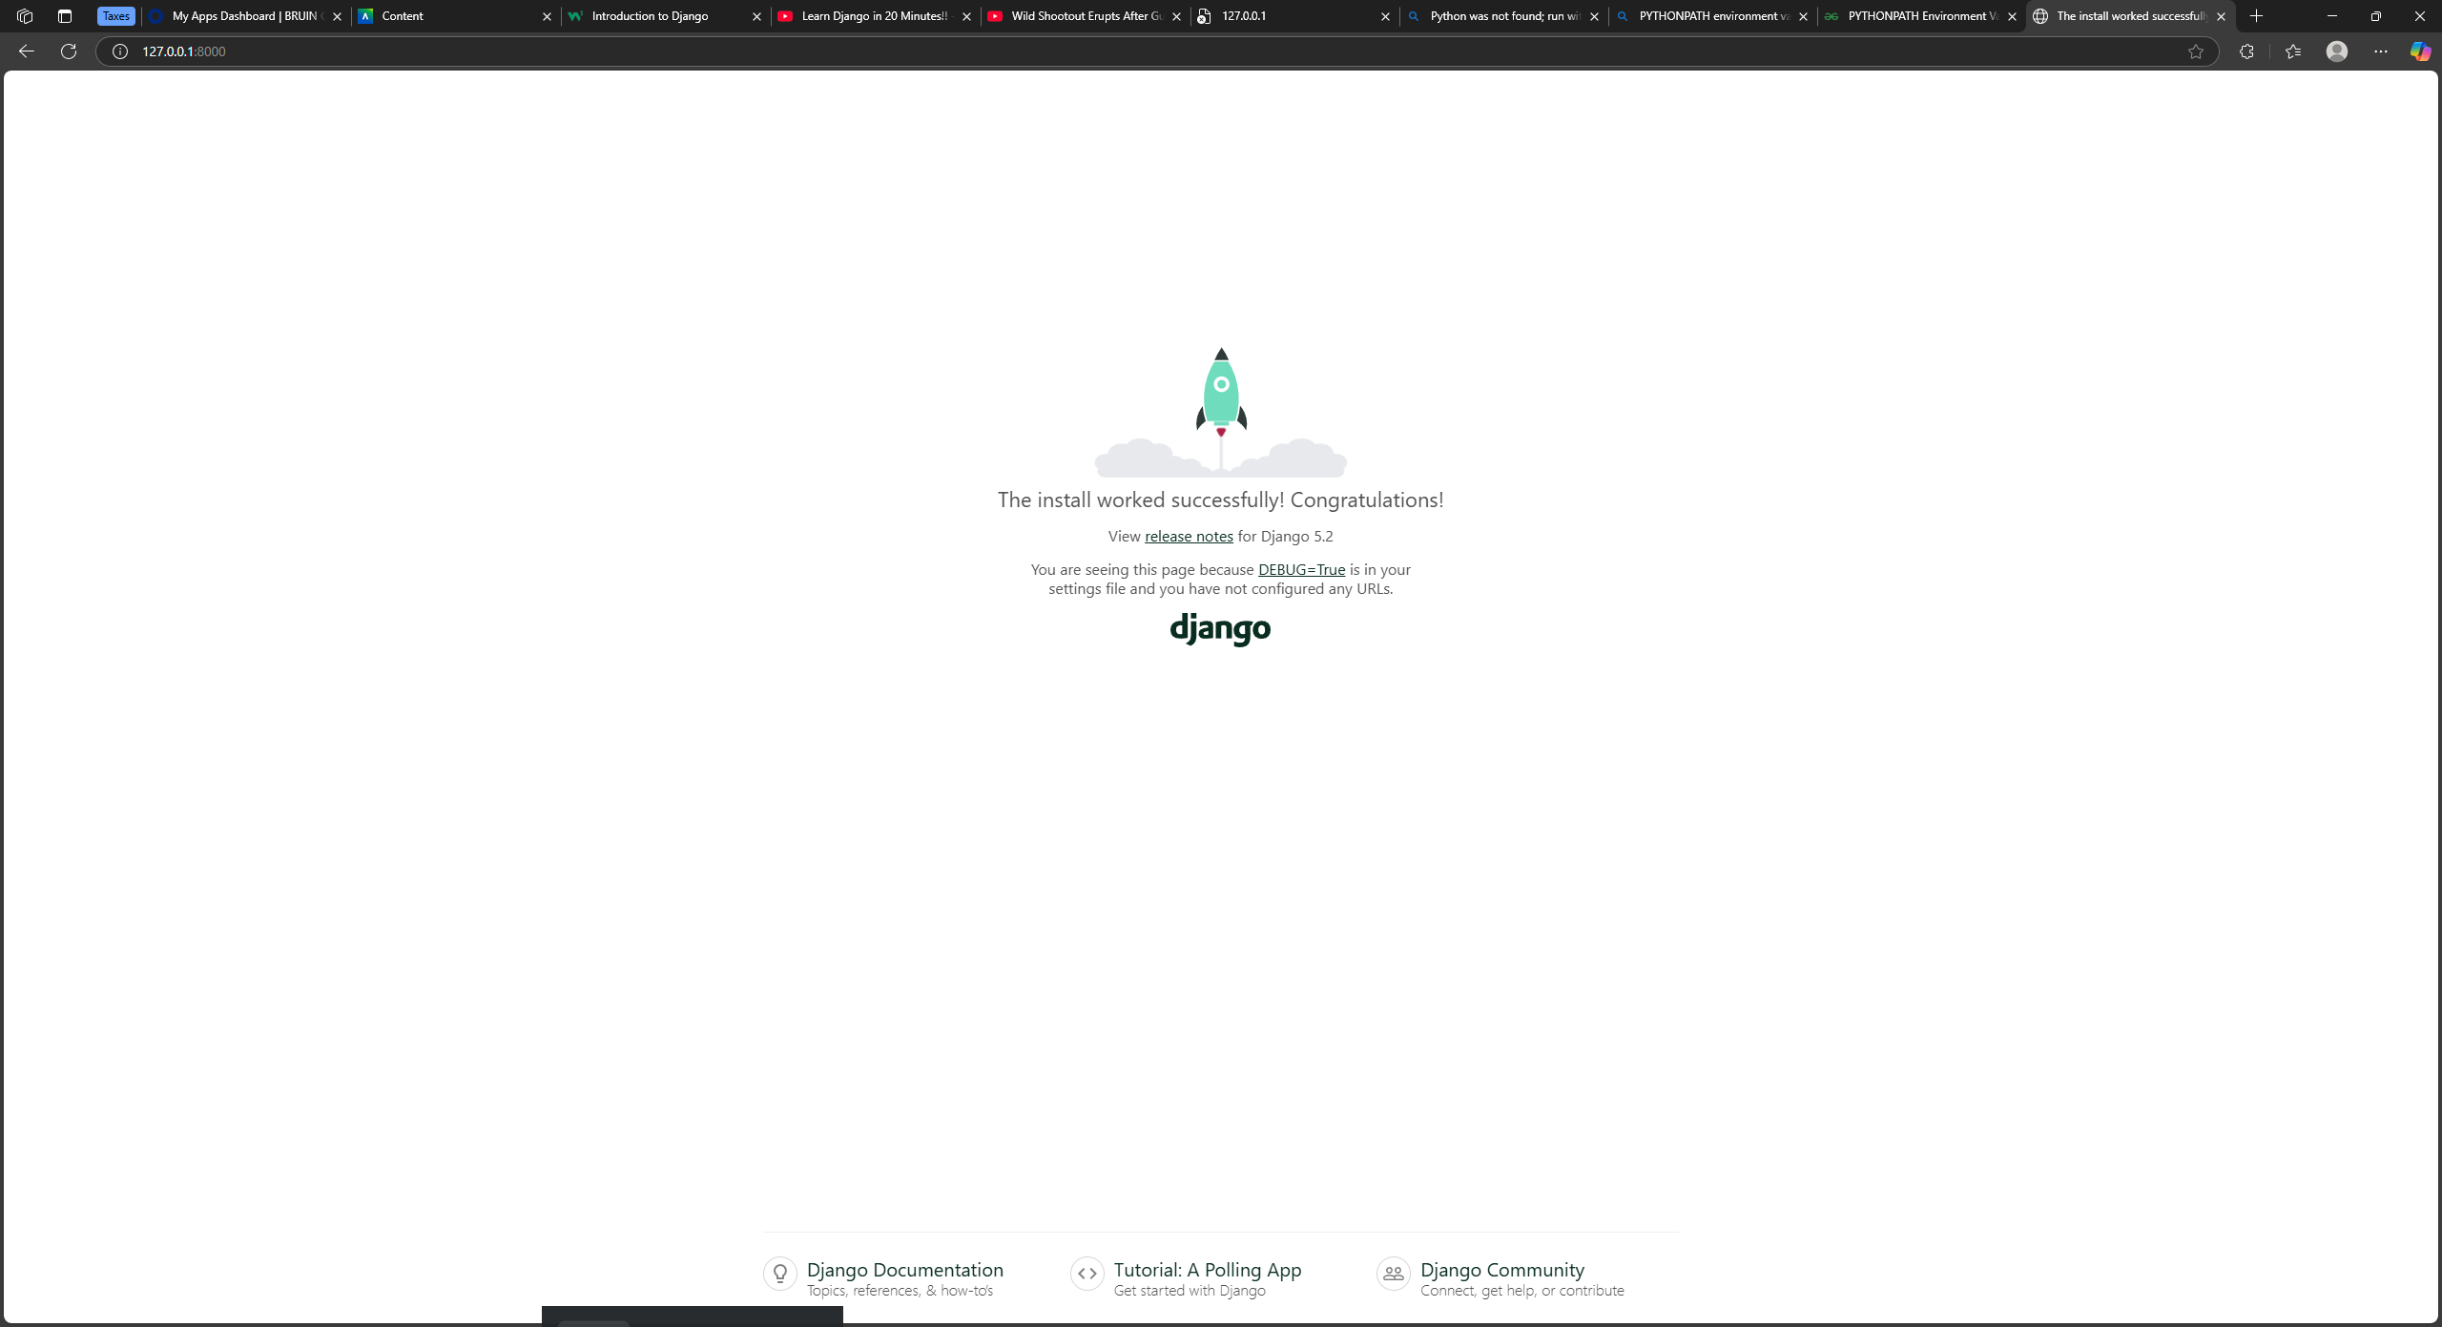

Robertson Says hello:

