Module 5

Robertson, Rashai

Bellevue University, CSD325

Assignment 5.2

04/06/2025

Rashai: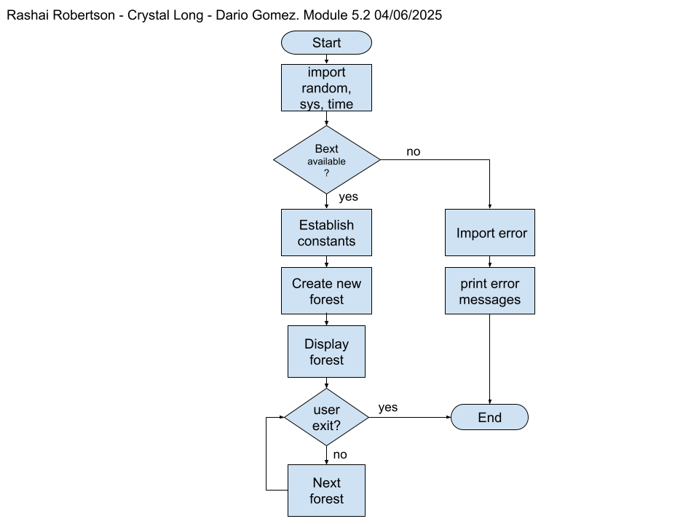

Dario:

