Module 4

Robertson, Rashai

Bellevue University, CSD310

Assignment 4.2

4/13/2025

Initial Databases: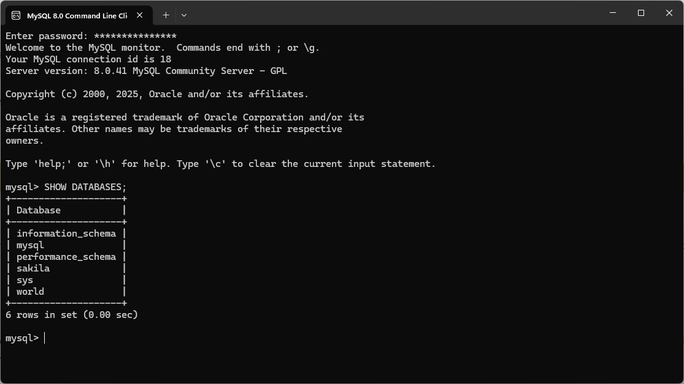

Created Movie Database: