Module 5

Robertson, Rashai

Bellevue University, CSD310

Assignment 5.2

4/13/2025

Current Time: This function could be used to add the creation time to a database for documentation purposes.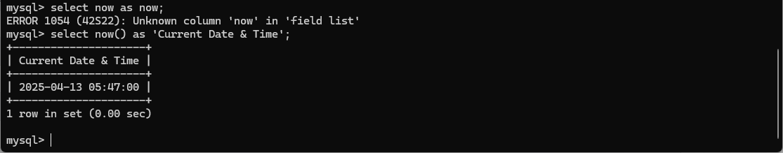

Repeat: This function could be used to repeat a statement. Sometimes data needs to be repeated, and this is the function that can be used to manipulate the data.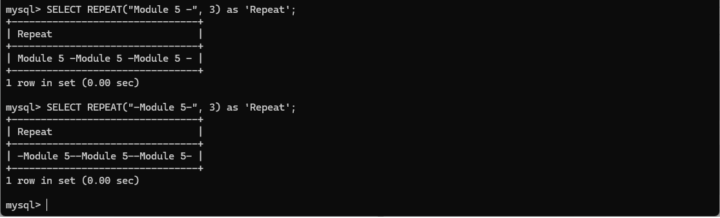

Reverse: This function could be used for fun. Maybe a database has some secret code that needs to be deciphered.

