Module 6

Robertson, Rashai

Bellevue University, CSD310

Assignment 6.2

4/20/2025

Running SQL Script: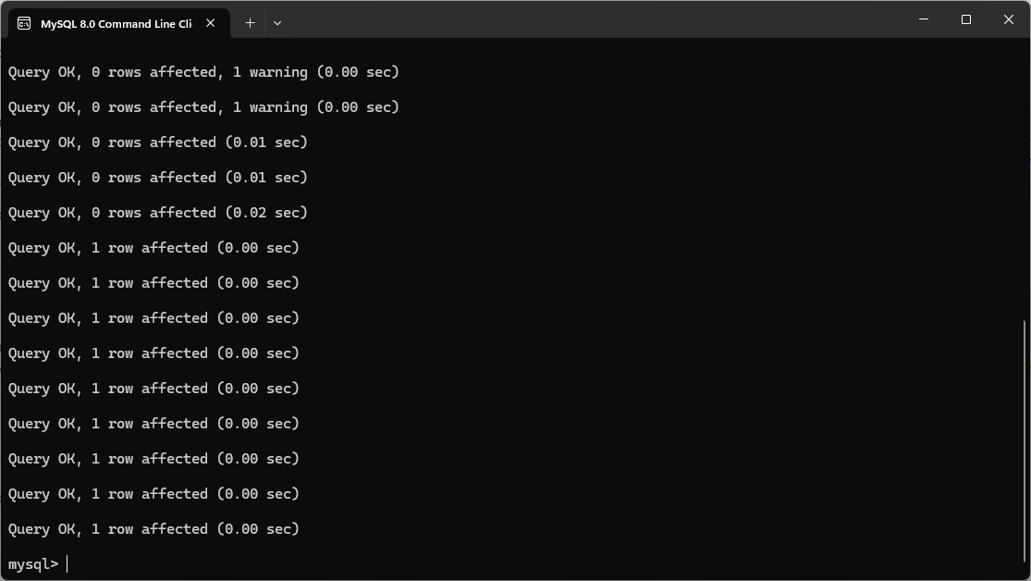

Movie Database: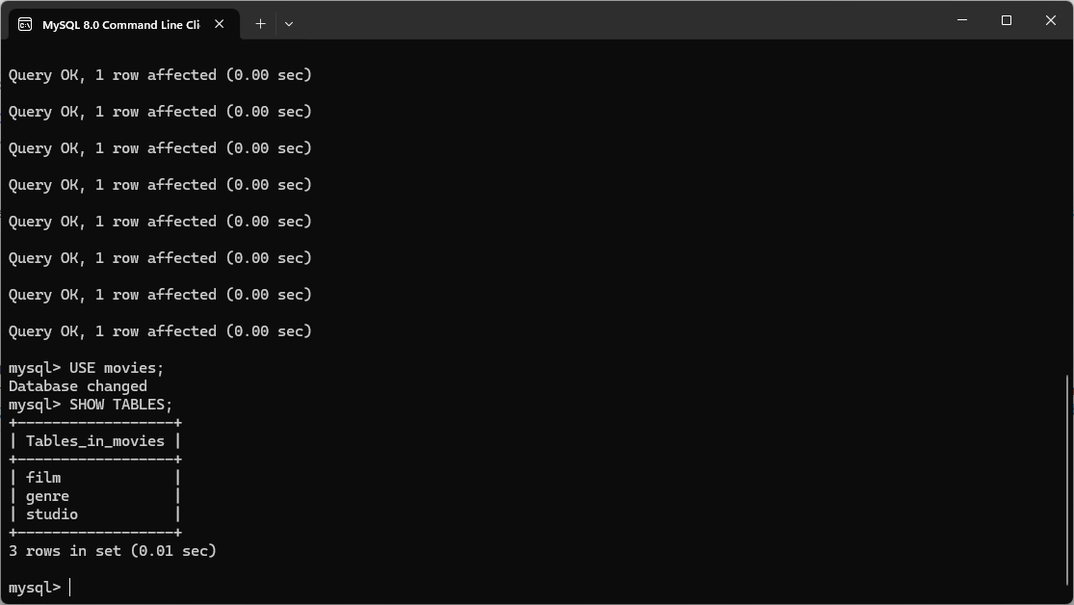

Script Results:

