Module 7

Robertson, Rashai

Bellevue University, CSD310

Assignment 7.2

4/27/2025

Running Script: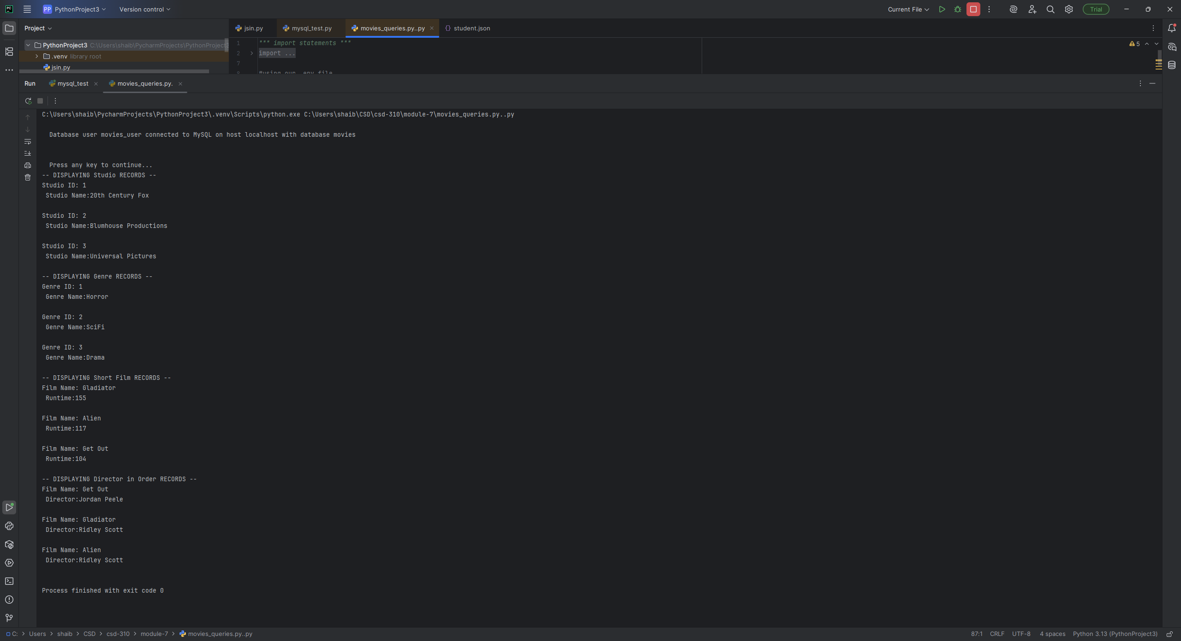

Git Hub: https://github.com/Rashair1/csd-310.git