Module 8

Robertson, Rashai

Bellevue University, CSD310

Assignment 8.2

4/27/2025

: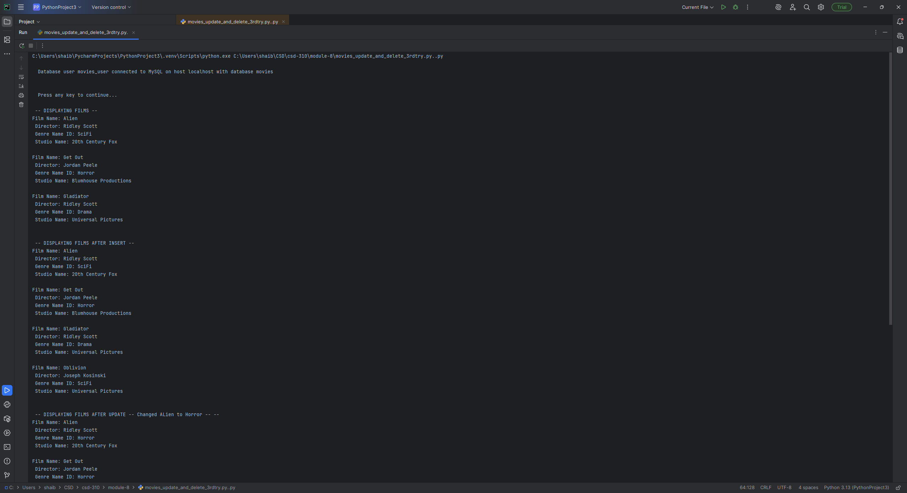

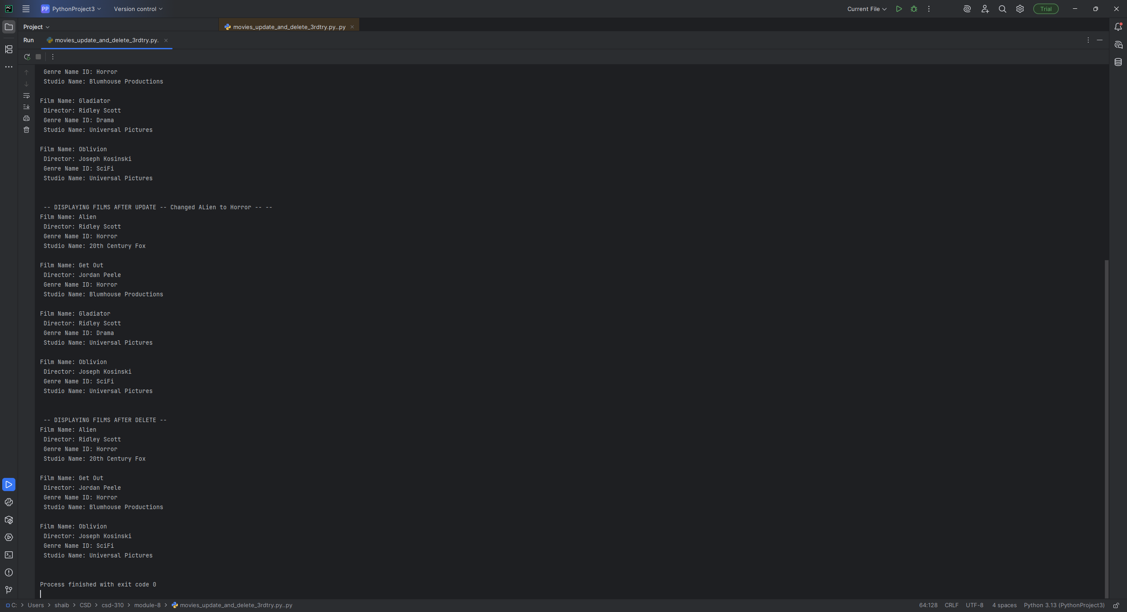

Git Hub: https://github.com/Rashair1/csd-310.git