Module 1

Robertson, Rashai

Bellevue University, CSD340

Assignment 1.2

6/1/2025

Git Hub:

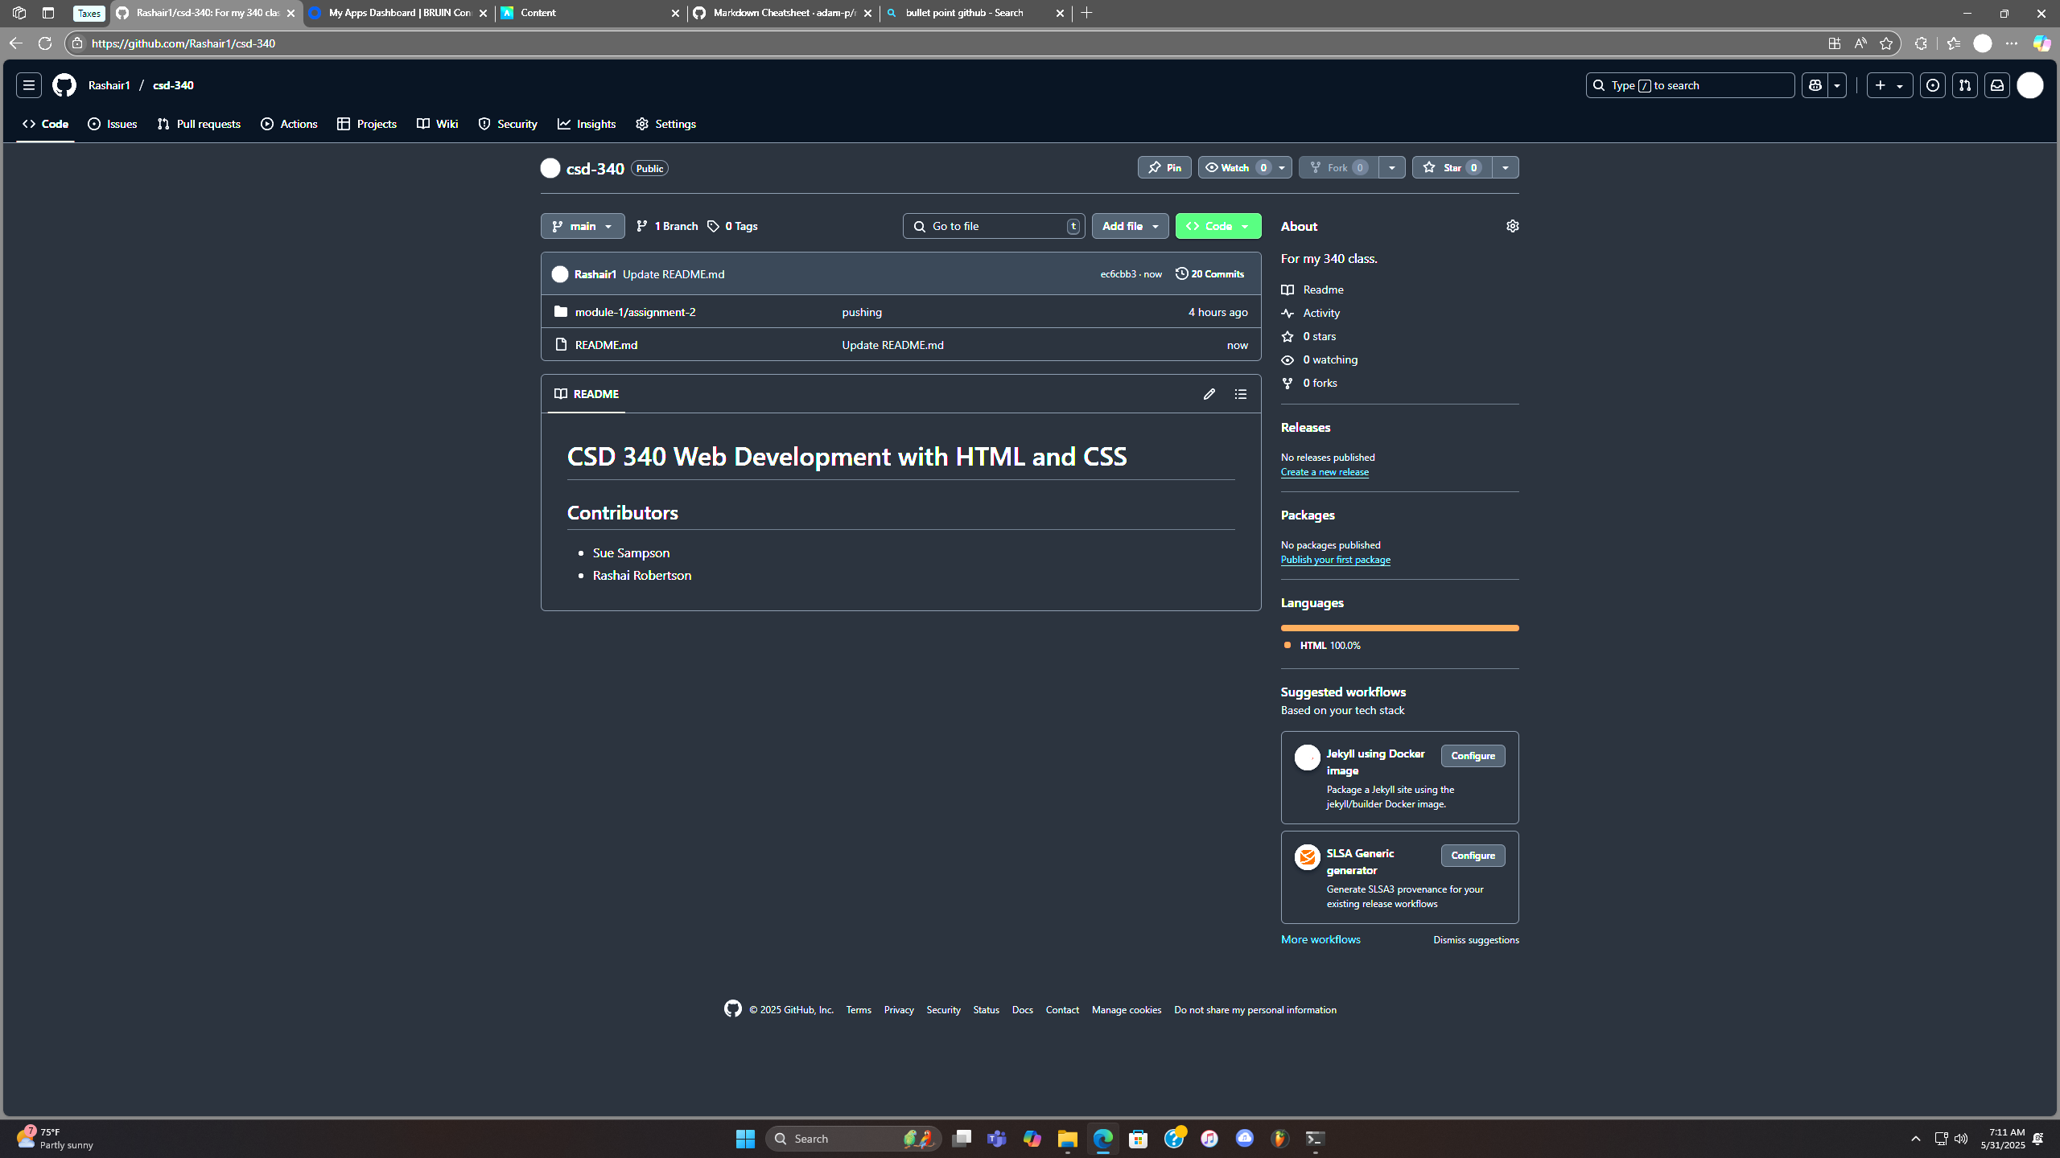

Local directory :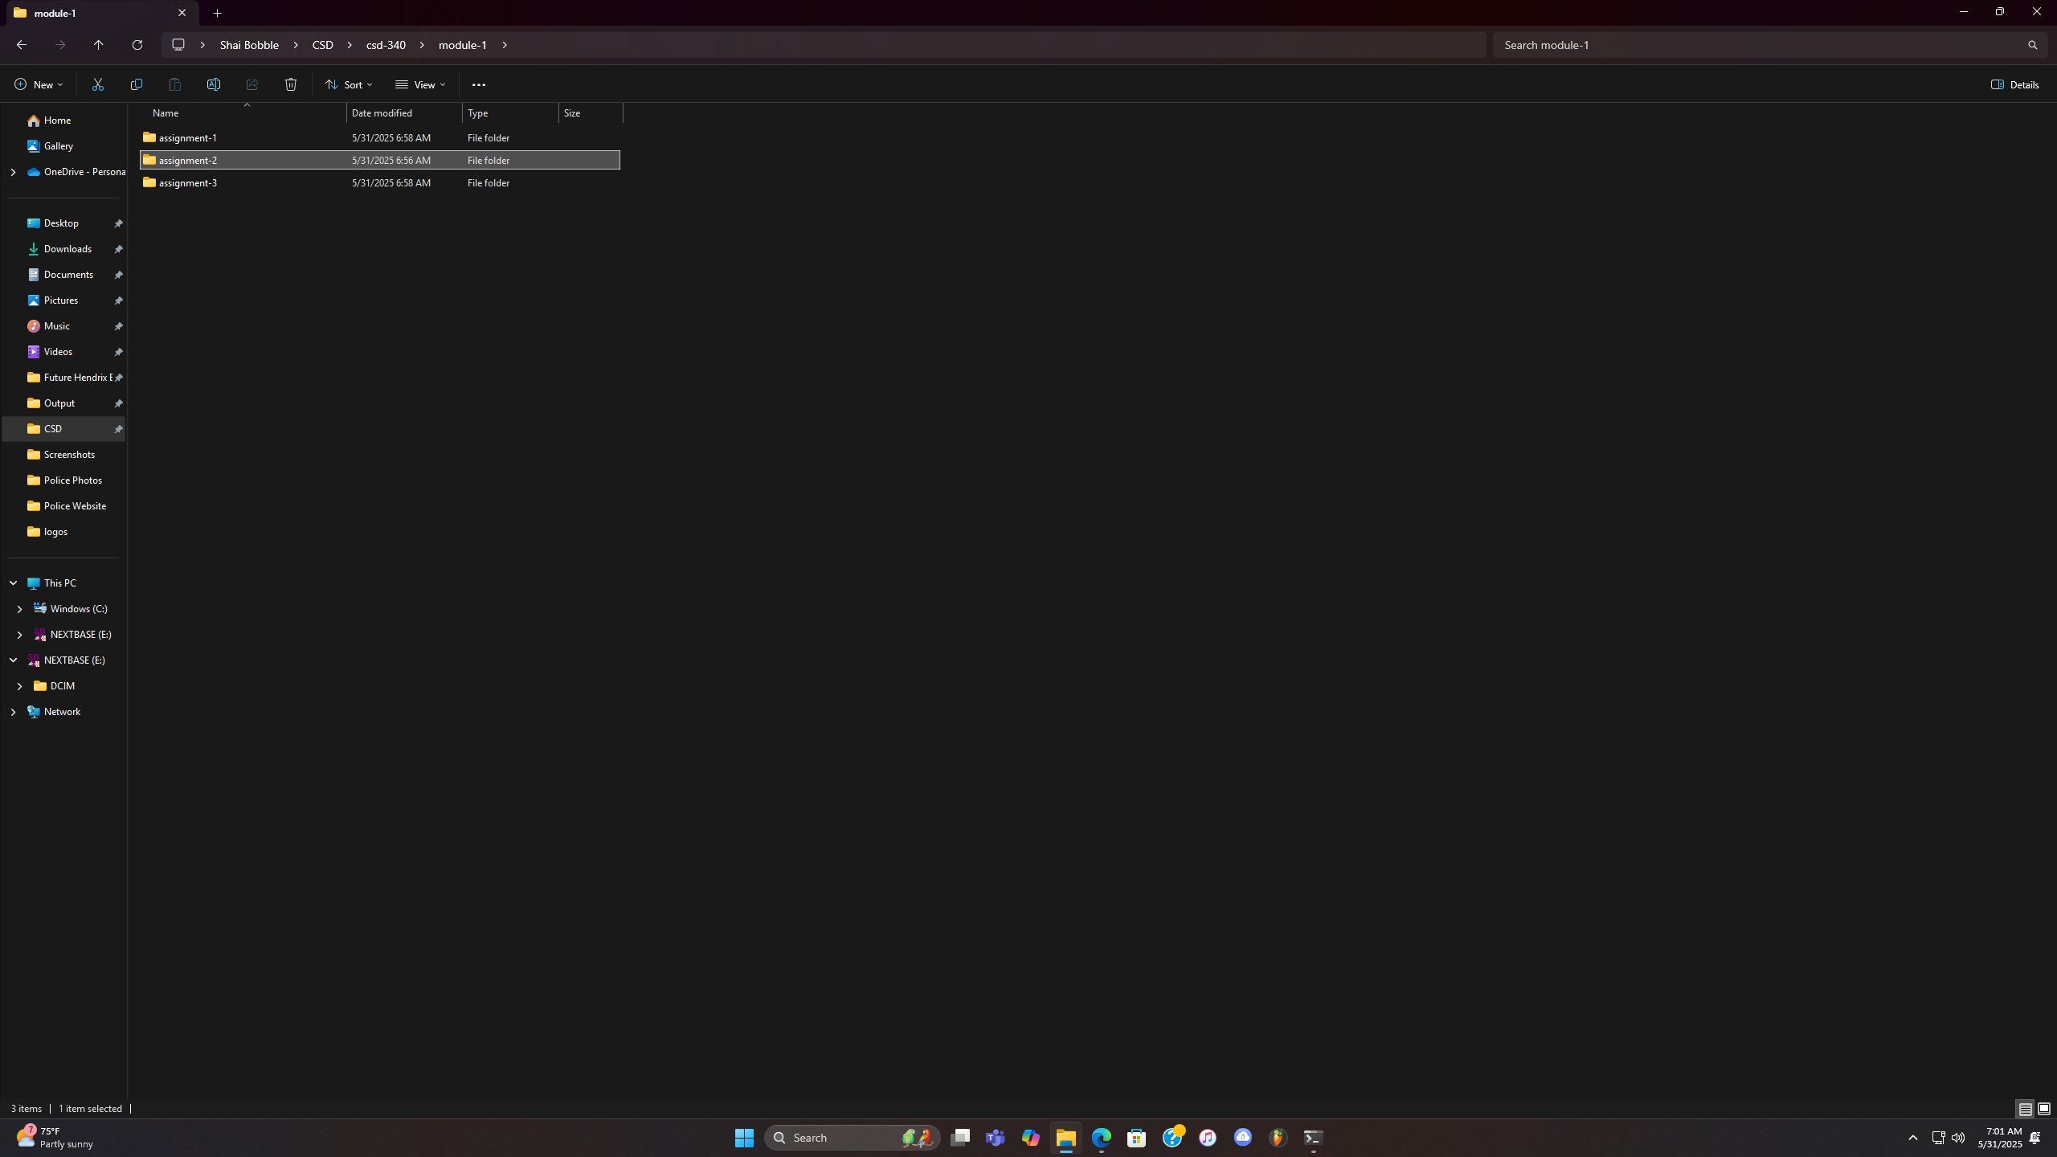

GitHub Link: https://github.com/Rashair1/csd-340.git