Module 1

Robertson, Rashai

Bellevue University, CSD340

Assignment 1.3

6/1/2025

Screen shot 1:

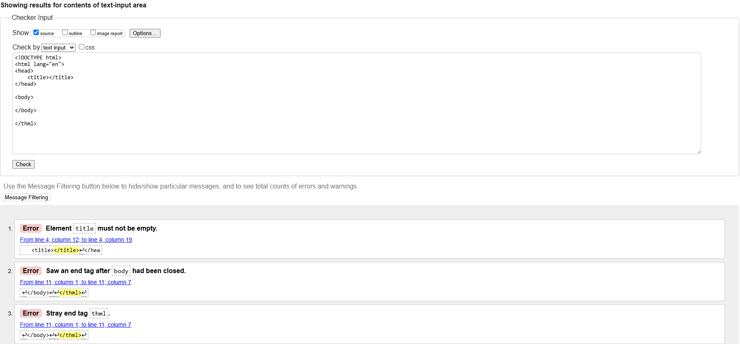

Screen shot 2: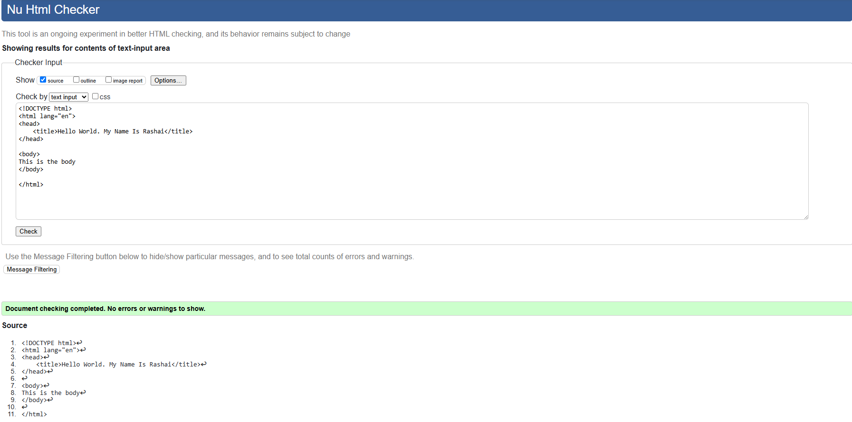

Screen shot 3: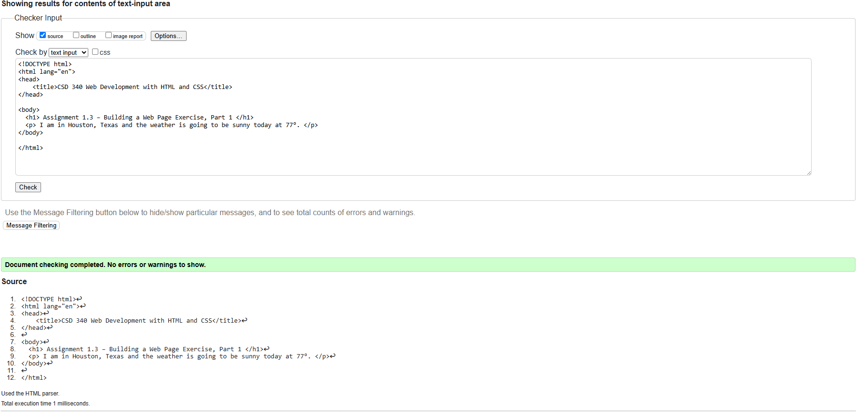Screen shot 4:

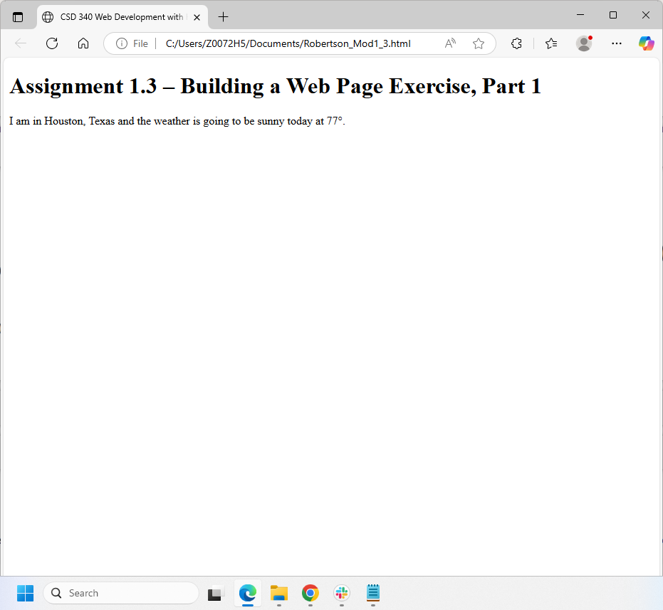

GitHub Link: https://github.com/Rashair1/csd-340.git