Project: Todo Application Test Plan
Course: CSD380 | Tester: Rashai Robertson
Description: Functional testing for the Todo web application
Date: 2026/06/24
To complete the test case plan, fill out the information for Project, Course, Description and Date in the header below.

TABLE OF CONTENTS
Verify Todo Website Loads Correctly 3
Create a New Todo Task Item 4
Edit an Existing Todo Task Item 5
Delete a Todo Task Item 7
Prevent Blank Todo Task Submission 8

For each test, the developer should: provide a test description, a test objective, the developer name and date tested. For each step, fill out the actions to be taken and describe the expected results, and indicate yes or no for each step depending upon the result. The peer tester should provide their name, date tested, indicate yes or no for each step depending upon the result, and a screenshot (thumbnail) of the result.

Test 1 | Verify Todo Website Loads Correctly
 | Test Objective: Verify that users can access the Todo application through standard website URL | Developer: Alexander Baldree  Date tested: 2026/06/24 | Peer tester: Rashai R.  Date tested: 2026/06/27
Step | Action | Expected results: | Developer pass/fail | Tester pass/fail  + Screenshot
1 | Open a web browser | Browser opens successfully | Yes | Yes  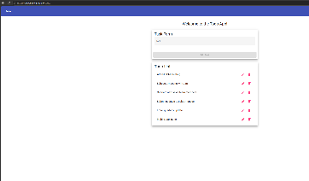
2 | Visit https://buwebdev.github.io/todo/ | Todo application page loads without errors | Yes | Yes  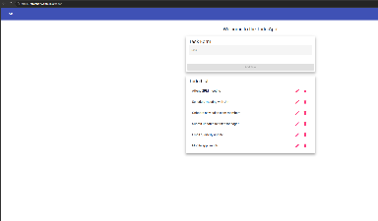
3 | Confirm the Todo list interface is visible | User can see the Todo list page and task input area | Yes | Yes  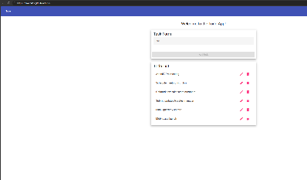
4 | Refresh the browser window | Page reloads correctly without errors | Yes | Yes  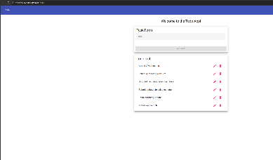
5 | Confirm the page still displays correctly after refresh | Todo application remains usable after reload | Yes | Yes  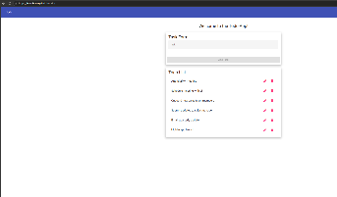
Comments | This test confirms that the Todo Website can be reached through the required URL. The page loaded correctly and continued to work after being refreshed.  I was able to access the website. The application loaded as expected.

Test 2 | Create a New Todo Task Item
 | Test Objective: Verify that a user can create a new todo task item | Developer: Alexander Baldree  Date tested: 2026/06/24 | Peer tester: Rashai R.  Date tested: 2026/06/27
Step | Action | Expected results: | Developer pass/fail | Tester pass/fail
1 | Open the Todo application website | Todo application loads successfuly | Yes | Yes  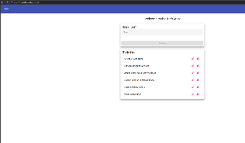
2 | Click inside the task input field | Cursor appears inside the input field | Yes | Yes  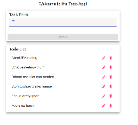
3 | Type a new task “Complete test plan assignment” | The typed text appears in the input field | Yes | Yes  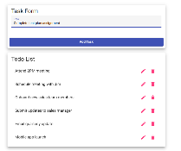
4 | Click the button to add or submit the task | The new task is added to the Todo list | Yes | Yes  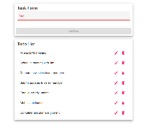
5 | Review the Todo list | The new task is visible in the list | Yes | Yes  
Comments | This test checks that users can add a new task to the Todo lists. The application should accept the task and display it in the task list after submission.  The task app allows me to create a new task. One thing I noticed is the cursor disappears when screenshotting/

Test 3 | Edit an Existing Todo Task Item
 | Test Objective: Verify that a user can update or edit an existing todo task item | Developer: Alexander Baldree  Date tested: 2026/06/24 | Peer tester: Rashai R.  Date tested: 2026/06/27
Step | Action | Expected results: | Developer pass/fail | Tester pass/fail
1 | Open the Todo application website | Todo application loads successfully | Yes | Yes  
2 | Create a new task if no task is already available | A task appears in the Todo list | Yes | Yes  
3 | Select the edit option for the task | The task opens for editing | Yes | Yes  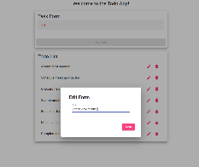
4 | Change the task to “Updated todo task.” | Updated text appears in the edit field | Yes | Yes  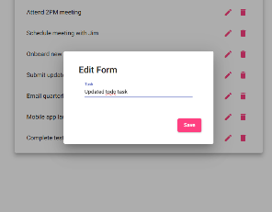
5 | Save or submit the edited task | The Todo lis displays the updated task text | Yes | Yes  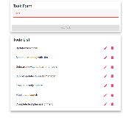
Comments | This test verifies that users can make changes to an existing task. The task should be updated correctly and show the new text after saving.  I was able to open the application perfectly. After opening, the edit function worked well, and making a new name was also a smooth process. Except that a blank name can be entered.

Test 4 | Delete a Todo Task Item
 | Test Objective: Verify that a user can delete a todo task item from the list | Developer: Alexander Baldree  Date tested: 2026/06/24 | Peer tester: Rashai R.  Date tested: 2026/06/27
Step | Action | Expected results: | Developer pass/fail | Tester pass/fail
1 | Open the Todo application website | Todo application loads successfully | Yes | Yes  
2 | Create a new task if no task is already available | A task appears in the Todo list | Yes | Yes  
3 | Locate the delete option for the task | Delete option is visible or available | Yes | Yes  
4 | Click the delete option | The selected task is removed from the list | Yes | Yes  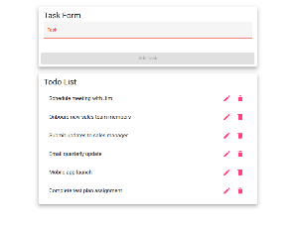
5 | Review the Todo list | Deleted task no longer appears | Yes | Yes  
Comments | This test checks that users can remove tasks from the Todo list. The deleted item should no longer be visible after the delete action is completed.  The task- updated task was successfully removed after pressing the delete button. I feel a conformation notification should appear before and after deleting.

Test 5 | Prevent Blank Todo Task Submission
 | Test Objective: Verify that the application does not allow users to submit a blank todo item | Developer: Alexander Baldree  Date tested: 2026/06/24 | Peer tester: Rashai R.  Date tested: 2026/06/27
Step | Action | Expected results: | Developer pass/fail | Tester pass/fail
1 | Open the Todo application website | Todo application loads successfully | Yes | Yes  
2 | Leave the todo task input field blank | Input field remains empty | Yes | Yes  
3 | Click the add or submit button | Application prevents the blank task from being submitted | Yes | No  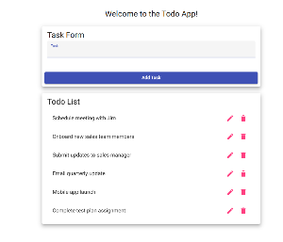
4 | Review the Todo list | No blank task appears in the list | Yes | No  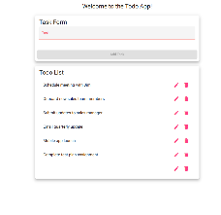
5 | Enter a valid task afterward and submit it | Valid task is accepted and appears in the list | Yes | Yes
Comments | This test confirms that blank tasks cannot be added to the Todo list. This helps prevent invalid or empty data from being submitted into the application.  This app will allow blank submissions in the form of four spaces. It also allows blank submissions by creating a task then editing it and erasing the name.

