Sara White –
CSD-380
Assignment 4.2

Tester: Rashai R.
2026/06/28

Test 1 | Create a new todo task item
 | Test Objective: Verify that a user can enter a valid task item (four or more characters) and add it to the Todo List. | Developer:  Date tested: <yyyy/mm/dd> | Peer tester: Rashai R.  Date tested: 2026/06/27
Step | Action | Expected results: | Developer pass/fail | Tester pass/fail
1 | Go to https://buwebdev.github.io/todo/ | The website should load successfully | <yes/no> | Yes  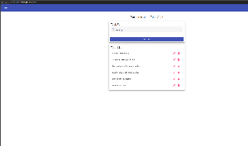
2 | Type in a task item (you can type “Test task item” | Add task button should remain grey/unclickable until at least 4 characters have been entered into the task form field | <yes/no> | Yes  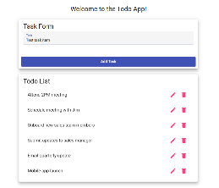
3 | Click “add task” | After clicking “add task” the new task item should be added to the bottom of the todo list | <yes/no> | Yes  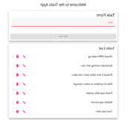
Comments | The app opened well when going to the website. When I wanted to add a new task, the app allowed me to by typing a name and clicking add task. The task appeared perfectly.

Test 2 | Delete a todo task item
 | Test Objective:  Verify that a user can remove an existing task item from the Todo List | Developer:  Date tested: <yyyy/mm/dd> | Peer tester: Rashai R.  Date tested: 2026/06/27
Step | Action | Expected results: | Developer pass/fail | Tester pass/fail
1 | Go to https://buwebdev.github.io/todo/ | The website should load successfully | <yes/no> | Yes  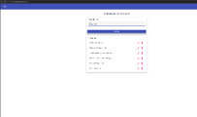
2 | Click the trashcan icon to the right of a Todo List task item | Task item should disappear from Todo List | <yes/no> | Yes  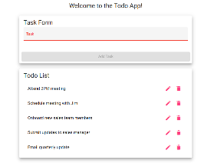
Comments | The app opened well when going to the website. I was able to delete the last task at hand by pressing the trashcan button.

Test 3 | For invalid URLs, provide users with a custom 404 error page
 | Test Objective:  Verify that a custom 404 message displays when an invalid Todo website URL is entered | Developer:  Date tested: <yyyy/mm/dd> | Peer tester: Rashai R.  Date tested: 2026/06/27
Step | Action | Expected results: | Developer pass/fail | Tester pass/fail
1 | Go to https://buwebdev.github.io/todo/404test | The site does not load a regular Todo page | <yes/no> | Yes  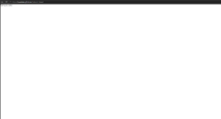
2 | Confirm a custom 404 message is displayed | User should see a custom 404 message (“not-found works!”) instead of a generic browser error | <yes/no> | Yes  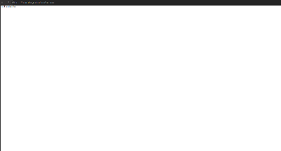
Comments | The app defaulted to the custom 404 page when trying to access a random page. This happens when typing any page not in the repo.

Test 4 | Prevent users from submitting a task form without entering a todo item
 | Test Objective:  Verify that the task form prevents a user from submitting a task item that is less than four characters. | Developer:  Date tested: <yyyy/mm/dd> | Peer tester: Rashai R.  Date tested: 2026/06/27
Step | Action | Expected results: | Developer pass/fail | Tester pass/fail
1 | Go to https://buwebdev.github.io/todo/ | The website should load successfully | <yes/no> | Yes  
2 | Click inside the Task Form input field | Placeholder text (“Task”) should shrink above caret | <yes/no> | Yes  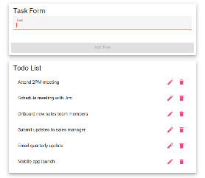
3 | Type “123” into the Task Form | “Add task” button should remain grey and inactive | <yes/no> | Yes  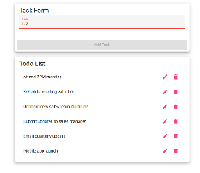
5 | Click “add task” | Nothing should happen. | <yes/no> | Yes  
Comments | The app opened well when going to the website. When I went to add 123 the app did not let me submit the task, and the button remained inactive.

Test 5 | Prevent users from submitting the edit form without entering a todo item
 | Test Objective:  Verify that the task form within the edit popup prevents a user from submitting a task item that is less than four characters. | Developer:  Date tested: <yyyy/mm/dd> | Peer tester: Rashai R.  Date tested: 2026/06/27
Step | Action | Expected results: | Developer pass/fail | Tester pass/fail
1 | Go to https://buwebdev.github.io/todo/ | The website should load successfully and task items should be present in the Todo List | <yes/no> | Yes  
2 | Click the edit icon to the right of one of the task items in the Todo List | Edit Form will pop up in the center of the page with the current task item in the input field | <yes/no> | Yes  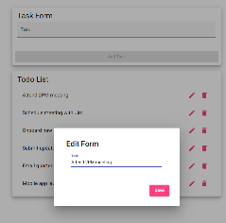
3 | Delete the text in the task item field (do not type anything into the field) | User should be able to delete the existing task item and the “save” button should appear grey | <yes/no> | No  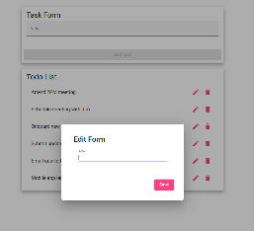
4 | Click the “save” button in the bottom right corner | Nothing should happen. The “save” button should not be clickable and should only be active and appear dark pink if four or more characters have been entered in the task item field | <yes/no> | No  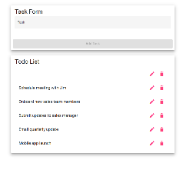
Comments | The website loaded properly with the app. The edit function also worked properly. Once I began to edit, tasks began to fail as I was able to delete the name of a task and save it as blank. Also, shouldn’t accept less than 4 characters.

