Module 1

Robertson, Rashai

Bellevue University, CSD402

Assignment 2

6/1/2025

Git Hub:

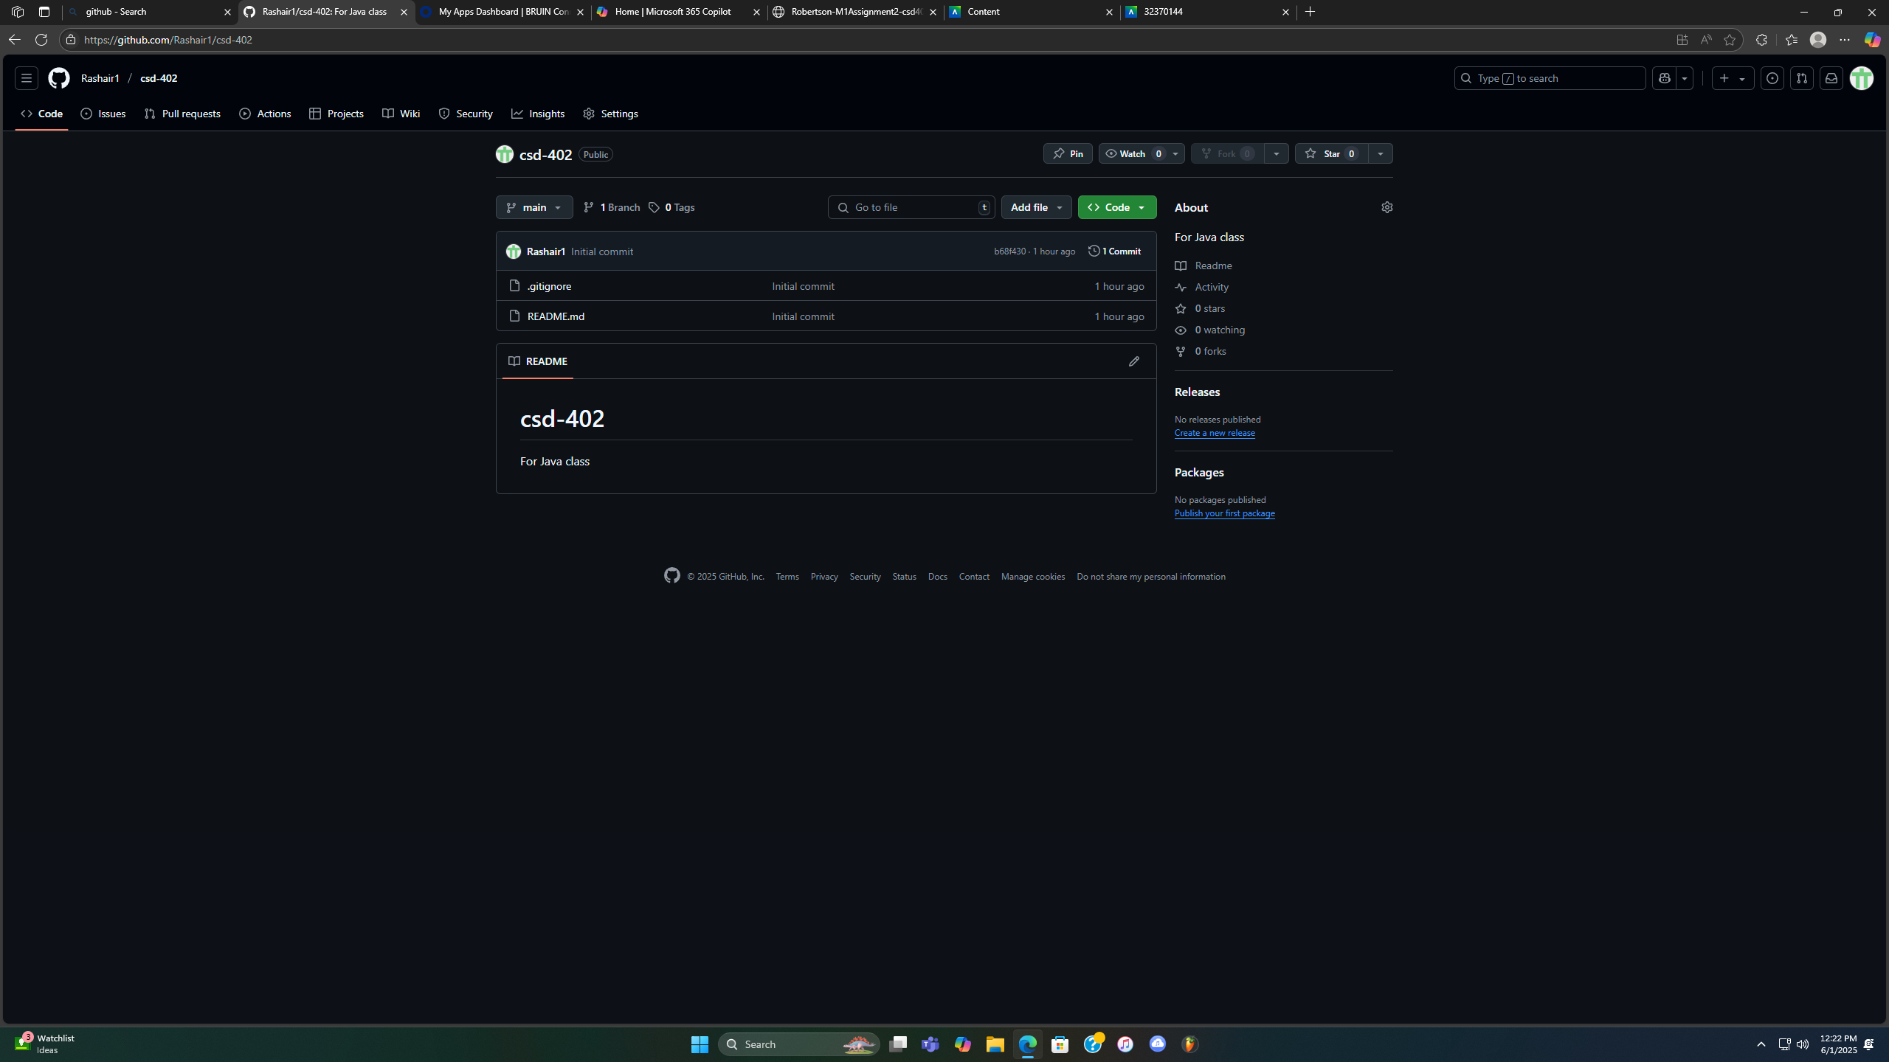

Local directory :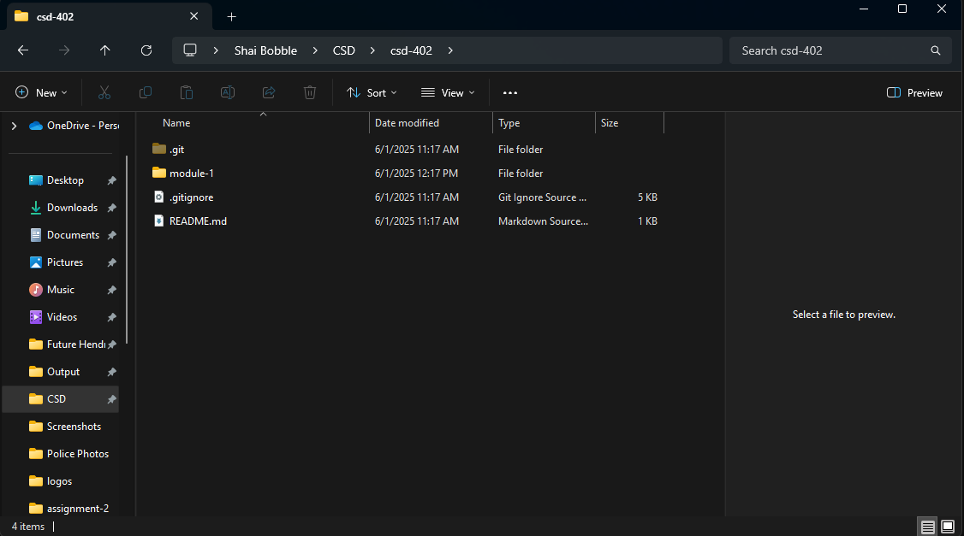

GitHub Link: <https://github.com/Rashair1/csd-340.git>

