Heart Disease Risk Prediction — MLOps Pipeline
  - AIMLCZG523 Assignment 01
Rashampreet Singh
July 2026

1. Project Overview
This project implements an end-to-end MLOps pipeline for predicting heart disease risk from patient clinical data, using the UCI Heart Disease dataset (Cleveland subset, 303 patients, 13 clinical features). The scope covers data acquisition and cleaning, model training with experiment tracking, automated testing and CI/CD, containerization, Kubernetes deployment, and monitoring.
Repository: https://github.com/Rashampreet4114/heart-disease-mlops
Three models were trained and compared (Logistic Regression, Random Forest, and XGBoost) rather than the minimum two required. The target variable was reframed from the raw multi-class severity scale (0–4) to a binary disease/no-disease label, consistent with the assignment’s risk-prediction framing. Monitoring uses a lightweight custom logging and metrics dashboard rather than a full Prometheus/Grafana stack, scaled to match its weight in the grading rubric.

1.1 Architecture
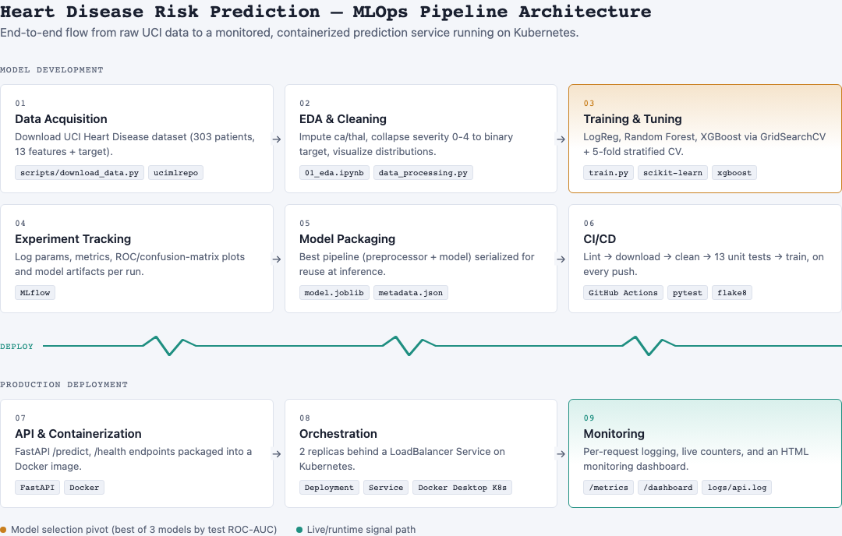
Architecture diagram
The pipeline is organized into two stages. The model development stage — data acquisition through CI/CD — runs on every code push. The production deployment stage — API, container, orchestration, monitoring — serves the trained model.

2. Setup / Install Instructions
# 1. Clone and enter the repo
git clone https://github.com/Rashampreet4114/heart-disease-mlops.git
cd heart-disease-mlops
# 2. Create an isolated virtual environment
python3 -m venv venv
source venv/bin/activate
pip install -r requirements.txt
# 3. Run the pipeline
python scripts/download_data.py # download raw dataset -> data/raw/
python -m src.data_processing # clean + binarize target -> data/processed/
python -m src.train # train, tune, MLflow-track, save best model
flake8 src/ api/ tests/ scripts/ # lint
pytest tests/ -v # 13 unit tests
# 4. Run the API
uvicorn api.main:app --host 0.0.0.0 --port 8000
# Swagger UI: http://localhost:8000/docs
# 5. Docker
docker build -t heart-disease-api:latest .
docker run -d -p 8000:8000 heart-disease-api:latest
# 6. Kubernetes (Docker Desktop Kubernetes or Minikube)
kubectl apply -f k8s/deployment.yaml -f k8s/service.yaml
kubectl port-forward svc/heart-disease-api-service 8080:80
Additional setup detail, including the access-instruction caveat for the local Kubernetes LoadBalancer, is documented in the repository’s README.md.

3. Data Acquisition & EDA
The dataset is retrieved programmatically via ucimlrepo (scripts/download_data.py) rather than committing a manually downloaded file, keeping the repository reproducible from a clean clone. It contains 303 patient records with 13 features — age, sex, chest pain type, resting blood pressure, cholesterol, fasting blood sugar, resting ECG, max heart rate, exercise angina, ST depression, slope, number of major vessels, and thalassemia — plus a target column.
Cleaning: the raw num column is a 0–4 severity scale. It was collapsed into a binary target column (0 = no disease, 1 = disease present) to match the assignment’s risk-classification framing. Two columns had missing values — ca (4 rows) and thal (2 rows) — imputed with median and mode respectively, appropriate given the small sample size.
EDA findings (full notebook: notebooks/01_eda.ipynb):
- Class balance is reasonable after binarization (approximately 54% no-disease, 46% disease), so accuracy is a meaningful metric alongside precision, recall, and ROC-AUC.
- cp (chest pain type), thalach (max heart rate), oldpeak (ST depression), ca (major vessels), and thal show the strongest correlation with the target and the clearest separation between classes in the box and count plots.
- age, chol, and trestbps correlate weakly with the target on their own but were retained, since tree-based models capture non-linear interactions that a linear correlation coefficient does not.
Missing values | Class balance | Correlation heatmap
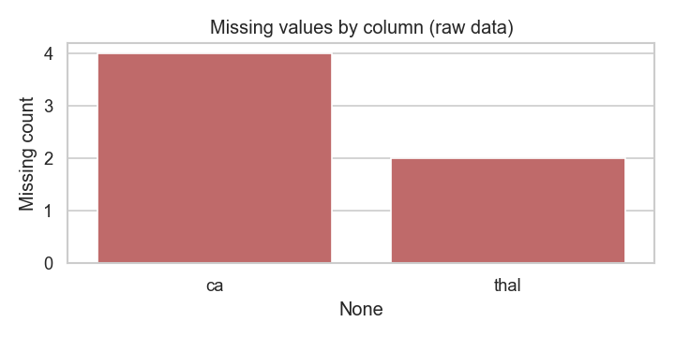 | 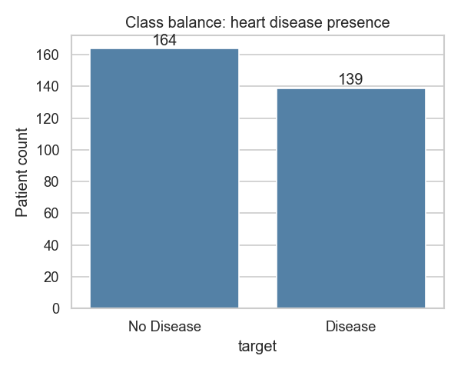 | 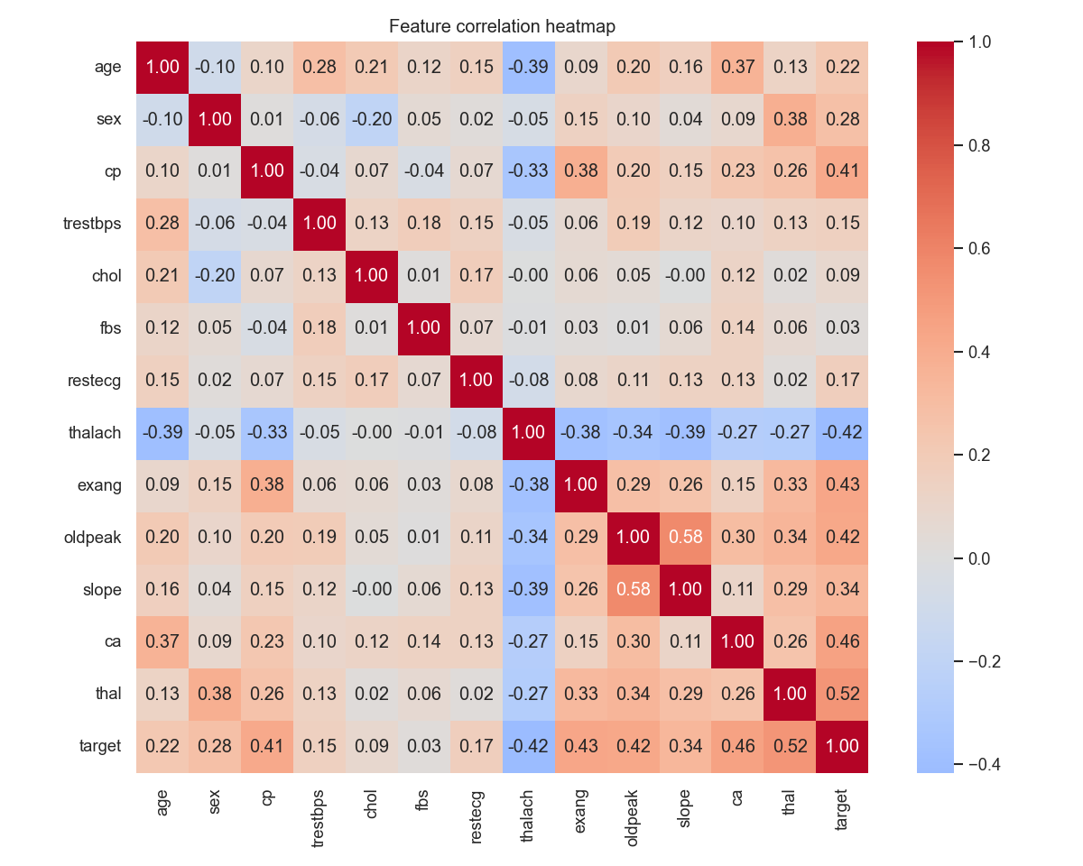
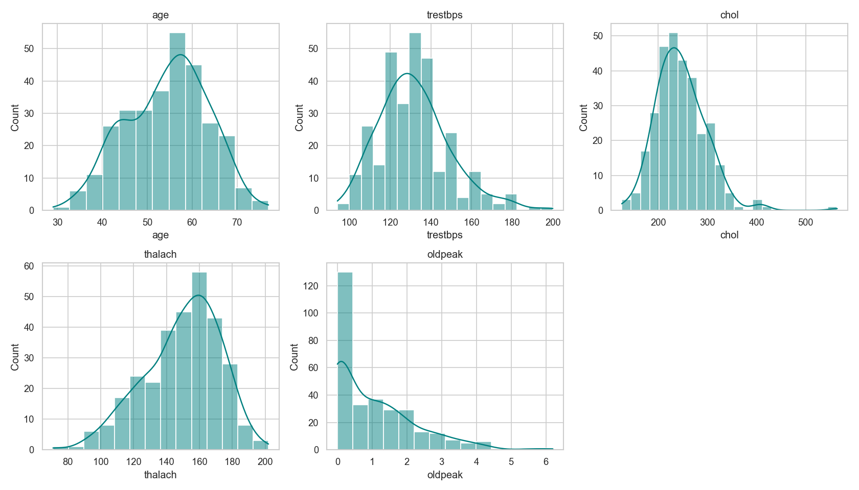
Feature histograms
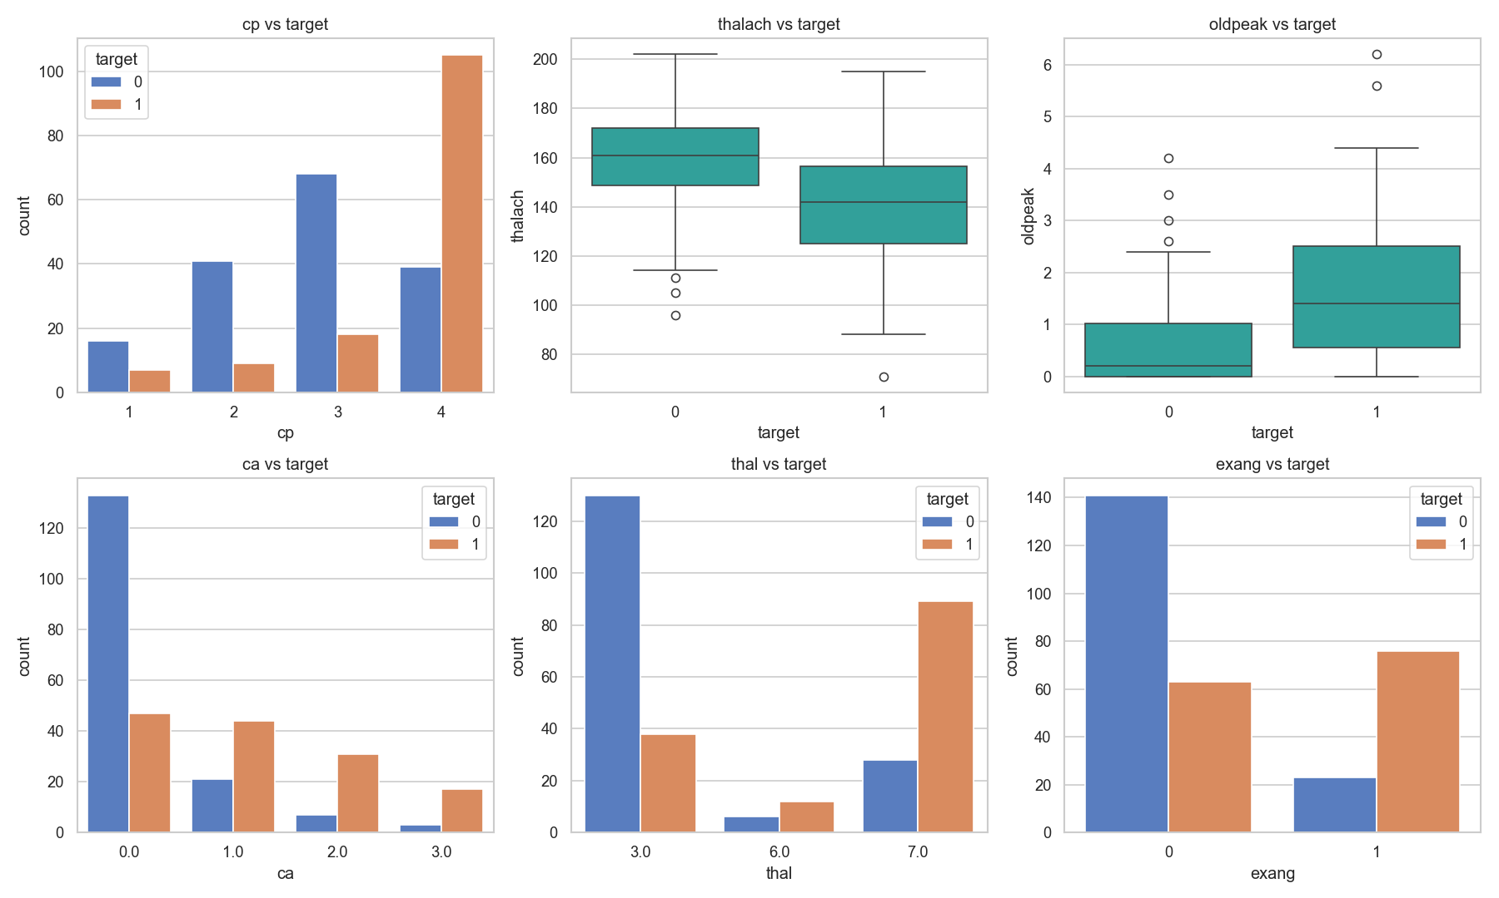
Feature relationships with target

4. Feature Engineering & Model Development
Preprocessing (src/pipeline.py) uses a ColumnTransformer with three feature groups:
- StandardScaler on continuous features: age, trestbps, chol, thalach, oldpeak, ca
- OneHotEncoder(drop="first") on multi-valued categorical features: cp, restecg, slope, thal
- sex, fbs, and exang pass through unchanged, as they are already binary
Three classifiers were trained and tuned with GridSearchCV over 5-fold stratified cross-validation, optimizing for ROC-AUC:
Model | Best hyperparameters | CV ROC-AUC | Test accuracy | Test precision | Test recall | Test F1 | Test ROC-AUC
Logistic Regression | C=1, solver=lbfgs | 0.909 | 0.852 | 0.806 | 0.893 | 0.847 | 0.957
Random Forest (best) | max_depth=3, min_samples_leaf=4, n_estimators=200 | 0.897 | 0.918 | 0.897 | 0.929 | 0.912 | 0.973
XGBoost | learning_rate=0.01, max_depth=3, n_estimators=100 | 0.878 | 0.869 | 0.885 | 0.821 | 0.852 | 0.936
Random Forest was selected as the final model, based on the highest test ROC-AUC (0.973) and the best balance of precision and recall. Logistic Regression scored marginally higher on cross-validated ROC-AUC alone (0.909 vs. 0.897), which illustrates that CV performance and held-out test performance can diverge on a dataset of this size. Both figures are reported rather than selecting the final model on CV score alone.
Confusion matrices | ROC curves
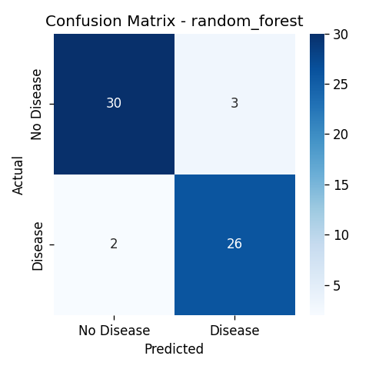 | 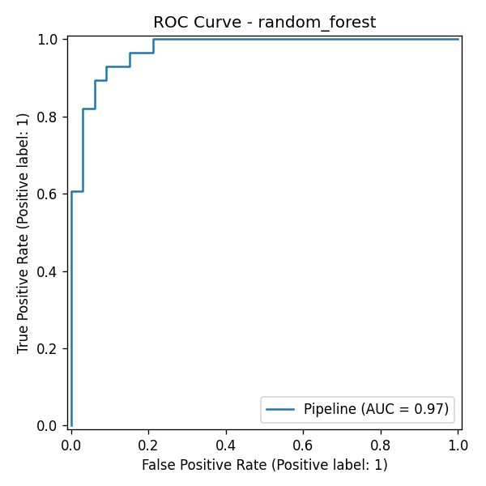
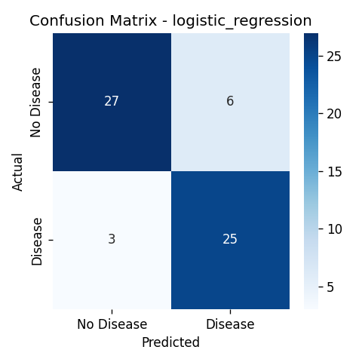 | 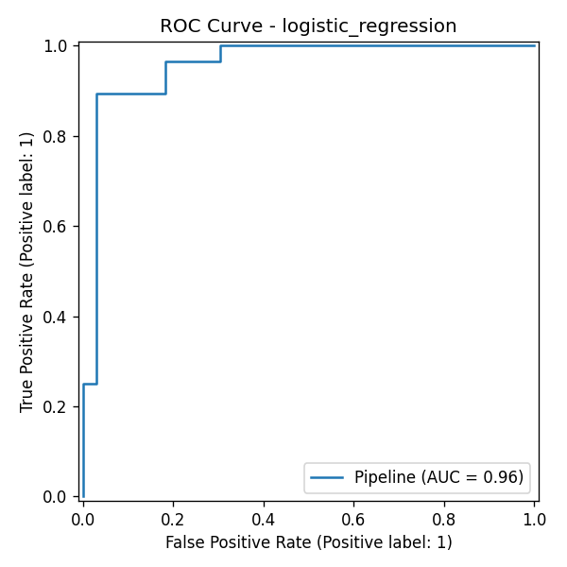
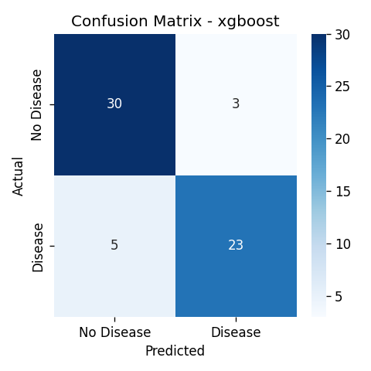 | 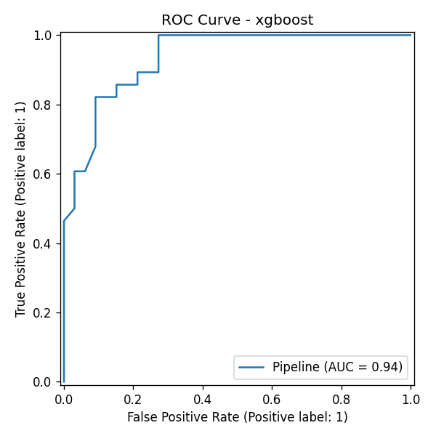

5. Experiment Tracking (MLflow)
Every training run is logged to MLflow under the heart-disease-classification experiment (src/train.py):
- Parameters: the best hyperparameters selected by GridSearchCV for each model
- Metrics: CV ROC-AUC mean and standard deviation, plus test accuracy, precision, recall, F1, and ROC-AUC
- Artifacts: the confusion matrix plot, the ROC curve plot, and the serialized sklearn pipeline for that run
Runs can be browsed and compared with mlflow ui (http://127.0.0.1:5000).

6. Model Packaging & Reproducibility
The final pipeline — preprocessing and model combined into a single sklearn.Pipeline object — is serialized with joblib to models/model.joblib. Alongside it, models/metadata.json records the selected model and the metrics for all three candidates. Bundling preprocessing and model together ensures the API replays the exact transformation used during training, without a separate, potentially inconsistent implementation at inference time. Dependencies are pinned in two files: requirements.txt for the full development and training environment, and requirements-api.txt containing only what the Docker image requires.

7. CI/CD Pipeline & Automated Testing
Tests (tests/, 13 total, Pytest) cover three areas: data cleaning correctness (missing-value imputation, binary target conversion, row-count consistency), preprocessing pipeline behavior (including handling of categories not seen during training), and API behavior (valid and invalid /predict requests, /health, /metrics).
CI (.github/workflows/ci.yml, GitHub Actions) runs: lint with flake8, download the dataset, clean the data, run the unit tests, then train and log to MLflow, uploading test results, the trained model, and MLflow run artifacts. An ordering issue was identified during setup: the initial workflow ran unit tests before downloading the dataset, which passed locally only because the raw CSV was already present from earlier manual runs, but failed on a fresh GitHub Actions runner with a FileNotFoundError, since data/raw/*.csv is intentionally git-ignored. Reordering the steps so data acquisition runs before the test step resolved this, and the corrected pipeline was verified end-to-end on a clean runner.
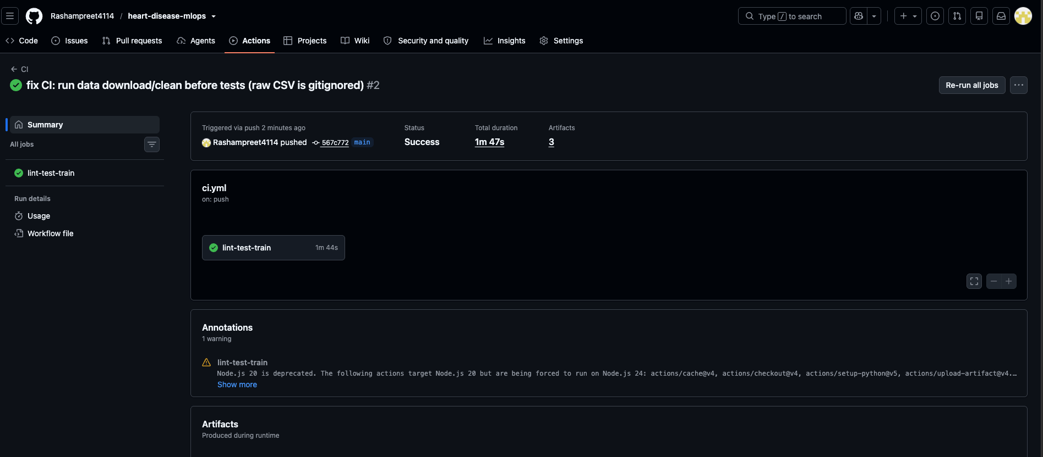
CI pipeline passing
A self-contained, interactive HTML test report (13/13 passing) is included at screenshots/pytest_report.html in the repository.

8. Model Containerization
The FastAPI service (api/main.py) exposes:
- POST /predict — accepts patient features as JSON, returns a prediction, label, and confidence score
- GET /health — liveness/readiness check
- GET /metrics — request and prediction counters as JSON
- GET /dashboard — an HTML view of the same counters
- GET /docs — auto-generated Swagger UI
The Dockerfile builds on python:3.11-slim and installs only requirements-api.txt, keeping the image free of training-only dependencies such as Jupyter and MLflow. The image was built and run locally to confirm correct operation:
docker build -t heart-disease-api:latest .
docker run -d --name heart-disease-api -p 8000:8000 heart-disease-api:latest
curl -X POST http://localhost:8000/predict -H "Content-Type: application/json" -d '{...}'
# -> {"prediction": 0, "label": "No Disease", "confidence": 0.6509}
This result matched the prediction obtained from the same request run directly (without Docker) and later through the Kubernetes deployment, confirming consistent behavior across environments.
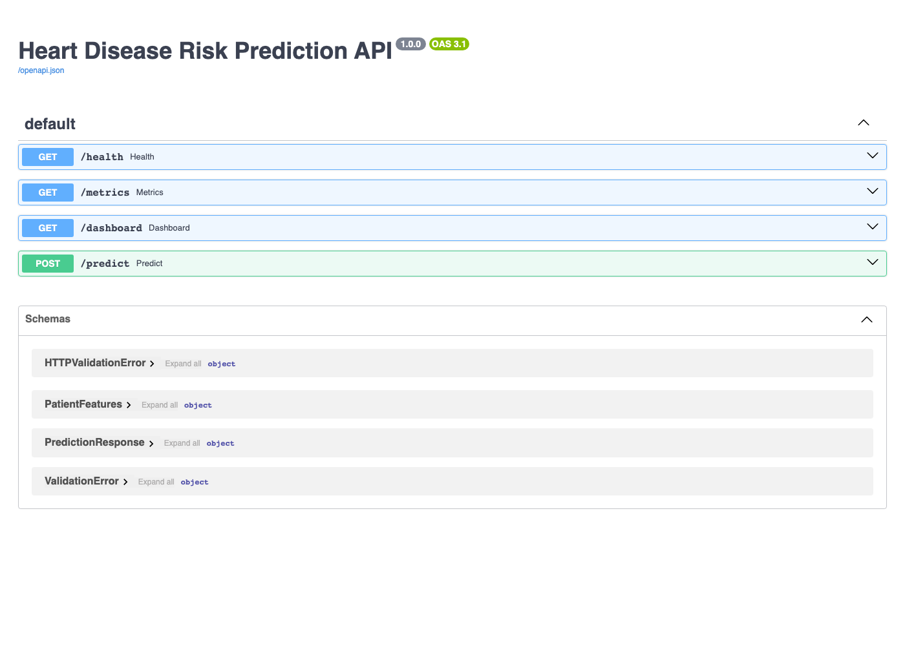
Swagger UI
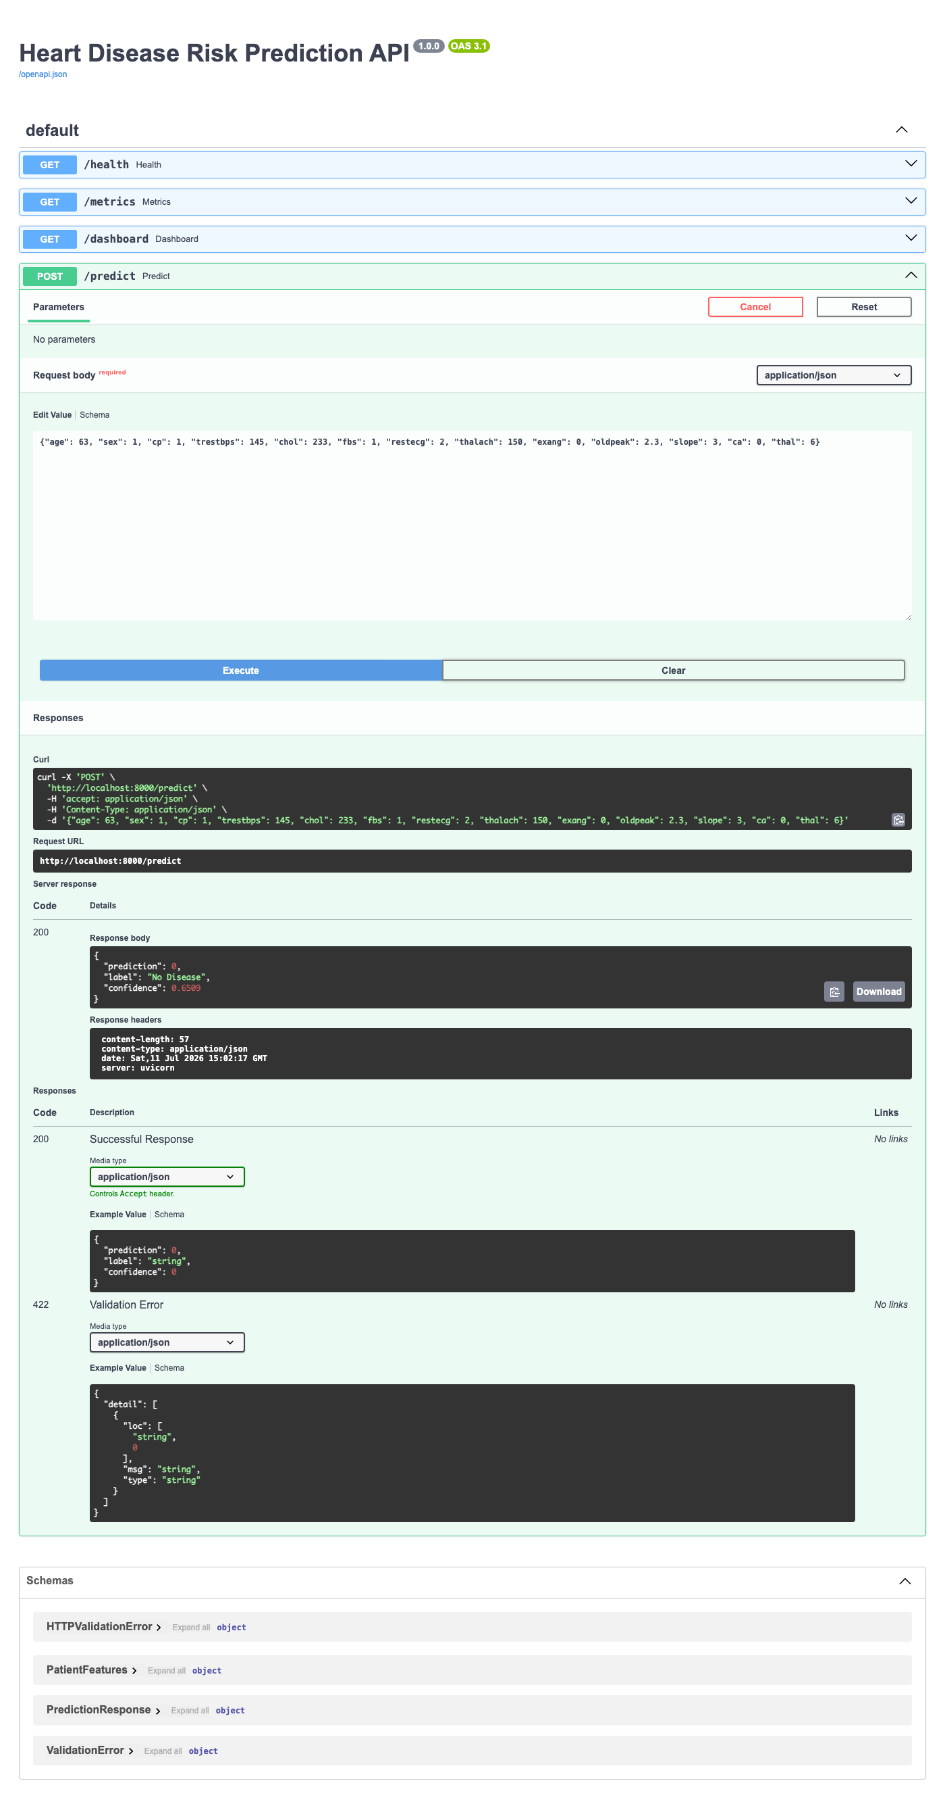
Live prediction via Swagger

9. Production Deployment
The API is deployed to Docker Desktop’s built-in Kubernetes cluster (k8s/deployment.yaml, k8s/service.yaml): 2 replicas behind a LoadBalancer Service, with readiness and liveness probes against /health.
kubectl apply -f k8s/deployment.yaml -f k8s/service.yaml
kubectl get pods,svc
On Docker Desktop’s local cluster, the EXTERNAL-IP assigned to the Service is not routable from the host, since there is no cloud load balancer backing it. Verification was therefore performed using kubectl port-forward svc/heart-disease-api-service 8080:80, which is also documented in the README as the access path for local grading. On a managed cloud cluster (EKS, GKE, or AKS), the external IP would be reachable directly.
NAME READY STATUS RESTARTS AGE
pod/heart-disease-api-b9ccfc57f-k8zjz 1/1 Running 0 110s
pod/heart-disease-api-b9ccfc57f-t6x4g 1/1 Running 0 110s
NAME TYPE CLUSTER-IP EXTERNAL-IP PORT(S)
service/heart-disease-api-service LoadBalancer 10.96.14.53 172.18.0.5 80:31363/TCP
Both /health and /predict responded correctly through the Service, confirming that Kubernetes was load-balancing requests across both pods rather than routing to a single instance.

10. Monitoring & Logging
Each request is logged — method, path, status code, latency — to both logs/api.log and stdout, using Python’s standard logging module. In-memory counters (total requests, counts by status code, total predictions, counts by predicted class) are exposed at /metrics as JSON and rendered as a table at /dashboard. This covers the core signals — traffic volume, error rate, and prediction distribution — that would feed into a Prometheus/Grafana setup at larger scale, at a level of effort consistent with this component’s weight in the grading rubric.
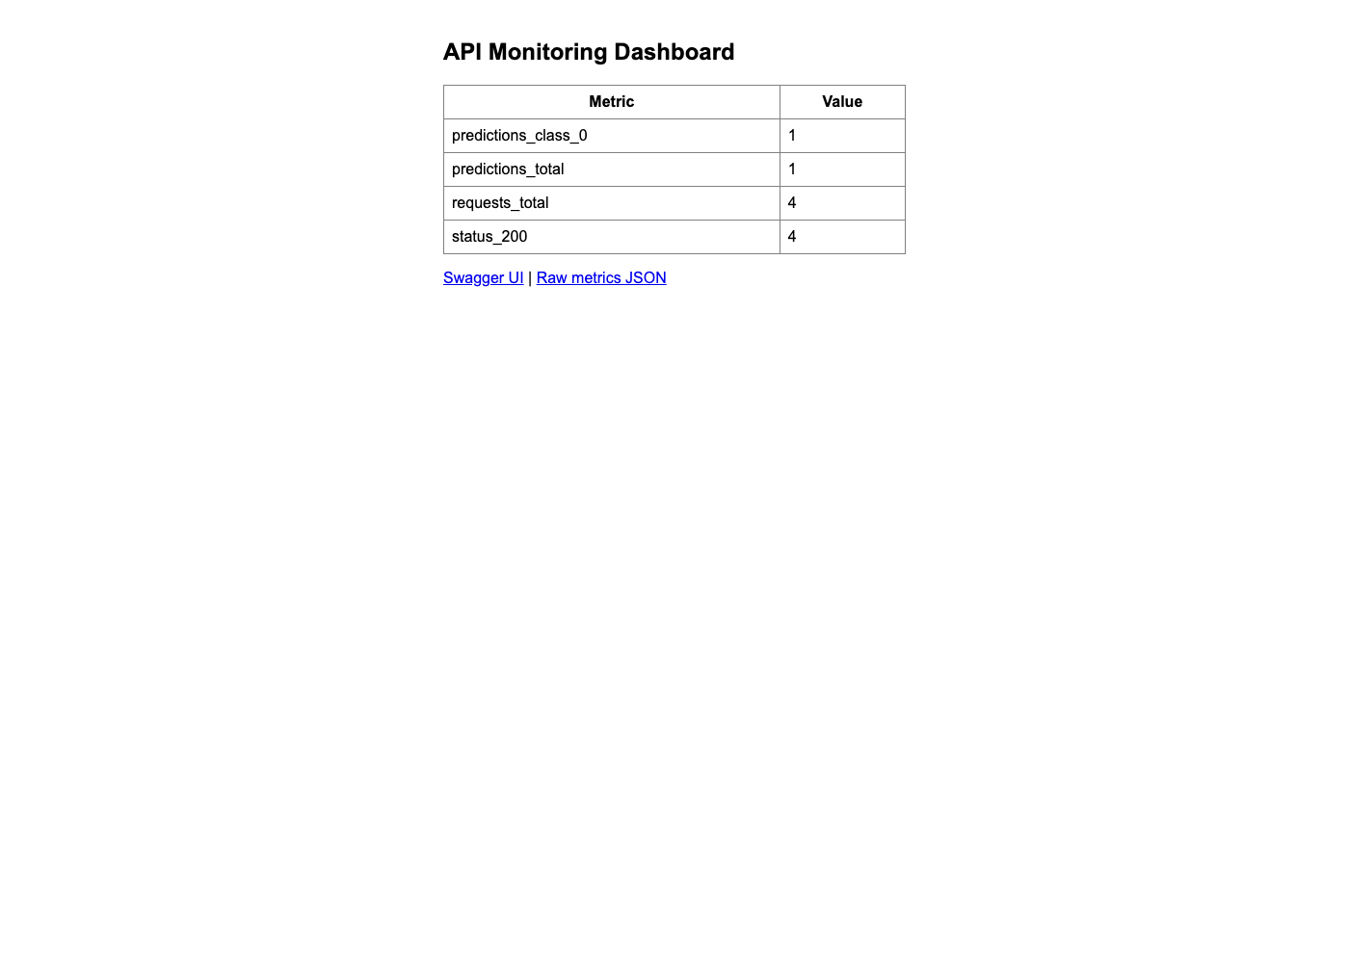
Monitoring dashboard

11. Conclusion
The pipeline addresses all nine assignment components: reproducible data acquisition and EDA, a tuned three-model comparison with cross-validation, MLflow tracking for every run, a packaged and reusable inference pipeline, a CI/CD pipeline that fails on error (and did so once during development, correctly surfacing a data-ordering bug), a containerized API verified with sample input, a Kubernetes deployment with a load-balanced Service, and request-level monitoring. Each component was verified in the environment it is intended to run in — locally, inside Docker, on the Kubernetes deployment, and on a clean GitHub Actions runner — before being considered complete.

