# Sri Lanka Institute of Information Technology

# Data Warehouse & Business Intelligence 2022

**Assignment 2**

Submitted By:

## **Wijerathna K.K.R.T.**

## **IT20017606**

**Contents**

# Step 1: Data source for the assignment 2………………………………………3

# ER……………………………………………………………………………………4

# Data Warehouse Design……………………………………………………………..5

# Step 2: SSAS Cube implementation……………………………………………7

# Step 3: Demonstration of OLAP operations…………………………………..14

# Step 4: SSRS Reports………………………………………………………….20

# Step 1: Data source for the assignment 2

* The selected data source is a collection of transactional data. The link to the source data set is mentioned below:

### <https://www.kaggle.com/datasets/nosbielcs/brazilian-delivery-center>

The data set derived from the source was modified as needed.

The dataset contains CSV files with information about orders data, deliveries data, customer data

and payment data. Modifications were made to the data set derived from the source as needed.

* **channel.csv - channel information of each channel**
* **deliveries.csv - delivery information of each delivery**
* **driver.csv - driver information of each driver**
* **hubs.csv - hubs information of each hub**
* **orders.csv - orders information of each order**
* **payments.csv - payments information of each payment**
* **stores.csv - stores information of each store**

All the data sources are provided as CSV files by the Kaggle.

Therefore, in the preparation of data sources, some CSV files were imported to the source database and added columns and separated some data to make other data files.

The final types of data sources are mentioned below:

* **SQL Database**
  + Customer
  + CustomerAddress
  + Customer Order
  + Deliveries
  + Drivers
  + Payments
  + Orders
* **CSV files**
  + channels.csv
  + hubs.csv
  + stores.csv

## ER Diagram

Above diagram shows the connection between entities

## Data Warehouse Design

Snowflake schema is used to design the Datawarehouse design. There is one fact table as transactions and 8-dimension tables including DimDate.

**Assumptions**

* DimCustomer is considered as a Slowly changing dimension

I used the Data Warehouse, I implemented and loaded with data in Assignment 01 as the source for the Assignment 02.

# Step 2: SSAS Cube implementation

* First, Created a new Analysis Services Multidimensional and Data Mining project in SSAS and created a Data Source and a Data Source View.

The OLAP cube is a multi-dimensional data storage mechanism and used to perform analysis.

I used SQL Server Data Tools in this approach.

A cube's fundamental components are its dimensions and measurements.

## 2.1 Data Source Creation

## 2.2 Data Source View Creation

## Right Click on the Data Source View and select New Data Source View.

* Then, Designed the cube including necessary measures in the FactReviews. Also included a hierarchies in DimCustomer, DimDeliveries, DimStores, and DimDate.

Measure groups:

## 2.3 To Create cube below KPI is used

## 2.4 Hierarchies

Hierarchies are used reduce complexity and normalized tables. This will use to drill down behavior.

## 2.5. Deploy the Cube

## 

# Step 3: Demonstration of OLAP operations

* Connected the excel workbooks to the cube using power pivot & MDX queries and

created below operations.

## **3.1. Cube Connection**

Data ➔ Get Data ➔ From Database ➔ From Analysis Services

## 

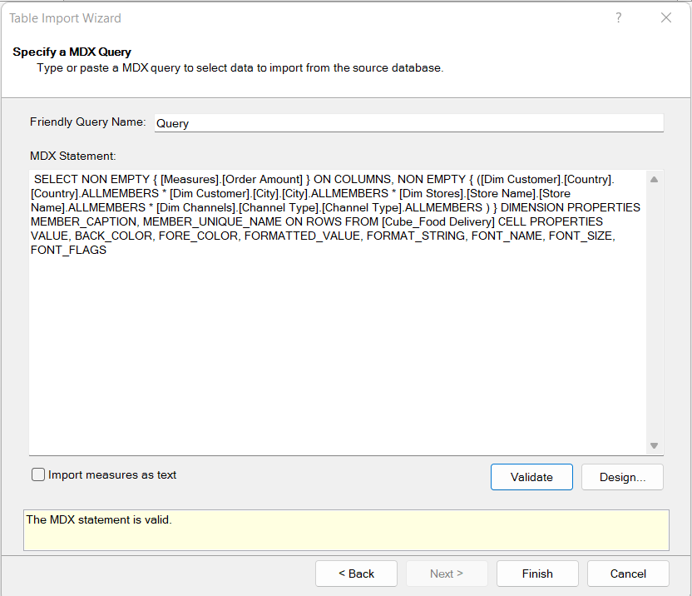

## **3.2 Roll-up**

* + Climbing up a hierarchy of a dimension to aggregate data means the Rollup.

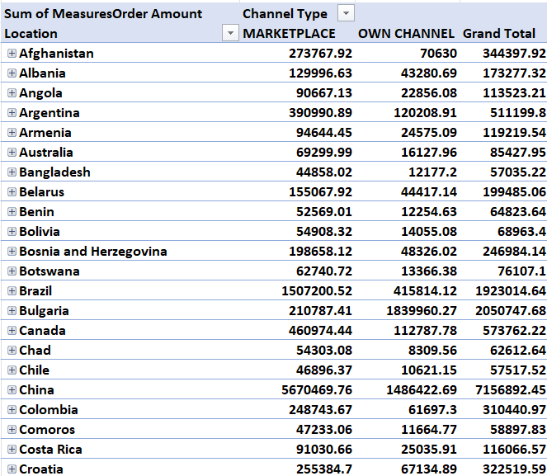

## **3.3 Drill-down**

* + Stepping down a hierarchy of a dimension allowing navigation through details means the Drill-down.

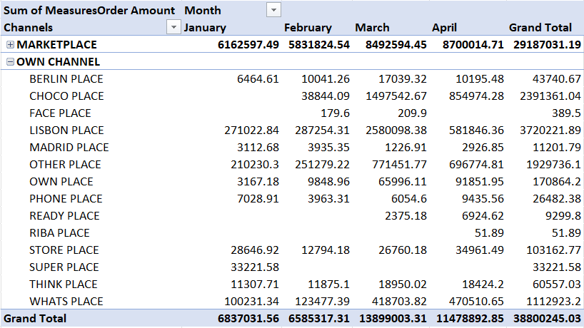

## **3.4 Slice**

## An OLAP data cube slice represents two or more dimensional views. A slice is like a report or

## a query. Then we can ask for the information we require.

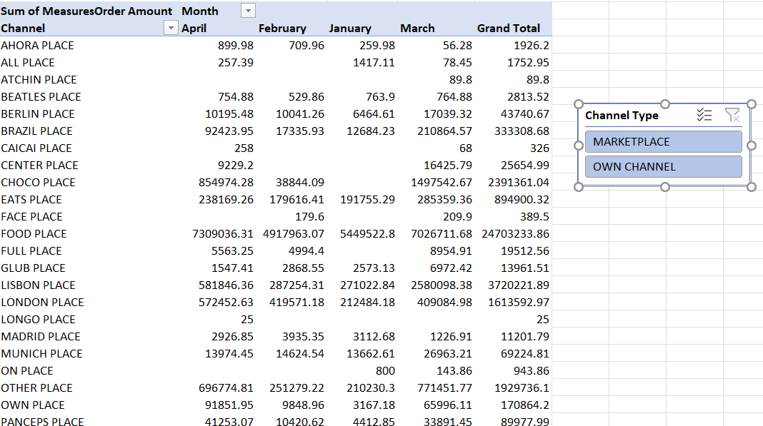

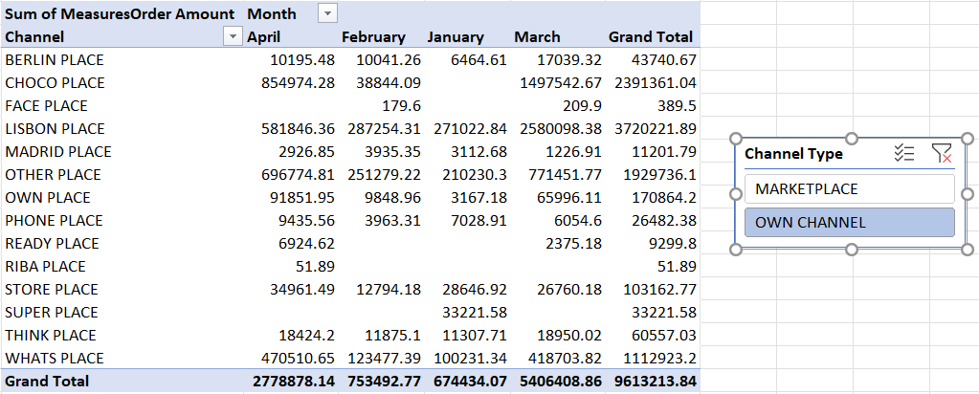

## **Dice**

Choose two or more dimensions from a cube and create a new sub-cube by picking particular values on those dimensions. Dice operations are comparable to slice operations.

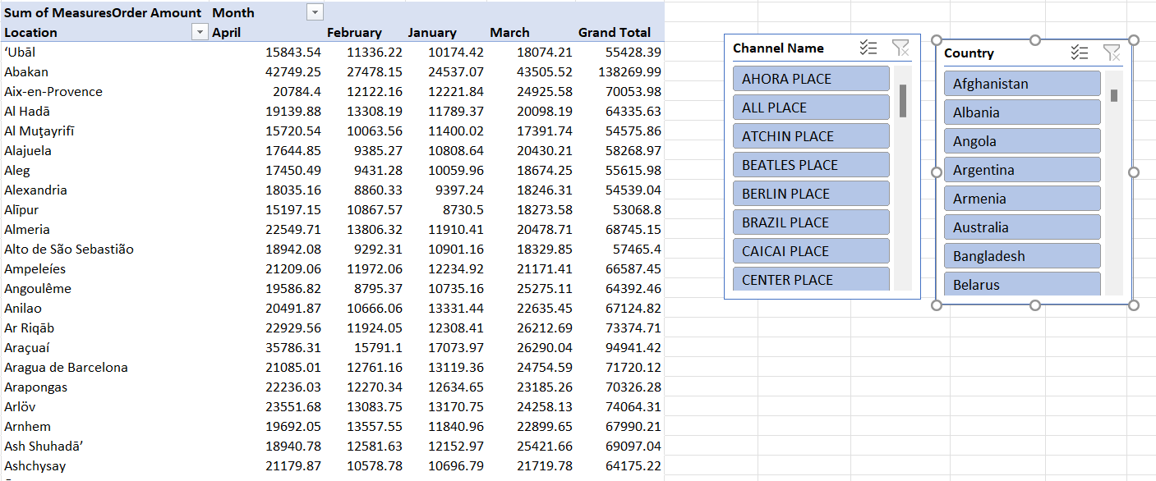

## **3.6 Pivot Chart**

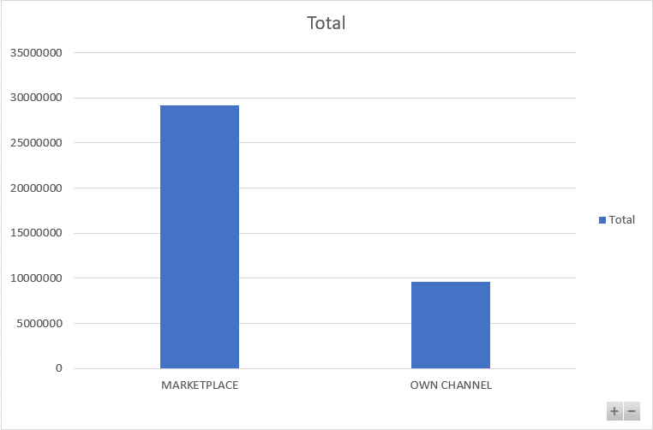

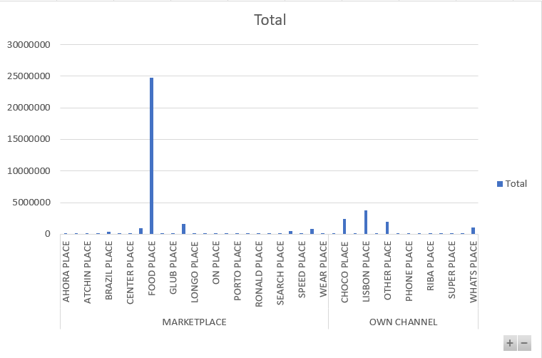

# Step 4: SSRS Reports

The SQL Server Reporting Service (SSRS) is a reporting tool that lets you create structured tables

reports with data, photos, diagrams, and charts.

## **4.1. Basic Steps of Report Builder**

* + - Data source Creation

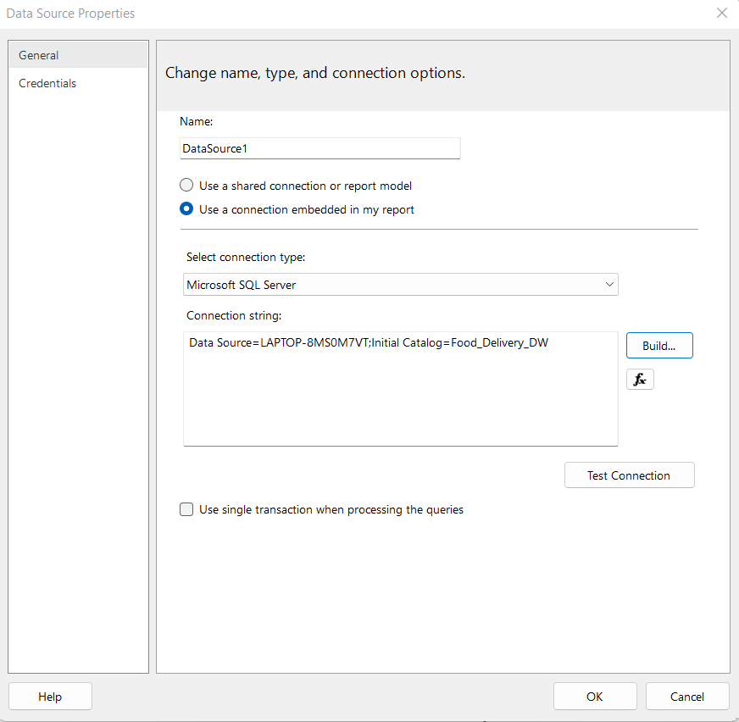

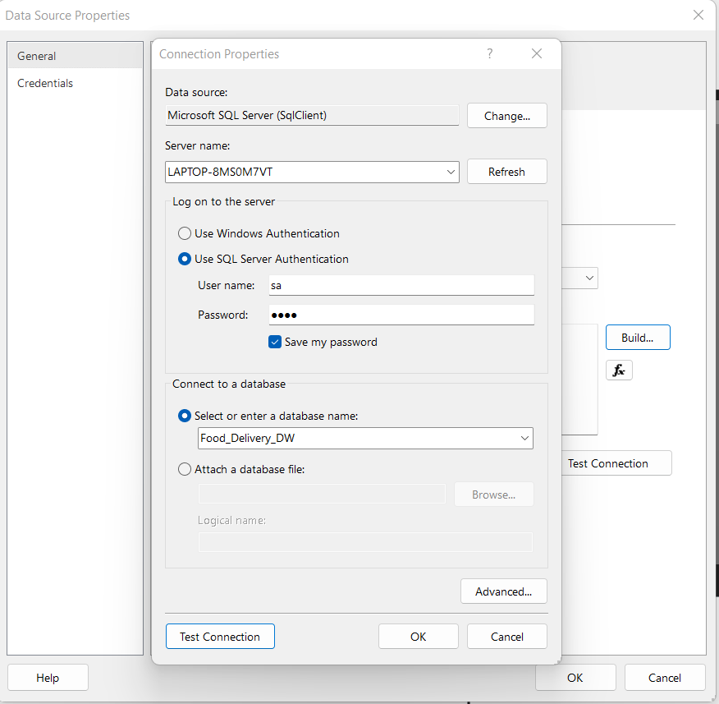

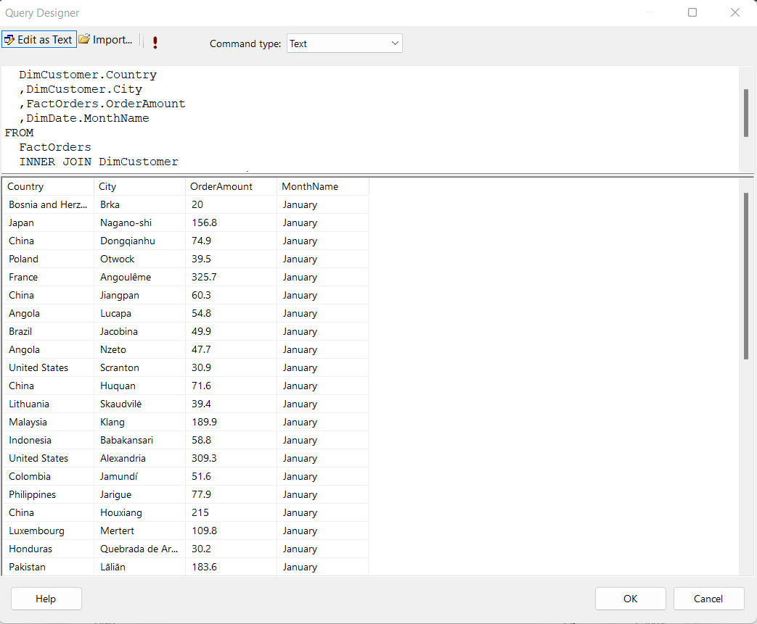

* + - Dataset Creation

## 

## 

## 4.2 Report 1: Report with a matrix

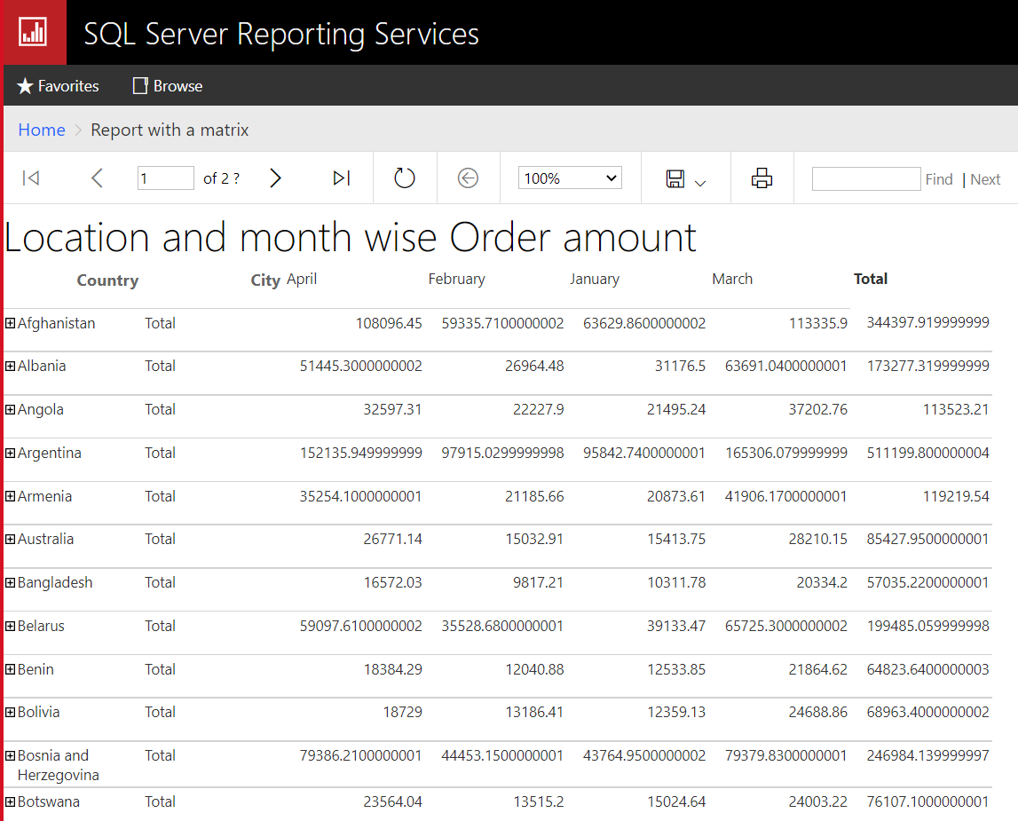

**Query:**

**SELECT**

**DimCustomer.Country**

**,DimCustomer.City**

**,FactOrders.OrderAmount**

**,DimDate.MonthName**

**FROM**

**FactOrders**

**INNER JOIN DimCustomer**

**ON FactOrders.CustomerKey = DimCustomer.CustomerSK**

**INNER JOIN DimDate**

**ON FactOrders.OrderDateKey = DimDate.DateKey**

## 4.3 Report 2 : Report with more than one parameter

## 

## **Query 1:**

## SELECT

## DimCustomer.Country

## ,DimCustomer.City

## ,DimDate.MonthName

## ,DimChannels.ChannelName

## ,FactOrders.OrderAmount

## FROM

## FactOrders

## INNER JOIN DimChannels

## ON FactOrders.ChannelKey = DimChannels.ChannelsSK

## INNER JOIN DimCustomer

## ON FactOrders.CustomerKey = DimCustomer.CustomerSK

## INNER JOIN DimDate

## ON FactOrders.OrderDateKey = DimDate.DateKey

## WHERE

## DimCustomer.Country = @country AND DimDate.MonthName = @month

## **Query 2:**

## SELECT

## DISTINCT (DimCustomer.Country)

## FROM

## DimCustomer

## **Query 3:**

## SELECT

## DISTINCT (DimDate.MonthName)

## FROM

## DimDate

## **4.4 Report 3: SSRS drill-down report**

## 

## 

## **Query 1:**

## SELECT

## DimCustomer.Country

## ,DimCustomer.City

## ,DimChannels.ChannelName

## ,FactOrders.OrderAmount

## FROM

## FactOrders

## INNER JOIN DimChannels

## ON FactOrders.ChannelKey = DimChannels.ChannelsSK

## INNER JOIN DimCustomer

## ON FactOrders.CustomerKey = DimCustomer.CustomerSK

## **4.5 Report 4: Drill through Report**

**Query 1:**

SELECT

DimChannels.ChannelName

,FactOrders.OrderAmount

,DimDate.QuarterName

FROM

FactOrders

INNER JOIN DimChannels

ON FactOrders.ChannelKey = DimChannels.ChannelsSK

INNER JOIN DimDate

ON FactOrders.OrderDateKey = DimDate.DateKey

**Query 2:**

SELECT

DimDate.MonthName

,DimDate.QuarterName

,FactOrders.OrderAmount

,DimChannels.ChannelName

FROM

FactOrders

INNER JOIN DimChannels

ON FactOrders.ChannelKey = DimChannels.ChannelsSK

INNER JOIN DimDate

ON FactOrders.OrderDateKey = DimDate.DateKey

WHERE

DimDate.QuarterName = @quater