**9JA DATA PLATFORM DATAFLUENCE 2.0 SURVEY REPORT**

**Introduction**

The 13-Week Microsoft Fabric Series organized by the 9JA Data Platform Community in Lagos, Nigeria. As the Lead for this initiative, I am thrilled to embark on this journey as we delve into the realm of data technology and explore the innovative capabilities of Microsoft Fabric.

**About Microsoft Fabric:**

Microsoft Fabric, launched in May 2023, represents a groundbreaking advancement in data management and integration solutions. With its robust features and functionalities, Microsoft Fabric offers unparalleled opportunities for organizations to streamline their data processes and unlock valuable insights.

**Our Objectives:**

Over the next 13 weeks, our series aims to achieve the following objectives:

Education and Exploration: Provide participants with a comprehensive understanding of Microsoft Fabric, its key features, and practical applications across various industries.

Skill Development: Offer hands-on workshops, expert sessions, and practical exercises to enhance participants' skills in utilizing Microsoft Fabric effectively.

Community Engagement: Foster a vibrant community of data enthusiasts, professionals, and learners through networking opportunities, collaborative projects, and knowledge sharing.

**Meet Our Team:**

I am delighted to introduce our dedicated team members who will be instrumental in ensuring the success of this series:

Popoola Isiaka (Program Manager): With his expertise in project management, Popoola will oversee the seamless execution of our series, ensuring that each session runs smoothly and efficiently.

Stephenie Ideho (Social Media Manager): Stephenie will be responsible for amplifying our online presence across platforms such as our website, YouTube, and LinkedIn, keeping our audience engaged and informed about our activities.

Dosumu Temitope Adebayo is in charge of designing our Graphics and Fliers to give the event an amazing outlook

**Bootcamp Sessions:**

In addition to our series, we will also be organizing bootcamp sessions designed to provide intensive training and practical experience with Microsoft Fabric. These sessions will offer participants the opportunity to dive deeper into specific aspects of Microsoft Fabric and gain hands-on experience under the guidance of industry experts.

**Conclusion:**

As we embark on this 13-week journey of exploration and learning, I invite you to join us in unlocking the full potential of Microsoft Fabric and shaping the future of data technology in Nigeria. Togetherness

**BI Concepts applied:**

* DAX Concepts: CountRows, Count.
* Data Cleaning, transformation and Loading
* Visual Formatting

**Problem Statement**

* Fabric Platform is considerably new and we need to promote it for early adopters
* Collaboration during Data Projects has not been seamless because different vendors manages different solutions like Azure, Real-time Analytics and Data Science
* Getting Data Professionals to pick from a single source of truths has been a big time blocker
* Data Engineering is now taking a fore front on Microsoft Fabric Platform
* Technically, efficiency and process optimization was lacking the past

**Data Gathering**

Firstly, I crrated a Microsoft Forms that was sent out to Data Professionals as to know the identity of out audience, the sector where they are currently operatiing. Their job roles. Theire learning mode, area of focus it temrs of the Topics they are keen to learn

It contains 1 sheets/tables:

1. ORDERS with row 477 and 20 columns
2. PEOPLE with 4771 rows and 20 columns
3. Microsoft Form link (https://forms.office.com/r/3YTYXqs5Xv)

**Data Transformation/Cleaning:**

Data was efficiently cleaned and transformed with the Power Query Editor of Power BI. [a screenshot of the applied steps] Some of the applied steps included

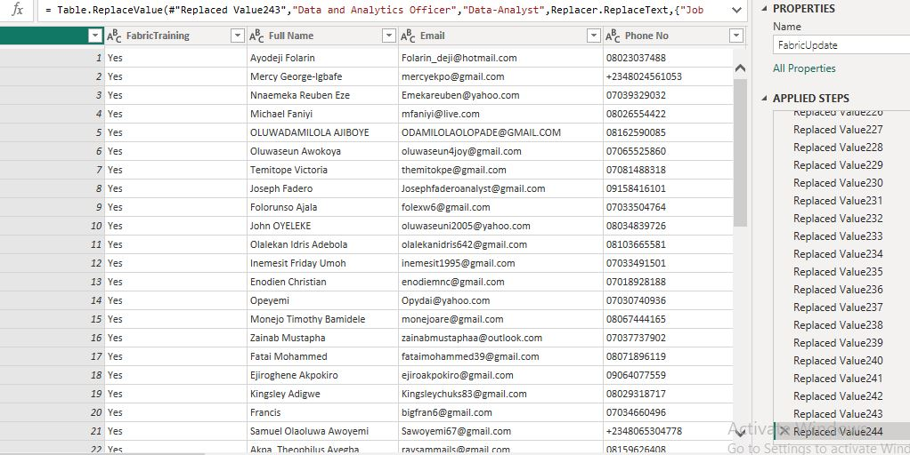

**DATA MODELLING**

Since the project involves a single table without complex data modeling requirements, the focus shifts to thorough analysis and visualization using Power BI tools. The objective remains to optimize various aspects of the project. By leveraging the capabilities of Power BI for analysis and visualization, the aim is to extract meaningful insights from the gathered data, enabling informed decision-making to enhance the overall planning and execution of the Project, which is regarded as a life project for the 9JA Data Platform community

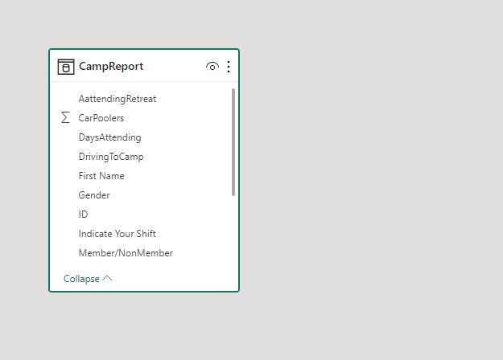

**Data Analysis and Visuals**

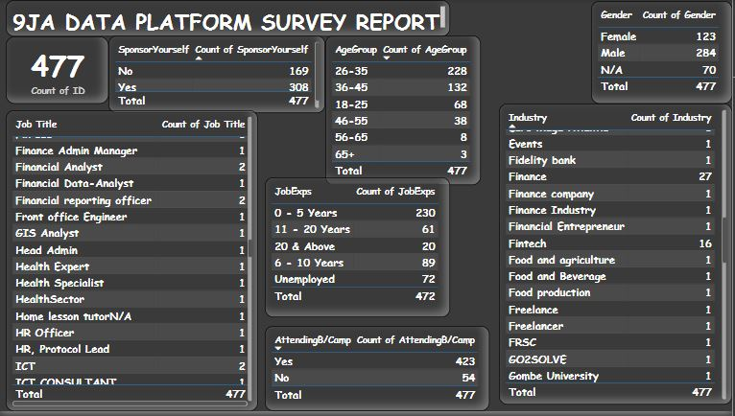

After analyzing the data in Power BI Desktop, several key findings have emerged:

1. The registered 477 attendees give the assurance of attending the Event

2. Approximately 123 female attendees registered for the Event as against 284 males

3. Looking at the Data , almost every industry shown keen interest in learning Fabric

4. Considering the Learning Format of the Attendees, 338 wanted recorded session followed by 317 for life sessions, while 311 picked interactive Workshop

5. looking the Topic of Interest 350 wants to learn Power BI, while 315 showed interest in Data Science and 233 for Data Factory.

6. Among the attendees, 423 has showed interest in attending the 3-Days BootCamp activities but, 308 are willing to Self-Sponsor while 169 wanted Scholarship

These findings provide valuable insights that can inform various aspects of Project planning, including accommodation arrangements, transportation logistics, volunteer management, and special provisions scholarship candidates

**Conclusions & Recommendations**

Based on the findings, here are suggested conclusions and recommendations:

Conclusions:

* Demographic Insights: The data analysis reveals a predominantly Male attendee demographic, are more than male counterparts
* High Attendance: The high percentage of registrants attending the camp portion indicates strong engagement and commitment to the Learning experience.
* Every Age Bracket is well covered in the Survey

**Recommendations:**

* Provision should be made for attendees asking for Scholarship
* The event must stayed committed to topics based on the request on the survey
* Project team needs to be inaugurated and starts planning towards the Boot-camp
* Sponsors needs to be sought after to fund Students asking for Scholarship