**CHURCH RETREAT DATA GATHERING ANALYSIS**

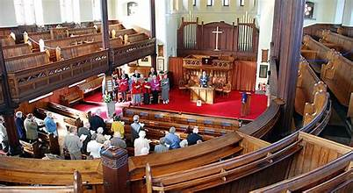

**Introduction**

The prayer unit arm of a local church in Lagos, Nigeria, is planning a 3-day retreat and seeks to optimize various aspects of the event, including accommodation, logistics, welfare, feeding, and understanding the demography of attendees.

To ensure a successful and efficient retreat, there is a need for comprehensive data gathering and analysis to inform decision-making and resource allocation. This involves collecting and analyzing data on attendee demographics, dietary preferences, accommodation requirements, transportation logistics, and overall welfare needs. By leveraging data-driven insights, the prayer unit aims to enhance the planning process, maximize resource utilization, and provide a fulfilling experience for all participants

**Power BI Concepts applied:**

* DAX Concepts: CountRows, Count.
* Data Cleaning, transformation and Loading
* Visual Formatting

**Problem Statement**

* How many people registered for the Retreat?
* How many Pregnant women/ Nursing Women registered for the retreat so that they can be well taken care-of?
* Are there people driving to Camp that pick people in their cars to save the Unit cost of logistics?
* Demographic status to ascertain how to accommodate attendees because women and men cannot be accommodated together except, they are couples?
* We need to know ascertain the No of Coastal Buses the Unit needs to book for to move people to and for the Camp
* The Data gathered will enable the Unit Plan for feeding the attendees including children
* The Data will enable the Unit Plan for third-party services providers like Instrumentalists and Caterers

**Data Gathering**

After being consulted as a Data Analyst for the prayer unit arm of a local church in Lagos, Nigeria, I utilized my Microsoft Forms developer account to gather essential data for an upcoming 3-day retreat. The data, downloaded in Excel format, was then imported into Power BI Desktop for thorough analysis and visualization. The objective is to optimize various aspects of the retreat, such as accommodation, logistics, welfare, feeding, and understanding attendee demography. By leveraging the capabilities of Power BI, the aim is to extract meaningful insights from the gathered data, enabling informed decision-making to enhance the overall planning and execution of the retreat

It contains 1 sheets/tables:

1. ORDERS with 491 rows and 15 columns
2. PEOPLE with 491 rows and 15 columns

**Data Transformation/Cleaning:**

Data was efficiently cleaned and transformed with the Power Query Editor of Power BI. [a screenshot of the applied steps] Some of the applied steps included

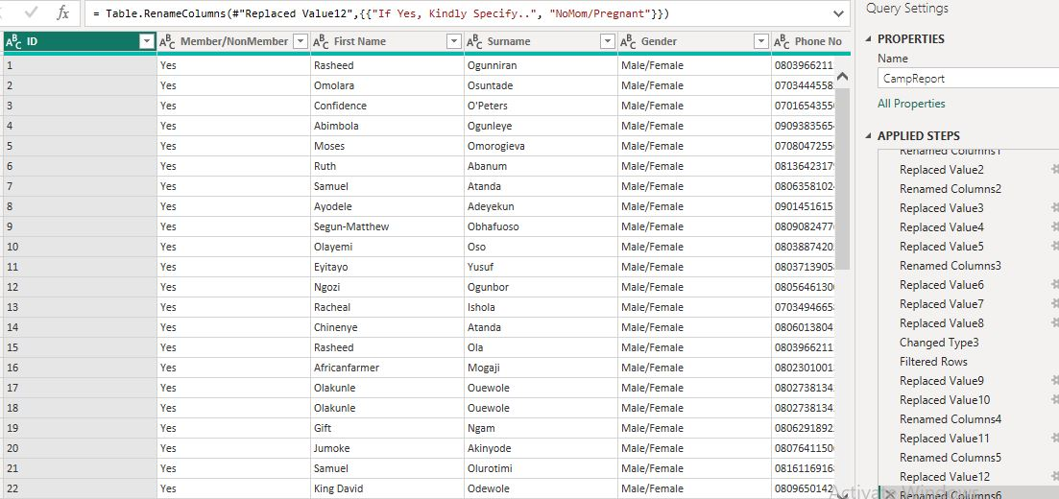

**DATA MODELLING**

Since the project involves a single table without complex data modeling requirements, the focus shifts to thorough analysis and visualization using Power BI tools. The objective remains to optimize various aspects of the retreat, such as accommodation, logistics, welfare, feeding, and understanding attendee demography. By leveraging the capabilities of Power BI for analysis and visualization, the aim is to extract meaningful insights from the gathered data, enabling informed decision-making to enhance the overall planning and execution of the retreat, which is regarded as a life project for the church community

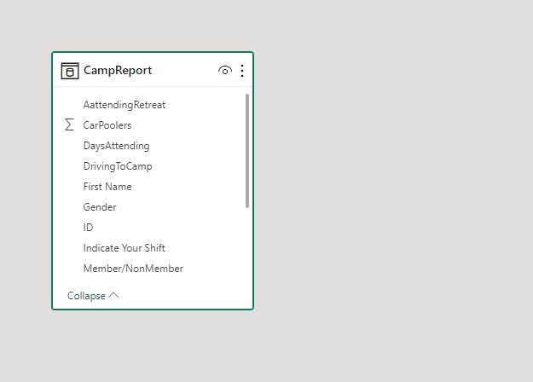

**Data Analysis and Visuals**

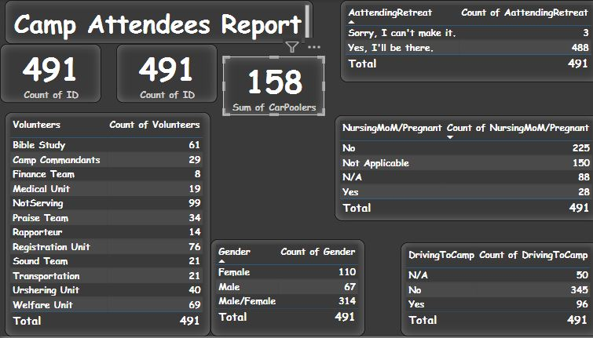

After analyzing the data in Power BI Desktop, several key findings have emerged:

1.Out of the 491 registered attendees for the retreat, none indicated the presence of children or couples.

2. Approximately 400 female attendees are expected to participate in the retreat.

3. A total of 96 attendees will be utilizing their personal transportation to the camp, potentially resulting in cost savings equivalent to three Coastal Buses.

4. The overwhelming majority of registrants, 488 out of 491, will be attending the camp portion of the retreat.

5. 390 individuals have expressed their willingness to serve as volunteers during the event, showcasing a strong spirit of community engagement.

6. Among the attendees, there are 28 nursing mothers/pregnant women who will be participating in the camp activities.

These findings provide valuable insights that can inform various aspects of retreat planning, including accommodation arrangements, transportation logistics, volunteer management, and special provisions for nursing mothers and pregnant women

**Conclusions & Recommendations**

Based on the findings, here are suggested conclusions and recommendations:

Conclusions:

* Demographic Insights: The data analysis reveals a predominantly adult and female attendee demographic, with a notable absence of children and couples.
* Transportation Optimization: With a significant portion of attendees opting for personal transportation, there's an opportunity to optimize transportation logistics and potentially reduce costs by adjusting the number of buses needed.
* High Camp Attendance: The high percentage of registrants attending the camp portion indicates strong engagement and commitment to the retreat experience.
* Volunteer Engagement: The willingness of 390 individuals to volunteer demonstrates a vibrant spirit of community involvement and support.
* Special Considerations: The presence of nursing mothers and pregnant women underscores the importance of providing appropriate accommodations and support during the retreat.

**Recommendations:**

* Child-Friendly Activities: Consider incorporating activities or provisions to accommodate families with children, enhancing the inclusivity of the retreat experience.
* Transportation Adjustment: Review transportation requirements based on the significant number of attendees using personal vehicles, potentially reducing bus allocation to optimize costs.
* Camp Logistics: Ensure adequate facilities and resources are in place to accommodate the high number of attendees at the camp portion of the retreat.
* Volunteer Management: Develop a structured volunteer program to effectively utilize the enthusiasm of the 390 individuals willing to serve, assigning roles based on skills and availability.
* Special Needs Support: Implement measures to support nursing mothers and pregnant women, such as providing comfortable accommodations, access to medical facilities if needed, and scheduling breaks or modified activities to accommodate their needs.
* By addressing these recommendations, the church can enhance the overall experience of the retreat, promote inclusivity, and ensure the well-being and satisfaction of all attendees.