**Practical 1**

**LINUX**

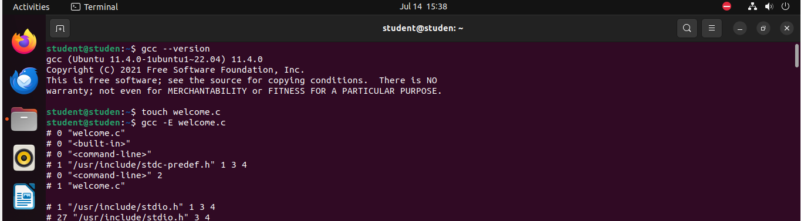

* The first file is formed by the touch tool.
* It is named as” name.c”

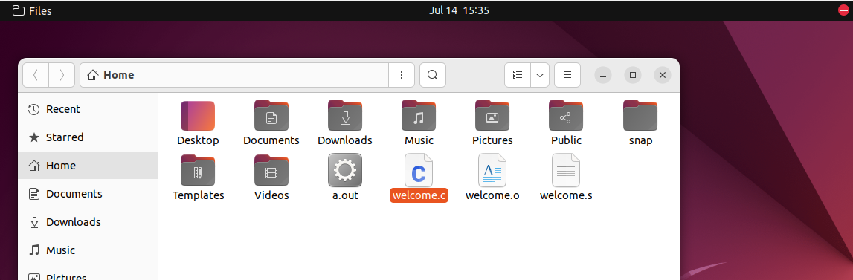

* The other floder id is named as welcome.s
* The third one is named as welcome.o
* And it has codes which is not shown as someone might copy it so the file welcome,o will not open

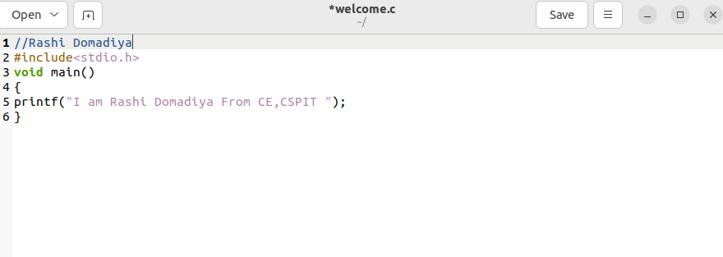

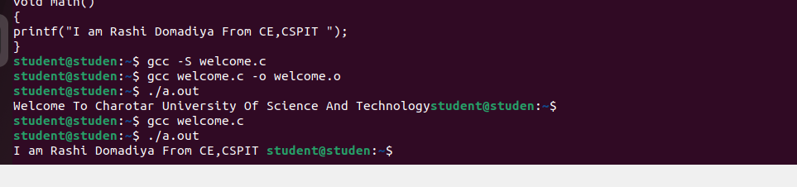

We got the output by “./a.out” which creates a folder of it

**CODE BLOCKS**

