Lab No. 2

LINEAR REGRESSION FOR HOUSE/CAR PRICE PREDICTION
Aim:
To develop a Linear Regression model for predicting house/car prices using a suitable dataset.
Objectives:
- To understand the concept and working of Linear Regression.
- To preprocess the dataset and prepare the required features..
- To develop a Linear Regression model using the training data.
- To predict prices using the trained Linear Regression model.
- To evaluate the performance of the model using suitable evaluation metrics.
- To visualize the relationship between actual and predicted prices.

Dataset / Resources Used
Dataset: USA Housing Dataset
Resources/Tools Used:
- Python
- Jupyter Notebook / Google Colab
- Pandas
- NumPy
- Scikit-learn
- Titanic dataset in CSV format
- GitHub for code submission

Date of Performance : 14 July 2026

GitHub Url : https://github.com/Rashi-Karule/ML/tree/main/Practical2

Output 1 – Importing Required Libraries
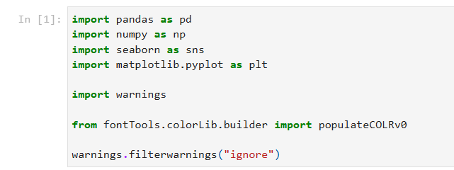
The required Python libraries are imported for data analysis, preprocessing, visualization, and machine learning.
Pandas and NumPy are used for data manipulation and numerical operations.
Seaborn and Matplotlib are used to create graphical visualizations.
The warnings module is also used to suppress unnecessary warning messages during execution.

Output 2 – Displaying First Five Records
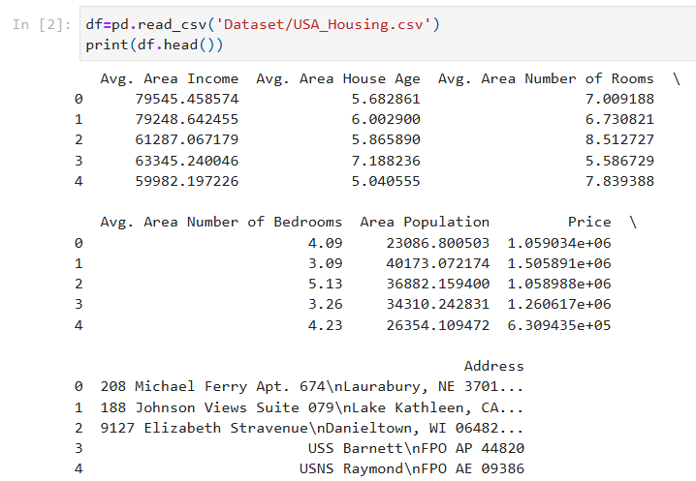
The USA Housing dataset is loaded from the CSV file using Pandas read_csv().
The df.head() function displays the first five records of the dataset.
The output provides an initial view of the housing features and their corresponding house prices.
This helps understand the structure and type of information available in the dataset.

Output 3 – Displaying Last Five Records
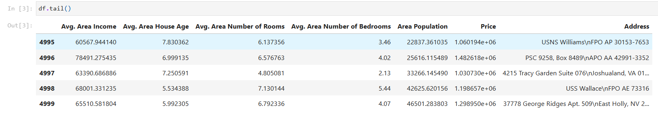
The df.tail() function displays the last five records of the USA Housing dataset.
It provides a view of the observations present at the end of the dataset.
This helps verify that the complete dataset has been loaded successfully.
The output also allows the values of the final records to be inspected.

Output 4 – Dataset Shape
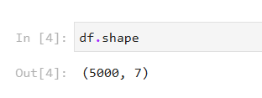
The df.shape function displays the number of rows and columns in the USA Housing dataset.
The rows represent individual housing records, while the columns represent different housing attributes.
This output provides the initial dimensions of the dataset before preprocessing.
It is useful for understanding the size of the dataset used for model development.

Output 5 – Dataset Columns
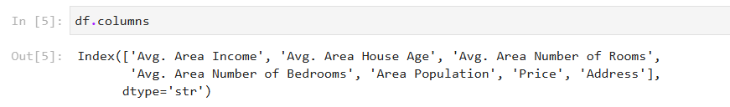
The df.columns function displays the names of all features available in the dataset.
The dataset contains features related to area income, house age, number of rooms, bedrooms, population, and house price.
The Address column is also initially present in the dataset.
This output helps identify the variables that will be used during preprocessing and regression.

Output 6 – Dataset Information
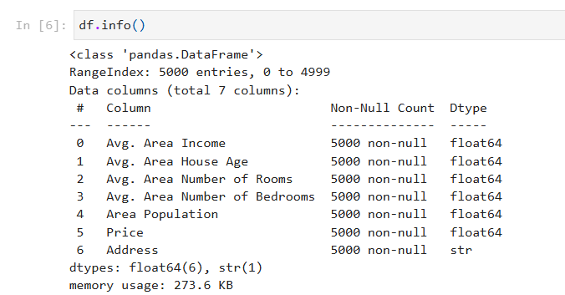
The df.info() function provides information about the dataset structure and data types.
It displays the number of records, columns, non-null values, and data types of the features.
This output is useful for checking whether the dataset contains missing values.
It also helps determine whether the features are suitable for numerical regression analysis.

Output 7 – Statistical Description
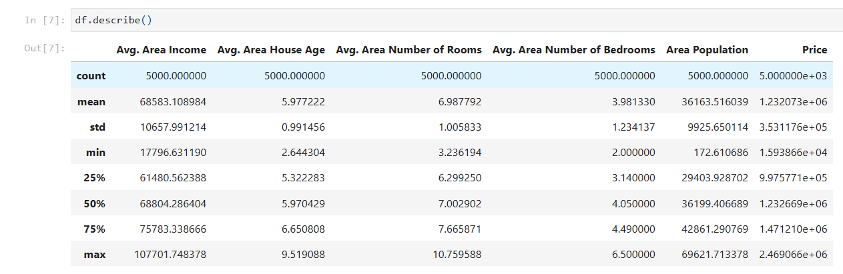
The df.describe() function generates statistical information for the numerical features.
It displays count, mean, standard deviation, minimum, quartiles, and maximum values.
These statistics provide an overview of the distribution and range of the housing variables.
The output is useful for understanding the numerical characteristics of the dataset.

Output 8 – Checking Missing Values
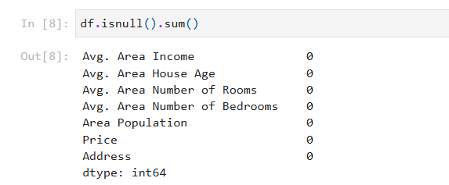
The df.isnull().sum() function is used to identify missing values in every column.
The output shows the number of null values present in each feature.
This step is important because missing values can affect the performance of a regression model.
The result is used to determine whether any missing-value treatment is required.

Output 9 – Removing Address Column
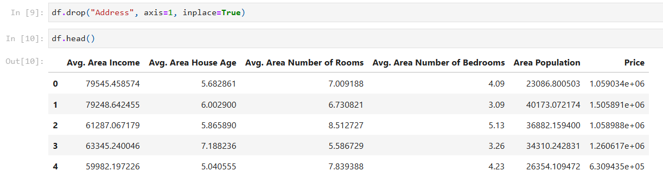
The Address column is removed from the dataset using the drop() function.
The Address feature is not required for the numerical regression analysis performed in this experiment.
Removing it leaves the relevant numerical housing features and the Price target variable.
This prepares the dataset for correlation analysis and regression modelling.
The df.head() output displays the dataset after removing the Address column.
The remaining columns contain numerical housing-related features and the target Price variable.
This confirms that the irrelevant Address feature has been successfully removed.
The cleaned dataset is now more suitable for numerical machine learning techniques.

Output 10 – Duplicate Record Check
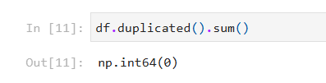
The df.duplicated().sum() function is used to check for duplicate records.
The output indicates whether repeated observations are present in the dataset.
Duplicate records can negatively affect statistical analysis and machine learning models.
This step confirms whether duplicate rows need to be removed before modelling.

Output 11 – Formatting Numerical Output
The Pandas display option is configured to show floating-point values with two decimal places.
This makes numerical outputs easier to read and interpret.
The formatting is applied only to the displayed values and does not change the underlying dataset.
It improves the presentation of subsequent outputs in the notebook.

Output 12 – Formatted Dataset Preview
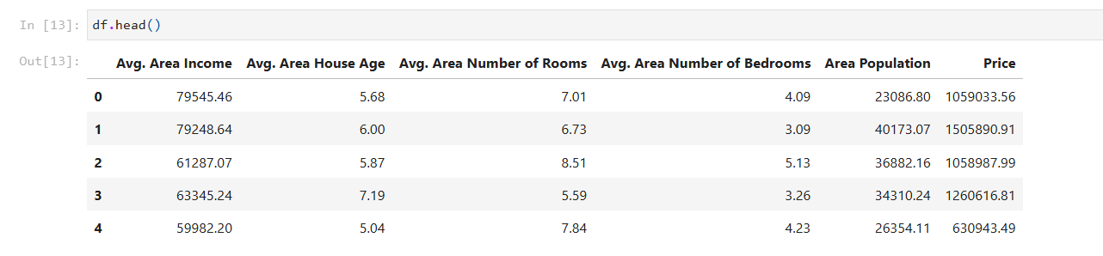
The df.head() function is used again after changing the display format.
Numerical values are now displayed with two decimal places, making the dataset easier to read.
The relevant housing features can be inspected before further analysis.
This output provides a cleaner presentation of the dataset.

Output 13 – Correlation Heatmap
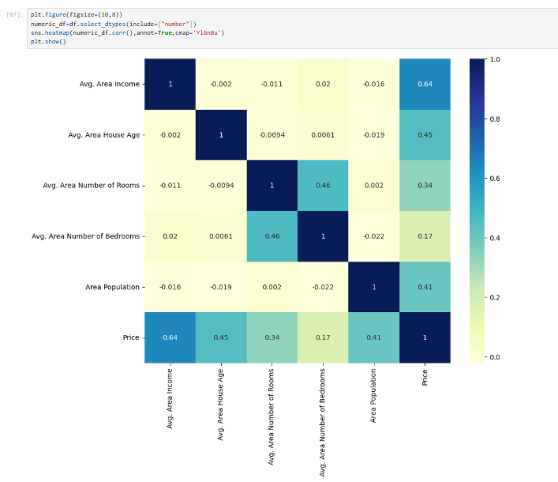

A correlation heatmap is generated using the numerical columns of the USA Housing dataset.
The heatmap displays the correlation coefficient between different housing features.
The annotated values help identify the strength and direction of relationships between variables.
This analysis is useful for understanding which features may have a strong relationship with house Price.

Output 14 – Area Income Boxplot Before Outlier Removal
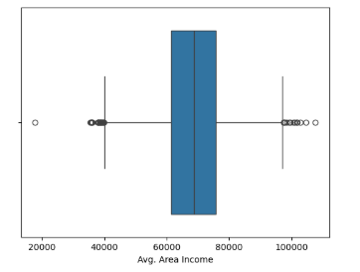
A boxplot is generated for the Avg. Area Income feature.
The plot displays the median, quartiles, and possible extreme income observations.
It helps identify potential outliers in the average area income data.
The IQR method is subsequently applied to treat extreme observations.

Output 15 – Removing Area Income Outliers
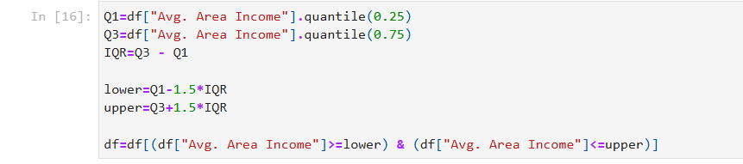
The Interquartile Range method is applied to the Avg. Area Income feature.
Q1, Q3, and IQR are calculated to determine the lower and upper acceptable limits.
Records outside the calculated limits are removed from the dataset.
This reduces the effect of extreme income observations on the regression model.

Output 16 – Area Income Boxplot After Outlier Removal
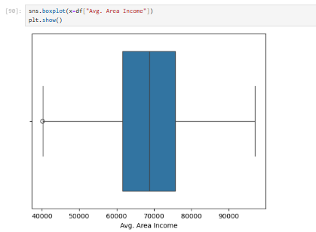
A boxplot is generated again after removing outliers from the Avg. Area Income feature.
The graph shows the distribution of area income after IQR-based filtering.
The effect of removing extreme observations can be observed by comparing it with the previous boxplot. This confirms that the income feature has undergone outlier treatment.

Output 17 – Price Boxplot Before Outlier Removal
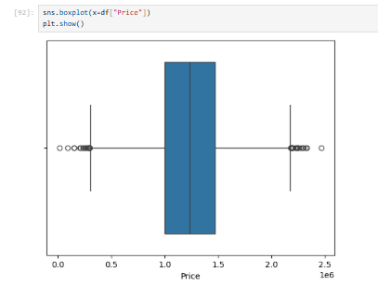
A boxplot is generated for the Price column to examine its distribution.
The graph shows the spread of house prices and highlights possible extreme price values.
Identifying these observations is important because extreme target values can influence regression results.
The IQR method is used next to handle the detected Price outliers.

Output 18 – Removing Price Outliers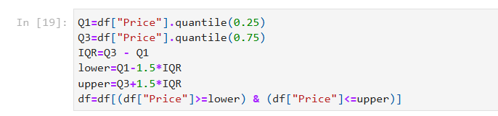
The IQR method is applied to the Price column to determine its acceptable range.
Q1 and Q3 are calculated and the IQR is obtained from their difference.
Lower and upper limits are then calculated using 1.5 times the IQR.
Records with Price values outside these limits are removed from the dataset.

Output 19 – Price Boxplot After Outlier Removal
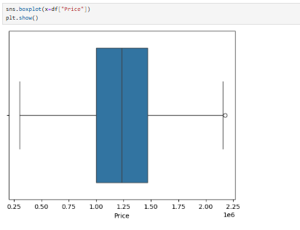
A new boxplot is generated for Price after applying IQR-based outlier filtering.
The resulting graph shows the Price distribution after extreme observations have been removed.
This provides a visual confirmation of the outlier-treatment process.
The resulting dataset is then used for regression modelling.

SIMPLE LINEAR REGRESSION (SLR)

Output 20 – Selecting Feature and Target for SLR
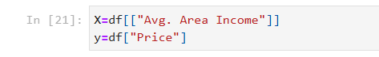
For Simple Linear Regression, Avg. Area Income is selected as the independent variable.
The Price column is selected as the dependent or target variable.
The feature is stored in X, while the target is stored in y.
This prepares the data for predicting house prices using a single feature.

Output 21 – Training and Testing Data Split for SLR
The dataset is divided into training and testing subsets using train_test_split().
An 80:20 split is used, with 80% of the observations for training and 20% for testing.
The training data is used to learn the relationship between income and house price.
The testing data is reserved for evaluating the model's prediction performance.

Output 22 – Training the Simple Linear Regression Model
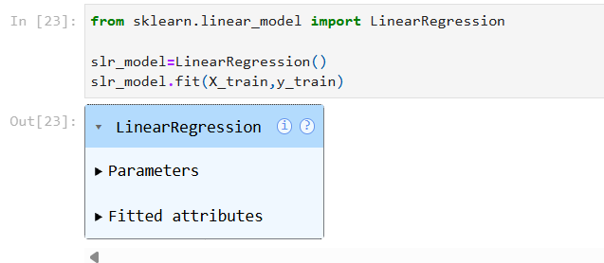
A Linear Regression model is created using Scikit-learn's LinearRegression class.
The model is trained using the training feature and target data.
The model learns a linear relationship between Average Area Income and House Price.
The trained model can then be used to predict prices for unseen test observations.

Output 23 – SLR Price Predictions
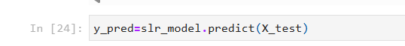
The trained Simple Linear Regression model is used to predict house prices for the test dataset.
The predict() function generates predicted Price values based on Average Area Income.
These predictions are compared with the actual test values during model evaluation.
The resulting predictions are used to calculate different regression performance metrics.

Output 24 – Simple Linear Regression Evaluation
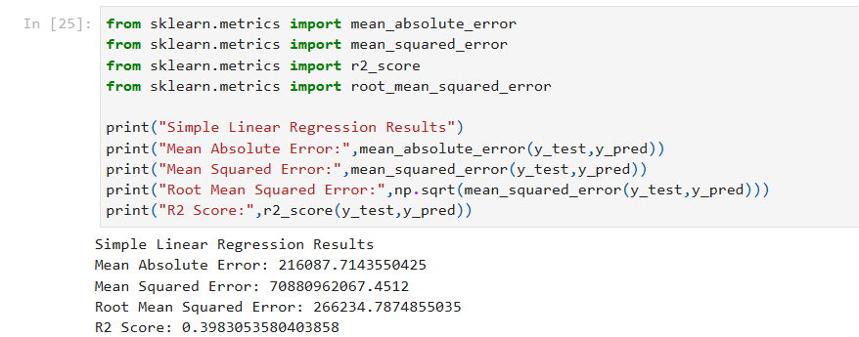
The SLR model is evaluated using MAE, MSE, RMSE, and R² Score.
MAE measures the average absolute prediction error, while MSE calculates the average squared error.
RMSE represents the square root of MSE and is expressed in the same units as Price.
R² Score indicates how well the model explains the variation in house prices.

Output 25 – SLR Intercept and Slope
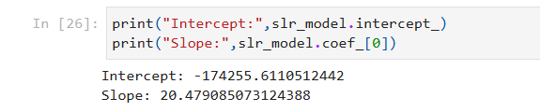
The intercept and slope of the Simple Linear Regression model are displayed.
The intercept represents the predicted house price when Average Area Income is zero.
The slope represents the change in predicted house price for a one-unit increase in Average Area Income.
Together, these values define the fitted linear regression equation.

Output 26 – Simple Linear Regression Plot
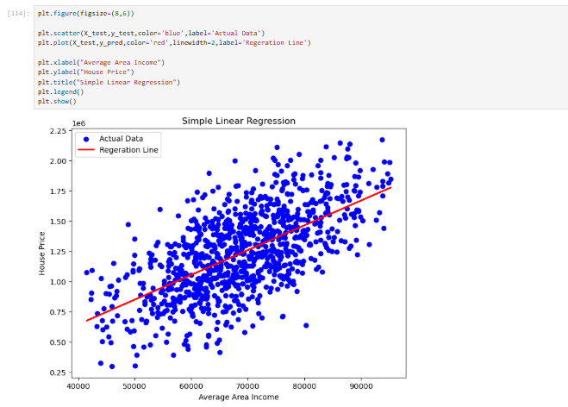



The graph displays the actual test observations along with the fitted regression line.
Average Area Income is represented on the x-axis and House Price on the y-axis.
The regression line represents the relationship learned by the Simple Linear Regression model.
The plot provides a visual comparison between the actual data and the fitted linear relationship.

Output 27 – SLR House Price Prediction for User Input
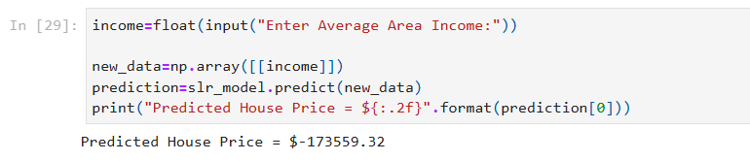
The program accepts Average Area Income as input from the user.
The entered value is passed to the trained Simple Linear Regression model.
The model predicts the corresponding house price based on the learned relationship.
The predicted price is displayed in dollar format with two decimal places.

MULTIPLE LINEAR REGRESSION (MLR)

Output 28 – Selecting Features for MLR
For Multiple Linear Regression, the Price column is separated as the target variable.
All remaining numerical housing features are assigned to the feature matrix X.
Multiple features are therefore used simultaneously to predict house Price.
The dataset is then divided into training and testing sets using an 80:20 ratio.

Output 29 – Training Multiple Linear Regression Model
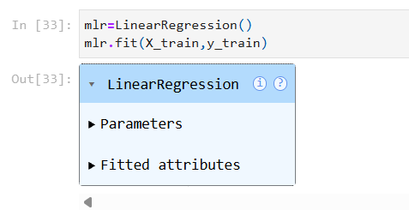
A Linear Regression model is created and trained using the multiple housing features.
Unlike SLR, MLR uses several independent variables to predict the target Price.
The model learns the contribution of the different housing features from the training data.
The trained model is then used to generate predictions on the test dataset.

Output 30 – MLR Coefficients
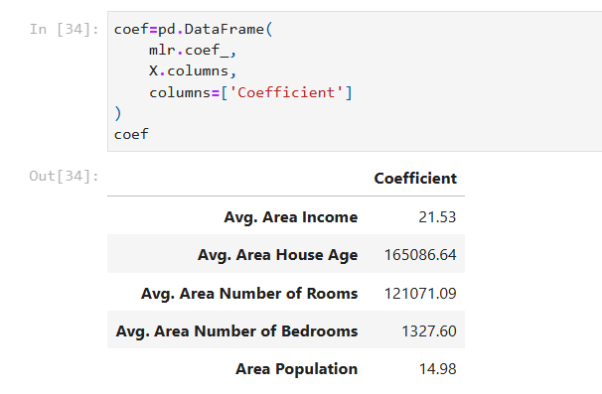
The coefficient table displays the learned coefficient corresponding to each independent feature.
Each coefficient represents the estimated effect of that feature on the predicted house Price while considering the other features.
Positive and negative coefficient values indicate different directions of relationship with Price.
This output helps interpret the contribution of individual features in the regression model.

Output 31 – Multiple Linear Regression Evaluation
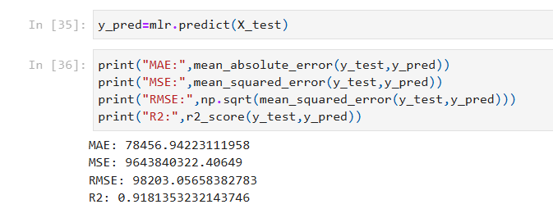
The MLR model is evaluated using MAE, MSE, RMSE, and R² Score.
These metrics measure the difference between actual and predicted house prices.
Lower MAE, MSE, and RMSE indicate smaller prediction errors.
A higher R² Score indicates that the model explains a larger proportion of the variation in house prices.

Output 32 – Actual vs Predicted Price Plot
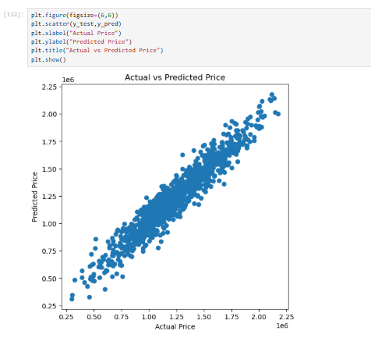

The scatter plot compares actual house prices with prices predicted by the Multiple Linear Regression model.
Actual Price values are represented on the x-axis, while Predicted Price values are represented on the y-axis.
Points closer to a straight diagonal relationship indicate better prediction performance.
The graph provides a visual evaluation of how closely predictions match actual prices.

Output 33 – MLR House Price Prediction
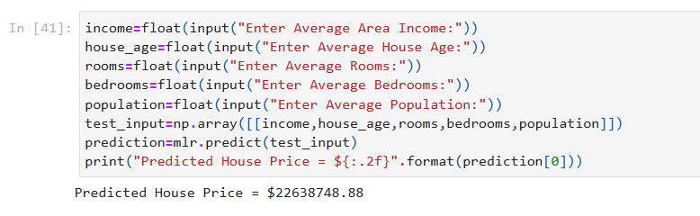
The program accepts five housing features from the user: Average Area Income, Average House Age, Average Rooms, Average Bedrooms, and Area Population.
These input values are combined into a single feature array.
The trained Multiple Linear Regression model uses these values to predict the house Price.
The predicted house price is displayed in dollar format.

RIDGE REGRESSION

Output 34 – Default Ridge Regression
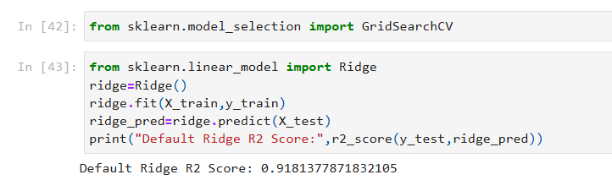
A Ridge Regression model is created and trained using the same training dataset.
Ridge Regression applies L2 regularization to reduce the effect of large regression coefficients.
The model is evaluated using the R² Score on the testing data.
This provides a baseline performance value before hyperparameter tuning.

Output 35 – Ridge Regression Parameter Grid
A parameter grid is created containing different possible values of the Ridge regularization parameter alpha.
The tested values range from 0.001 to 100.
Different alpha values control the strength of regularization applied by the Ridge model.
This grid is used by GridSearchCV to find a suitable parameter value.

Output 36 – Ridge Grid Search
GridSearchCV is used to evaluate different Ridge alpha values using five-fold cross-validation.
The model is trained and evaluated for each candidate alpha value.
Cross-validation helps identify the parameter that provides better generalization performance.
The best parameter is selected based on the R² scoring criterion.

Output 37 – Best Ridge Alpha
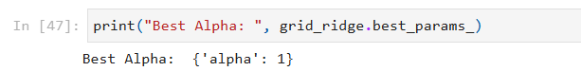
The best_params_ attribute displays the alpha value selected by GridSearchCV.
This value represents the regularization strength that performed best during cross-validation.
Selecting an appropriate alpha helps balance model fitting and regularization.
The selected Ridge model is then used for predictions on the test dataset.

Output 38 – Best Ridge Cross-Validation Score
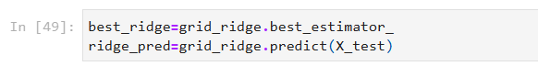
The best_score_ output displays the best cross-validation score obtained during Ridge hyperparameter tuning.
This score represents the performance of the best parameter combination across the validation folds.
It provides an estimate of how well the selected Ridge model generalizes.
The result is used to assess the effectiveness of the tuning process.

Output 39 – Tuned Ridge Regression Evaluation
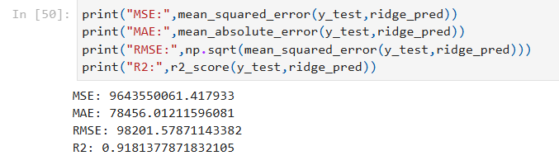
The best Ridge estimator is used to predict prices for the test dataset.
The model is evaluated using MSE, MAE, RMSE, and R² Score.
These metrics provide a detailed assessment of the prediction errors and model performance.
The results can be compared with the ordinary Multiple Linear Regression model.
LASSO REGRESSION

Output 40 – Lasso Regression Parameter Grid
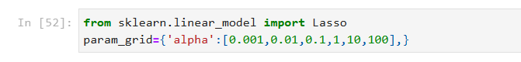
Lasso Regression is introduced using the Scikit-learn Lasso model.
A parameter grid containing multiple alpha values is created for hyperparameter tuning.
Alpha controls the strength of L1 regularization applied by the Lasso model.
GridSearchCV is used to identify a suitable alpha value using cross-validation.

Output 41 – Best Lasso Alpha
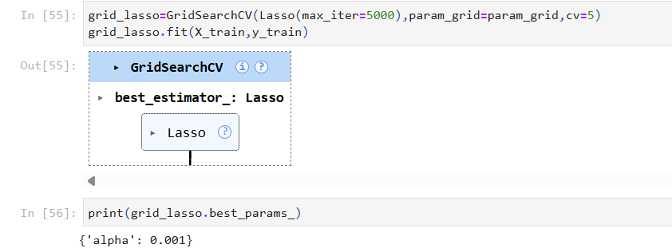
GridSearchCV trains and evaluates Lasso Regression using the different alpha values.
The best_params_ output displays the alpha value that provides the best cross-validation performance.
The selected parameter determines the regularization strength of the final Lasso model.
This process helps improve the model's generalization performance.

Output 42 – Lasso Regression R² Score
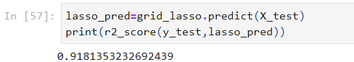
The tuned Lasso Regression model is used to predict house prices for the test dataset.
The R² Score is calculated by comparing the predicted prices with the actual test prices.
The score indicates how much variation in house prices is explained by the Lasso model.
This result can be compared with the Linear and Ridge Regression models.

VIVA QUESTIONS AND ANSWERS

Q1. What is Linear Regression and what is its purpose in this experiment?
Answer:
Linear Regression is a supervised machine learning algorithm used to predict a continuous numerical value. In this experiment, it is used to predict house Price based on housing-related features. Simple Linear Regression uses one independent variable, such as Average Area Income, while Multiple Linear Regression uses multiple independent variables to predict the house Price.

Q2. What is the difference between Simple Linear Regression and Multiple Linear Regression?
Answer:
Simple Linear Regression uses only one independent variable to predict the target variable. In this experiment, Average Area Income is used to predict House Price. Multiple Linear Regression uses multiple independent variables, such as Average Area Income, Average House Age, Average Number of Rooms, Average Number of Bedrooms, and Area Population, to predict House Price.

Q3. What are MAE, MSE, RMSE, and R² Score?
Answer:
MAE (Mean Absolute Error) measures the average absolute difference between actual and predicted values.
MSE (Mean Squared Error) calculates the average squared difference between actual and predicted values.
RMSE (Root Mean Squared Error) is the square root of MSE and represents error in the same unit as the target variable.
R² Score measures how well the regression model explains the variation in the target variable; a higher value generally indicates better model fit.

Q4. What is Ridge Regression and why is it used?
Answer:
Ridge Regression is a modified form of Linear Regression that uses L2 regularization. It adds a penalty based on the squared magnitude of the model coefficients. This helps reduce the effect of large coefficients and can help control overfitting. In this experiment, different alpha values are tested using GridSearchCV to find a suitable regularization strength.

Q5. What is the difference between Ridge Regression and Lasso Regression?
Answer:
Ridge Regression uses L2 regularization, which penalizes the squared values of the coefficients. Lasso Regression uses L1 regularization, which penalizes the absolute values of the coefficients. Lasso can reduce some coefficients to exactly zero, which can help with feature selection. In this experiment, both Ridge and Lasso use GridSearchCV to select a suitable alpha value through cross-validation.

