ML Lab No. 3
FIND-S AND CANDIDATE ELIMINATION ALGORITHMS
Name | Rashi Karule
Section | C
Roll No. | 24
Batch | C2
Dataset | EnjoySport Dataset
Date of Performance

Lab Aim and Objective: To implement Find-S and Candidate Elimination Algorithms on the EnjoySport dataset and compare the generated hypotheses.
Dataset / Resources Used: Dataset: EnjoySport Dataset
Tools: Python, Jupyter Notebook / Google Colab, Pandas, NumPy, EnjoySport CSV dataset, GitHub, Microsoft Word
GitHub URL: https://github.com/Rashi-Karule/ML/tree/main/Practical3

THEORY

1. Concept Learning
Concept learning is the process of learning a general rule or hypothesis from labelled training examples. In this experiment, the concept is whether a person will Enjoy Sport based on environmental conditions such as Sky, AirTemp, Humidity, Wind, Water and Forecast.

2. Find-S Algorithm
Find-S is a simple concept-learning algorithm that finds the most specific hypothesis consistent with the positive training examples. The algorithm starts with the most specific hypothesis and generalizes it whenever a positive example differs from the current hypothesis. Negative examples are ignored during hypothesis updating.

Steps of Find-S
1. Initialize the hypothesis with the most specific possible hypothesis.
2. Examine each training example.
3. Ignore negative examples.
4. For a positive example, compare each attribute with the current hypothesis.
5. Replace mismatching attribute values with ?.
6. Continue until all training examples are processed.
7. Return the final hypothesis.

3. Candidate Elimination Algorithm
Candidate Elimination maintains the complete set of hypotheses consistent with the training examples by maintaining two boundaries: the Specific Boundary (S) and the General Boundary (G). The hypotheses between these boundaries form the version space.

Steps of Candidate Elimination
1. Initialize the specific boundary and general boundary.
2. Process training examples sequentially.
3. Update the boundaries according to positive and negative examples.
4. Generalize or specialize hypotheses as required.
5. Continue until all examples are processed.
6. Display the final S and G boundaries.

4. Comparison of Find-S and Candidate Elimination
Find-S produces a single most-specific hypothesis, while Candidate Elimination maintains specific and general boundaries. Find-S is simpler and primarily updates using positive examples. Candidate Elimination gives a broader representation of the hypothesis space.
Comparison Table
Find-S | Candidate Elimination
Produces one most-specific hypothesis. | Maintains a set of consistent hypotheses.
Uses positive examples for hypothesis updates. | Maintains both specific and general boundaries.
Simple to implement. | More comprehensive concept-learning approach.
Produces a single final hypothesis. | Produces a version space represented by S and G.

PROCEDURE
1. Open Jupyter Notebook or Google Colab and create a Python notebook.
2. Import Pandas and NumPy.
3. Load the EnjoySport CSV dataset using pd.read_csv().
4. Display the first and last five records.
5. Inspect the structure using df.info().
6. Separate the input attributes and target variable.
7. Implement the Find-S algorithm and display intermediate hypotheses.
8. Display the final Find-S hypothesis.
9. Implement the Candidate Elimination algorithm.
10. Display the S and G boundaries after processing the examples.
11. Display the final specific and general boundaries.
12. Compare the generated hypotheses.
13. Upload the code to GitHub and include the repository URL in the report.

MATERIALS / SOFTWARE USED
1. Laptop / Computer
2. Python
3. Jupyter Notebook / Google Colab
4. Pandas
5. NumPy
6. EnjoySport CSV dataset
7. GitHub
8. Microsoft Word

Importing Required Libraries
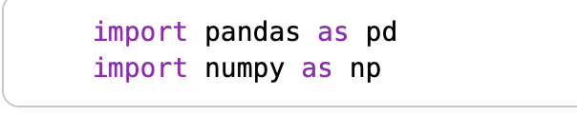

Loading the Dataset


Separating Features and Target
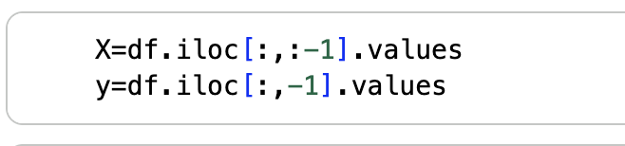

Find-S Algorithm
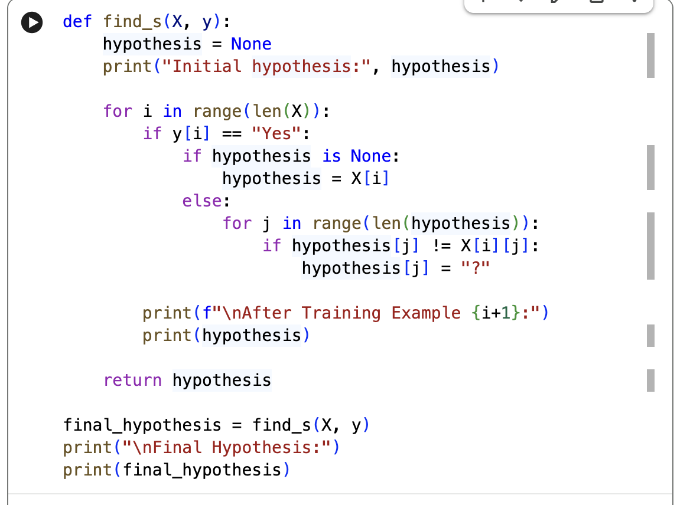

Candidate Elimination Algorithm
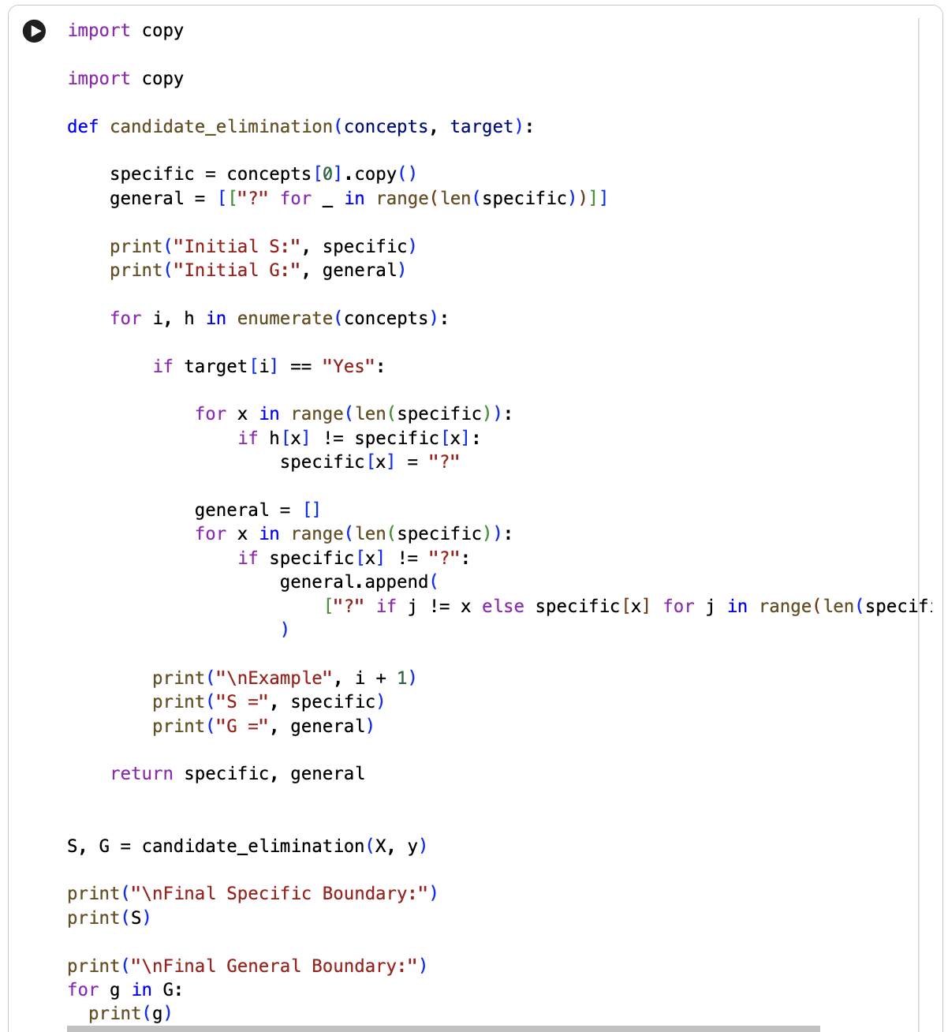

Output 1 – Displaying First Five Records
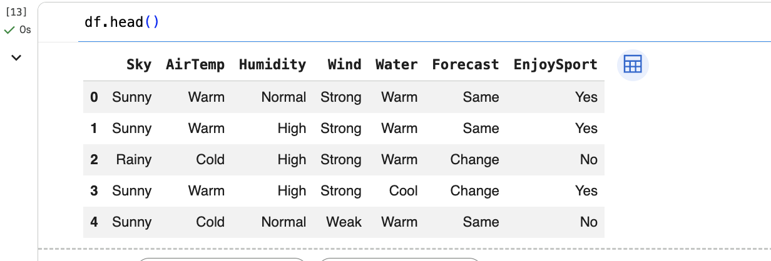
The EnjoySport dataset is loaded using Pandas and the first five records are displayed using df.head(). The output shows six environmental attributes and the EnjoySport target column. This confirms that the dataset has been loaded correctly and that the feature names are available for concept learning.

Output 2 – Dataset Information
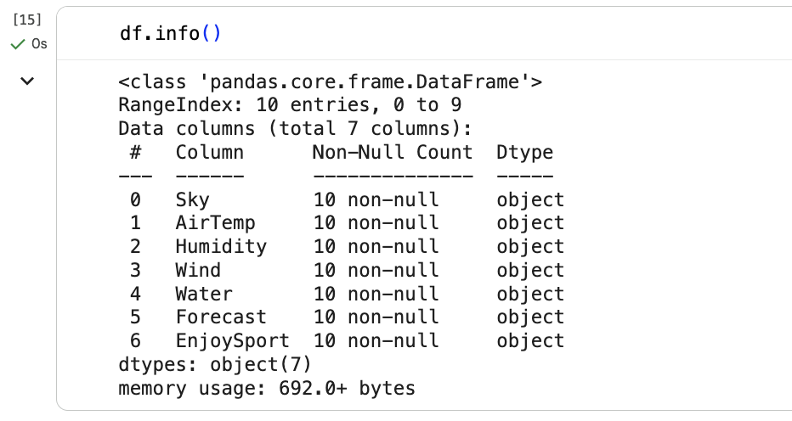
The df.info() function is used to inspect the structure of the dataset. The output shows 10 records and 7 columns, with no missing values in the displayed fields. This confirms that the data is ready for the Find-S and Candidate Elimination implementations.

Output 3 – Find-S Hypothesis After Training
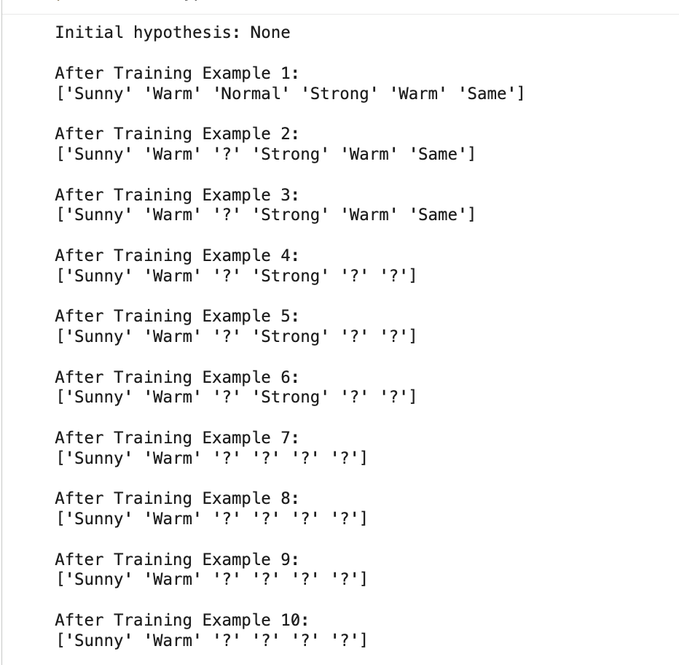
The Find-S algorithm processes the training examples sequentially. Positive examples are used to update the current hypothesis, while negative examples are ignored. As mismatching attribute values are found, they are replaced by the wildcard symbol ?. The output shows the hypothesis becoming more general during training.

Output 4 – Final Find-S Hypothesis
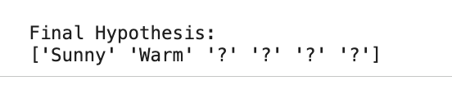
After processing all ten examples, the final Find-S hypothesis is [Sunny, Warm, ?, ?, ?, ?]. This indicates that Sunny and Warm remain as specific conditions while the other attributes are generalized using ?. This is the most-specific hypothesis obtained by the implemented Find-S program.

Output 5 – Candidate Elimination Boundaries
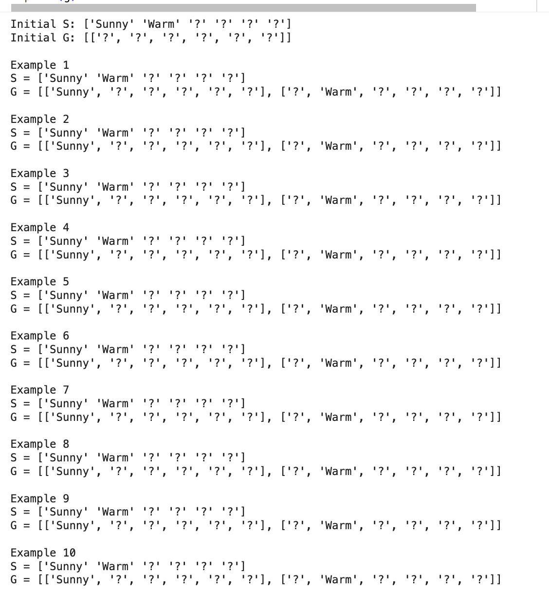
The Candidate Elimination program displays the specific and general boundaries during learning. The final specific boundary is [Sunny, Warm, ?, ?, ?, ?]. The general boundary contains two hypotheses, [Sunny, ?, ?, ?, ?, ?] and [?, Warm, ?, ?, ?, ?], representing the implemented general boundary.

Output 6 – Final Hypotheses Comparison
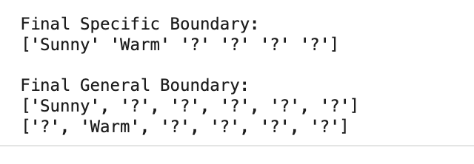
The final specific boundary from Candidate Elimination matches the final Find-S hypothesis. Candidate Elimination additionally provides the general boundary. Therefore, Find-S gives one most-specific result while Candidate Elimination represents a wider set of consistent hypotheses.

RESULT / CONCLUSION
The Find-S and Candidate Elimination algorithms were successfully implemented using the EnjoySport dataset. The Find-S algorithm generated [Sunny, Warm, ?, ?, ?, ?]. Candidate Elimination generated the same specific boundary and additionally produced the general boundary [Sunny, ?, ?, ?, ?, ?] and [?, Warm, ?, ?, ?, ?]. The experiment demonstrates how hypotheses are generalized while learning a concept from labelled examples.

VIVA QUESTIONS AND ANSWERS
Q1. What is the Find-S algorithm?
Find-S is a concept-learning algorithm that finds the most specific hypothesis consistent with positive training examples. It generalizes the hypothesis whenever different positive examples contain different attribute values.
Q2. What does ? represent in a hypothesis?
The symbol ? represents a wildcard or any-value condition. It is used when an attribute is allowed to take any value because the positive examples contain different values for that attribute.
Q3. What are the specific and general boundaries in Candidate Elimination?
The specific boundary S contains the most specific hypotheses consistent with the training data. The general boundary G contains the most general consistent hypotheses. The hypotheses between them form the version space.
Q4. What is the final Find-S hypothesis for this dataset?
The final Find-S hypothesis is [Sunny, Warm, ?, ?, ?, ?]. This means Sunny weather and Warm air temperature are retained as specific conditions, while the remaining attributes can take any value.
Q5. What is the difference between Find-S and Candidate Elimination?
Find-S produces a single most-specific hypothesis and primarily updates it using positive examples. Candidate Elimination maintains both specific and general boundaries and therefore provides a broader representation of the consistent hypothesis space.

